**Demo-vlc media player using hand gestures**

**Outcome = Play**

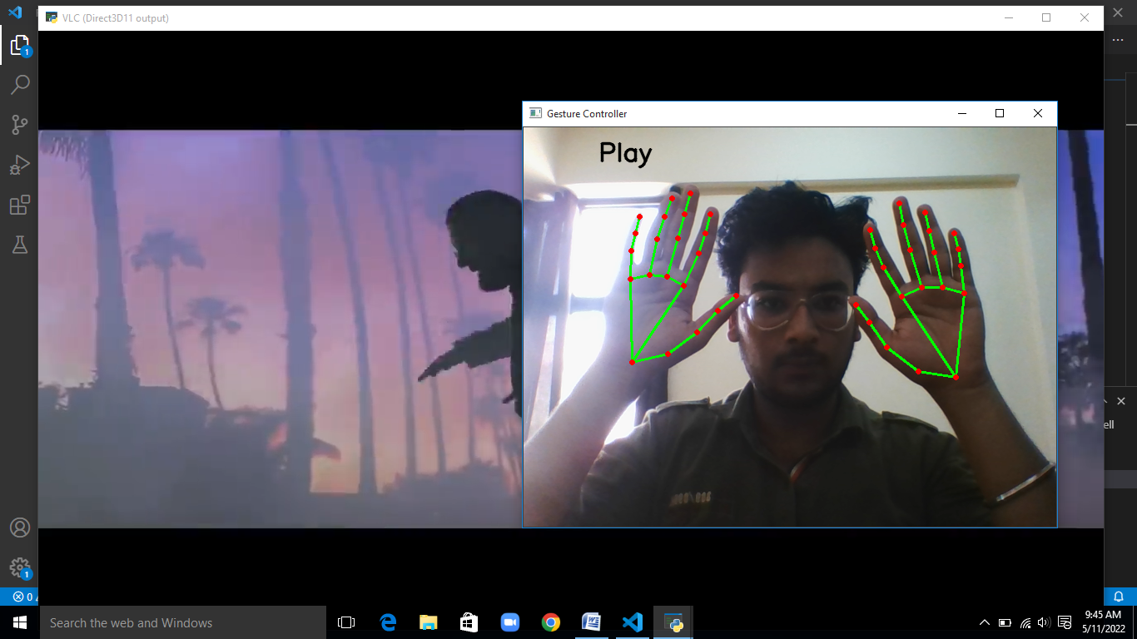

**Outcome = Stop**

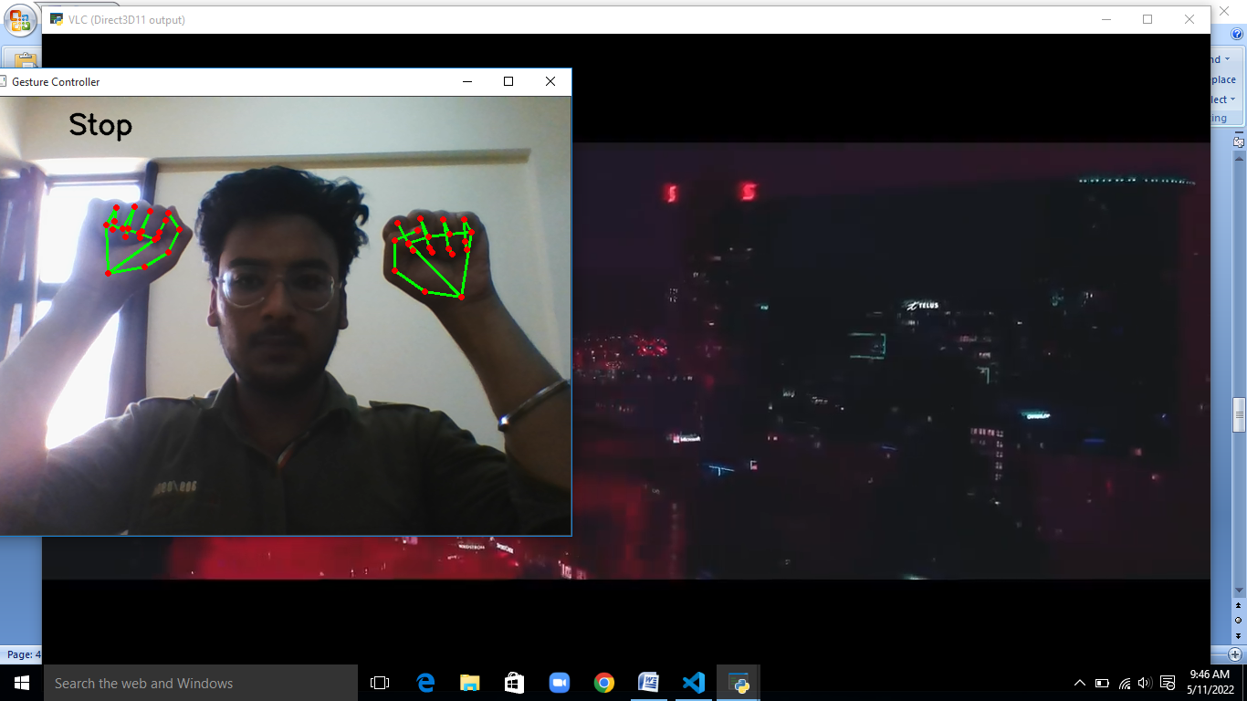

**Outcome = Volume up**

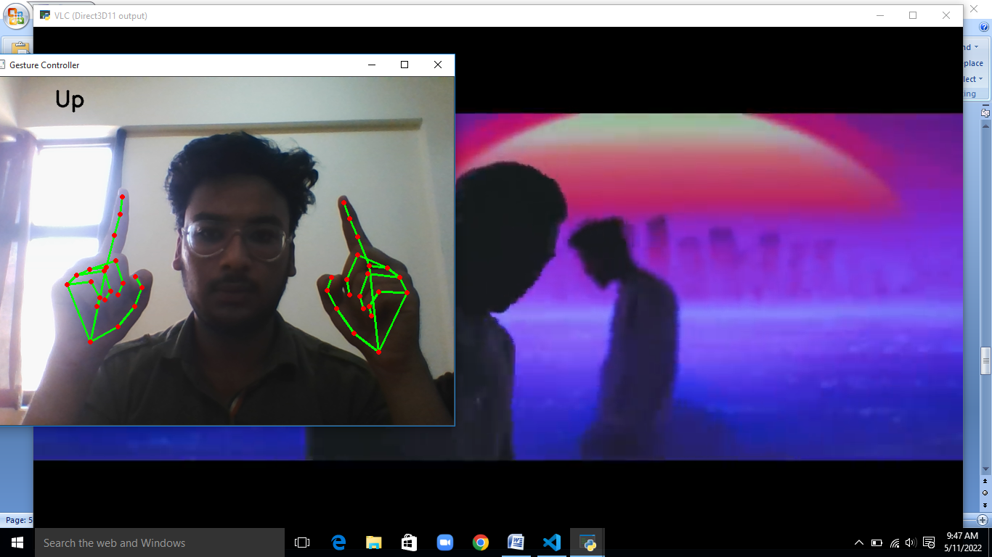

**Outcome = Volume down**

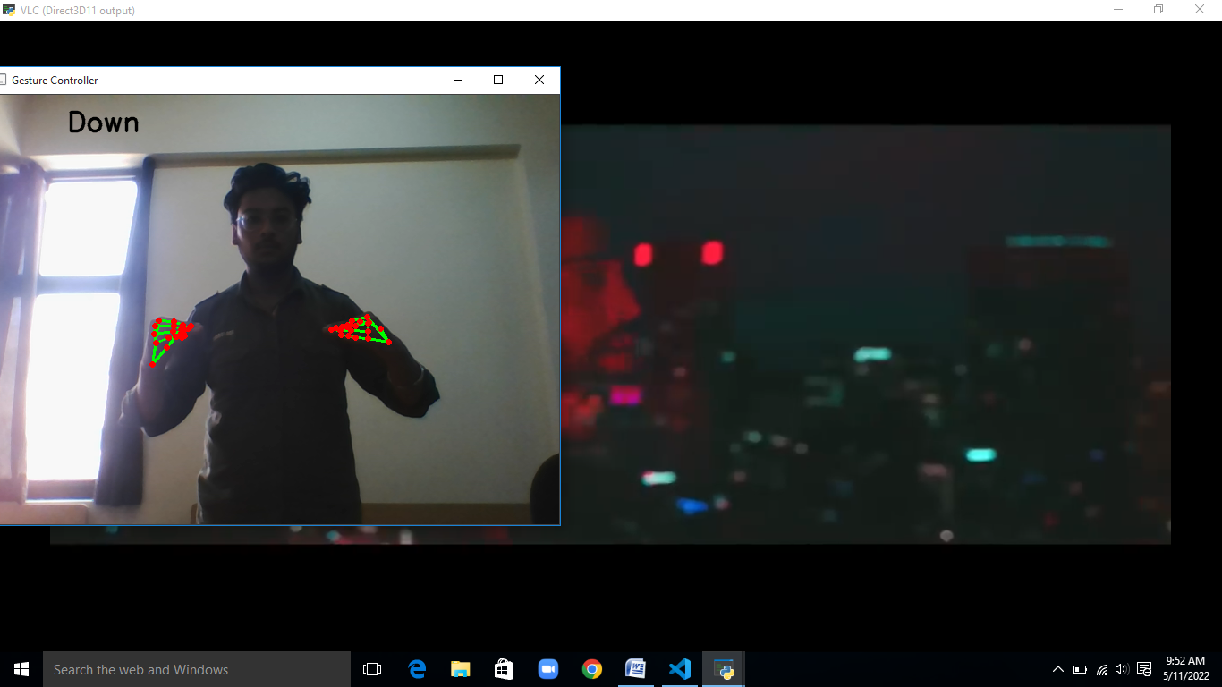

**Outcome = forward**

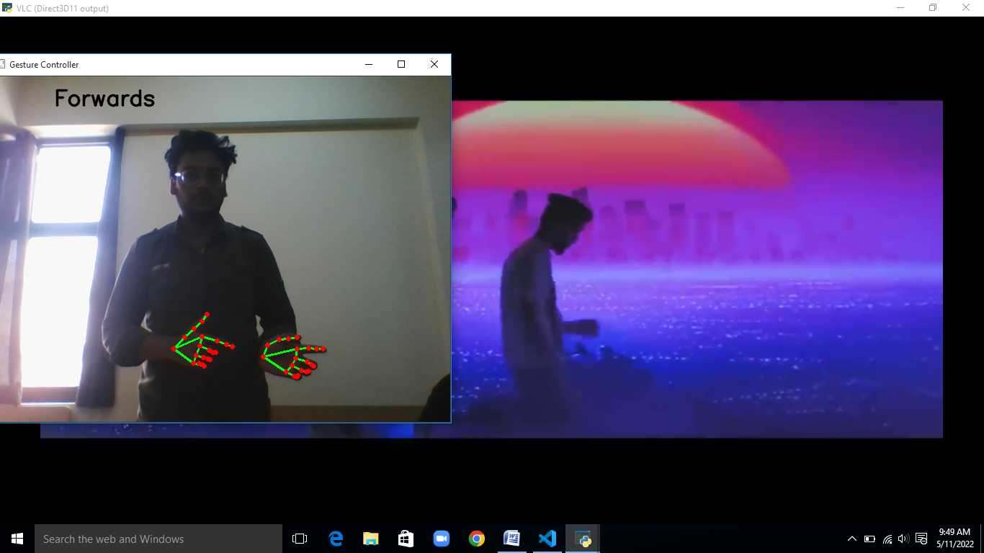

**Outcome = backward**

