Introduction:

64 bits is a word size that defines 64-bit width processor registers, address buses, or data buses of that size. 64-bit CPUs and ALUs are those based on 64-bit processor registers, address buses. 64-bit architecture can be used for a single element in a data format or that should be processed or transmitted in parallel.

From the software perspective, 64-bit computing means the use of machine code with 64-bit virtual memory address.

A 64-bit register can hold any of 2^64 (over 18 quintillion or 1.8*10^) different values. The range of integer values that can be stored in 64 bits depends on the integer representation used. A processor with 64-bits memory addresses can directly access 2^64 bytes (16 exbibytes or EiB) of byte addressable memory.

History of 64-bit computing

64-bit data timeline:

1961: IBM delivers the IBM 7030 stretch supercomputer which uses 64-bit data words and 32- or 64-bit instruction words.

1974: CDC star-100 using a 64-bit word architecture, international computers limited launches the ICL 2900 series with 32-bit, 64-bit and 128-bit two’s complement integers; 64-bit and 128-bit floating point; 32-bit, 64-bit and 128-bit packed decimal and 128-bit accumulator register.

1981: Intel introduces the Inter i680 RISC computer marketed as a “64-bit microprocessor” , it had essentially a 32-bit architecture, entranced with 3d graphics unit capable of 64-bit integer operations.

64-bit address timeline:

1991: MIPS computer systems produces the first 64-bit microprocessor , the R4000.

1996: Nintendo introduces the Nintendo 64 video game console, HP releases the first implementation of its 64-bit PA-RISC 2.0 architecture.

2000: IBM ships its first 64-bit 2/Architecture mainframe the z-series 2900.

2001: Intel ships its IA-64 processor line.

2006: IBM, Sony and Toshiba begin manufacturing the 64-bit cell processor for various appliances.

64-bit OS timeline:

1985: Cray releases UNICS, the first 64-bit implementation of the Unix operating system.

1993: DEC releases 64-bit DEC OSF/1AXP Unix with systems based on the Alpha architecture.

2000: IBM releases z10S, a 64-bit OS for new z series 64-bit mainframes.

2001: Linux becomes the OS kernel to fully support x86-64.

2006: Windows Vista was released, that retained 32-bit compatibility, despite all windows commands being 64-bit.

Why did the need for 64-bit computing arise?

A 32-bit address register meant that 2^32 addresses, or 4 Gib of RAM ( Random Access Memory) could be referenced, when these architectures were devised , 4 Gib of memory was so for beyond the typical amounts ( 4 MiB) in installations, this was considered to be enough headroom for addressing, 4.29 billion addresses were considered an appropriate size to work with or important reason : 4.29 billion integers are enough to assign unique references to most entities like in databases. Continual reductions in the cost of memory let to installations with amounts of AM approaching 4 GiB , and the use of virtual memory spaces exceeding the GiB celling became desirable of handling certain types of problems.

|  |  |  |
| --- | --- | --- |
| Parameter | 32-bit processors | 64-bit processors |
| Architecture | General computing is included in the 32-bit system, which includes the DEC VAX , the Intel  IA-32 , IBM system/370 , Motora 68000 family and different versions. | The registers are often divided for addresses of numerous uses and names such as index , address or base registers and divided into various groups like control , integer , floating. |
| Application Support | In a 32-bit computer, 64-bit programs and applications will not work. | In a 64-bit computer, 32-bit programs and applications will work existing. |
| Calculations per second | There are two versions available of the 32-bit system, which are dual core and quad core. | There are various versions of 64-bit systems such as dual-core, and eight-core. Due to multiple cores, its speed of calculations per second has increased. |
| OS and CPU requirement | 32-bit CUPs are needed by 32-bit applications and operating systems. | A 64-bit CPU and operating system are required for 64-bit programmers, while a 64-bit operating system requires a 64-bit CPU. |
| Memory limits | 32-bit system addresses limitation doesn’t allow users to utilize full 4 GB of physical memory space as it is limited to 3.2GB of RAM 32-bit windows. | It allows the users to store up to 17 billion GB of RAM. |
| Support for multi-tasking | Multitasking and stress testing is not considered ideally. | Since it contains a large amount of addressable space, hence it has the potential for it. |

Advantages of 64-bit Computers:

The major benefits of 64-bit computers are discuses below:

* More RAM equates to more speed.
* Overall efficiency is also better.
* 64-bit architecture provides a much better protection because of kernel patent protection and hardware D.E.P offers protection for the boot sector.

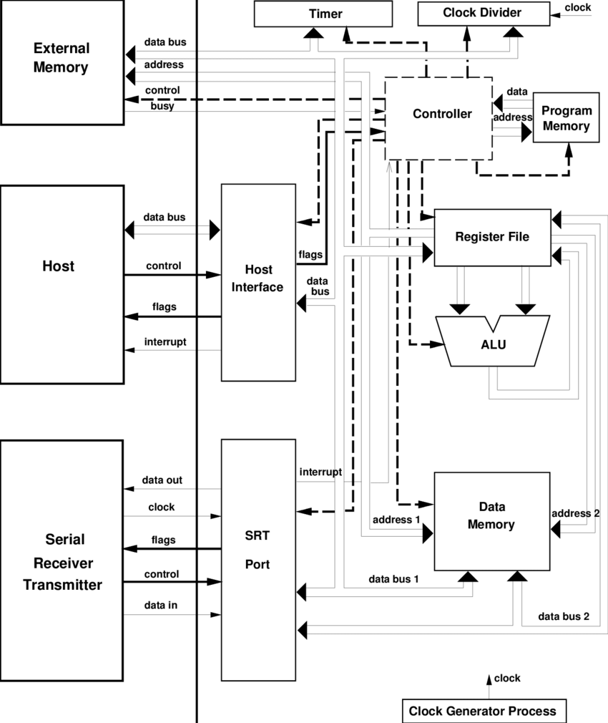

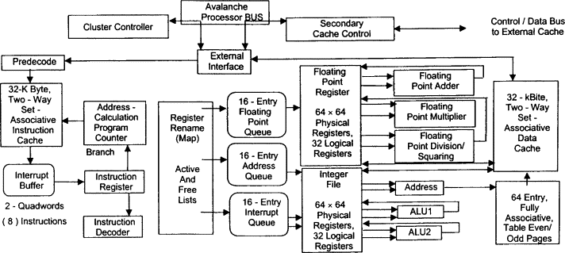

Limitations of 64-bit system:

* More memory occupancy for small tasks: A 64 bit operating system computing takes up more memory space in comparison to 32-bit systems for the same data. Pointers are now twice as big and take up twice as space.
* Low availability of 64-bit drivers for older systems.
* Issued with outdated software.
* Not compatible with 32 bit systems.