**Summary:**

As a real estate investor, I am interested in knowing if my chosen property will make a successful AIRBNB in next two years.

Successful AIRBNB can be measured by many factors. I am going to focus my study on upcoming locations, percentage of listings increased over last 3 years, Number_Of_Reviews per property for that location, Price to cost ratio for one example property

**Data Procurement:**

I downloaded AIRBNB data for several cities in bay area from insideairbnb.com. There are two files per city in the data set.

1. Listings: This is the primary file used for the analysis. It contains information regarding property and its type, host and host ratings, price, availability calendar, review ratings etc.
2. Reviews: This file contains all reviews per property. This file will be used to do text sentiment analysis.

**Data Cleanup:**

I appended the listings data for several cities into one “Bay_Area_Listings” worksheet. My primary analysis involves clear location by city, so I created a “smart_location” column which contains major city names.

There were a few properties that were listed only during Superbowl 50 in year 2015. Those were also the properties with prices way higher than the properties in that area. I removed those listings from the analysis. Few properties had blank or 0 value Price column. I have excluded those listings from the analysis.

I also corrected prices manually for remaining outliers by checking the actual listing on AIRBNB site.

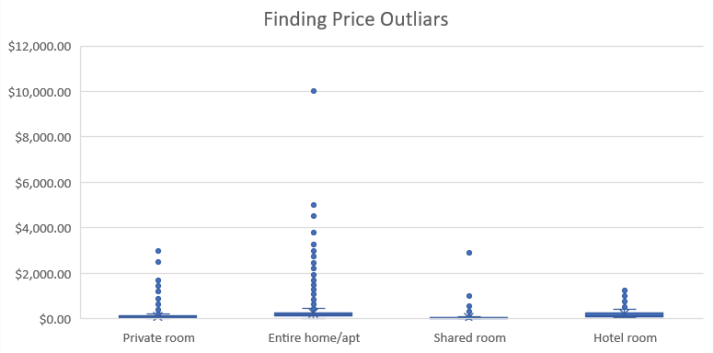

**Analysis:**

1. Room Type: The most popular room type to list in bay area is Entire home/apt followed by Private room.

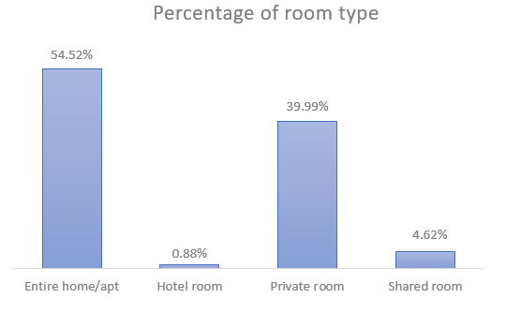

Room Type per location:

San Francisco, Oakland, San Jose have the most listings of Airbnb. Maybe because these three locations have airports. Even Santa Clara, mountain view and Sunnyvale shows more listings than rest of the suburbs, one reason can be because each of these cities have at least one major software company which might drive the rental traffic.

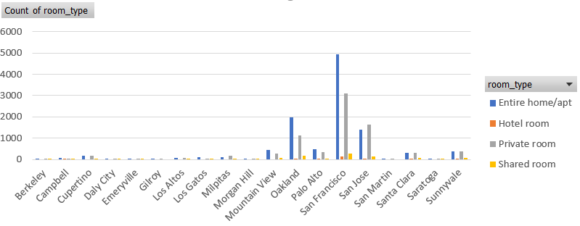

**Conclusion - We can see again that the most popular property type is Entire home/ APT and Private room. Since the objective is to find successful investment property I would like to focus on Entire home/apt and private room.**

1. AIRBNB Success can be measured by various factors and one of it is positive review rating.

Price and number of reviews shows that all type of properties which are priced higher have got lesser reviews. Most of the reviews are for properties with per night rate below $500. This trend can be observed for entire home rentals as well where per night prices are in higher range.

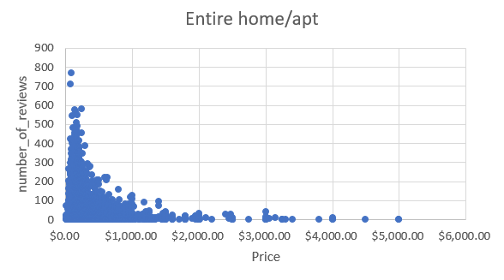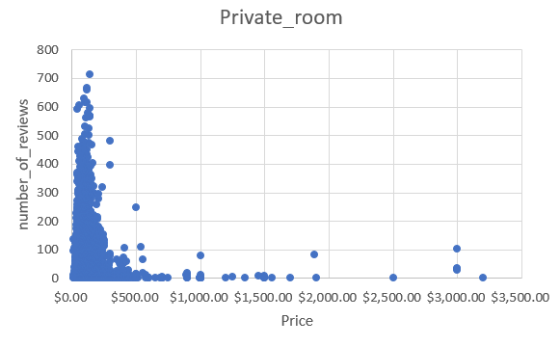

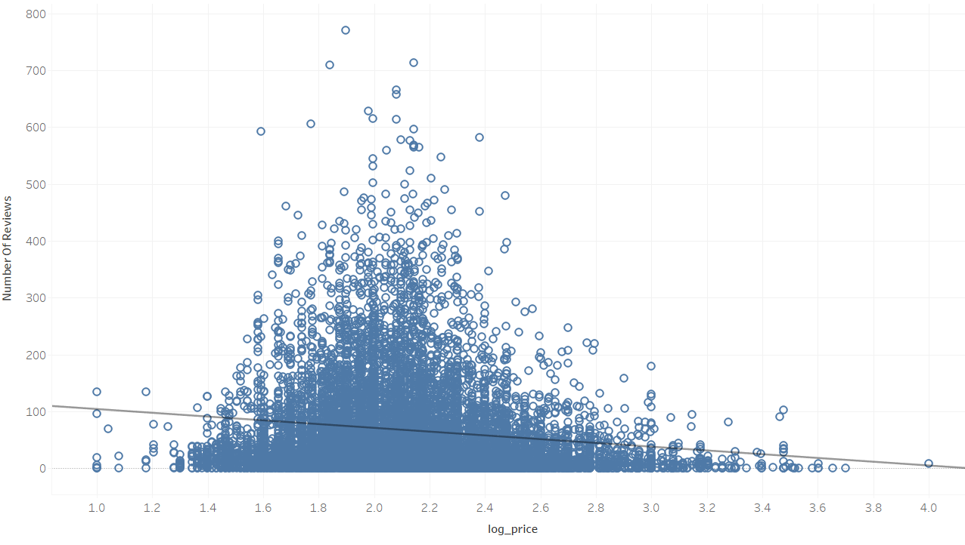

**Conclusion: We can conclude that getting more reviews in fact doesn’t affect price increase.**

1. Locations: Tracking san Jose, Morgan hill and Santa Clara Airbnb listing trends. San jose city has seen increase in Airbnb’s in the last 3 years. And looks like a good location to invest in Airbnb.

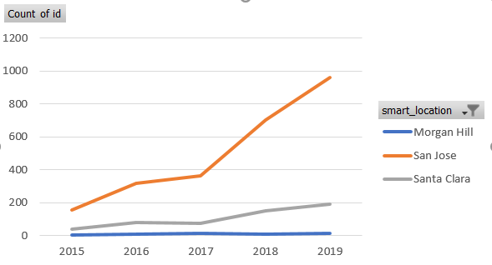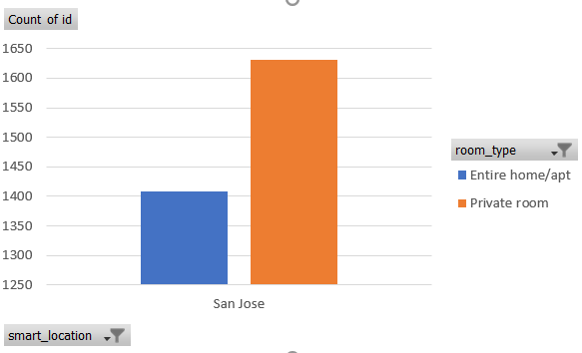

Most significant variables are room_type, accommodates and bedrooms.

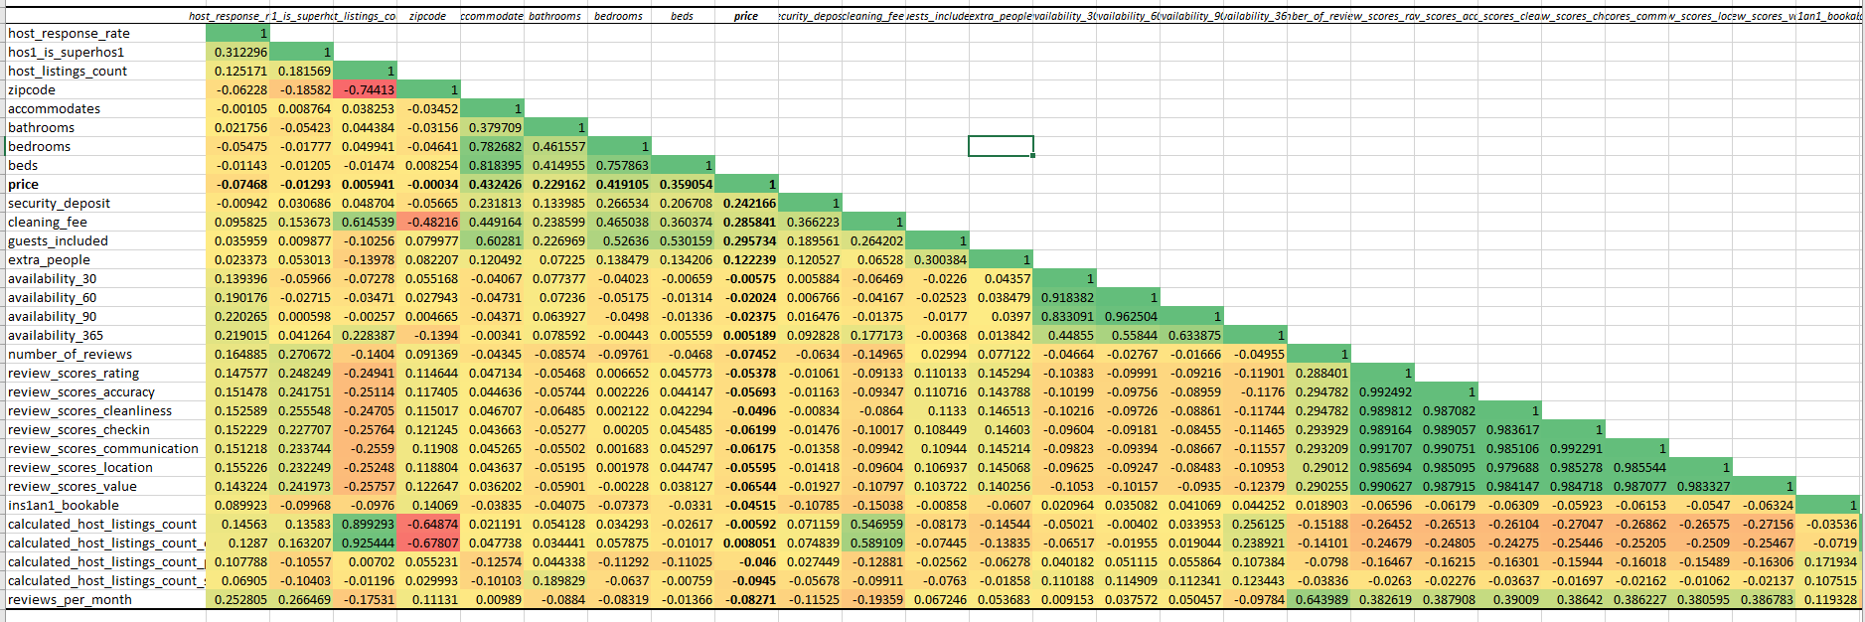

Linear trend line shows that there is a marginally increasing impact of accommodations on the price.

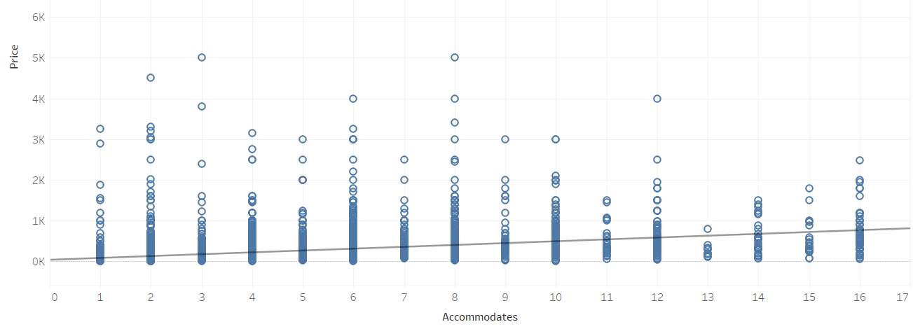

Conclusion:

So far, we have not find a variable that significantly impacts price for all over market. But we have decided to focus on certain real estate markets where the property values to rent can still yield positive cash flow then.

Lets look at the review score rating to understand if the score is associated with location or not.

Very interesting to see the review_score_ratings for Entire Family/APT room type. Ratings for cities away from the tech industry has good ratings for cheaper properties. The scores seem to be decreasing significantly for high priced properties. But the trend is different for the cities closer to the tech companies, like SF, Palo Alto, Daly City, Berkely – all shows that the review scores show slightly positive upward trend for higher priced properties.

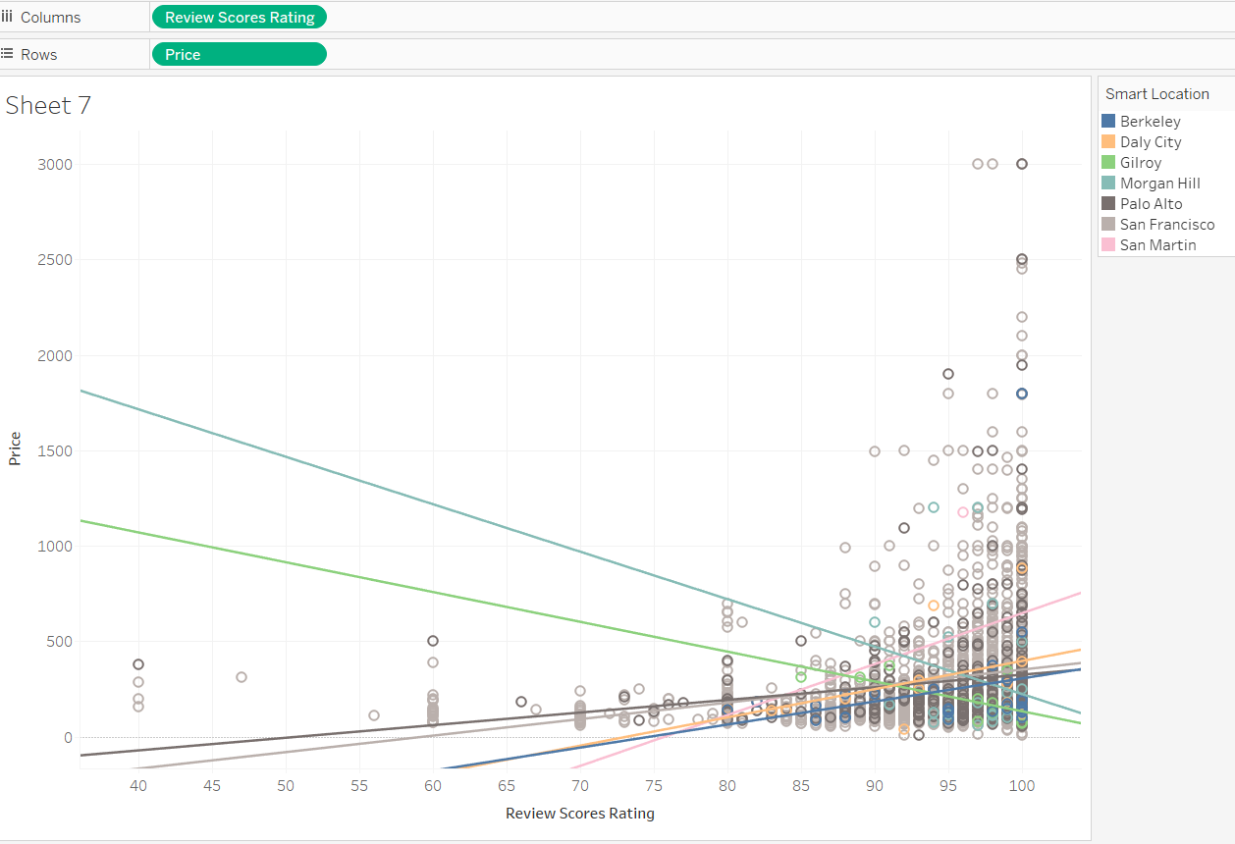

The purpose of this study is to predict which location and room type are good to invest as AIRBNB property. At this point we are unable to reach to a conclusion regarding multivariable impact, but single variable study did show some good results regarding upcoming locations such as san jose.