1. Login Page

1. Employee List

1. Add new Employee

1. Detail employee

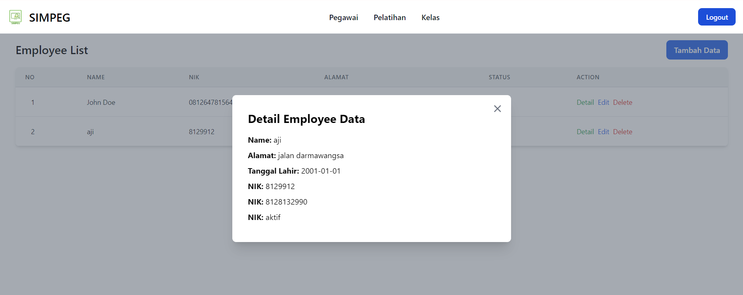

1. Edit Data Employee

1. Delete employee data (comfirmation modal)

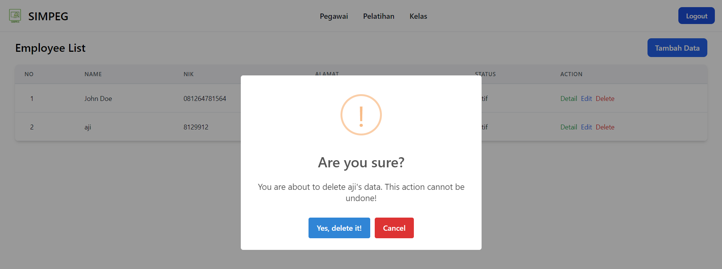

1. Success deleted data employee

