HEALTHCARE PLANNING · MICROSOFT FABRIC
Budget Patients, Not Dollars
How driver-based planning in Microsoft Fabric turns patient demand into staffing, labor cost and capacity decisions that leaders can test before they commit.
October 2026 · Reading time: about 10 minutes

Executive summary
Most hospital budgets start from last year's spending. When costs run over, the explanation is usually "volume was up", and the conversation ends there. In practice, volume explains only part of the story. The rest comes from staffing intensity and premium labor rates, which have different owners and need different responses.
This article walks through a driver-based alternative built in Planning in Fabric IQ. Instead of budgeting dollars, the plan budgets patients. A forecast of patient days drives nursing hours, nursing hours drive paid FTEs, and FTEs drive labor cost. Every link is a simple, visible rule with a named owner.

$51,295  Q2 labor variance on one unit, split into three owned causes | 94,180  patient days forecast for 2027 across 11 inpatient units | ≈$57.5M  base-case 2027 direct-care labor cost | 122%  peak occupancy on two units in a winter surge

Key takeaways for leadership
Variance becomes accountable. Only 55% of one unit's overrun was higher census; 45% came from staffing and premium rates.
One model, one version of the truth. Census, labor and finance work from the same data in one Fabric platform, with no exports or reconciliations.
Decisions are testable. Changing a single driver recalculates hours, FTEs and cost across every scenario automatically.
Seasonality matters more than totals. A surge that adds only 3.6% to annual volume would push four units beyond bed capacity in winter.

01 "Volume was up" explains only half the overrun
In Q2 2026, Med-Surg 3 West ran $51,295 over its direct-care labor budget. A traditional review would attribute this to higher census and move on. A driver-based view splits the same variance into three causes, each with a clear owner.
Driver | Variance | Share | What happened | Owner
Volume | $28,328 | 55% | 28.3 patients a day vs 27.4 planned | Strategy & access
Staffing | $8,673 | 17% | 8.58 hours per patient day vs 8.50 target | Nursing leadership
Rate | $14,294 | 28% | $42.83 per worked hour vs $42.19 (agency, overtime) | HR & workforce
Total | $51,295 | 100%

The pattern repeats across the hospital. From January to August 2026, agency labor ran $1.29M over budget, 66% above plan. Agency FTEs rose from 18.05 budgeted to 30.04 actual, and every unit finished above plan, led by Surgical Services, the ICU and the Emergency Department.
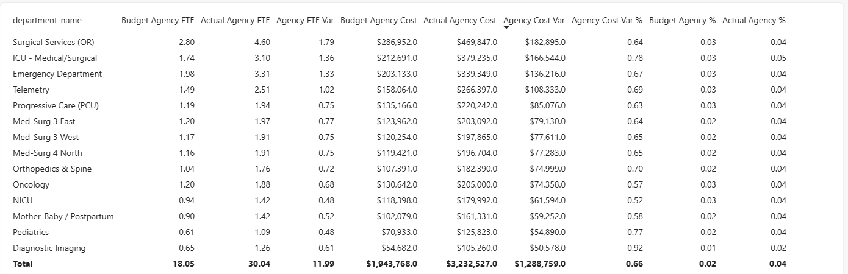
Figure 1. Agency FTE and cost by department, budget against actual, January to August 2026. Total agency cost rose from $1.94M budgeted to $3.23M actual.
Why it matters: when variance is reported as a single number, nobody owns it. When it is split by driver, each leader can act on the part they control.

02 Forecast the patients, and let everything else follow
The core idea is simple: labor cost is a consequence of patient demand, not of last year's budget. The plan therefore forecasts the driver and derives everything downstream through transparent rules.
Step | Calculation | Owner
1. Patient days | Predicted from 32 months of monthly history | Strategy
2. Nursing hours | Forecast patient days × hours per patient day (HPPD) | Nursing
3. Paid FTEs | Nursing hours ÷ paid hours per nurse | HR
4. Labor cost | Hours × wage rate × benefits load | Finance

Because each link is a rule rather than a typed-in number, a change at the top flows through automatically. In the 2027 base case, the model forecasts 94,180 patient days, which translate into roughly 945,000 nursing hours and an average of about 514 paid FTEs.

03 One Fabric platform, from source data to plan
The census behind the plan is the same census in every report. Data flows through a single platform, so operations, workforce and finance never reconcile competing spreadsheets.
Layer | Role
Source data | Census, timekeeping, payroll and general ledger
Lakehouse (OneLake) | Delta tables that store operational data once
Semantic model | Star schema, relationships and measures defined once and reused everywhere
Planning sheet | Forecast, Predict, staffing formulas and scenarios
Intelligence | Actual-versus-budget variance and executive reporting

Direct Lake reads the Lakehouse tables directly, with no import or copy. The semantic model uses six dimensions (date, department, job class, payer, GL account and scenario) and five fact tables (census, ancillary volume, labor, patient revenue and general ledger). Measures are defined once in a Calculations table.
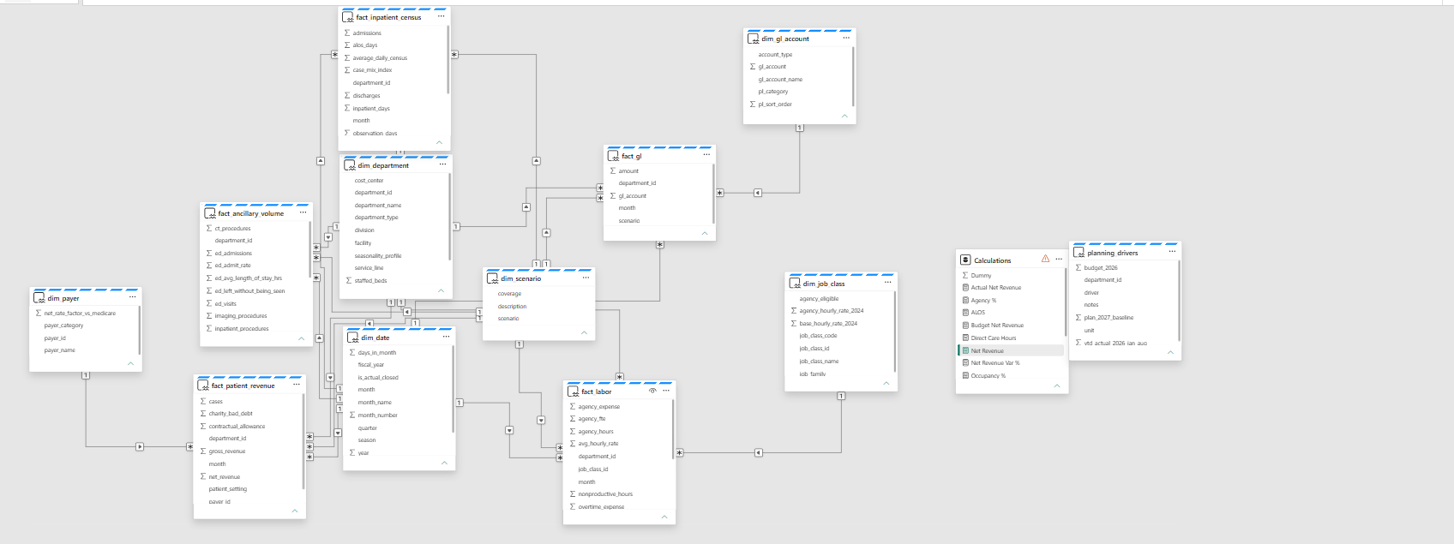
Figure 2. The semantic model: fact tables joined to shared dimensions, with measures in a single Calculations table alongside the planning drivers.

04 Five steps to a driver-based plan
The plan is built in a short, repeatable sequence inside the planning sheet:
- Filter to actuals. Set Scenario = Actual and include inpatient units only, so budget rows do not mix into history. Without this step, 2026 can double count and teach the forecast a false jump.
- Create the forecast measure. Define the forecast period. Closed months link to actual patient days; future months stay open for the forecast to fill.
- Run Predict. Use Trend Decomposition with MSTL, trained on January 2024 to August 2026 with 12-month seasonality.
- Add staffing formulas. Nursing hours, paid FTEs and labor cost calculate month by month from the forecast.
- Simulate scenarios. Model changes such as +10% and −5% volume, then compare them side by side.
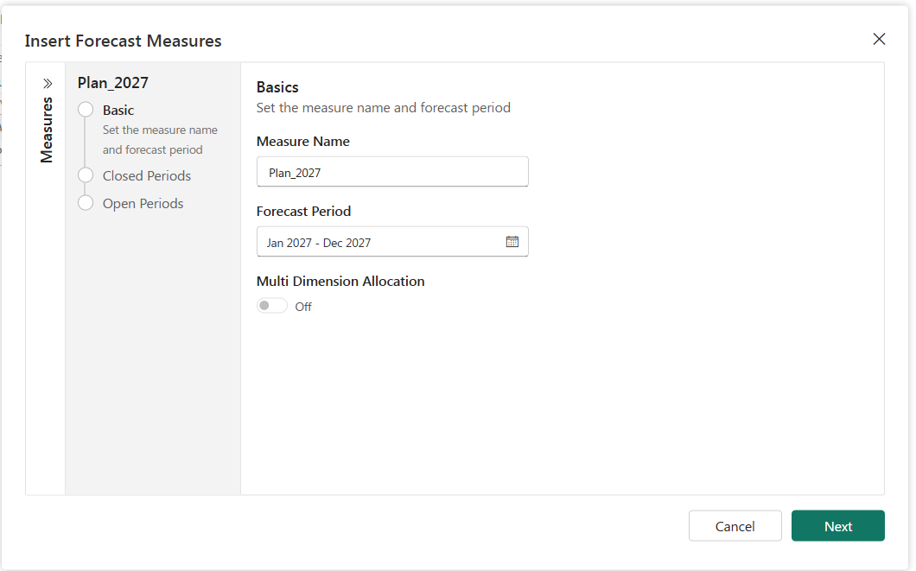
Figure 3. Insert Forecast Measures: name the measure and set its period, then define closed and open periods.
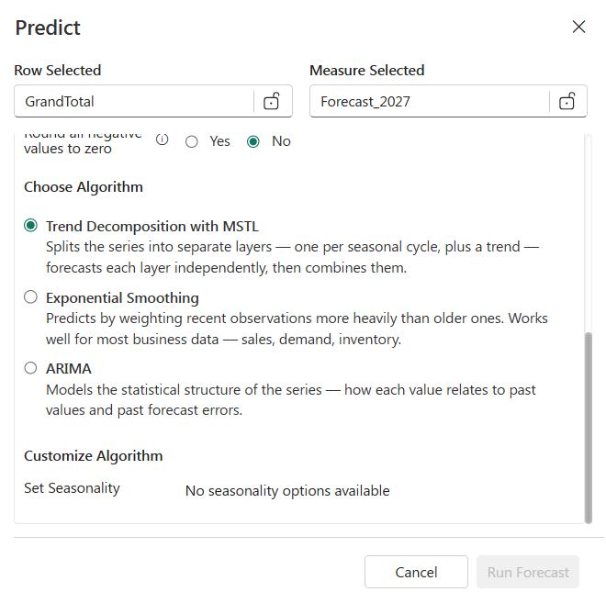
Figure 4. Predict with Trend Decomposition with MSTL selected. Forecasting needs monthly columns; with yearly columns there is no seasonality to learn, so Run stays disabled.

05 Four constants turn hours into people and dollars
The staffing formulas rely on four planning constants. Each is visible and can be challenged or updated by its owner.
Constant | Value | Meaning
Worked share | 0.885 | 11.5% of paid time goes to PTO, holidays and sick days
Hours per FTE | 173.33 | 2,080 paid hours a year ÷ 12 months
Blended wage (2027) | $41.91 | Average hourly rate across RNs, LPNs and nursing assistants
Benefits load | 1.285 | Adds 28.5% for health, retirement and payroll taxes

The chain in one line: patient days × HPPD = nursing hours → ÷ hours per nurse = FTEs → × wage and benefits = labor cost.

06 The 2027 forecast: 94,180 patient days
Predict learns from 32 months of history (January 2024 to August 2026) and forecasts September 2026 through December 2027. Actual history stays untouched; only open periods are filled.
Quarter | Patient days | Note
Q1 2027 | 24,590 | Respiratory season peak
Q2 2027 | 22,850
Q3 2027 | 22,770 | Seasonal low
Q4 2027 | 23,970
Full year | 94,180 | 11 inpatient units

The forecast also surfaced a signal nobody programmed in. Orthopedics climbs to 10,330 patient days, up from 8,600 in 2025. The model picked up the growth from a new surgeon group on its own, purely from the historical trend.
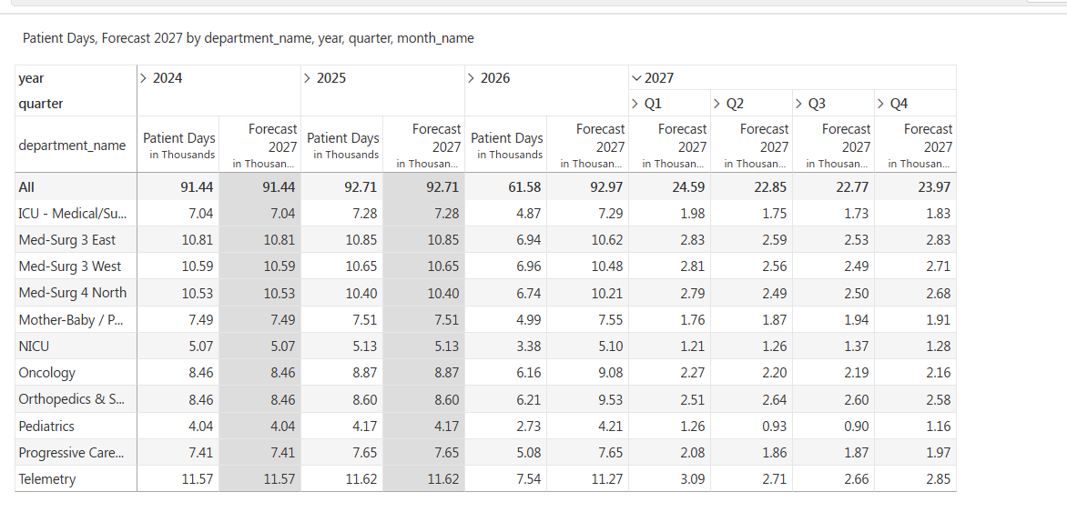
Figure 5. Patient days and Forecast 2027 by unit. Closed years match actuals; 2027 is forecast by quarter for each inpatient unit.

07 Testing decisions before they happen
With the drivers in place, a scenario is a single change. Leaders create a scenario tab, select the cells to adjust and enter the percentage once. Hours, FTEs and cost recalculate automatically, and every changed cell is tagged so the adjustment is always visible.
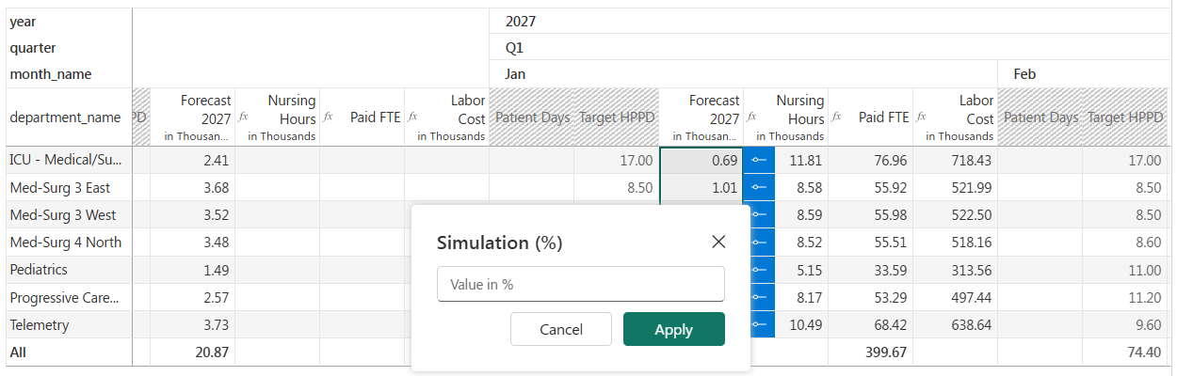
Figure 6. Entering a simulation: select a block of forecast cells and apply a percentage change once.
Scenario | Patient days | Labor cost
−5% volume | 89,470 | ≈$54.6M
Base | 94,180 | ≈$57.5M
+10% volume | 103,600 | ≈$63.3M
Respiratory surge | 97,600 | ≈$59.6M

Example: ICU at +10% volume
A 10% increase lifts ICU patient days from 7,300 to 8,030. Nursing hours follow automatically, from 124,100 to 136,510, and paid FTEs rise from about 67 to 74.2, for a labor cost of $8.31M. The ICU needs roughly twice Med-Surg's hours per patient day, so the same percentage change has a much larger staffing effect.
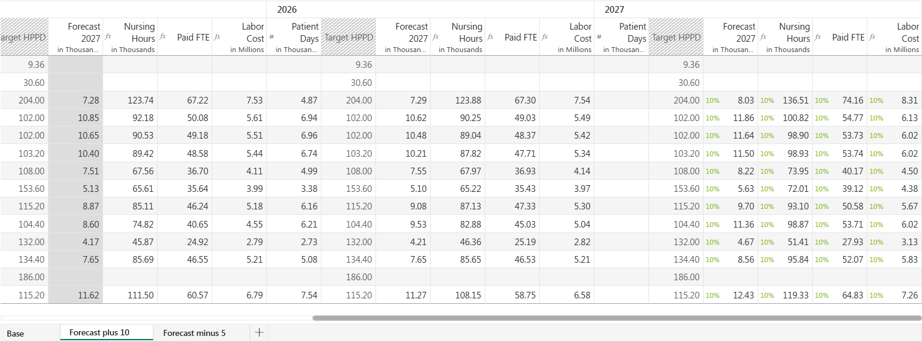
Figure 7. The +10% scenario tab. Each changed cell carries a 10% tag, and nursing hours, paid FTEs and labor cost update together.

08 The non-obvious insight: seasonality, not totals
The respiratory-surge scenario adds 20% volume on seven units for three winter months. Across the year, that is only 3.6% more patient days, which looks manageable on an annual budget. The monthly view tells a different story.
+3,420  additional patient days in the year | ≈76  extra FTEs a month during the surge | ≈+$2.1M  additional labor, concentrated in Dec–Feb

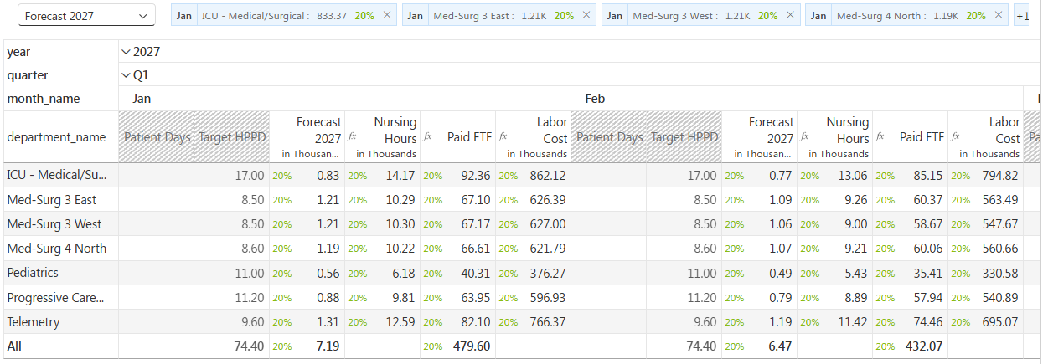
Figure 8. Respiratory surge, Q1 2027. January alone requires 479.60 paid FTEs across the seven surge units.

The capacity check changes the conversation
When surge census is compared with staffed beds, four units run well beyond capacity:
Unit | Patients per day | Staffed beds | Occupancy
Med-Surg 3 East | 39 | 32 | ≈122%
Med-Surg 3 West | 39 | 32 | ≈122%
Telemetry | 42 | 36 | ≈117%
ICU | 27 | 24 | ≈112%

This is not only a staffing problem
At surge levels the hospital would run out of beds. The right response is to plan overflow units, diversion protocols and agency cover before winter, not simply to hire more nurses.

09 The plan becomes a decision system
All scenarios sit side by side in a single Compare view, using the same drivers and the same formulas.
2027, all inpatient units | −5% | Base | +10% | Surge
Patient days | 89,470 | 94,180 | 103,600 | 97,600
Nursing hours | ≈898,000 | ≈945,000 | ≈1,040,000 | ≈980,000
Paid FTEs (average) | ≈488 | ≈514 | ≈565 | +76 in surge months
Labor cost | ≈$54.6M | ≈$57.5M | ≈$63.3M | ≈$59.6M

The surge adds the least volume of the growth scenarios, yet it is the hardest to staff, because the demand lands in three months. That insight is invisible in an annual dollar budget.
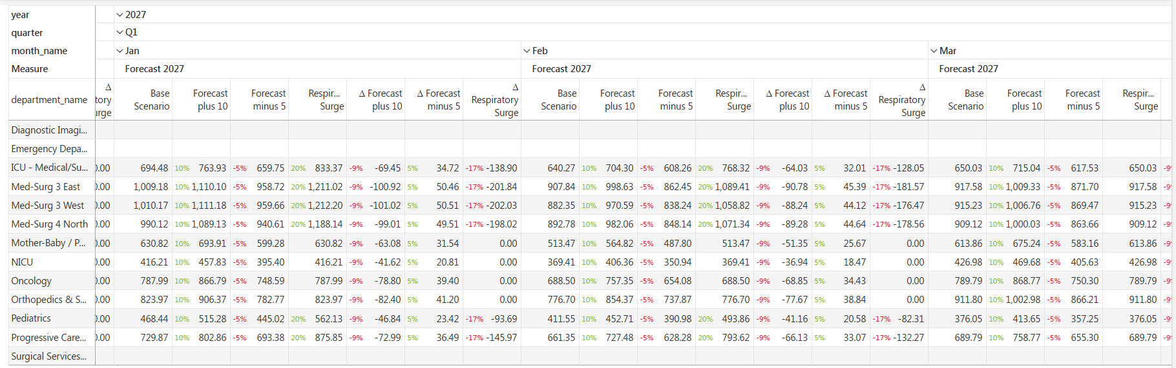
Figure 9. The Compare view: base, +10%, −5% and respiratory surge side by side, with difference columns and percentage tags cell by cell.

10 What this means for leadership
Driver-based planning gives each executive a direct answer to the question they own:
Function | Question answered | How
Operations | What will demand do? | Forecast patient volume and see capacity pressure early
Workforce | What will staffing require? | Translate demand into HPPD, hours and FTEs by unit and month
Finance | What will it cost? | Turn the same drivers into labor dollars and scenario comparisons

Recommended next steps
- Adopt patient days as the primary planning driver for inpatient labor, with HPPD targets owned by nursing leadership.
- Report variance by driver (volume, staffing, rate) so each overrun has a named owner and a clear response.
- Run a winter-surge scenario before Q4 and pair it with a bed-capacity check to plan overflow and agency cover in advance.
- Keep the plan on one platform so operational, workforce and financial reporting share a single semantic model.

Conclusion
Budgeting dollars tells leaders what was spent. Budgeting patients tells them why, and what will happen next. By forecasting the driver and letting the model calculate the consequence, operational assumptions become visible, owned and testable before they turn into financial surprises.
Move the driver. See the consequence.
About the data: All figures in this article use the Contoso Health demo, a synthetic dataset representing a 300-bed hospital. Values marked ≈ are rounded.

