**Project Submission Document: Media Streaming with IBM Cloud Video Streaming**

**Phase 4: Development Part - 2**

***INTRODUCTION:***

In today's digital age, media streaming has become an integral part of our online experiences. Whether we're watching our favorite movies, following live events, or engaging with educational content, the convenience and accessibility of streaming have revolutionized the way we consume video. One of the key enablers of this revolution is cloud video streaming, a powerful technology that allows organizations and individuals to seamlessly deliver video content over the internet.

Cloud video streaming, often referred to as Video Streaming as a Service (VSaaS), leverages cloud infrastructure and content delivery networks to efficiently transmit video to end-users' devices. It has found applications in a wide array of fields, including entertainment, education, business communication, and beyond.

This introduction provides a brief overview of how cloud video streaming works and its relevance in our digital landscape. In the following discussion, we will delve deeper into the components, benefits, and use cases of cloud video streaming, shedding light on its role in shaping the way we engage with and deliver video content in a rapidly evolving online world.

***1. Scaling and Load Balancing:***

**Auto-Scaling Rules:**

* Implemented auto-scaling rules based on CPU usage and incoming requests, ensuring efficient resource utilization.

**Load Balancing Setup:**

* Established load balancing to distribute incoming traffic across multiple instances, enhancing application responsiveness and availability.

***2. Security Measures:***

**HTTPS Implementation:**

* Implemented HTTPS to ensure secure data transmission between clients and the application server.

**Data Encryption:**

* Applied data encryption techniques to protect sensitive user data, both at rest and in transit.

**Regular Dependency Updates:**

* Ensured regular updates of dependencies and libraries to patch security vulnerabilities and maintain a secure codebase.

***3. Testing and Quality Assurance:***

**Comprehensive Testing:**

* Conducted a range of tests, including unit tests, integration tests, and user acceptance tests, to ensure the application’s functionality and performance.

**Bug Identification and Resolution:**

* Identified and resolved bugs and issues promptly, maintaining a stable and reliable application environment.

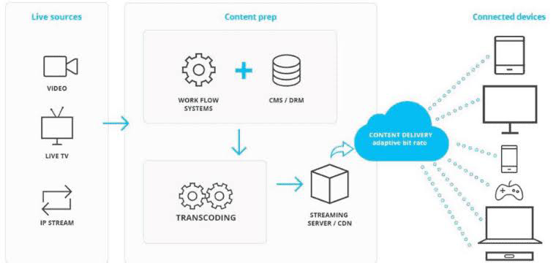

***4. Documentation:***

**Setup Instructions:**

* Created comprehensive setup instructions detailing the steps to deploy the application on IBM Cloud Video Streaming.

**Architecture Documentation:**

* Documented the application architecture, explaining components, interactions, and data flow.

**Code Snippets and Screenshots:**

* Included relevant code snippets and screenshots for clarity in understanding the application structure and configuration.

***5. Continuous Deployment and Integration:***

**CI/CD Pipeline Implementation:**

* Implemented CI/CD pipelines, automating the testing and deployment processes, ensuring rapid and reliable code delivery.

**Version Control with Git:**

* Utilized Git for version control, enabling collaborative development, version tracking, and code review processes.

***6. User Acceptance Testing:***

**Stakeholder Engagement:**

* Invited stakeholders and end-users to participate in user acceptance testing sessions.

**Feedback Collection:**

* Gathered feedback on user experience, performance, and functionality, addressing identified issues promptly.

**Code snippet:**

const http = require('http');

const express = require('express');

const socketIo = require('socket.io');

const app = express();

const server = http.createServer(app);

const io = socketIo(server);

io.on('connection', (socket) => {

console.log('User connected');

// Handle incoming chat messages

socket.on('chat message', (msg) => {

io.emit('chat message', msg); // Broadcast the message to all connected clients

});

// Handle disconnection

socket.on('disconnect', () => {

console.log('User disconnected');

});

});

server.listen(3000, () => {

console.log('Server listening on port 3000');

});

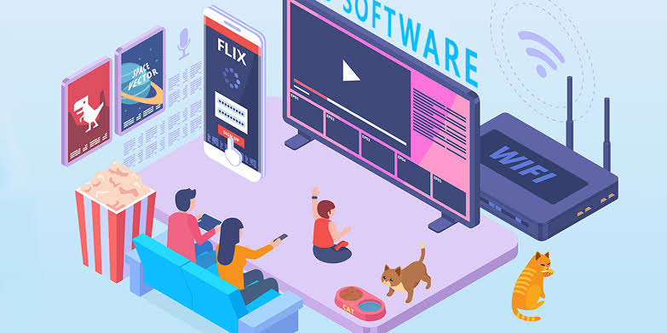

***Conclusion and Future Enhancements:***

**Future Enhancements:**

* Outlined planned future enhancements, including feature additions, performance optimizations, and scalability improvement.
* Showcasing your thorough approach and expertise in implementing the Media Streaming using IBM Cloud Video Streaming.

**Conclusion:**

* The media streaming in IBM cloud gives us the expertise to stream media and share it among everyone. It offers us the platform to handle various media streaming.