**What is Java**

Java is a **programming language** and a **platform**. Java is a high level, robust, object-oriented and secure programming language.

Java was developed by **Sun Microsystems** (which is now the subsidiary of Oracle) in the year 1995. **James Gosling** is known as the father of Java. Before Java, its name was **Oak**. Since Oak was already a registered company, so **James Gosling** and his team changed the Oak name to **Java**.

**Platform**: Any hardware or software environment in which a program runs, is known as a platform. Since Java has a runtime environment (JRE) and API, it is called a platform.

## Application

According to Sun, 3 billion devices run Java. There are many devices where Java is currently used. Some of them are as follows:

1. Desktop Applications such as acrobat reader, media player, antivirus, etc.
2. Web Applications such as irctc.co.in, gmail.com, etc.
3. Enterprise Applications such as banking applications.
4. Mobile
5. Embedded System
6. Robotics
7. Games, etc.

# **Features of Java**

### Simple

### Object-oriented

* 1. Object
  2. Class
  3. Inheritance
  4. Polymorphism
  5. Abstraction
  6. Encapsulation

1. Platform Independent
2. Secured
3. Multi-threaded

**Difference between JDK, JRE, and JVM**

**JVM**

JVM (Java Virtual Machine) is an abstract machine. It is called a virtual machine because it doesn't physically exist. It is a specification that provides a runtime environment in which Java bytecode can be executed. It can also run those programs which are written in other languages and compiled to Java bytecode.

The JVM performs the following main tasks:

Loads code

Verifies code

Executes code

**JRE**

JRE is an acronym for Java Runtime Environment. It is also written as Java RTE. The Java Runtime Environment is a set of software tools which are used for developing Java applications. It is used to provide the runtime environment. It is the implementation of JVM. It physically exists. It contains a set of libraries + other files that JVM uses at runtime.

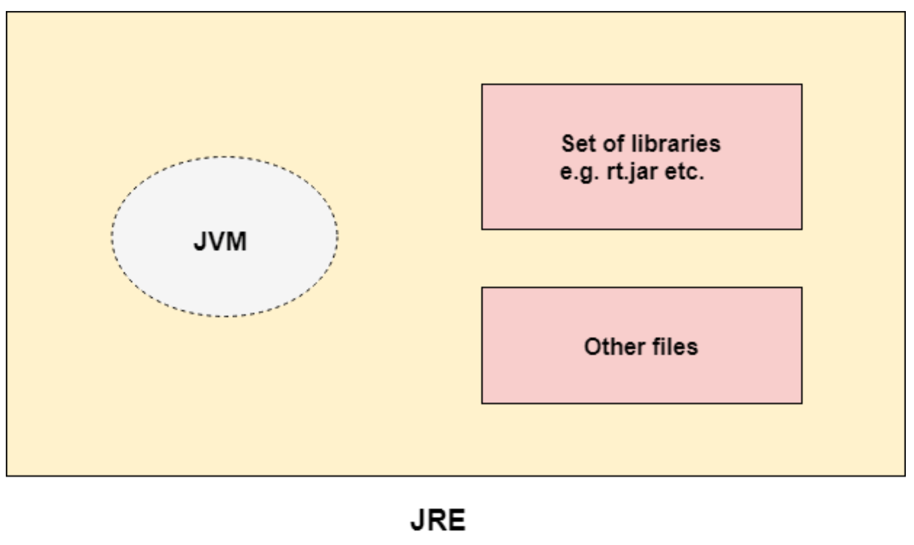

**JDK**

JDK is an acronym for Java Development Kit. The Java Development Kit (JDK) is a software development environment which is used to develop Java applications and applets. It physically exists. It contains JRE + development tools.

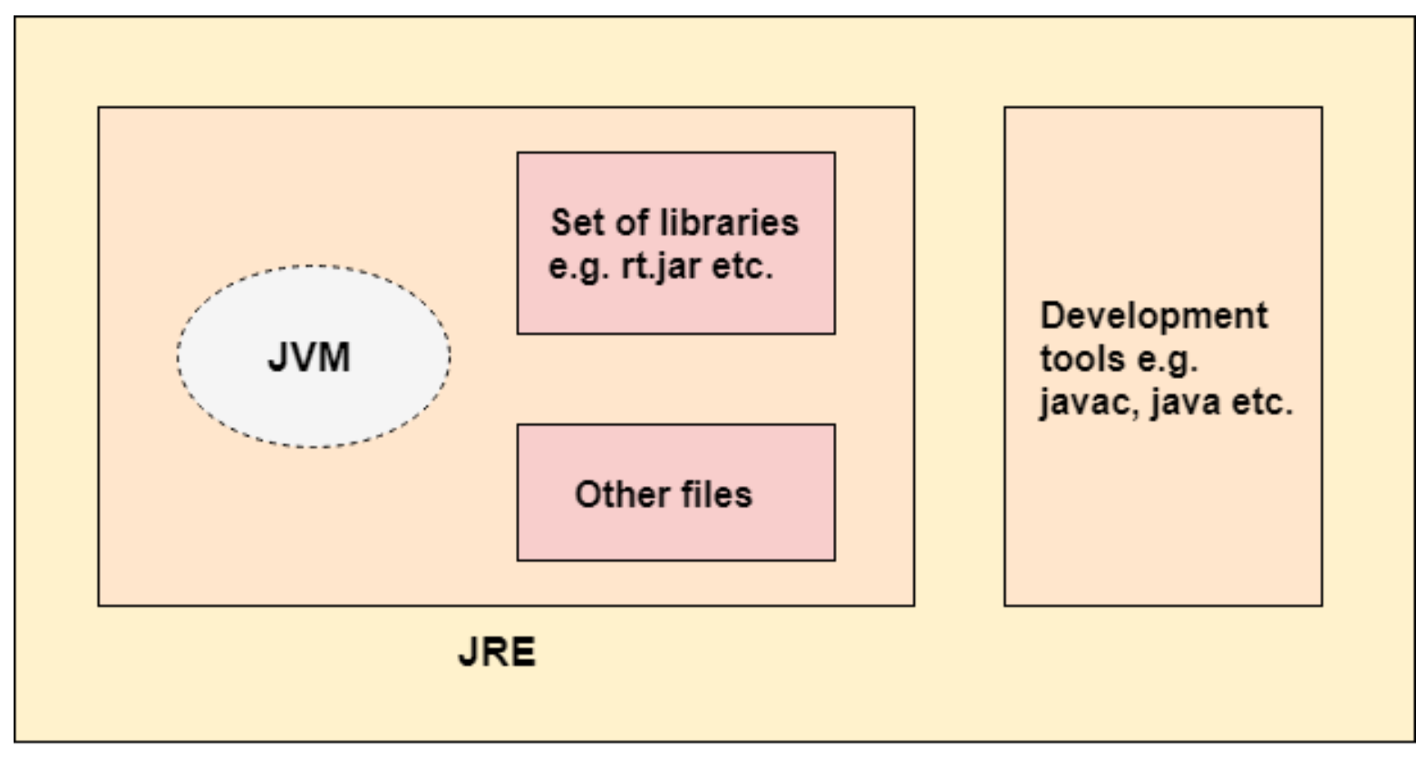

First Java Program | Hello World Example

**class Simple{  
 public static void main(String args[]){   
 System.out.println("Hello Java");   
 }  
}**

save this file as Simple.java

**To compile:** javac Simple.java

**To execute:** java Simple

**Compilation Flow:**

When we compile Java program using javac tool, java compiler converts the source code into byte code.

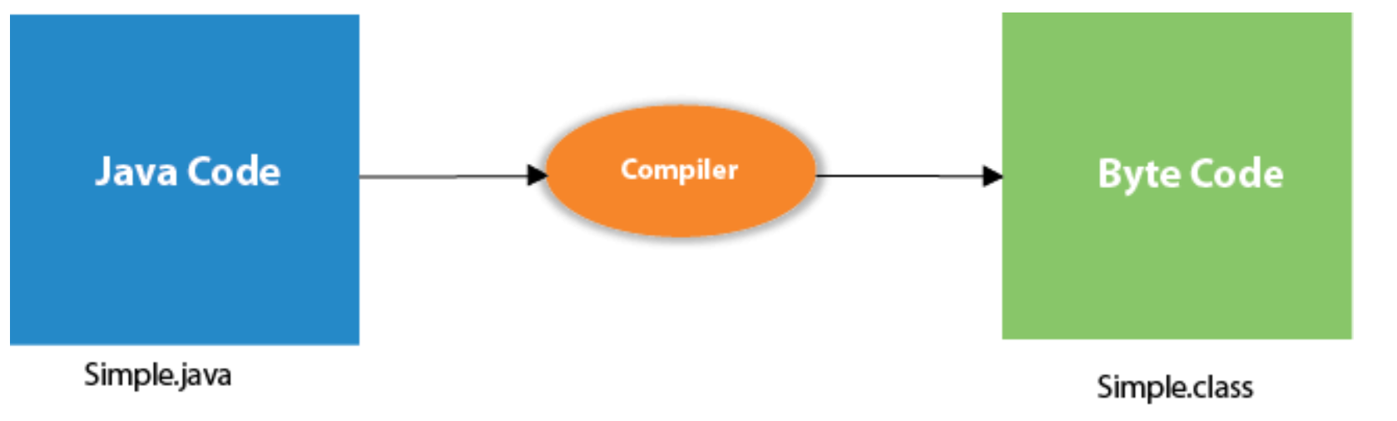

**Parameters used in First Java Program**

Let's see what is the meaning of **class, public, static, void, main, String[], System.out.println()**.

**class** keyword is used to declare a class in java.

**public** keyword is an access modifier which represents visibility. It means it is visible to all.

**static** is a keyword. If we declare any method as static, it is known as the static method. The core advantage of the static method is that there is no need to create an object to invoke the static method. The main method is executed by the JVM, so it doesn't require to create an object to invoke the main method. So it saves memory.

**void** is the return type of the method. It means it doesn't return any value.

**main** represents the starting point of the program.

**String[] args** is used for command line argument. We will learn it later.

**System.out.println()** is used to print statement. Here, System is a class, out is the object of PrintStream class, println() is the method of PrintStream class. We will learn about the internal working of System.out.println statement later.

**Java Variables**

A variable is a container which holds the value while the Java program is executed. A variable is assigned with a data type.Variable is a name of memory location.

There are three types of variables in java: **local, instance and static.**

There are two types of data types in Java: **primitive and non-primitive.**

**int data=10;//Here data is variable**

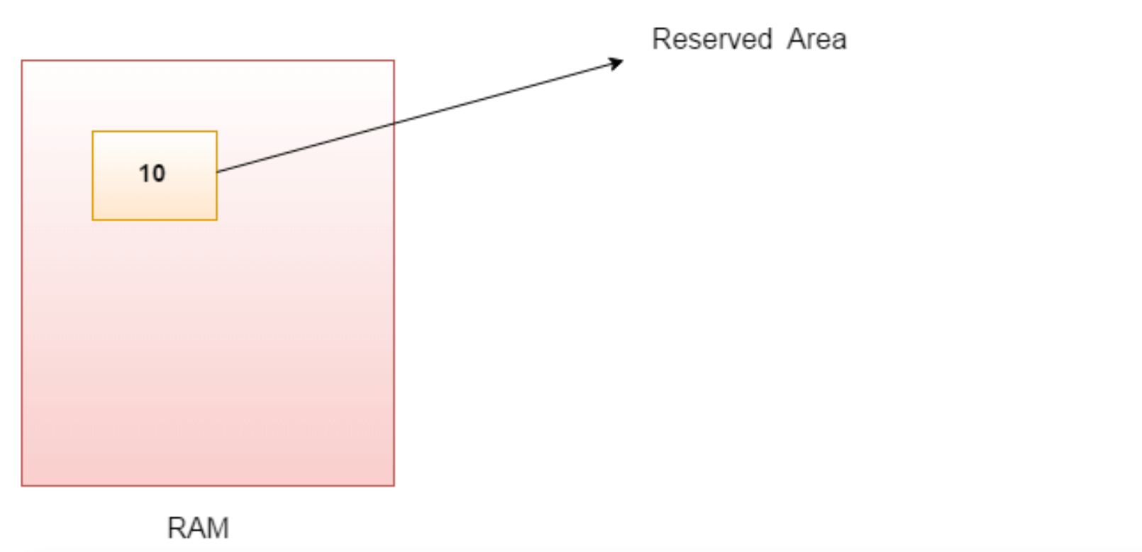

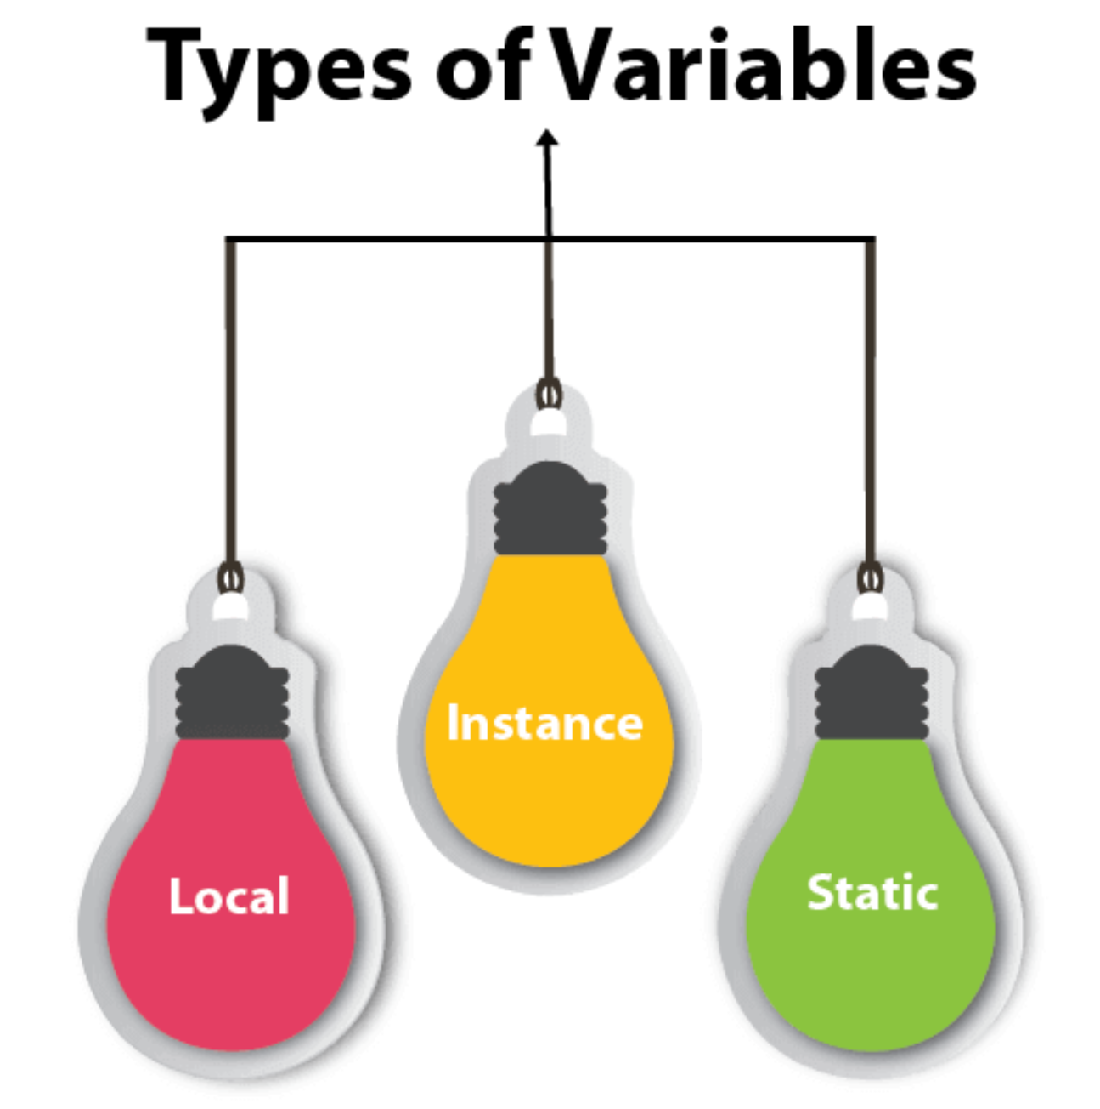

**1) Local Variable**

A variable declared inside the body of the method is called local variable. You can use this variable only within that method and the other methods in the class aren't even aware that the variable exists.

A local variable cannot be defined with "static" keyword.

**2) Instance Variable**

A variable declared inside the class but outside the body of the method, is called instance variable. It is not declared as static.

It is called instance variable because its value is instance specific and is not shared among instances.

**3) Static variable**A variable which is declared as static is called static variable. It cannot be local. You can create a single copy of static variable and share among all the instances of the class. **Memory allocation for** static variable happens only once when the class is loaded in the memory.

**Example to understand the types of variables in java**

class A{

int data=50;//instance variable

static int m=100;//static variable

void method(){

int n=90;//local variable

}

}//end of class

**Data Types in Java**

Data types specify the different sizes and values that can be stored in the variable. There are two types of data types in Java:

**Primitive data types:** The primitive data types include boolean, char, byte, short, int, long, float and double.

Data types that are provided by Java and allow specific type of data to be stored by a variable are called primitive types.

**Non-primitive data types:** The non-primitive data types include Classes, Interfaces, and Arrays.

data types are not defined by the programming language but are instead created by the programmer

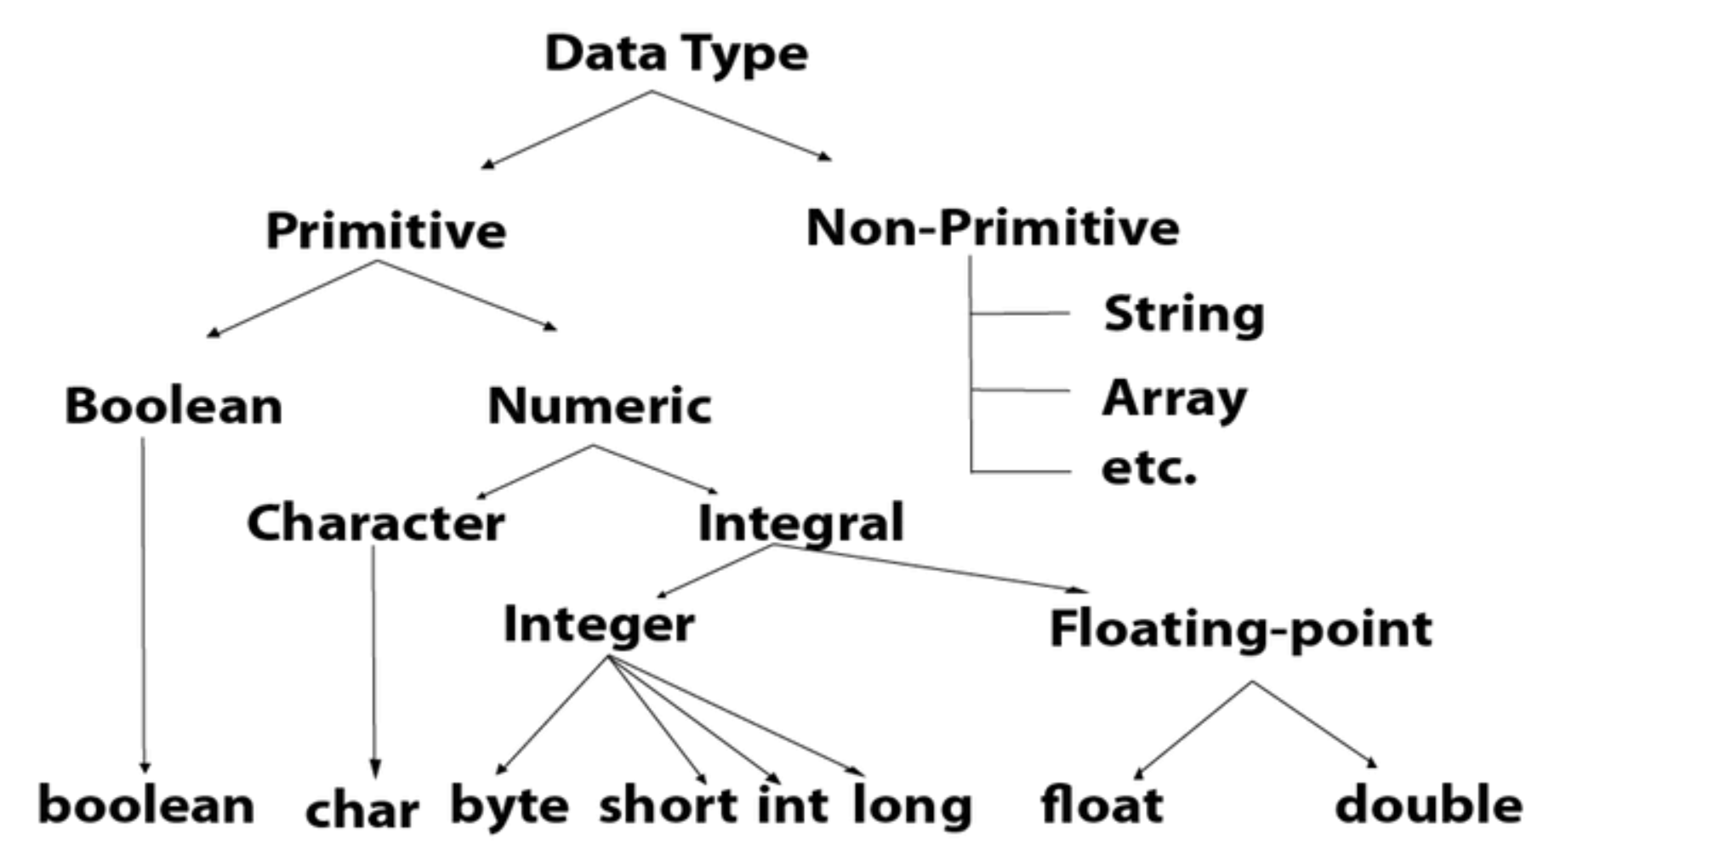

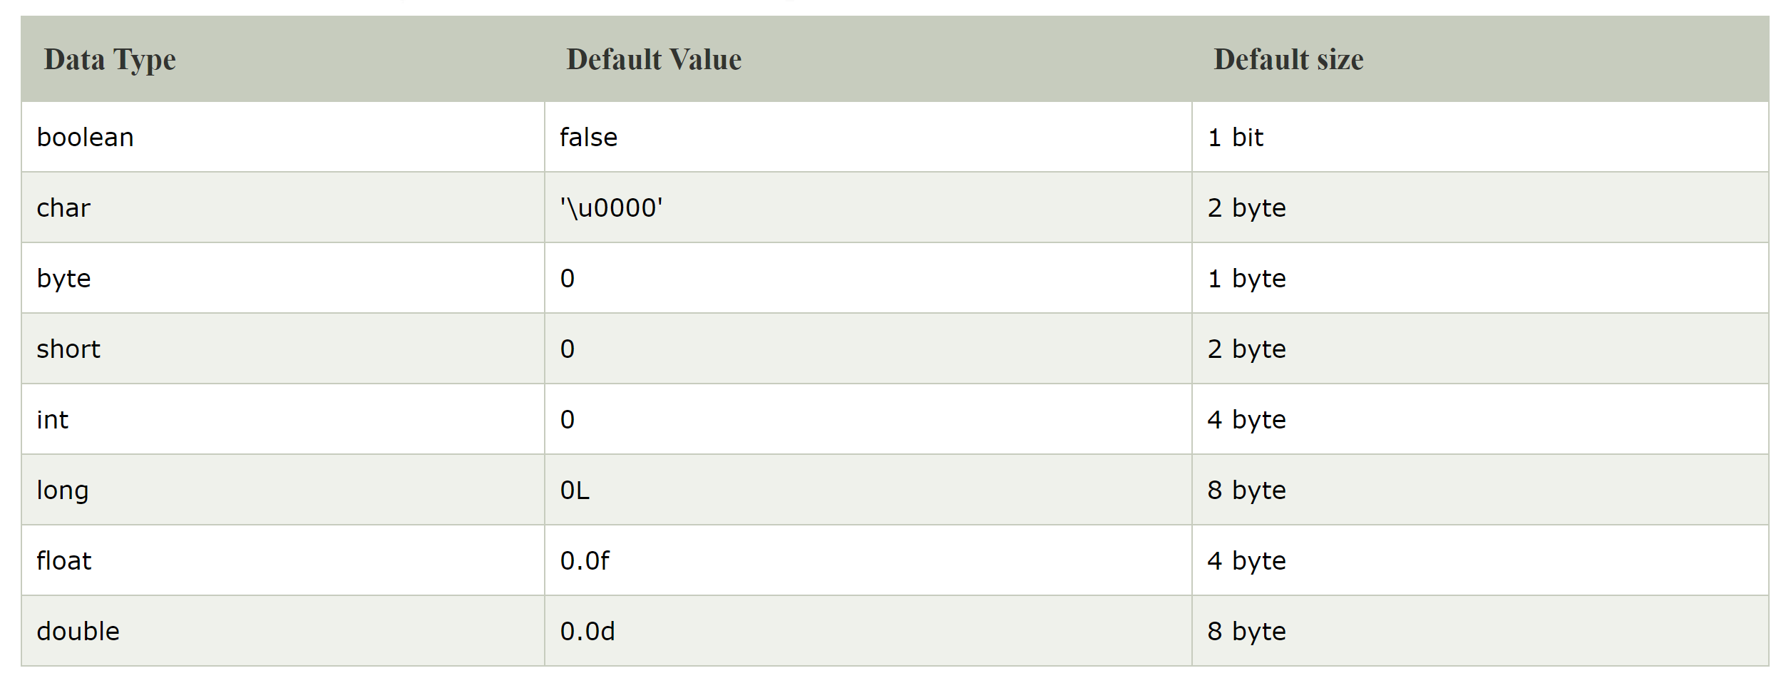

Int Data Type

Example: int a = 100000, int b = -200000

Boolean Data Type

Example: Boolean one = false

Float Data Type

Example: float f1 = 234.5f

Double Data Type

Example: double d1 = 12.3

Char Data Type

Example: char letterA = 'A'

Eclipse : <https://www.eclipse.org/downloads/download.php?file=/technology/epp/downloads/release/2020-12/R/eclipse-java-2020-12-R-win32-x86_64.zip>

https://www.eclipse.org/downloads/download.php?file=/technology/epp/downloads/release/2019-12/R/eclipse-java-2019-12-R-win32-x86_64.zip

Java 8 : https://www.oracle.com/java/technologies/javase/javase-jdk8-downloads.html

**Questions :**

1. What is JVM,JRE and JDK?
2. What is variable?
3. Types of variables?
4. Difference bw local, instance and static variables?
5. What is Data Type?
6. Types of Data Types?