Q2 2026 GDP forecasting model
rm(list = ls())
set.seed(100)
# Loading Libraries
library(tseries)
## Warning: package 'tseries' was built under R version 4.6.1
## Registered S3 method overwritten by 'quantmod':
## method from
## as.zoo.data.frame zoo
library(BVAR)
## Warning: package 'BVAR' was built under R version 4.6.1
library(BVARverse)
## Warning: package 'BVARverse' was built under R version 4.6.1
library(ggplot2)
library(zoo)
## Warning: package 'zoo' was built under R version 4.6.1
##
## Attaching package: 'zoo'
## The following objects are masked from 'package:base':
##
## as.Date, as.Date.numeric
library(rmarkdown)
## Warning: package 'rmarkdown' was built under R version 4.6.1
library(knitr)
library(readxl)
## Warning: package 'readxl' was built under R version 4.6.1
# Loading Data
df <- read_excel("C:/Users/yugandhar wani/OneDrive/Desktop/My Folder/GDP Data/Data (2022-23 Series).xlsx")
df <- df[,c(2,3,4,5,6)]
df <- ts(data = df,start = c(2023,2),end = c(2026,1),frequency = 4)
# fitting model
mn <- bv_minnesota(lambda = bv_lambda(mode = 0.2,sd=0.4,min = 1e-04,max = 5),alpha = bv_alpha(mode = 2),var = 1e+07)
mh <- bv_metropolis(scale_hess = 0.01,adjust_acc = TRUE,acc_lower = 0.25,acc_upper = 0.45)
priors <- bv_priors(hyper = "auto",mn=mn)
mod <- bvar(df,4,n_draw = 50000,n_burn = 25000,n_thin = 1,priors = priors,mh=mh)
## Optimisation concluded.
## Posterior marginal likelihood: -133.31
## Hyperparameters: lambda = 0.97906
## Finished MCMC after 21.93 secs.
# Plots
bv_ggplot(mod,type = "trace")+ggthemes::theme_economist()
## Ignoring unknown labels:
## • colour : "MCMC chain"
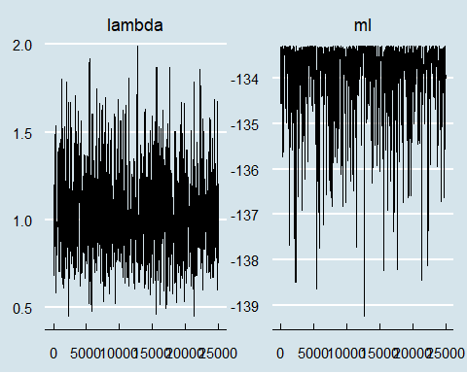
bv_ggplot(mod,type = "dens")+ggthemes::theme_economist()
## Ignoring unknown labels:
## • colour : "MCMC chain"
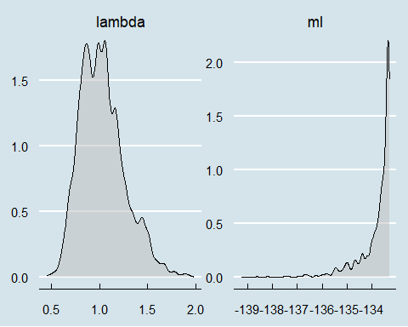
# forecasts
fcast <- predict(mod,horizon=1)
pointfcast <- fcast$quants["50%",,1]
pointfcast
## 50%
## 6.505211
#Plotting Forecast Data
fcplot <- bv_ggplot(fcast,vars = "GDP Growth Rate",t_back = 5)+ggthemes::theme_economist()+geom_point(aes(x=time,y=value),inherit.aes = FALSE)+geom_label(aes(x=time,y=value,label = round(value,2)),inherit.aes = FALSE)+scale_x_yearqtr(format = "%Y Q%q")
## Scale for x is already present.
## Adding another scale for x, which will replace the existing scale.
start_quarter <- as.yearqtr("2026 Q2")
all_quarter <- seq(start_quarter,by=0.25,length.out=6)
quarter_labels <- format(all_quarter,"%Y Q%q")
quarter_labels
## [1] "2026 Q2" "2026 Q3" "2026 Q4" "2027 Q1" "2027 Q2" "2027 Q3"
fcplot+scale_x_continuous(breaks = seq(all_quarter),labels = quarter_labels)
## Scale for x is already present.
## Adding another scale for x, which will replace the existing scale.
## Warning: Removed 10 rows containing missing values or values outside the scale range
## (`geom_point()`).
## Warning: Removed 10 rows containing missing values or values outside the scale range
## (`geom_label()`).
