A Project Report on
BAYESIAN DEEP LEARNING–BASED FIDELITY ESTIMATION FOR UAV COMMUNICATION DIGITAL TWINS
submitted in partial fulfilment of the requirements for the course
MACHINE LEARNING
25SC2107E
in
A.Y.: 2026-27
by
D. KARTHIK | 2520040082
S. KARTHIKEYA | 2520040004
P. YUGANDHAR | 2520040027

Under the Esteemed guidance of
Mr. N Lava Prasad
Assistant Professor,
Department of ECE


DEPARTMENT OF ELECTRONICS & COMMUNICATION ENGINEERING
Name of Title:
Bayesian Deep Learning-Based Fidelity Estimation for UAV Communication Digital Twins
1. Abstract:
Unmanned Aerial Vehicles (UAVs) are increasingly used in applications such as surveillance, disaster management, agriculture, delivery, and communication. In these applications, reliable wireless communication between UAVs and ground stations is important because factors such as distance, mobility, signal strength, interference, and network conditions can continuously change during flight. A Digital Twin can be used to create a software-based representation of a UAV communication network and predict its behaviour under different conditions. However, a Digital Twin may not always produce reliable predictions, especially when the network conditions differ from those observed during model training. Therefore, simply measuring prediction error is not sufficient to determine whether the Digital Twin can be trusted for a particular situation.
This project proposes a Bayesian deep learning-based approach for estimating the fidelity of a UAV communication Digital Twin. The system uses machine learning to predict important communication parameters such as throughput, latency, packet loss, or signal-related characteristics from UAV network conditions. Bayesian Neural Networks, Monte Carlo Dropout, or Deep Ensemble methods can be used to estimate prediction uncertainty and confidence. The system also considers model mismatch and out-of-distribution conditions to identify situations where the Digital Twin may be less reliable. These factors are combined to generate a calibrated Twin-Fidelity Score that represents the current reliability of the Digital Twin. A higher score indicates that the prediction is more reliable, while a lower score indicates higher uncertainty or possible mismatch with the real UAV network. The proposed approach aims to provide not only a prediction of UAV communication behaviour but also an estimate of how much the prediction should be trusted.
2. SOFTWARE REQUIREMENTS:
Software/Tool | Purpose
Python 3 | Primary programming language used for data merging, model training and evaluation.
Google Colab (CPU runtime) | Cloud notebook environment used for experimentation, data analysis and model training; flight files read from Google Drive.
Jupyter Notebook / VS Code | Notebook format of the project code (.ipynb) and optional local editor.
NumPy 2.1.3 | Numerical computation, array operations and percentile calculations.
Pandas 2.2.3 | Loading CSV files, timestamp merging (merge_asof), cleaning and summary statistics.
Matplotlib | Plots of target behaviour, learning curves, uncertainty bands, distribution shift and mismatch alerts.
Scikit-learn | RandomForestRegressor baseline, StandardScaler and MAE / RMSE / R² metrics.
PyTorch 2.11 (CPU) | FidelityNet neural network, Adam optimiser and Monte Carlo Dropout inference.
CSV Files | Store the SNR, download and UAV telemetry measurements of the recorded flight.
Streamlit (planned) | Interactive dashboard planned for the final end-to-end demonstration.
Windows 10/11 or Ubuntu Linux | Operating system platform used for development and execution.

Signature of the Supervisor | Course Instructor
Index
S. No. | Chapters | Topics | Page.no
 | Title Page |  | i
 | Abstract & Software Requirements |  | ii
1 | Introduction | 1.1 Background of the project  1.2 Problem statement  1.3 Scope of the project  1.4 Objectives of the project  1.5 Importance of the application  1.6 Target users/audience | 7
2 | System Requirements | 2.1 Hardware requirements  2.2 Software requirements  2.3 Development tools and libraries | 10
3 | Dataset & Digital Twin Model | 3.1 Data source and measurement campaign  3.2 Dataset description  3.3 Input features and prediction targets  3.4 Behaviour of the download targets  3.5 Feature correlation analysis | 12
4 | Proposed Methodology | 4.1 Overall system workflow  4.2 Data merging and cleaning  4.3 Chronological train/validation/test split  4.4 Feature and target scaling  4.5 Baseline models  4.6 FidelityNet neural network  4.7 Monte Carlo Dropout uncertainty  4.8 Fidelity score and mismatch detection | 16
5 | Implementation Details | 5.1 Step-by-step notebook workflow  5.2 Environment setup and data loading  5.3 Training hyperparameters  5.4 Key code listings | 20
6 | Results & Visual Analysis | 6.1 Random Forest baseline  6.2 Neural network training progress  6.3 MC Dropout validation results  6.4 Fidelity scores  6.5 Distribution shift analysis of dl_lw3  6.6 Uncertainty versus actual error  6.7 Persistence baseline and untouched test set  6.8 Digital twin mismatch detection  6.9 Consolidated summary | 24
7 | Challenges & Limitations | 7.1 Single short flight recording  7.2 Distribution shift and near-constant test set  7.3 Overconfident uncertainty and alert rule  7.4 Scope of the fidelity score | 34
8 | Conclusion & Future Work | 8.1 Summary of the project  8.2 Skills & learnings acquired  8.3 Future enhancements | 35
9 | References | Academic literature & standard documentation | 37
List of Figures
Figure 3.1: Output of the data loading step showing the shape, columns and first three rows of the three raw files. 13
Figure 3.2: Observed download measurements of the four links over the flight with the train/validation and validation/test boundaries (dashed). 14
Figure 3.3: Correlation matrix of the input features and the four download targets. 15
Figure 4.1: Overall workflow of the UAV communication digital twin. 16
Figure 4.2: Architecture of the FidelityNet neural network. 18
Figure 5.1: Environment setup in Google Colab showing library versions and Google Drive mounted. 21
Figure 5.2: Merged and cleaned dataset (652 rows x 22 columns). 21
Figure 5.3: FidelityNet model summary and trainable parameter count. 22
Figure 5.4: Training log of FidelityNet over 200 epochs. 22
Figure 6.1: Neural network learning curves (training and validation MSE loss on standardised targets). 24
Figure 6.2: Validation predictions with the MC Dropout mean and the ±2 standard deviation uncertainty band for the four links. 25
Figure 6.3: Relative-error-based fidelity score of each link on the validation data. 26
Figure 6.4: Temporal distribution shift in dl_lw3 (training versus validation with the boundary line). 27
Figure 6.5: Training versus validation SNR distributions for the four links. 28
Figure 6.6: Persistence baseline versus actual validation readings. 29
Figure 6.7: Untouched test set: actual values, persistence prediction and neural network prediction. 30
Figure 6.8: Absolute prediction error of the neural network on the test set over time. 31
Figure 6.9: Test error against the validation-based threshold with flagged mismatch points. 32
Figure 6.10: Final digital twin evaluation summary printed by the notebook. 33
List of Tables
Table 2.1: Hardware requirements 10
Table 2.2: Development tools and libraries 10
Table 3.1: Dataset files and merged dataset 12
Table 3.2: Input features and prediction targets 13
Table 3.3: Summary statistics of the four download targets 13
Table 4.1: Chronological data split 17
Table 5.1: Implementation steps and corresponding notebook cells 20
Table 5.2: Model and training hyperparameters 21
Table 6.1: Random Forest versus train-mean guess on validation data 24
Table 6.2: Validation MAE of all models and mean MC Dropout uncertainty 25
Table 6.3: Validation fidelity score per link 26
Table 6.4: Target distribution in training and validation segments 26
Table 6.5: Input feature statistics in training and validation segments 27
Table 6.6: Uncertainty compared with actual error 28
Table 6.7: Test-set comparison of the neural network and persistence 30
Table 6.8: Variability of the test targets 30
Table 6.9: Mismatch thresholds (from validation errors) and test alerts 31
Table 6.10: Final digital twin evaluation summary 32
CHAPTER - 1 INTRODUCTION
1.1 Background of the Project
Unmanned Aerial Vehicles (UAVs), commonly called drones, are now used in surveillance, disaster management, precision agriculture, parcel delivery, infrastructure inspection and as flying communication nodes. For most of these tasks the UAV depends on a wireless link, increasingly a 5G or LTE cellular link, to exchange control commands, telemetry and payload data with a ground station. Unlike a fixed user on the ground, a UAV moves in three dimensions, changes its altitude, speed and orientation, and sees a different radio environment every few seconds. As a result, the signal-to-noise ratio (SNR) and the achievable throughput of a UAV link keep changing during flight.
A Digital Twin is a software representation of a physical system that is kept in step with real measurements and is used to predict how the system will behave. For a UAV communication network, a digital twin can take the current flight state and signal quality as input and predict communication quantities such as the download throughput. Such a twin allows engineers to test and monitor the network without relying only on live measurements, and it is a key building block for planning, monitoring and optimising UAV wireless services.
A twin is useful only while its predictions can be trusted. When the flight conditions drift away from what the model saw during training, a standard machine learning model continues to produce confident numbers that may be wrong. This project therefore treats the digital twin as a predictor that must also report how reliable each prediction is. Using a real flight recording of a UAV connected to a 5G/LTE network, we build a twin that predicts the download throughput of four wireless links, attaches an uncertainty estimate to every prediction using Monte Carlo (MC) Dropout, computes a fidelity score, and raises a mismatch alert when the twin and the real network disagree.
1.2 Problem Statement
Conventional throughput predictors give a single number and no indication of how far that number can be trusted. In UAV networks this is a serious limitation because of the following issues:
1. Continuously changing link conditions: SNR, position, speed and battery state change throughout the flight, so the download throughput of each link keeps changing.
2. Single-value predictions: A normal regression model returns one value and fails silently when conditions change; the operator receives no sign that the prediction is shaky.
3. Short recording and shifting conditions: Only one flight of about 11 minutes (652 samples) is available, and behaviour learned in the early part of the flight may not hold later. Evaluating with a time-ordered split exposes this problem honestly.
The problem addressed in this project is: to predict UAV download throughput from SNR and flight telemetry together with an uncertainty estimate, and to check whether the digital twin can be trusted for the current situation.
1.3 Scope of the Project
The scope of the project covers the complete data-to-decision pipeline of a UAV communication digital twin built from one recorded flight:
• Data integration: merging the SNR, download and UAV telemetry files by timestamp into a single dataset of 652 samples.
• Leakage-free evaluation: a chronological 70/15/15 split in which scalers and alert thresholds are learned from earlier data only.
• Prediction models: a Random Forest baseline, a neural network (FidelityNet) and a persistence baseline for the four download links.
• Uncertainty estimation: Monte Carlo Dropout with 100 stochastic forward passes to obtain a mean prediction and a standard deviation.
• Reliability assessment: a per-link relative-error fidelity score, a distribution-shift analysis, and a mismatch alert based on the 95th percentile of validation error.
• Out of scope (future work): multi-flight training, calibrated uncertainty, out-of-distribution detection and the Streamlit dashboard.
1.4 Objectives of the Project
1. Predict download throughput: predict the download measurement of four wireless links (dl_lw1 to dl_lw4) from SNR and the UAV flight state.
2. Quantify prediction uncertainty: use MC Dropout (100 passes) to return a mean and a standard deviation instead of a single number.
3. Score twin fidelity: score fidelity per link with a relative-error metric and compare the neural network against Random Forest and persistence baselines.
4. Detect twin-reality mismatch: raise an alert when a test error exceeds the 95th-percentile validation error so that shaky predictions are caught.
5. Evaluate honestly: report limitations such as distribution shift, overconfident uncertainty and the single-flight dataset instead of only favourable numbers.
1.5 Importance of the Application
• Trust-aware predictions: knowing when a prediction is shaky is as valuable as the prediction itself; the twin reports value ± uncertainty plus a mismatch alert.
• Safer UAV network operation: an operator can fall back to measured values or conservative settings when the twin signals low fidelity.
• Detection of silent failure: the project shows with real data how a model can be confidently wrong when training and operating conditions differ.
• Foundation for 5G/6G UAV digital twins: the same pipeline can be extended with more flights, more links and richer uncertainty methods.
1.6 Target Users and Audience
The work is intended for students and researchers in wireless communication and machine learning, UAV network engineers who need to judge the reliability of a throughput predictor, and operators of UAV-based cellular services who can use a fidelity score and mismatch alert to decide when the digital twin should be trusted.
CHAPTER - 2 SYSTEM REQUIREMENTS
2.1 Hardware Requirements
The project is lightweight: the dataset has only 652 rows and the neural network has 3,300 trainable parameters, so the complete pipeline trained and ran on a CPU-only Google Colab runtime (GPU available: False). No specialised hardware is required.
Table 2.1: Hardware requirements
Hardware Component | Minimum Specification | Recommended Specification
Processor (CPU) | Intel Core i3 / AMD Ryzen 3 (Quad Core) | Intel Core i5 / AMD Ryzen 5 or higher
System Memory (RAM) | 4 GB RAM | 8 GB RAM or higher
Storage Space | 5 GB free storage | 10 GB free SSD
GPU | Not required (CPU runtime used) | Optional, for larger datasets
Display Resolution | 1366 x 768 pixels | 1920 x 1080 Full HD
Internet Connection | Standard broadband (5 Mbps) | High-speed internet (for Google Colab and Drive access)

2.2 Software Requirements
The software stack consists of open-source programming languages, libraries and notebook environments:
• Operating system: Windows 10 / Windows 11, Ubuntu Linux 20.04+ or macOS (any system that can run a browser for Google Colab).
• Programming language: Python 3, chosen for its mature data science and deep learning ecosystem.
• Development environment: Google Colab (CPU runtime) with Google Drive mounted to read the flight files; Jupyter Notebook or Visual Studio Code can also be used.
• Planned deliverable: Streamlit for the interactive dashboard in the final demonstration.
2.3 Development Tools and Libraries
Table 2.2: Development tools and libraries
Tool / Framework | Specific Project Purpose | Role
Python 3 | Data merging, training loop and evaluation | Core development
Google Colab | Notebook environment with Drive access to the flight files (CPU runtime) | Training platform
NumPy 2.1.3 & Pandas 2.2.3 | Timestamp merging (merge_asof), cleaning, percentiles and error computation | Data and math computation
Matplotlib | Uncertainty bands, learning curves, shift and mismatch plots | Visual analytics
scikit-learn | RandomForestRegressor baseline, StandardScaler, MAE / RMSE / R² metrics | Classical ML toolkit
PyTorch 2.11 (CPU) | FidelityNet (16-64-32-4), Adam optimiser and MC Dropout inference | Neural network engine
Streamlit (planned) | Interactive dashboard for the final end-to-end demonstration | Planned deliverable

• Pandas: reads the three CSV files, converts timestamps to datetime and aligns the files with pd.merge_asof using a 2-second nearest-match tolerance.
• scikit-learn: supplies the RandomForestRegressor baseline, StandardScaler for feature and target scaling, and the MAE, RMSE and R² metrics.
• PyTorch: implements the FidelityNet network (nn.Sequential), the MSE loss, the Adam optimiser and the repeated stochastic forward passes used for MC Dropout.
• Matplotlib: produces all figures shown in this report.
CHAPTER - 3 DATASET & DIGITAL TWIN MODEL
3.1 Data Source and Measurement Campaign
The project uses measurements recorded during a single UAV flight on 11 September 2025 between 09:42 and 09:53 (about 11 minutes). During the flight the UAV was connected to wireless links while its position, attitude, velocity and battery state were logged. The measurements are stored in three CSV files that were read from Google Drive (dataset folder AADM2025Dryad): vehicleOut_snr.csv (signal quality), vehicleOut_download.csv (download measurements) and vehicleOut.csv (UAV telemetry). Four separate wireless links, named lw1 to lw4, were measured in the same flight, so every sample carries four SNR values and four download values.
A UAV digital twin in this project is therefore a learned mapping from the current signal quality and flight state of the UAV to the download measurement of each link, together with a mechanism that reports how reliable that mapping is.
3.2 Dataset Description
Table 3.1: Dataset files and merged dataset
File | Rows | Columns | Content
SNR measurements | 653 | 18 | SNR of links lw1 to lw4 with UAV state
Download measurements | 652 | 18 | Download of links lw1 to lw4 with UAV state
UAV telemetry | 716 | 14 | Position, attitude, velocity, battery, GPS
Merged + cleaned | 652 | 22 | Timestamp, 4 targets, 16 features, num

All three files were converted to datetime and checked: there are no missing timestamps and no duplicate timestamps in any file. After merging there are no missing values and no duplicate rows. The recorded time ranges are 09:42:36.723 to 09:53:38.546 for SNR, 09:42:37.713 to 09:53:38.546 for download and 09:41:43.810 to 09:53:39.498 for telemetry.
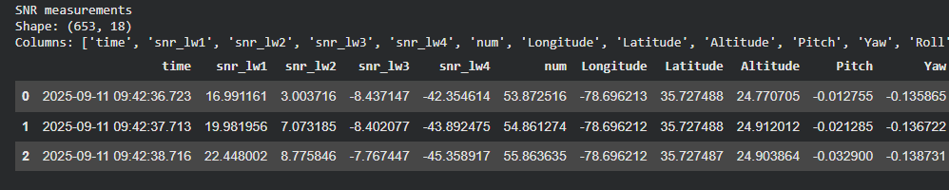
Figure 3.1: Output of the data loading step showing the shape, columns and first three rows of the three raw files.
3.3 Input Features and Prediction Targets
The model uses 16 input features and predicts 4 targets. The features describe the signal quality on each link and the physical state of the UAV; the targets are the download measurements of the four links.
Table 3.2: Input features and prediction targets
Group | Features | Description
Signal quality (4) | snr_lw1, snr_lw2, snr_lw3, snr_lw4 | SNR measured on each of the four wireless links
Position (3) | Longitude, Latitude, Altitude | UAV location and height
Attitude (3) | Pitch, Yaw, Roll | UAV orientation
Velocity (3) | VelocityX, VelocityY, VelocityZ | UAV speed along each axis
Health (3) | BatteryVolts, GPSFix, NumberOfSatellites | Battery voltage and GPS status
Targets (4) | dl_lw1, dl_lw2, dl_lw3, dl_lw4 | Download measurement of links 1 to 4, predicted jointly

3.4 Behaviour of the Download Targets
Table 3.3: Summary statistics of the four download targets
Target | Mean | Std | Min | Max | Zero readings (of 652)
dl_lw1 | 561.74 | 119.30 | 5.46 | 600.00 | 0
dl_lw2 | 459.34 | 239.03 | 0.00 | 600.00 | 83
dl_lw3 | 175.69 | 254.71 | 0.00 | 600.00 | 380
dl_lw4 | 11.55 | 10.36 | 0.00 | 21.66 | 200

Figure 3.2 plots the four targets against time together with the two dashed lines that mark the train/validation and validation/test boundaries. Four patterns are visible:
• Ramp, then plateau: each link climbs and then saturates near 600 (lw1 to lw3) or 21.7 (lw4).
• Staggered start: lw1 rises first, lw2 follows, and lw3 stays at zero until late in the training segment.
• Many zero readings: 83 (lw2), 380 (lw3) and 200 (lw4) of the 652 readings are exactly zero.
• Nearly flat end of flight: after the validation boundary most links are almost constant, which strongly affects the test results in Chapter 6.
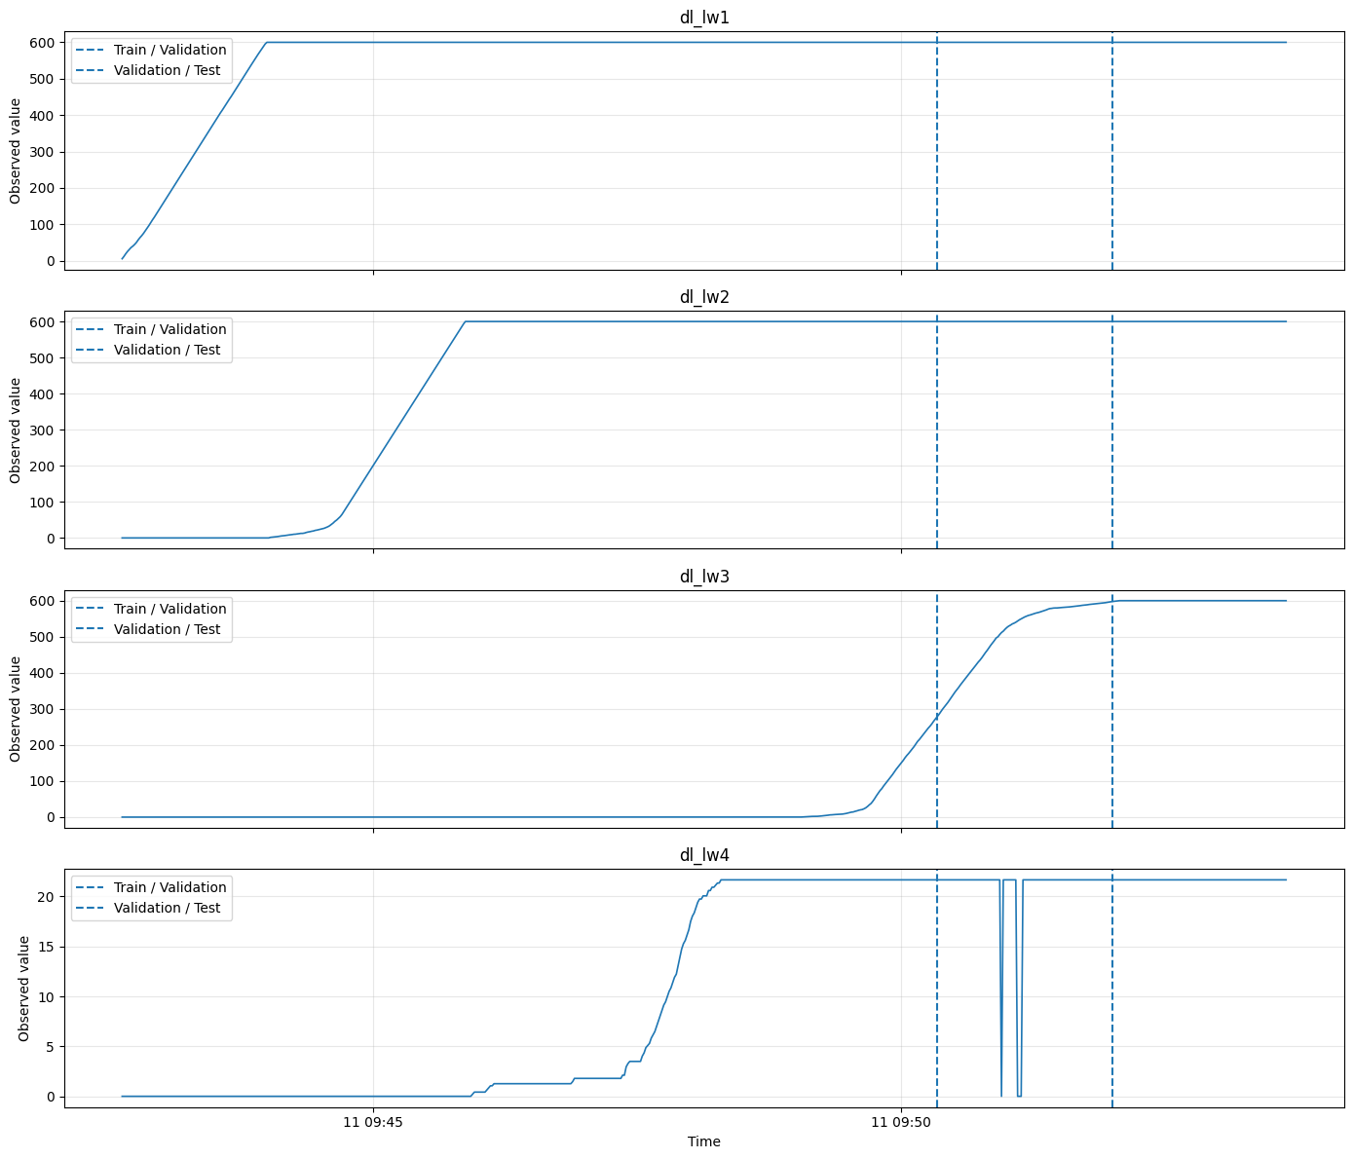
Figure 3.2: Observed download measurements of the four links over the flight with the train/validation and validation/test boundaries (dashed).
3.5 Feature Correlation Analysis
Figure 3.3 shows the correlation matrix of the 16 features and the 4 targets. The row and column of GPSFix are blank because GPSFix is constant (value 4) throughout the flight, so its correlation is undefined. The matrix shows that the SNR values, position and battery voltage are correlated with the download targets with both positive and negative signs, but no single feature explains a target, which motivates a non-linear model that uses all features together.
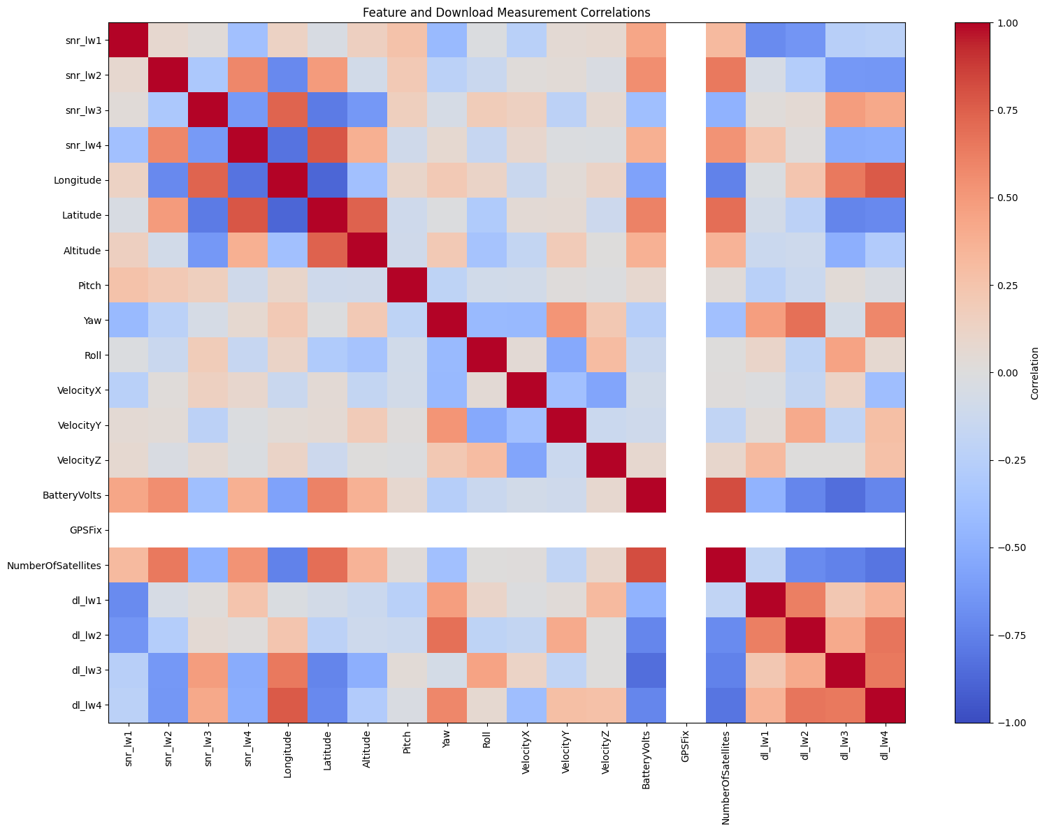
Figure 3.3: Correlation matrix of the input features and the four download targets.
CHAPTER - 4 PROPOSED METHODOLOGY
4.1 Overall System Workflow
The proposed digital twin follows a six-step pipeline. Everything is learned from the past and judged on the future: the scalers and the alert thresholds use earlier data only, and the test segment stays untouched until the final evaluation, so the results show how the twin would behave on new flight data.
1. Merge the data: SNR, download and telemetry files are matched by timestamp (within 2 s) giving a 652 x 22 table.
2. Split by time: the first 70% of samples are used for training, the next 15% for validation and the last 15% for testing, with no shuffling.
3. Scale features: StandardScaler is fitted on the training data only, for both inputs and targets.
4. Train models: a Random Forest baseline and the neural network FidelityNet are trained on the training segment.
5. Add uncertainty: dropout is kept ON and the network predicts 100 times; the mean is the answer and the standard deviation is the uncertainty.
6. Check the twin: the fidelity score, the persistence baseline and the mismatch alerts are computed from validation errors.
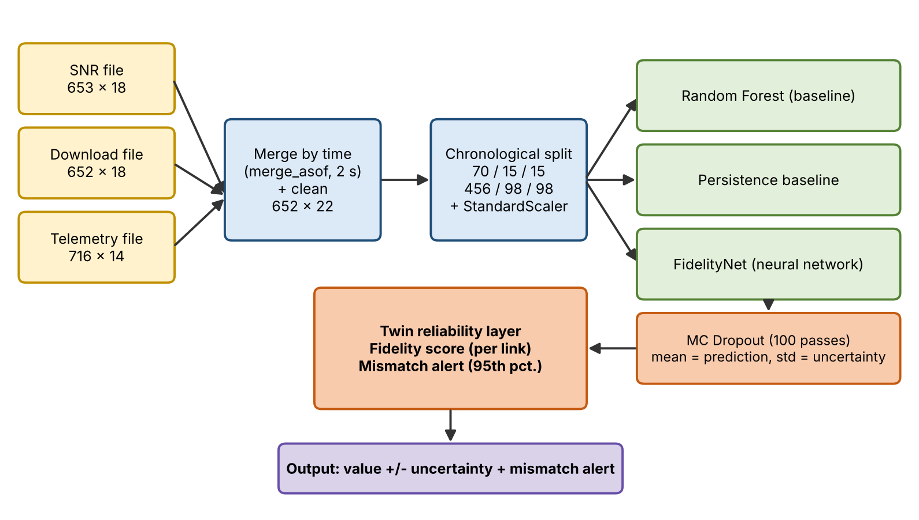
Figure 4.1: Overall workflow of the UAV communication digital twin.
4.2 Data Merging and Cleaning
The three files have slightly different timestamps, so a direct join on equal time stamps would lose most rows. The download file (652 rows) is used as the reference. The SNR values are attached using pandas merge_asof with direction='nearest' and a tolerance of 2 seconds; the telemetry record nearest in time is then attached in the same way. The second merge brings duplicate telemetry columns with the suffix _telemetry, which are dropped. Finally the records are sorted chronologically. The result is a 652 x 22 dataset with no missing values and no duplicate rows.
4.3 Chronological Train/Validation/Test Split
Because the target behaviour depends on time (ramp, plateau and staggered start), a random shuffle would put neighbouring samples from the future into the training set and give overly optimistic results. The data is therefore split strictly in time order.
Table 4.1: Chronological data split
Segment | Samples | Share | Time range (11 Sep 2025)
Training | 456 | 70% | 09:42:37.713 to 09:50:19.462
Validation | 98 | 15% | 09:50:20.470 to 09:51:58.957
Test | 98 | 15% | 09:51:59.978 to 09:53:38.546

4.4 Feature and Target Scaling
Features and targets have very different ranges (for example Longitude is about -78.7 while dl_lw1 reaches 600). Two StandardScaler objects, one for the 16 inputs and one for the 4 targets, are fitted on the training data only and then applied unchanged to the validation and test data. Fitting on the training segment alone avoids leaking information from later parts of the flight. Predictions of the network are converted back to the original download units with the inverse transform of the target scaler.
4.5 Baseline Models
Three reference methods are used to judge the neural network:
• Train-mean guess: predicts the mean of the training targets for every validation sample.
• Random Forest: RandomForestRegressor with 200 trees, maximum depth 12, minimum 2 samples per leaf and random seed 42, trained on the 456 training samples.
• Persistence baseline: predicts each sample using the immediately previous reading of the same link (a 'repeat the last value' forecast). It is very strong when the signal changes slowly.
4.6 FidelityNet Neural Network
FidelityNet is a small fully connected network that maps the 16 scaled inputs to the 4 scaled targets. It has two hidden layers of 64 and 32 neurons with ReLU activation, and a dropout layer with probability 0.2 after each hidden layer. The dropout provides regularisation during training and is reused at prediction time to obtain uncertainty. The network has 1,088 + 2,080 + 132 = 3,300 trainable parameters.
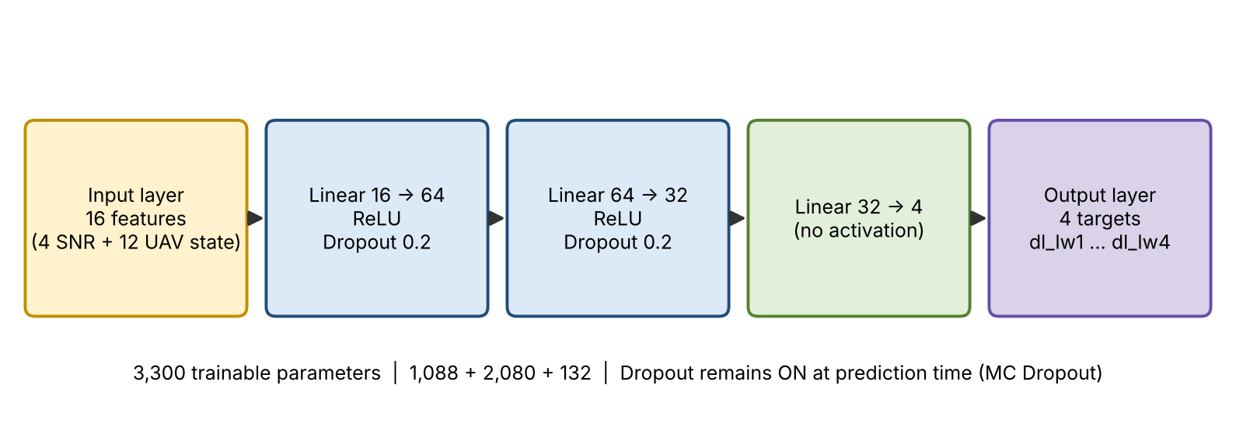
Figure 4.2: Architecture of the FidelityNet neural network.
Training minimises the mean squared error (MSE) on the standardised targets with the Adam optimiser (learning rate 0.001) for 200 full-batch epochs. At every epoch the validation loss is logged in evaluation mode so that the learning curves can be inspected.
4.7 Monte Carlo Dropout Uncertainty
A normal network gives one answer for an input. With Monte Carlo Dropout the dropout layers are kept active at prediction time, so every forward pass uses a slightly different sub-network. Repeating the prediction T = 100 times for the same input gives a set of answers. Their mean is used as the prediction and their standard deviation as the uncertainty. If the answers spread out the model is unsure; if they agree the model is confident. This follows the interpretation of dropout as an approximate Bayesian inference method [1].
ŷ = (1/T) Σ f(x; dropout mask t), σ = std over t = 1..T, T = 100
4.8 Fidelity Score and Mismatch Detection
Fidelity score. For each link the project computes a relative-error fidelity score from the validation MAE of the MC Dropout mean prediction:
Fidelity (%) = max(0, 1 − MAE / mean|actual|) × 100
A score of 100% means no error and a score of 0% means that the error is as large as the signal itself. This is a relative-error project metric and not a calibrated standard measure of fidelity.
Mismatch alert. For each link the absolute validation errors are collected and their 95th percentile is stored as the alert threshold. For every test sample the absolute error of the neural network is compared with this threshold; the sample is flagged as a twin-reality mismatch when the error exceeds it.
threshold = 95th percentile of |actual − predicted| on validation data; flag = (test error > threshold)
Because the threshold is learned from validation data only, no information from the test segment is used to set it.
CHAPTER - 5 IMPLEMENTATION DETAILS
5.1 Step-by-Step Notebook Workflow
The complete implementation is a single Jupyter notebook (ML_PROJECT_CLEANED_READY.ipynb) executed on Google Colab. The main stages and the notebook cells that implement them are listed below.
Table 5.1: Implementation steps and corresponding notebook cells
Step | Task | Output
1 | Import libraries and print versions (Cell 1) | NumPy 2.1.3, Pandas 2.2.3, PyTorch 2.11.0+cpu, no GPU
2 | Mount Google Drive and load the three CSV files (Cells 2-3) | Shapes 653x18, 652x18, 716x14
3 | Timestamp and target quality checks (Cell 4) | No missing/duplicate timestamps; zero counts per link
4 | Merge by time and drop duplicate columns (Cells 5-6) | Merged dataset 652 x 22
5 | Define features and targets (Cell 7) | 16 inputs, 4 targets
6 | Chronological split (Cell 8) | 456 / 98 / 98 samples
7 | Random Forest and train-mean baselines (Cells 9, 12) | Baseline MAE / RMSE per link
8 | Target and correlation plots (Cells 10-11) | Figures 3.2 and 3.3
9 | Scale data and build tensors (Cell 13) | 456x16 and 98x16 tensors
10 | Define and train FidelityNet (Cells 14-16) | 3,300 parameters; learning curves
11 | Neural network and MC Dropout validation (Cells 17-20) | MAE, RMSE and mean sigma per link
12 | Fidelity scores (Cells 21-22) | Per-link fidelity percentage
13 | Distribution-shift diagnosis (Cells 23-27) | Train vs validation statistics and plots
14 | Persistence baseline (Cells 28-29) | Validation persistence MAE
15 | Untouched test evaluation (Cells 30-31, 34-37) | NN vs persistence on the test set
16 | Mismatch thresholds and alerts (Cells 32-33) | Flag counts per link

5.2 Environment Setup and Data Loading
The notebook starts by importing NumPy, Pandas, Matplotlib, scikit-learn and PyTorch and printing their versions. The runtime used NumPy 2.1.3, Pandas 2.2.3 and PyTorch 2.11.0 (CPU build); no GPU was available. Google Drive is then mounted and the three CSV files are loaded.
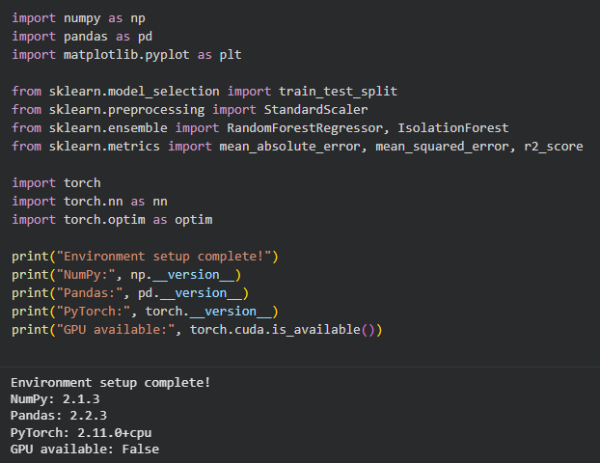
Figure 5.1: Environment setup in Google Colab showing library versions and Google Drive mounted.

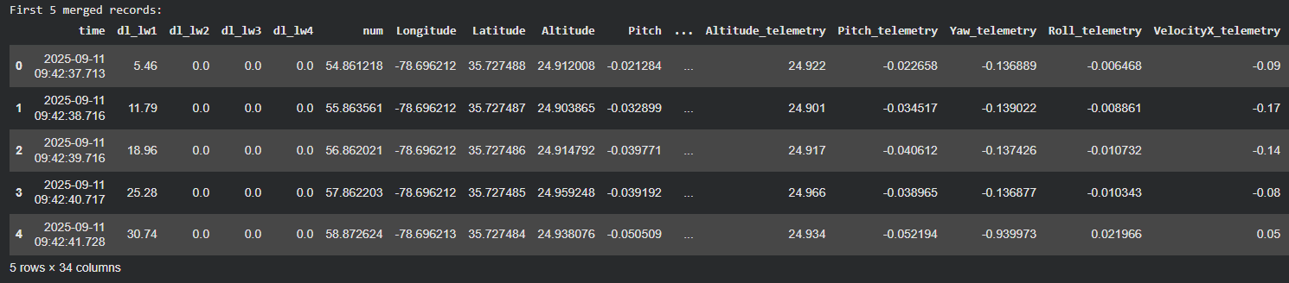Figure 5.2: Merged and cleaned dataset (652 rows x 22 columns).
5.3 Training Hyperparameters
Table 5.2: Model and training hyperparameters
Hyperparameter | Value | Purpose
Architecture | 16 → 64 → 32 → 4 (ReLU) | Small network suitable for 456 training samples
Regularisation | Dropout 0.2 after each hidden layer | Reduces overfitting and enables MC Dropout
Trainable parameters | 3,300 | Lightweight model
Loss function | MSE on standardised targets | Joint regression of 4 links
Optimiser | Adam, learning rate 0.001 | Stable gradient updates
Training epochs | 200 (full batch, 456 samples) | Complete training run
Scaling | StandardScaler on X and y, fitted on training data | Avoids data leakage
MC Dropout passes | 100 | Mean = prediction, std = uncertainty
Random Forest | 200 trees, max depth 12, min leaf 2, seed 42 | Classical baseline
Mismatch threshold | 95th percentile of validation absolute error | Alert rule for the twin
Compute | Google Colab CPU runtime | No GPU needed

Each training epoch consists of three stages: (1) a forward pass of the 456 x 16 training tensor with dropout on and computation of the MSE loss; (2) back-propagation and an Adam update of all 3,300 weights; (3) a validation pass in evaluation mode to log the validation loss.

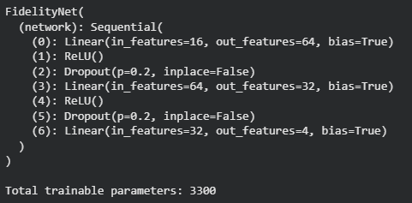
Figure 5.3: FidelityNet model summary and trainable parameter count.
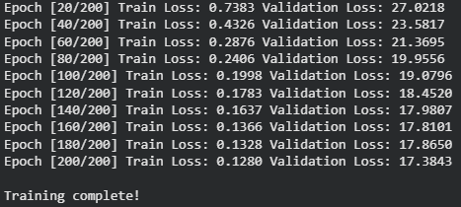
Figure 5.4: Training log of FidelityNet over 200 epochs.
5.4 Key Code Listings
Merging and splitting the data
communication_df = pd.merge_asof(download_sorted, snr_sorted[[...]],
on="time", direction="nearest", tolerance=pd.Timedelta("2s"))
communication_df = pd.merge_asof(communication_df, telemetry_sorted[telemetry_cols],
on="time", direction="nearest", tolerance=pd.Timedelta("2s"))

X = communication_df[feature_cols]; y = communication_df[target_cols]
train_end = int(n * 0.70); val_end = int(n * 0.85) # chronological split
X_train, y_train = X.iloc[:train_end], y.iloc[:train_end]
X_val, y_val = X.iloc[train_end:val_end], y.iloc[train_end:val_end]
X_test, y_test = X.iloc[val_end:], y.iloc[val_end:]

scaler_X = StandardScaler(); X_train_scaled = scaler_X.fit_transform(X_train)

FidelityNet model and training loop
class FidelityNet(nn.Module):
def __init__(self, input_size=16, output_size=4):
super().__init__()
self.network = nn.Sequential(
nn.Linear(input_size, 64), nn.ReLU(), nn.Dropout(0.2),
nn.Linear(64, 32), nn.ReLU(), nn.Dropout(0.2),
nn.Linear(32, output_size))
def forward(self, x): return self.network(x)

criterion = nn.MSELoss()
optimizer = optim.Adam(model.parameters(), lr=0.001)
for epoch in range(200):
model.train(); optimizer.zero_grad()
loss = criterion(model(X_train_tensor), y_train_tensor)
loss.backward(); optimizer.step()

Monte Carlo Dropout, fidelity score and mismatch rule
model.train() # keep dropout ON during prediction
mc_predictions = []
with torch.no_grad():
for _ in range(100):
pred = model(X_val_tensor).numpy()
mc_predictions.append(scaler_y.inverse_transform(pred))
mc_mean = np.array(mc_predictions).mean(axis=0) # prediction
mc_std = np.array(mc_predictions).std(axis=0) # uncertainty

fidelity = max(0, 1 - mae / np.mean(np.abs(actual))) * 100

val_errors = np.abs(val_actual - val_pred)
threshold = np.percentile(val_errors, 95) # learned on validation only
mismatch_flags = test_errors > threshold

CHAPTER - 6 RESULTS & VISUAL ANALYSIS
6.1 Random Forest Baseline
The Random Forest was trained on the 456 training samples and evaluated on the 98 validation samples. R² is not meaningful here because several validation targets are almost constant (R² is zero or negative), so MAE and RMSE in the original download units are used.
Table 6.1: Random Forest versus train-mean guess on validation data
Link | RF MAE | RF RMSE | Train-mean MAE | Train-mean RMSE
dl_lw1 | 73.815 | 138.265 | 54.704 | 54.704
dl_lw2 | 114.705 | 214.562 | 201.115 | 201.115
dl_lw3 | 428.039 | 468.400 | 492.431 | 501.734
dl_lw4 | 5.780 | 8.803 | 13.988 | 14.054

The Random Forest beats the train-mean guess on lw2 (114.7 vs 201.1), lw3 (428.0 vs 492.4) and lw4 (5.8 vs 14.0), but loses on dl_lw1 (73.8 vs 54.7). On dl_lw3 it misses by 428, which is the first sign of distribution shift between training and validation data.
6.2 Neural Network Training Progress
The training loss falls from 0.738 at epoch 20 to 0.128 at epoch 200, so the network fits the early part of the flight well. The validation loss falls only from 27.02 to 17.38 and remains about 130 times higher than the training loss. This large gap indicates that the later segment of the flight behaves differently from what the network learned, which motivates the distribution-shift analysis in Section 6.5.
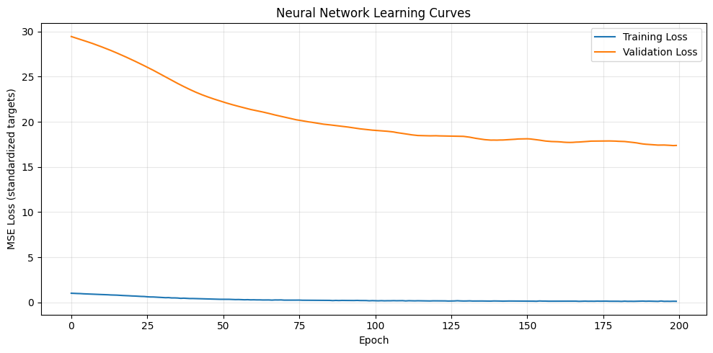
Figure 6.1: Neural network learning curves (training and validation MSE loss on standardised targets).
6.3 MC Dropout Validation Results
Table 6.2: Validation MAE of all models and mean MC Dropout uncertainty
Link | RF MAE | NN MAE | MC Dropout MAE | Mean σ (uncertainty)
dl_lw1 | 73.815 | 12.092 | 16.251 | 33.296
dl_lw2 | 114.705 | 38.806 | 42.480 | 64.520
dl_lw3 | 428.039 | 372.602 | 374.042 | 29.677
dl_lw4 | 5.780 | 3.801 | 3.659 | 3.224

• Neural network beats Random Forest: on all four links; for example dl_lw1 falls from 73.8 to 12.1 (about 6 times lower) and dl_lw2 from 114.7 to 38.8 (about 3 times lower).
• Cost of uncertainty: the MC mean is slightly less accurate than one deterministic pass on lw1 to lw3, but it provides a sigma with every prediction. On dl_lw4 the MC mean (3.66) is slightly better than the single pass (3.80).
• dl_lw3 fails: its MAE is 374 for every neural model.
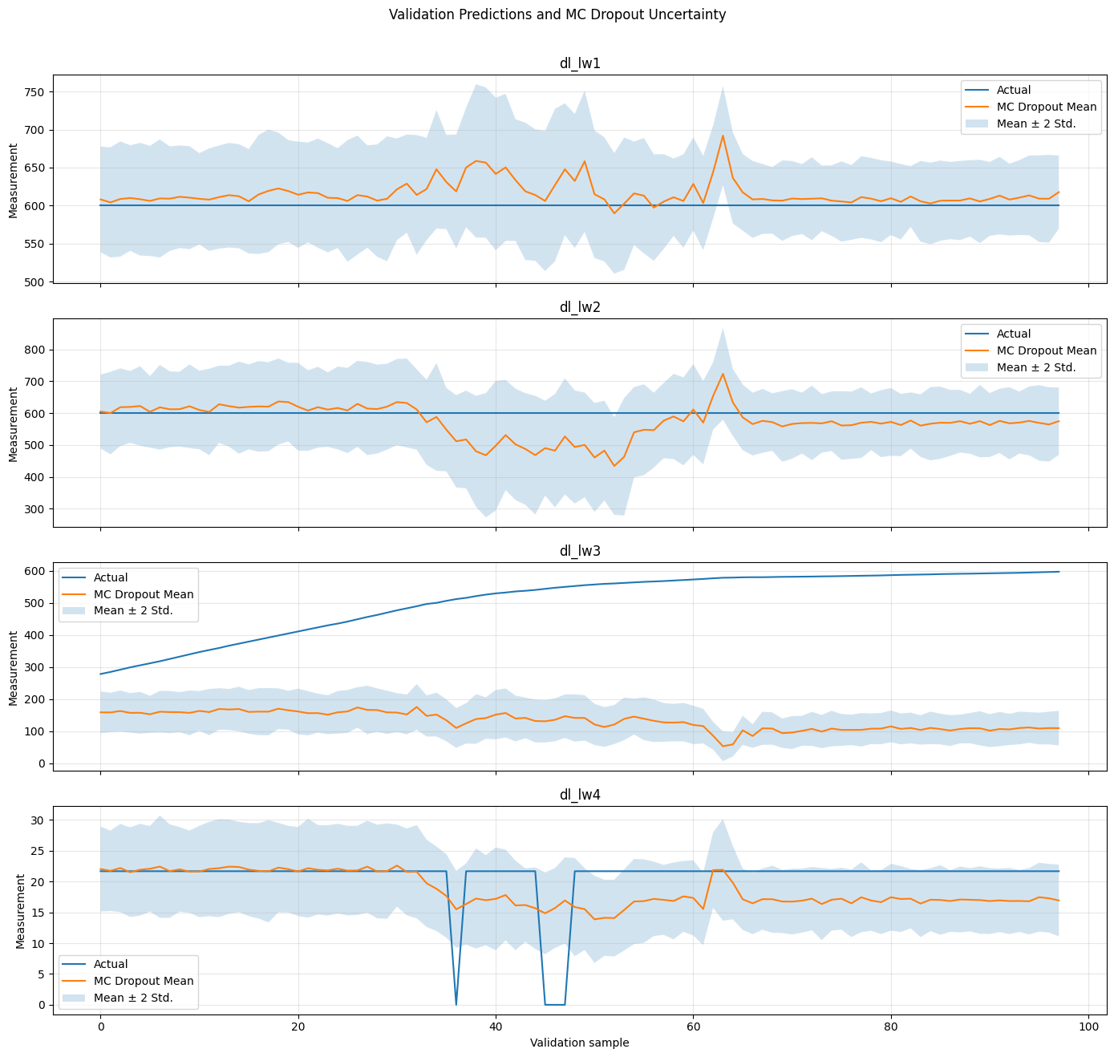
Figure 6.2: Validation predictions with the MC Dropout mean and the ±2 standard deviation uncertainty band for the four links.
In Figure 6.2 the band is wide on dl_lw1 and dl_lw2 and covers the actual value, which shows cautious uncertainty. On dl_lw3 the actual value rises from about 280 to 600 while the prediction stays near 100 to 170 inside a narrow band, so the model is wrong and unaware of it.
6.4 Fidelity Scores
Table 6.3: Validation fidelity score per link
Link | MAE | Mean |actual| | Fidelity score
dl_lw1 | 16.251 | 600.000 | 97.3%
dl_lw2 | 42.480 | 600.000 | 92.9%
dl_lw3 | 374.042 | 505.966 | 26.1%
dl_lw4 | 3.659 | 20.776 | 82.4%

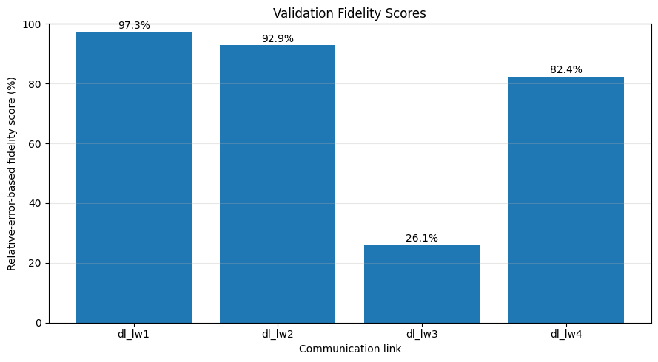
Figure 6.3: Relative-error-based fidelity score of each link on the validation data.
The twin is highly faithful on dl_lw1 (97.3%), dl_lw2 (92.9%) and dl_lw4 (82.4%), but only 26.1% faithful on dl_lw3, where the predictions miss badly.
6.5 Distribution Shift Analysis of dl_lw3
To explain the failure on dl_lw3 the training and validation distributions were compared. In the training segment 83.3% of dl_lw3 readings are exactly zero, the mean is 13.5 and the maximum is 272.1. In the validation segment there are no zeros, the mean is 506 and the values range from 278.5 to 596.9. The network was therefore trained on a mostly-zero link and then tested on a link at high throughput; since a model can only predict what it has seen, the error is structural and not random.
Table 6.4: Target distribution in training and validation segments
Link | Train mean | Val mean | Train zero % | Val zero % | Train max | Val min
dl_lw1 | 545.30 | 600.00 | 0.00 | 0.00 | 600.00 | 600.00
dl_lw2 | 398.89 | 600.00 | 18.20 | 0.00 | 600.00 | 600.00
dl_lw3 | 13.54 | 505.97 | 83.33 | 0.00 | 272.13 | 278.46
dl_lw4 | 7.39 | 20.78 | 42.98 | 4.08 | 21.66 | 0.00

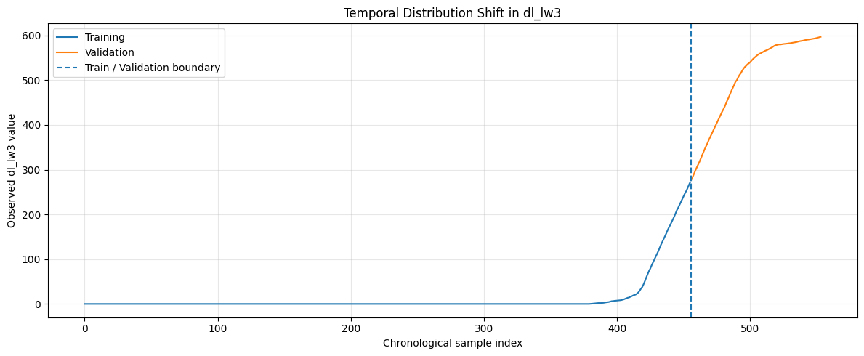
Figure 6.4: Temporal distribution shift in dl_lw3 (training versus validation with the boundary line).
The input features also shifted between the two segments, as shown by their means and standard deviations in Table 6.5 and by the SNR histograms in Figure 6.5. For example the mean altitude drops from 38.33 to 24.99 and its standard deviation collapses from 13.7 to 0.05, snr_lw3 moves from -9.80 to +9.23, snr_lw4 from -24.05 to -42.53 and VelocityY from 0.82 to -1.96.
Table 6.5: Input feature statistics in training and validation segments
Feature | Train mean | Val mean | Train std | Val std
snr_lw1 | 3.546 | -2.048 | 10.496 | 3.543
snr_lw2 | 9.755 | -2.912 | 9.988 | 4.544
snr_lw3 | -9.795 | 9.234 | 14.288 | 9.490
snr_lw4 | -24.053 | -42.526 | 17.997 | 1.721
Longitude | -78.698 | -78.693 | 0.003 | 0.001
Latitude | 35.728 | 35.725 | 0.002 | 0.000
Altitude | 38.330 | 24.993 | 13.695 | 0.051
Pitch | -0.041 | -0.038 | 0.089 | 0.074
Yaw | -0.126 | -0.098 | 1.926 | 1.332
Roll | -0.011 | 0.005 | 0.023 | 0.023
VelocityX | -0.641 | 0.122 | 3.859 | 0.164
VelocityY | 0.817 | -1.961 | 4.261 | 3.838
VelocityZ | -0.006 | -0.005 | 0.502 | 0.048
BatteryVolts | 46.593 | 45.965 | 0.265 | 0.127
GPSFix | 4.000 | 4.000 | 0.000 | 0.000
NumberOfSatellites | 27.186 | 26.000 | 0.651 | 0.000

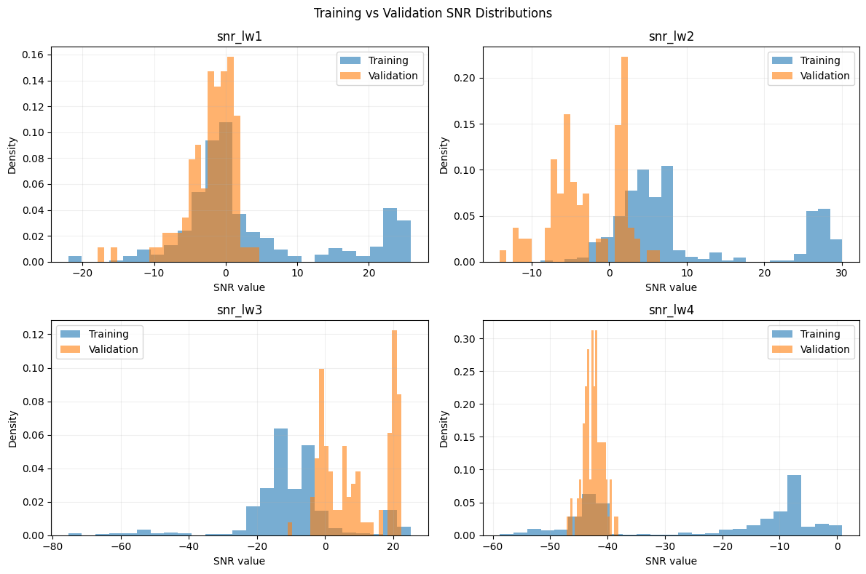
Figure 6.5: Training versus validation SNR distributions for the four links.
6.6 Uncertainty versus Actual Error
The ratio of the mean predictive standard deviation to the actual MAE tells whether the uncertainty is realistic. A ratio above 1 means the model is cautious, a ratio near 1 means it is well matched, and a ratio far below 1 means it is overconfident.
Table 6.6: Uncertainty compared with actual error
Link | Mean σ | MC MAE | σ ÷ MAE | Interpretation
dl_lw1 | 33.3 | 16.3 | 2.0× | Cautious
dl_lw2 | 64.5 | 42.5 | 1.5× | Cautious
dl_lw3 | 29.7 | 374.0 | 0.08× | Overconfident
dl_lw4 | 3.22 | 3.66 | 0.88× | Well matched

On dl_lw3 the uncertainty (σ ≈ 29.7) is more than 12 times smaller than the real error (MAE ≈ 374), so the twin is confidently wrong. MC Dropout alone therefore cannot warn about a distribution shift; an additional mismatch check and out-of-distribution detection are needed.
6.7 Persistence Baseline and Untouched Test Set
On the validation data the persistence baseline gives MAE 0.000 for lw1 and lw2, 3.314 for lw3 and 0.884 for lw4, far lower than the MC Dropout network (16.251, 42.480, 374.042 and 3.659).
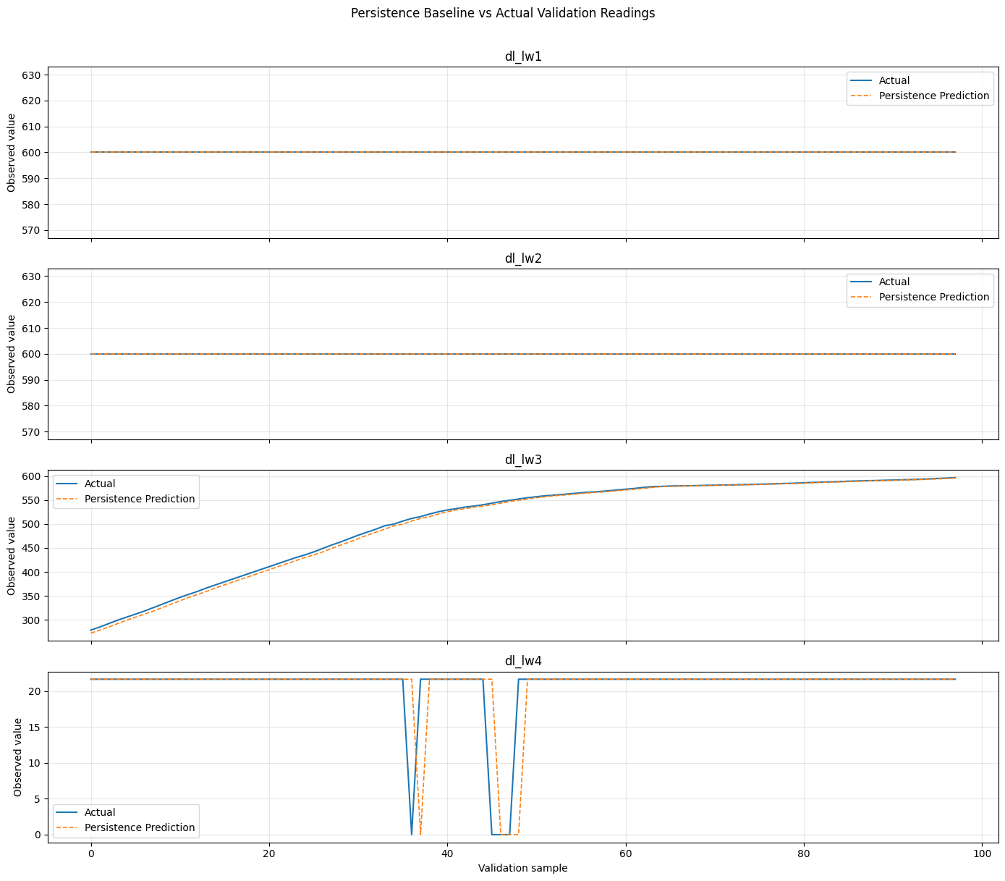
Figure 6.6: Persistence baseline versus actual validation readings.
The last 15% of the flight (98 samples) was kept untouched until the final evaluation. Figure 6.7 compares the actual values, the persistence prediction and the neural network prediction on this test set.
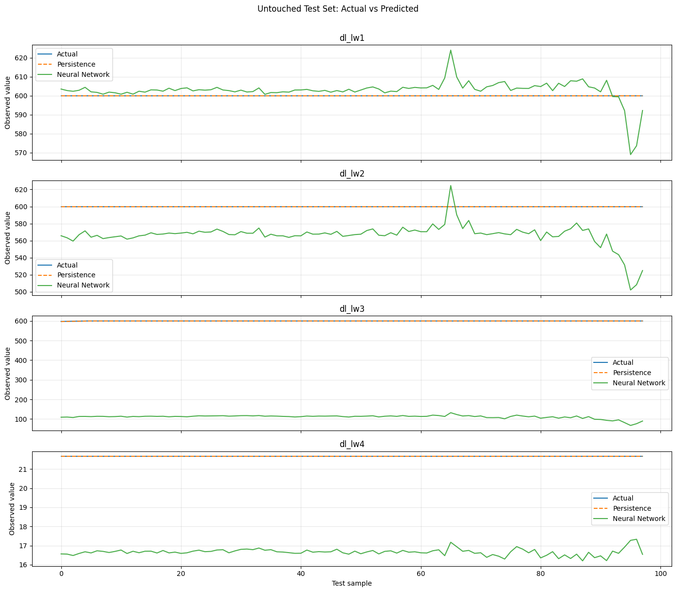
Figure 6.7: Untouched test set: actual values, persistence prediction and neural network prediction.
Table 6.7: Test-set comparison of the neural network and persistence
Link | NN MAE | NN RMSE | Persistence MAE | Persistence RMSE | Better
dl_lw1 | 4.366 | 6.309 | 0.000 | 0.000 | Persistence
dl_lw2 | 33.869 | 35.953 | 0.000 | 0.000 | Persistence
dl_lw3 | 488.849 | 488.930 | 0.032 | 0.145 | Persistence
dl_lw4 | 5.000 | 5.003 | 0.000 | 0.000 | Persistence
Overall | 133.021 | 245.158 | 0.008 | 0.072 | Persistence

Table 6.8: Variability of the test targets
Link | Unique values | Mean | Std | Min | Max | Range
dl_lw1 | 1 | 600.000 | 0.000 | 600.00 | 600.00 | 0.0
dl_lw2 | 1 | 600.000 | 0.000 | 600.00 | 600.00 | 0.0
dl_lw3 | 5 | 599.939 | 0.322 | 597.70 | 600.00 | 2.3
dl_lw4 | 1 | 21.660 | 0.000 | 21.66 | 21.66 | 0.0

The test targets barely move: lw1, lw2 and lw4 are constant and lw3 spans only 2.3. Repeating the last reading is therefore almost perfect (overall MAE 0.008 against 133.0 for the neural network). This reflects the nature of this flight segment and does not show that persistence is generally the better model; it should be re-evaluated on flights where the throughput varies. Figure 6.8 shows the absolute test error of the neural network over time.
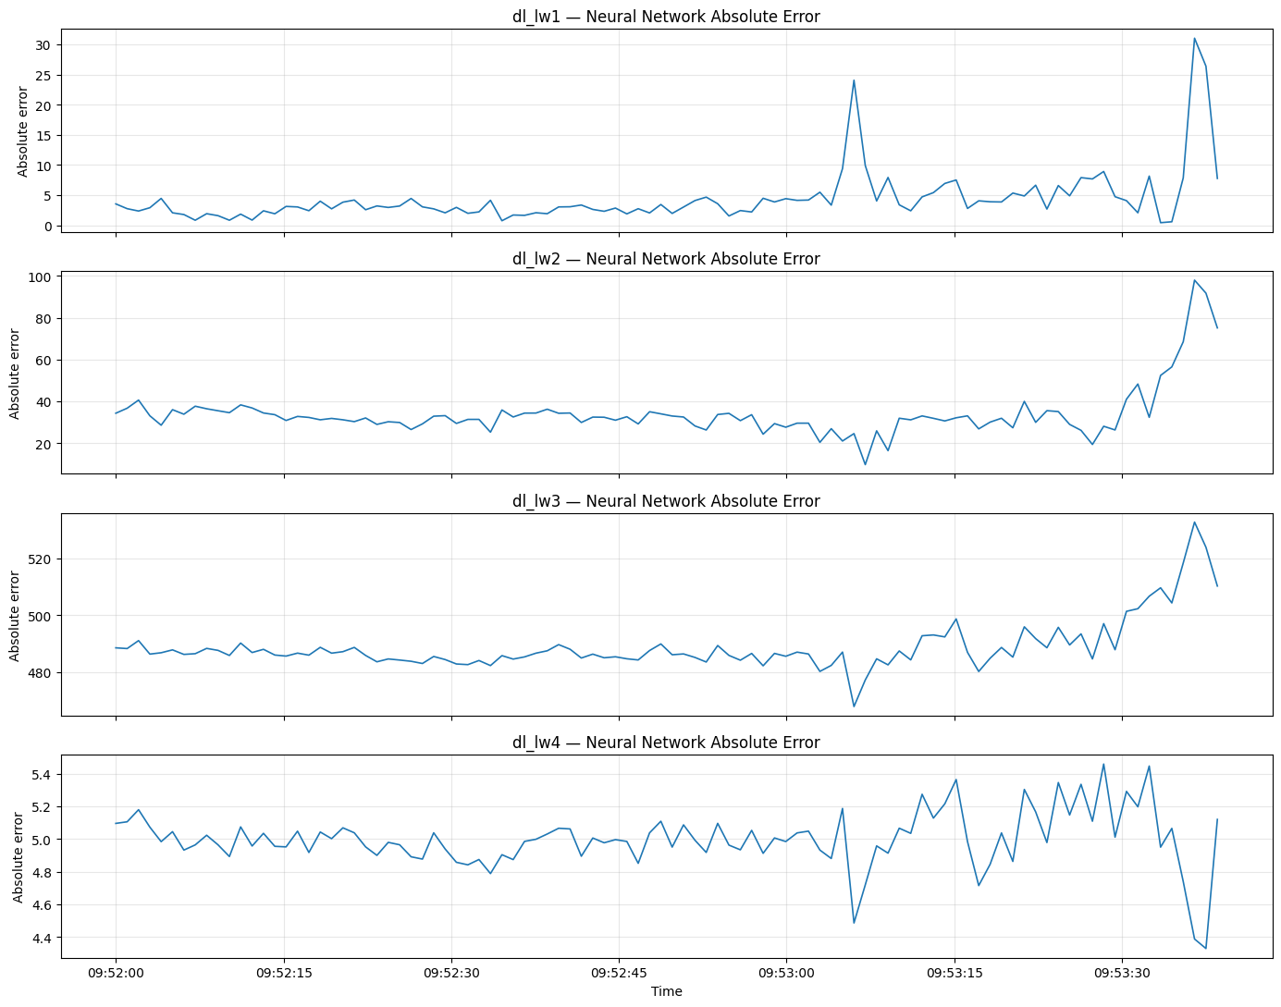
Figure 6.8: Absolute prediction error of the neural network on the test set over time.
6.8 Digital Twin Mismatch Detection
Table 6.9: Mismatch thresholds (from validation errors) and test alerts
Link | 95th percentile threshold | Flagged samples | Flagged (%)
dl_lw1 | 50.105 | 0 / 98 | 0.0%
dl_lw2 | 124.740 | 0 / 98 | 0.0%
dl_lw3 | 487.914 | 33 / 98 | 33.7%
dl_lw4 | 7.630 | 0 / 98 | 0.0%

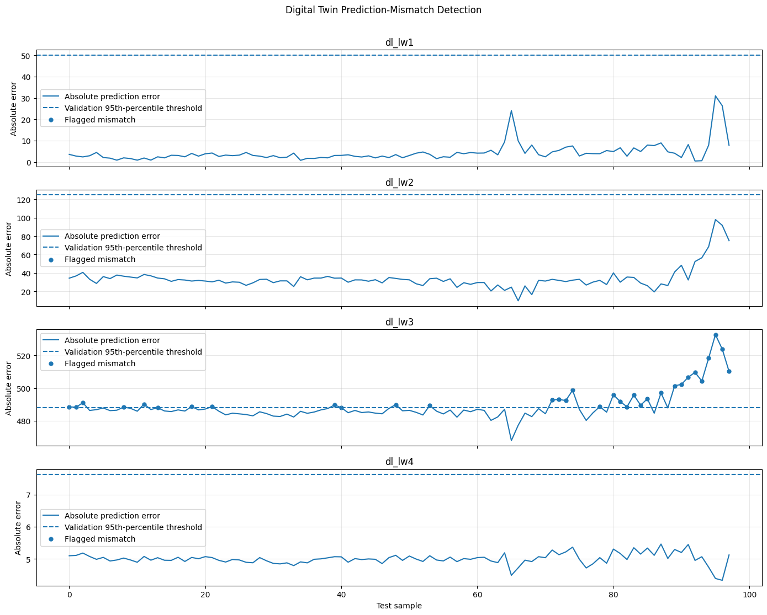
Figure 6.9: Test error against the validation-based threshold with flagged mismatch points.
Alerts fire only on dl_lw3 (33 of 98 samples), the link the model could not predict, and there are no false alarms on dl_lw1, dl_lw2 and dl_lw4. A limitation is that the dl_lw3 test error is about 489 on almost every sample, but the threshold of 487.9 was learned from already-large validation errors, so only about one third of these samples trigger the alert.
6.9 Consolidated Summary
Table 6.10: Final digital twin evaluation summary
Link | Val. fidelity | NN test MAE | Persistence test MAE | Mismatch alerts
dl_lw1 | 97.3% | 4.366 | 0.000 | 0 / 98
dl_lw2 | 92.9% | 33.869 | 0.000 | 0 / 98
dl_lw3 | 26.1% | 488.849 | 0.032 | 33 / 98
dl_lw4 | 82.4% | 5.000 | 0.000 | 0 / 98

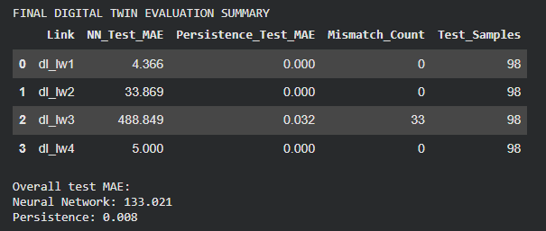
Figure 6.10: Final digital twin evaluation summary printed by the notebook.
• Best learned model per link (validation MAE): dl_lw1 neural network 12.1, dl_lw2 neural network 38.8, dl_lw3 neural network 372.6 and dl_lw4 MC Dropout 3.7.
• Value of the twin: its main contribution is not raw accuracy but the uncertainty estimate, the fidelity score and the mismatch alert that tell when a prediction should not be trusted.
CHAPTER - 7 CHALLENGES & LIMITATIONS
7.1 Single Short Flight Recording
All results come from one flight of about 11 minutes with 652 samples. The model cannot learn the behaviour of conditions that never occur in this recording, and conclusions about general performance cannot be drawn. The evaluation note in the notebook states this explicitly: the results are evidence for this recorded flight segment and not proof of performance on other flights.
7.2 Distribution Shift and Near-Constant Test Set
The links start at zero and ramp up at different times, so the training segment is very different from the later segments. This produced the large failure on dl_lw3 (training 83.3% zeros, validation mean 506). The test segment is almost constant, so the persistence baseline is nearly perfect there and the neural network cannot beat it; a fair comparison needs segments where the throughput varies.
7.3 Overconfident Uncertainty and Alert Rule
• Overconfidence: MC Dropout reports small uncertainty on dl_lw3 (σ ≈ 29.7) while the actual error is about 374. The uncertainty is not calibrated.
• Alert threshold: the 95th-percentile rule learned on an already-shifted validation segment is too lenient for dl_lw3, so only 33.7% of test samples are flagged.
• Different predictors: the validation errors that set the threshold use the MC Dropout mean, whereas the test errors use a single deterministic pass of the network; using the same predictor for both would make the rule more consistent.
7.4 Scope of the Fidelity Score
The fidelity score used here, max(0, 1 − MAE / mean|actual|) × 100, is a simple relative-error project metric. It is not a standard calibrated measure and does not yet combine uncertainty, mismatch and out-of-distribution evidence into the full calibrated Twin-Fidelity Score described in the project abstract. The Streamlit dashboard for the end-to-end demonstration is also still to be built.
CHAPTER - 8 CONCLUSION & FUTURE WORK
8.1 Summary of the Project
This project built a UAV 5G communication digital twin that merges SNR, download and telemetry measurements of a real flight and predicts the download throughput of four wireless links with Monte Carlo Dropout uncertainty. The main findings are:
1. Digital twin built: three raw files were merged and cleaned into a 652 x 22 dataset and split chronologically into 456, 98 and 98 samples without leakage.
2. Neural network beats Random Forest: FidelityNet had lower validation MAE than Random Forest on all four links, with fidelity of 97.3% on dl_lw1, 92.9% on dl_lw2 and 82.4% on dl_lw4, but only 26.1% on dl_lw3.
3. Distribution shift exposed: dl_lw3 was 83.3% zeros in training and at least 278 in validation; the input features shifted as well. The persistence baseline wins on the almost constant test segment, so the results are flight-specific.
4. The twin knows when it fails: mismatch alerts flagged dl_lw3 (33 of 98 test samples, 33.7%) and stayed silent on the other three links.
Overall, the project moves from UAV measurements to a twin that reports not only a prediction but also how far that prediction can be trusted.
8.2 Skills & Learnings Acquired
• Data engineering: aligning multi-source time series with merge_asof and validating timestamps, missing values and duplicates.
• Leakage-free machine learning: chronological splitting, fitting scalers and thresholds on earlier data only.
• Deep learning with PyTorch: building, training and evaluating a small regression network and reading learning curves.
• Uncertainty estimation: using MC Dropout and interpreting the ratio of uncertainty to actual error.
• Critical evaluation: using baselines such as Random Forest, train-mean and persistence, diagnosing distribution shift and reporting limitations honestly.
8.3 Future Enhancements
• More flights: train and test on several flights and on segments where the throughput varies, not on one 11-minute recording.
• Reduce the dl_lw3 shift: collect more varied training data so that every link is seen at low and high throughput.
• Calibrated uncertainty: calibrate the uncertainty estimates and compare MC Dropout with Bayesian Neural Networks and Deep Ensembles [2], [3].
• Out-of-distribution detection: add an OOD detector on the input features so that shifted conditions are flagged even when the uncertainty is small.
• Twin-Fidelity Score: combine uncertainty, mismatch and OOD evidence into a single calibrated Twin-Fidelity Score as proposed in the project abstract.
• Streamlit dashboard: build the interactive dashboard and a final end-to-end demonstration.
CHAPTER - 9 REFERENCES
[1] Y. Gal and Z. Ghahramani, ‘Dropout as a Bayesian Approximation: Representing Model Uncertainty in Deep Learning,’ Proceedings of the 33rd International Conference on Machine Learning (ICML), PMLR vol. 48, pp. 1050–1059, 2016.
[2] B. Lakshminarayanan, A. Pritzel, and C. Blundell, ‘Simple and Scalable Predictive Uncertainty Estimation using Deep Ensembles,’ Advances in Neural Information Processing Systems (NeurIPS), vol. 30, 2017.
[3] C. Blundell, J. Cornebise, K. Kavukcuoglu, and D. Wierstra, ‘Weight Uncertainty in Neural Networks,’ Proceedings of the 32nd International Conference on Machine Learning (ICML), PMLR vol. 37, pp. 1613–1622, 2015.
[4] C. Guo, G. Pleiss, Y. Sun, and K. Q. Weinberger, ‘On Calibration of Modern Neural Networks,’ Proceedings of the 34th International Conference on Machine Learning (ICML), PMLR vol. 70, pp. 1321–1330, 2017.
[5] Y. Ovadia et al., ‘Can You Trust Your Model’s Uncertainty? Evaluating Predictive Uncertainty Under Dataset Shift,’ Advances in Neural Information Processing Systems (NeurIPS), vol. 32, 2019.
[6] N. Srivastava, G. Hinton, A. Krizhevsky, I. Sutskever, and R. Salakhutdinov, ‘Dropout: A Simple Way to Prevent Neural Networks from Overfitting,’ Journal of Machine Learning Research, vol. 15, no. 56, pp. 1929–1958, 2014.
[7] D. P. Kingma and J. Ba, ‘Adam: A Method for Stochastic Optimization,’ International Conference on Learning Representations (ICLR), arXiv:1412.6980, 2015.
[8] L. Breiman, ‘Random Forests,’ Machine Learning, vol. 45, no. 1, pp. 5–32, 2001.
[9] M. Grieves and J. Vickers, ‘Digital Twin: Mitigating Unpredictable, Undesirable Emergent Behavior in Complex Systems,’ in Transdisciplinary Perspectives on Complex Systems, Springer, pp. 85–113, 2017.
[10] M. Mozaffari, W. Saad, M. Bennis, Y. H. Nam, and M. Debbah, ‘A Tutorial on UAVs for Wireless Networks: Applications, Challenges, and Open Problems,’ IEEE Communications Surveys & Tutorials, vol. 21, no. 3, pp. 2334–2360, 2019.
[11] Y. Zeng, R. Zhang, and T. J. Lim, ‘Wireless communications with unmanned aerial vehicles: opportunities and challenges,’ IEEE Communications Magazine, vol. 54, no. 5, pp. 36–42, 2016.
[12] A. Paszke et al., ‘PyTorch: An Imperative Style, High-Performance Deep Learning Library,’ Advances in Neural Information Processing Systems (NeurIPS), vol. 32, 2019.
[13] F. Pedregosa et al., ‘Scikit-learn: Machine Learning in Python,’ Journal of Machine Learning Research, vol. 12, pp. 2825–2830, 2011.
[14] C. R. Harris et al., ‘Array programming with NumPy,’ Nature, vol. 585, pp. 357–362, 2020.
[15] J. D. Hunter, ‘Matplotlib: A 2D Graphics Environment,’ Computing in Science & Engineering, vol. 9, no. 3, pp. 90–95, 2007.

