CareerOps Login Pipeline — Complete Reference
Sign-in page for returning users. Supports email/password and Google OAuth, optional Remember Me, and a built-in jumbled word CAPTCHA below the password field (no Google reCAPTCHA iframe on the email form). Guests only; authenticated users are redirected into the app. Shows a session-expired banner when redirected from a silent refresh failure.

1. Architecture Overview
The login stack spans four layers: React UI (Login.tsx + AuthContext), Axios HTTP client with CSRF and silent refresh, Express middleware BFF (cookie issuance + validation + HMAC proxy), and Spring Boot backend (AuthService, WordCaptchaService, TwoFactorService, GoogleOAuthService, JwtService).

1.1 Auth stack layers
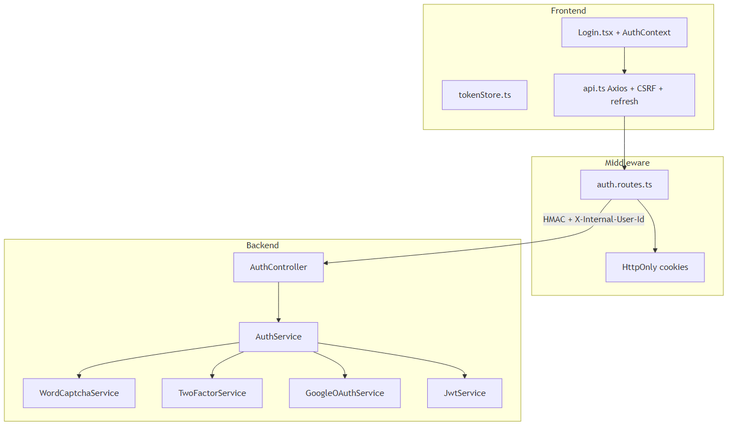
Frontend → Middleware BFF → Java backend with HMAC trust boundary

2. Route and Access Control
Property | Value
URL | /login
Guard | GuestRoute
Layout | Standalone (LoginPageShell + AuthIntelligencePanel right panel)
Redirects (logged-in) | onboarded → /dashboard or state.from path; not onboarded → /onboarding

2.1 Query parameters
Param | Effect
?reason=session_expired | Shows banner: Your session expired. Please sign in again.
?email= | Prefills email field; stripped from URL via history.replaceState

2.2 GuestRoute redirect logic
- While AuthContext.loading is true, shows PageLoader.
- If user is already authenticated, Navigate to loginRedirectTarget(user, from).
- safeRedirectPath rejects open redirects and auth-loop paths (/login, /signup, etc.).
- Default: onboarded users → /dashboard; non-onboarded → /onboarding.

3. Fields and Inputs
Field order on the form: Email → Password → Security check → Remember me → Submit.
Field | Required | Validation | When shown
Email | Yes | HTML5 type=email, trimmed on submit | Always
Password | Yes | Client min length 8 + server enforcement | Always
Security check | Yes (prod/staging) | Jumbled 5 chars; case-insensitive; captchaToken = challengeId:answer | When LOGIN_WORD_CAPTCHA_REQUIRED
Remember me | No | Passed to signIn as rememberMe: true | Always

3.1 Security check (Word CAPTCHA) UX
- On mount, WordCaptchaField fetches GET /auth/captcha/challenge.
- Server returns challengeId + SVG with 5 jumbled characters (per-letter rotation/color).
- Answer is embedded only in SVG — never returned as plain text in JSON.
- User types left-to-right; frontend builds captchaToken as challengeId:answer.
- Refresh button loads a new challenge. Failed login also refreshes the challenge.
- Each challengeId is one-time use (consumed on verify). TTL: 10 minutes server-side.
- Google sign-in does NOT use word CAPTCHA (uses reCAPTCHA on consent sheet when CAPTCHA_ENABLED).

4. User Actions
Action | Trigger | Result
Sign in (email) | Form submit | Client validate → AuthContext.signIn → POST /auth/login
Sign in (Google) | LoginGoogleButton credential | Consent sheet if needed → signInWithGoogle → POST /auth/google
Link Google to password account | 409 LINK_REQUIRES_VERIFICATION | Password + reCAPTCHA → POST /auth/google/link/confirm
2FA verify | 6-digit OTP submit | completeTwoFactor → POST /auth/two-factor/verify
Refresh security check | Button on captcha row | New GET /auth/captcha/challenge
Forgot password | Link | Navigate to /forgot-password
Sign up | Footer link | Navigate to /signup
Show/hide password | Eye toggle | Toggles input type

5. Login Pipeline — Phased Flow
The login journey is split into seven phases. Each phase has a sequence diagram below.

5.0 Phase 0 — Route entry and session bootstrap
- GuestRoute wraps /login; triggers AuthContext.refresh() on mount.
- shouldSkipInitialSessionProbe(): on guest pages with no tokens, skip /auth/me (fast path).
- If co_refresh cookie exists, ensureFreshSession → POST /auth/refresh → GET /auth/me.
- If user already authenticated, GuestRoute redirects before Login.tsx renders.

Diagram: Phase 0 — Session bootstrap
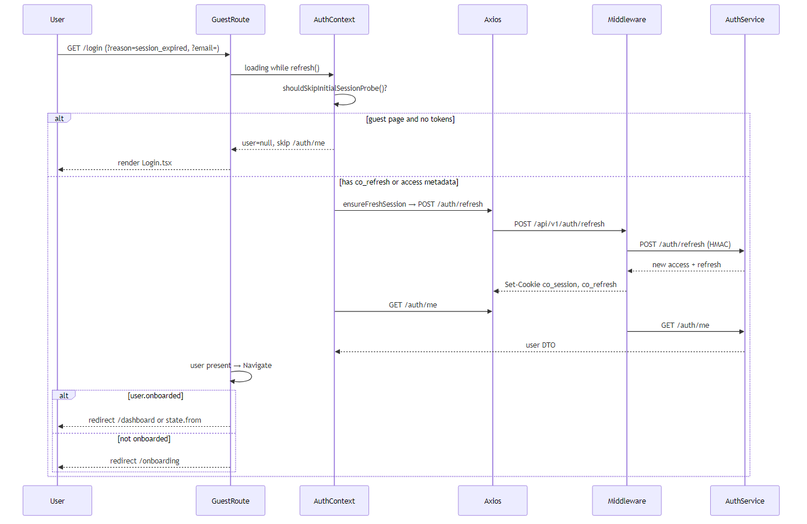

5.1 Phase 1 — Page mount: word CAPTCHA challenge
- WordCaptchaField mounts when LOGIN_WORD_CAPTCHA_REQUIRED (prod/staging) or captchaRequired flag set after failed login.
- WordCaptchaService.createChallenge(): 5 chars from A-Z/2-9 (no ambiguous chars), shuffled with rotation in SVG.
- Disabled in local dev: auth.login.word-captcha.required=false on backend; LOGIN_WORD_CAPTCHA_REQUIRED=false on frontend.

Diagram: Phase 1 — CAPTCHA challenge
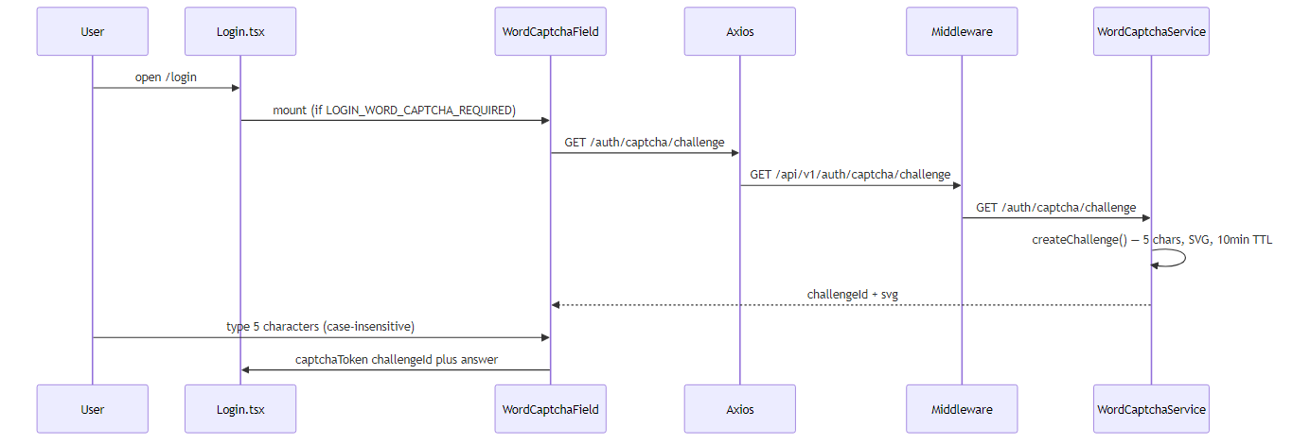

5.2 Phase 2 — Email/password login (primary path)
AuthService.login() security behaviors:
- Account lockout checked BEFORE password verify (lockedUntil in future → generic 401).
- Word CAPTCHA verified when loginWordCaptchaRequired is true.
- Google-only accounts (null password hash) → generic 401 with timing-safe dummy BCrypt.
- Always runs BCrypt verify (DUMMY_HASH if user not found) — prevents timing/email enumeration.
- Failed attempts: atomic incrementFailedAttempts; at 5 failures → lock 15 minutes + ACCOUNT_LOCKED audit.
- Success: resetFailedAttempts, assertAccountActive, audit LOGIN.
- If 2FA enabled: issueChallengeToken → requiresTwoFactor response (no cookies yet).
- If no 2FA: createAuthResponse → JWT access (15min) + refresh token (SHA-256 at rest, UA/subnet binding).

Diagram: Phase 2 — Email/password login
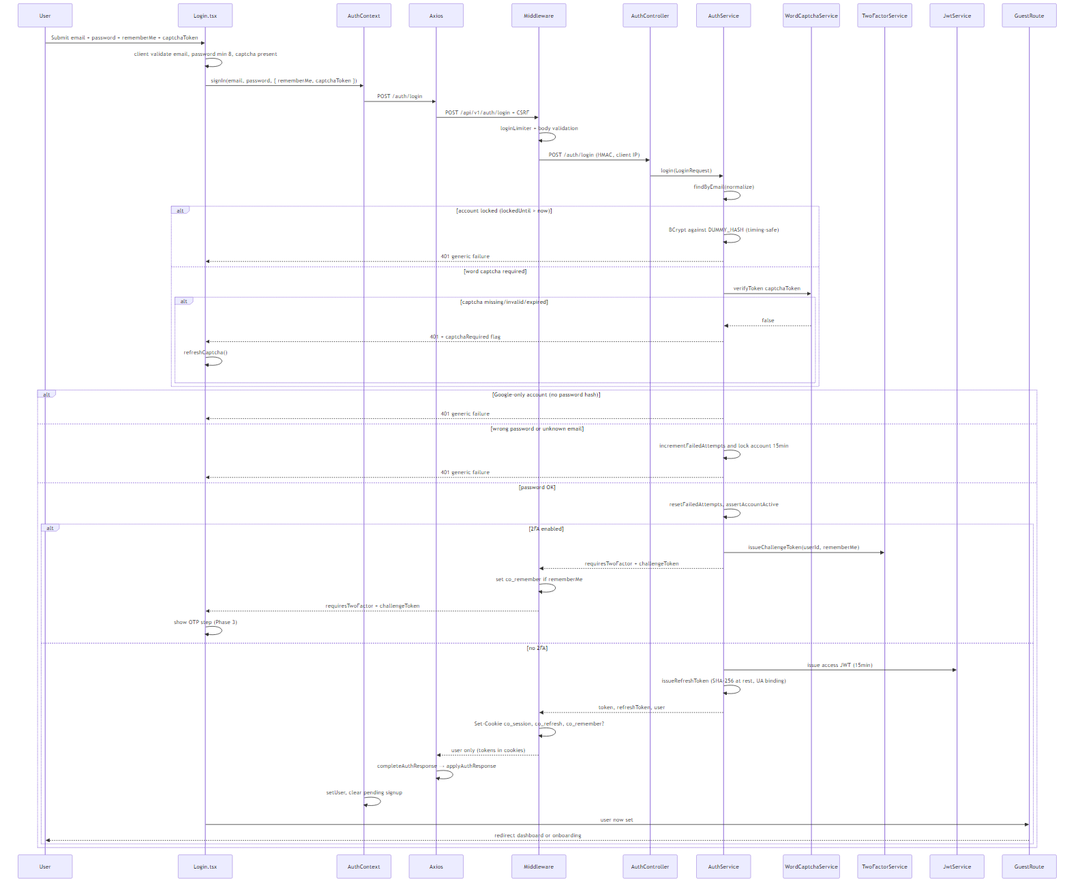
Primary login path with captcha, lockout, 2FA branch, and cookie issuance

5.3 Phase 3 — Two-factor authentication completion
- Login.tsx catches TWO_FACTOR_REQUIRED error with challengeToken; shows OtpInput (6 digits).
- Middleware sets co_remember cookie at login step if rememberMe was checked (before 2FA).
- POST /auth/two-factor/verify: resolveRememberMe from cookies + body.
- TwoFactorService.verifyLoginCode validates TOTP against challenge.
- Success: createAuthResponse + issueAuthCookies; AuthContext.setUser.

Diagram: Phase 3 — 2FA verification
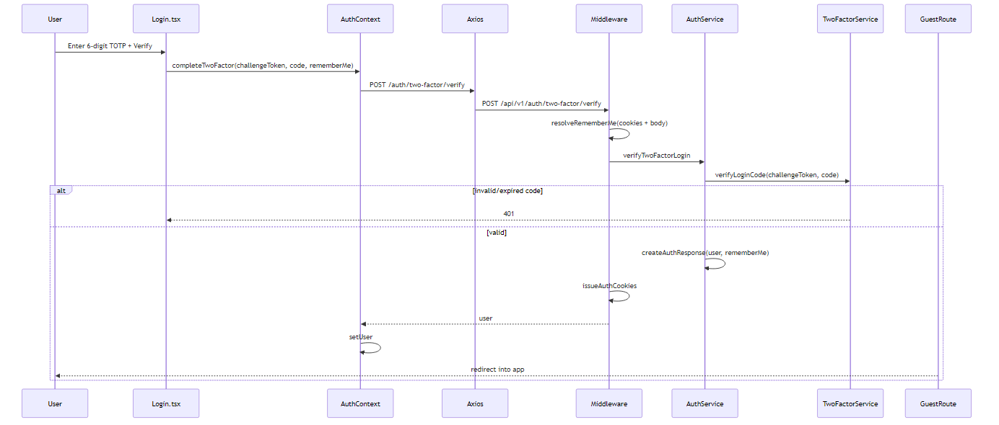

5.4 Phase 4 — Google sign-in
- LoginGoogleButton returns Google idToken via GIS credential callback.
- resolveGoogleLoginConsent(sessionStorage): may open GoogleConsentSheet for terms/AI/marketing/analytics.
- authenticateWithGoogle: verifyIdToken → find by googleSub or email.
- Existing googleSub user: assert active, reset failures, update lastLoginAt.
- Email exists with password but no googleSub: 409 LINK_REQUIRES_VERIFICATION → Phase 5.
- Email exists, linkable (no password): auto-set googleSub.
- New user: requires terms + AI consent; createGoogleUser + provisionDefaultOrg.
- Google path uses requireRecaptchaWhenConfigured on consent sheet (not word CAPTCHA).

Diagram: Phase 4 — Google sign-in
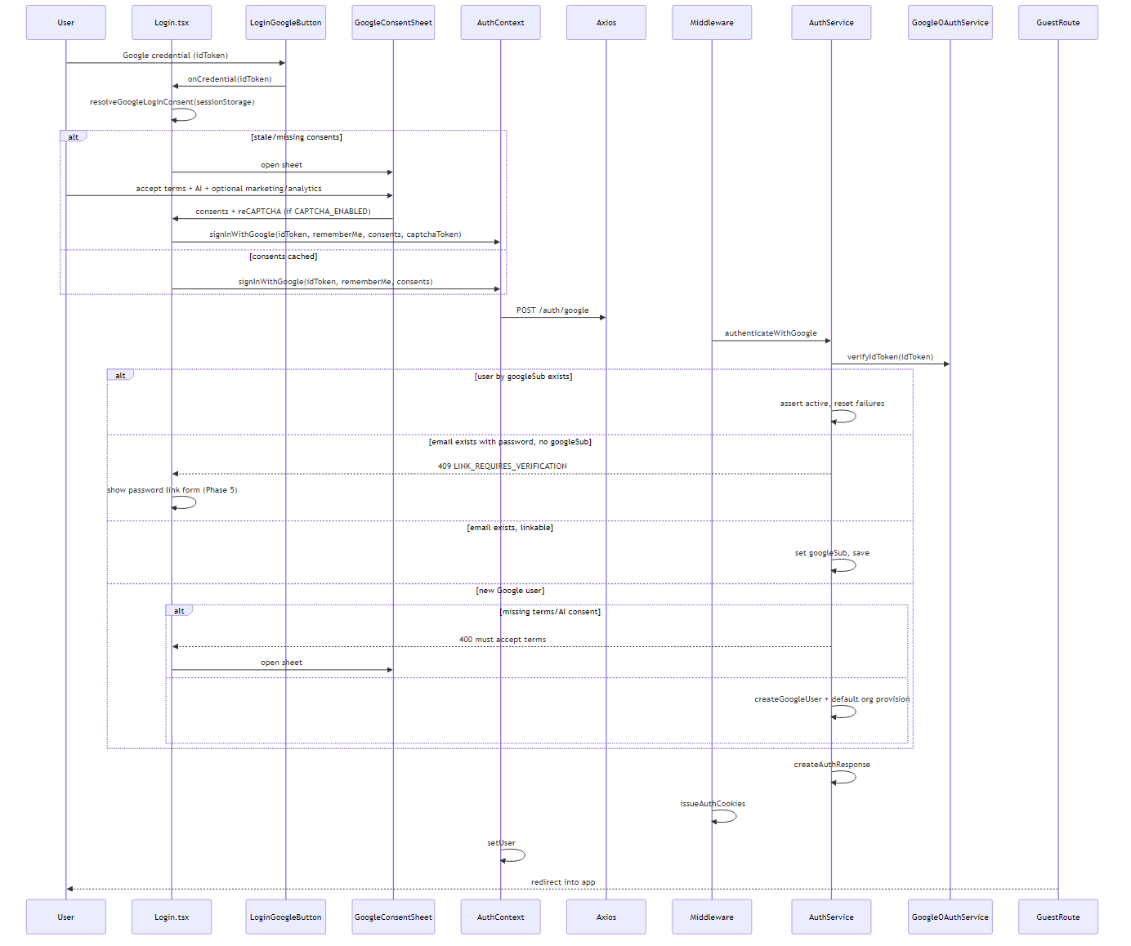

5.5 Phase 5 — Google account linking
- Triggered when email/password account exists and user signs in with Google for same email.
- writePendingGoogleLink(idToken) to sessionStorage; in-memory googleLinkToken state.
- User enters account password + reCAPTCHA (if CAPTCHA_ENABLED).
- confirmGoogleLink: verify idToken + BCrypt password → set googleSub, GOOGLE provider.
- Page refresh loses link flow — user must click Google again (UI warns).

Diagram: Phase 5 — Google link confirm
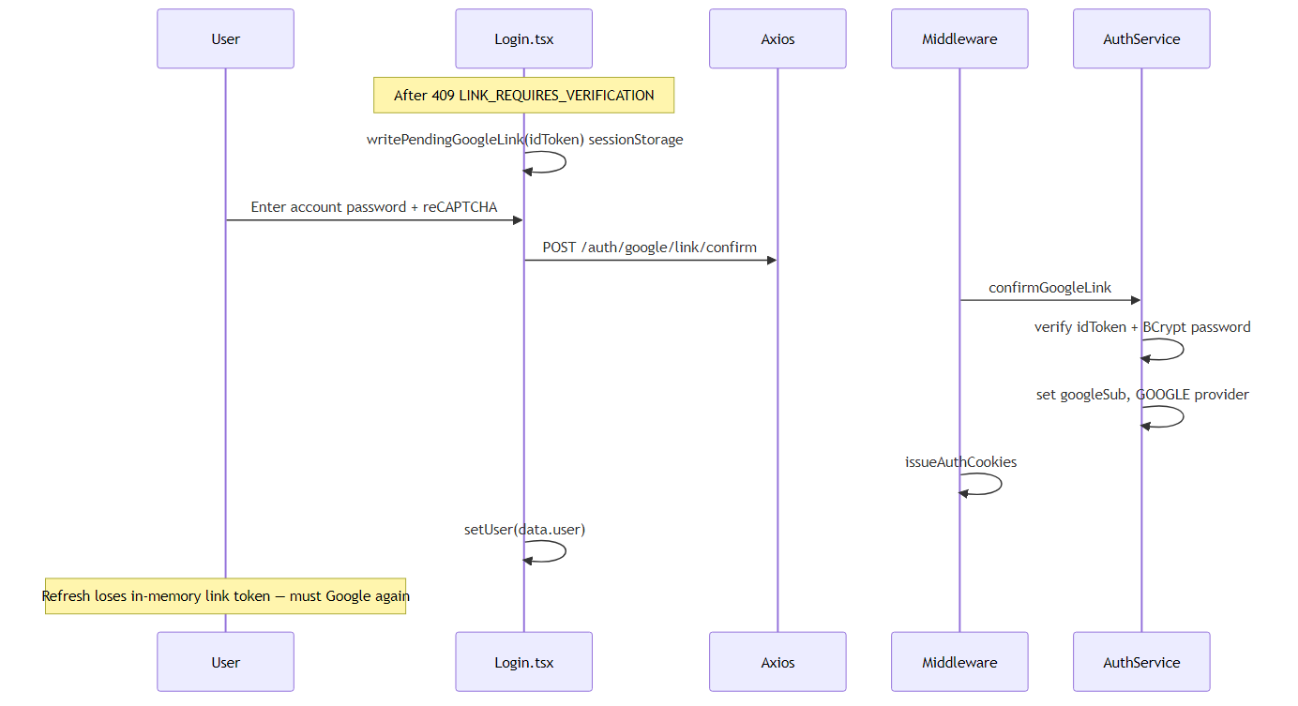

5.6 Phase 6 — Post-login redirect
- AuthContext.setUser triggers GuestRoute re-render.
- safeRedirectPath(state.from) used if user was sent from protected route.
- Otherwise: user.onboarded ? /dashboard : /onboarding.
- On success: clearPendingSignup(), clearOnboardingVerification(), syncLocalAnalyticsConsentToBackend().

Diagram: Phase 6 — Post-login redirect
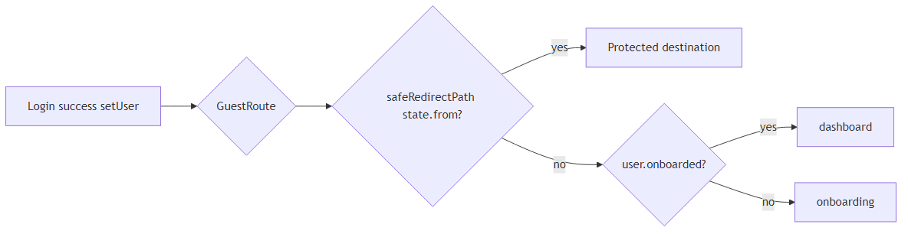

6. Auth, Cookies, and Tokens
Cookie / artifact | Purpose | Lifetime
co_session | Access JWT (HttpOnly) | 15 minutes
co_refresh | Refresh JWT (HttpOnly) | Session cookie OR 30 days (remember me)
co_remember | Persistent refresh flag | 30 days when remember me checked
co_csrf | CSRF token for mutating requests | Session
tokenStore (memory) | Access token metadata for Bearer header | In-memory only

6.1 Remember me behavior
Remember me | Refresh storage | TTL
Unchecked | HttpOnly co_refresh session cookie | Browser session
Checked | HttpOnly co_refresh + co_remember | 30 days

Access token handling is identical in both modes. Refresh token is NEVER stored in sessionStorage.

6.2 Middleware cookie issuance
- authJsonResponse: Set-Cookie co_session + co_refresh; JSON body returns { user } only (LSA-071).
- completeAuthResponse in api.ts: if no token in JSON, POST /auth/refresh to get in-memory access.
- 2FA login step: middleware may set co_remember before returning challengeToken.

6.3 Refresh token security (backend)
- Raw refresh token never stored in DB — SHA-256 hash only.
- Token rotation on refresh; reuse detection revokes entire token family.
- Binding hash: User-Agent + /24 subnet; mismatch → 401 + family revoke.

7. API Endpoints
User action | Frontend | Middleware (/api/v1) | Java (/api)
Load captcha | authApi.getWordCaptchaChallenge | GET /auth/captcha/challenge | WordCaptchaService.createChallenge
Email login | authApi.login | POST /auth/login | AuthService.login
2FA verify | authApi.verifyTwoFactor | POST /auth/two-factor/verify | AuthService.verifyTwoFactorLogin
Google login | authApi.google | POST /auth/google | AuthService.authenticateWithGoogle
Google link | authApi.confirmGoogleLink | POST /auth/google/link/confirm | AuthService.confirmGoogleLink
Session probe | authApi.me | GET /auth/me | AuthService.me
Silent refresh | authApi.refresh / ensureFreshSession | POST /auth/refresh | AuthService.refresh
Logout | authApi.logout | POST /auth/logout | AuthService.logout

7.1 Login request body (email path)
{ email, password, rememberMe?, captchaToken? } where captchaToken = challengeId:answer (required when word CAPTCHA enabled).

8. File Map

8.1 Frontend
Role | Path
Page | frontend/src/pages/Login.tsx
Word CAPTCHA UI | frontend/src/components/auth/WordCaptchaField.tsx
Shell / intelligence panel | frontend/src/components/auth/LoginPageShell.tsx, AuthIntelligencePanel.tsx
Google button | frontend/src/components/auth/LoginGoogleButton.tsx
Google consent sheet | frontend/src/components/auth/GoogleConsentSheet.tsx
Copy constants | frontend/src/components/auth/loginCopy.ts
Auth state | frontend/src/context/AuthContext.tsx
HTTP client | frontend/src/services/api.ts
Token store | frontend/src/lib/tokenStore.ts
Route guard | frontend/src/components/ProtectedRoute.tsx (GuestRoute)
Pending Google link | frontend/src/lib/pendingGoogleLink.ts
Pending Google consents | frontend/src/lib/pendingGoogleConsents.ts

8.2 Middleware
Role | Path
Auth routes | middleware/src/routes/auth.routes.ts
Auth guard | middleware/src/authGuard.ts
JWT verification | middleware/src/jwtVerification.ts
Remember me resolver | middleware/src/authRememberMe.js
Rate limiting | middleware/src/rateLimiter.ts (loginLimiter)

8.3 Backend
Role | Path
Controller | backend/src/main/java/com/careerops/controller/AuthController.java
Login + brute-force | backend/src/main/java/com/careerops/service/AuthService.java
Word CAPTCHA | backend/src/main/java/com/careerops/service/WordCaptchaService.java
2FA | backend/src/main/java/com/careerops/service/TwoFactorService.java
Google OAuth | backend/src/main/java/com/careerops/service/GoogleOAuthService.java
JWT | backend/src/main/java/com/careerops/security/JwtService.java
Google reCAPTCHA (consent/link) | backend/src/main/java/com/careerops/service/CaptchaService.java

9. Edge Cases and Error Handling
- Session expired redirect: Axios interceptor / silent refresh failure → /login?reason=session_expired. First-time guest visits to protected routes go to plain /login (no banner).
- 2FA remember me: rememberMe passed in POST /auth/two-factor/verify body; co_remember cookie may be set at login step.
- Google link refresh: link step-up token in-memory + sessionStorage; refreshing page requires signing in with Google again.
- Email prefill: ?email= pre-populates field; query param removed from address bar immediately after read.
- One-time CAPTCHA challenge: each challengeId consumed on verify; refresh or retry fetches new one.
- Challenge TTL: 10 minutes server-side; expired challenges return invalid captcha.
- Google-only account: password login fails with generic error (no enumeration).
- Account lockout: 5+ failures → 15-minute lock; still returns generic 401.
- No VITE_RECAPTCHA_SITE_KEY needed for email word CAPTCHA (unlike onboarding reCAPTCHA).
- Failed login with captchaRequired flag in API error re-enables CAPTCHA UI even in dev.
- Middleware loginLimiter applied to POST /auth/login and /auth/two-factor/verify.
- CSRF: mutating requests include X-CSRF-Token from co_csrf cookie.
- HMAC: middleware → Java requests signed with APP_INTERNAL_SECRET (see shared/auth-infrastructure.md).
- Generic error messages: all login failures return same message to prevent email enumeration.
- Timing attack mitigation: BCrypt always runs even when user not found.

10. Related Documentation
- pagesflow/login/PAGE.md — concise page reference
- pagesflow/shared/auth-infrastructure.md — cookies, refresh, axios, HMAC
- pagesflow/shared/route-guards.md — GuestRoute, ProtectedRoute, redirect tree
- pagesflow/mandatory-fields.md — env vars for auth in dev/prod
- pagesflow/signup/PAGE.md — deferred signup flow
- pagesflow/onboarding/PAGE.md — post-login onboarding for new users
- pagesflow/forgot-password/PAGE.md — password reset flow

11. Environment Variables (Login-relevant)
Variable | Layer | Purpose
LOGIN_WORD_CAPTCHA_REQUIRED / auth.login.word-captcha.required | Frontend + Java | Enable word CAPTCHA on email login
VITE_RECAPTCHA_SITE_KEY / RECAPTCHA_SECRET_KEY | Frontend + Java | Google consent sheet and link form reCAPTCHA
JWT_PUBLIC_KEY / JWT keys | Middleware + Java | Access token issue and verify
APP_INTERNAL_SECRET | Middleware + Java | HMAC signing for BFF → backend
COOKIE_NAME, COOKIE_SAMESITE | Middleware | Session cookie configuration
TRUSTED_PROXY | Middleware + Java | Client IP for rate limits and refresh binding

Generated for CareerOps pagesflow/login. Diagram sources: pagesflow/login/diagrams/*.mmd

