CareerOps Signup + Onboarding Pipeline — Complete Reference
End-to-end documentation for deferred email signup (/signup) and three-step onboarding (/onboarding) through first dashboard visit (/dashboard?welcome=1). Covers the Google shortcut entry path, all validation rules, HTTP errors, sessionStorage handoff, email OTP verification, account registration on finish, CV AI parse, and job delivery polling/SSE.

0. End-to-End Journey Overview

0.1 Full journey
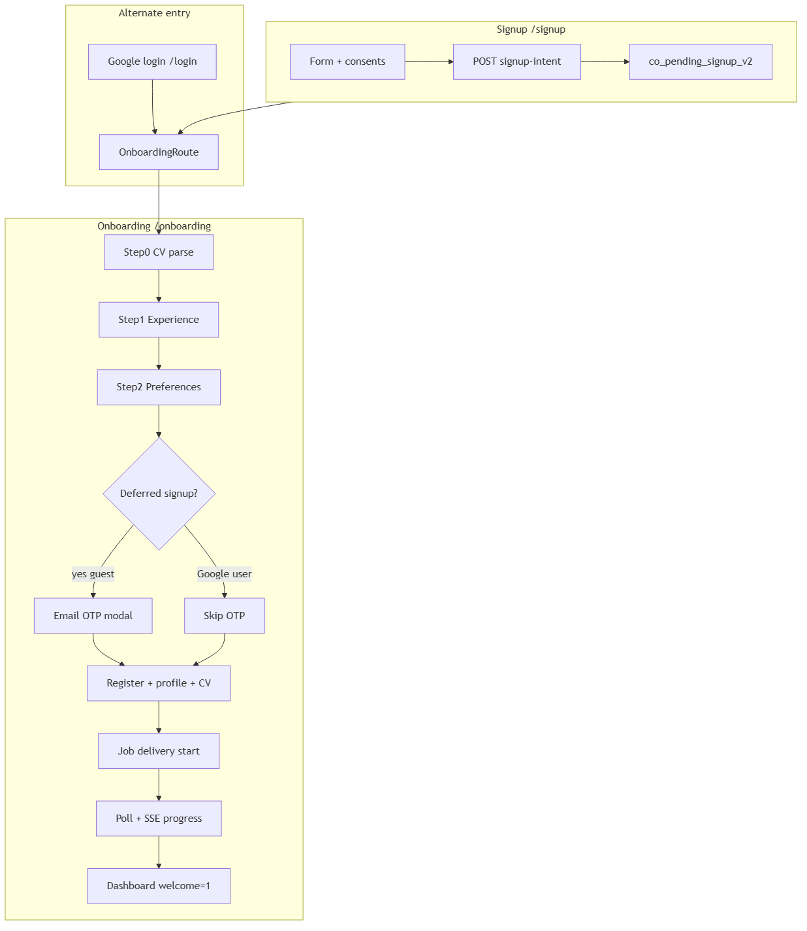
Signup → Onboarding (3 steps) → Email OTP (deferred only) → Register → Job delivery → Dashboard

0.2 Scenario matrix
Scenario | Entry | OTP | Register at finish | Outcome
Happy path email | /signup | Yes | Yes | Dashboard + welcome=1
Duplicate email decoy | /signup | Yes | Fails at register | Generic error at finish; intent was never stored
Tab closed mid-flow | any | — | — | Must restart from /signup
Session expired | onboarding | — | — | /signup?reason=session_expired
Google new user | /login | No | No (already authed) | Dashboard after delivery
Delivery timeout | finish | — | Profile saved | Toast + continue to dashboard
Plan limit 402 | delivery start | — | Profile saved | Upgrade toast; billing redirect intended
CV parse AI fallback | step 0 | — | — | Regex parse + warning toast

1. Architecture Overview
Four layers: React UI (Signup.tsx, Onboarding.tsx), Axios HTTP client with CSRF, Express middleware BFF (auth.routes.ts, onboarding.routes.ts), and Spring Boot backend (SignupIntentService, OnboardingEmailVerificationService, OnboardingCvParseService, OnboardingDeliveryService, AuthService.register). Deferred signup stores credentials server-side as a signup intent; the frontend only holds intent id + consents in sessionStorage.

1.1 Auth stack layers
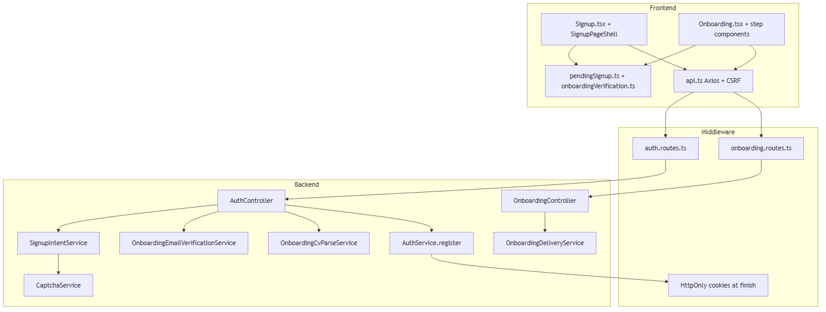
Frontend → Middleware BFF → Java backend with HMAC trust boundary

Part A — Signup (/signup)

2. Signup Route and Access Control
Property | Value
URL | /signup (canonical); /register redirects here
Guard | GuestRoute
Layout | Standalone (SignupPageShell)
Redirects (logged-in) | onboarded → /dashboard; not onboarded → /onboarding

2.1 Query parameters
Param | Effect
?reason=session_expired | Clears tokens, co_pending_signup_v2, co_onboarding_verification_v2; logout; shows banner

3. Signup Fields, Validation, and Consents
Field | Required | Validation | When shown
Full name | Yes | Non-empty trim | Always
Email | Yes | HTML5 email; trimmed on submit | Always
Password | Yes | Min 8; upper+lower+digit; HIBP server check | Always
Terms + Privacy | Yes | termsAccepted must be true | Always
AI processing consent | Yes | Required for CV parse during onboarding | Always
Marketing emails | No | Optional | Always
Analytics consent | No | Optional; also written to cookie consent | Always
reCAPTCHA | Conditional | Required when VITE_RECAPTCHA_SITE_KEY set | When CAPTCHA_ENABLED

3.1 Password strength (client indicator)
- Too short (<8), Weak (pattern fail), Fair/Good/Strong (pattern pass) — only acceptable passwords submit.
- Server pattern: ^(?=.*[a-z])(?=.*[A-Z])(?=.*\d).{8,128}$ plus HIBP pwned-password check.
- Pwned password → 400: This password is not secure enough. HIBP down (prod) → 503.

3.2 Duplicate email (anti-enumeration)
- If email already registered, SignupIntentService returns HTTP 200 with a random decoy UUID (never persisted).
- UI navigates to onboarding identically; registration fails later at finish when intent is consumed.
- Logs SIGNUP_INTENT_DECOY server-side. Frontend mapSignupIntentError still handles 409 if ever returned elsewhere.

4. Signup Pipeline — Phased Flow
Signup journey split into six phases before onboarding handoff.

4.0 Phase 0 — Route entry
- GuestRoute wraps /signup; shouldSkipInitialSessionProbe() on guest pages with no tokens.
- Authenticated users redirected via loginRedirectTarget before Signup.tsx renders.

Diagram: Signup Phase 0
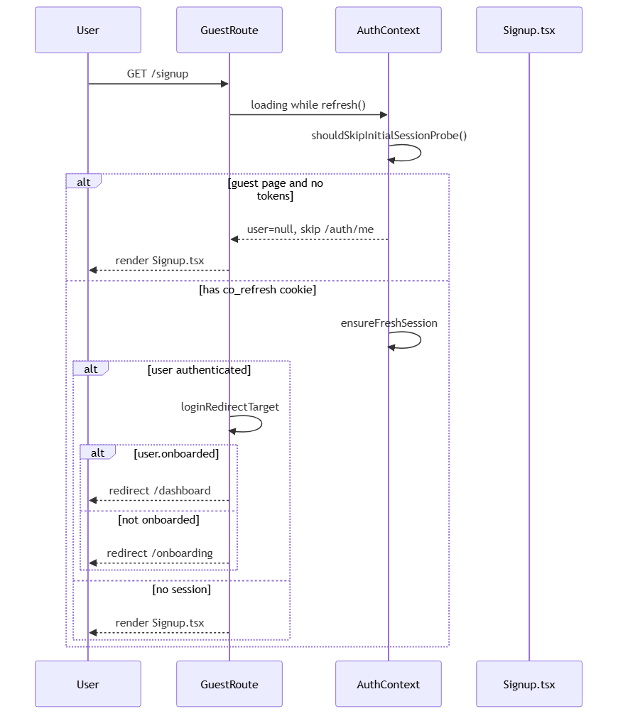

4.1 Phase 1 — Session expired bootstrap
- ?reason=session_expired: tokenStore.clear(), clearPendingSignup(), clearOnboardingVerification().
- Best-effort authApi.logout() to clear HttpOnly cookies.
- Banner: Your sign-up session expired. Please enter your details again to continue.

Diagram: Signup Phase 1
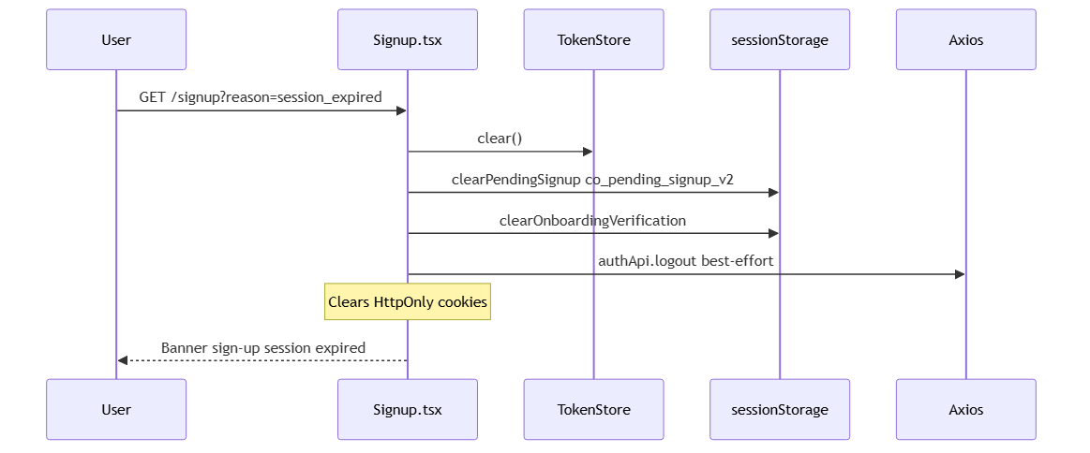

4.2 Phase 2 — Client validation
- All validation runs before any API call; errors shown inline in alert role=alert.
- Editing email clears the error message.

Diagram: Signup Phase 2
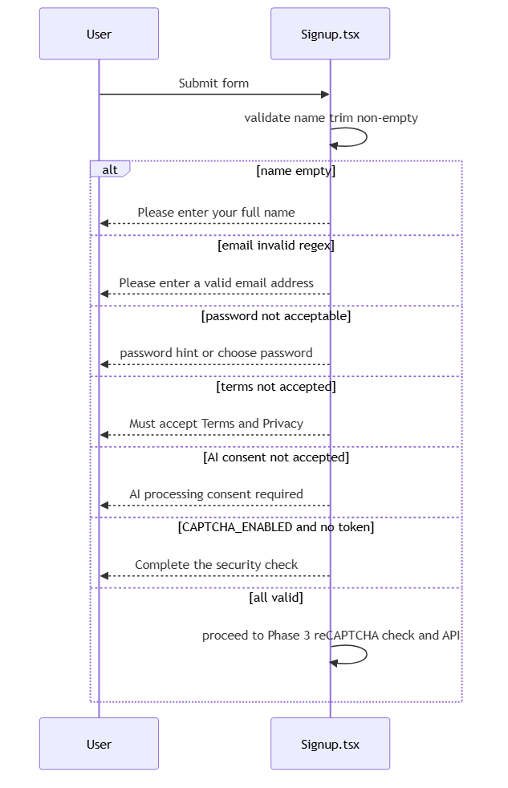

4.3 Phase 3 — reCAPTCHA
- RecaptchaBlock when CAPTCHA_ENABLED (VITE_RECAPTCHA_SITE_KEY set).
- Server: CaptchaService.requireRecaptchaWhenConfigured on signup-intent.
- Failed submit resets captcha widget. Signup does NOT use login word-CAPTCHA.

Diagram: Signup Phase 3
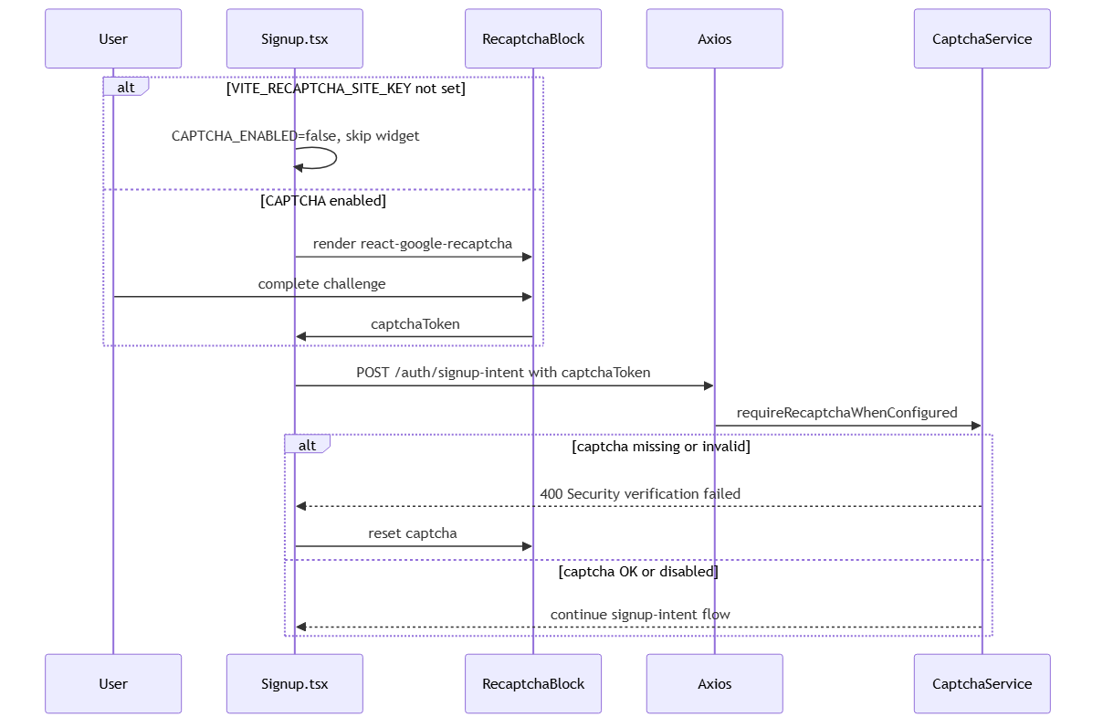

4.4 Phase 4 — POST /auth/signup-intent
- Middleware: authLimiter (20/15min prod), csrfGuard, express-validator.
- Java: IpRateLimitFilter 20/min/IP; consent checks; decoy or real intent (30min TTL).
- Success: { signupIntentId, expiresAt }. No JWT/cookies issued.

Diagram: Signup Phase 4
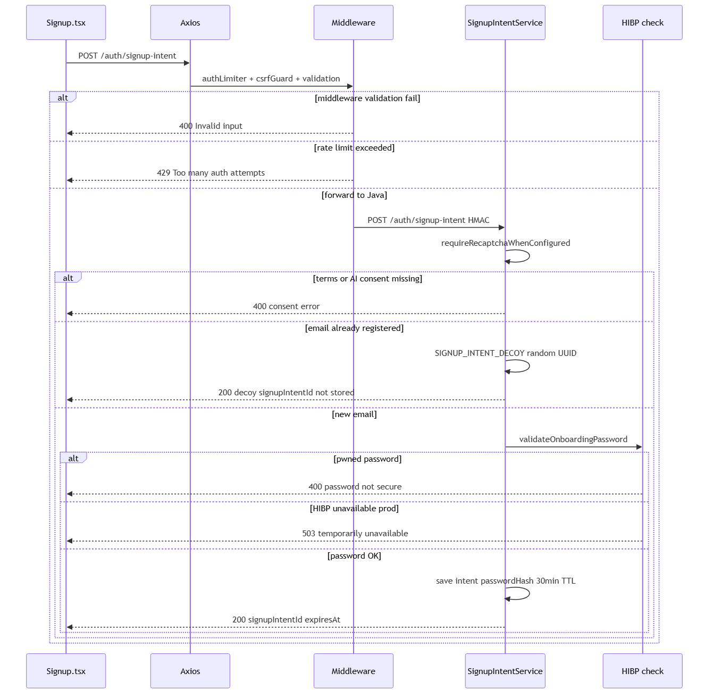

4.5 Phase 5 — Handoff to onboarding
- writePendingSignup → co_pending_signup_v2 (30min client TTL aligned with server).
- writePendingGoogleConsents + writeAnalyticsConsent for Google path consistency.
- navigate('/onboarding', { replace: true }). OnboardingRoute requires hasPendingSignup() for guests.

Diagram: Signup Phase 5
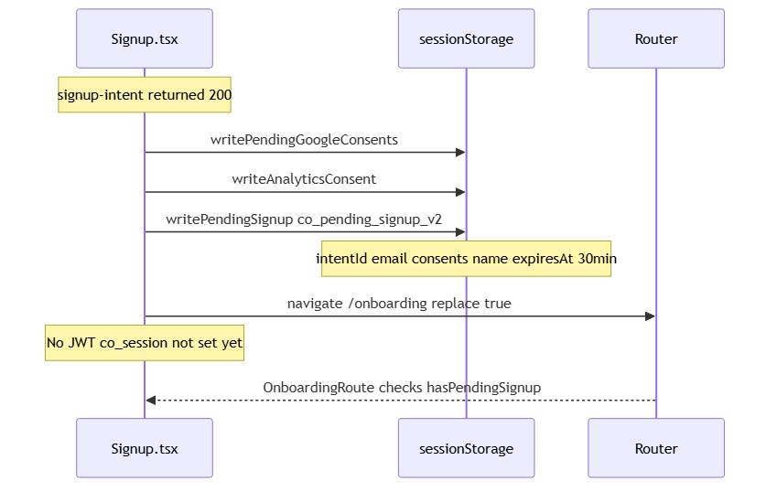

5. Signup API and Error Catalog

5.1 Middleware POST /api/v1/auth/signup-intent
Status | Condition | Response
200 | Success (incl. decoy) | { signupIntentId, expiresAt }
400 | express-validator failure | { error: Invalid input, details: [...] }
400 | Backend 4xx forwarded | Backend message
403 | CSRF failure | CSRF validation failed
429 | authLimiter | Too many auth attempts. Try again later.

5.2 Java POST /auth/signup-intent
Status | Message / condition
200 | New intent saved or decoy UUID for existing email
400 | You must accept the Terms of Service
400 | AI processing consent is required to upload and parse your CV during onboarding.
400 | This password is not secure enough. Please choose a different password. (HIBP)
400 | Security verification failed. Please try again. (reCAPTCHA)
400 | Validation failed (Jakarta @Valid fieldErrors)
429 | Too many requests. Please wait 60 second(s) before retrying.
503 | Password security check is temporarily unavailable. Please try again shortly.

5.3 Frontend error mapping (mapSignupIntentError)
Status | User-facing message
409 | An account may already exist for this email. Try signing in or use a different email.
400 password/pwned | This password is not secure enough. Please choose a different password.
400 captcha | Security verification failed. Please try again.
400 consent | Could not continue. Please try again.
429 | Too many attempts. Please wait and try again.
503 | Service temporarily unavailable. Please try again shortly.
default | Could not continue. Please try again.

6. Signup sessionStorage
Key | TTL | Contents
co_pending_signup_v2 | 30 min (expiresAt) | signupIntentId, email, consents, optional name
co_pending_signup_v1 | — | Legacy; cleared on clearPendingSignup
co_google_consents_v1 | Session | Consents for Google OAuth reuse from signup

Part B — Onboarding (/onboarding)

7. Onboarding Route and Entry Paths
Property | Value
URL | /onboarding
Guard | OnboardingRoute
Layout | Full-width standalone (OnboardingPageShell)
Guest without pendingSignup | Redirect /signup
Already onboarded | Redirect /dashboard or /dashboard?welcome=1

7.1 Entry paths
Path | How user arrives | pendingSignup | JWT | Email OTP at finish
Deferred signup | /signup → signup-intent | Yes | No until register | Yes
Google user | /login → Google OAuth | No | Yes | No
Return mid-flow | Authenticated, !onboarded | Maybe | Yes | Depends

7.2 Billing exempt during onboarding
- ProtectedRoute allows /account/billing, /billing/success, /billing/cancel without completing onboarding.
- Plan limit 402 on delivery shows upgrade toast; intended redirect to /account/billing.
- Known gap: Onboarding.tsx L402 calls navigate() but hook is nav — billing redirect may not fire.

Diagram: Onboarding Phase 0
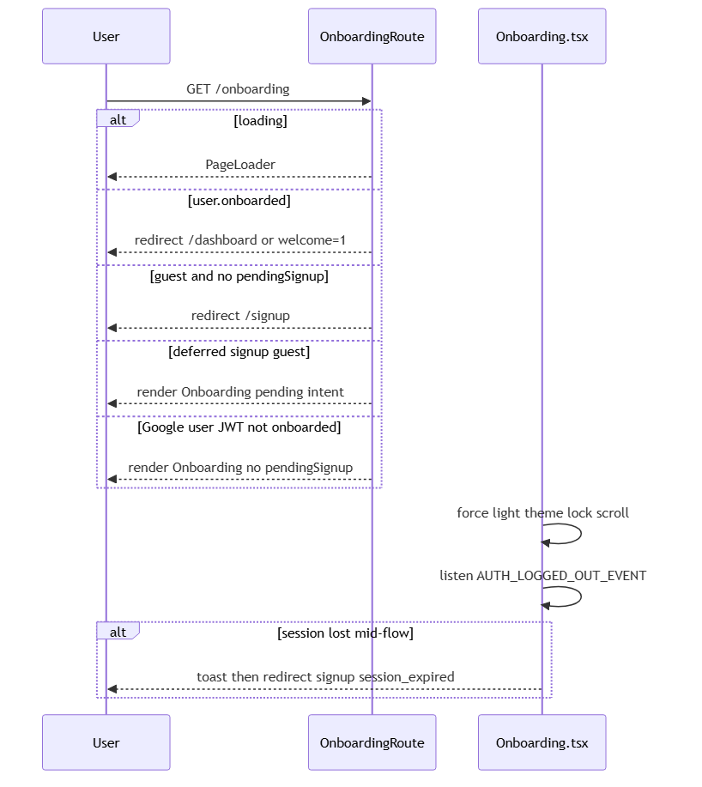

8. Onboarding Fields by Step

8.1 Step 0 — Basic info + CV (BasicInfoStep)
Field | Required | Validation
Full name | Yes | Non-empty trim
Headline | Yes | Non-empty trim (required at Continue)
Years of experience | Yes | Selected value
Location | Yes | Default Dublin, Ireland
LinkedIn / Portfolio / GitHub | No | Valid URL if non-empty
CV file | Yes | PDF or DOCX, max 5 MB
reCAPTCHA | Conditional | Required when CAPTCHA_ENABLED on parse

8.2 Step 1 — Experience (ExperienceStep)
- Work Experience, Education, Projects — collapsible sections; prefilled from CV parse.
- No required fields; invalid project URL shows toast but Continue still advances (soft validation).
- AI review banner when parseSource=ai and sections have rows.

8.3 Step 2 — Preferences (PreferencesStep)
Field | Required | Notes
Target roles | Yes (gate) | At least one role chip; cvFile must exist in state
Work settings | Yes | At least one of remote/onsite/hybrid
Tech stack | No | Prefilled from extractedTechStack on AI parse
Salary range | No | Clamped 20–300k EUR, 5k min gap
Availability / filters | No | Defaults: 2 weeks notice, 60% match, 7 day job age

8.4 Email verification modal
Field | Required | Notes
8-digit OTP | Yes | Exactly 8 digits (not 6)
reCAPTCHA | Conditional | On send and verify when CAPTCHA_ENABLED

9. Onboarding Pipeline — Phased Flow

9.1 Phase 1 — CV parse at Step 0 Continue
- POST /auth/onboarding/parse-cv — multipart file, signupIntentId, email, captchaToken.
- AI path when consent + onboarding.cv.ai-parse.enabled + NVIDIA configured; else regex.
- AI failure → regex fallback with parseWarnings toast.
- writeOnboardingCvDraft (cvMarkdown truncated 32KB client-side).

Diagram: Onboarding Phase 1
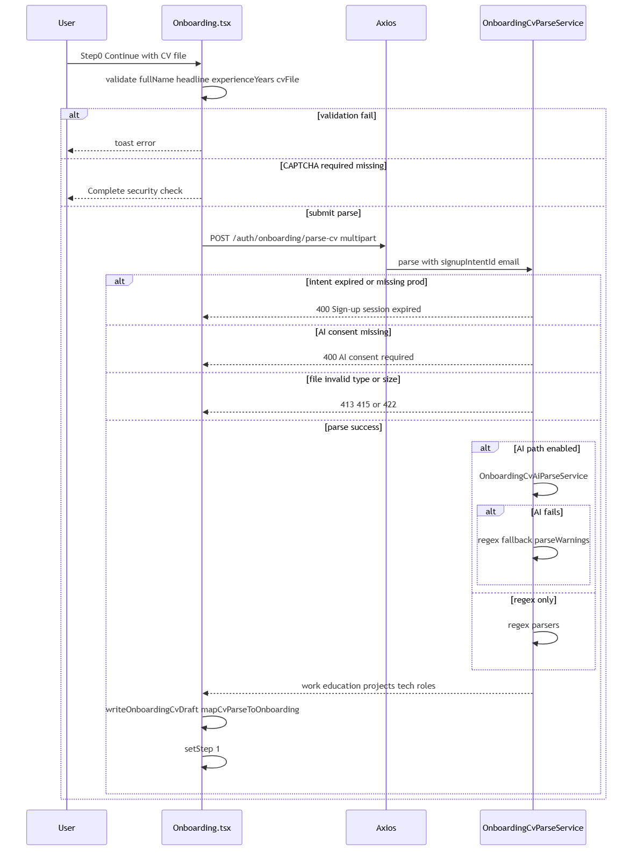

9.2 Phase 2 — Experience review

Diagram: Onboarding Phase 2
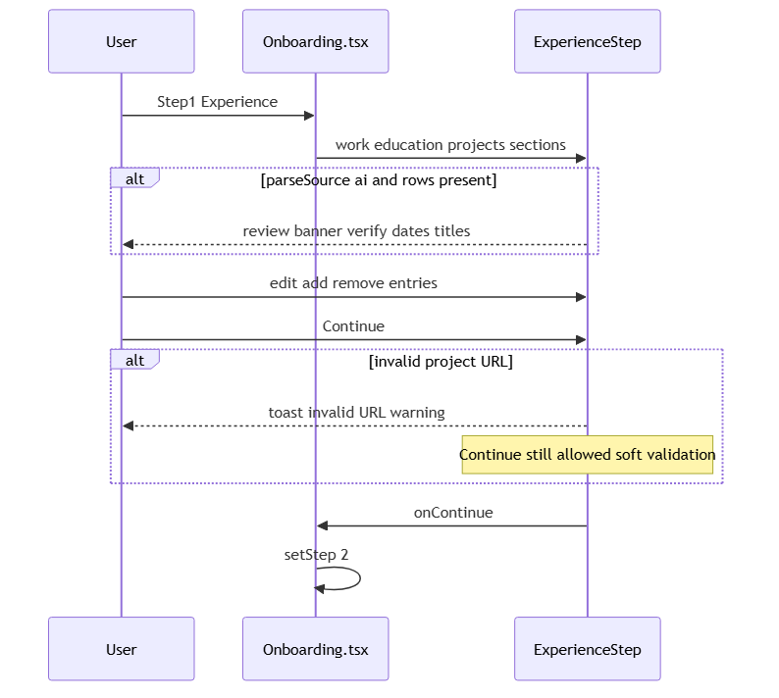

9.3 Phase 3 — Preferences

Diagram: Onboarding Phase 3
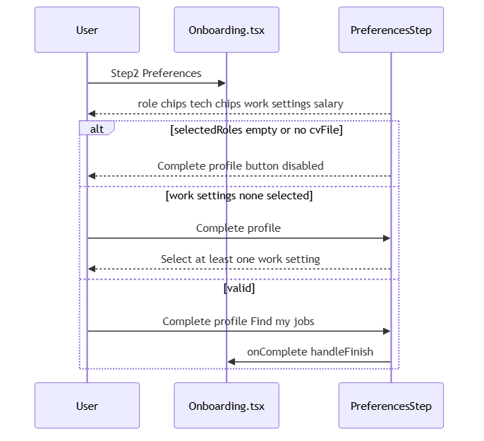

9.4 Phase 4 — Email OTP (deferred signup only)
- Skipped for Google users (already authenticated, email verified at Google signup).
- send-verification-otp → 202; verify-email → verificationId.
- writeOnboardingVerification → co_onboarding_verification_v2, 15 min TTL.
- Registered email: decoy OTP (202 accepted, no email sent) — anti-enumeration.
- Max 3 resends; 300s cooldown; max 3 verify attempts; OTP expires 15 min.

Diagram: Onboarding Phase 4
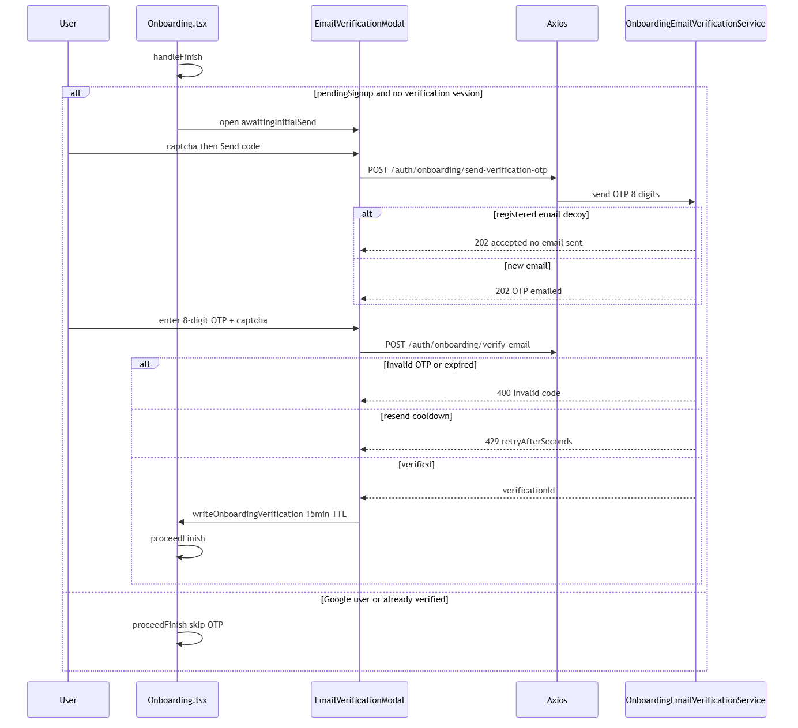

9.5 Phase 5 — Finish pipeline (completeOnboardingFinish)
- 1. signUp (pending) or ensureFreshSession (Google) — Creating your account…
- 2. PUT /profile onboarded:true — Saving your profile…
- 3. POST /profile/cv + POST /profile/portfolio per project
- 4. POST /onboarding/delivery/start — Starting job search…
- 5. clearPendingSignup + clearOnboardingVerification on success

Diagram: Onboarding Phase 5
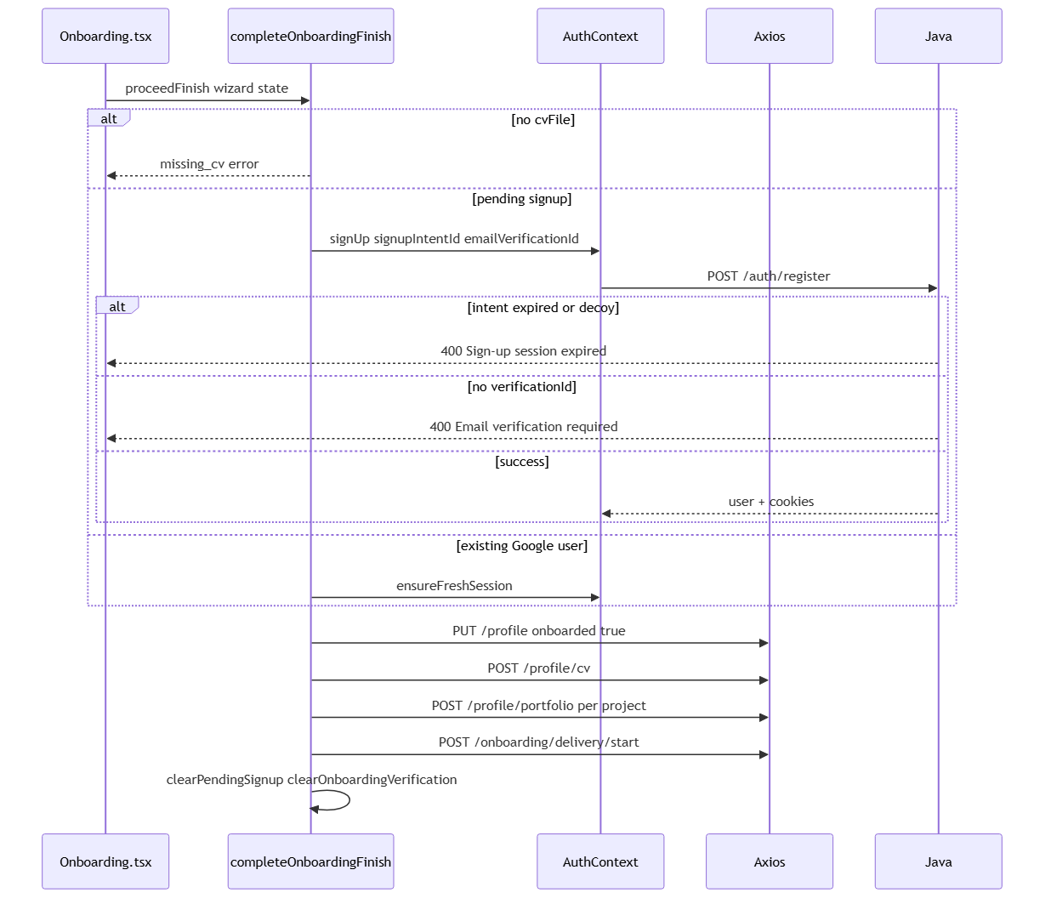

9.6 Phase 6 — Job delivery
- Stages: reading_cv → normalizing_cv → fetching_jobs → evaluating_jobs → ready | ready_partial | failed.
- Poll GET /onboarding/delivery/status every 1.5s, max 5 minutes.
- JobSearchRadarLoader overlay with per-stage messages.
- @PlanGated ai_skill_run → 402 if monthly quota exceeded.

Diagram: Onboarding Phase 6
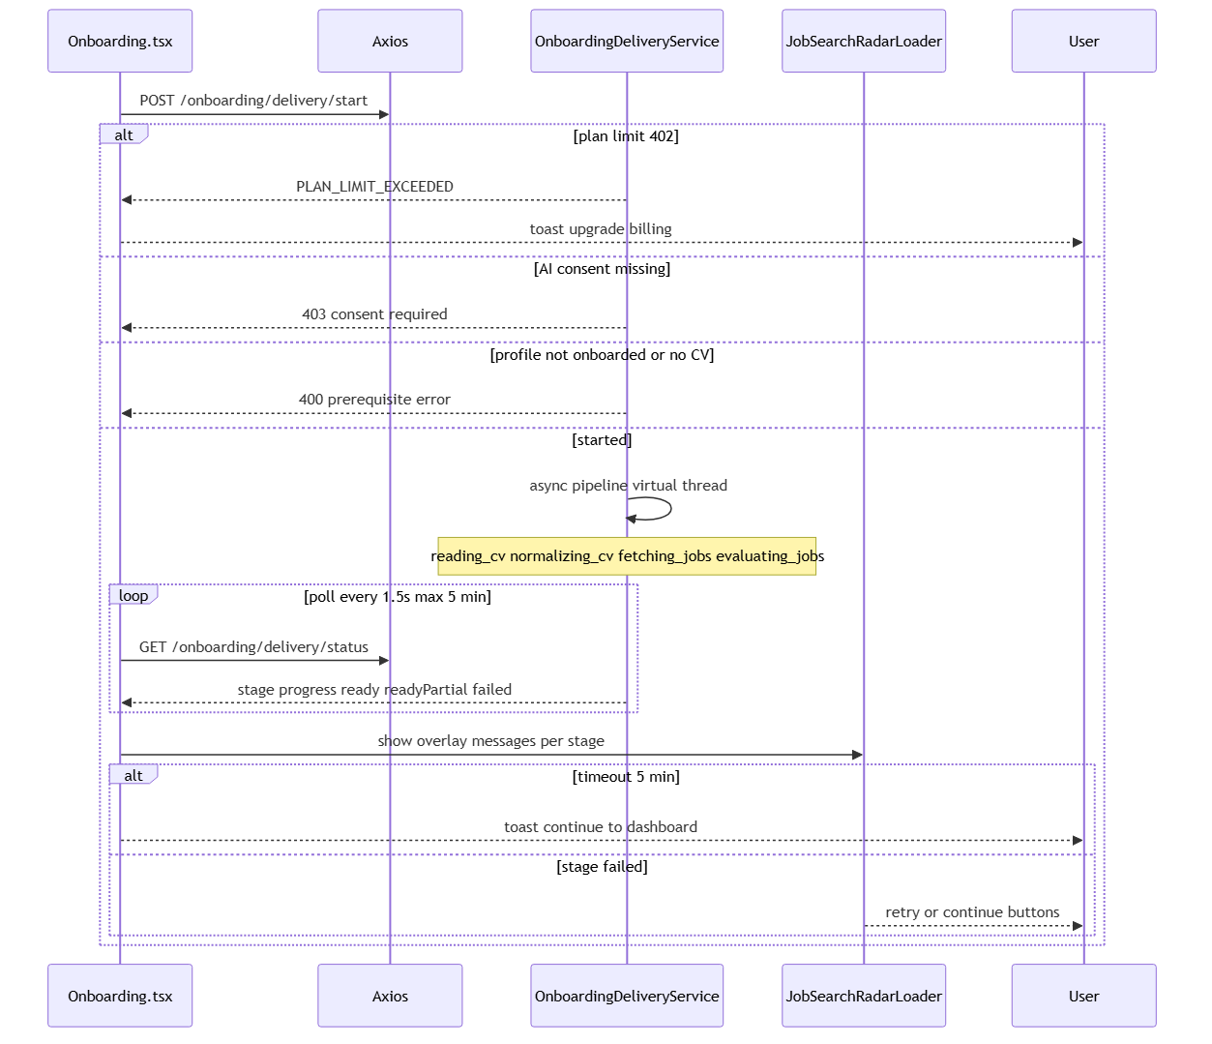

9.7 Phase 7 — Redirect to dashboard
- SSE GET /api/jobs/evaluation-progress?userId= — SOURCE_FOUND, JOB_EVALUATED, COMPLETE.
- finishToDashboard: clearOnboardingCvDraft, setWelcomePendingFlag (nc_welcome_pending).
- Navigate /dashboard?welcome=1; CareersHomeDashboard shows welcome celebration.
- Poll ready OR SSE COMPLETE can trigger dashboard navigation.

Diagram: Onboarding Phase 7
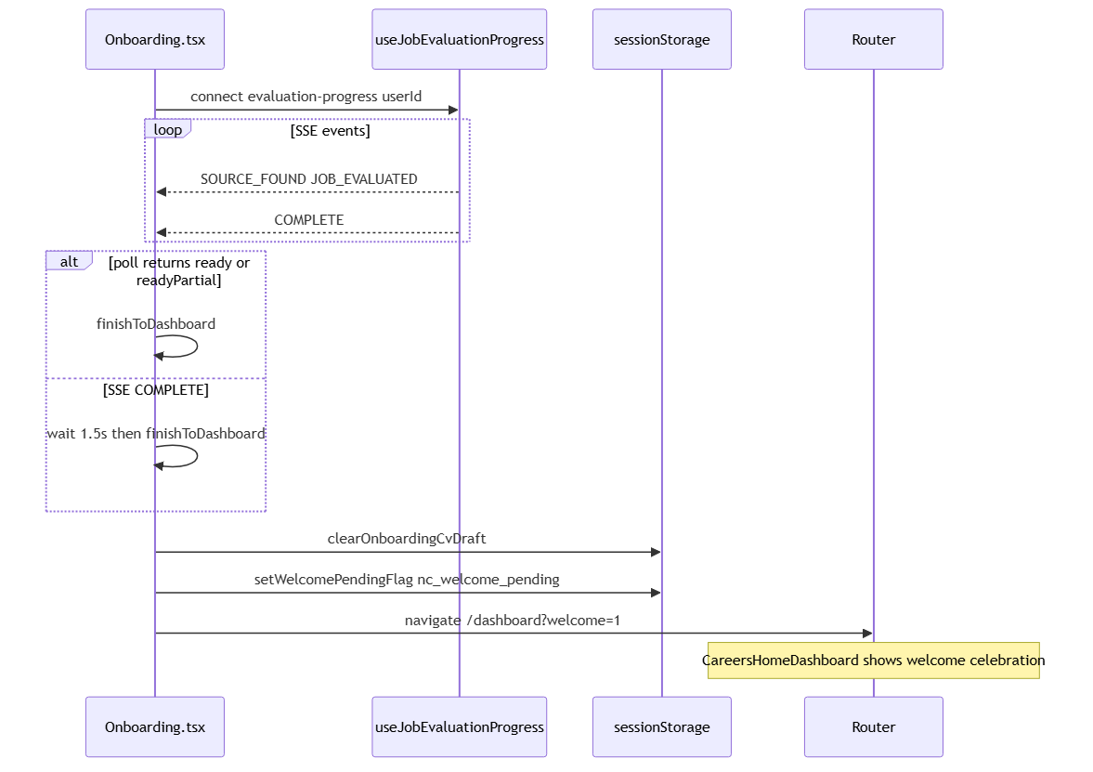

10. Onboarding API Catalog
User action | Frontend | Middleware | Java
Parse CV | authApi.parseOnboardingCv | POST /auth/onboarding/parse-cv | OnboardingCvParseService
Send OTP | authApi.sendOnboardingVerificationOtp | POST /auth/onboarding/send-verification-otp | OnboardingEmailVerificationService
Resend OTP | authApi.resendOnboardingVerificationOtp | POST /auth/onboarding/resend-verification-otp | OnboardingEmailVerificationService
Verify email | authApi.verifyOnboardingEmail | POST /auth/onboarding/verify-email | OnboardingEmailVerificationService
Register | authApi.signup via signUp | POST /auth/signup | AuthService.signup
Update profile | profileApi.update | PUT /profile | ProfileController
Upload CV | profileApi.uploadCv | POST /profile/cv | ProfileController
Portfolio | profileApi.addPortfolioItem | POST /profile/portfolio | ProfileController
Start delivery | onboardingApi.startDelivery | POST /onboarding/delivery/start | OnboardingDeliveryService
Poll status | onboardingApi.deliveryStatus | GET /onboarding/delivery/status | OnboardingDeliveryService
SSE progress | useJobEvaluationProgress | GET /api/jobs/evaluation-progress | JobEvaluationProgressController

11. Complete Error Catalog

11.1 CV parse errors
Status | Message
400 | Upload your CV to continue
400 | Sign-up session expired. Please start again.
400 | AI processing consent is required to parse your CV.
400 | Sign-up session required. (prod/staging)
400 | Email is required with sign-up session.
413 | Max 5 MB
415 | Only PDF or DOCX / security violation content mismatch
422 | Could not read text from your CV file

11.2 Email OTP errors
Status | Message
202 | OTP send/resend accepted
400 | Invalid code.
400 | Unable to send code. Please try again.
400 | Security verification failed. Please try again.
429 | Resend cooldown (retryAfterSeconds, default 300s)

11.3 Register / finish errors
Status | Message / frontend
400 | Email verification required.
400 | Sign-up session expired. Please start again.
400 | You must accept the Terms of Service
409 | Unable to create account / username conflict (retries with suffix)
402 | PLAN_LIMIT_EXCEEDED on CV upload or delivery start
403 | AI processing consent required for delivery

11.4 Delivery errors
Status / stage | Message
400 | Complete your profile first / Mark onboarding complete / Upload your CV
failed stage | We could not find enough matching roles yet. You can fetch more from the dashboard.
exception | Job matching hit a snag — try again from the dashboard.
poll timeout | Matching is taking longer than expected. You can open the dashboard.

11.5 Session and storage
Key | Storage | TTL | Purpose
co_pending_signup_v2 | sessionStorage | 30 min | Deferred signup handoff
co_onboarding_verification_v2 | sessionStorage | 15 min | verificationId after OTP
careerops_onboarding_cv_draft | sessionStorage | — | CV parse metadata between steps
nc_welcome_pending | sessionStorage | — | Dashboard welcome modal flag
co_google_consents_v1 | sessionStorage | Session | Google consent handoff

12. File Map, Environment, Related Docs

12.1 Frontend
Role | Path
Signup page | frontend/src/pages/Signup.tsx
Onboarding page | frontend/src/pages/Onboarding.tsx
Pending signup | frontend/src/lib/pendingSignup.ts
Finish orchestration | frontend/src/lib/completeOnboardingFinish.ts
Email verification session | frontend/src/lib/onboardingVerification.ts
CV draft | frontend/src/lib/onboardingCvDraft.ts
Session expiry | frontend/src/lib/onboardingSession.ts
Auth errors | frontend/src/lib/authErrors.ts
Route guards | frontend/src/components/ProtectedRoute.tsx
Email modal | frontend/src/components/onboarding/OnboardingEmailVerificationModal.tsx
Step components | frontend/src/components/onboarding/BasicInfoStep.tsx, ExperienceStep.tsx, PreferencesStep.tsx
Delivery UI | frontend/src/components/onboarding/JobSearchRadarLoader.tsx
SSE hook | frontend/src/hooks/useJobEvaluationProgress.ts

12.2 Middleware
Role | Path
Auth routes | middleware/src/routes/auth.routes.ts
Onboarding delivery | middleware/src/routes/onboarding.routes.ts

12.3 Backend
Role | Path
Auth controller | backend/src/main/java/com/careerops/controller/AuthController.java
Onboarding controller | backend/src/main/java/com/careerops/controller/OnboardingController.java
Signup intent | backend/src/main/java/com/careerops/service/SignupIntentService.java
Email verification | backend/src/main/java/com/careerops/service/OnboardingEmailVerificationService.java
CV parse | backend/src/main/java/com/careerops/service/OnboardingCvParseService.java
CV AI parse | backend/src/main/java/com/careerops/service/OnboardingCvAiParseService.java
Job delivery | backend/src/main/java/com/careerops/service/OnboardingDeliveryService.java
Registration | backend/src/main/java/com/careerops/service/AuthService.java
reCAPTCHA | backend/src/main/java/com/careerops/service/CaptchaService.java

12.4 Environment variables
Variable | Layer | Purpose
VITE_RECAPTCHA_SITE_KEY / RECAPTCHA_SECRET_KEY | Frontend + Java | reCAPTCHA on signup-intent, CV parse, OTP
onboarding.cv.ai-parse.enabled | Java | Enable NVIDIA AI CV parse
NVIDIA API keys | Java | OnboardingCvAiParseService
APP_INTERNAL_SECRET | Middleware + Java | HMAC BFF → backend
JWT keys | Middleware + Java | Session cookies at register

12.5 Related documentation
- pagesflow/signup/PAGE.md — concise signup reference
- pagesflow/onboarding/PAGE.md — concise onboarding reference
- pagesflow/login/login-pipeline.docx — login flow (Google entry to onboarding)
- pagesflow/shared/auth-infrastructure.md — cookies, refresh, axios, HMAC
- pagesflow/shared/route-guards.md — GuestRoute, OnboardingRoute, ProtectedRoute
- pagesflow/mandatory-fields.md — env vars for dev/prod

Generated for CareerOps pagesflow/signup-onboarding. Diagram sources: pagesflow/signup-onboarding/diagrams/*.mmd

