实验报告完整整理
整理范围：实验目录中具有“指令 + 原始运行图片”的记录。判定“是”表示记录已输出目标像素坐标并在截图中出现对应目标；“否”表示未形成有效目标定位。
序号 | 指令 | 是否找到物品 | 现象 | 运行图片
1 | Find the fire extinguisher, move to it, and stop in front of it. | 否 | 输出错误目标 | 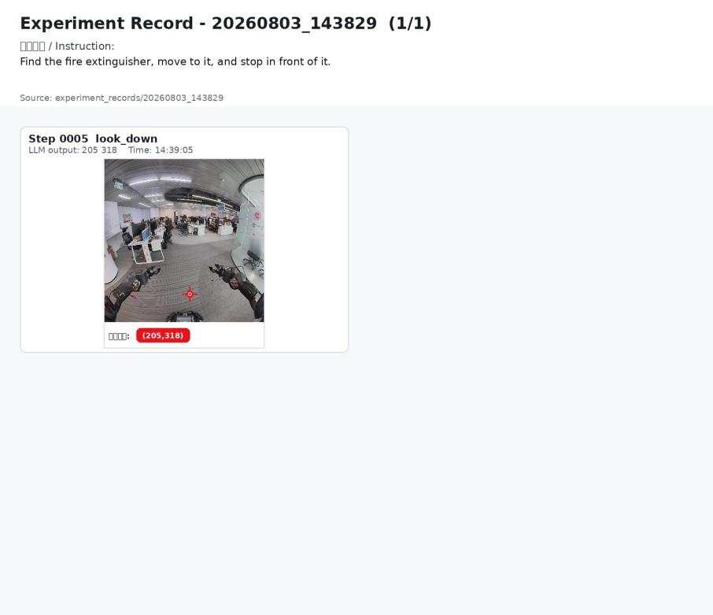
2 | Move to the fire extinguisher and stop in front of it. | 否 | 输出错误目标 | 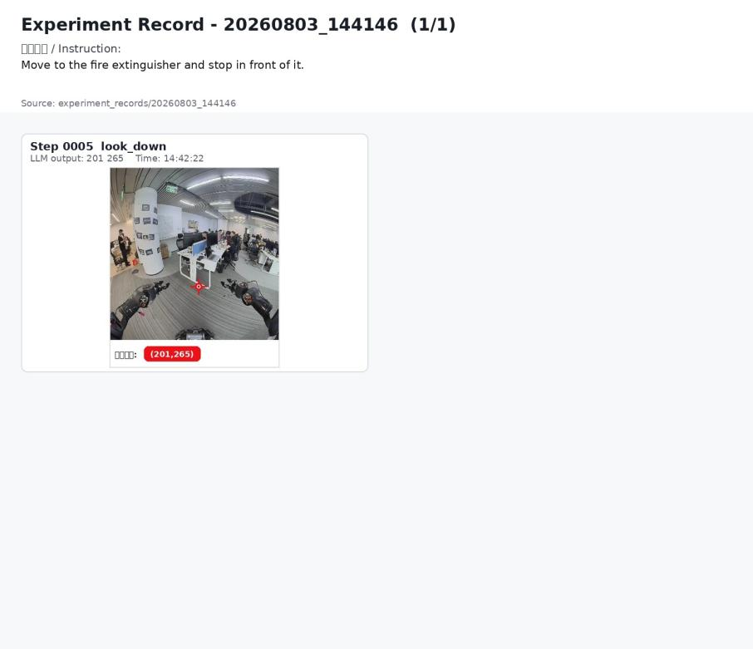
3 | Move to the red fire extinguisher cabinet and stop in front of it. | 是 | 已输出目标像素坐标，运行图中记录了目标定位帧。 | 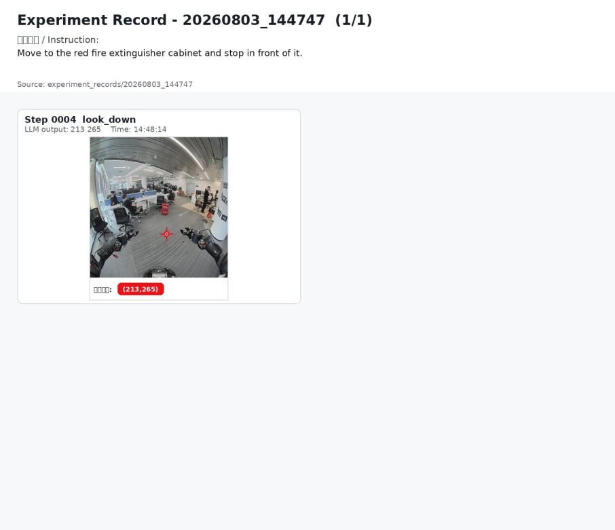
4 | Move to the red fire extinguisher cabinet and stop in front of it. | 是 | 第 5 步输出目标坐标 | 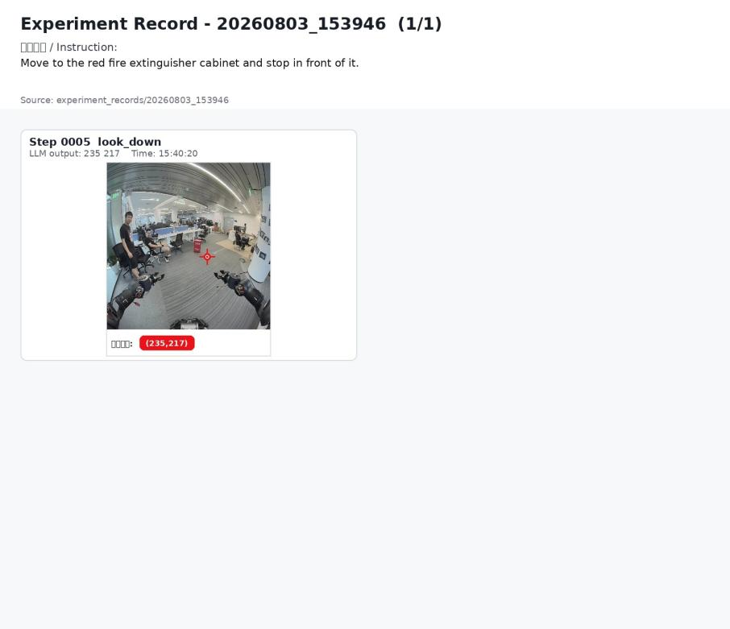
5 | Move to the fire extinguisher cabinet and stop in front of it. | 否 | 输出错误目标 | 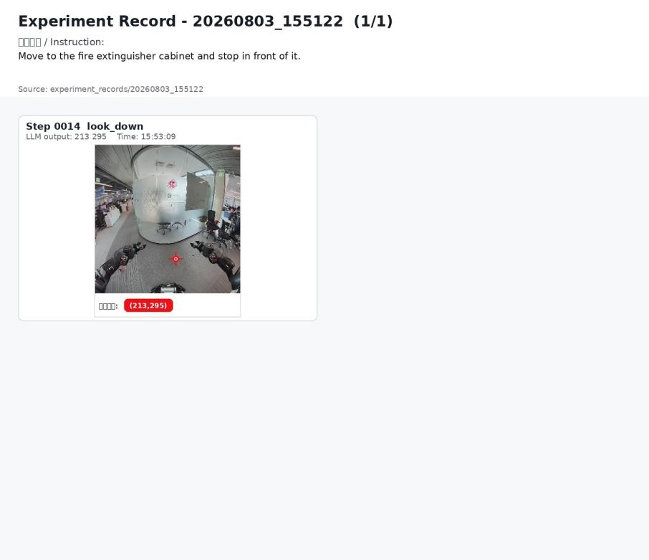
6 | Find the fire extinguisher cabinet and stop when you are close to it. | 否 | 输出错误目标 | 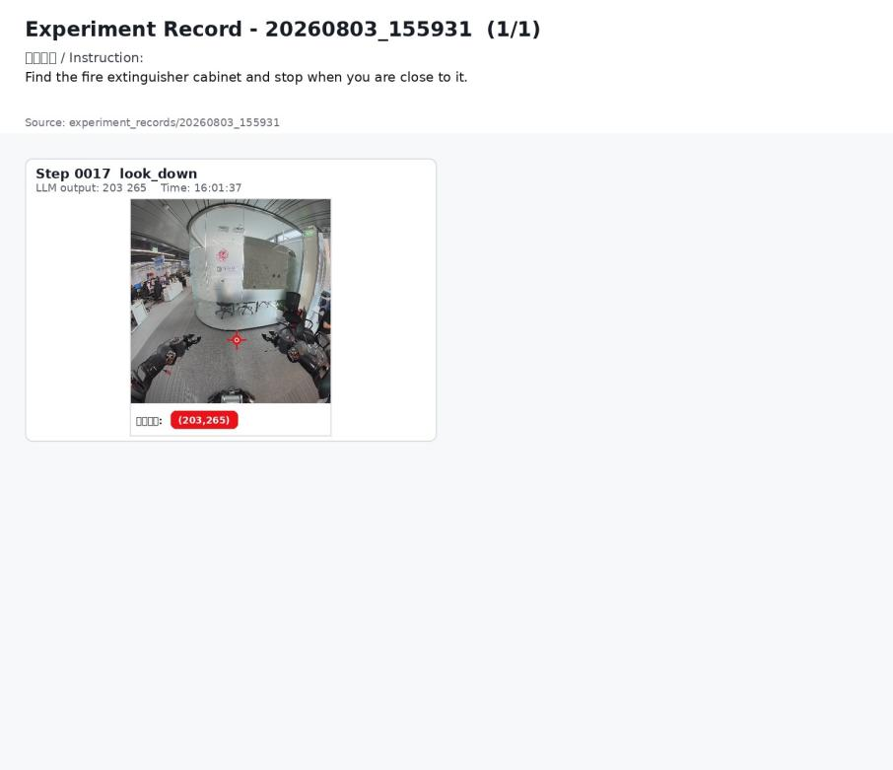
7 | Find the fire extinguisher cabinet and stop when you are close to it. | 否 | 输出错误目标 | 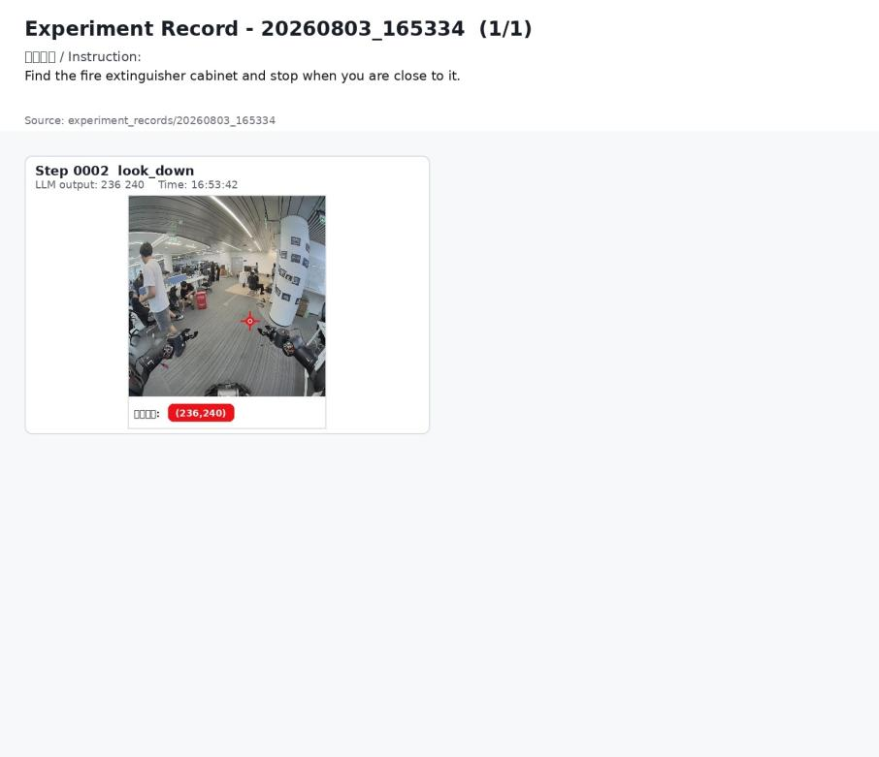
8 | Find the fire extinguisher cabinet and stop when you are close to it. | 否 | 输出错误目标 | 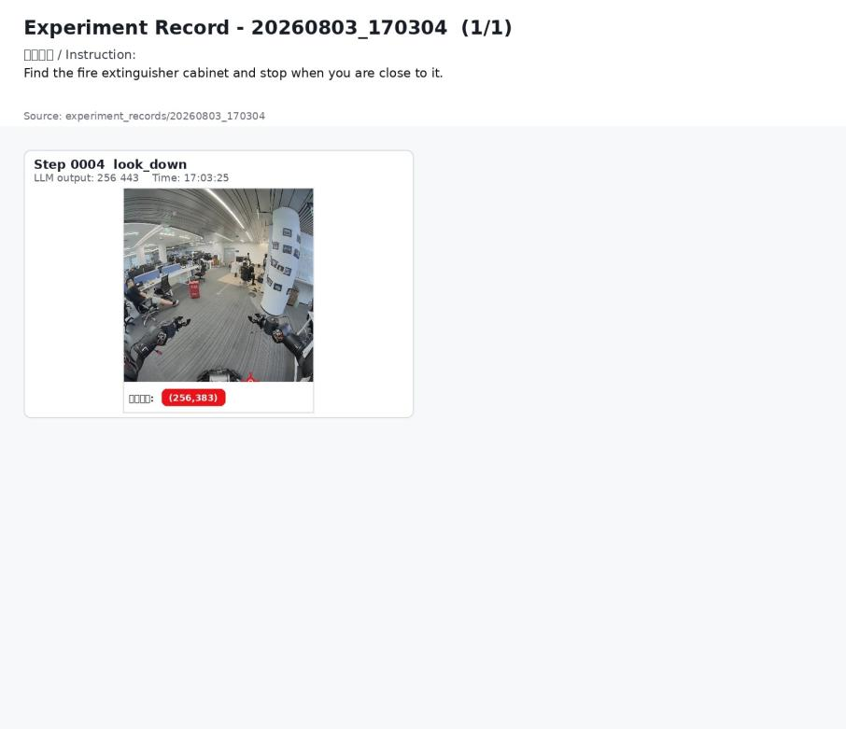
9 | Find the red fire extinguisher cabinet and stop when you are close to it. | 否 | 输出错误目标 | 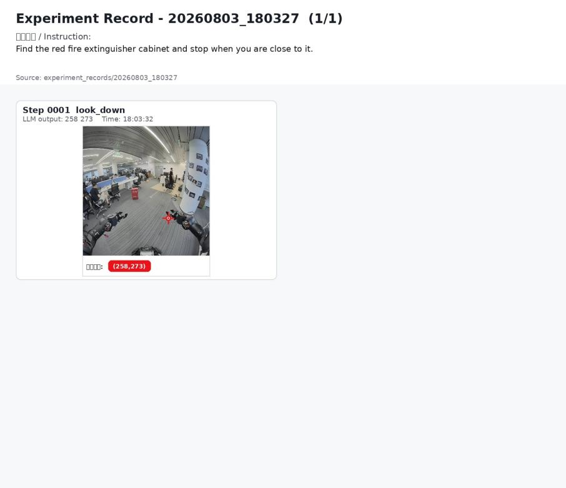
10 | Find the red fire extinguisher cabinet and stop when you are close to it. | 否 | 输出错误目标 | 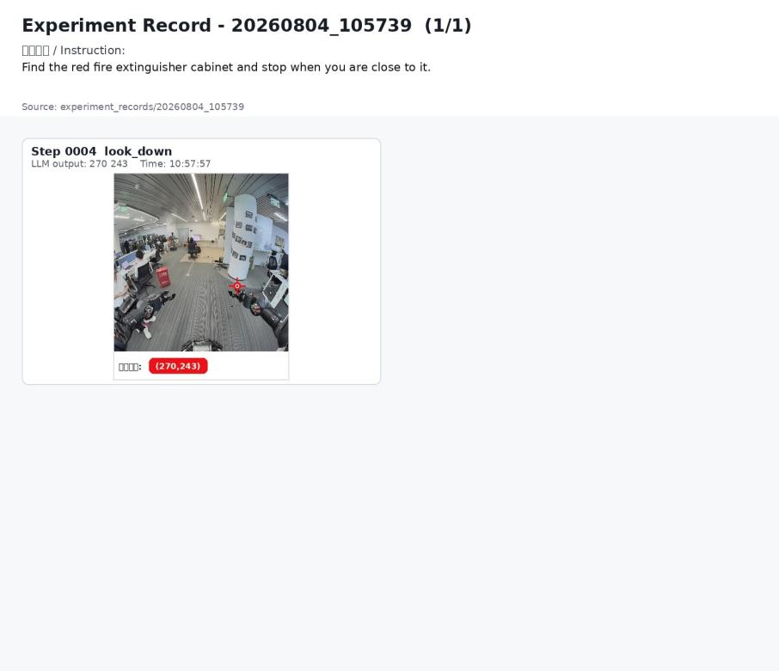
11 | Find the red fire extinguisher cabinet and stop when you are close to it. | 否 | 输出错误目标 | 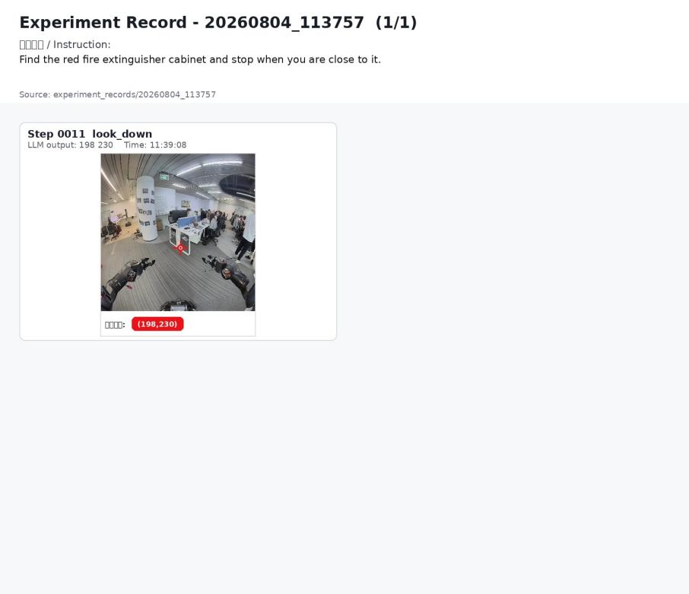
12 | Find the fire extinguisher cabinet and stop when you are close to it. | 否 | 机器人原地旋转搜索；记录中未形成有效目标定位，未完成靠近并停下。 | 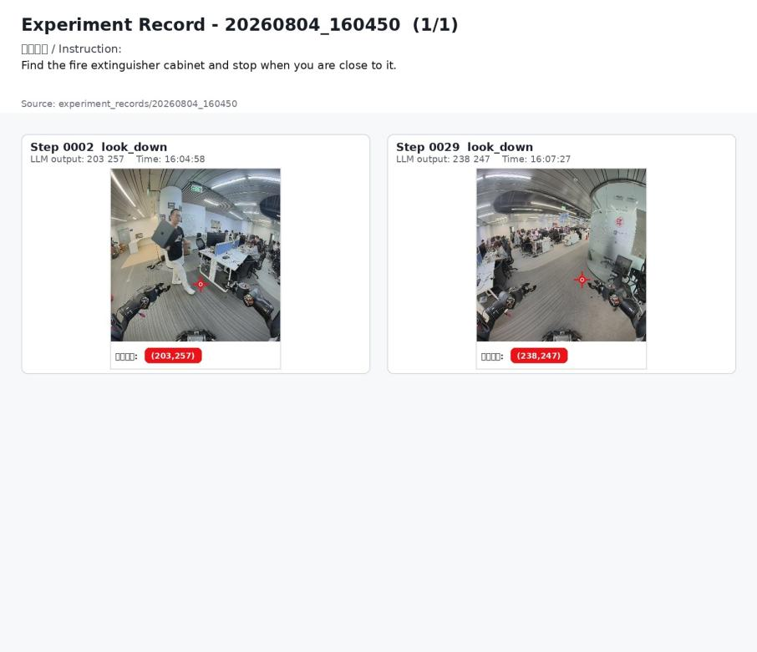
13 | Find the red fire extinguisher cabinet and stop when you are close to it. | 是 | 画面左前方出现红色灭火器柜；第 1 步输出目标像素坐标。 | 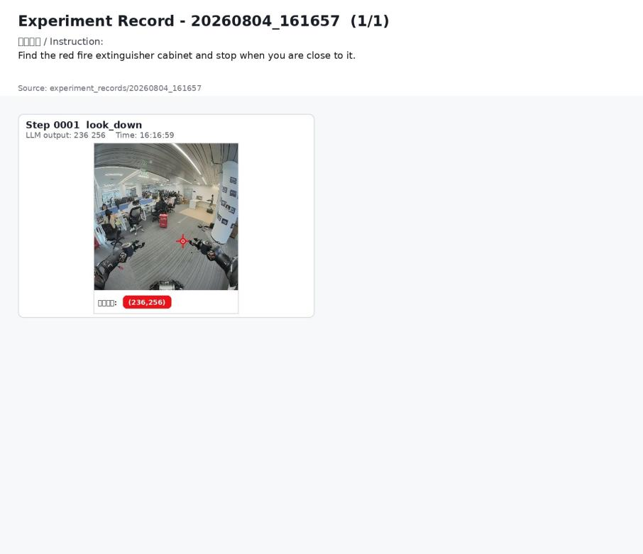
14 | Find the red fire extinguisher cabinet and stop when you are close to it. | 否 | 输出错误目标 | 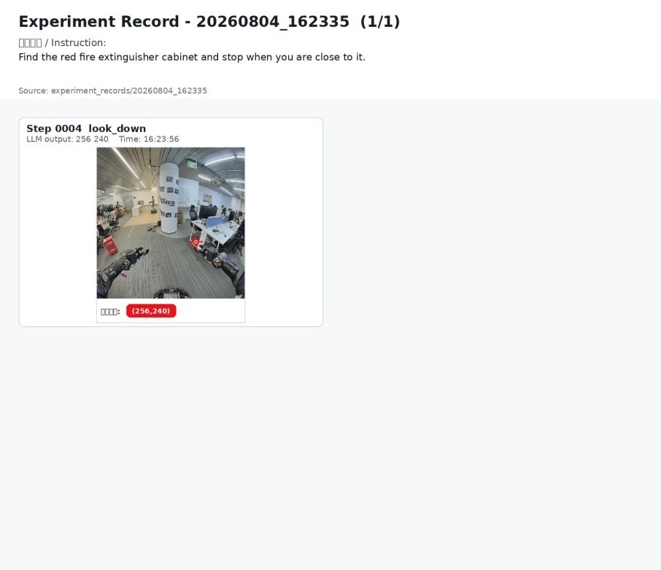
15 | Move to the red fire extinguisher cabinet and stop next to it. | 是 | 已输出目标像素坐标，运行图中记录了目标定位帧。 | 