实验报告完整整理
整理范围：实验目录中具有“指令 + 原始运行图片”的记录。判定“是”表示记录已输出目标像素坐标并在截图中出现对应目标；“否”表示未形成有效目标定位。
序号 | 指令 | 是否找到物品 | 现象 | 运行图片
1 | Find the fire extinguisher, move to it, and stop in front of it. | 否 | 输出错误目标 | 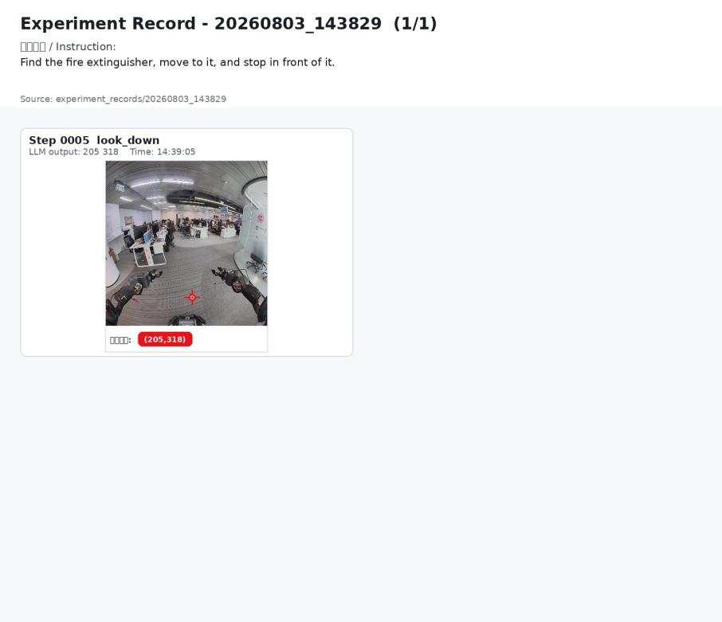
2 | Move to the fire extinguisher and stop in front of it. | 否 | 输出错误目标 | 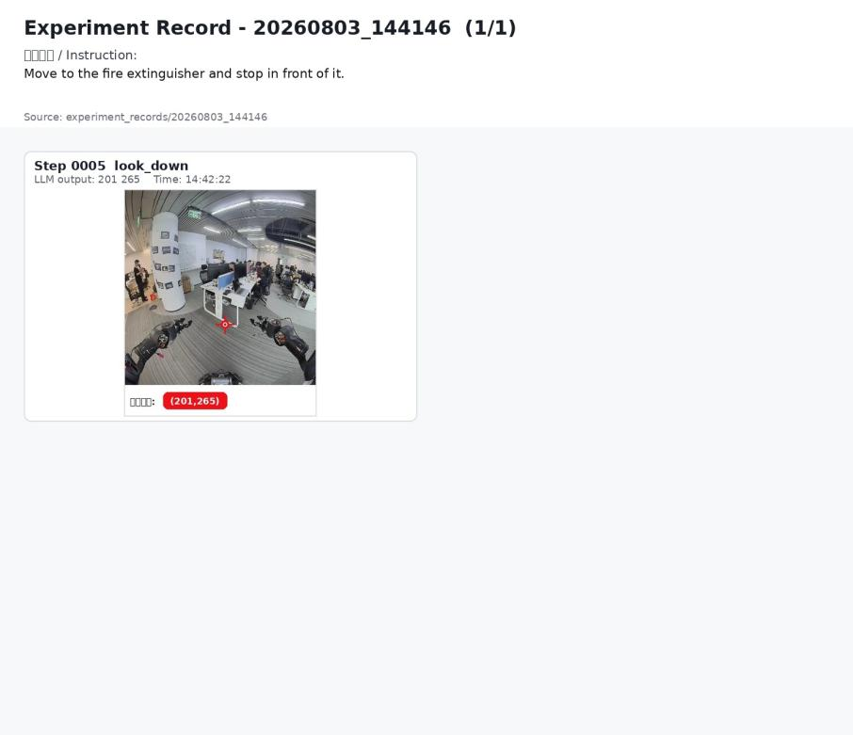
3 | Move to the red fire extinguisher cabinet and stop in front of it. | 是 | 已输出目标像素坐标，运行图中记录了目标定位帧。 | 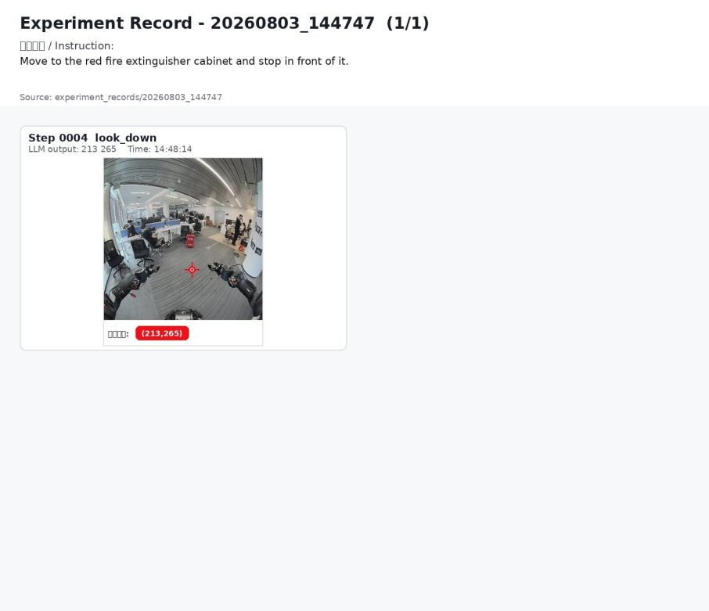
4 | Move to the red fire extinguisher cabinet and stop in front of it. | 是 | 第 5 步输出目标坐标 | 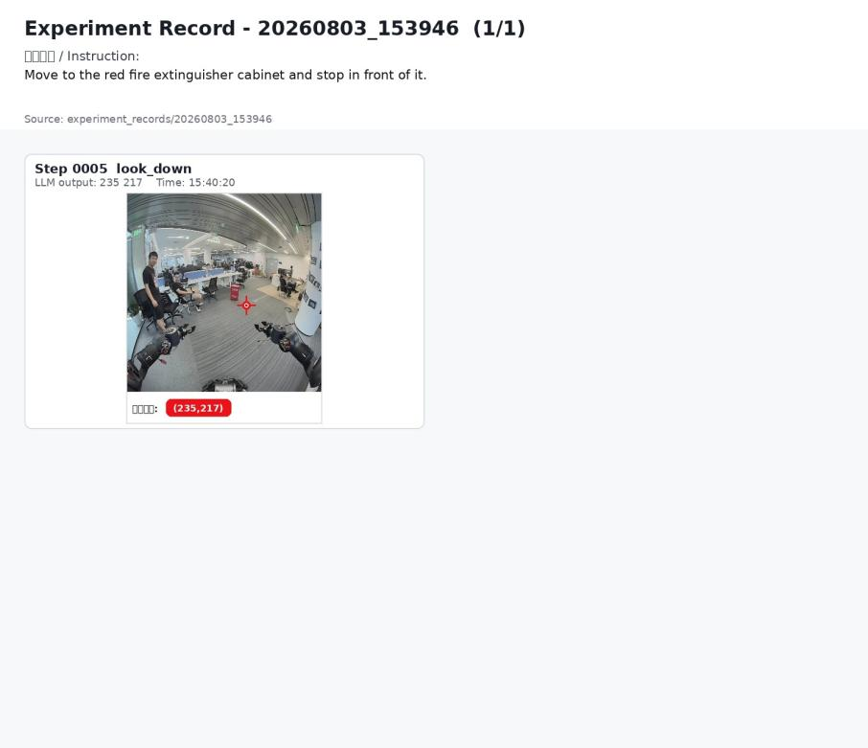
5 | Move to the fire extinguisher cabinet and stop in front of it. | 否 | 输出错误目标 | 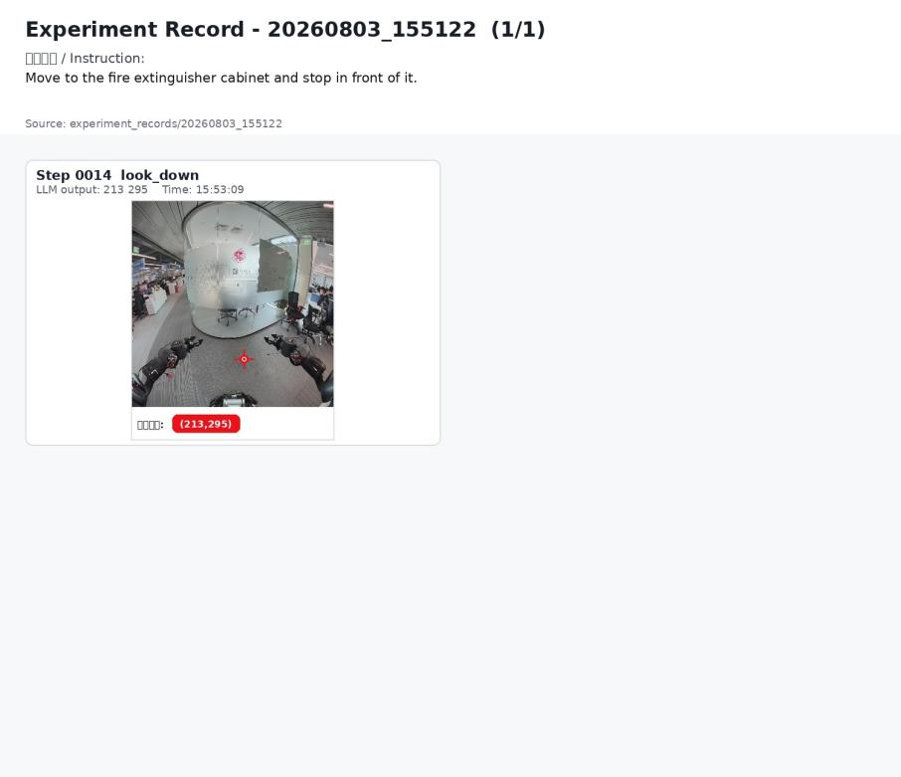
6 | Find the fire extinguisher cabinet and stop when you are close to it. | 否 | 输出错误目标 | 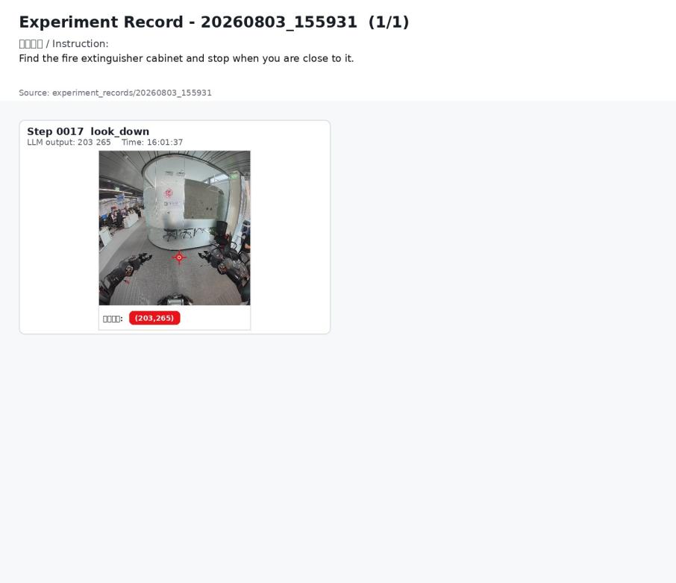
7 | Find the fire extinguisher cabinet and stop when you are close to it. | 否 | 输出错误目标 | 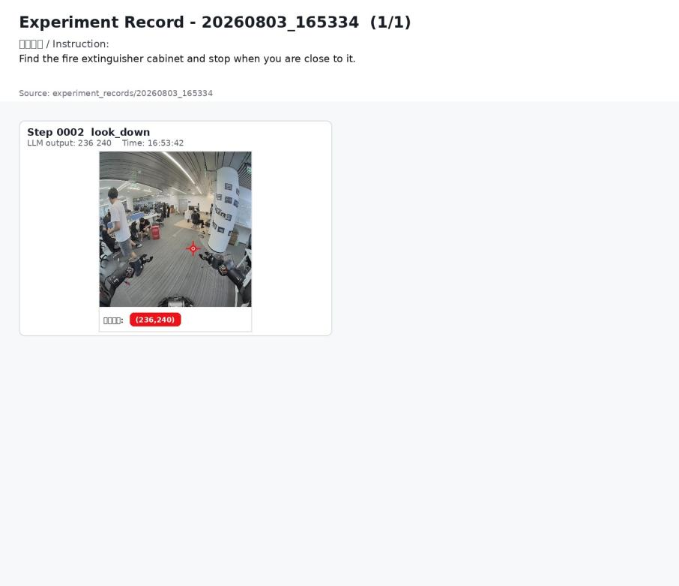
8 | Find the fire extinguisher cabinet and stop when you are close to it. | 否 | 输出错误目标 | 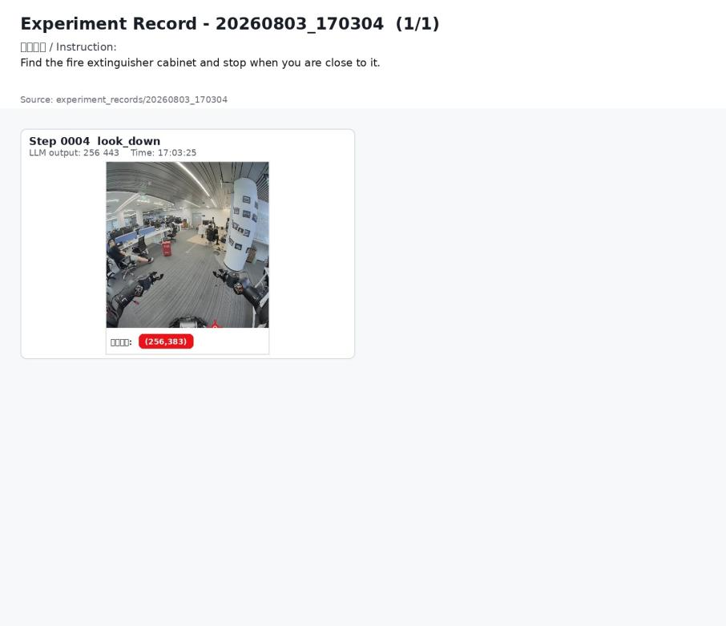
9 | Find the red fire extinguisher cabinet and stop when you are close to it. | 否 | 输出错误目标 | 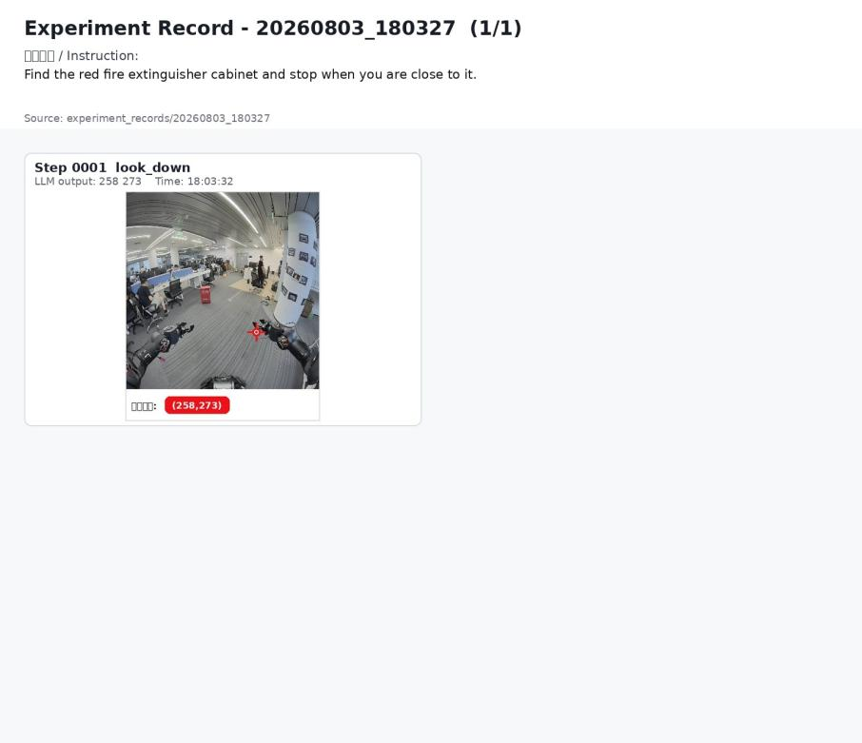
10 | Find the red fire extinguisher cabinet and stop when you are close to it. | 否 | 输出错误目标 | 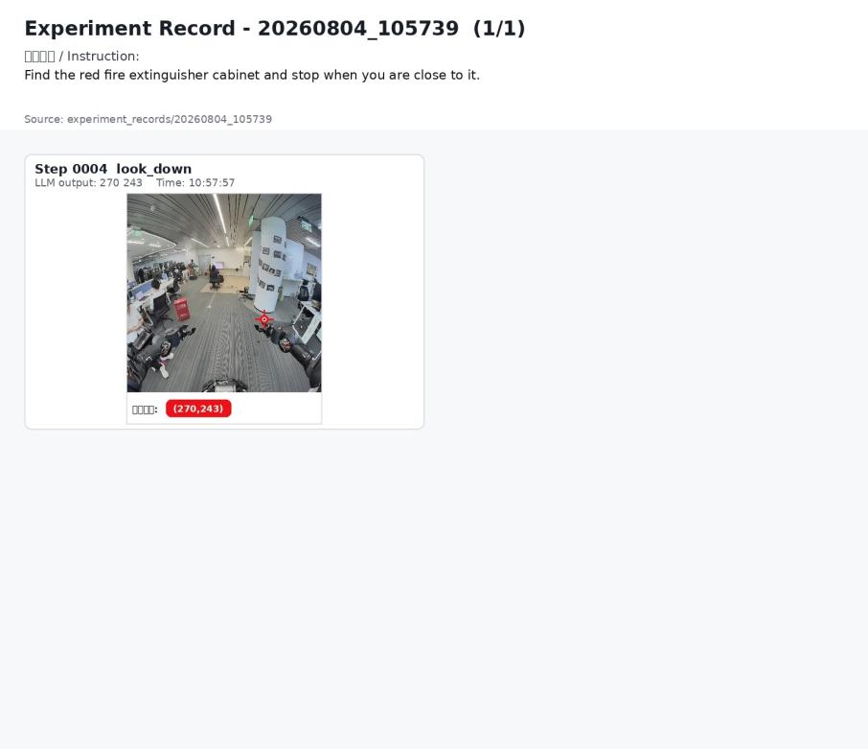
11 | Find the red fire extinguisher cabinet and stop when you are close to it. | 否 | 输出错误目标 | 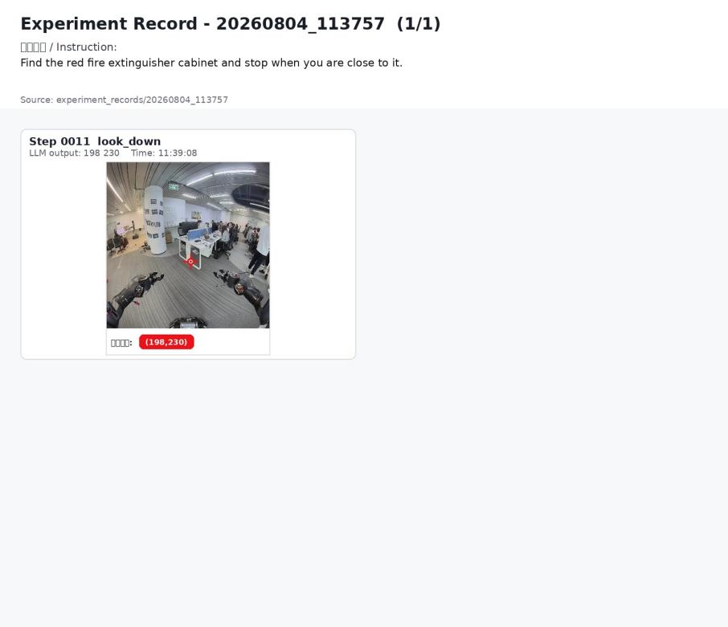
12 | Find the fire extinguisher cabinet and stop when you are close to it. | 否 | 机器人原地旋转搜索；记录中未形成有效目标定位，未完成靠近并停下。 | 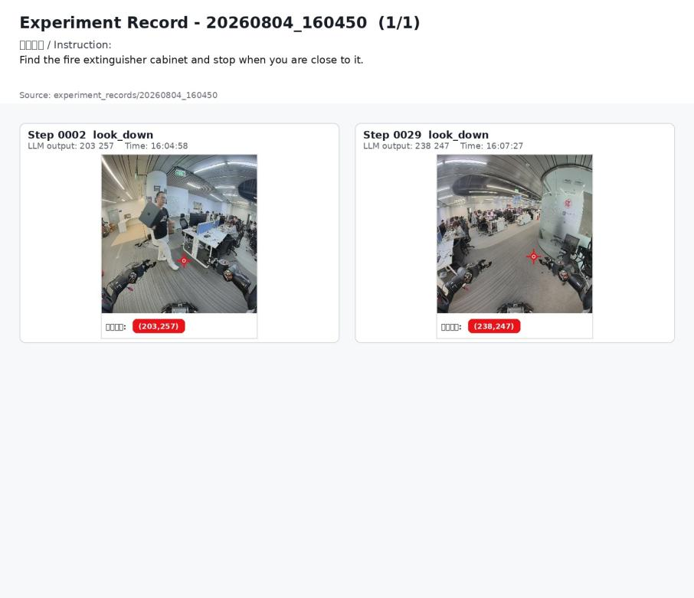
13 | Find the red fire extinguisher cabinet and stop when you are close to it. | 是 | 画面左前方出现红色灭火器柜；第 1 步输出目标像素坐标。 | 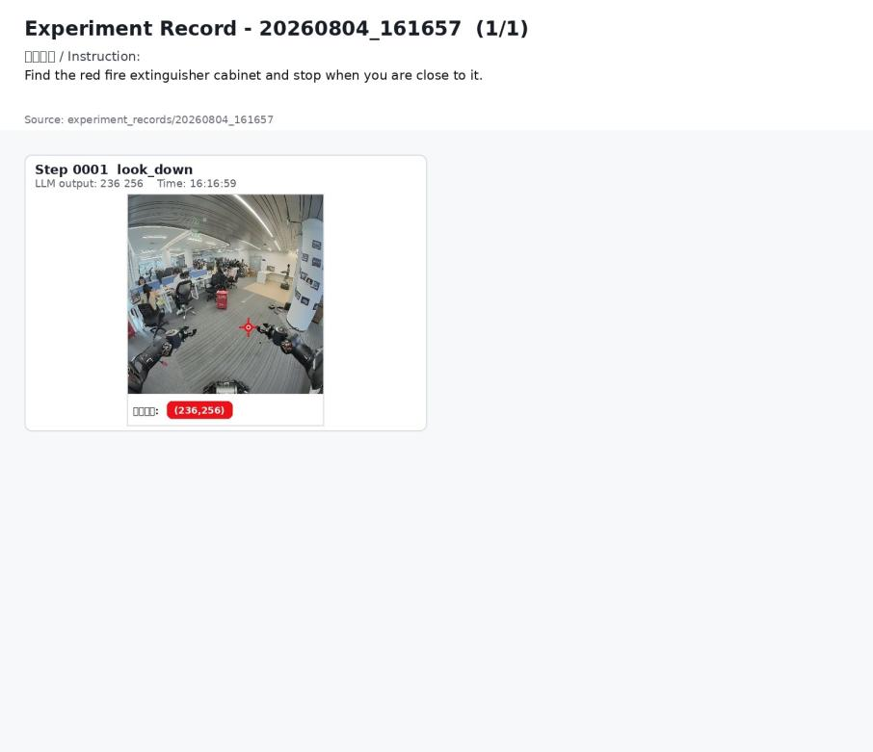
14 | Find the red fire extinguisher cabinet and stop when you are close to it. | 否 | 输出错误目标 | 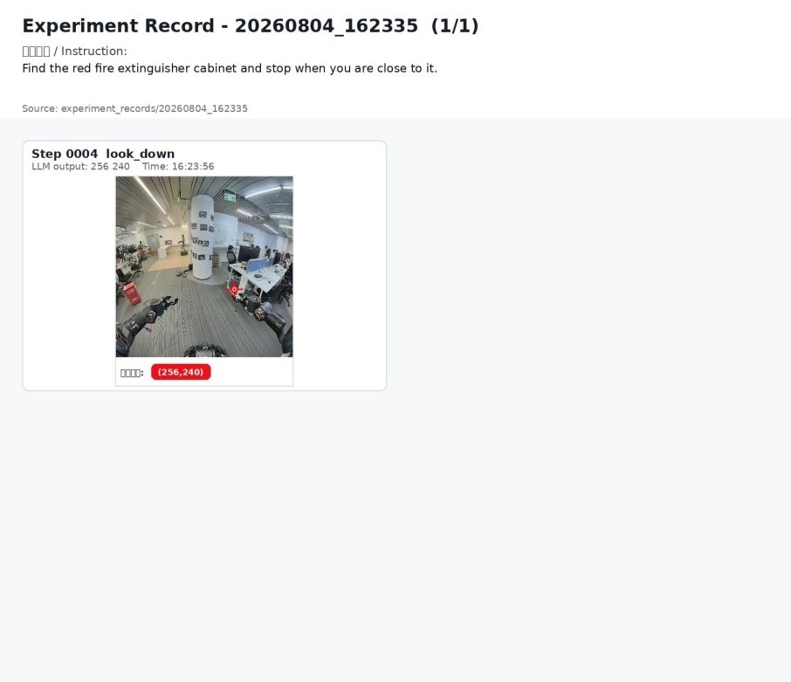
15 | Move to the red fire extinguisher cabinet and stop next to it. | 是 | 已输出目标像素坐标，运行图中记录了目标定位帧。 | 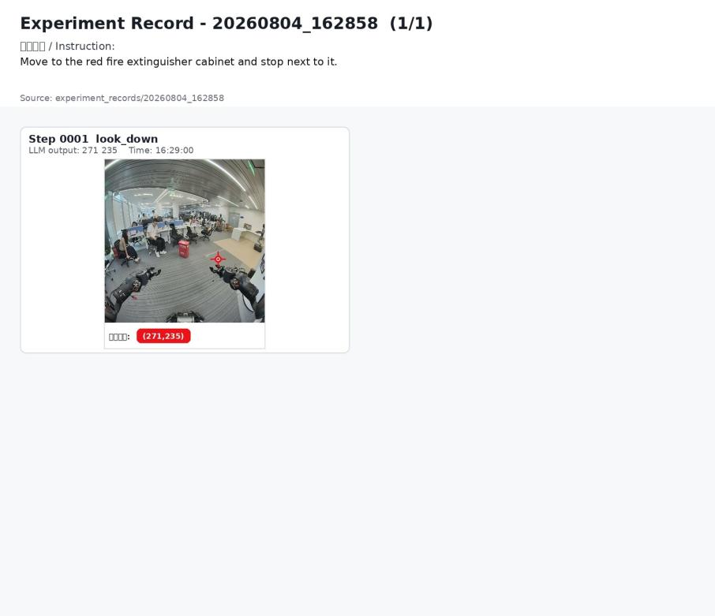

0804 纸箱子、左转与黄色牌子桌子实验补充
整理范围：/home/spirit-ai/Intern_g1/experiment_records/0804/20260804_183908 至 /home/spirit-ai/Intern_g1/experiment_records/20260804_195755。 本节按现有报告口径补充时间戳记录，运行图片优先采用 pixel_goal 可视化图；现象中同步记录实机运动结果。
序号 | 指令 | 是否找到物品 | 现象 | 运行图片
16 | Move to the cardboard box and stop next to it. | 是 | 20260804_183908；输出目标像素坐标 236 256；仅保存模型输出与运行图片。对应运行目录：未匹配 real_motion 汇总。 | 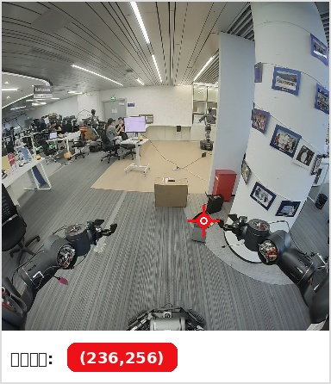
17 | Move to the cardboard box and stop next to it. | 是 | 20260804_184415；输出目标像素坐标 283 267；最大位移 0.065m；yaw 变化 -8.6deg；最终 HOLD：motion timeout after 10.05s。对应运行目录：real_motion_move_cardboard_box_retest_20260804_184408。 | 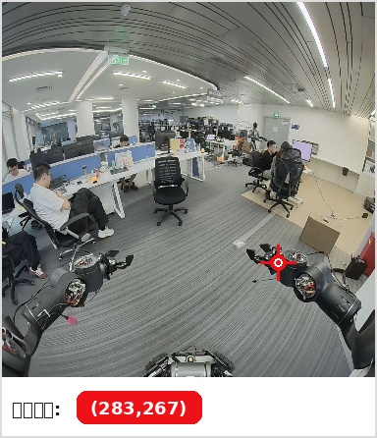
18 | Turn right until you see the cardboard box, then move to the front of the cardboard box and stop. | 是 | 20260804_184652；输出目标像素坐标 358 217；搜索转向完成 2 段；最大位移 0.044m；yaw 变化 -11.2deg；最终 HOLD：motion timeout after 10.05s。对应运行目录：real_motion_turn_right_to_cardboard_box_20260804_184645。 | 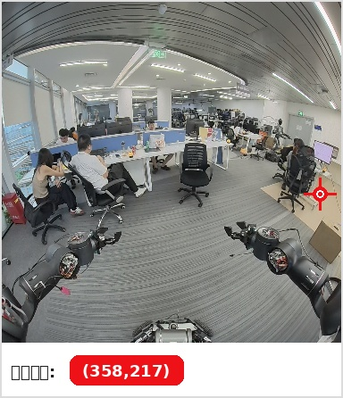
19 | Turn left until you see the cardboard box, then move to the front of the cardboard box and stop. | 是 | 20260804_184856；输出目标像素坐标 275 341；搜索转向完成 1 段；最大位移 0.025m；yaw 变化 -0.1deg；最终 HOLD：motion timeout after 10.05s。对应运行目录：real_motion_turn_left_to_cardboard_box_20260804_184849。 | 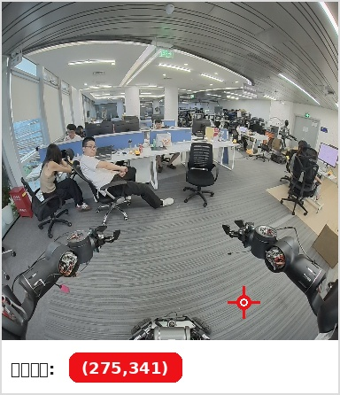
20 | Turn left until you see the cardboard box, then move to the front of the cardboard box and stop. | 是 | 20260804_185104；输出目标像素坐标 276 280；搜索转向完成 1 段；最大位移 0.022m；yaw 变化 -0.0deg；最终 HOLD：motion timeout after 10.05s。对应运行目录：real_motion_turn_left_to_cardboard_box_retest_20260804_185056。 | 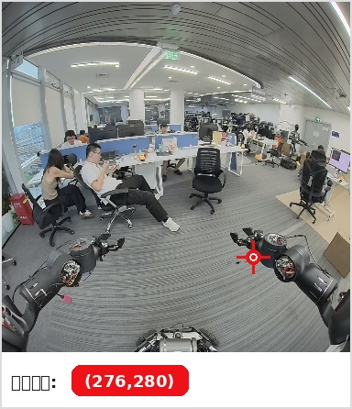
21 | Turn left until you see the cardboard box, then move to the front of the cardboard box and stop. | 是 | 20260804_185322；输出目标像素坐标 275 308；前进完成 0.390m、0.391m；搜索转向完成 2 段；最大位移 1.035m；yaw 变化 0.0deg；最终 HOLD：motion timeout after 10.05s。对应运行目录：real_motion_turn_left_to_cardboard_box_retest2_20260804_185315。 | 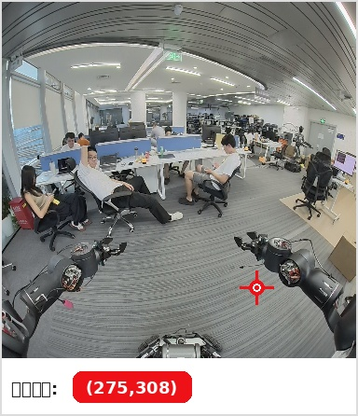
22 | Turn left until you see the cardboard box, then move to the front of the cardboard box and stop. | 是 | 20260804_185534；输出目标像素坐标 285 307；最大位移 0.038m；yaw 变化 -11.2deg；最终 HOLD：motion timeout after 10.05s。对应运行目录：real_motion_turn_left_to_cardboard_box_retest3_20260804_185527。 | 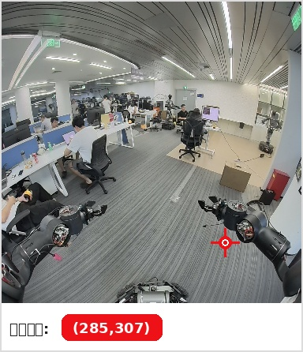
23 | Turn right until you see the cardboard box, then move to the front of the cardboard box and stop. | 是 | 20260804_185726；输出目标像素坐标 283 253；最大位移 0.035m；yaw 变化 -12.6deg；最终 HOLD：motion timeout after 10.05s。对应运行目录：real_motion_turn_right_to_cardboard_box_retest_20260804_185719。 | 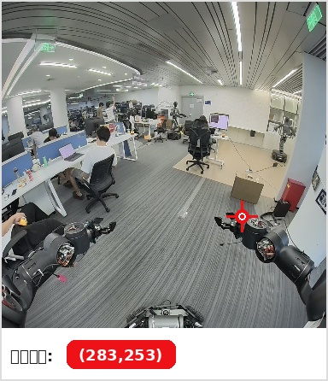
24 | Turn left until you see the cardboard box, then move to the front of the cardboard box and stop. | 是 | 20260804_185928；输出目标像素坐标 280 311；最大位移 0.114m；yaw 变化 -1.1deg；最终 HOLD：motion timeout after 10.05s。对应运行目录：real_motion_turn_left_to_cardboard_box_retest4_20260804_185921。 | 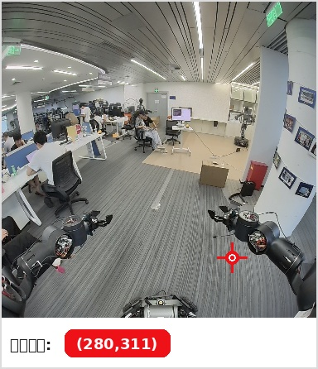
25 | Turn left until you see the cardboard box, then move to the front of the cardboard box and stop. | 是 | 20260804_192229；输出目标像素坐标 265 243；最大位移 0.032m；yaw 变化 43.4deg；触发 E_STOP：spin overshoot: 28.37deg。对应运行目录：real_motion_turn_left_to_cardboard_box_retest5_20260804_192222。 | 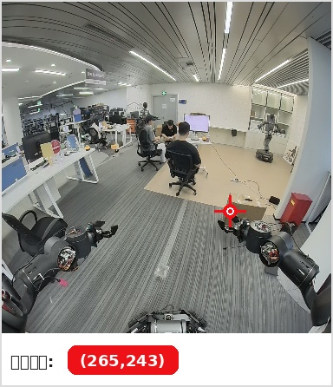
26 | Turn left until you see the cardboard box, then move to the front of the cardboard box and stop. | 是 | 20260804_192326；输出目标像素坐标 261 257；最大位移 0.118m；yaw 变化 -1.8deg；最终 HOLD：motion timeout after 18.00s。对应运行目录：real_motion_turn_left_to_cardboard_box_retest6_signfix_20260804_192319。 | 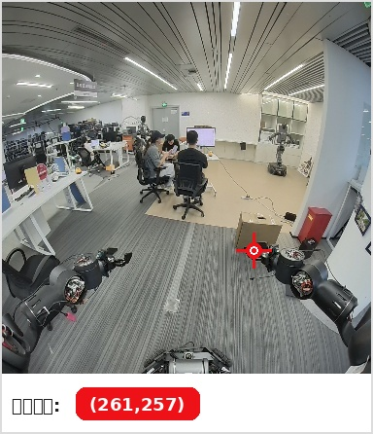
27 | Turn left until you see the cardboard box, then move to the front of the cardboard box and stop. | 是 | 20260804_192546；输出目标像素坐标 273 261；最大位移 0.033m；yaw 变化 -0.1deg；最终 HOLD：motion timeout after 22.05s。对应运行目录：real_motion_turn_left_to_cardboard_box_retest7_20260804_192539。 | 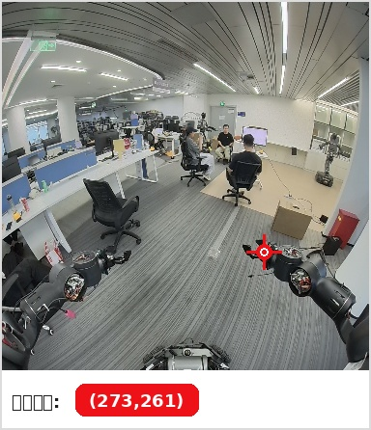
28 | Turn left until you see the cardboard box, then move to the front of the cardboard box and stop. | 是 | 20260804_192738；输出目标像素坐标 273 285；前进完成 0.291m、0.345m、0.298m；最大位移 0.936m；yaw 变化 -3.1deg；最终 HOLD：motion timeout after 12.05s。对应运行目录：real_motion_turn_left_to_cardboard_box_retest8_20260804_192731。 | 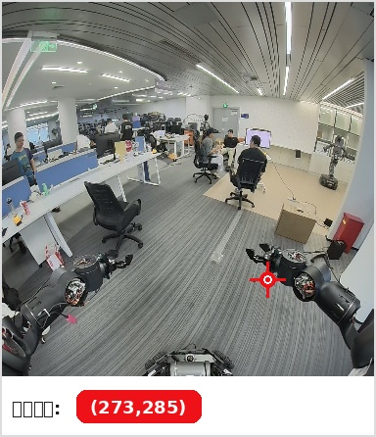
29 | Turn left 180 degrees until you see the cardboard box, then move to the front of the cardboard box and stop. | 是 | 20260804_193057；输出目标像素坐标 236 256；前进完成 0.290m；搜索转向完成 6 段；最大位移 0.320m；yaw 变化 117.4deg；最终 HOLD：motion timeout after 35.05s。对应运行目录：real_motion_turn_left_180_to_cardboard_box_20260804_193050。 | 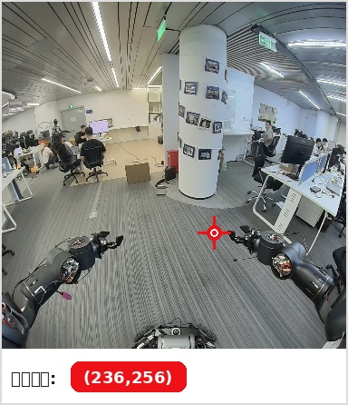
30 | Move forward to the cardboard box, then turn left, then move to the table with the yellow sign and stop in front of it. | 部分 | 20260804_194034；输出目标像素坐标 230 247；前进完成 0.298m；最大位移 0.435m；yaw 变化 -6.3deg；最终 HOLD：motion timeout after 28.05s。对应运行目录：real_motion_cardboard_then_left_to_yellow_sign_table_20260804_194027。 | 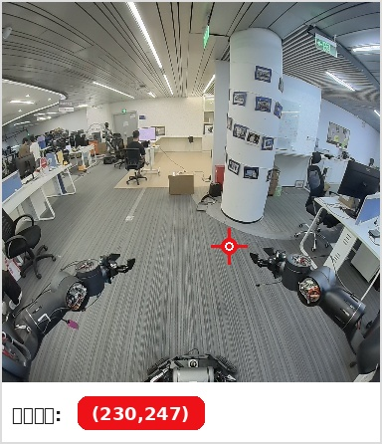
31 | Follow these stages in order. Stage 1: move forward only toward the cardboard box and stop close in front of the cardboard box. Stage 2: after stopping at the cardboard box, turn left in place until the table with the yellow sign is visible. Stage 3: move forward to the table with the yellow sign and stop in front of it. Do not go to the yellow sign table before completing the cardboard box stop and the left turn. | 部分 | 20260804_194404；输出目标像素坐标 270 280；最大位移 0.041m；yaw 变化 147.7deg；最终 HOLD：motion timeout after 30.05s。对应运行目录：real_motion_staged_cardboard_left_yellow_table_20260804_194357。 | 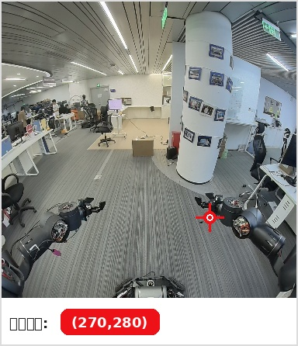
32 | Stage A: go straight to the cardboard box and stop in front of it; do not turn yet. Stage B: after the cardboard box stop, rotate left to search for the table with the yellow sign. Stage C: when the yellow sign table is visible, go straight to that table and stop in front of it. | 部分 | 20260804_194524；输出目标像素坐标 246 257；前进完成 0.273m、0.273m、0.274m；最大位移 0.892m；yaw 变化 -27.7deg；最终 HOLD：motion timeout after 30.05s。对应运行目录：real_motion_staged_cardboard_left_yellow_table_v2_20260804_194517。 | 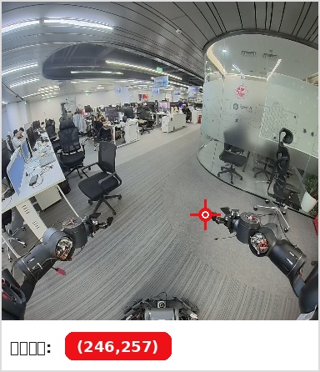
33 | Go straight toward the cardboard box and stop directly in front of it without turning. After you have completely stopped at the cardboard box, rotate to the left and continue turning until you can see the table with the yellow sign. Once the table with the yellow sign is clearly visible, stop rotating, move straight toward it, and stop directly in front of the table. | 部分 | 20260804_195053；输出目标像素坐标 206 237；最大位移 0.259m；yaw 变化 -1.4deg；最终 HOLD：motion timeout after 30.05s。对应运行目录：real_motion_user_prompt_cardboard_left_yellow_table_20260804_195046。 | 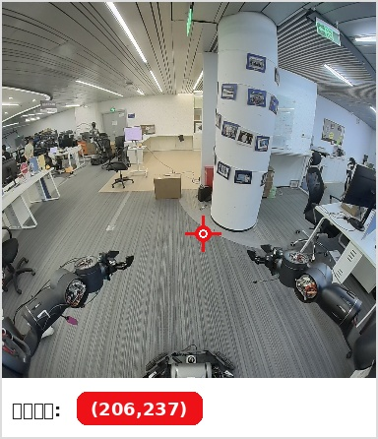
34 | Go straight toward the cardboard box and stop directly in front of it without turning. After you have completely stopped at the cardboard box, rotate to the left and continue turning until you can see the table with the yellow sign. Once the table with the yellow sign is clearly visible, stop rotating, move straight toward it, and stop directly in front of the table. | 部分 | 20260804_195254；输出目标像素坐标 278 236；最大位移 0.030m；yaw 变化 147.6deg；最终 HOLD：motion timeout after 30.05s。对应运行目录：real_motion_user_prompt_cardboard_left_yellow_table_retest_20260804_195247。 | 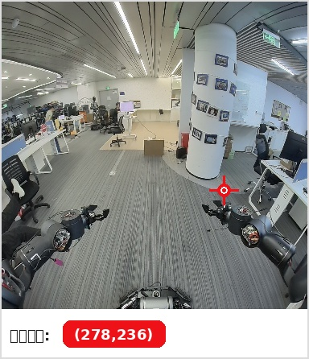
35 | Go straight toward the cardboard box and stop directly in front of it without turning. After you have completely stopped at the cardboard box, rotate to the left and continue turning until you can see the table with the yellow sign. Once the table with the yellow sign is clearly visible, stop rotating, move straight toward it, and stop directly in front of the table. | 部分 | 20260804_195536；输出目标像素坐标 278 236；最大位移 0.046m；yaw 变化 146.8deg；最终 HOLD：motion timeout after 30.05s。对应运行目录：real_motion_user_prompt_cardboard_left_yellow_table_retest2_20260804_195529。 | 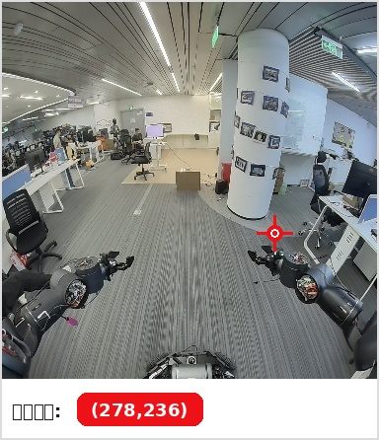
36 | Go straight toward the cardboard box and stop directly in front of it without turning. After you have completely stopped at the cardboard box, rotate to the left and continue turning until you can see the table with the yellow sign. Once the table with the yellow sign is clearly visible, stop rotating, move straight toward it, and stop directly in front of the table. | 部分 | 20260804_195755；输出目标像素坐标 236 275；前进完成 0.246m、0.606m；最大位移 0.830m；yaw 变化 -7.6deg；最终 HOLD：motion timeout after 30.05s。对应运行目录：real_motion_user_prompt_cardboard_left_yellow_table_retest3_20260804_195748。 | 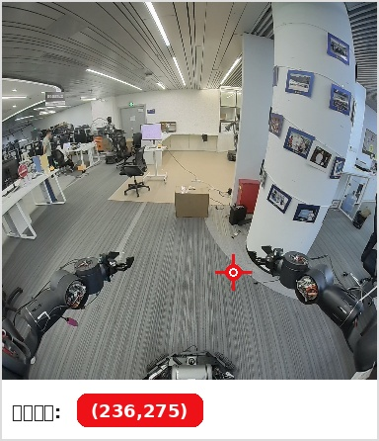
补充结论：本批记录中，纸箱子目标多数能输出像素坐标并触发前进；复合任务“纸箱子 -> 左转 -> 黄色牌子桌子”可稳定完成前进到纸箱子与进入左转的阶段切换，但左转段多次因 motion timeout 停止，未进入最终走向黄色牌子桌子的阶段。

