An Internship Report
Of
C++ Programming

Submitted
To
School of Computer Science and Engineering
IILM University, Greater Noida, U.P.

In partial fulfilment of the requirement of degree of
B-Tech (CSE)



By

Roll Number of Student:- 25SCS1003004157
Name of Student: Yuganshu Kumar Jha

Batch: 2025-29
CANDIDATE'S DECLARATION
I, YUGANSHU KUMAR JHA, do hereby declare that the internship report titled “C++ PROGRAMMING” has been completed by me to fulfil the requirement for the award of the degree of Bachelor of Technology in Computer Science and Engineering. All the references have been quoted and I have not taken as such any material from any other source. I affirm that this report is my own and has not been submitted to any other institute for any degree/diploma requirement, and further I shall be solely responsible for any kind of copyright violation in this regard.
Signature:-

Student Name: YUGANSHU KUMAR JHA

Roll No.: 25SCS1003004157

ACKNOWLEDGEMENT
I am using this opportunity to express my gratitude to everyone who supported me throughout the Internship Program. I am thankful for their aspiring guidance, invaluably constructive criticism and friendly advice during this work. I am sincerely grateful to them for sharing their truthful and illuminating views on a number of issues related to this work.
I would like to thank the THIRANEX VIRTUAL INTERNSHIP for providing me the opportunity and the structured platform to learn and gain hands-on exposure in the domain of C++ PROGRAMMING. I am also thankful to my institute, IILM University, Greater Noida, and the faculty of the School of Computer Science and Engineering for their continuous support and encouragement.
I express my gratitude to my parents for their blessings.
Signature:

Student Name: YUGANSHU KUMAR JHA

Roll No.: 25SCS1003004157

TABLE OF CONTENTS
1. Candidate's Declaration i
2. Acknowledgement ii
3. Internship Completion Certificate -
4. Project Description
4.1 Introduction 1
4.2 Organization Profile 1
4.3 Problem Statement 2
4.4 Project Objectives 2
4.5 Scope of the Project 2
4.6 Technologies and Tools Used 3
4.7 System Architecture 3
4.8 Methodology 4
4.9 Expected Outcomes 5
4.10 Certificates of Completion and Communication Proof 6
5. Bibliography/References 7
3. INTERNSHIP COMPLETION CERTIFICATE
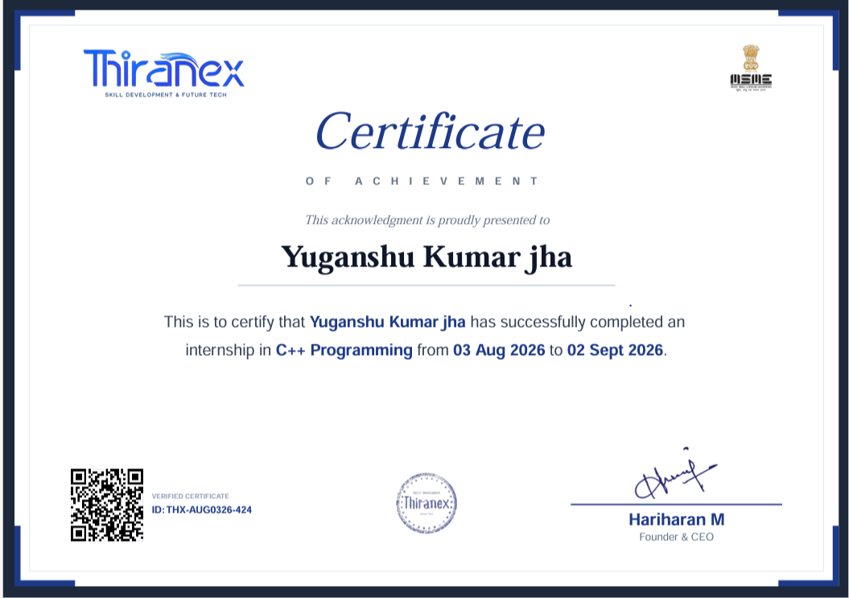

Internship Offer Letter
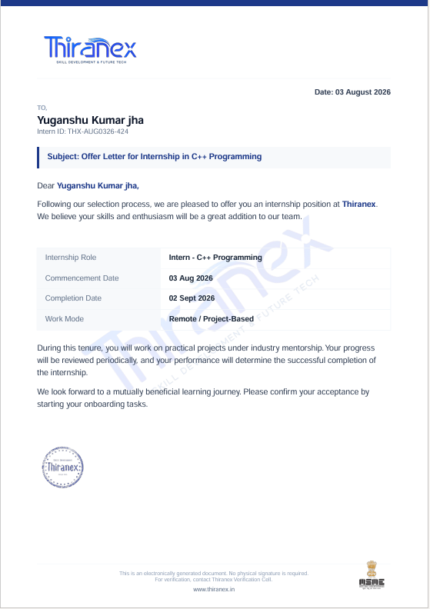

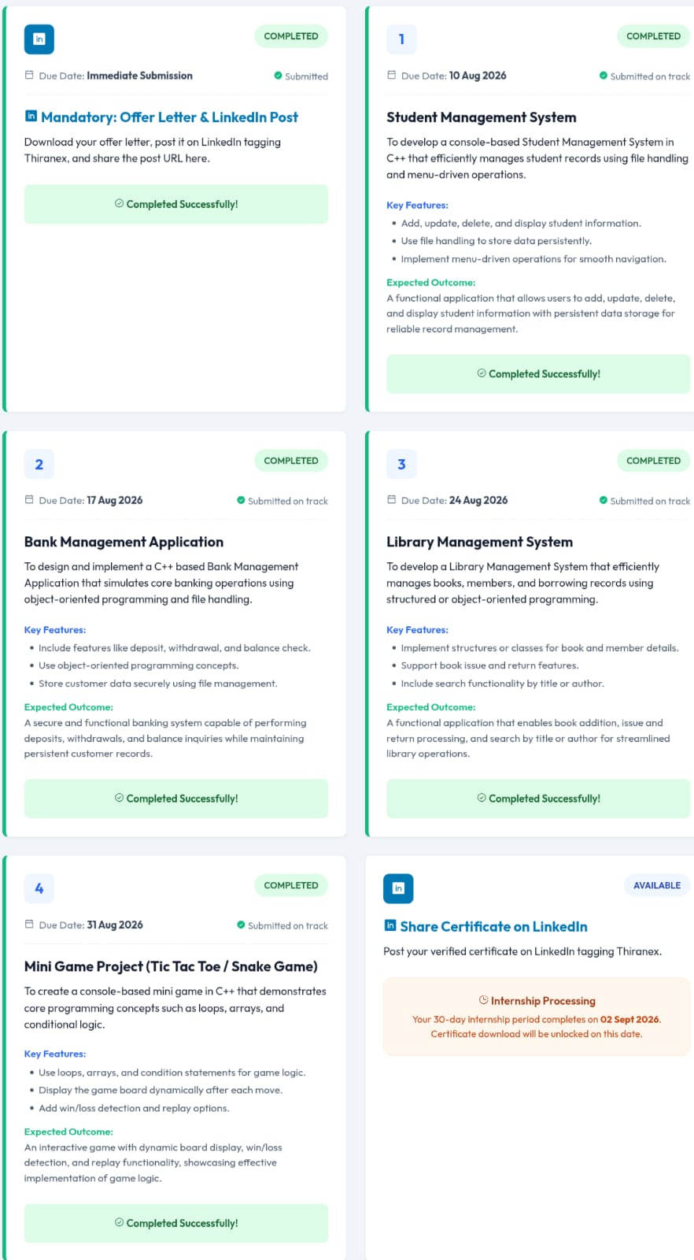

4. PROJECT DESCRIPTION

4.1 Introduction
This report presents a detailed account of the 4-week Virtual Internship undertaken under the THIRANEX Virtual Internship Program, in the domain of “C++ Programming”. The internship was carried out from July 2026 to August 2026 as part of the requirement of the Bachelor of Technology (Computer Science and Engineering) programme at IILM University, Greater Noida. The primary aim of this internship was to bridge the gap between theoretical understanding of Artificial Intelligence and Machine Learning and their real-world, production-grade deployment. Over the course of the programme, the learner was exposed to industry-relevant tools and practices used to take AI/ML models from a research or prototype stage to a fully deployed, monitored, and scalable production system.
The internship followed a structured, week-wise curriculum that combined conceptual learning with hands-on assignments, weekly assessments, project documentation, and a final capstone project. On successful completion of all the requirements, including the final assessment test, a Virtual Internship Certificate was awarded by THIRANEX INDIA.

4.2 Organization Profile
Thiranex India is a software development and technology learning platform dedicated to fostering talent and innovation across various domains. The organization provides virtual internship programs designed to bridge the gap between academic learning and industry requirements by offering hands-on experience in cutting-edge technologies such as Web Development, App Development, Data Science, Cyber Security, and Python/Java programming. Through real-world project assignments, remote learning frameworks, and structured mentorship, Thiranex helps students and aspiring tech professionals strengthen their technical skill sets, build practical portfolios, and enhance their overall employability.

4.3 Problem Statement
The project aims to develop practical C++-based applications that solve simple real-world problems while demonstrating fundamental programming concepts.
The internship tasks focus on creating:
Student Management System
Bank Management Application
Library Management System
Mini Game Project (Tic Tac Toe/ Snake Game)

4.4 Project Objectives
- To develop practical applications using C++ programming.
- To understand and implement C++ fundamentals.
- To use conditional statements and loops for program control.
- To work with String, OOPS, Functions.
- To implement basic Methods for storing and retrieving information.
- To automate repetitive tasks using C++ scripts.
- To develop a simple rule-based Management System using predefined responses.
- To improve problem-solving and logical-thinking skills.
- To create simple, user-friendly command-line applications.

4.5 Scope of the Project
The scope of this project covers the development of simple and practical C++-based applications designed to demonstrate fundamental programming and problem-solving skills. The project includes the implementation of tasks such as a text-based Management System and Game. It involves the use of C++ programming concepts including variables, conditional statements, loops, functions, strings, user input/output. The developed applications are intended for learning and demonstration purposes and operate primarily in a local or command-line environment.
4.6 Technologies and Tools Used
- Programming Language : C++
- Development : C++ IDE/VS Code /IDLE
- Version Control : Git and GitHub
- Data Structure : OOPS,String,Functions
- User Interaction :input() / print()
- Logic : if-else,loops,functions
4.7 System Architecture
The Student Management System follows a modular, console-based architecture developed using C++. The system uses a menu-driven interface to allow users to manage student records efficiently. Data is stored persistently using file handling, so records remain available even after the program is closed.

Architecture Components
- User Interface Layer
  - Provides a console-based menu.
  - Allows users to select operations such as Add, Update, Delete, Search, and Display.
  - Accepts user input and displays system results.
- Application/Business Logic Layer
  - Processes user requests.
  - Performs operations on student records.
  - Validates student information and manages program flow.
  - Implements functions such as adding, updating, deleting, searching, and displaying records.
- Student Data Model
  - Represents student information using C++ structures/classes.
  - Stores details such as Student ID, Name, Course, Age, Contact, etc.
  - Provides organized access to student records.
- File Handling / Data Storage Layer
  - Stores student records in files such as .txt or .dat.
  - Reads existing records when required.
  - Updates and deletes records while maintaining persistent storage.

4.8 Methodology
The Student Management System is developed using a step-by-step modular methodology in C++. The development process focuses on efficient student record management, persistent data storage, and simple user interaction.

1. Requirement Analysis
Identify the basic requirements of the system, including adding, updating, deleting, searching, and displaying student records.

2. System Design
Design a menu-driven console application with separate functions for each major operation. Define the student data structure/class and file storage mechanism.

3. Implementation
Develop the system using C++ and Object-Oriented Programming (OOP) concepts. Implement functions for:
- Add Student
- Update Student
- Delete Student
- Search Student
- Display All Students

4. File Handling
Use C++ file handling to store student records permanently. The system reads data from files when required and writes updated information back to the storage file.

5. Input Validation
Validate user inputs such as Student ID and other required details to reduce invalid or duplicate records and ensure reliable data management.

6. Testing
Test each module individually and then test the complete system to verify that all operations work correctly and data is stored and retrieved properly.

7. Deployment and Usage
After successful testing, the application can be compiled and executed as a console-based C++ application, allowing users to manage student records through the menu interface.
4.9 Expected Outcomes
The Student Management System successfully provides a simple and reliable way to manage student records through a console-based C++ application. The system demonstrates effective use of Object-Oriented Programming, file handling, and menu-driven operations.

Key Outcomes
- Successfully adds, updates, deletes, searches, and displays student records.
- Provides persistent data storage using file handling.
- Reduces manual effort in maintaining student information.
- Provides a simple and user-friendly console interface.
- Demonstrates practical implementation of C++ OOP concepts.
- Maintains student records efficiently for future retrieval.
- Improves accuracy and organization of student data management.

Final Expected Outcome
A functional Student Management System that efficiently manages student records with persistent file storage, providing reliable and easy-to-use operations for adding, updating, deleting, searching, and displaying student information.

4.10 Certificates of Completion and Communication Proof
The Internship Offer Letter and the Internship Completion Certificate issued by Thiranex India , confirming successful completion of the 4-weeks Thiranex Virtual Internship Program in C++ Programming, are attached in Chapter 3 of this report.

5. BIBLIOGRAPHY/REFERENCES• Bjarne Stroustrup, The C++ Programming Language, 4th Edition, Addison-Wesley Professional.
- Stanley B. Lippman, Josée Lajoie, and Barbara E. Moo, C++ Primer, 5th Edition, Addison-Wesley Professional.
- C++ Reference – File Input/Output (fstream)
- C++ Reference – Classes and Objects
- GeeksforGeeks – C++ Programming Language
- W3Schools – C++ Tutorial

