**Disability Friendliness Portal**

* **Note**

1. We use .npmrc file in which one has to put in their github token, we require this as for installing alfa-packages, it requires the github token. In case there is some error while installing package for alfa, then their are chances that previously generated token has expired, in that case please generate new token. Please follow the screenshots on how to generate the token.
   1. First, go to settings
   2. Then go to developer settings,

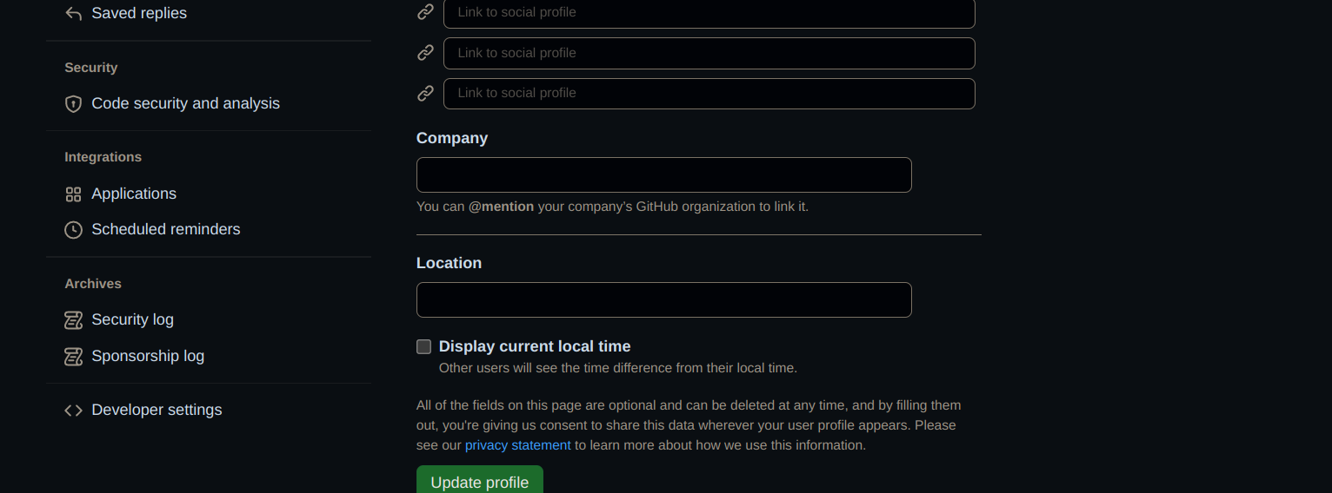

* 1. Then go to personal tokens and then to Tokens(classic)

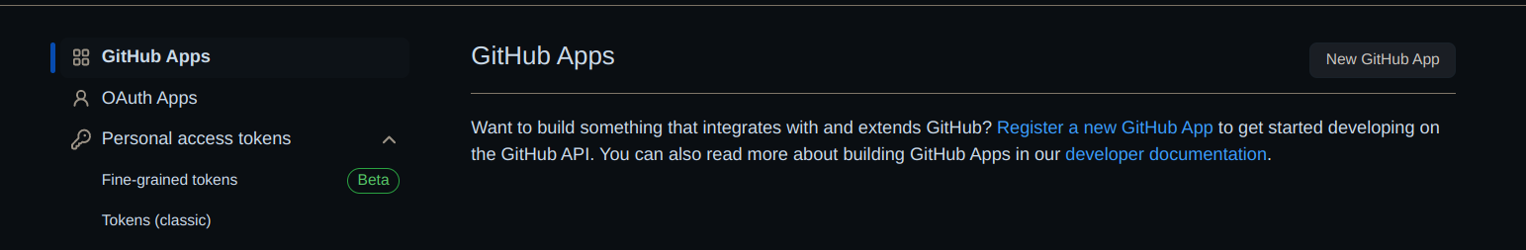

* 1. Go to Generate Token and then to Generate new token (Classic)

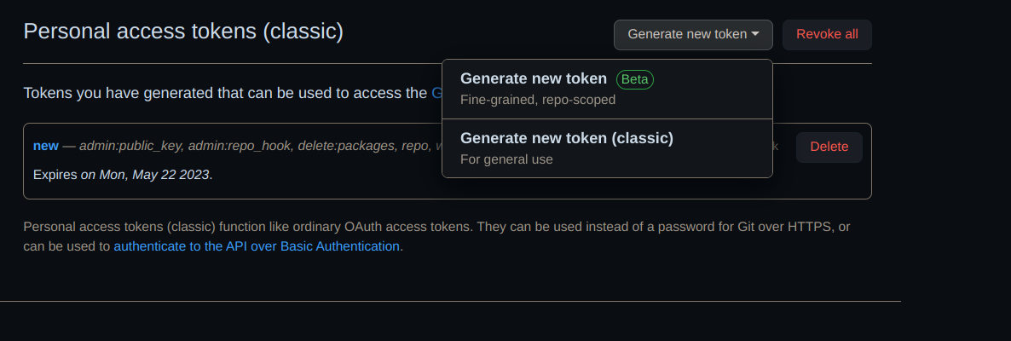

* 1. By this new token will be generated.
  2. Copy the generated token and paste it in the .npmrc file as shown

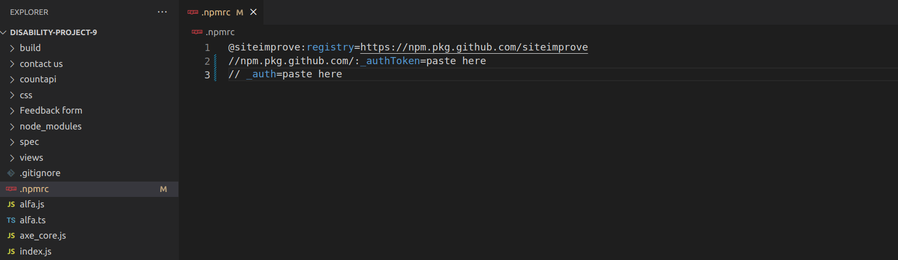

1. To install all the packages as in package.json, use command “**npm install**”.

* **Running the Portal on localhost**

1. To run the portal on local host use the command “**node index.js”**.