**Sentiment Analysis on Hindi Audio**

**A Major Project Report**

***In partial fulfillment for the award of the degree***

***of***

**Bachelor of Technology**

***in***

**Computer Science Engineering**

***by***

**Yugant Narania, 04920902718**

**Sunderam Bhartiya, 04220902718**

**Shubham Gaur, 04120902718**

**Guided by**

**Dr. Amit R. Khaparde**

**Assistant Professor**



**DEPARTMENT OF COMPUTER SCIENCE AND ENGINEERING**

**G.B. PANT GOVT. ENGINEERING COLLEGE, NEW DELHI**

**(AFFILIATED TO GURU GOBIND SINGH INDRAPRASTHA UNIVERSITY, DELHI)**

**JUNE, 2022**

**CANDIDATE’S DECLARATION**

I hereby certify that the work which is being presented in the Major Project entitled “**Sentiment Analysis on Hindi Audio”** in partial fulfillment for the award of the Degree of Bachelor of Technology in Computer Science and Engineering / Information Technology affiliated to **Guru Gobind Singh Indraprastha University, New Delhi** and submitted to the Department of Computer Science and Engineering G.B.Pant Govt. Engineering College , is an authentic record of my own work carried out during a period from **March 2022 to June 2022**. The matter represented in this report has not been submitted by me for the award of any other degree of this or any other institute/university.

**Date:-** 1-06-2022 **Name-**Shubham Gaur(04120902718)

Sunderam Bhartiya(04220902718)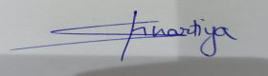

Yugant Narania(04920902718) 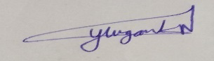

This is to certify that the above statement made by the candidate is correct to the best of our knowledge.

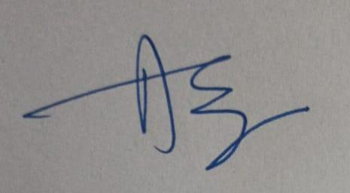

#### *Signature of Supervisor*

#### **Date:-** 01-06-2022 **Name & Designation**

Dr. Amit R. Khaparde

**TABLE OF CONTENTS**

| **Chapter No.** | **TITLE** | **PAGE NO.** |
| --- | --- | --- |
|  | **LIST OF FIGURES** | 6 |
|  | **ABBREVIATIONS** | 8 |
|  | **ACKNOWLEDGEMENT** | 9 |
|  | **ABSTRACT** | 10 |
| **CHAPTER 1**. | **INTRODUCTION** | 11-14 |
|  | 1.1 OVERVIEW | 11 |
|  | 1.2 MOTIVATION | 12 |
|  | 1.3 PROBLEM STATEMENT | 12 |
|  | 1.4 OBJECTIVE | 13 |
|  | 1.5 SCOPE OF PROJECT | 13 |
|  | 1.6 OUTLINE OF PROJECT | 13 |
| **CHAPTER 2** | **LITERATURE REVIEW** | 15-26 |
|  | 2.1 EXISTING SYSTEM | 15 |
| **CHAPTER 3** | **PROBLEM DESCRIPTION AND SPECIFICATION** | 26-28 |
|  | 3.1 PROBLEM DESCRIPTION | 26 |
|  | 3.2 PROBLEM SPECIFICATION | 27 |
|  | 3.3 REQUIREMENTS | 27 |
|  | 3.3.1 SOFTWARE REQUIREMENTS | 27 |
|  | 3.3.2 HARDWARE REQUIREMENTS | 28 |
|  | 3.3.3 OTHER REQUIREMENTS | 28 |
| **CHAPTER 4** | **SYSTEM DESIGN** | 29-41 |
| **CHAPTER 5** | **RESULT AND ITS DISCUSSION** | 42-45 |
|  | 5.1 TESTING | 44 |
| **CHAPTER 6** | **CONCLUSION AND FUTURE SCOPE** | 46 |
|  | 6.1 CONCLUSION | 46 |
|  | 6.2 FUTURE SCOPE | 46 |
| **CHAPTER7** | **REFERENCES** | 47 |
|  |  |  |

**LIST OF FIGURES**

| **S.No** | **Topic** | **Page No.** |
| --- | --- | --- |
| 1 | Flow-chart of the proposed system |  |
| 2 | Architecture of system |  |
| 3 | Importing Libraries for Speech to text |  |
| 4 | Importing Libraries for Ulmfit |  |
| 5 | Importing Libraries for BERT |  |
| 6 | Importing Libraries for LSTM |  |
| 7 | Dataset Used |  |
| 8 | Data Preprocessing : Ulmfit |  |
| 9 | Data Preprocessing : BERT |  |
| 10 | Data Preprocessing : LSTM |  |
| 11 | Training the Model : ULMFit |  |
| 12 | Training the Model : BERT |  |
| 13 | Training the Model : LSTM |  |
| 14 | Testing the Model : ULMFit |  |
| 15 | Testing the Model : BERT |  |
| 16 | Testing the Model : LSTM |  |
| 17 | Training and Testing Accuracies |  |
| 18 | Confusion Matrix : ULMFit |  |
| 19 | Confusion Matrix : LSTM |  |

**LIST OF ABBREVIATIONS USED**

| **S.NO** | **Nomenclature** | **Referred to** |
| --- | --- | --- |
| 1 | NMT | Neural Machine Translation |
| 2 | LSTM | Long Short - Term Memory |
| 3 | RNN | Recurrent Neural Network |
| 4 | NLP | Natural Language Processing |
| 5 | BLEU | Bilingual Evaluation Understudy Score |
| 6 | CNN | Convolution Neural Network |
| 7 | TTS | Text-To-Speech |

**ACKNOWLEDGEMENT**

It is our pleasure to be indebted to various people, who directly or indirectly contributed in the development of this work and who influenced our thinking, behavior and acts during the course of study.

We extend our sincere appreciation to Dr. Amit Khaparde who provided his valuable suggestions and precious time in accomplishing our project report.

Also, we would like to appreciate the whole team effort for the completion of this project. We would like to express our gratitude for the Department of Computer Science Engineering, Gobind Ballabh Pant Government Engineering college for providing us with the opportunity to work on this project and to all the teachers and mentors guiding along the way. We would also like to acknowledge all the college faculty members who helped us during our academic career.

Lastly, we would like to thank the almighty and our parents for their moral support and our friends with whom we shared our day-to-day experience and received lots of suggestions that improved our quality of work.

**ABSTRACT**

This study is based on developing a deep learning model on sentiment analysis of Hindi audio based on Universal Language Model Fine-tuning (ULMFiT), LSTM and BERT. These algorithms are to be performed on a standard data-set to achieve sentiment analysis on Hindi Text that is extracted from Hindi Audio and make a comparative study of these three algorithms to find the best suited model for sentiment classification on Hindi Text and Audio. In this model, Audio (hindi) data is taken as an input and the devised algorithms are executed to convert it into text format and then a NLP algorithm is used to determine the polarity or sentiment of the extracted text. It will provide the context of the extracted text and will give if the text is negative, neutral or positive as an output.

.

**CHAPTER-1**

**INTRODUCTION**

In recent years, innovative techniques like Transfer Learning have had a significant impact on Natural Language Processing. As of today the research in the field of sentiment analysis on hindi text and audio is still in its nascent stage. In this project we’re devising a deep learning model on sentiment analysis of hindi audio. We propose a Universal Language Model Fine-tuning (ULMFiT) model to achieve our goal. And also we will perform some other algorithms on the same data set to achieve sentiment analysis on hindi audio and make a comparative study of all different algorithms and find which is the best among them. These algorithms are ULMFiT , LSTM and BERT. This model will take Hindi audio as an input and perform the devised algorithms and determine the polarity or sentiment of the input data. It will provide the context of the extracted data and will give, if the polarity of data is negative, neutral or positive as an output.

**1.2 MOTIVATION**

Sentiment analysis on many languages has recently gotten a lot of interest since the useful features derived from sentiment analysis can be applied to a wide range of applications, including opinion detection, political promotion, and decision making. Sentiment Classification of a text, audio and video by an artificial device is a necessary step in the advancement of AI and NLP . A lot of work has already been done in the same field for different languages. But, As of today the research in the field of sentiment analysis on Hindi text and audio is still in its nascent stage and therefore the motivation for our study is to devise an algorithm to perform sentiment analysis which is best suited for Hindi Language.

**1.3 PROBLEM STATEMENT**

To determine the sentiments (Polarity of speech) of a given Audio data.

# **1.4 SCOPE OF PROJECT**

* **Benefit companies for better customer interaction** 
  + Making it possible for the company to analyze the sentiment of customer
  + interaction for better interaction
* **Smart car slowing down**
  + A smart car slows down when the person has negative emotions.

# **1.5 OUTLINE OF THE PROJECT**

The following chapters in this report give a detailed glance of effort put in the direction of development of this project

CHAPTER 2 contains the literature review from the existing model and research paper based on Sentiment analysis.

CHAPTER 3 describes the problem description and specification of the project . It also consists of the software , hardware and other requirements.

CHAPTER 4 describes the system design , study and understanding of the dataset . The machine learning algorithms used in this model and the architecture of the model are also listed in this chapter .

CHAPTER 5 shows the result discussion . The code and the result of the output are printed in this chapter .

CHAPTER 6 and CHAPTER 7 states the conclusion , future scope and list of references used for the study and designing of the model.

**CHAPTER – 2**

**Literature Survey**

**2.1 INTRODUCTION**

In this section, we will look into some of the earlier works presented in the direction of this project. There has been a lot of work that has already happened in the field of Sentiment Analysis on Text and Audio using NLP. While preparing this project we have gathered ideas from different research materials and models. Here, we are going to enlist them.

**2.2 EXISTING SYSTEM**

**ULM-Fit :-**

* **Article A Novel Machine Learning Approach for Sentiment Analysis on Twitter Incorporating the Universal Language Model Fine-Tuning and SVM.**

This study introduced a new effective sentiment analysis approach based on deep learning architectures that combines "universal language model fine-tuning" (ULMFiT) and support vector machine (SVM) to improve detection efficiency and accuracy.

* **HASOC-Dravidian-CodeMixFIRE2020: Pre-training ULMFiT on Synthetically Generated Code-Mixed Data for Hate Speech Detection.**

The goal of the job is to find foul language in a code-mixed dataset of Dravidian language comments/posts obtained from social media. This study proposed pretraining ULMFiT on synthetically created code-mixed data, which was generated by modeling code-mixed data production as a Markov process using Markov chains. This model received a 0.91 weighted F1-score (4th Rank) in Sub-task A for mixed-script Malayalam-English and 0.74 weighted F1-score (5th Rank) in Sub-task B for code-mixed Malayalam-English.

* **Advance Transfer Learning Approach for Improving Spanish Sentiment Analysis.**

# In this research, it is intended to provide a state-of-the-art algorithm for Spanish Sentiment Analysis of brief sentences. They adapted the ULMFiT algorithm to this situation. When compared to fancy deep learning algorithms, experimental findings on benchmark datasets (InterTASS 2017 and InterTASS 2018) show that this straightforward transfer learning strategy performs well.

* **Universal Language Model Fine-tuning for Text Classification.**

# This study has discussed strategies for fine-tuning a language model and proposed Universal Language Model Fine-tuning (ULMFiT), an effective transfer learning method that can be used to any NLP application. On six text classification tasks, our strategy surpasses the state-of-the-art, reducing error by 18- 24 percent on the majority of datasets. Furthermore, it matches the performance of training from scratch on 100 more data with only 100 labeled instances.

**BERT :-**

* **Multi - Class Sentiment analysis of urdu text using multilingual BERT**

This Study shows the use of sentiment analysis on urdu datasets extracted from various social media. Various machine learning and deep learning is used and multi level class sentiment to form a baseline results.

* **An Effective BERT-Based Pipeline for Twitter Sentiment Analysis: A Case Study in Italian**

The goal of this study was to propose a two-step approach to Twitter sentiment analysis. Using the tweet jargon, and BERT language model. The findings of this study indicated the success of the methodology and suggest that, due to its methodological foundation, it may also be promising for other languages.

**Bidirectional LSTM :-**

* **Sentiment Analysis of Chinese Microblog Based on Stacked Bidirectional LSTM. (2019)**

This study, which predicts sentiments on Chinese Microblogs combines the Continuous Bag-of-Words (CBOW) model with a stacked bidirectional LSTM model. To conduct the sentiment prediction, Bi-LSTM features are extracted and fed into a binary softmax.This model achieves better performance over other ML and DL models.

* **A Convolutional Stacked Bidirectional LSTM with a Multiplicative Attention Mechanism for Aspect Category and Sentiment Detection**

The proposed model has been treated as a multiclass classification problem in more detail. SemEval-2015 and SemEval-2016 datasets are used to test the suggested model. In terms of aspect-based sentiment analysis, the suggested model exceeds existing results.

**LSTM :-**

* **Sentiment Analysis and Emotion Detection on Cryptocurrency Related Tweets Using Ensemble LSTM-GRU Model. (2022)**

This research examines cryptocurrency-related tweets for sentiment analysis and emotion recognition. With a 0.99 accuracy score and precision and recall of 0.99 and 0.98, respectively, the suggested model obtains the best performance for sentiment analysis.

* **IJERT-Text based Sentiment Analysis using LSTM. (2020)**

This research provides a sentiment classification method for text data based on LSTM. It does sentiment analysis on Amazon and IMDB reviews using a deep learning model i.e. LSTM. This model reaches upto 85% accuracy when there is more training data.

**2.3 PROPOSED SYSTEM**

The plan is to devise a deep learning model for sentiment classification of Hindi Text based on Three Models that are ULMFit, Bert and LSTM, these models are trained on Hindi Text Data Set and classifiers are made and them will take Hindi audio as an input and after performing speech to text the devised algorithms will determine the polarity or sentiment of the input data. It will provide the context of the extracted data and will give if the data is negative, neutral or positive as an output.

**2.4 OUR APPROACH**

This proposed system will use Python as an API . We are creating 3 models on three different technologies ULMFit, Bert, and LSTM. After the training the audio data is first pre processed and converted into text and after that it will work on each model that we have created and corresponding accuracies of them are compared.

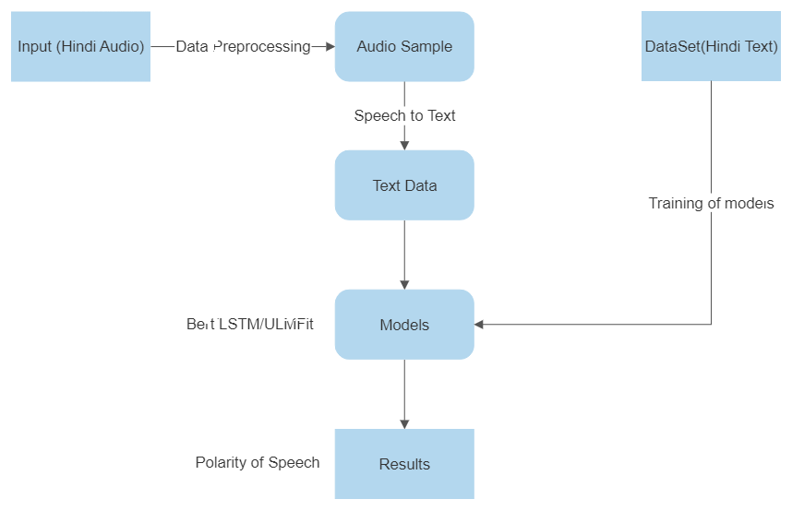

Fig. 1 Flow-chart of the proposed system

**CHAPTER – 3**

**PROBLEM DESCRIPTION AND SPECIFICATION**

**3.1 Problem Description**

To determine the sentiments (Polarity of speech) of a given Audio data.

**3.2 Specification**

The aim of this project is to find the polarity of Hindi speech and text data and compare three different models on their accuracies using a dataset which consists of 10,000 labeled data from movie reviews and tweets . The text of the dataset is divided into training , testing and verification. In the future , we can use more labeled data to train our models and enhance the accuracy of the models .

**3.3 Requirements**

**3.3.1 Software Requirements**

● Python Version 3.6+

● IDE: JupyterLab or PyCharm

**3.3.2 Hardware Requirements**

● Processor: - Intel i3+ or AMD A6+

● RAM: - 2GB/+

● Hard Disk Space: - 4GB

**3.3.3 Other Requirements**

● Dataset containing Labeled hindi text.

● For training the model - GooglevColab/Kaggle Notebook/JupyterLab

**Chapter 4**

**SYSTEM DESIGN**

**4.1 ARCHITECTURE**

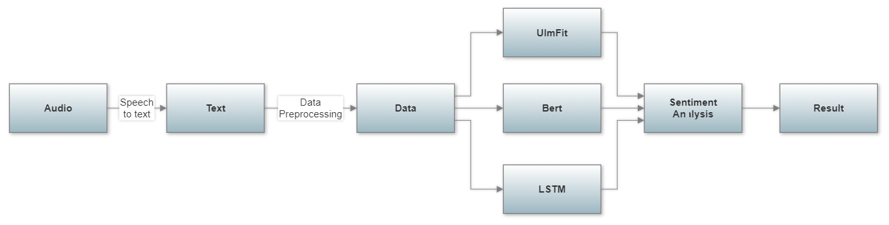

Fig. 2 Architecture of system

**4.2 Sentiment Analysis**

We’ve first trained 3 models using a textual dataset containing more than 10,000 labeled data (positive, negative, and neutral) then using trained models classifiers are made.

After the training is done we feed the audio file to our speech to text converter that uses google speech recognition API to convert the audio data into text and then this text is passed as an input to our models and polarity of speech is received as an output.

**4.2.1 Libraries Required**

* **Speech To Text**

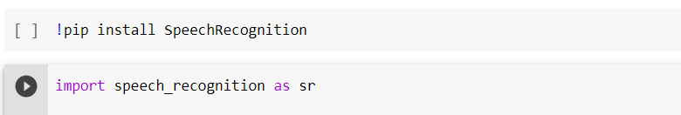

Fig. 3 Importing Libraries for Speech to text

* **Ulmfit**

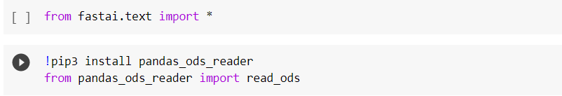



Fig. 4 Importing Libraries for Ulmfit

* **Bert**

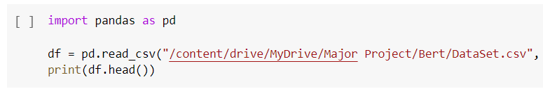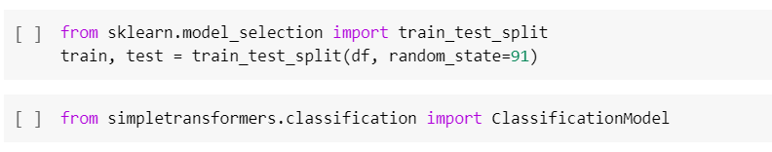

Fig. 5 Importing Libraries for Bert

* **LSTM**

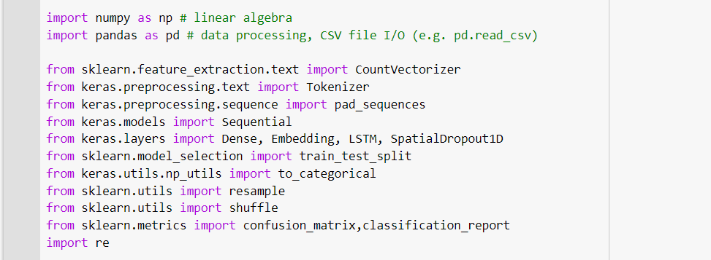

Fig. 6 Importing Libraries for LSTM

**4.2.2 Dataset Used**

The dataset we used is a mixed dataset labeled hindi text containing 10,000 labeled text. The data is a mixture of Hindi movies reviews and tweets.

Dataset contains two columns, one is text and other is sentiment that contains positive, negative, or neutral.

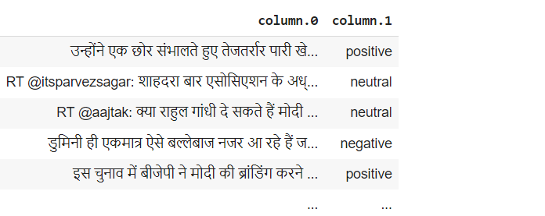

Fig.7 Dataset Used

**4.2.3 Data Preprocessing**

All the special Characters are removed and the labeling of data is done.

And other preprocessing of data is done according to different models.

* **ULMFit**

For UlmFit the library provides an API to make a Text data bunch for text processing. This is to retain all the information which can be used to gather an understanding of the new task’s vocabulary. Tokenization of text is done as:-

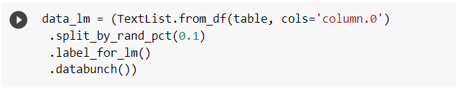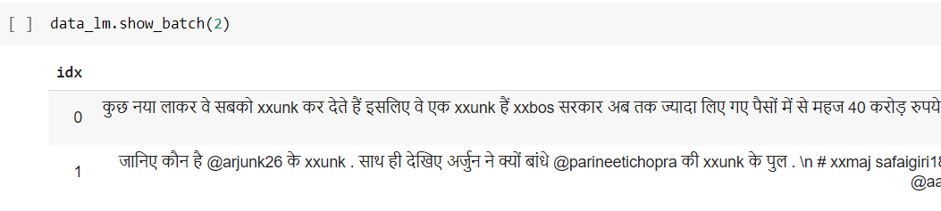

Fig. 8 Data Preprocessing : Ulmfit

xxbos represent beginning of sentence.

xxunk tokens used instead of an uncommon word

etc…

* **BERT**

For bert the data preprocessing is done as follows

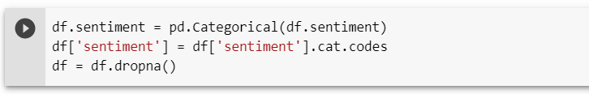

Fig. 9 Data Preprocessing : BERT

* **LSTM**

For LSTM we first defined the max features as 2000 and then used a tokenizer to vectorizes and convert the text into sequence so the network will use it as an input.

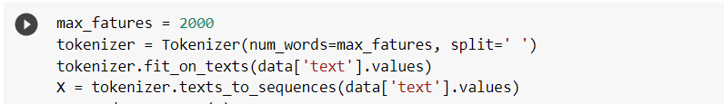

Fig. 10 Data Preprocessing : LSTM

**4.2.4 Training the model**

To train the models, we have used the 8,000 training labeled text and trained the model for 10 epochs (for Ulmfit 30).

* ULMFit

The training of ULMfit is different from others as we are using transfer learning with fine tuning of the model.

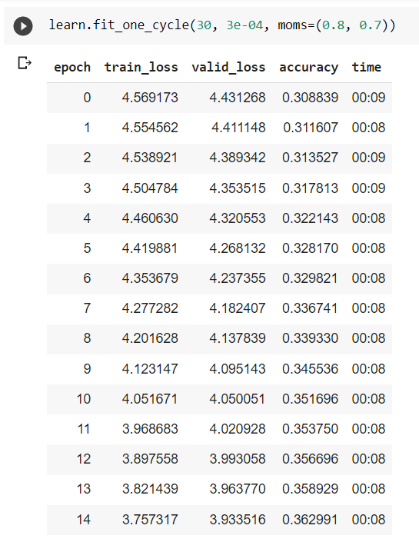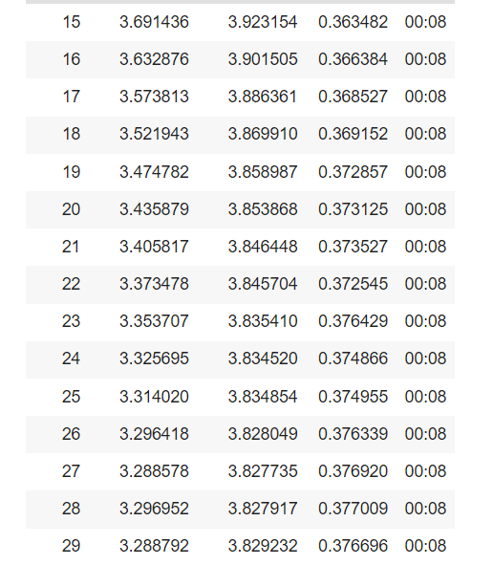

Gradual freezing and unfreezing of classifier is done to increase the accuracy

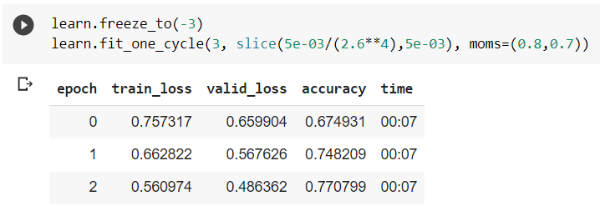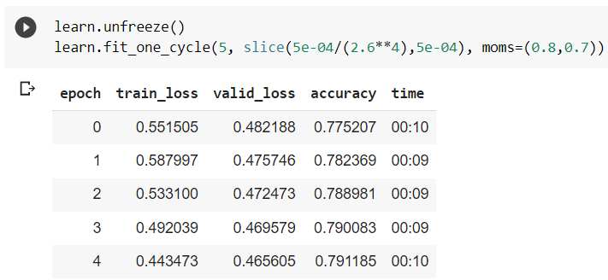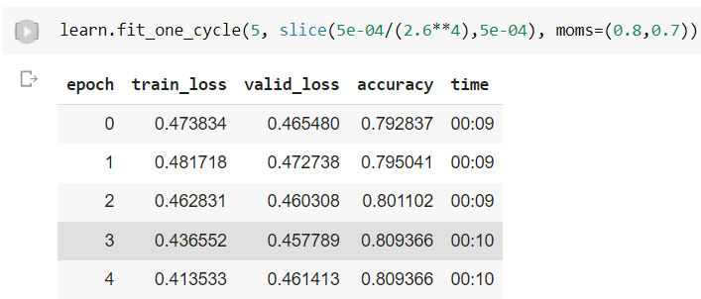

Fig.11 Training the Model : ULMFit

* Bert

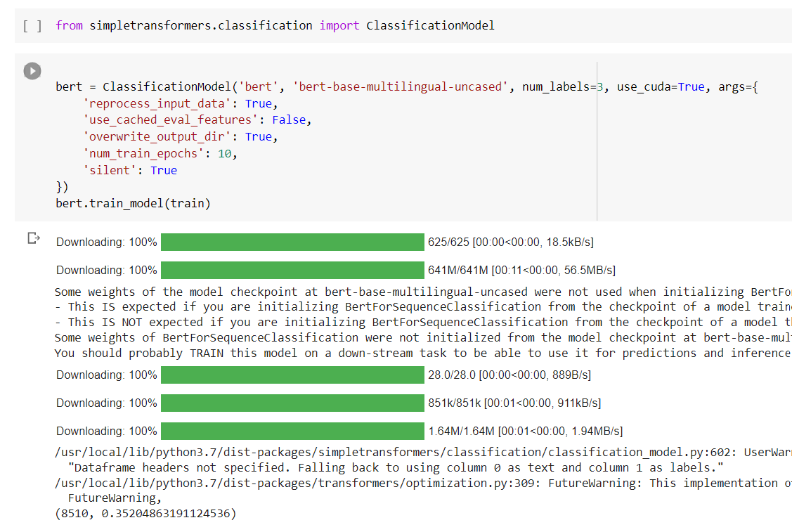

Fig.12 Training the Model : BERT

* LSTM

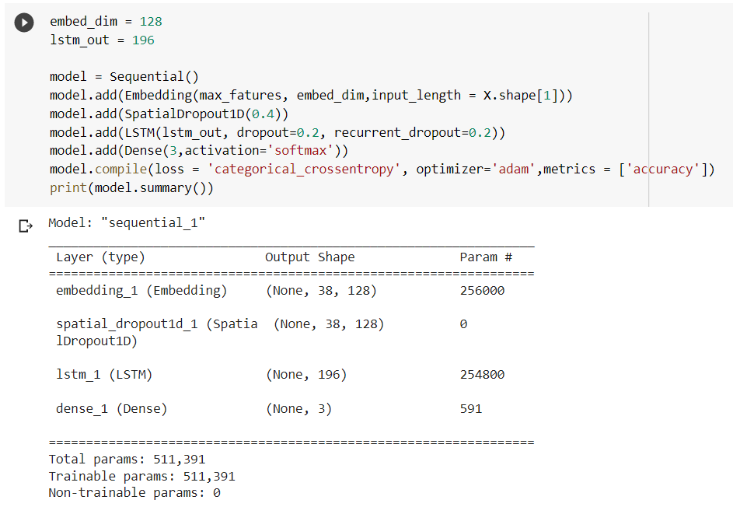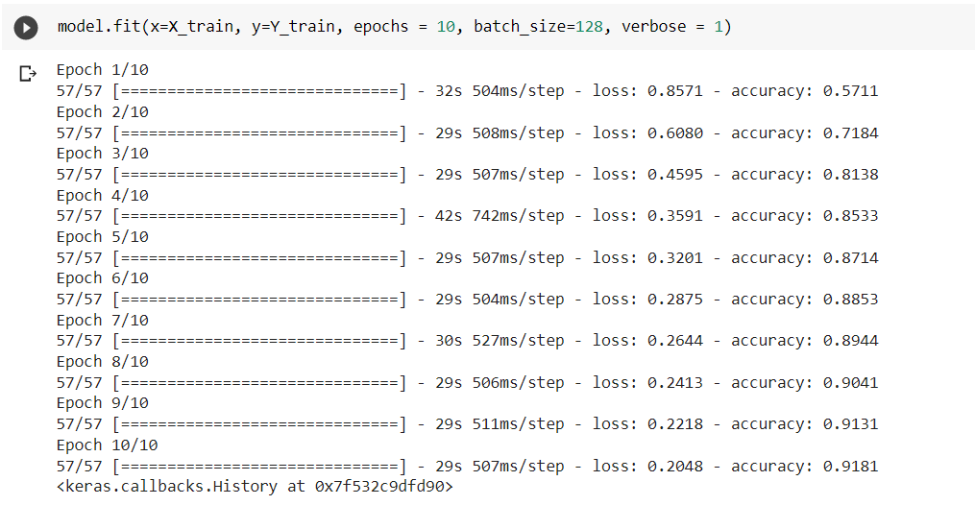

Fig.13 Training the Model : LSTM

**4.2.9 Testing the model**

After the model training, we load the model and generate predictions.

* **ULMFit**

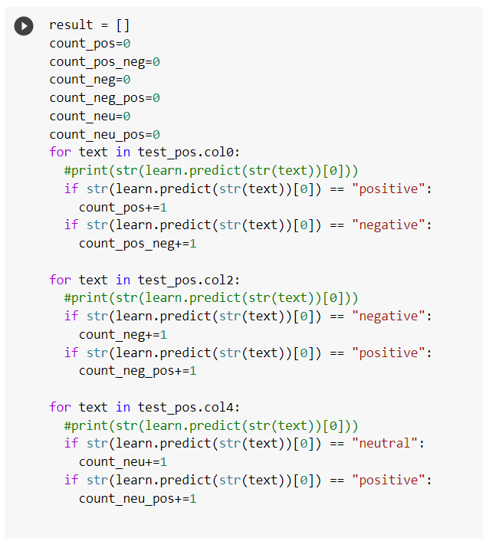

Fig.14 Testing the Model : ULMFit

* **Bert**

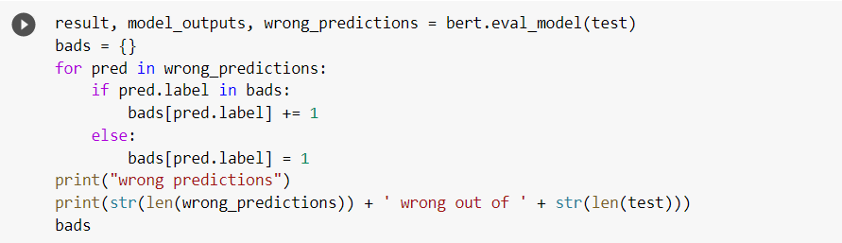

Fig.15 Testing the Model : BERT

* **LSTM**

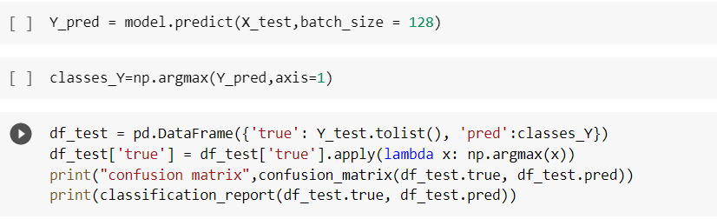

Fig.16 Testing the Model : LSTM

**CHAPTER 5**

**RESULT AND ITS DISCUSSION**

**5.1 Training and Testing Accuracies**

The number of accurately anticipated data points out of all the data points is known as accuracy. Accuracy formula :

**Accuracy = TP + TN TP + TN + FP + FN**

After running the three models i.e ULMFit, BERT and LSTM for 10 epochs . The testing and training accuracies are as follows:

| **Model** | **Training Accuracy**  (10 epochs) | **Testing Accuracy** |
| --- | --- | --- |
| ULMFit | 80.93% | 82.98% |
| Bert | - | 80.52% |
| LSTM | 91.81% | 80.1% |

Fig. 17 Training And Testing Accuracies

**5.2 Confusion Matrices**

**5.2.1 ULMFit**

|  | Positive | Negative | Neutral |
| --- | --- | --- | --- |
| Positive | 524 | 161 | 1 |
| Negative | 105 | 580 | 1 |
| Neutral | 64 | 18 | 604 |

Prediction

Fig. 18 Confusion matrix : ULMFit

**5.2.2 LSTM**

|  | Positive | Neutral | Negative |
| --- | --- | --- | --- |
| Positive | 532 | 23 | 103 |
| Neutral | 33 | 470 | 32 |
| Negative | 124 | 27 | 472 |

Prediction

Fig. 19 Confusion Matrix : LSTM

**CHAPTER 6**

**CONCLUSION AND FUTURE SCOPE**

**6.1 CONCLUSION**

This study aims at implementing different Deep Learning models on the publicly available dataset , for the purpose of sentiment analysis of Hindi audio data. The dataset was preprocessed and Labeled. By using the feature dataset, multiple Deep Learning models were trained for sentiment analysis of Hindi data and their performances were calculated. Therefore, Sentiment analysis on Hindi speech data has been achieved using three different deep learning models ULMfit, BERT and LSTM with 82.98, 80.52 and 80.1 Testing Accuracy respectively. And the comparative study shows that ULMfit is the best model for our approach.

**6.2 FUTURE SCOPE**

As future work, we plan to extract a larger dataset to make the models accuracy better. And also we’re planning to use pitch analysis on it that will drastically increase the accuracy of our model.

**CHAPTER 7**

**REFERENCES**

1. **Gauravarora@HASOC-Dravidian-CodeMix FIRE2020: Pre-training ULMFiT on Synthetically Generated Code-Mixed Data for Hate Speech Detection.**
2. **Advanced Transfer Learning Approach for Improving Spanish Sentiment Analysis, Daniel Palomino ,Universidad Nacional de Ingeniería (Peru)**
3. **Multi‑class sentiment analysis of urdu text using multilingual BERT, Lal Khan , AmmarAmja1 , NomanAshraf & Hsien‑Tsung Chang.**
4. **Sentiment Analysis and Emotion Detection on Cryptocurrency Related Tweets Using Ensemble LSTM-GRU Model, NAILA ASLAM, FURQAN RUSTAM , ERNESTO LEE , PATRICK BERNARD WASHINGTON, AND IMRAN ASHRAF**
5. **Sentiment Analysis of Chinese Microblog Based on Stacked Bidirectional LSTM JUNHAO ZHOU , YUE LU , HONG-NING DAI , (Senior Member, IEEE),HAO WANG , (Member, IEEE), AND HONG XIAO**
6. **Text based Sentiment Analysis using LSTM Dr. Gorti Satyanarayana Murty, Department of Computer Science and Engineering, Aditya Institute of Technology and Management, Srikakulam, Andhra Pradesh, Shanmukha Rao All*u*, Department of Computer Science and Engineering, Aditya Institute of Technology and Management, Srikakulam, Andhra Pradesh.**
7. **Universal Language Model Fine-tuning for Text Classification**

**Jeremy Howard*∗* fast.ai, University of San Francisco. Sebastian Ruder*∗* Insight Centre, NUI Galway, Aylien Ltd., Dublin.**

1. **FinBERT: Financial Sentiment Analysis with Pre-trained Language Models**

**Dogu Tan Araci,** [**dogu.araci@student.uva.nl**](mailto:dogu.araci@student.uva.nl)**, University of Amsterdam, Amsterdam, The Netherlands**

1. **Sentiment Analysis on Speaker Specific Speech Data Maghilnan S, Rajesh Kumar M, Senior IEEE, Member School of Electronic Engineering VIT University Tamil Nadu, India.**
2. **Sentiment Analysis of Speech Aishwarya Murarka, Kajal Shivarkar, Sneha, Vani Gupta ,Prof. Lata Sankpal Student, Department of Computer Engineering, Sinhgad Academy of Engineering, Pune, India.**
3. **Audio Sentiment Analysis by Heterogeneous Signal Features Learned from Utterance-Based Parallel Neural Network Ziquan Luo, Hua Xu, and Feiyang Chen Tsinghua University, China.**
4. **Automatic speech recognition – Hindi Anish Saha Vellore Institute of Technology, Vellore Prof. A.G. Ramakrishnan Indian Institute of Science, Bengaluru.**
5. **Speech Recognition with Sentiment Analysis by Ng Wai Foong**