WEB MINI PROJECT

Automobile Test Drive & Showroom Booking Portal — Frontend Flow
ATDP | Navi Mumbai, Maharashtra | Academic Year 2025-26

Aim
To show the frontend of the Automobile Test Drive & Showroom Booking Portal going with the flow — from login/registration, through the customer journey (home → vehicle selection → booking → dashboard), to the admin dashboard. The aim is to demonstrate how a customer and an admin use the website step by step.

Software Used
Software / Tool | Purpose
Visual Studio Code | Writing HTML, CSS, JavaScript
Google Chrome | Running and testing the website
Node.js + Express | Running the site on http://localhost:5000 and http://localhost:3000
SQLite | Storing cars, users and bookings (backend)

Theory
This is a frontend mini project. The user sees the website, the admin manages it. Both use the same site but see different pages after login. All pages share the same green theme and work on both laptop and mobile.
How Customer Works (Step by Step):
- Opens the Home page (first page) and sees cars and showrooms in Navi Mumbai.
- Goes to Login/Register — new customer registers, existing customer logs in. Admin has a separate login with a secret code.
- Browses Vehicles — filters by Brand, Fuel, Price and Status to find a car.
- Clicks a car to open Vehicle Detail — sees photos, price in rupees, engine, mileage and the automatically assigned showroom.
- Books Test Drive — picks a future date, sees 9 time slots (9am-6pm), selects a free slot, and confirms. If not logged in, the site asks to login first.
- Opens Customer Dashboard — sees all bookings with status Pending (waiting), Approved (green), Cancelled (red) and any message from admin. Can cancel pending bookings and edit profile.
- After the test drive is marked Completed by admin, the Review button appears — customer gives 5 stars and writes suggestions, which go to admin.
How Admin Works (Step by Step):
- Logs in via Admin login (needs secret code).
- Opens Admin Dashboard — sees total counts (users, cars, showrooms, bookings), charts for bookings by status and cars by brand.
- Goes to Bookings tab — sees all customer requests. For each Pending request, clicks Approve (with a congratulatory message) or Reject (with a reason) in a popup window. The message appears in the customer dashboard.
- Manages Vehicles, Showrooms and Users in their tabs — can add or delete.
- Goes to Reviews tab — sees all 5-star ratings and suggestions given by customers after completed drives.

Output — Screenshots in Flow Order
Photos taken from the folder WEB MINI PROJECT PHOTOS (19 images) plus additional captures from http://localhost:5000 / http://localhost:3000. All pages are shown in the order a user and admin would experience them. Times New Roman 12, all text black as requested.
1. Login Page (login.html)
Customer and Admin login with User/Admin tabs. Admin needs secret code (hidden). Demo logins shown.
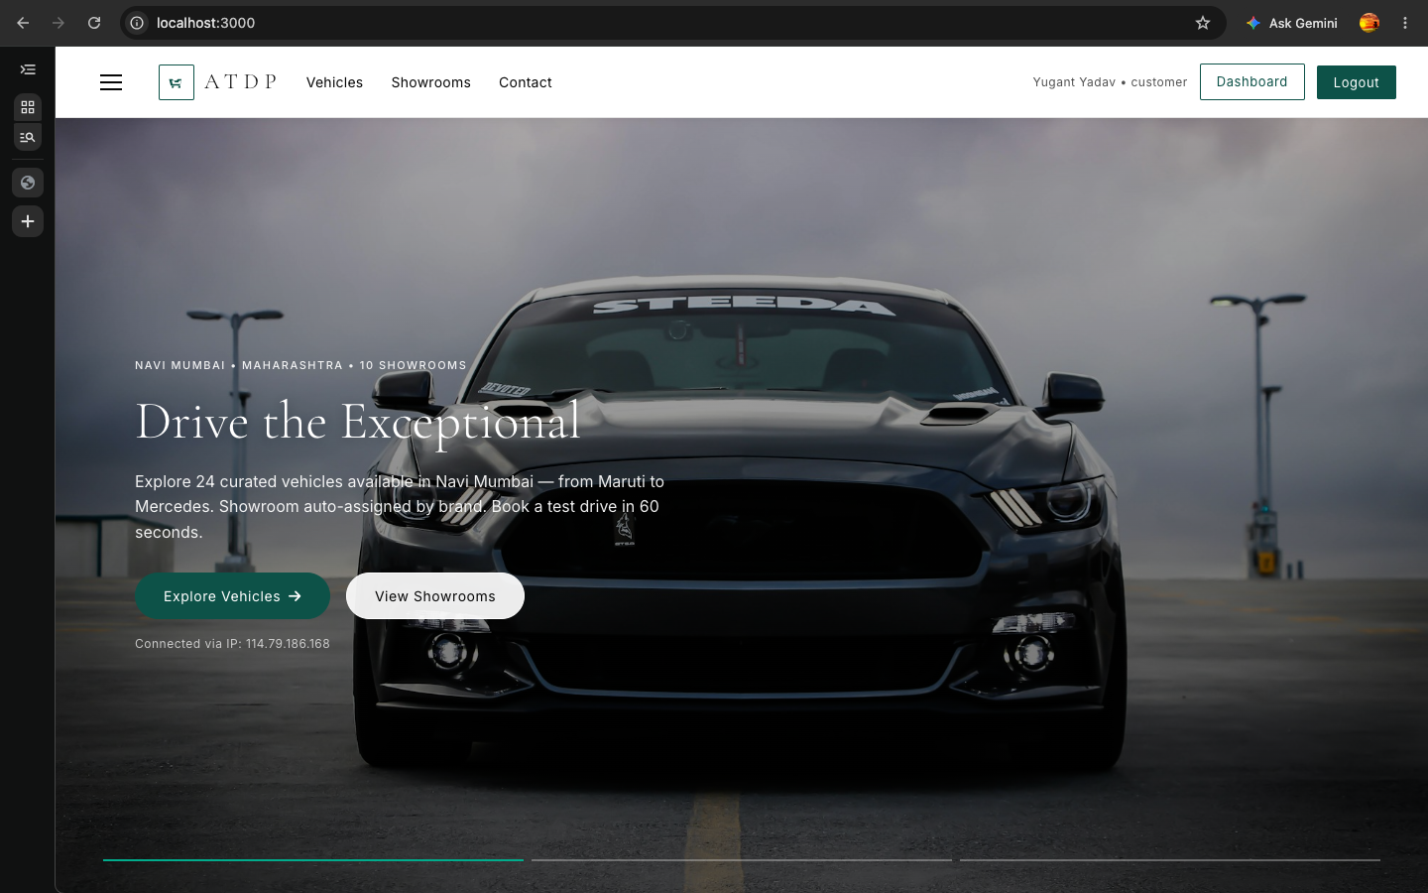
Fig 1: 1. Login Page (login.html)
2. Registration Page (register.html)
New customer creates account with name, email, password, phone, address.
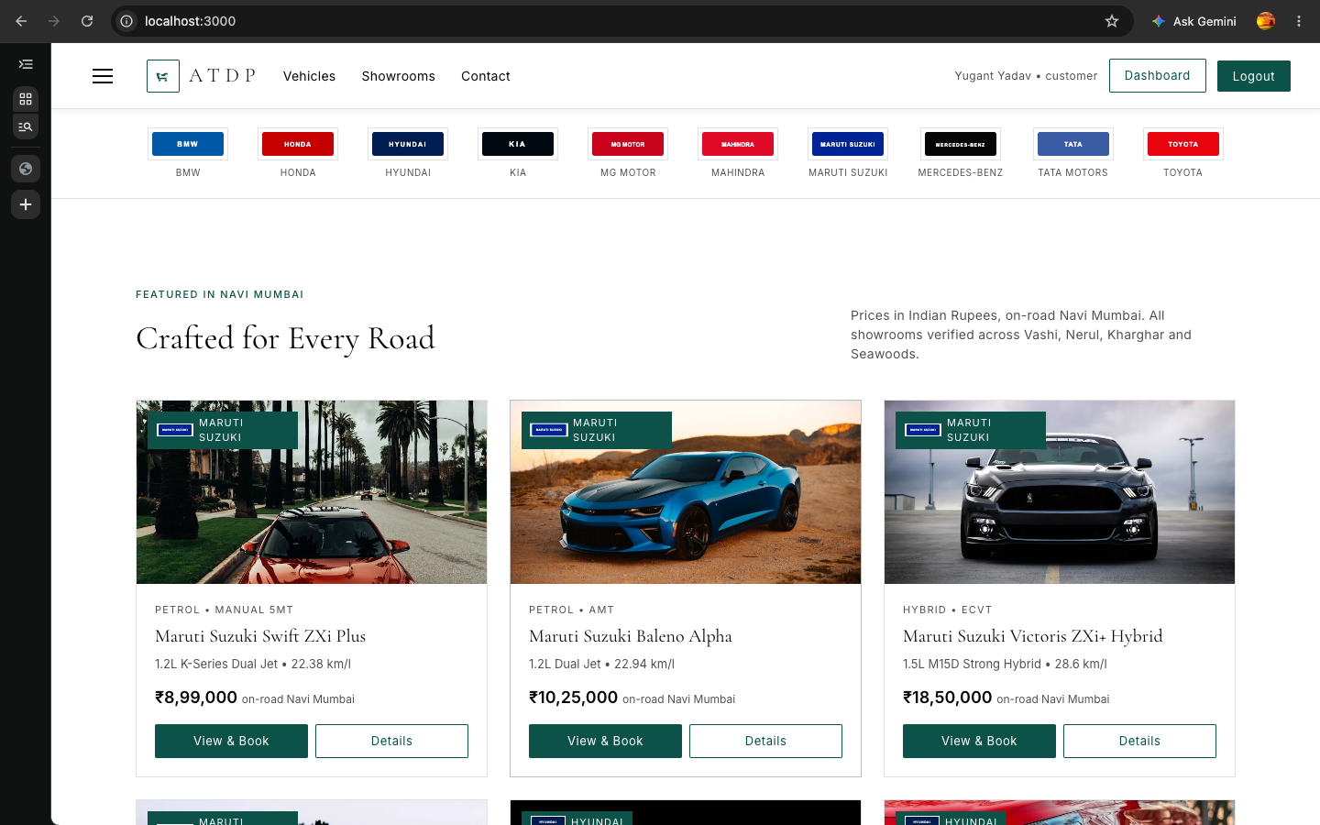
Fig 2: 2. Registration Page (register.html)
3. Home Page — First Page (index.html)
Landing page with big car banner, 10 showrooms in Navi Mumbai, 24 featured cars, green contact footer.
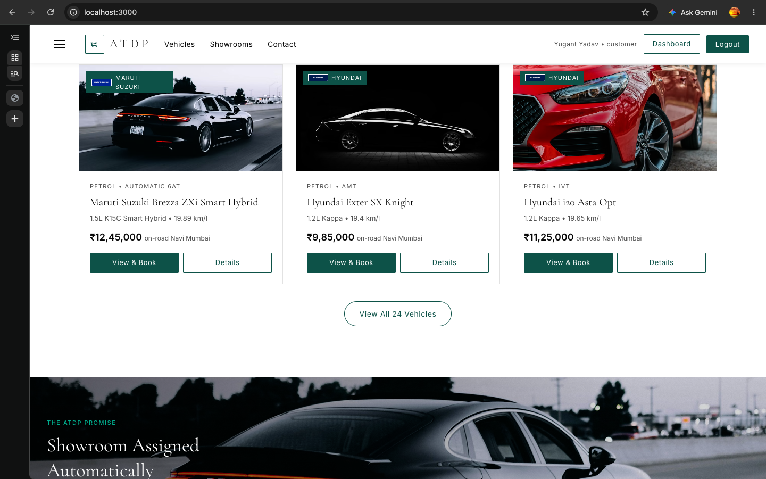
Fig 3: 3. Home Page — First Page (index.html)
4. Brand Strip on Home
Local SVG logos for 10 brands (Maruti to Mercedes) — always visible, no external dependency.
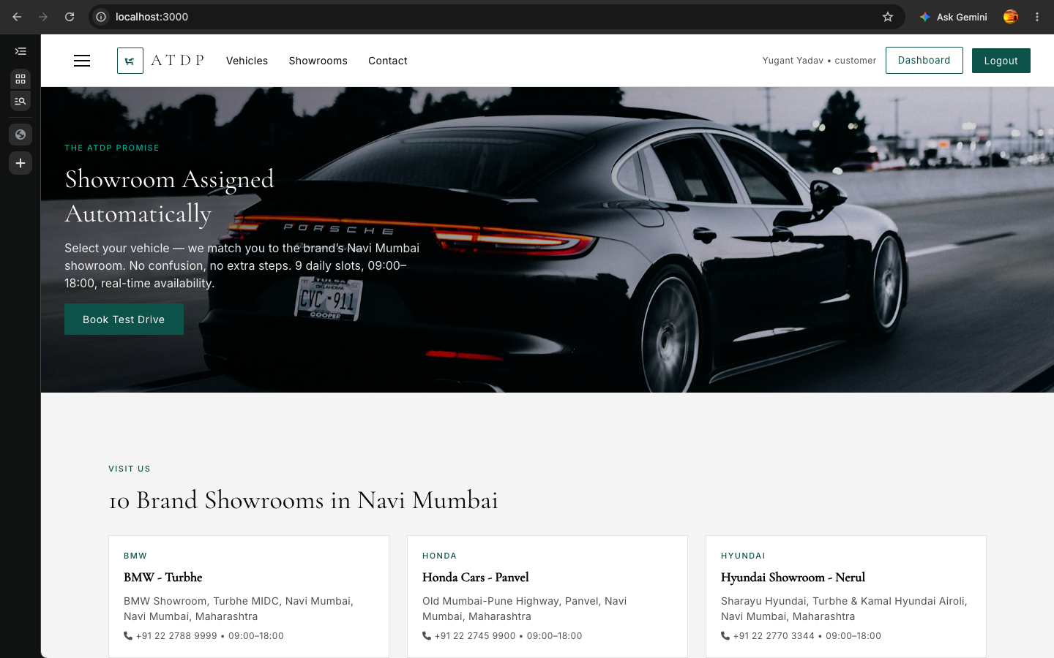
Fig 4: 4. Brand Strip on Home
5. Browse Vehicles — All Brands (vehicles.html)
All Brands with dropdowns Brand/Fuel/Max Price/Status only (no search bar), pagination 9 per page.
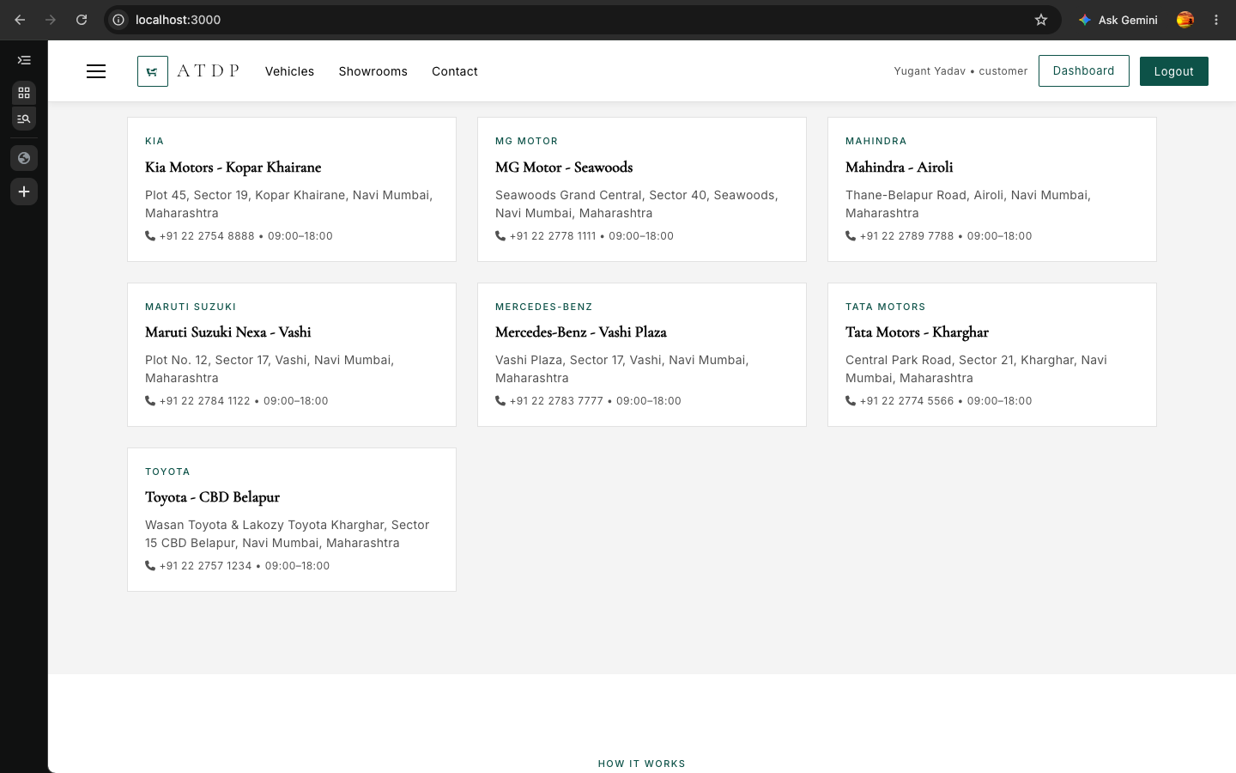
Fig 5: 5. Browse Vehicles — All Brands (vehicles.html)
6. Browse Vehicles — Filter by Brand (Maruti Suzuki)
Selecting Maruti Suzuki shows only Maruti cars (Swift, Baleno, Victoris, Brezza) — filter works across all brands.
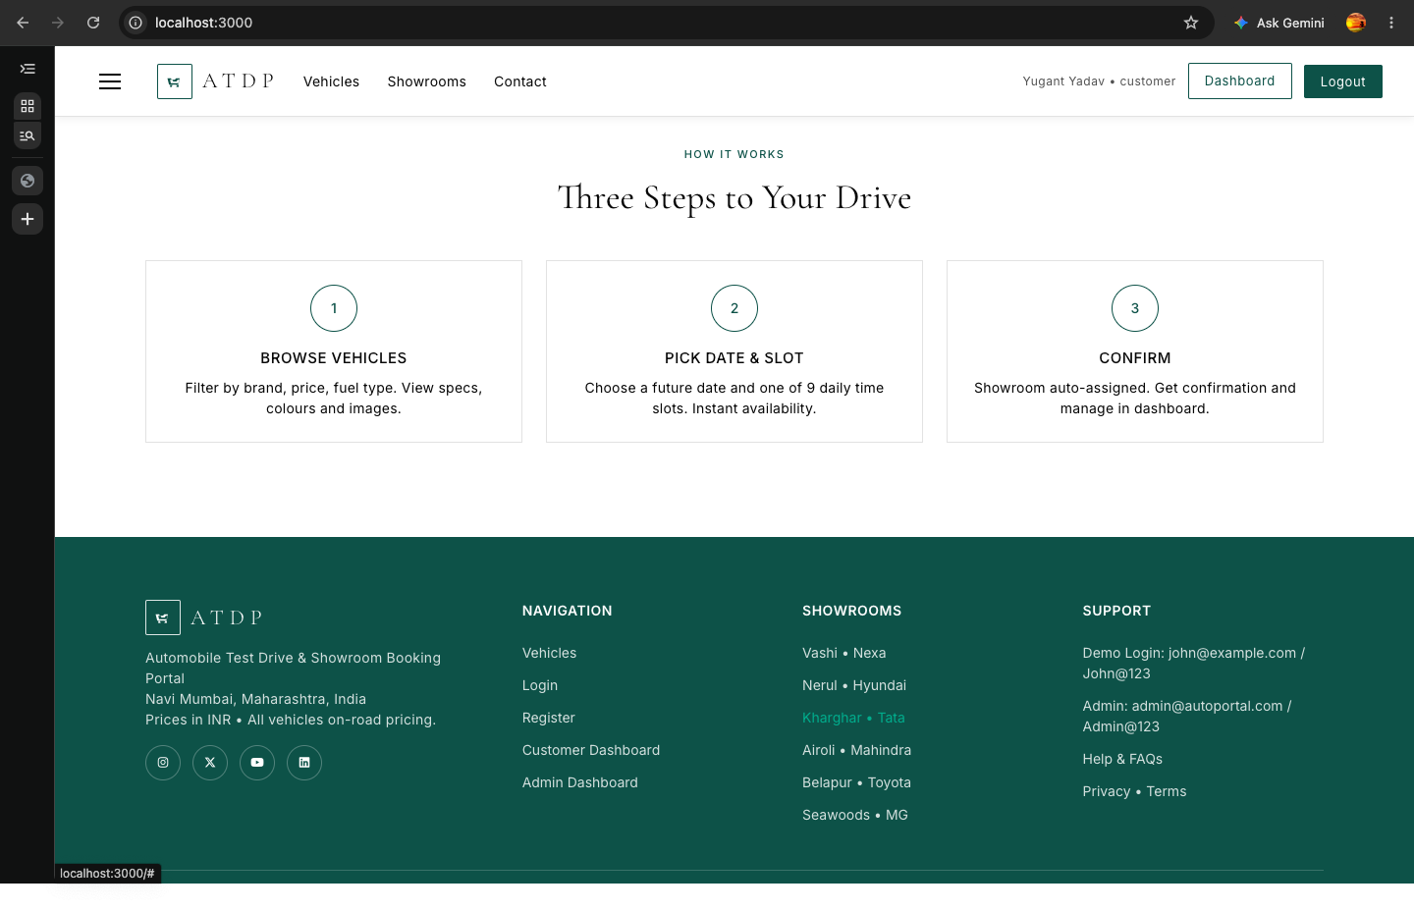
Fig 6: 6. Browse Vehicles — Filter by Brand (Maruti Suzuki)
7. Browse Vehicles — Filter by Fuel (Petrol)
Selecting Petrol shows only Petrol cars across all brands (Swift, Baleno, Exter, etc.).
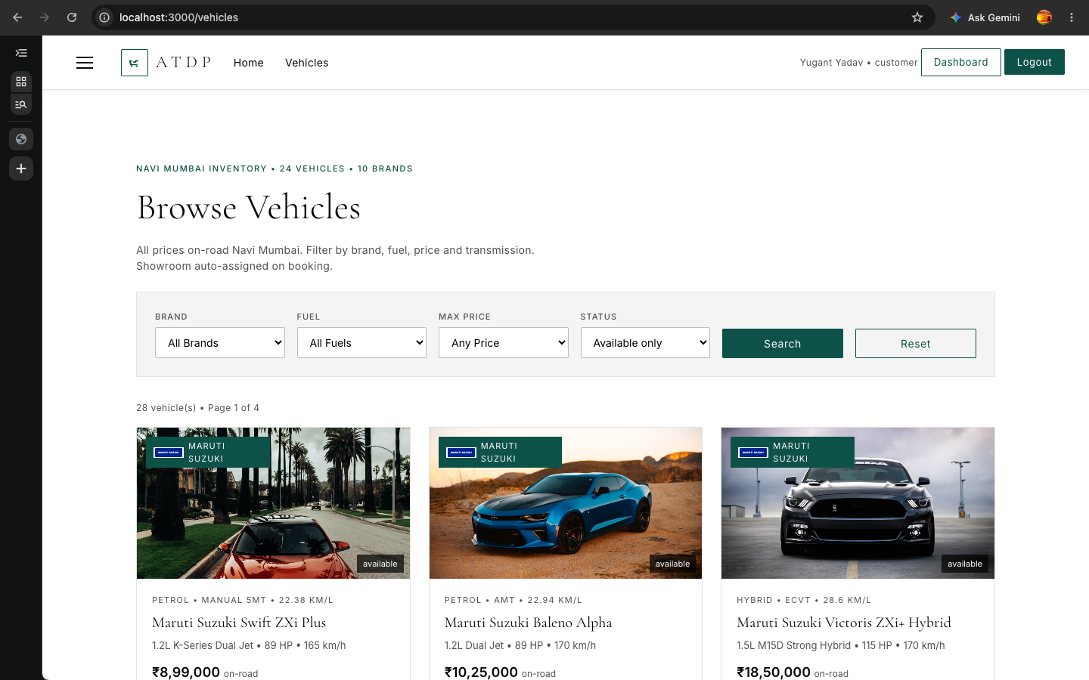
Fig 7: 7. Browse Vehicles — Filter by Fuel (Petrol)
8. Browse Vehicles — Filter by Price (≤10 Lakh)
Selecting Max Price ≤10 Lakh shows only cars under 10 lakh (Swift, Exter, Punch) across all brands.
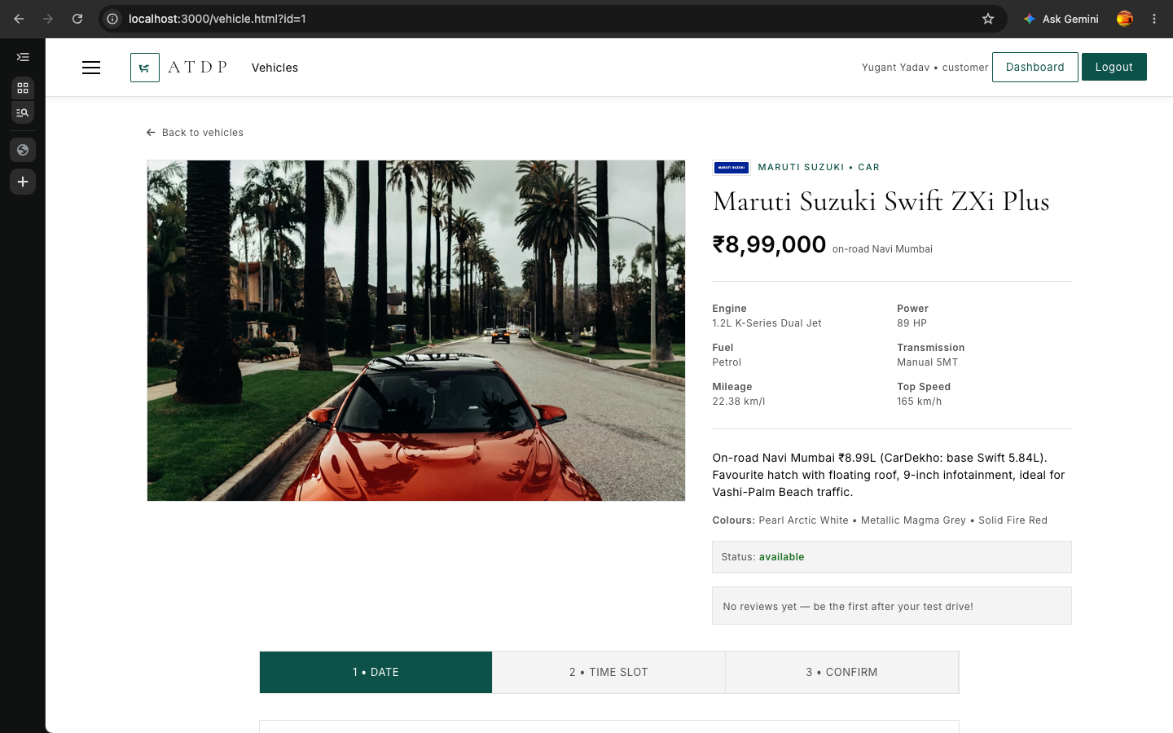
Fig 8: 8. Browse Vehicles — Filter by Price (≤10 Lakh)
9. Vehicle Detail Page (vehicle.html?id=1)
Full details of selected car — photo, brand logo, price in rupees, engine, mileage, colours, status, and auto-assigned showroom.
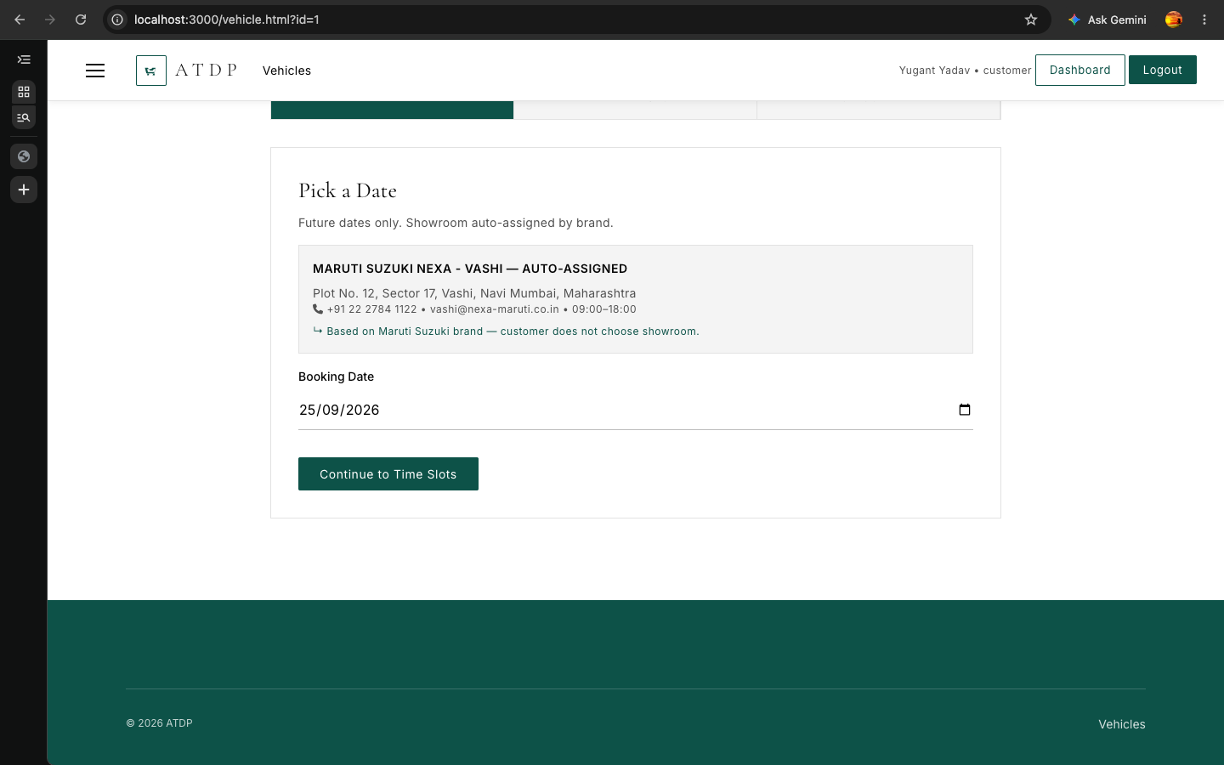
Fig 9: 9. Vehicle Detail Page (vehicle.html?id=1)
10. Booking Step 1 — Pick Date
Customer picks a future date (tomorrow minimum), showroom is already auto-assigned by brand, login gate if not logged in.
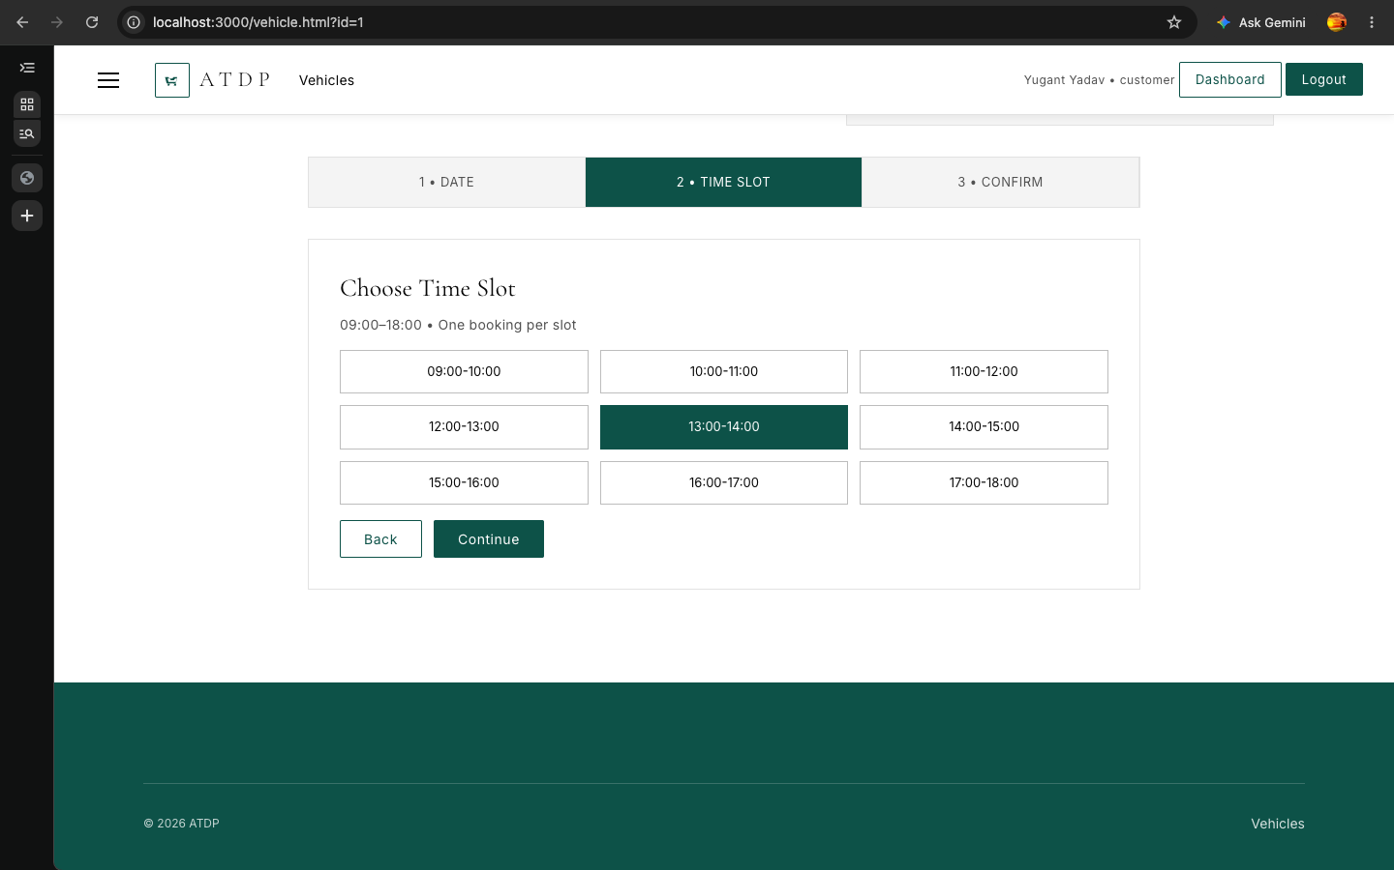
Fig 10: 10. Booking Step 1 — Pick Date
11. Booking Step 2 — Pick Time Slot
9 slots from 9am to 6pm, shows free vs booked (grey strikethrough), selected turns green.
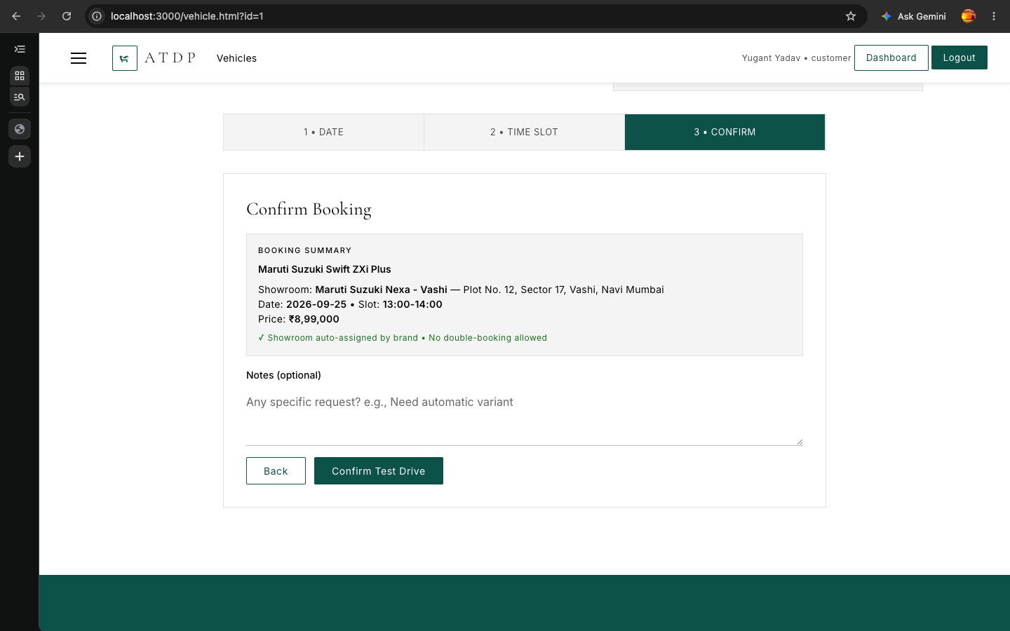
Fig 11: 11. Booking Step 2 — Pick Time Slot
12. Booking Step 3 — Confirm
Summary shows car, showroom, date, slot, price — Confirm creates booking with Pending status.
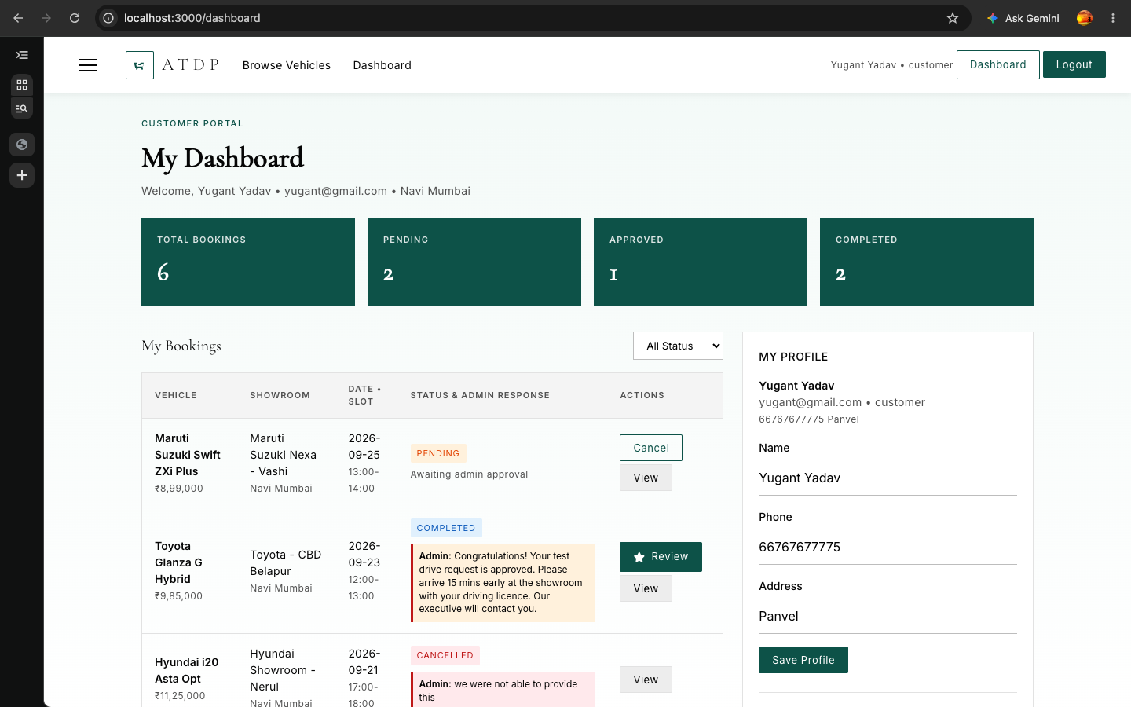
Fig 12: 12. Booking Step 3 — Confirm
13. Customer Dashboard — My Bookings
Green stats boxes, table with Vehicle, Showroom, Date/Slot, Status & Admin Response (green for Approved, red for Cancelled), Cancel and View buttons.
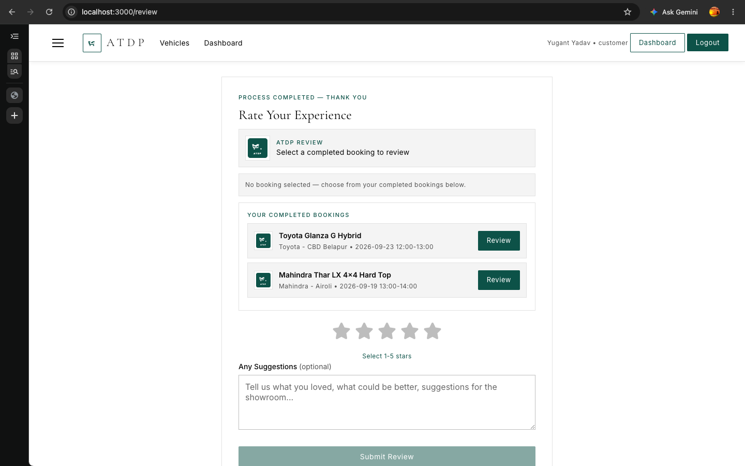
Fig 13: 13. Customer Dashboard — My Bookings
14. Customer Dashboard — Profile
Shows name, email, phone, address, and Change Password form.
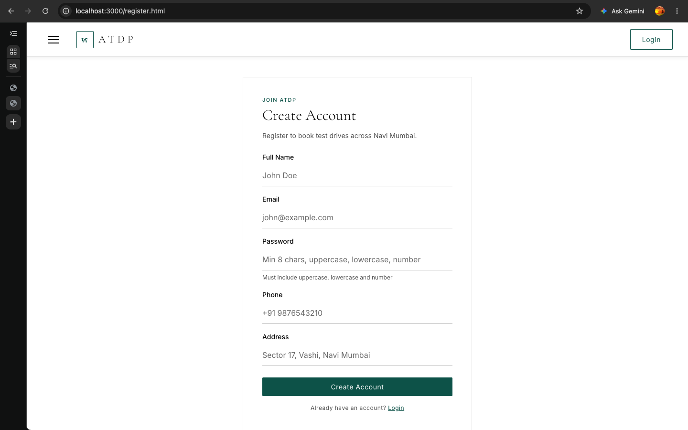
Fig 14: 14. Customer Dashboard — Profile
15. Admin Login
Same login page but Admin tab selected, secret code required (not displayed).
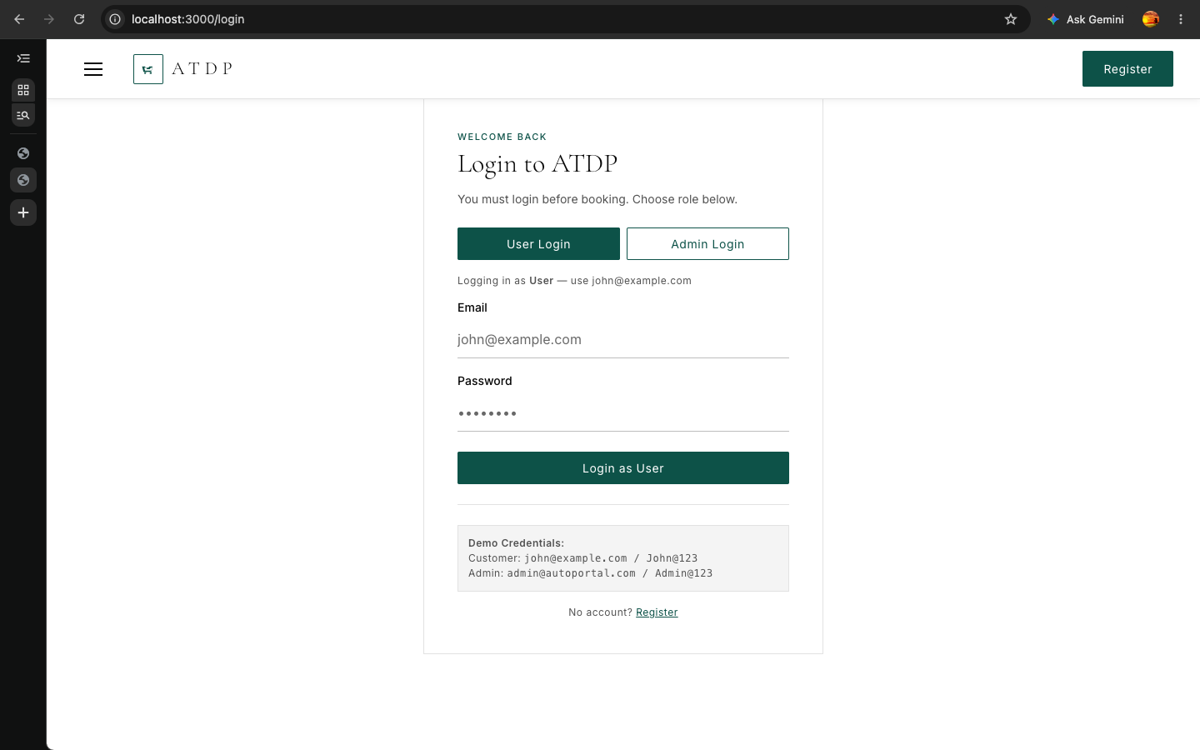
Fig 15: 15. Admin Login
16. Admin Dashboard — Overview
Stats for users, cars, showrooms, bookings, charts for booking status and cars by brand.
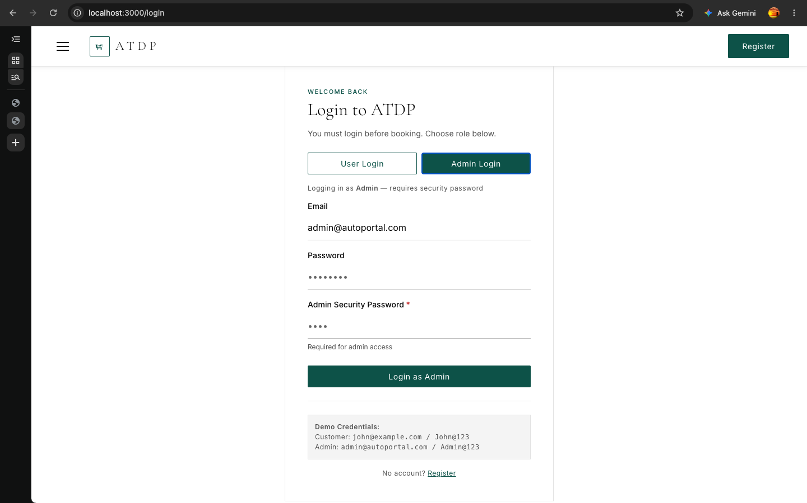
Fig 16: 16. Admin Dashboard — Overview
17. Admin — Bookings Tab
All Status shows 5 demo bookings. Each row has Approve/Reject buttons that open a green-themed popup window for typing a message.
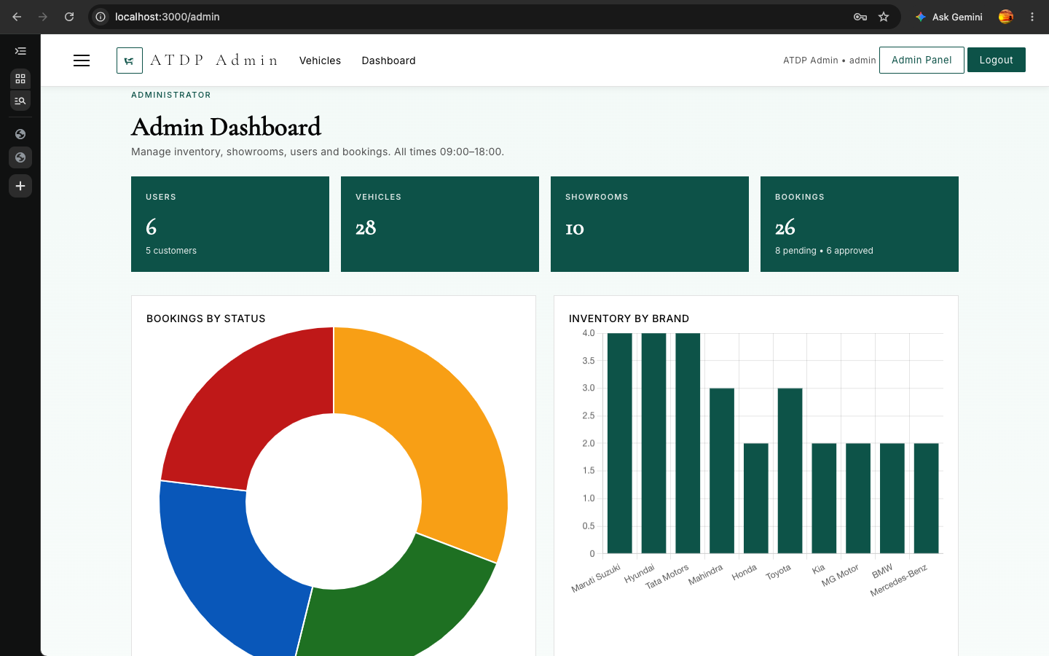
Fig 17: 17. Admin — Bookings Tab
18. Admin — Bookings Approve Modal
Popup window after clicking Approve/Reject — green theme, textarea for congratulatory or rejection reason, Confirm goes to customer dashboard.
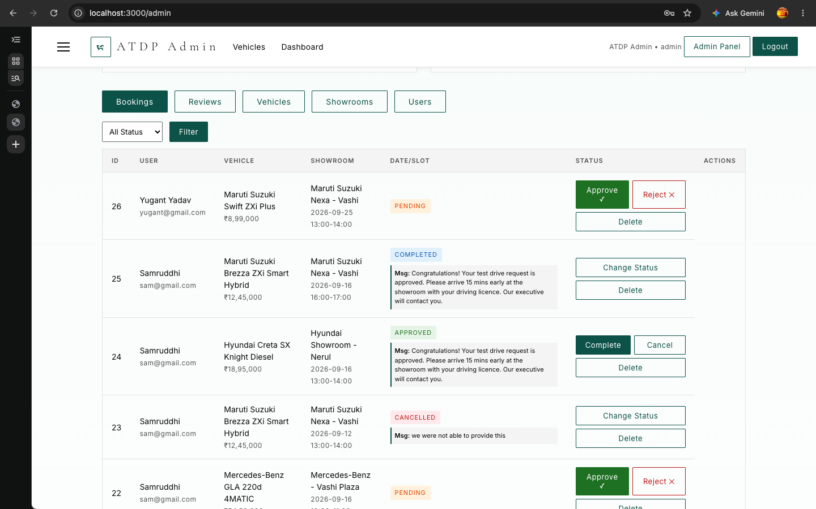
Fig 18: 18. Admin — Bookings Approve Modal
19. Admin — Reviews Tab
Shows all customer 5-star ratings and Any Suggestions after completed drives, with average rating and delete option.
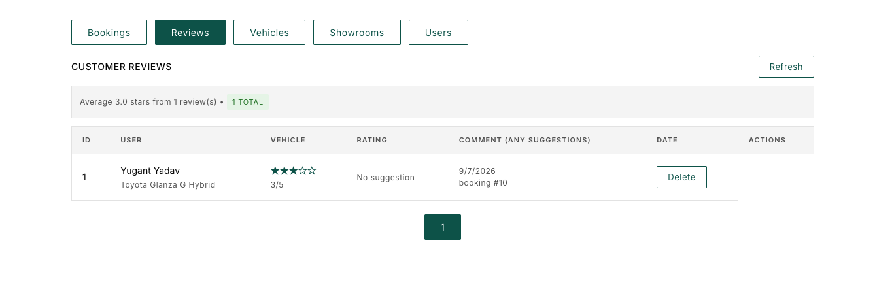
Fig 19: 19. Admin — Reviews Tab

Conclusion
In this experiment we have shown the complete frontend flow of the mini project — from login/registration, through browsing and booking as a customer, to managing as an admin — using only HTML, CSS and JavaScript. The customer can book a test drive and see the admin response, and the admin can approve or reject with a message and later see customer reviews.
Generated 2026-09-03 | http://localhost:5000 (backend) & http://localhost:3000 (frontend) | 19 photos from WEB MINI PROJECT PHOTOS + live captures

