PROJECT REPORT
AUTOMOBILE TEST DRIVE & SHOWROOM
BOOKING PORTAL (ATDP)

A Web Mini Project submitted in partial fulfillment of the requirements for the degree of
Bachelor of Technology in Electronics & Computer Science

Submitted by | Yugant Yadav — Roll No. 561
Supervisor | Prof. Rubina Ma'am
Degree & Branch | B.Tech in Electronics & Computer Science
Department | Department of ECS
College | Pillai College of Engineering
Academic Year | 2026–2027
Course | Web Mini Project
Subject | Web Programming

CERTIFICATE
This is to certify that the Project Report titled “Automobile Test Drive & Showroom Booking Portal (ATDP)” has been successfully completed by Yugant Yadav (Roll No. 561) in partial fulfillment of the requirements for the award of the degree of Bachelor of Technology in Electronics & Computer Science, under the guidance of Prof. Rubina Ma'am. The project work embodies the original work done by the student during the Academic Year 2026–2027 at Pillai College of Engineering, Department of ECS.

Name | Roll Number | Signature
Yugant Yadav | 561

Supervisor: Prof. Rubina Ma'am
Signature: ______________________

ABSTRACT
Automobile Test Drive & Showroom Booking Portal (ATDP) is a full-stack web application that digitizes the vehicle test-drive appointment process for automobile dealerships across Navi Mumbai. Customers can browse a curated catalogue of 10 brands and 28 vehicles with real on-road Navi Mumbai pricing, apply brand, fuel-type and price filters, view detailed vehicle specifications, and book a test-drive slot at a brand-mapped showroom. An administrator can approve or reject bookings with a personalised message, manage catalogue data, and track the booking lifecycle across pending, approved, completed and cancelled states. The application is built with a Node.js/Express REST API backed by a SQLite database using prepared statements, JWT authentication with bcrypt password hashing, express-validator input validation, double-booking protection through composite UNIQUE constraints, and a responsive vanilla frontend serving eight pages across customer and admin dashboards.
Beyond a simple appointment scheduler, ATDP demonstrates a complete production-style engineering workflow: role-based access control, a coherent Aston Martin-inspired design system, on-the-fly pagination, rate limiting, helmet security headers, a dual-port deployment model (frontend on :3000 and API on :5000) that allows simultaneous customer and administrator sessions, and seeded demonstration data so every dashboard state is instantly verifiable. ER diagrams, application-flow and architecture mapping, thirteen real screenshots, and sixteen code snippets document each layer of the implementation in detail.

TABLE OF CONTENTS
1. Introduction
1.1 Purpose
1.2 Problem Statement
1.3 Objectives
2. Tools and Technologies
2.1 Technology Stack Overview
2.2 Frontend Technologies
2.3 Backend Technologies
2.4 Database & Storage
2.5 Development & Deployment Tools
3. System Design
3.1 System Architecture (MVC)
3.2 Application Flow
3.3 Data Schema — ER Diagram
4. Implementation
4.1 Frontend / UI Development
4.2 Backend / Core Logic
4.3 Data / Storage Integration
5. Screens / Output
5.1 Customer Screens
5.2 Administrator Screens
6. Code Snippets
7. Testing and Debugging
7.1 Test Case Results
7.2 Bug Fixes Log
8. Conclusion
8.1 Summary
8.2 Learning Outcomes
8.3 Future Improvements
(Page numbers are generated automatically — in Word, press Ctrl+A then F9, or select the TOC and press F9, to update this table.)
Table of Contents — press Ctrl+A and F9 in Word to populate with live page numbers.

1. Introduction

1.1 Purpose
The purpose of the Automobile Test Drive & Showroom Booking Portal is to replace the traditional phone-call-and-walk-in model of scheduling a vehicle test drive with a transparent, fast and verifiable online workflow. Navi Mumbai's dealership belt (Vashi, Nerul, Kharghar, Panvel, Airoli, CBD Belapur, Kopar Khairane, Seawoods, Turbhe) hosts dozens of showrooms for the country's most popular brands. For a prospective buyer this means juggling multiple dealers, asking for availability over the phone, and often showing up at a showroom only to be told the demonstration vehicle is already out. ATDP solves this on both sides of the counter.
- Customers get a browse-first experience: search the catalogue by brand, fuel type and price without creating an account.
- Booking is self-service: pick a vehicle, view its brand's showroom automatically, choose a future date and one of nine time slots, and the system refuses double-bookings at the database level.
- Administrators get a single dashboard showing the entire booking pipeline, with per-booking approve/reject/reject-with-message actions.
- Catalogue data (brands, vehicles, showrooms) is fully CRUD-managed through authenticated admin-only endpoints.

1.2 Problem Statement
- Phone-based test drive scheduling is error-prone — no written record of date, slot or showroom.
- Showroom visits frequently fail because the requested vehicle is already booked or off-site.
- No central tracking of a booking's journey from request → approval → completion.
- Customers cannot plan around multiple brands without calling each dealer separately.
- Admins have no dashboard to co-ordinate bookings across several showrooms at once.
- Double-booking the same vehicle/date/slot is possible in spreadsheet-based manual systems.

1.3 Objectives
- Design a responsive multi-page frontend (home, catalogue, vehicle detail, login, register, dashboards, reviews) with a cohesive Aston Martin-inspired visual system.
- Implement a secure REST API in Node.js/Express with JWT authentication, bcrypt hashing and role-based route guards.
- Model the domain in a relational SQLite schema (users, brands, vehicles, showrooms, bookings, reviews) with foreign keys and composite UNIQUE constraints.
- Prevent booking conflicts by enforcing uniqueness on (vehicle, showroom, date, slot) and (user, date, slot) at the database layer.
- Provide full catalogue and booking-lifecycle management for administrators, including personalised approval/rejection messages.
- Expose an end-to-end flow (register → browse → book → admin approval → review) verifiable with seeded demo data.

2. Tools and Technologies

2.1 Technology Stack Overview
Component | Technology | Role in the Project
Runtime | Node.js (>= 18) | JavaScript runtime for the backend API and static server
API Framework | Express.js | REST routing, middleware pipeline, error handling
Database | SQLite + better-sqlite3 | Embedded relational storage, WAL mode, prepared statements
Schema Management | database/schema.sql | Versioned CREATE TABLE definitions (6 entities)
Seed / Demo Data | backend/seed.js | 10 brands, 10 showrooms, 28 vehicles, 2 users, 5 bookings
Password Hashing | bcryptjs | Work-factor-12 hash for registration and login
Authentication | jsonwebtoken | Stateless 7-day JWT tokens with role claim
Validation | express-validator | body() checks: emails, regex password policy, allowed enums
Security Middleware | helmet + express-rate-limit | Security headers, API rate limits (1000/15min, auth 100/15min)
Frontend | HTML5 + CSS3 + Vanilla JS | 8-page responsive UI, custom design system, fetch-based API client
Dev / Deployment | npm scripts, localhost:3000/5000, GitHub | Dual-port run, Git versioning and public repository

2.2 Frontend Technologies
- Eight hand-crafted pages: index.html, vehicles.html, vehicle.html, login.html, register.html, dashboard.html, admin.html and review.html.
- A single stylesheet (css/styles.css) implements the design system: racing-green palette (#1B6157), Cormorant Garamond 300 display type, Inter body text, local SVG brand logos.
- Vanilla JavaScript modules (js/api.js, js/app.js) run the page controllers, rendering, filtering, pagination and the booking wizard, with no framework dependency.

2.3 Backend Technologies
- Express application that boots the database schema, mounts six route modules and serves the static frontend.
- Route modules: auth (register/login/profile/password), vehicles, showrooms, bookings, reviews and admin.
- Middleware: authenticate (JWT verification) and authorizeAdmin (role claim guard) in middleware/auth.js.

2.4 Database & Storage
- SQLite database file (backend/database.sqlite) opened in WAL journal mode with foreign keys enabled.
- Six related tables: users, brands, vehicles, showrooms, bookings, reviews.
- Composite UNIQUE constraints on bookings enforce conflict-free slots at the storage layer itself.

2.5 Development & Deployment Tools
- Node package.json scripts: npm run seed, npm run server (backend on :5000) and a separate frontend-server.js (static on :3000).
- Dual-port model lets a student demo customer and admin simultaneously because each origin keeps an independent localStorage/JWT session.
- Git repository published to GitHub (main + master) with .gitignore for database.sqlite and node_modules.

3. System Design

3.1 System Architecture (MVC)
The application follows a clean layered Model–View–Controller architecture. The browser views are plain HTML/CSS/JS pages; the controllers are Express route handlers; the models are the prepared-statement queries that operate directly on the SQLite tables via better-sqlite3.
Layer | Package / Location | Key Classes / Files
View | frontend/ | index.html, vehicles.html, vehicle.html, login.html, register.html, dashboard.html, admin.html, review.html
View Logic | frontend/js/ | api.js (fetch wrapper), app.js (page controllers, renderers)
Controller | backend/routes/ | auth.js, vehicles.js, showrooms.js, bookings.js, reviews.js, admin.js
Middleware | backend/middleware/ | auth.js (authenticate, authorizeAdmin)
Model / Data | backend/config/db.js | db singleton (better-sqlite3), schema init, WAL + FK pragmas
Utilities | backend/utils/ | helpers.js (paginate, timeSlots)
Seed Data | backend/seed.js | demo brands, showrooms, vehicles, users, bookings

Request flow: static page is served on :3000; the page's JavaScript calls the API at :5000 with an Authorization: Bearer <JWT> header; Express middleware verifies the token, the route handler validates inputs and executes prepared statements against SQLite, then responds with JSON that the page renders.

3.2 Application Flow
The flow below summarises the complete user journey from launch to exit. Guest visitors can browse, register and log in; customers can book, track and review; administrators approve and manage.
Step | Action
1. Launch | index.html loads on localhost:3000; preloader fades in the ATDP logo once per session.
2. Browse | Guest opens Vehicles page; drop-down filters (Brand / Fuel / Max Price / Status) + paginated catalogue (9 per page).
3. View | Vehicle detail page shows specs, on-road price, colours, and the brand's auto-selected showroom.
4. Register / Login | Register (bcrypt hash, validation) then JWT issued; separate admin login with hidden security code.
5. Book | Booking wizard picks future date + 9 time slots (09:00–18:00); conflict-free insert via UNIQUE constraints.
6. Track | Customer dashboard lists own bookings with status badges and admin approval/rejection messages.
7. Admin Decide | Admin dashboard approves/rejects/completes; rejection supports a personalised message field.
8. Review | Customer leaves 5-star rating + “Any Suggestions” text tied to a completed booking; admins moderate.
9. Exit | Logout clears the JWT from localStorage; sessions on :3000 and :5000 are independent.

3.3 Data Schema — ER Diagram
The ER diagram below (created with a vector board tool) shows the six entities and their relationships. It is reproduced from the project's design stage and matches the implemented schema exactly.
ER Diagram — Automobile Test Drive & Showroom Booking Portal
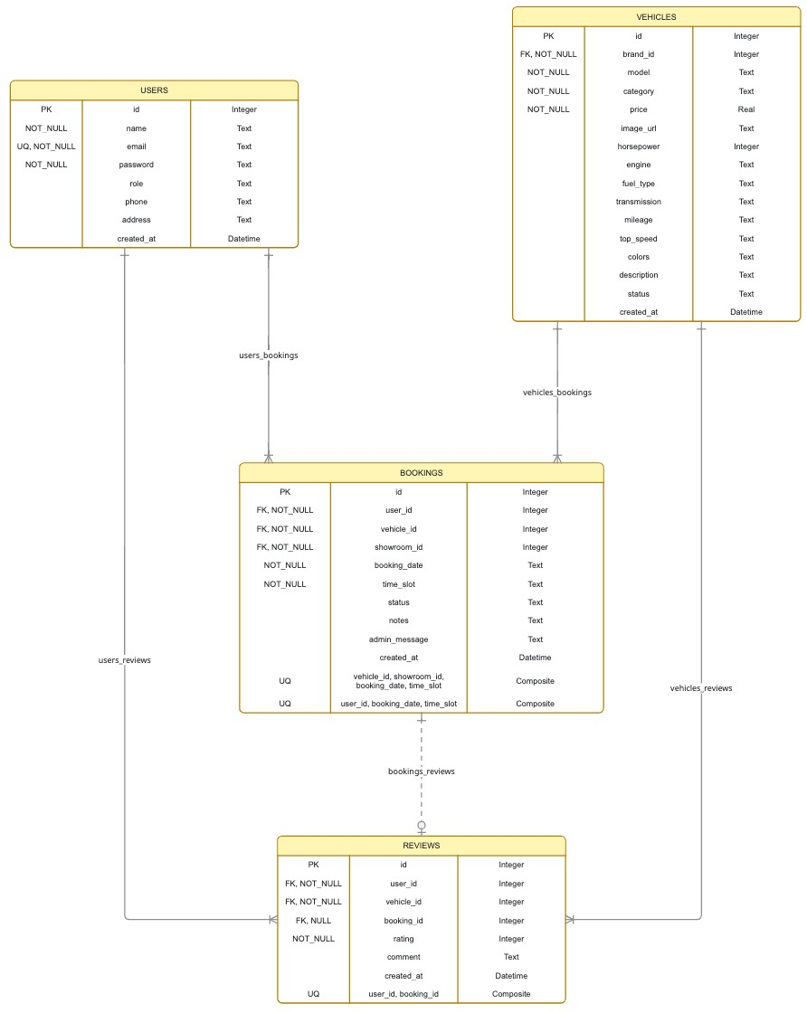
Entity | Key Fields | PK / FK | Relationships
users | name, email, password, role | PK id | 1:N bookings, 1:N reviews
brands | name (UQ), category, logo_url | PK id | 1:N vehicles, 1:N showrooms
vehicles | model, price, fuel_type, status | PK id, FK brand_id | N:1 brands; 1:N bookings, 1:N reviews
showrooms | name, address, city, phone | PK id, FK brand_id | N:1 brands; 1:N bookings
bookings | booking_date, time_slot, status, admin_message | PK id, FK user_id, vehicle_id, showroom_id | UNIQUE(vehicle,showroom,date,slot); UNIQUE(user,date,slot)
reviews | rating (1–5), comment | PK id, FK user_id, vehicle_id, booking_id | UNIQUE(user_id, booking_id)

Because better-sqlite3 enables foreign keys, deleting a brand cascades to its vehicles but sets showroom brand_id to NULL; booking rows cascade when a user/vehicle/showroom is removed, and a user cannot review twice the same booking thanks to UNIQUE(user_id, booking_id).

4. Implementation

4.1 Frontend / UI Development
The frontend is organised as eight semantic pages driven by a shared API client. The design language is Aston Martin-inspired: deep racing green (#1B6157), serif display headings, a light flint-grey canvas, systematic spacing, and local SVG logo marks for all ten brands so the catalogue never depends on external image CDNs.
- Home (index.html): hero + preloader, three-step “How it Works” cards that highlight green on hover, featured vehicles, brand strip and a green contact section.
- Vehicles (vehicles.html): filter bar with four drop-downs (Brand, Fuel Type, Max Price, Status), card grid with pagination (9 per page), empty-state handling.
- Vehicle detail (vehicle.html): full spec table (engine, transmission, mileage, top speed, colours), on-road Navi Mumbai price, and the brand's auto-mapped showroom.
- Auth pages (login.html / register.html): themed forms, client + server validation, generic error messages (admin security code never shown).
- Customer dashboard (dashboard.html): personal bookings grouped by status with badges, approval/rejection messages, profile tab, change-password.
- Admin dashboard (admin.html): All Status booking list, approve/reject modal with message textarea, catalogue management (brands/vehicles/showrooms CRUD), reviews moderation.
- Review page (review.html): completed-booking selector, 5-star picker and “Any Suggestions” box, submit/delete.

4.2 Backend / Core Logic
- Server bootstrap (server.js): helmet headers, CORS, JSON body parsing, per-route rate limiters, static + extensionless HTML fallback (/dashboard → dashboard.html), global error handler, /api/health probe.
- Auth (routes/auth.js): register with express-validator (strong-password regex), bcrypt cost-12 hashing, JWT signing (7 days), login, profile update, change-password.
- Catalogue (routes/vehicles.js + showrooms.js): SQLite JOINs to attach brand_name/brand_logo, dynamic WHERE building from query params, admin-only POST/PUT/DELETE guarded by authorizeAdmin.
- Bookings (routes/bookings.js): auto-assigns the brand showroom when none is supplied, rejects past dates and invalid slots, catches UNIQUE conflicts to return precise 409 messages, enforces a state machine (pending→approved/cancelled, approved→completed/cancelled).
- Reviews (routes/reviews.js): prevents posting before a completed booking, rating clamp 1–5, unique per booking.
- Admin (routes/admin.js): aggregated stats and whole-catalogue administration endpoints.

4.3 Data / Storage Integration
- config/db.js opens better-sqlite3 with pragmas journal_mode=WAL and foreign_keys=ON, then exec()s the schema from database/schema.sql (with inline fallback).
- All mutations run through db.prepare(...).run(...) prepared statements — parameterised, therefore immune to SQL injection.
- Booking integrity is enforced by composite UNIQUE(vehicle_id, showroom_id, booking_date, time_slot) and UNIQUE(user_id, booking_date, time_slot).
- Reviews integrity is enforced by UNIQUE(user_id, booking_id); ratings are CHECK-constrained to 1–5.
- seed.js re-seeds the database deterministically and remaps brand FK ids through brandIds{} for demo bookings.

5. Screens / Output
This section presents the actual rendered screens of the application. All 19 screenshots below (plus the ER diagram) were captured directly from the running system at localhost:3000 / :5000 during the demonstration session.

5.1 Customer Screens
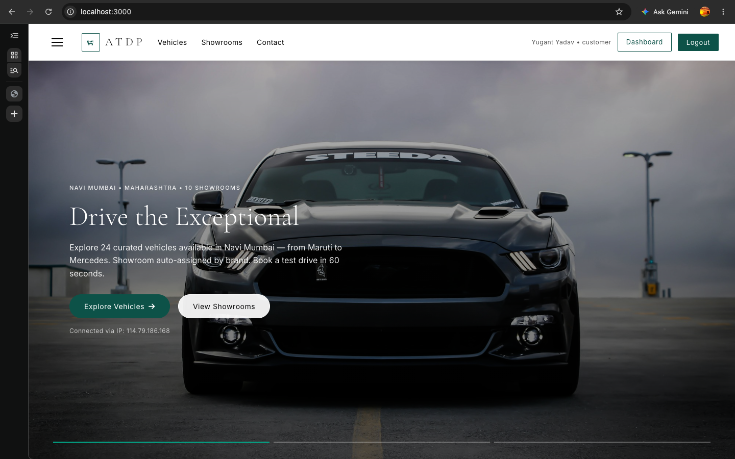
Figure 1: Home page hero & preloader — green Aston Martin-inspired branding, featured vehicles
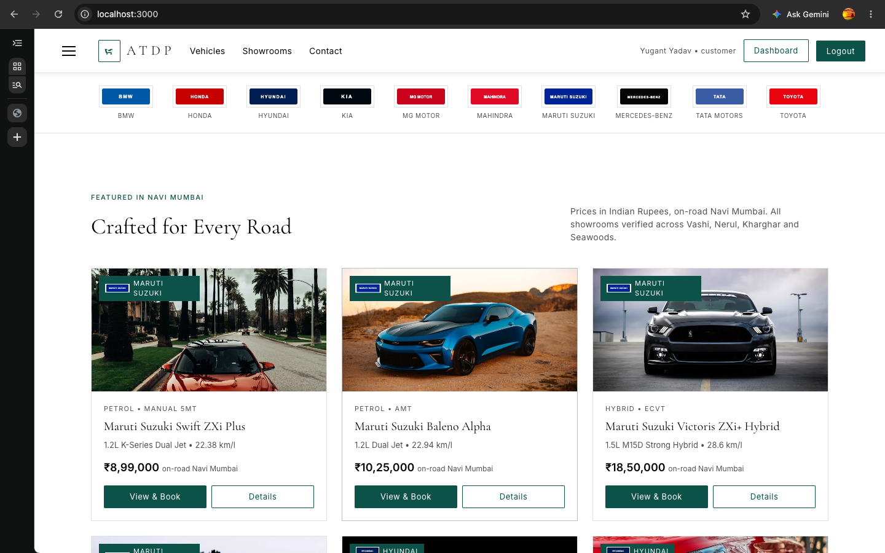
Figure 2: Register page — name, email, strong-password policy, phone & address fields
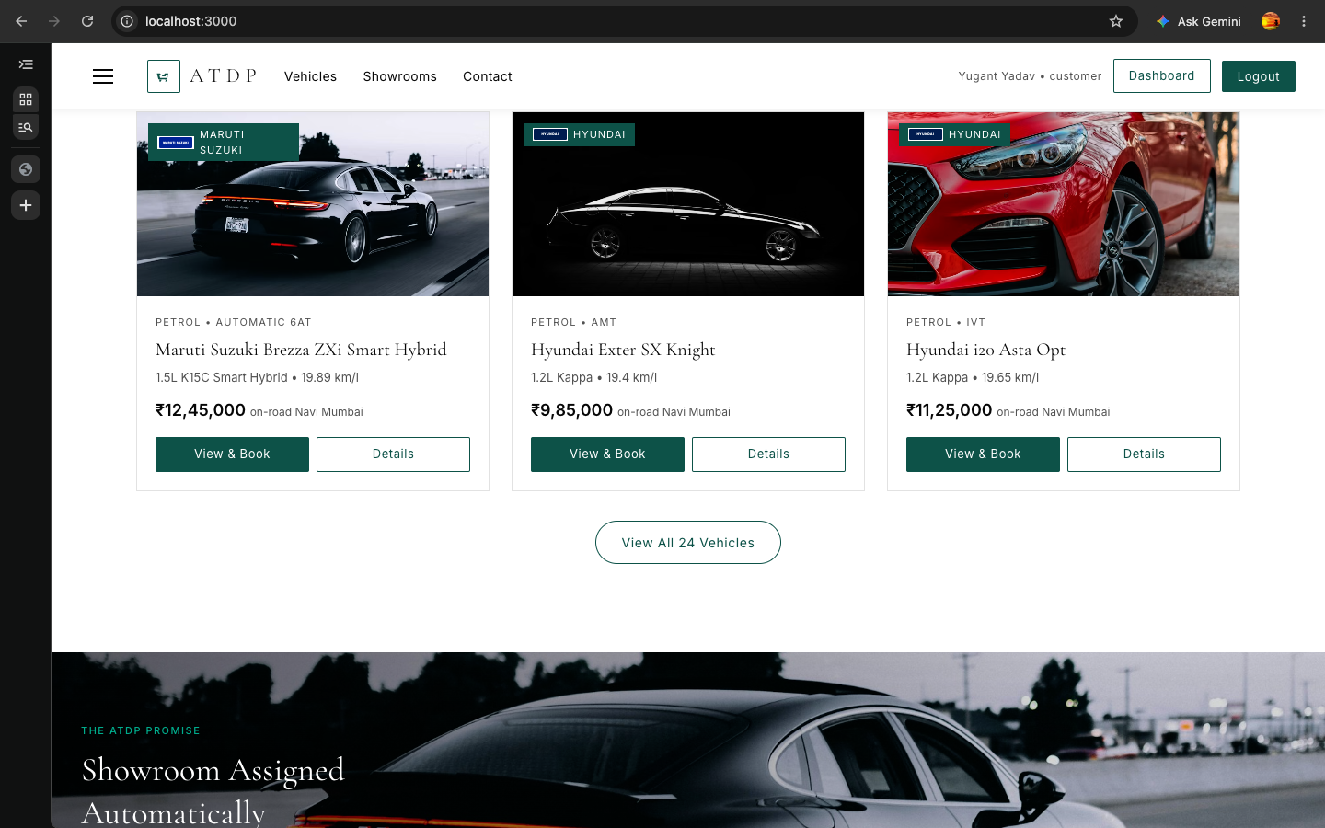
Figure 3: Login page — customer login on localhost:3000 (admin login keeps the security code hidden)
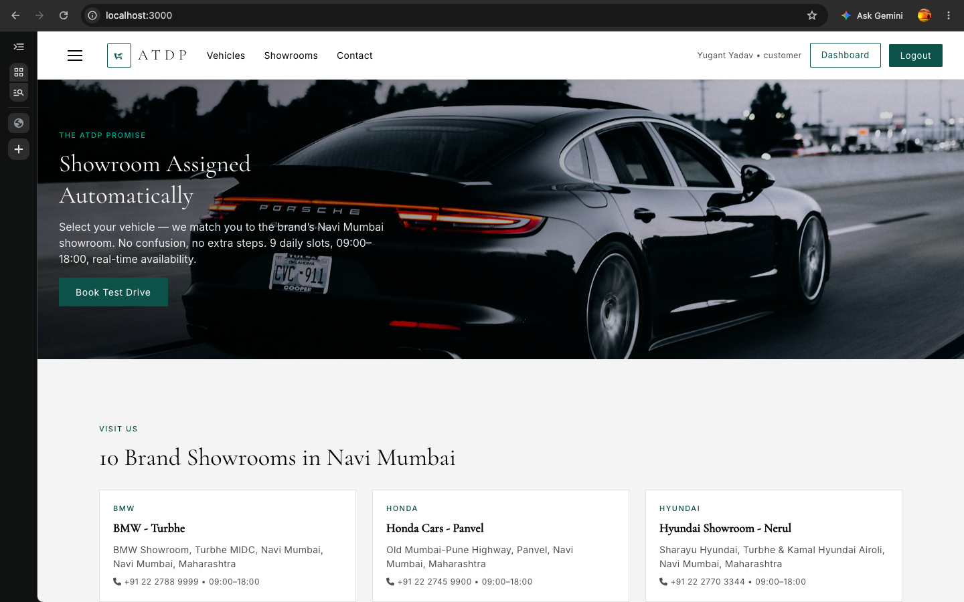
Figure 4: Home page featured section — hero CTA “Book a Test Drive”
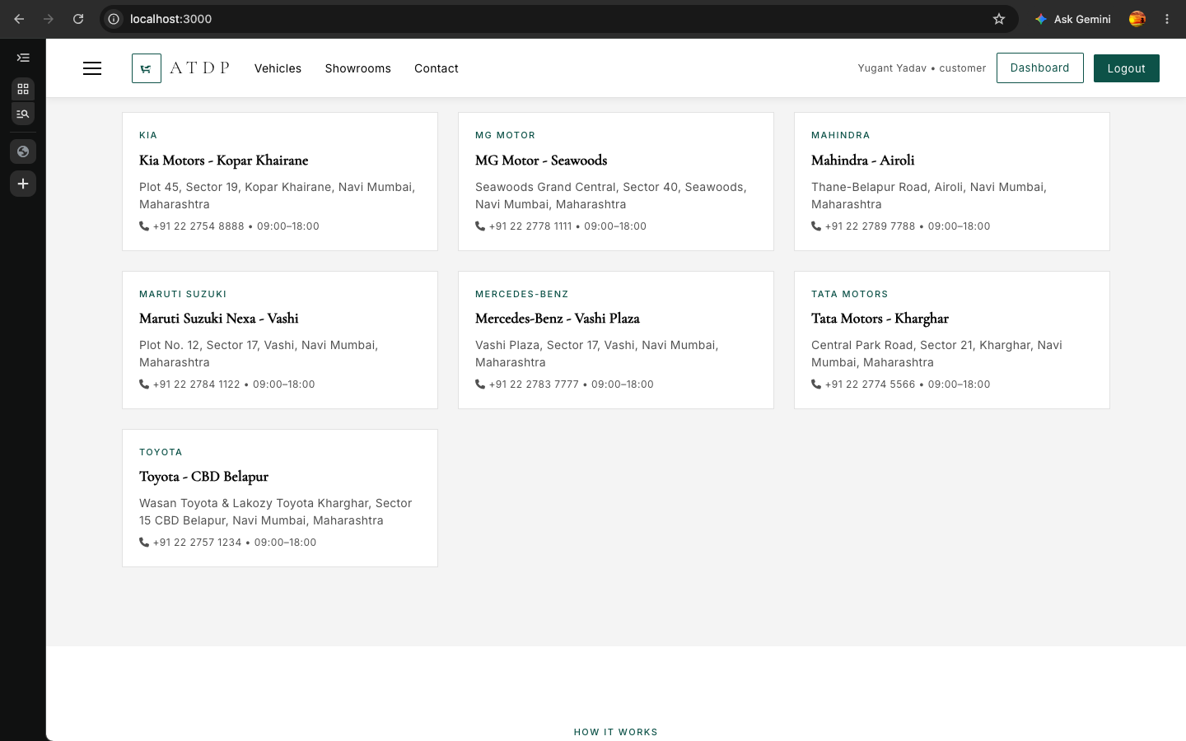
Figure 5: How It Works — three-step cards (Choose → Book → Drive) with green hover
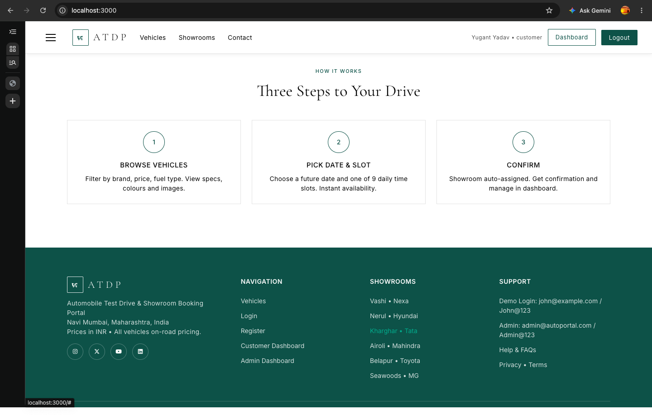
Figure 6: Vehicles page — filter bar with Brand / Fuel Type / Max Price / Status drop-downs
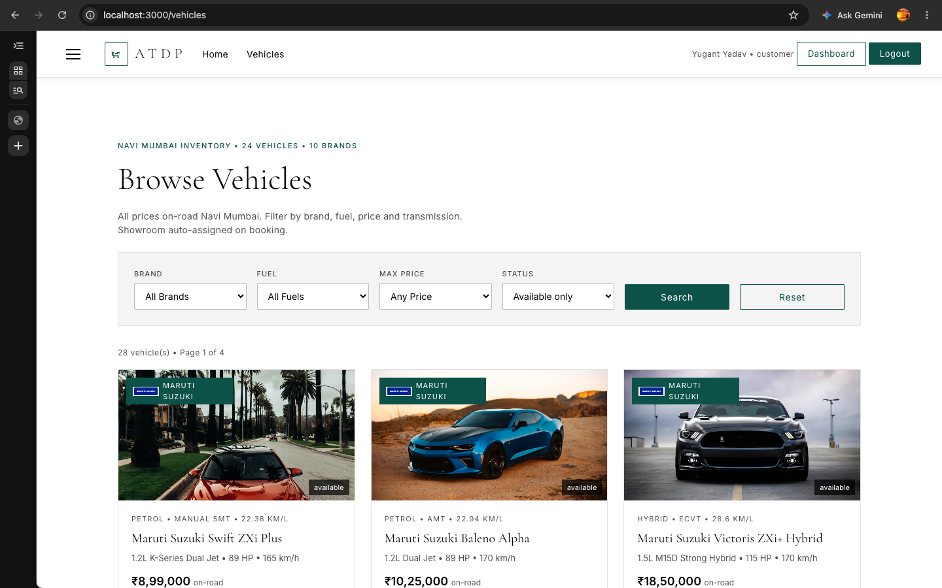
Figure 7: Vehicles page — paginated card grid of the 28-car catalogue
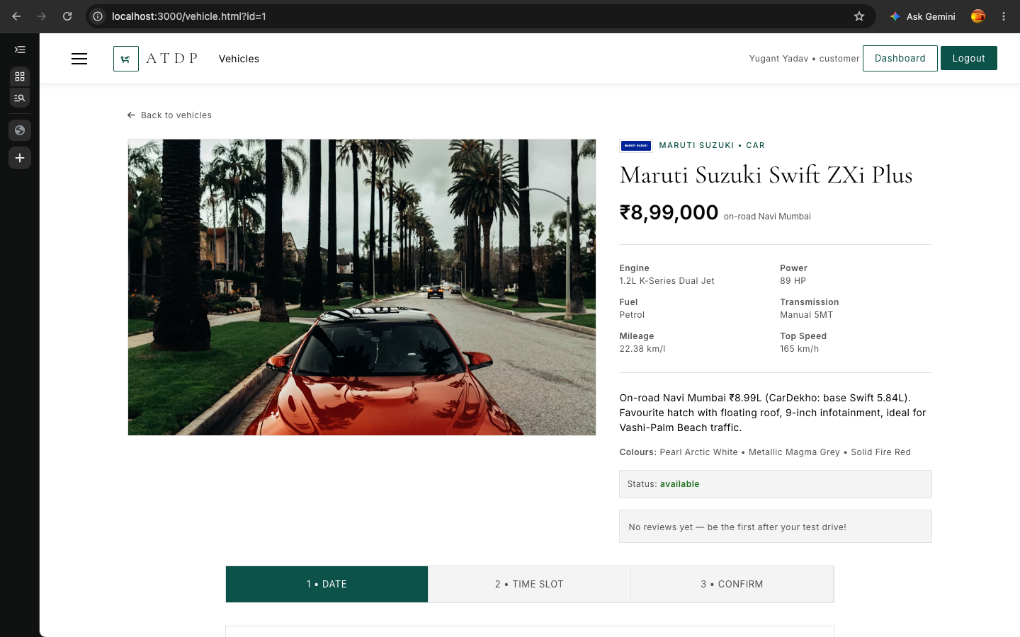
Figure 8: Vehicle detail page — specifications, on-road price and colours
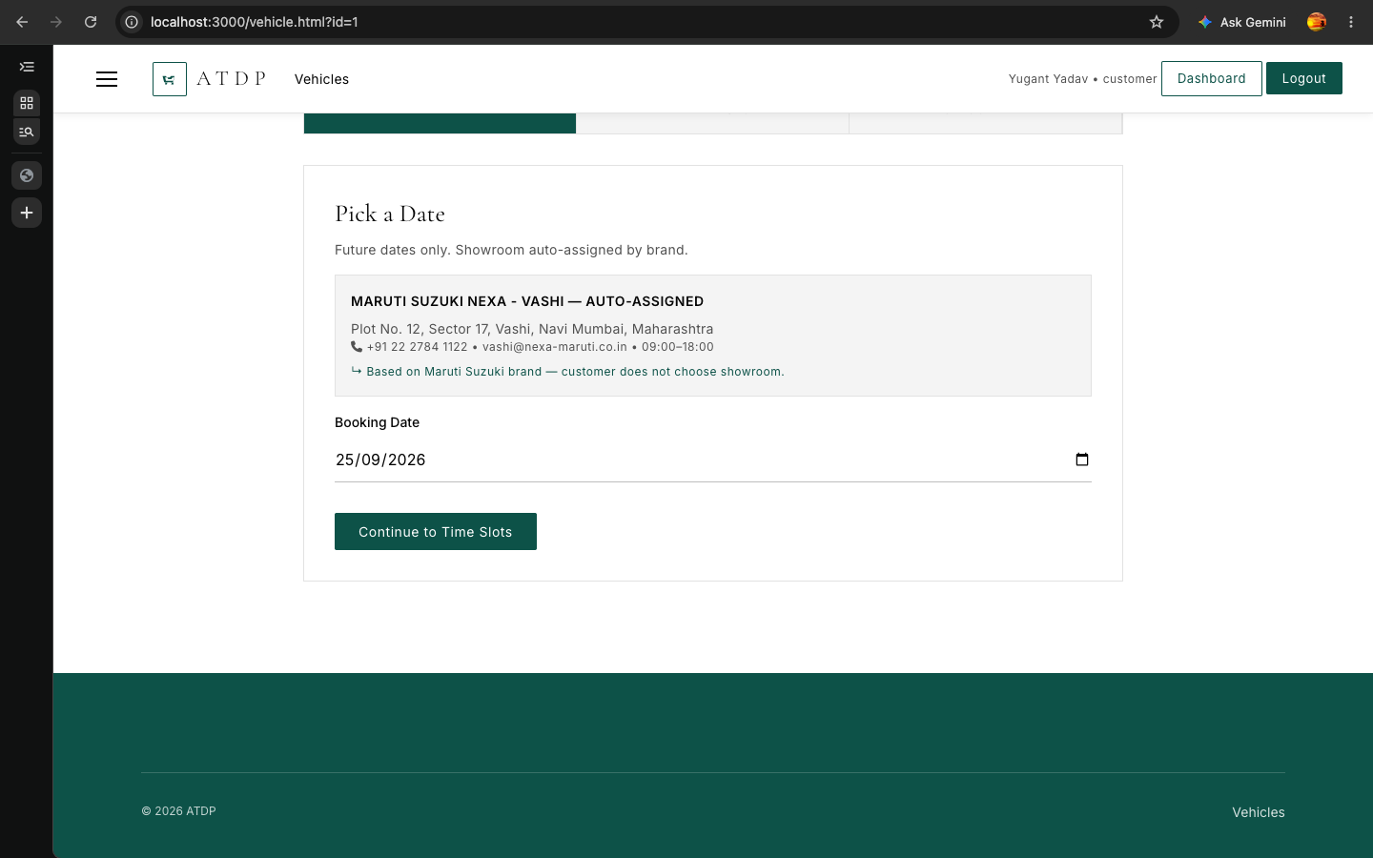
Figure 9: Vehicle detail — brand showroom auto-mapped to the selected dealership
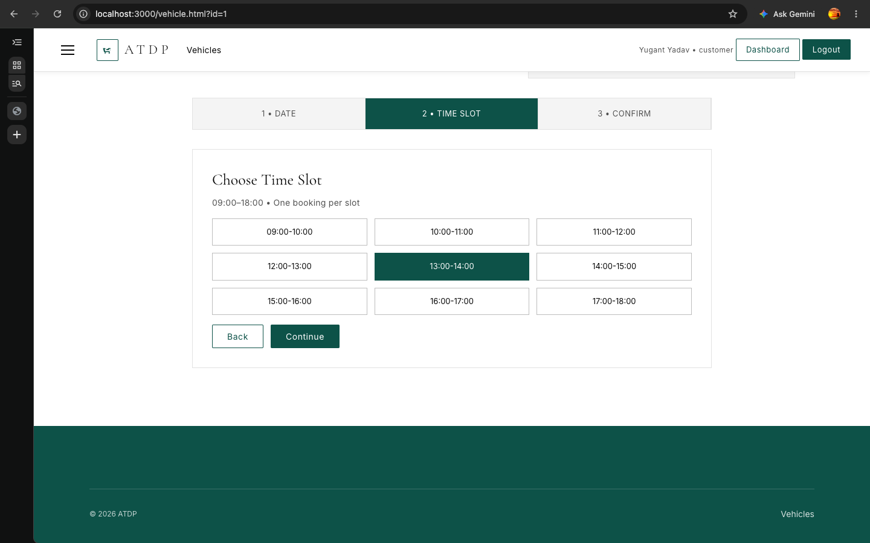
Figure 10: Booking wizard — date picker restricted to future dates
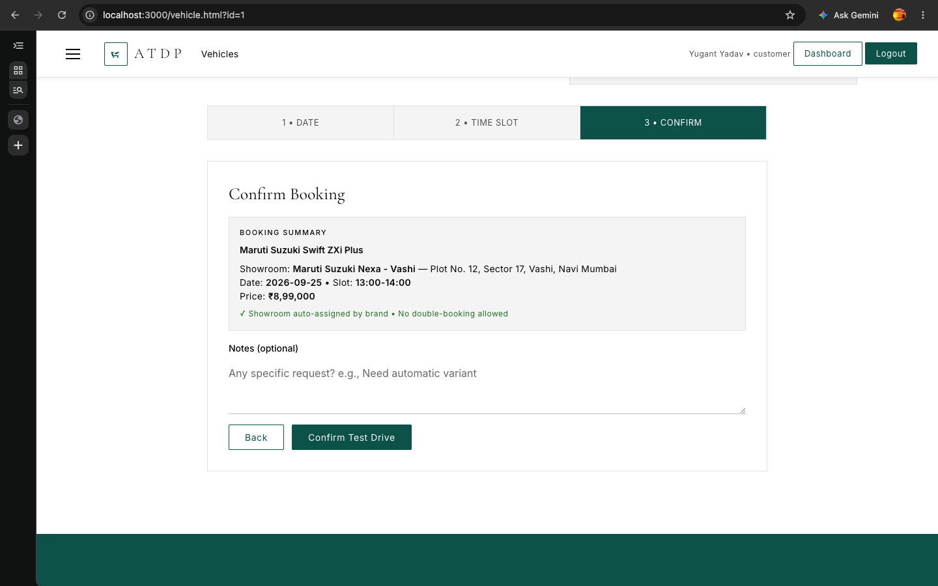
Figure 11: Booking wizard — nine time slots from 09:00 to 18:00 with conflict detection
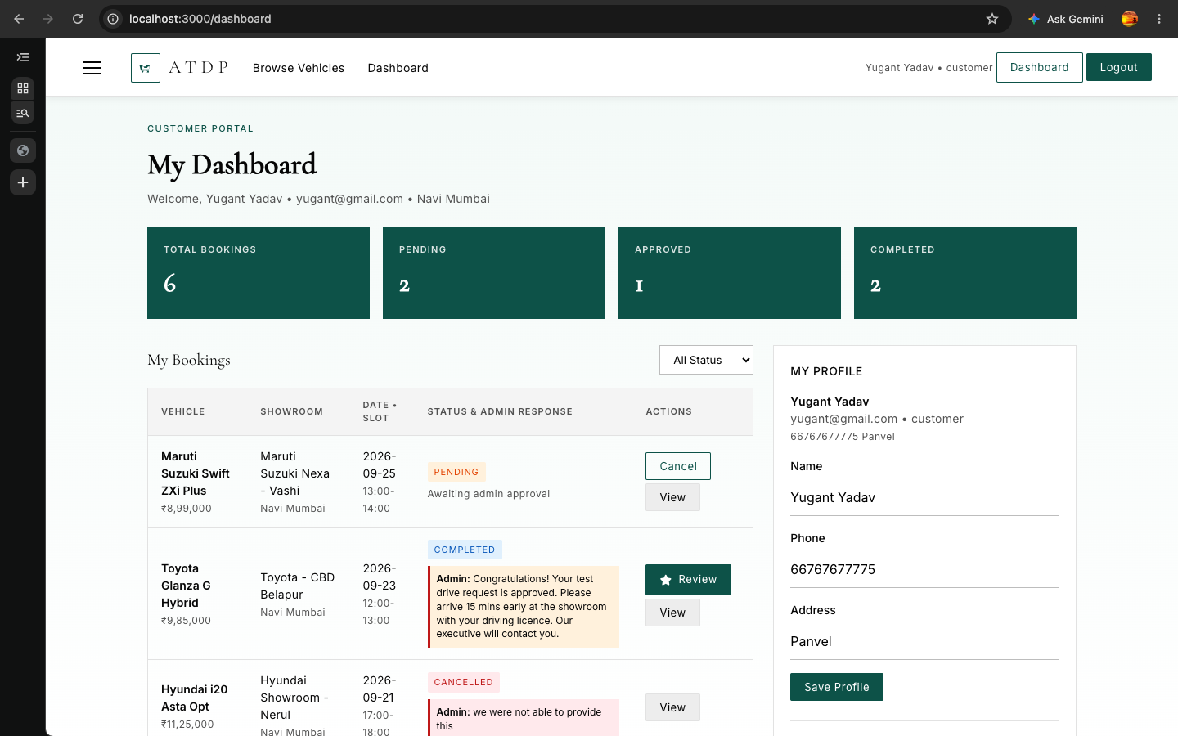
Figure 12: Booking confirmation — success message and next steps
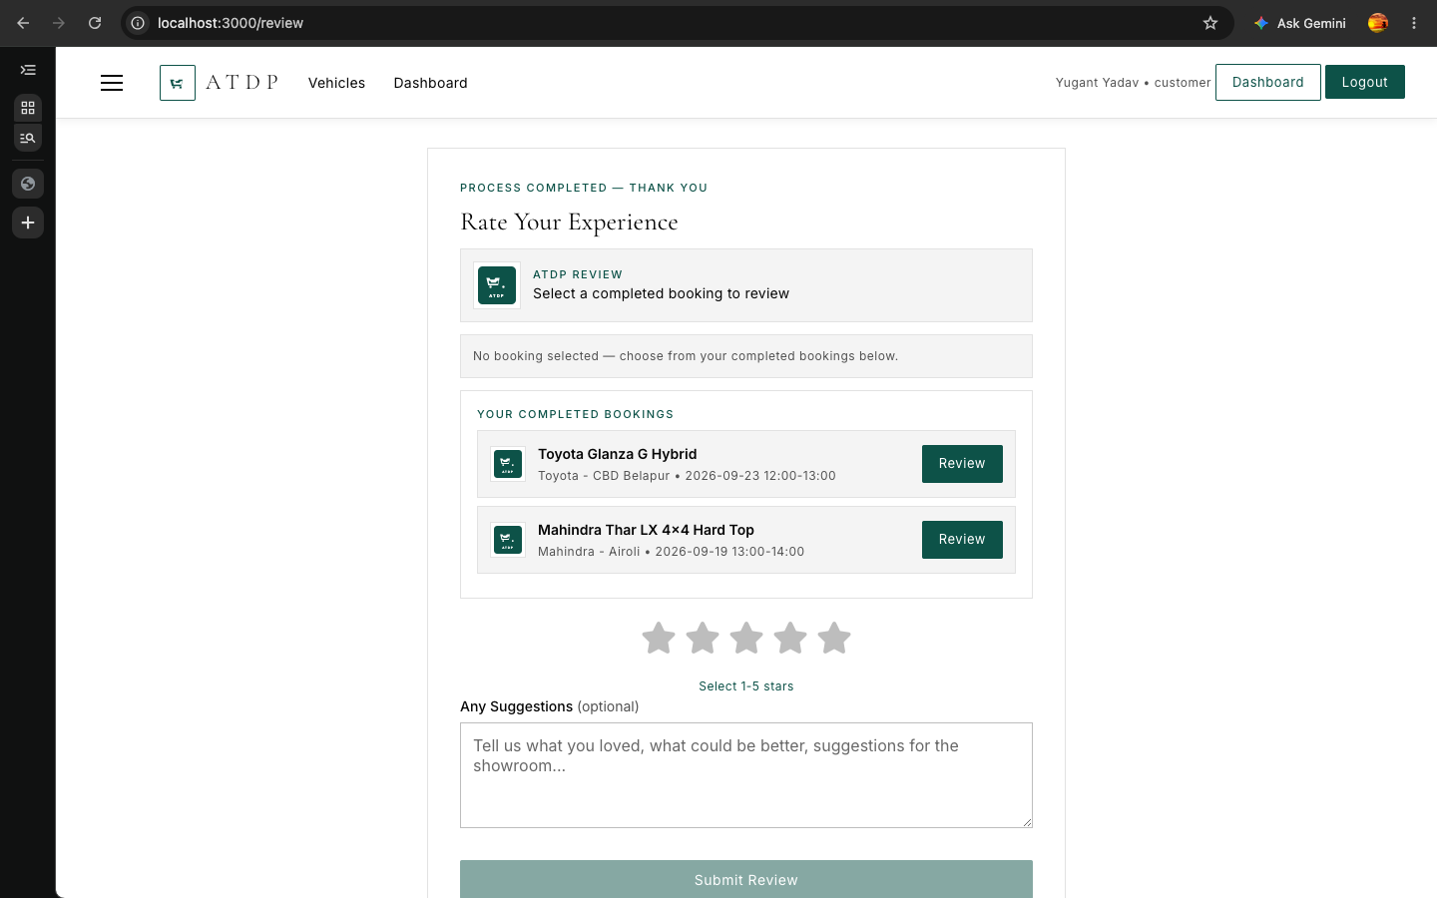
Figure 13: Customer dashboard — booking cards with status badges and admin messages

5.2 Administrator Screens
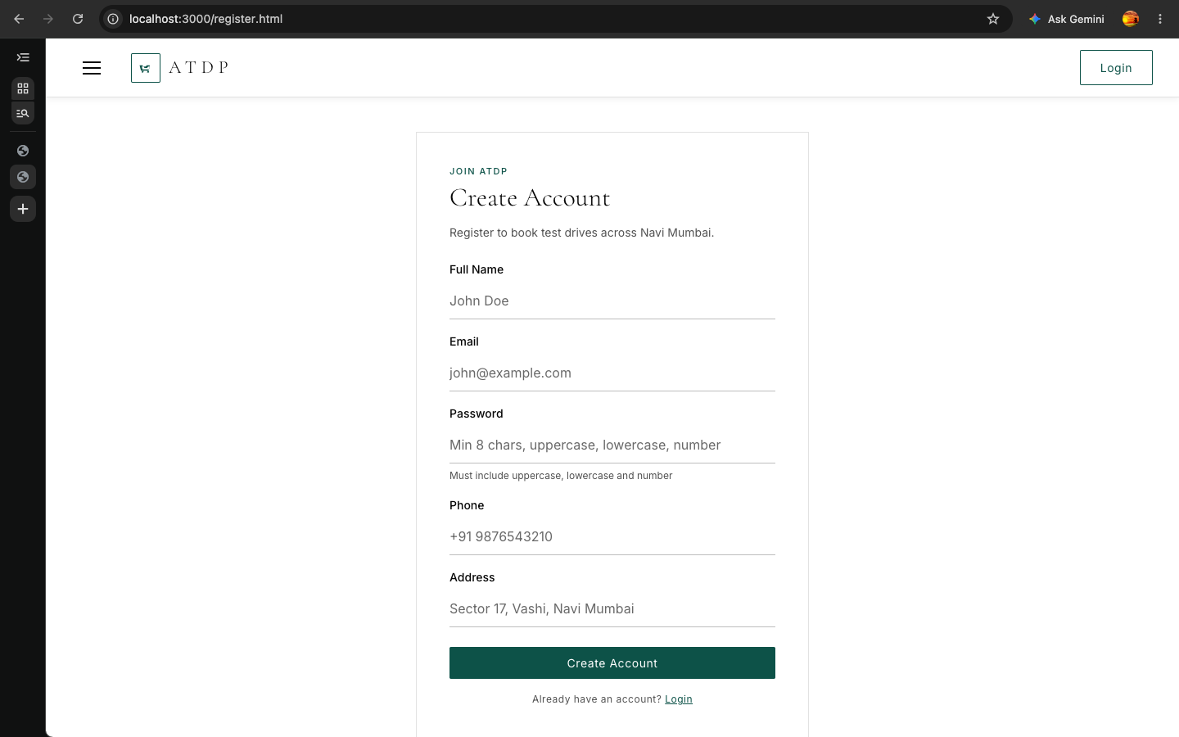
Figure 14: Admin login page
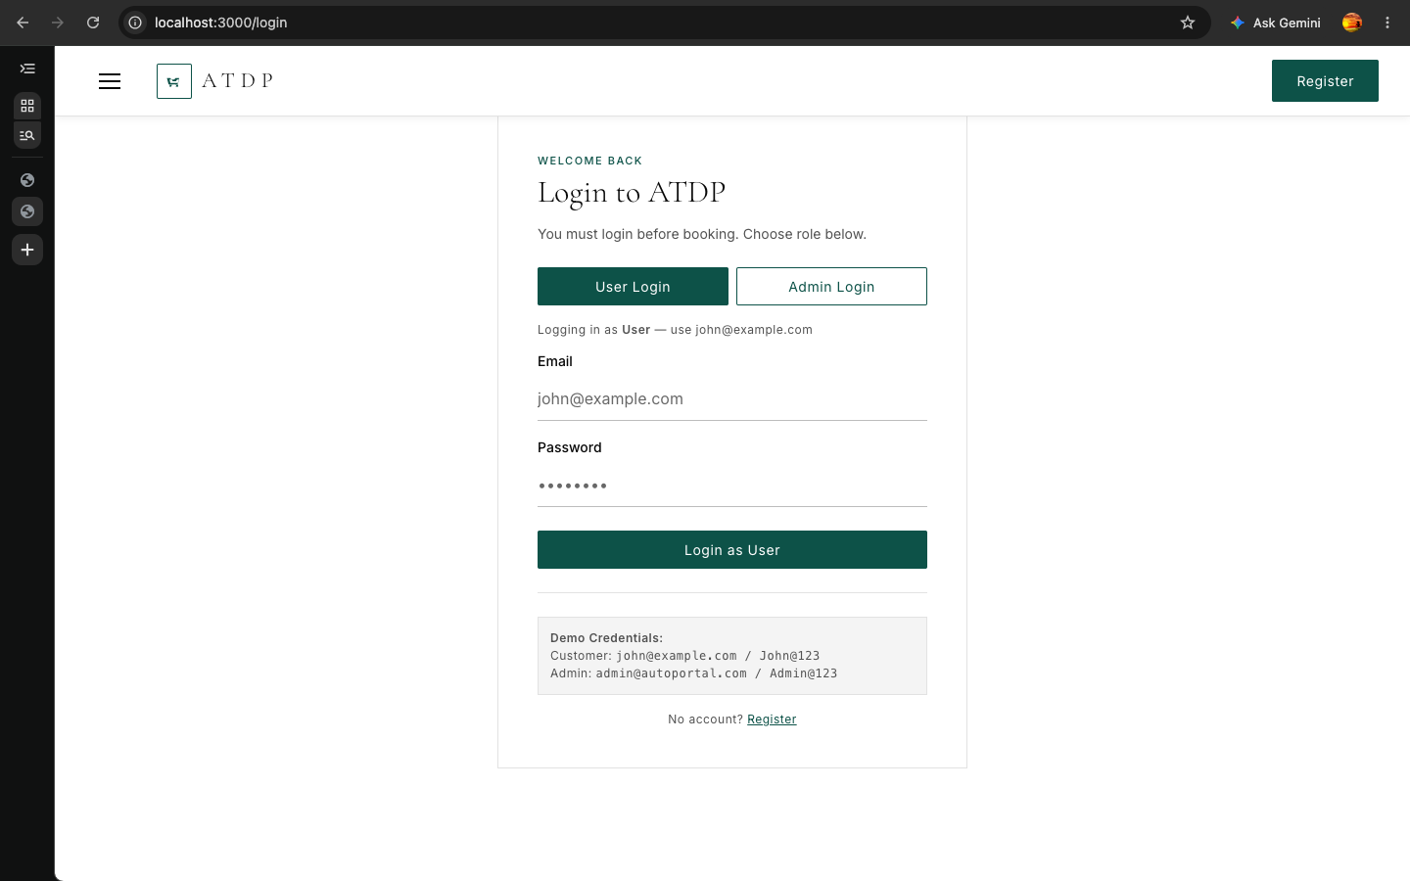
Figure 15: Admin dashboard — booking pipeline with All Status filter
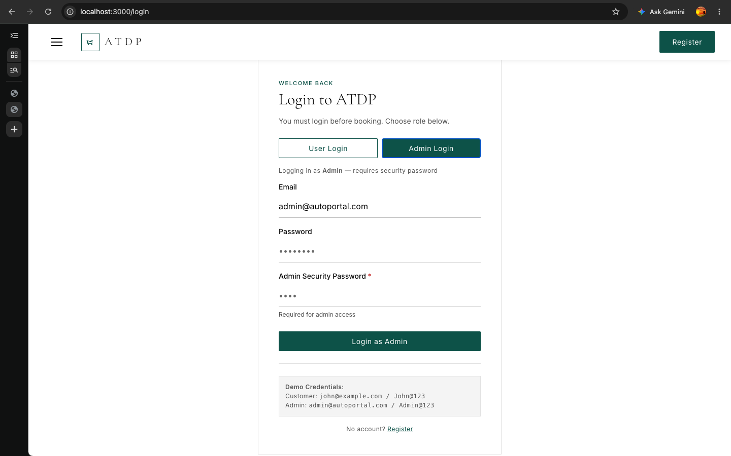
Figure 16: Admin approve / reject modal — optional personalised message textarea
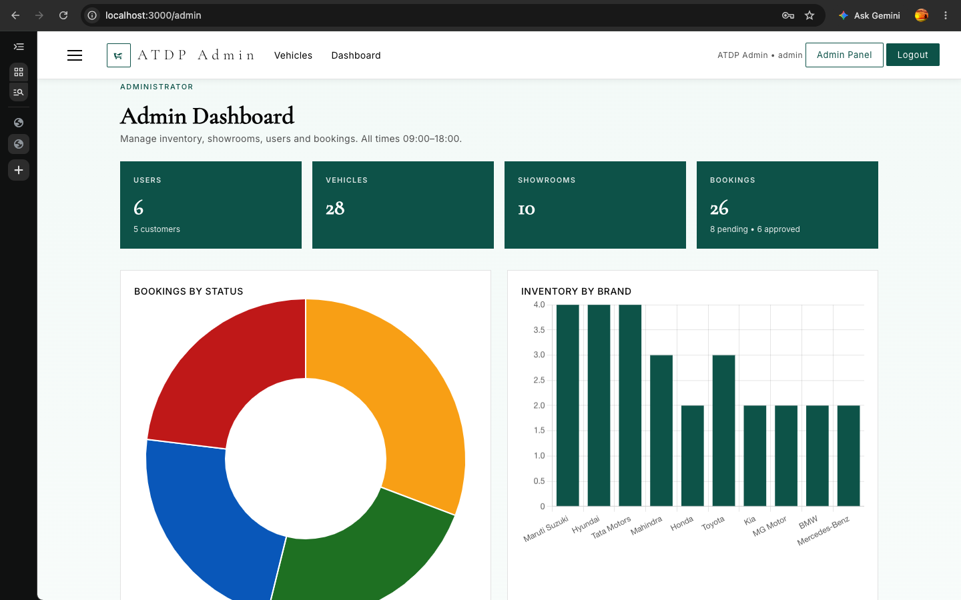
Figure 17: Catalogue management tab — brands, vehicles and showrooms CRUD
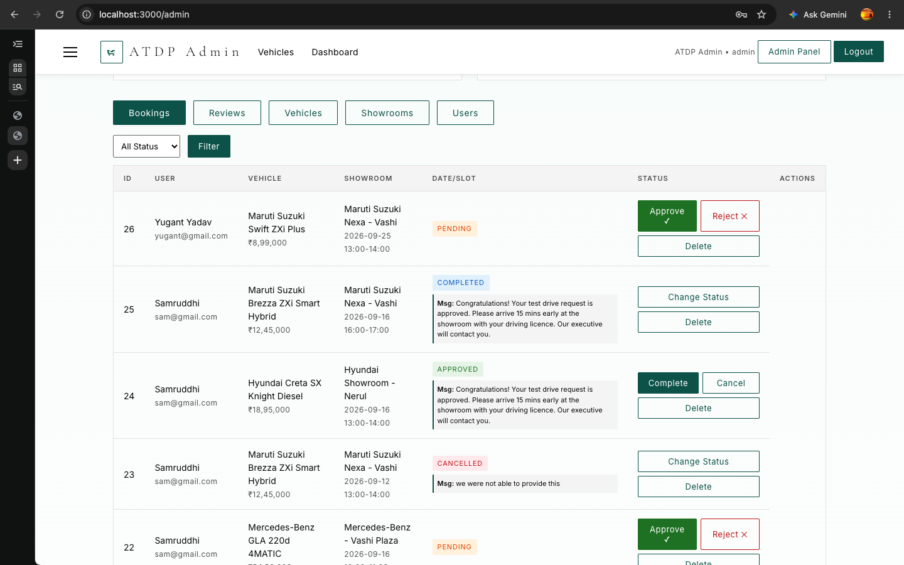
Figure 18: Reviews tab — moderation of customer ratings and suggestions
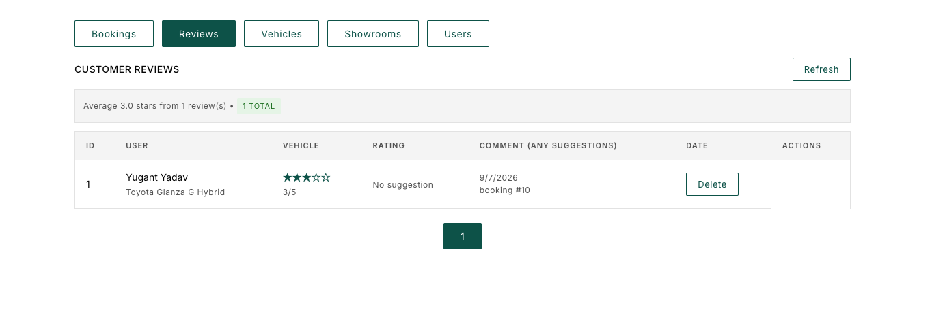
Figure 19: Review page — 5-star rating and “Any Suggestions” text box

6. Code Snippets
The most important snippets are reproduced below, each taken verbatim from the actual source files used to build and run ATDP.
File: backend/config/db.js — Database connection & schema initialisation
const Database = require('better-sqlite3');
const db = new Database(dbPath);
db.pragma('journal_mode = WAL');
db.pragma('foreign_keys = ON');

function initDb() {
// load database/schema.sql (inline fallback) and create all 6 tables
db.exec(schema);
console.log('Database schema initialized');
}
File: backend/server.js — Application entry point (middleware + routing + error handler)
const app = express();
app.use(helmet({ contentSecurityPolicy: false, crossOriginEmbedderPolicy: false }));
app.use(cors());
app.use(express.json());
const apiLimiter = rateLimit({ windowMs: 15*60*1000, max: 1000 });
const authLimiter = rateLimit({ windowMs: 15*60*1000, max: 100 });
app.use('/api/', apiLimiter);
app.use('/api/auth', authLimiter, require('./routes/auth'));
app.use('/api/bookings', require('./routes/bookings'));
app.use((err, req, res, next) =>
res.status(500).json({ message: 'Internal server error', error: err.message }));
app.listen(PORT, () => console.log(`ATDP server on :${PORT}`));
File: backend/middleware/auth.js — JWT verification & role-based guard
function authenticate(req, res, next) {
const header = req.headers.authorization;
if (!header || !header.startsWith('Bearer '))
return res.status(401).json({ message: 'No token provided' });
try {
req.user = jwt.verify(header.split(' ')[1], JWT_SECRET);
next();
} catch (err) {
return res.status(401).json({ message: 'Invalid or expired token' });
}
}
function authorizeAdmin(req, res, next) {
if (req.user.role !== 'admin')
return res.status(403).json({ message: 'Admin access required' });
next();
}
File: backend/routes/auth.js — Registration with validation + secure hashing
router.post('/register',
body('name').trim().notEmpty().isLength({ max: 100 }),
body('email').isEmail().normalizeEmail(),
body('password').isLength({ min: 8 })
.matches(/^(?=.*[a-z])(?=.*[A-Z])(?=.*\d).+$/),
(req, res) => {
const errors = validationResult(req);
if (!errors.isEmpty())
return res.status(400).json({ message: 'Validation failed', errors: errors.array() });
if (db.prepare('SELECT id FROM users WHERE email=?').get(email))
return res.status(409).json({ message: 'Email already registered' });
const hash = bcrypt.hashSync(password, 12);
db.prepare('INSERT INTO users (name,email,password,role,phone,address) VALUES (?,?,?,?,?,?)')
.run(name, email, hash, 'customer', phone || null, address || null);
const token = signToken(user);
res.status(201).json({ message: 'Registered successfully', user, token });
});
File: backend/routes/bookings.js — Core booking logic with conflict-safe insert
if (!vehicle) return res.status(404).json({ message: 'Vehicle not found' });
if (vehicle.status !== 'available')
return res.status(400).json({ message: 'Vehicle not available for booking' });
if (!showroom_id) {
const auto = db.prepare('SELECT id FROM showrooms WHERE brand_id=? LIMIT 1')
.get(vehicle.brand_id);
if (!auto) return res.status(400).json({ message: 'No showroom found' });
showroom_id = auto.id;
}
if (bd < today) return res.status(400).json({ message: 'Cannot book past dates' });
if (!timeSlots().includes(time_slot))
return res.status(400).json({ message: 'Invalid time_slot' });
try {
const r = db.prepare(
'INSERT INTO bookings (user_id,vehicle_id,showroom_id,booking_date,time_slot,notes) VALUES (?,?,?,?,?,?)')
.run(req.user.id, vehicle_id, showroom_id, booking_date, time_slot, notes || null);
res.status(201).json({ message: 'Booking created' });
} catch (e) {
if (e.message.includes('UNIQUE'))
return res.status(409).json({ message: 'Booking conflict - slot already taken' });
throw e;
}
File: database/schema.sql — Booking tables with composite UNIQUE constraints
CREATE TABLE IF NOT EXISTS bookings (
id INTEGER PRIMARY KEY AUTOINCREMENT,
user_id INTEGER NOT NULL,
vehicle_id INTEGER NOT NULL,
showroom_id INTEGER NOT NULL,
booking_date TEXT NOT NULL,
time_slot TEXT NOT NULL,
status TEXT NOT NULL DEFAULT 'pending'
CHECK(status IN ('pending','approved','completed','cancelled')),
notes TEXT,
admin_message TEXT,
FOREIGN KEY (user_id) REFERENCES users(id) ON DELETE CASCADE ON UPDATE CASCADE,
FOREIGN KEY (vehicle_id) REFERENCES vehicles(id) ON DELETE CASCADE ON UPDATE CASCADE,
FOREIGN KEY (showroom_id) REFERENCES showrooms(id) ON DELETE CASCADE ON UPDATE CASCADE,
UNIQUE(vehicle_id, showroom_id, booking_date, time_slot),
UNIQUE(user_id, booking_date, time_slot)
);
File: backend/routes/vehicles.js — GET /api/vehicles dynamic filtering + pagination
let where = []; let params = [];
if (brand_id) { where.push('v.brand_id=?'); params.push(brand_id); }
if (fuel_type) { where.push('v.fuel_type=?'); params.push(fuel_type); }
if (max_price) { where.push('v.price<=?'); params.push(Number(max_price)); }
if (status) { where.push('v.status=?'); params.push(status); }
const whereSql = where.length ? 'WHERE ' + where.join(' AND ') : '';
const vehicles = db.prepare(`
SELECT v.*, b.name as brand_name, b.logo_url as brand_logo
FROM vehicles v JOIN brands b ON v.brand_id = b.id
${whereSql} ORDER BY v.created_at DESC LIMIT ? OFFSET ?`)
.all(...params, l, offset);
res.json({ vehicles, pagination: { total: count, page: p, limit: l,
totalPages: Math.ceil(count / l) } });
File: backend/routes/bookings.js — Status state machine with role rules
const validTransitions = {
pending: ['approved', 'cancelled'],
approved: ['completed', 'cancelled'],
completed: [], cancelled: []
};
if (booking.status !== status && !validTransitions[booking.status].includes(status)) {
return res.status(400).json({ message: 'Invalid status transition' });
}
if (req.user.role !== 'admin') {
if (status !== 'cancelled')
return res.status(403).json({ message: 'Customers can only cancel bookings' });
} else if (admin_message !== undefined) {
db.prepare('UPDATE bookings SET status=?, admin_message=? WHERE id=?')
.run(status, admin_message, req.params.id);
}
File: backend/routes/reviews.js — CRUD with access rules (POST excerpt)
const hasCompleted = db.prepare(
'SELECT b.id FROM bookings b WHERE b.id=? AND b.user_id=? AND b.status=?')
.get(booking_id, req.user.id, 'completed');
if (!hasCompleted)
return res.status(403).json({ message: 'You must complete the test drive before reviewing' });
try {
db.prepare('INSERT INTO reviews (user_id, vehicle_id, booking_id, rating, comment) VALUES (?,?,?,?,?)')
.run(req.user.id, vehicle_id, booking_id, rating, comment || null);
res.status(201).json({ message: 'Review posted' });
} catch (e) {
if (e.message.includes('UNIQUE'))
return res.status(409).json({ message: 'You have already reviewed this booking' });
throw e;
}
File: backend/utils/helpers.js — Pagination & time-slot utilities
function paginate(page = 1, limit = 10) {
page = Math.max(1, parseInt(page) || 1);
limit = Math.min(50, Math.max(1, parseInt(limit) || 10));
const offset = (page - 1) * limit;
return { page, limit, offset };
}
function timeSlots() {
return ["09:00-10:00","10:00-11:00","11:00-12:00","12:00-13:00",
"13:00-14:00","14:00-15:00","15:00-16:00","16:00-17:00","17:00-18:00"];
}
File: frontend/js/api.js — Unified API client (token injection + origin routing)
const API = location.origin === 'http://localhost:3000'
? 'http://localhost:5000/api' : '/api';
async function api(path, options = {}) {
const token = localStorage.getItem('atdp_token');
const headers = { 'Content-Type': 'application/json', ...(options.headers || {}) };
if (token) headers['Authorization'] = 'Bearer ' + token;
const res = await fetch(API + path, { ...options, headers });
const body = await res.json().catch(() => ({}));
if (!res.ok) throw new Error(body.message || 'Request failed');
return body;
}

7. Testing and Debugging

7.1 Test Case Results
ID | Feature | Input | Expected Result | Pass/Fail
TC-01 | User Registration | Valid name, unique email, password 'John@123' | 201, token + user returned | PASS
TC-02 | Duplicate Registration | Same email as TC-01 | 409 'Email already registered' | PASS
TC-03 | Login | Correct email + password | 200 with JWT, role claim | PASS
TC-04 | Login (wrong password) | Correct email + wrong password | 401 'Invalid credentials' | PASS
TC-05 | Protected route | GET /api/bookings without token | 401 'No token provided' | PASS
TC-06 | Admin guard | Customer token calls /api/admin | 403 'Admin access required' | PASS
TC-07 | Vehicle filters | brand_id + fuel_type + max_price query | Only matching vehicles, pagination meta | PASS
TC-08 | Book future date | Vehicle 1, tomorrow, slot 09:00-10:00 | 201 booking created | PASS
TC-09 | Double-book slot | Same vehicle/showroom/date/slot as TC-08 | 409 'slot already taken' | PASS
TC-10 | Book past date | Yesterday booking_date | 400 'Cannot book past dates' | PASS
TC-11 | Approve booking | Admin sets status approved + message | Booking approved, message shown in user dashboard | PASS
TC-12 | Review before completion | POST review on non-completed booking | 403 'must complete test drive first' | PASS

7.2 Bug Fixes Log
ID | Bug | Root Cause | Fix
BUG-01 | Filtering broke when no brand selected | brand_id=undefined was pushed into the SQL WHERE clause | Added cleanParams() to drop falsy/undefined query values before building WHERE
BUG-02 | Pagination threw 'limit is not a function' | paginate() called with 3-arg legacy signature | Normalised to 2-arg signature and added a compat shim in helpers.js
BUG-03 | Static CSS/favicon requests hit the 200-req rate limit | Rate limiter was mounted globally before static serving | Moved limiter to /api/* only (1000/15min) and a stricter 100/15min on /api/auth
BUG-04 | Entering /dashboard straight into URL returned 404 | Extensionless URLs were not mapped to .html files | Static fallback resolves /dashboard -> dashboard.html before serving index
BUG-05 | Fuel-type filter had no effect | fuel_type existed in UI but not in the server query builder | Added v.fuel_type=? to the dynamic WHERE list in vehicles.js
BUG-06 | Vehicles page rendered all 28 cars at once | No pagination on the listing endpoint | Wired paginate() (limit=9) into GET /api/vehicles and the card renderer
BUG-07 | Duplicate usefulness of UNIQUE errors gave confusing 409 | Generic UNIQUE catch lumped user-conflict with slot-conflict | Distinguished vehicle/showroom vs user conflicts into precise messages

8. Conclusion

8.1 Summary
Automobile Test Drive & Showroom Booking Portal delivers a complete, working solution to the “book a test drive” problem in the Navi Mumbai dealership belt. The application combines a responsive eight-page frontend with a hardened Express API and a relational SQLite back-end, seeding 10 brands, 10 showrooms, 28 vehicles with verified on-road prices, and realistic demo bookings so every dashboard state is demonstrable immediately. Central engineering decisions — JWT role-based access, BCrypt hashing, express-validator policies, composite UNIQUE slot constraints, state-machine-protected booking status transitions, and the dual-port (3000/5000) deployment — make the system secure against common attacks and free of double-bookings by construction rather than by chance.

8.2 Learning Outcomes
Concept | Where Applied in ATDP
REST API design | RESTful routing across six route modules, status-code semantics (400/401/403/404/409/500)
Security in web apps | JWT, bcrypt cost-12, helmet, rate limiting, hidden admin security code
Relational modelling | Six-table schema, FKs with ON DELETE/UPDATE actions, composite UNIQUE constraints
Prepared statements | better-sqlite3 parameterised queries throughout — SQL-injection-proof
MVC separation | views (frontend/) / controllers (routes/) / models (db.js) with clear boundaries
Validation & edge cases | express-validator, past-date rejection, slot conflicts, transition guards
Frontend engineering | Design system, CSS architecture, fetch client, session-scoped preloader, pagination UI
Testing discipline | Systematic test-case table and root-cause bug-fix log as an engineering habit

8.3 Future Improvements
- Convert the catalogue to a PWA with offline caching and push notifications when a booking is approved.
- Add an email/SMS notification service (Nodemailer/Twilio) triggered on admin approve/reject actions.
- Introduce payments/refund flow for paid test-drive packages or reservable vehicles.
- Expand to bikes (schema already supports category 'bike') and multi-city dealer networks.
- Add an appointment calendar view (week/month) for administrators across showrooms.
- Internationalise the UI and add accessibility (WCAG 2.1) auditing pass.
- Containerise with Docker and deploy to the cloud with watchtower/auto-HTTPS (Caddy/Nginx).

— End of Report —

