Experiment No. 7

Frontend for Mini Project — Automobile Test Drive Portal
ATDP | Navi Mumbai, Maharashtra | Academic Year 2025-26

Aim
To design and develop the frontend for a mini project — Automobile Test Drive & Showroom Booking Portal — where customers in Navi Mumbai can browse cars, view details, and book test drives online. The admin can manage cars, showrooms and bookings.

Software Used
Software / Tool | Purpose
VS Code | Code editor for HTML/CSS/JS
Google Chrome | Testing and screenshots (headless)
Node.js 22 + Express | Serves frontend on http://localhost:3000 and backend API on http://localhost:5000
HTML5, CSS3, JavaScript | Structure, Aston Martin design, interactivity (Fetch API)
Font Awesome 6, Chart.js | Icons and admin charts

Theory
Frontend is the part of a website that a user sees and interacts with. It is built with three basic technologies: HTML for structure, CSS for design, and JavaScript for behaviour. When a user clicks or types, JavaScript sends a request to the backend (server) and displays the reply without reloading the page.
For this mini project we used the Aston Martin design system: a luxury racing-green colour (#1B6157), big car photos as background, light elegant headings (Cormorant Garamond weight 300), and simple pill buttons. The layout is clean — one big heading, a short line, and one or two buttons per screen — so the car photo remains the hero.
Key frontend concepts used: (1) Responsive design — same page works on mobile (375px) and desktop (1920px) via Flexbox/Grid and media queries. (2) Fetch API — JavaScript calls backend JSON APIs (e.g., GET /api/vehicles) and updates the page dynamically. (3) LocalStorage — remembers login (JWT token) so the user stays logged in. (4) Preloader — ATDP logo with wings animates for 1 second on the home page first visit, then fades.

Output — Photos of Each Page
All screenshots taken at 1920×1080 via Chrome headless on http://localhost:5000 (frontend also on http://localhost:3000). Prices in Indian Rupees, on-road Navi Mumbai.
1. Home Page (index.html)
Hero with ATDP preloader (logo photo), brand strip with local SVG logos, featured 6 vehicles, promo band, 10 showrooms, 3 steps (hover to green), green contact footer.

Fig: 1. Home Page (index.html)
2. Browse Vehicles (vehicles.html)
Filters: Brand / Fuel / Max Price / Status dropdowns only (no search bar). Shows 28 cars, pagination 9/page, card with brand logo badge.
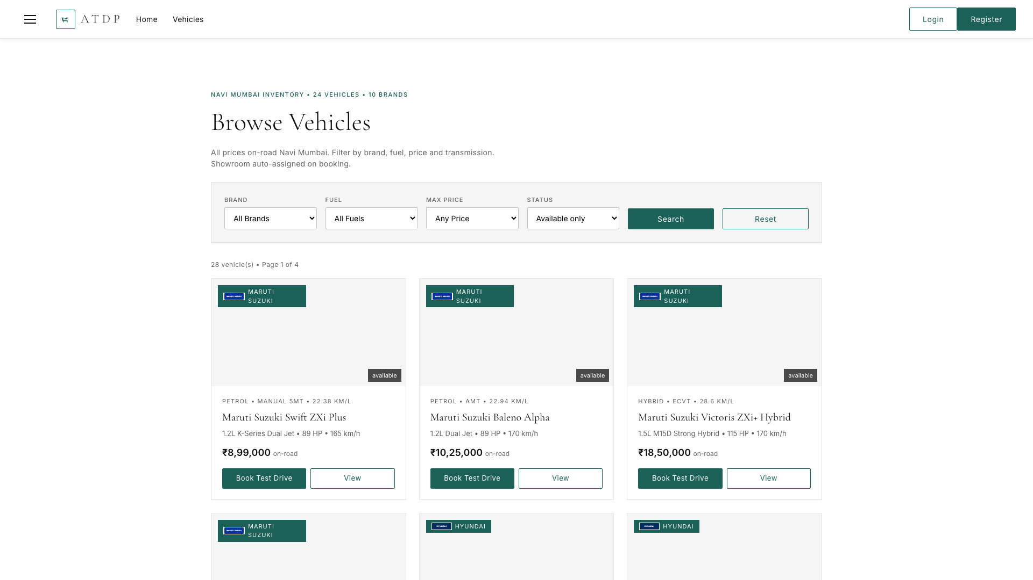
Fig: 2. Browse Vehicles (vehicles.html)
3. Vehicle Detail & Booking Wizard (vehicle.html?id=1)
Car specs, colours, on-road price, auto-assigned showroom, 3-step wizard (Date → Time Slot 09-18 → Confirm), login gate if not logged in.
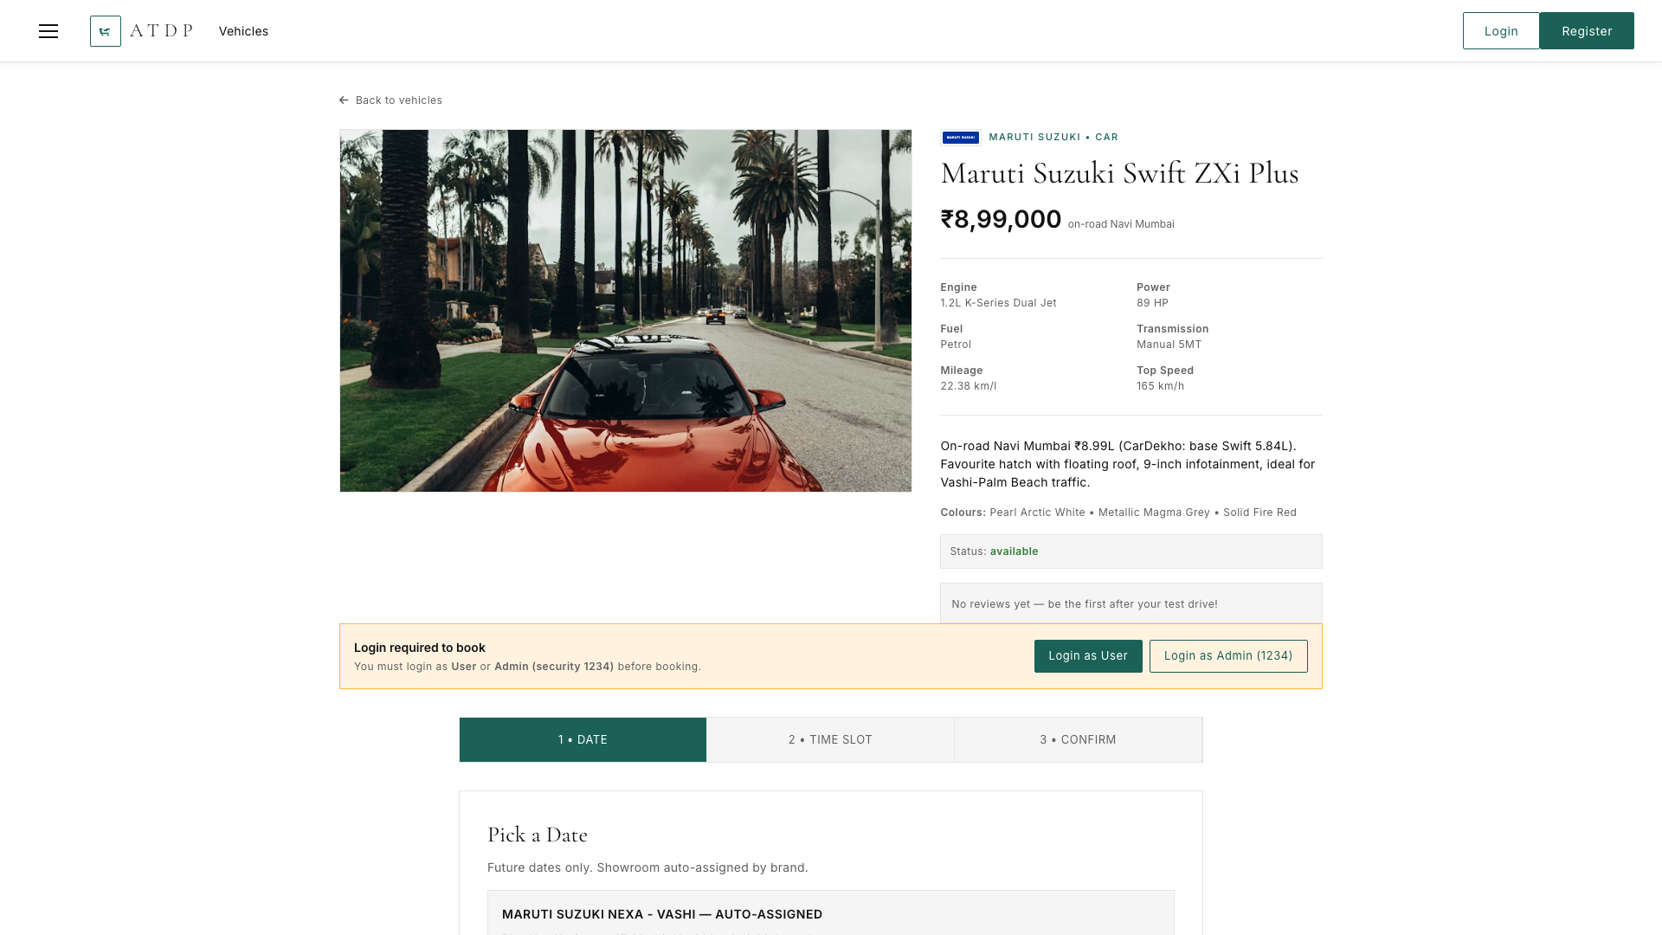
Fig: 3. Vehicle Detail & Booking Wizard (vehicle.html?id=1)
4. Login (login.html)
User/Admin tabs, Admin needs secret code (hidden hint), demo logins visible, JWT stored in localStorage.
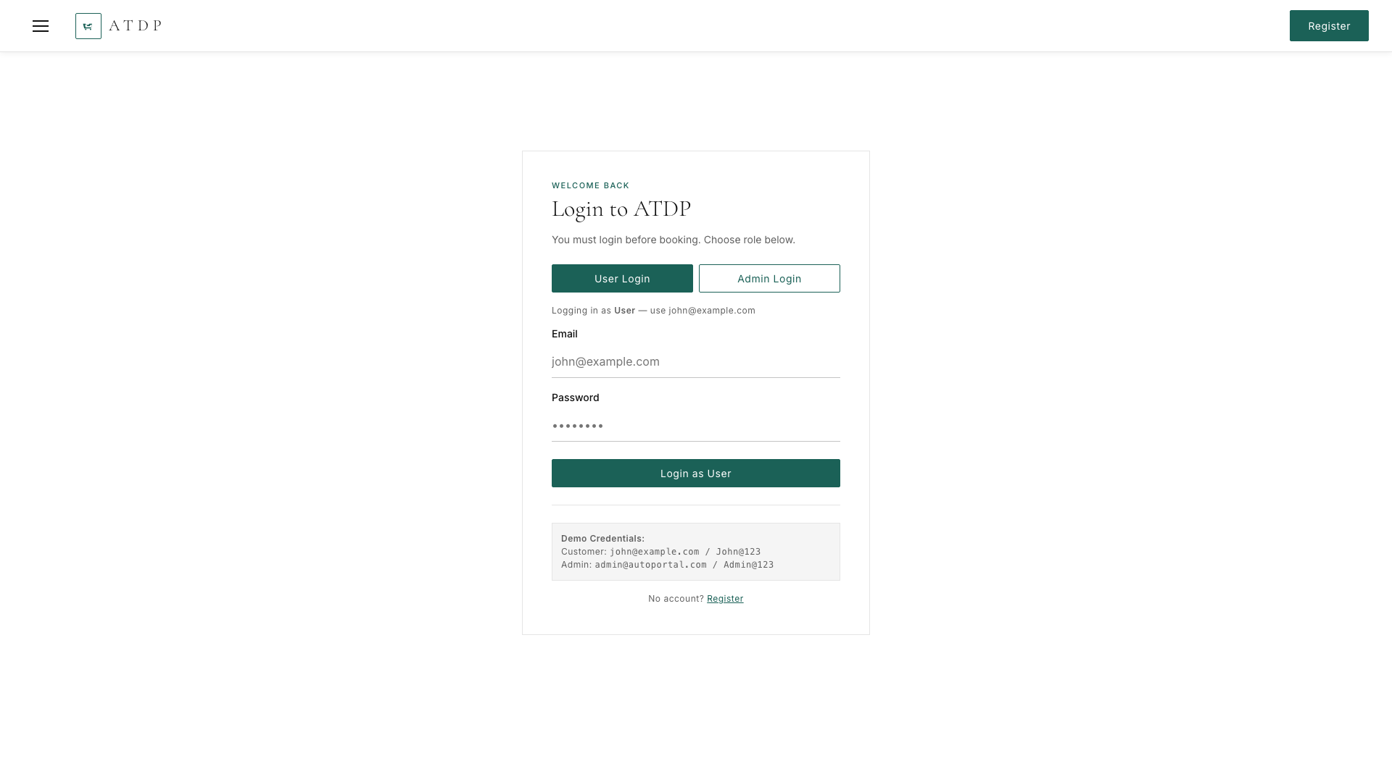
Fig: 4. Login (login.html)
5. Register (register.html)
Name, email, password (8 chars + upper/lower/digit), phone, address → creates customer account.
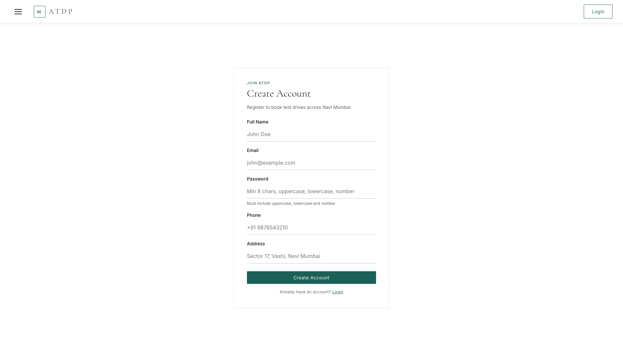
Fig: 5. Register (register.html)
6. Customer Dashboard (dashboard.html)
Green stats (Total/Pending/Approved/Completed) #1B6157 bold, bookings table with Status & Admin Response, Profile + Change Password, Review button for Completed.
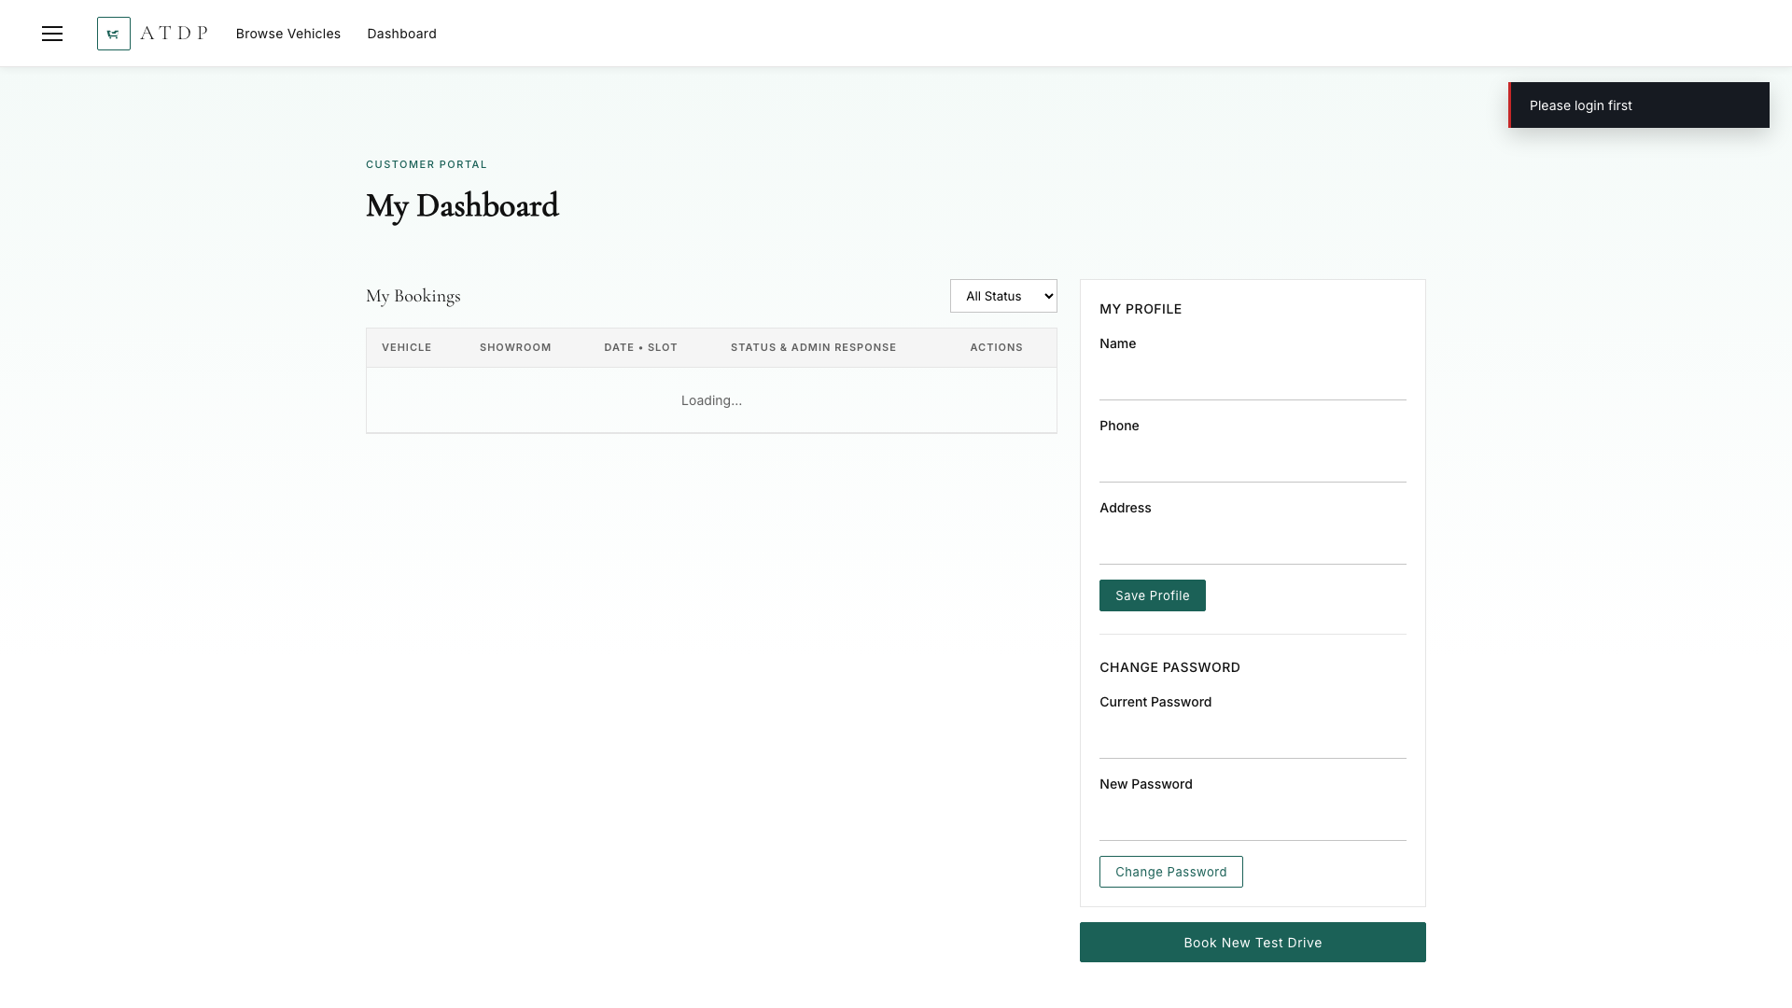
Fig: 6. Customer Dashboard (dashboard.html)
7. Admin Dashboard (admin.html)
Green stats, doughnut + bar charts, tabs Bookings/Vehicles/Showrooms/Users/Reviews, Approve/Reject via themed modal window with textarea, vehicle price fix (was ₹NaN).

Fig: 7. Admin Dashboard (admin.html)
8. Review Page (review.html)
After completion: 5-star selection (★), Any Suggestions textarea, ATDP logo while loading, selector for completed bookings if direct access.
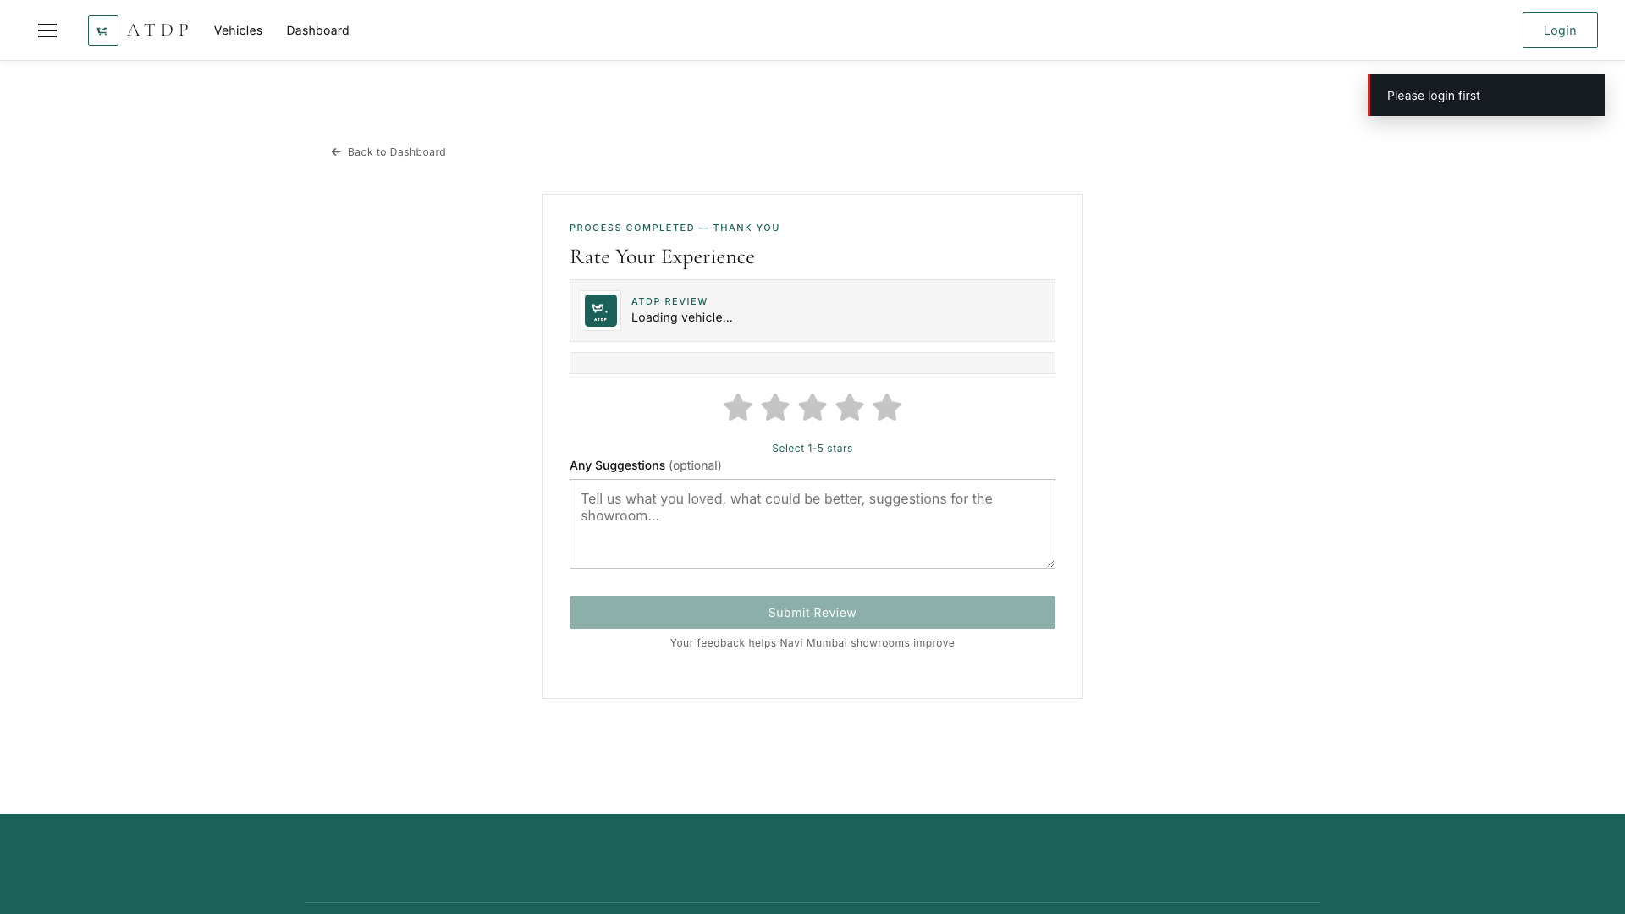
Fig: 8. Review Page (review.html)

Conclusion
Thus, we have successfully designed and developed the frontend for the mini project — a responsive, luxury-themed portal for Navi Mumbai with 7 pages, dropdown-only filters, green hover effects, and complete booking-to-review flow — using only basic HTML, CSS, JavaScript and SQLite backend APIs.
Generated 2026-09-03 | http://localhost:5000 (backend) & http://localhost:3000 (frontend) | github.com/yugantyadav/Automobile-TestDrive-Portal

