Experiment No. 9

ER Diagram of Backend — Automobile Test Drive Portal
ATDP | Navi Mumbai | Backend: Node/Express + SQLite | Academic Year 2025-26

Aim
To design and show the ER (Entity-Relationship) Diagram for the backend database of the Automobile Test Drive Portal — showing tables, attributes, primary keys, foreign keys and how they are connected.

Software Used
Software / Tool | Purpose
Visual Studio Code | Making the database and backend code
SQLite (better-sqlite3) | Storing data in tables
Python + Pillow | Drawing the ER diagram image
Microsoft Word | Writing this experiment document

Theory
Backend is the part the user does not see — it stores data in tables. Each table is an entity with attributes (columns). Primary Key (PK) uniquely identifies a row, Foreign Key (FK) connects one table to another, Unique (UQ) prevents duplicates.
This project has 6 tables:
- users — stores customers and admin (id, name, email, password, role, phone, address)
- brands — stores car companies (id, name, category car/bike, logo)
- vehicles — stores cars (id, brand_id linked to brands, model, price in rupees, photo, engine, fuel, status)
- showrooms — stores shops (id, brand_id linked to brands, name, address, city Navi Mumbai, phone)
- bookings — stores test drive requests (id, user_id linked to users, vehicle_id linked to vehicles, showroom_id linked to showrooms, date, time slot, status pending/approved/completed/cancelled, notes, admin message)
- reviews — stores feedback after completed drive (id, user_id, vehicle_id, booking_id, rating 1-5, comment)
How they are connected (One to Many): One brand has many cars and many showrooms. One user has many bookings and many reviews. One car has many bookings and many reviews. One showroom has many bookings. One booking can have one review (via booking_id). All connections are shown with lines marked 1 — ∞ in the diagram.

ER Diagram
The diagram below shows all 6 tables with their columns and keys, and lines showing foreign key connections. PK in green, FK in light green, UQ in orange. All tables use SQLite with foreign keys ON.
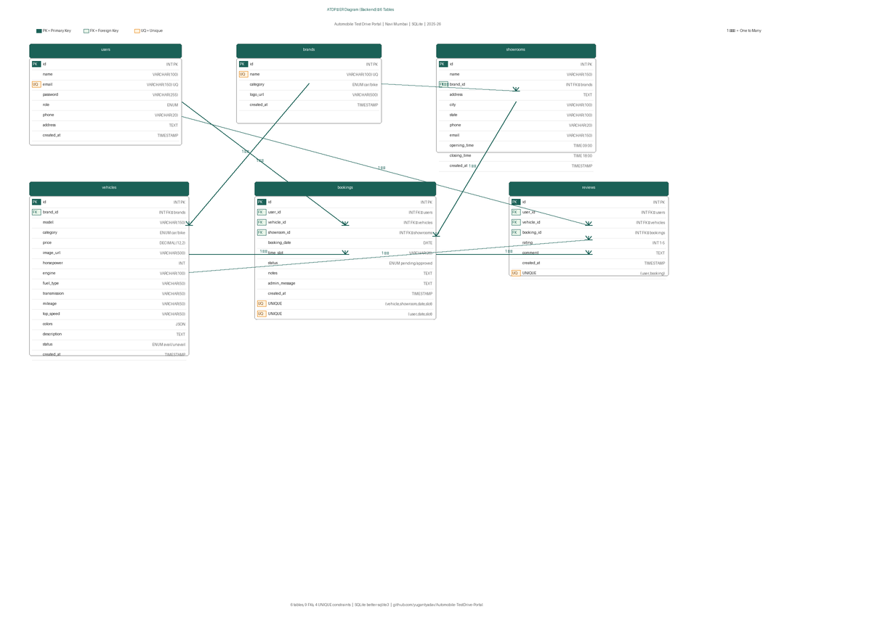
Fig 1: ER Diagram — 6 tables, 9 FKs, 4 UNIQUE constraints (backend)

Conclusion
Thus, we have successfully designed the ER diagram for the backend — 6 tables with clear primary keys, foreign keys and relationships — which supports the full flow from browsing cars to booking and reviewing. This structure prevents double booking and keeps user, brand, vehicle, showroom, booking and review data correctly linked.
Generated 2026-09-03 | Backend: http://localhost:5000/api | Database: backend/database.sqlite | github.com/yugantyadav/Automobile-TestDrive-Portal

