Fitflex your personal fitness Companion – Frontend Documentation

# 1. Project Title

Fitflex your personal fitness Companion – Frontend Module  
  
Team ID: NM2025TMID40779  
Team Leader: Yugaprasath V - yugaprasath001@gmail.com  
Team Members:

* Sathya seelan .P - sathya0828rs@gmail.com
* Simand D Souza .L.M - simondsouza249@gmail.com
* Srinivasan .S - sakthisrinivasansakthi@gmail.com
* SUBHASH S - subhashs0307@gmail.com

# 2. Project Overview

Purpose:  
The Fitness Web App frontend provides users with a clean, modern, and responsive interface to explore exercises, filter by body parts or equipment, and learn about fitness.  
  
Frontend Features:  
- Landing page with hero section and search bar  
- Exercise listing by category (body parts, equipment)  
- About section with fitness information  
- Navbar and Footer for easy navigation  
- Responsive design (desktop & mobile friendly)  
- Background image and video for modern UI feel

# 3. Architecture (Frontend)

- Framework: React.js (Create React App)  
- Styling: CSS (modular per component)  
- Assets: Images, icons, and background video stored locally

# 4. Setup Instructions

Prerequisites:  
- Node.js (latest LTS)  
- npm (comes with Node.js)  
- Code editor (VS Code)  
  
Installation Steps:  
# Clone the repository  
git clone <repository-url>  
cd code  
  
# Install dependencies  
npm install  
  
# Start development server  
npm start  
  
Access:  
Open http://localhost:3000 in browser

# 5. Folder Structure (Frontend Only)

code/  
 ├── public/  
 │ ├── index.html  
 │ ├── logo192.png  
 │ ├── logo512.png  
 │ ├── favicon.ico  
 │ ├── manifest.json  
 │ └── robots.txt  
 ├── src/  
 │ ├── index.js  
 │ ├── App.js  
 │ ├── App.css  
 │ ├── index.css  
 │ ├── reportWebVitals.js  
 │ ├── setupTests.js  
 │ ├── pages/  
 │ │ ├── Home.jsx  
 │ │ ├── Exercise.jsx  
 │ │ ├── EquipmentCategory.jsx  
 │ │ └── BodyPartsCategory.jsx  
 │ ├── components/  
 │ │ ├── Navbar.jsx  
 │ │ ├── Hero.jsx  
 │ │ ├── About.jsx  
 │ │ ├── HomeSearch.jsx  
 │ │ └── Footer.jsx  
 │ ├── styles/  
 │ │ ├── Hero.css  
 │ │ ├── Home.css  
 │ │ ├── Categories.css  
 │ │ ├── HomeSearch.css  
 │ │ ├── About.css  
 │ │ ├── Exercise.css  
 │ │ ├── Footer.css  
 │ │ └── Navbar.css  
 │ └── assets/  
 │ ├── about-Img.png  
 │ ├── bg_img.png  
 │ └── bg_vid.mp4

# 6. Running the Application

- Start frontend:  
npm start  
  
- Default port: 3000  
- Open browser → http://localhost:3000

# 7. UI Components

- Navbar.jsx – Navigation bar  
- Hero.jsx – Landing page hero section  
- HomeSearch.jsx – Search bar component  
- About.jsx – About page section  
- Footer.jsx – Footer with links

# 8. Pages

- Home.jsx – Main landing page  
- Exercise.jsx – Displays exercise details  
- EquipmentCategory.jsx – Exercises by equipment  
- BodyPartsCategory.jsx – Exercises by body part

# 9. User Interface (Frontend Pages)

- Hero Section with background video  
- Search functionality  
- Responsive cards for exercises  
- About page with images  
- Footer with contact/info links

**10. Screenshots**

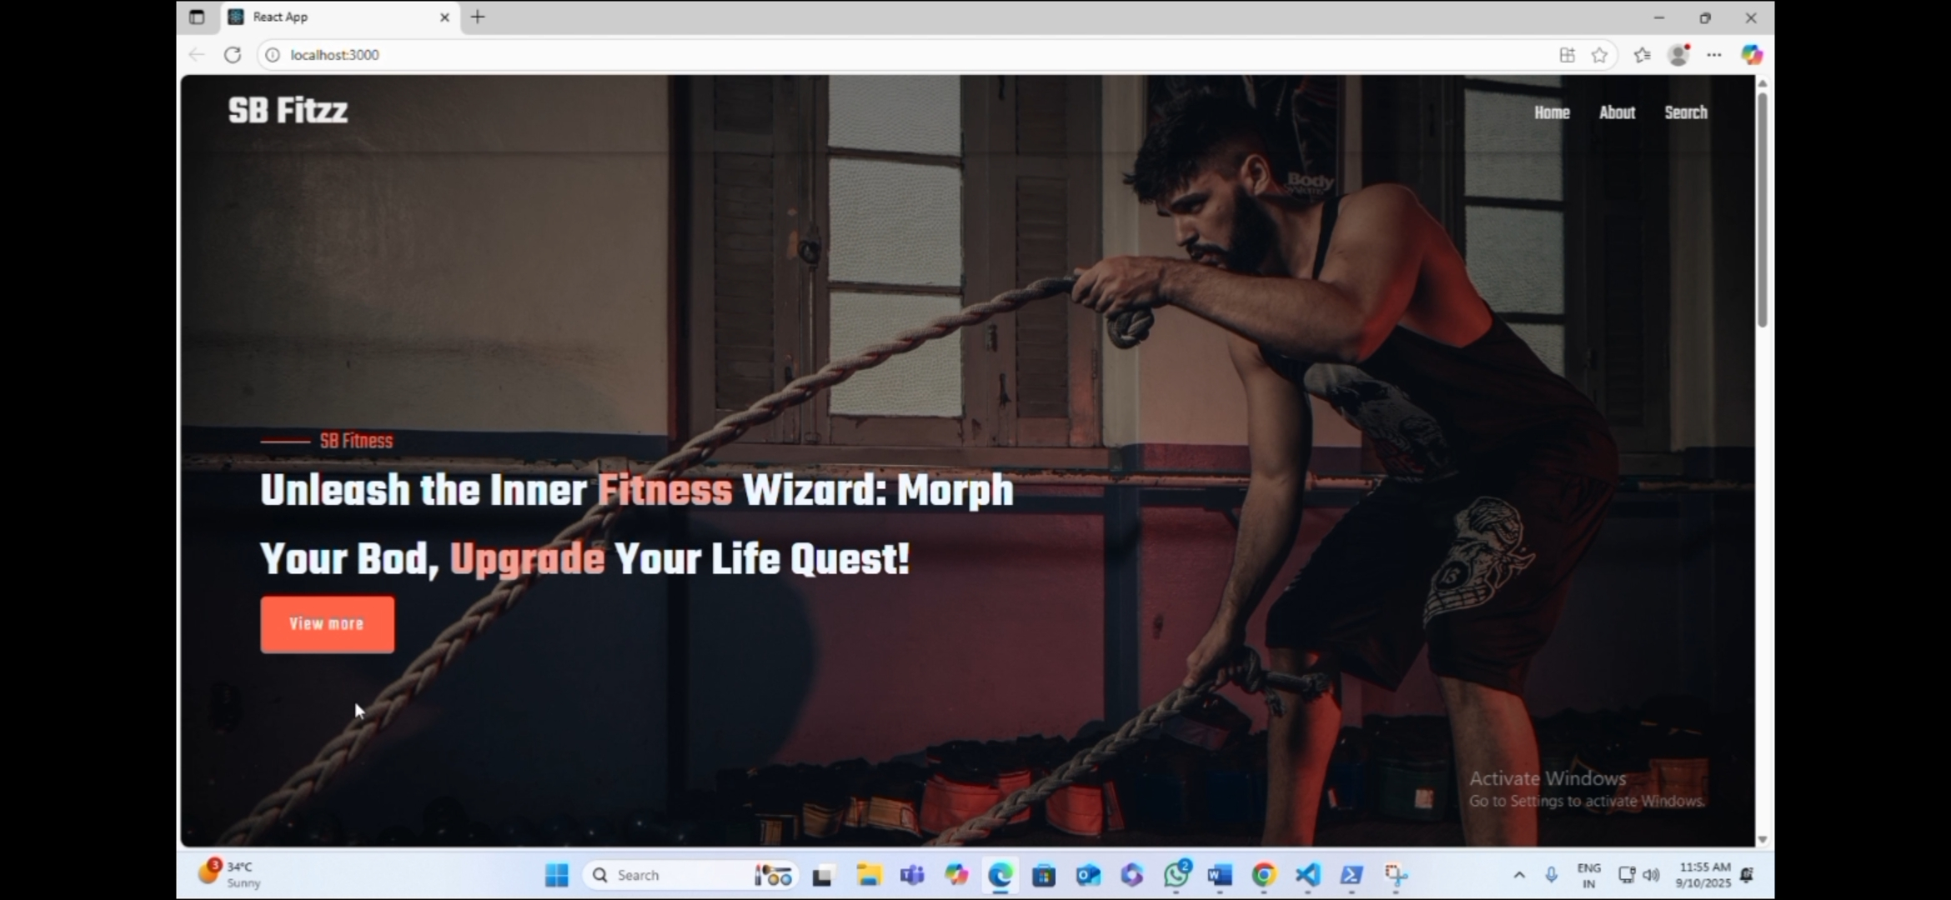

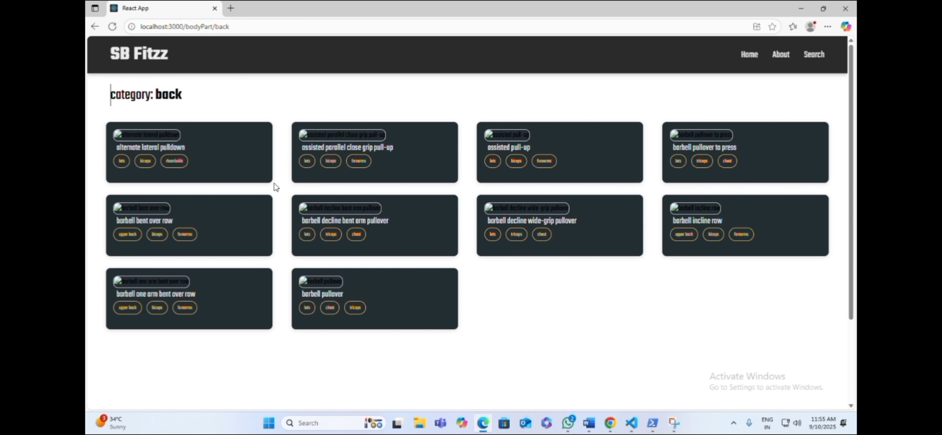

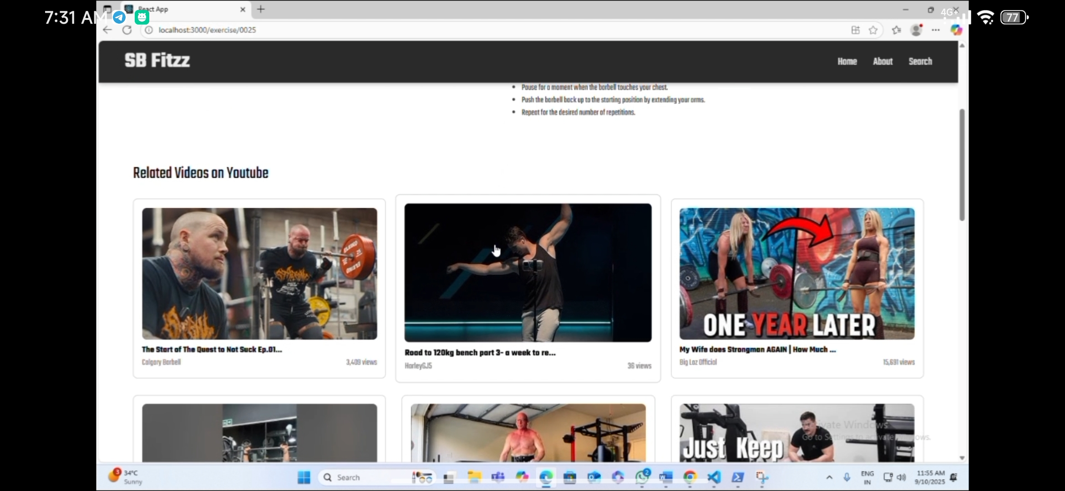

# 11. Testing (Frontend)

- Tested using browser dev tools  
- Verified responsive behavior on desktop & mobile  
- Manual component testing

# 12. Future Enhancements

- Add user login & authentication  
- Save favorite exercises  
- Improve UI animations  
- Add API integration for real-time exercise data