Assignment webshop Lycos (meubelvriend)

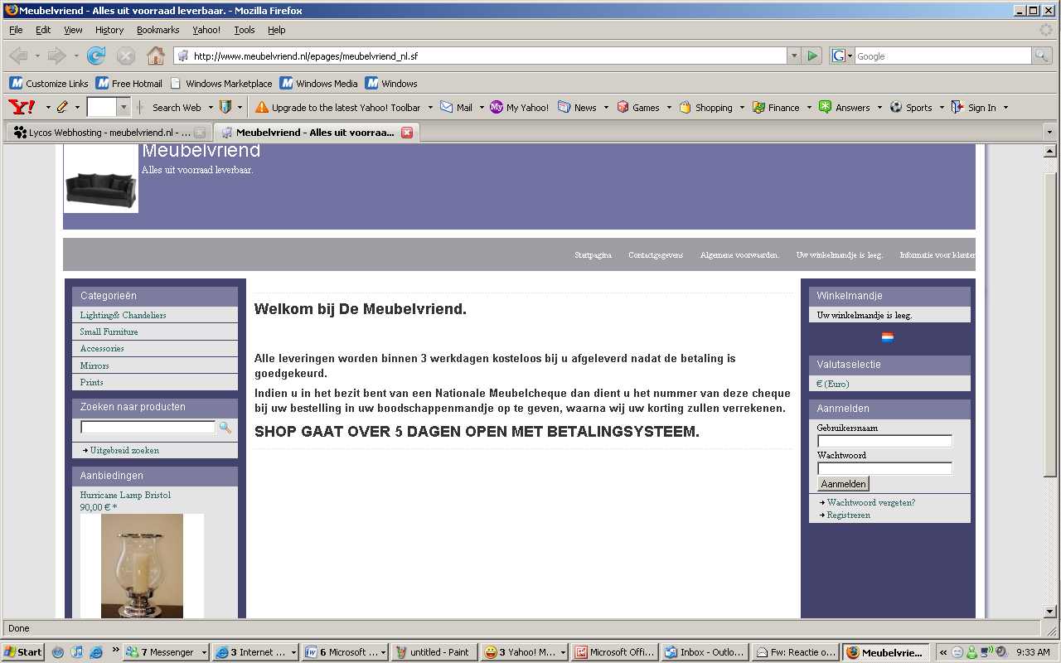

Improve the design for this webshop.
All the elements are fixed!!!!!!!!!!!!!!

Changes:
The top logo (make a good logo)
Flash (make a flash like the one in wannekes by using the pictures you have)
Font (change the font to a nice looking one)
Backgroud color (Make the whole webshop look nice. If you want to change the background color, feel free to do so)
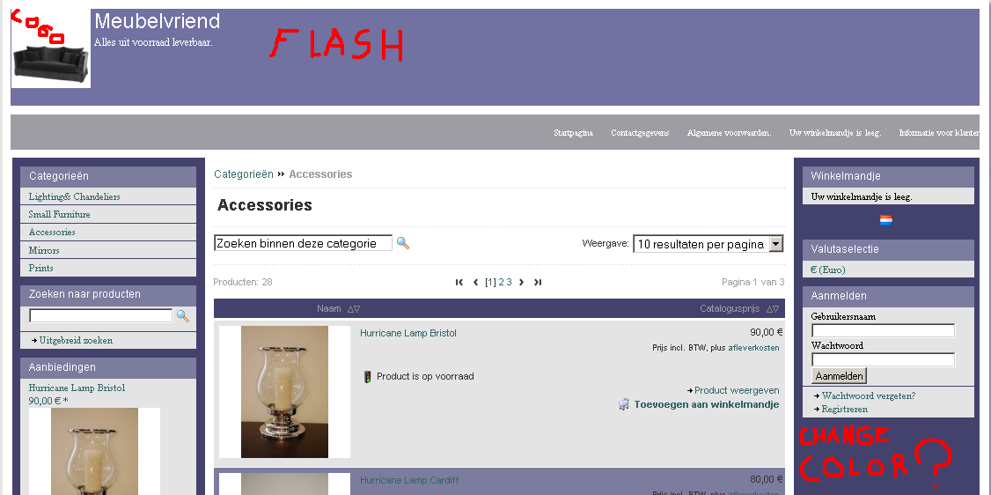

The website sell high priced furniture to people who just bought a new house.

