CiteHumanize – RAG-Based Academic Text Humanization and Citation Support System
Department: CSE Year: IV B.Tech Section: B Semester: VII
Course Name: Course Code: AY: 2025-26
Name of the Student | K Yugavardhan
Registration ID | 122311510201

- Introduction
Large language models (LLMs) are now widely used to draft and polish academic manuscripts, yet rewriting scientific text with them carries real risks. Paraphrasing can silently alter numerical values, units, percentages, directionality and negation; generated claims may lack support in the available literature; and citations can drift away from the claims they are meant to support. AI-assisted text also tends to carry statistical patterns that detectors can pick up [1], [2]. Existing paraphrasers, AI writing assistants, reference managers and AI-text detectors each address only a fragment of this workflow, and none keeps project-specific literature context while validating facts, evidence and citations. CiteHumanize addresses this gap with a Retrieval-Augmented Generation (RAG) system in which the LLM proposes rewritten text and deterministic validators decide whether it may be released, so that readability improves without sacrificing scientific integrity.
Early work on machine-generated text concentrated on detection: GLTR [1] uses statistical token analysis and DetectGPT [2] uses probability curvature, while the systematic review by Liyanage et al. [3] surveys detection methods without addressing humanization. Retrieval-Augmented Generation [4], [5] improves knowledge-grounded generation but does not validate academic citations. Ji et al. [6] combine retrieval, reflection and refinement to improve factuality and citation quality, but not for academic rewriting; scientific RAG synthesis [7] improves literature-grounded writing, although citation attribution remains difficult; CiteCheck [8] detects unsupported or hallucinated citations but focuses on verification rather than rewriting; and scite [9] classifies the context and intent of citations. Taken together, the literature offers detection, retrieval and verification components, but no framework that humanizes academic text while preserving facts, grounding claims in evidence and re-anchoring citations.
- Proposed System Architecture / Block Diagram
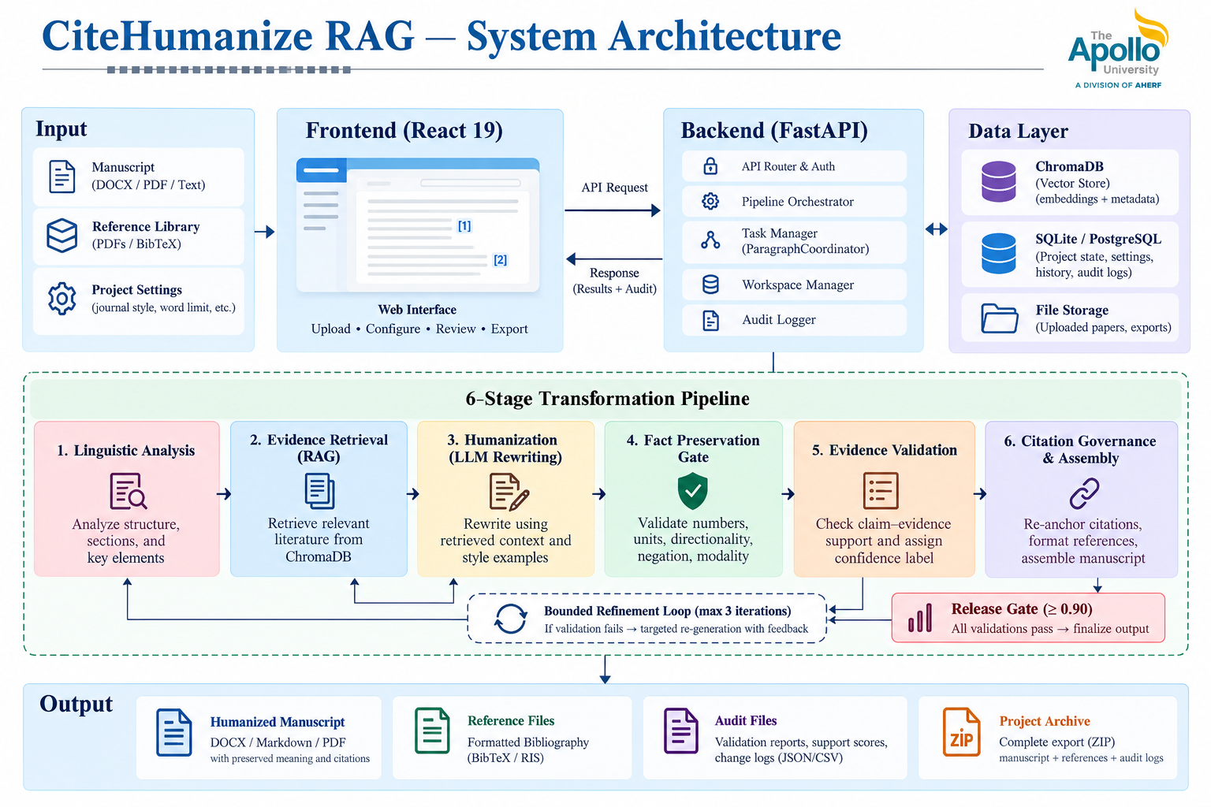
Figure 1: System Architecture of CiteHumanize RAG
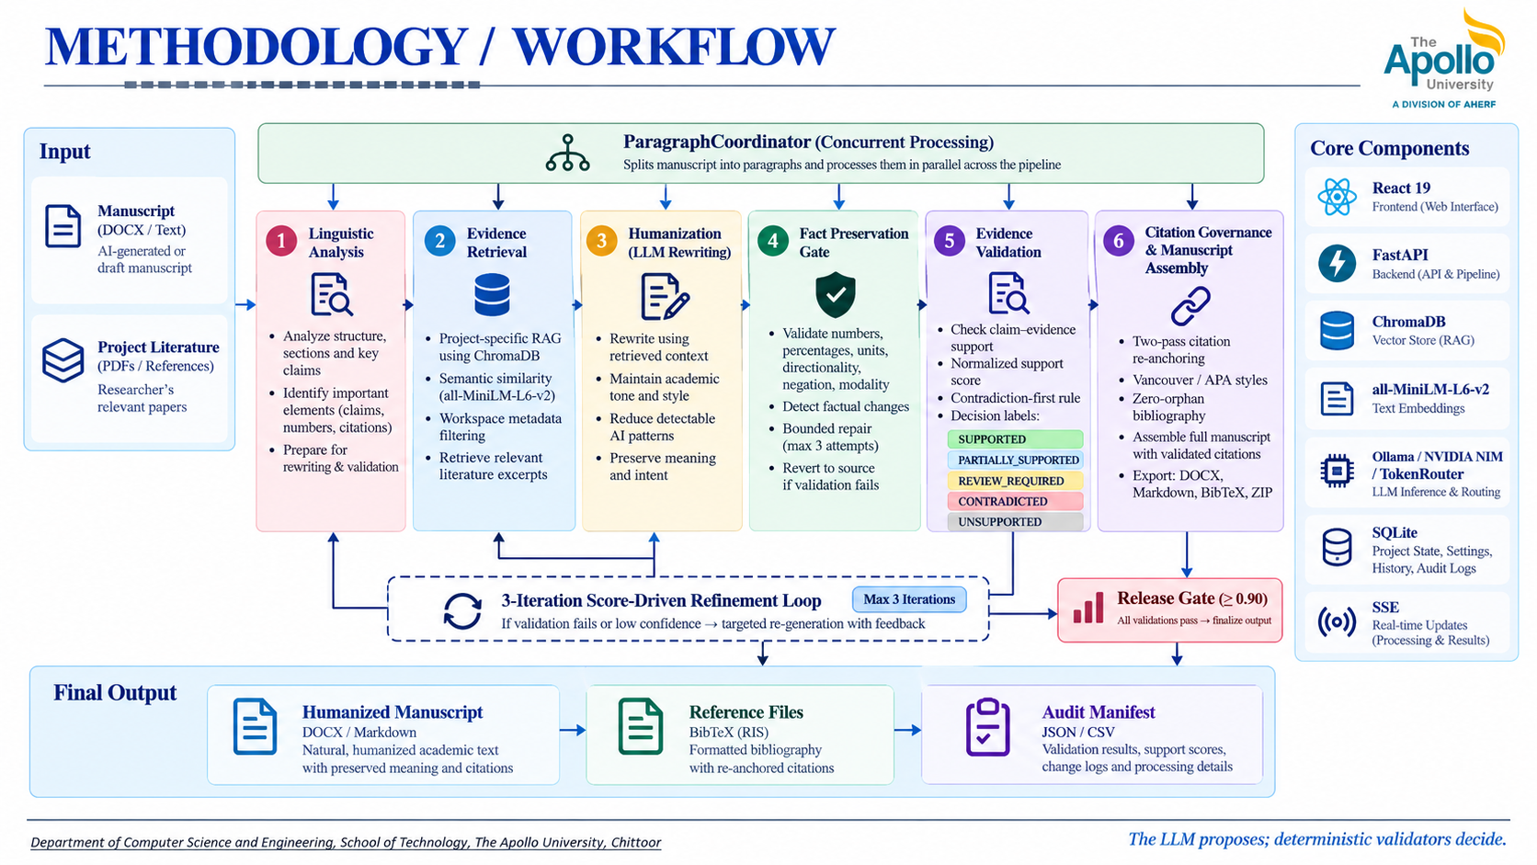
Figure 2: Methodology / Workflow (Flowchart)
- Novelty & Technologies Used
Novelty | Technologies / Tools Used
- Generate-then-validate design: the LLM proposes rewrites and deterministic validators decide whether they are released.  - Fact Preservation Gate that checks numbers, percentages, units, directionality, negation and modality, with bounded repair and reversion to the source text.  - Evidence validation using a normalised support score with a contradiction-first rule, classifying claims as supported, partially supported, review-required, contradicted or unsupported.  - Two-pass citation re-anchoring with Vancouver/APA support that prevents orphan bibliography entries.  - Project-specific RAG built from the researcher's own literature, with workspace metadata filtering.  - Six-block pipeline with a concurrent paragraph coordinator, a bounded three-iteration refinement loop (release threshold ≥ 0.90) and SHA-256 audit manifests. | - Frontend: React 19 + Vite  - Backend: Python + FastAPI (JWT authentication, SSE streaming)  - RAG: ChromaDB + all-MiniLM-L6-v2 (384-dim embeddings, cosine similarity)  - AI / NLP: Ollama + NVIDIA NIM + spaCy  - Data: SQLite for project and audit persistence  - Processing: PyMuPDF + Crossref + arXiv APIs; DOCX / Markdown / BibTeX / ZIP export
- Code Link
Link: https://github.com/yugavardhank/citehumaniserag
- Result
The implemented system was verified with 124 automated tests across 31 test files, all passing. On the qualification fixtures it achieved 100% fact preservation and 100% citation retention against a release threshold of ≥ 0.90. The screenshots below show the researcher workspace of the working platform.
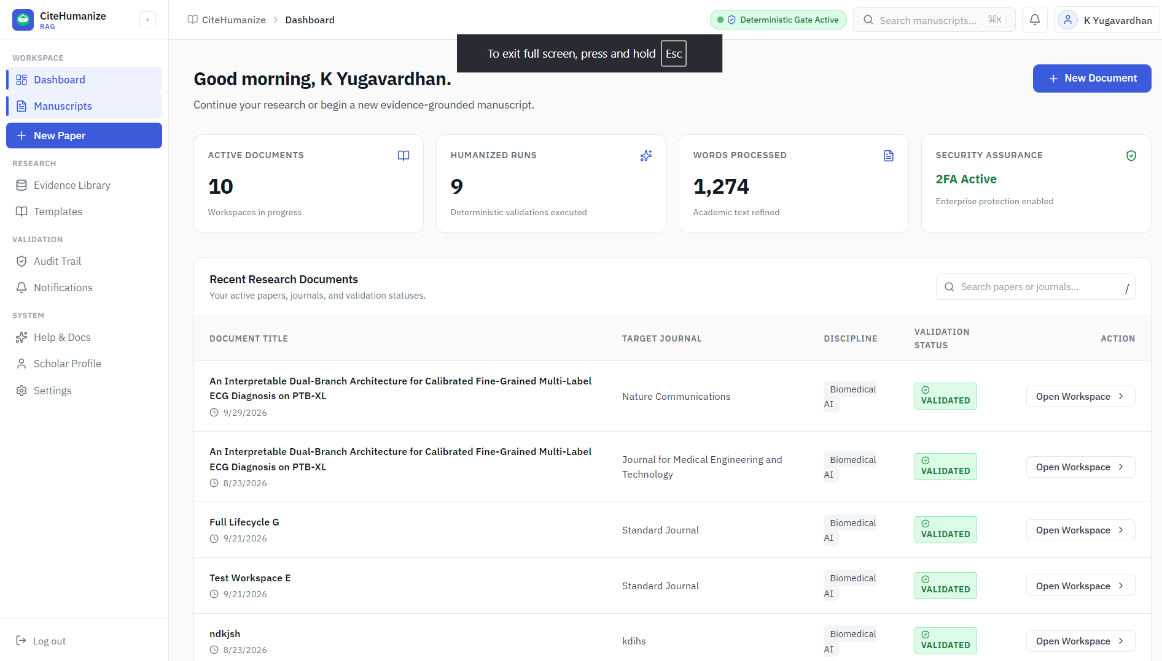  Figure 3: Dashboard | 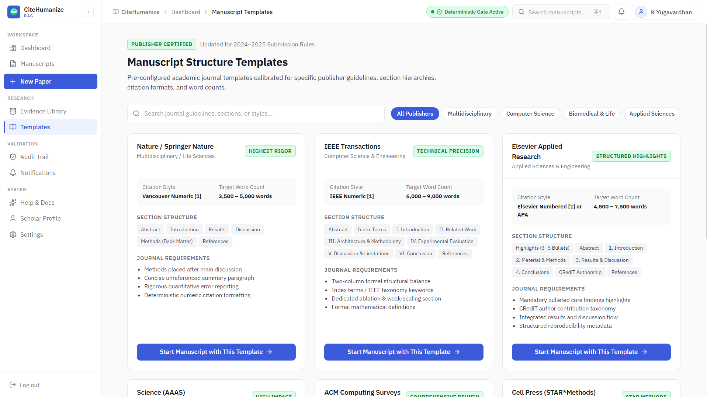  Figure 4: Manuscript structure templates
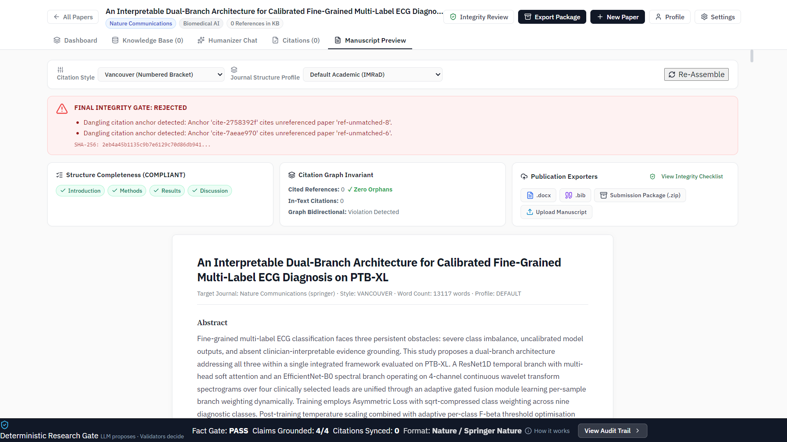  Figure 5: Manuscript preview with integrity gate |   Figure 6: Project overview and submission readiness
- Conclusion
CiteHumanize RAG provides an evidence-grounded approach to academic text humanization by combining project-specific literature retrieval, LLM-assisted rewriting, deterministic fact validation, evidence verification and citation governance. It preserves scientific integrity during rewriting, grounds generation in the researcher's own literature, validates facts and evidence before content is released, and maintains claim–citation relationships through deterministic citation handling. The platform supports complete manuscript assembly and export with audit-ready outputs, and has been verified through 124 automated tests with 100% fact preservation and citation retention on qualification fixtures. In doing so, it shifts AI-assisted academic writing from generation-first to evidence-first, validation-driven manuscript preparation.
Future work includes integrating reference managers such as Zotero and Mendeley for automatic reference synchronization, supporting LaTeX/Overleaf workflows, and extending validation to publisher-specific formatting and camera-ready layouts. Further directions are real-time collaborative editing and review, detailed observability and pipeline analytics, benchmarking humanization quality with semantic similarity, perplexity and human evaluation, and cloud-based deployment for larger academic workloads.
- References
[1] S. Gehrmann, H. Strobelt, and A. M. Rush, “GLTR: Statistical detection and visualization of generated text,” in Proc. 57th Annu. Meeting Assoc. Comput. Linguistics: System Demonstrations, 2019, pp. 111–116, doi: 10.18653/v1/P19-3019.
[2] E. Mitchell, Y. Lee, A. Khazatsky, C. D. Manning, and C. Finn, “DetectGPT: Zero-shot machine-generated text detection using probability curvature,” in Proc. 40th Int. Conf. Mach. Learn., vol. 202, 2023, pp. 24950–24962.
[3] Liyanage et al., “A systematic review of AI-generated text detection,” 2022.
[4] P. Lewis et al., “Retrieval-augmented generation for knowledge-intensive NLP tasks,” in Adv. Neural Inf. Process. Syst., vol. 33, 2020, pp. 9459–9474, doi: 10.5555/3495724.3496517.
[5] Y. Gao et al., “Retrieval-augmented generation for large language models: A survey,” arXiv preprint arXiv:2312.10997, 2023, doi: 10.48550/arXiv.2312.10997.
[6] Ji et al., “Verifiable generation with retrieval and reflection,” 2025.
[7] OpenScholar, “Scientific literature synthesis with retrieval-augmented LLMs,” 2026.
[8] CiteCheck, “Citation hallucination detection,” 2026.
[9] J. M. Nicholson et al., “scite: A smart citation index that displays the context of citations and classifies their intent using deep learning,” Quant. Sci. Stud., vol. 2, no. 3, pp. 882–898, 2021, doi: 10.1162/qss_a_00146.
Submitted by: K Yugavardhan Submitted to: Dr K Sudheer

