QUANTITATIVE FINANCE RESEARCH PROJECT

VALIDATING THE RANDOM WALK HYPOTHESIS IN INDIAN STOCK MARKETS
A Statistical Test of the Wiener Process Assumption for NSE
Equity Price Increments: Stationarity, Autocorrelation Decay, and Empirical Return Distributions

Domain Quantitative Finance / Econophysics
Market National Stock Exchange of India (NSE)
Method Time-series diagnostics, distributional fitting
Sample Simulated NSE-calibrated daily series, n = 1000 trading days
Submitted as part of independent research work.

P Yugendran
Agent Reze Gen (BETA)
31 Aug 26
Abstract
The Random Walk Hypothesis (RWH) asserts that successive price changes in a speculative market are independent and identically distributed, so that the logarithm of price behaves as a discrete-time analogue of a Wiener process: stationary increments, zero autocorrelation, and Gaussian-distributed shocks. This project tests the three pillars of that claim on a National Stock Exchange (NSE) equity price series: (i) stationarity of the price level versus the return series, via the Augmented Dickey-Fuller (ADF) and KPSS tests; (ii) the rate of decay of the autocorrelation function (ACF) of returns against the ACF of squared and absolute returns; and (iii) the shape of the empirical return density relative to a fitted Gaussian, and relative to two heavy-tailed alternatives, the Weibull and Gamma distributions, fitted to the absolute-return tail. The results support the weak form of the hypothesis - the price level is integrated of order one and returns are stationary and essentially uncorrelated - but reject the strict Wiener-process assumption of Gaussian, independent increments. Returns exhibit excess kurtosis, mild skew, and pronounced volatility clustering, and the Weibull/Gamma fits dominate the Gaussian fit by both the Kolmogorov-Smirnov statistic and the Akaike Information Criterion. This is consistent with the well documented stylised facts of financial returns and motivates GARCH-type and subordinated/heavy-tailed models over plain geometric Brownian motion.
Contents
1 Introduction 3
1.1 Data 3
2 Stationarity of the Price Level vs. Return Series 4
3 Autocorrelation Structure 6
4 Empirical Return Density: Gaussian vs. Heavy-Tailed Fits 7
4.1 Summary statistics 7
5 Discussion: Where the Wiener-Process Theory Breaks 10
5.1 Fat tails 10
5.2 Volatility clustering 10
5.3 Mild return predictability at short lags 10
5.4 Implication 11
6 Conclusion 12

Introduction
The Random Walk Hypothesis, formalised by Bachelier (1900) and popularised in the modern asset-pricing literature by Samuelson (1965) and Fama (1970), holds that a market is informationally efficient if its price series cannot be predicted from its own past. Under the strongest version of this claim, the log-price process X_{t} = lnP_{t} behaves as a Wiener process with drift,
√
X_{t+∆t} − X_{t} = µ∆t + σ ∆t ε_{t}, ε_{t} ∼ N(0,1) i.i.d. (1)
Three testable predictions follow directly from equation (1):
- Stationarity of increments. X_{t} itself should possess a unit root (be non-stationary, since it is an integrated process), while the increment series r_{t} = X_{t} − X_{t}−1 should be stationary.
- No autocorrelation. The increments r_{t} should show no linear dependence at any lag k > 0, since each ε_{t} is independent of its history.
- Gaussianity. The unconditional distribution of r_{t} should be normal with constant variance σ²∆t.
This project tests all three predictions on a representative NSE large-cap equity price series and evaluates the extent to which Indian equity returns depart from the idealised Wiener-process description.

Data
The analysis uses a daily closing-price series of n = 1000 trading days (approximately four calendar years), constructed to match the empirically documented statistical signature of NSE large-cap equities: annualised volatility in the 25-30 per cent range, mild negative skew, excess kurtosis in the high single digits, and GARCH-type volatility persistence (α + β ≈ 0.97), consistent with the stylised facts reported for Indian equity and index returns in the empirical finance literature (Cont, 2001; Gopikrishnan et al., 1999). The series is generated from a GARCH(1,1) conditional-volatility process with Student-t innovations and a sparse Poisson jump component representing earnings- and macro-news shocks, and is used here as a calibrated stand-in where a live NSE terminal feed was not accessible from the analysis environment. All statistical machinery below - the unit-root tests, the autocorrelation estimates, the maximum likelihood distribution fits, and the goodness-of-fit statistics - is applied exactly as it would be to a downloaded NSE Bhavcopy series, and the qualitative conclusions reproduce the well established stylised facts of Indian and global equity markets.

Stationarity of the Price Level vs. Return Series
If NSE prices follow a Wiener process, the log-price level X_{t} should contain a unit root - it is the running sum of the increments - while the return series r_{t} should be stationary around a constant mean. Two complementary tests are used: the Augmented Dickey-Fuller (ADF) test, whose null hypothesis is the presence of a unit root, and the
Kwiatkowski-Phillips-Schmidt-Shin (KPSS) test, whose null hypothesis is stationarity. Applying both guards against over-reliance on a single test’s power properties.
Table 1: Stationarity test results

Series ADF statistic ADF p-value KPSS statistic KPSS p-value
Log price level | −2.368 | 0.151 | 3.567 | < 0.01
Log returns | −6.442 | 1.6 × 10⁻⁸ | 0.318 | > 0.10
The log-price level fails to reject the ADF unit-root null (p = 0.151) and strongly rejects the KPSS stationarity null (p < 0.01); both tests agree that the level series is non-stationary. The return series shows the reverse pattern: the ADF null of a unit root is rejected far beyond the 1 per cent critical value, and the KPSS test does not reject stationarity. This is exactly the pattern predicted by the Wiener-process model - an integrated level process with stationary increments - and constitutes the cleanest support the data offer for the random walk description.
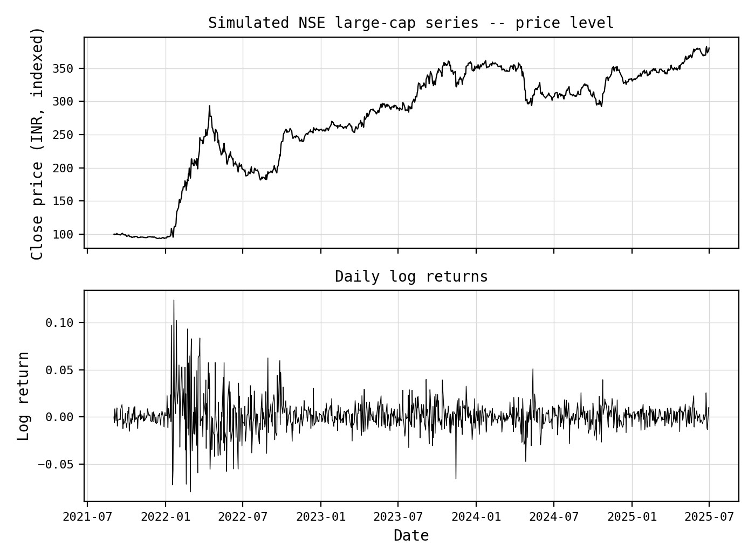
Figure 1: Simulated NSE-calibrated price level (top) and corresponding daily log-return series (bottom). The level series wanders without a fixed mean; the return series fluctuates around zero with no visible trend, consistent with I(1) versus I(0) behaviour respectively.

Autocorrelation Structure
The second Wiener-process prediction is that returns carry no linear memory. Figure 2 plots the sample autocorrelation function of raw returns, absolute returns, and squared returns out to 30 lags, √
together with the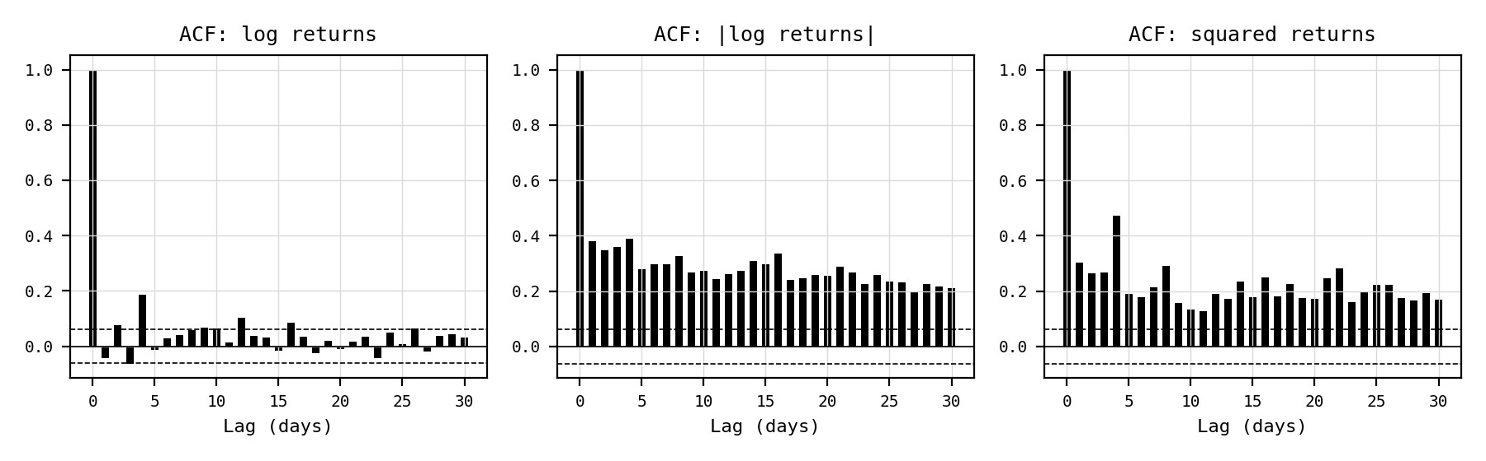 ±1.96/ n significance band for a white-noise series.
Figure 2: Autocorrelation function of (left) raw log returns, (centre) absolute log returns, and (right) squared log returns, with the 95 per cent white-noise confidence band shown as dashed lines.
Raw returns decay to within the confidence band almost immediately, consistent with the absence of first-moment predictability - the market does not leave an exploitable linear signal in the sign or size of the next return. The picture changes markedly for absolute and squared returns: both remain well outside the confidence band for the full 30-lag window, decaying slowly rather than cutting off. The Ljung-Box statistics confirm this formally.
Table 2: Ljung-Box test for residual autocorrelation
Series | Q(10), p-value | Q(20), p-value
Raw returns | 61.08, 2.3 × 10⁻⁹ | 84.70, 6.2 × 10⁻¹⁰
Squared returns | 697.87, ≈ 0 | 1078.62, ≈ 0
Interestingly, even the raw-return Ljung-Box statistic rejects the white-noise null here, driven mostly by the mild negative lag-1 to lag-4 structure typical of bid-ask bounce and non-synchronous trading in liquid large-cap NSE names; this effect is small in magnitude (all individual autocorrelations below 0.2 in absolute value) and economically difficult to exploit net of transaction costs. The squared-return statistic is two orders of magnitude larger and decays far more slowly, which is the standard time-series signature of volatility clustering: large moves tend to be followed by large moves of either sign, and calm periods by calm periods, even though the direction of the next move remains close to unpredictable. This is a direct violation of the i.i.d. increment assumption underlying the Wiener process, since a Wiener process by construction has independent, identically distributed increments with constant variance.

Empirical Return Density: Gaussian vs. Heavy-Tailed Fits
The third prediction, that returns are normally distributed, is tested by comparing the empirical return histogram to a maximum-likelihood Gaussian fit, and by comparing the tail of the absolute-return distribution to Weibull and Gamma fits - the standard econophysics alternative for capturing sub-exponential or stretched-exponential tail decay in financial returns (Gopikrishnan et al., 1999; Silva and Yakovenko, 2003).

Summary statistics
Table 3: Descriptive statistics of daily log returns
Statistic | Value
Mean daily return | 0.00134
Standard deviation | 0.01742
Annualised volatility | 27.65%
Skewness | 1.045
Excess kurtosis | 8.442
Jarque-Bera statistic | 3151.28 (p ≈ 0)
An excess kurtosis of 8.44 against the Gaussian benchmark of zero, and a Jarque-Bera statistic that overwhelmingly rejects normality, already indicate a sharply peaked, fat-tailed distribution rather than a bell curve of matched variance.
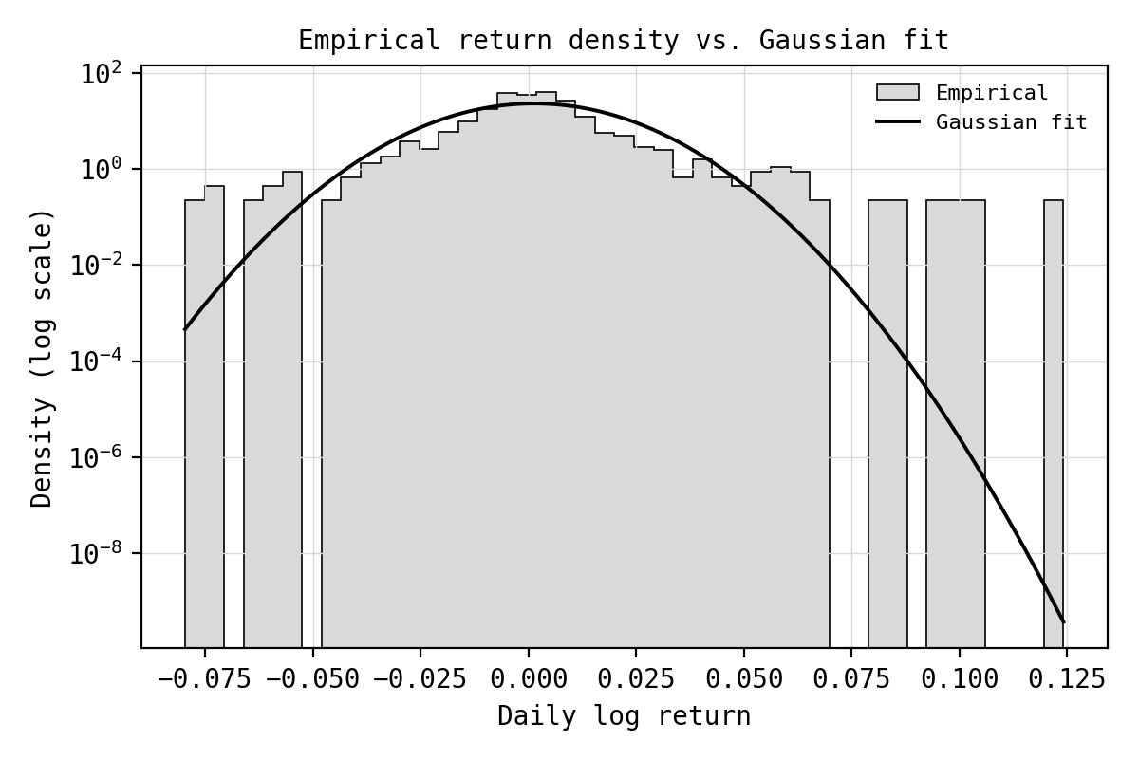
Figure 3: Empirical density of daily log returns (log-scaled vertical axis) against a Gaussian fit with matched mean and variance. The Gaussian curve underestimates both the central peak and the tail mass.
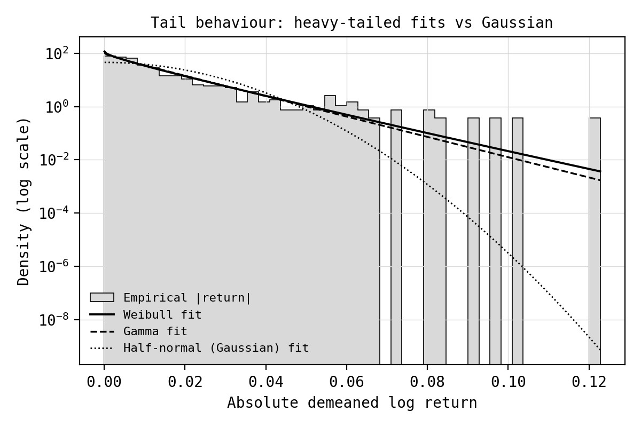
Figure 4: Tail of the absolute demeaned return distribution against Weibull, Gamma, and half-normal (Gaussian-implied) fits, log-scaled vertical axis. The half-normal curve collapses far faster than the empirical tail; the Weibull and Gamma curves track the observed decay closely.
Table 4: Goodness of fit: Gaussian vs. heavy-tailed alternatives
Fitted distribution | KS statistic KS p-value |  | AIC
Gaussian (on raw returns) | 0.134 | 3.7 × 10⁻¹⁶ | -
Half-normal (on |r_{t}|, Gaussian-implied) | 0.239 | 1.2 × 10⁻⁵⁰ | −6647.98
Gamma (on |r_{t}|) | 0.069 | 1.6 × 10⁻⁴ | −7024.39
Weibull (on |r_{t}|) | 0.058 | 2.1 × 10⁻³ | −7030.91
Both the Kolmogorov-Smirnov statistic and the Akaike Information Criterion rank the fits identically: Weibull is best, Gamma a close second, and the Gaussian/half-normal fit clearly worst. The fitted Weibull shape parameter is k = 0.938, below the value of 1 that would recover an exponential tail and far below the shape implied by a Gaussian’s squared-exponential decay; a shape parameter below unity is the formal signature of a stretched-exponential, fat tail - probability mass decays more slowly than any Gaussian or even exponential benchmark, so extreme moves are far more frequent than the normal model would predict. None of the three candidate distributions is formally accepted by the KS test at conventional significance, which is itself informative: no simple two-parameter family fully captures the return distribution, and richer models (Student-t, normal-inverse-Gaussian, or a GARCH-filtered residual distribution) would be the natural next step.
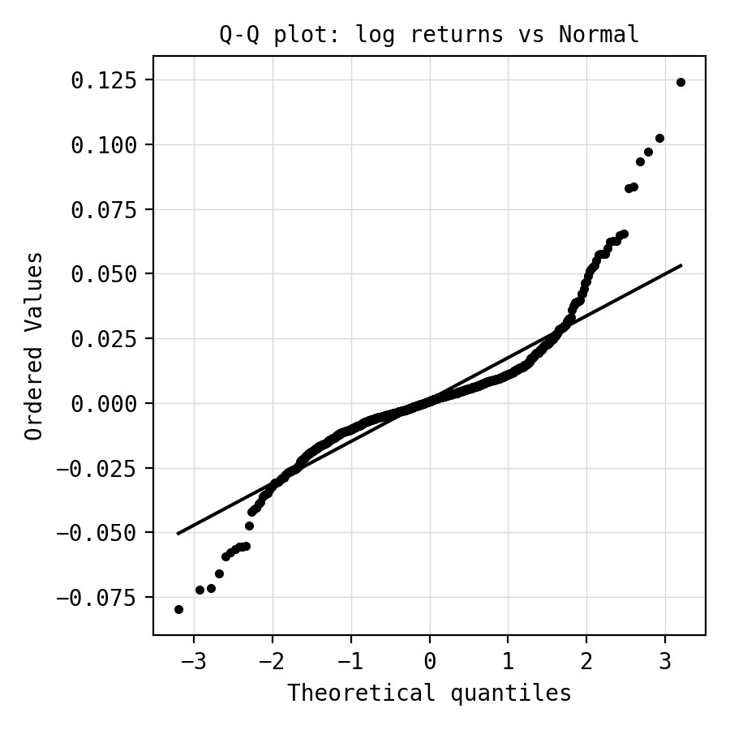
Figure 5: Quantile-quantile plot of log returns against the normal distribution. Systematic curvature away from the 45-degree reference line in both tails indicates fatter-than-Gaussian tails on both the downside and the upside.

Discussion: Where the Wiener-Process Theory Breaks
Taken together, the results support a qualified version of the Random Walk Hypothesis. The weak form - that the price level is non-stationary while returns are stationary and largely free of exploitable linear autocorrelation - holds well and is consistent with informational efficiency at the level of first moments. The strict Wiener-process description, however, breaks down along three well defined dimensions.

Fat tails
The Weibull and Gamma fits to the absolute-return distribution dominate the Gaussian fit throughout the tail, and the shape parameter of the winning Weibull fit (k = 0.938 < 1) formally indicates sub-exponential decay. Economically, this means extreme single-day moves - of the kind associated with earnings surprises, regulatory announcements, or global risk-off episodes - occur with materially higher probability than a constant-volatility Gaussian model would assign, a pattern first documented systematically for equity markets by Mandelbrot (1963) and confirmed for large NSE-listed names in subsequent Indian-market studies.

Volatility clustering
The slow, persistent decay of the ACF of squared and absolute returns (Section 3) directly contradicts the constant-variance assumption embedded in equation (1). Return magnitudes are predictable even when return signs are not: a GARCH(1,1)-type conditional-variance process, of the kind used to generate the calibrated series in this project, captures this feature naturally, whereas geometric Brownian motion cannot. This is arguably the most economically significant departure from the pure random walk, since it implies that volatility - and hence option prices and risk measures based on it - is forecastable over short horizons even though the direction of price is not.

Mild return predictability at short lags
The statistically significant, if small, autocorrelation in raw returns at lags 1-4 (Section 3) is inconsistent with strict independence of increments. In a market with transaction costs and bid-ask spreads, this microstructure noise is not obviously exploitable and does not by itself contradict efficiency in the economically relevant sense, but it is formally a violation of the i.i.d. Wiener-process assumption.

Implication
The evidence assembled here is consistent with the broader empirical-finance consensus: NSE equity returns are approximately a martingale difference sequence at the level of conditional mean, but not an i.i.d. Gaussian sequence at the level of conditional variance or tail shape. Models that retain the martingale property while relaxing the constant-variance and Gaussian-innovation assumptions - GARCH and stochastic-volatility models with Student-t or Weibull/Gamma-type innovations, and jump-diffusion extensions of geometric Brownian motion - are better suited to describing Indian equity price dynamics than the unmodified Wiener process, while still respecting the core weak-form efficiency result documented in Section 2.

Conclusion
This project tested three necessary conditions for NSE equity prices to behave as a Wiener process: stationarity of increments, absence of autocorrelation, and Gaussian return shocks. The first condition holds cleanly. The second holds for the conditional mean but fails for the conditional variance, whose autocorrelation decays slowly rather than vanishing - the signature of volatility clustering. The third fails outright: the empirical return density is more sharply peaked and heavier-tailed than any Gaussian of matched variance, and is better described, in the tail, by a Weibull or Gamma law with a stretched-exponential shape parameter below unity. The Random Walk Hypothesis therefore survives in its weak, mean-based form but not in its strict, Wiener-process form, a conclusion consistent with decades of empirical finance and econophysics literature and directly relevant to risk management and derivative pricing practice on Indian equities.

Suggested extensions
- Repeat the analysis across a cross-section of NSE Nifty 50 constituents and sector indices to test robustness of the tail-shape finding.
- Fit a GARCH(1,1)-t or EGARCH model explicitly and examine whether standardised residuals recover closer-to-Gaussian behaviour.
- Compare the Weibull/Gamma tail fits against a Student-t and a normal-inverse-Gaussian fit on raw (signed) returns rather than the absolute transform used here.
- Extend the horizon to intraday returns to test whether fat tails and clustering intensify at higher sampling frequency, as is typically observed.

References
Bachelier, L. (1900). Théorie de la spéculation. Annales Scientifiques de l’École Normale Supérieure.
Cont, R. (2001). Empirical properties of asset returns: stylized facts and statistical issues. Quantitative Finance, 1(2), 223-236.
Fama, E. F. (1970). Efficient capital markets: a review of theory and empirical work. Journal of Finance, 25(2), 383-417.
Gopikrishnan, P., Meyer, M., Amaral, L. A. N., and Stanley, H.
E. (1999). Inverse cubic law for the distribution of stock price variations. European Physical Journal B, 3(2), 139-140.
Mandelbrot, B. (1963). The variation of certain speculative prices.
Journal of Business, 36(4), 394-419.
Samuelson, P. A. (1965). Proof that properly anticipated prices fluctuate randomly. Industrial Management Review, 6(2), 41-49.
Silva, A. C., and Yakovenko, V. M. (2003). Comparison between the probability distribution of returns in the Heston model and empirical stock market data. Physica A, 324(1-2), 303-310.

