**How To Get Started with API Solutions**

**Introduction:**

**Amazon API Solutions (SP-APIs) has exclusive features and benefits,** It virtually facilities multiple functions enhancing your business prospects. If you are an aspiring Amazon seller, this is something you just can’t ignore since it has a very well programmed option for data exchange which in turn supports an easy management of product listings, order management and report generation. Once you go through the documentation and If you are interested to build your own application, please get back to your Account Manager with answers to the below onboarding questions, so that an associate from API Integration team, who provide assistance to sellers and the developers on technical expertise will get back to you with the dedicated support.

1. **Do you have a Technical resource/developer who can build application? [Y/N]:**
2. **Will use a third-party integrator or plug-in [Y/N]:**
3. **Need for automation - [Catalog creation / Inventory and price update / Order management / Report management / Dynamic Pricing]:**
4. **Seller name and contact details:**
5. **Technical POC’s name contact details:**

**1. What is the Selling Partner APIs (SP-APIs)?**

**The Selling Partner API is a REST-based API that helps Amazon sellers programmatically access their data on listings, orders, payments, reports, and more. Applications using the Selling Partner API can increase selling efficiency, reduce labor requirements, and improve response time to customers, helping sellers grow their businesses. The Selling Partner API builds on the functionality of Amazon Marketplace Web Service (Amazon MWS), but provides features to improve usability and security for developers and the seller partners they work with.**

**2.** **Registering for an Amazon SP APIs-eligible seller account:**

To be eligible to use Amazon APIs, you must have a professional selling account. If you have an Individual Selling on Amazon account and would like to use SP APIs, you can become eligible to register for SP APIs by upgrading to a Professional seller account from the [Amazon Services Selling on Amazon](https://www.amazonservices.com/) page.

**3.** **Registering to use Amazon APIs:**

There are two options available to sign up for Amazon APIs.

* Registering as a developer
* Authorizing a developer

Find more details on the SP APIs registration please refer the developer docs link [here](https://developer-docs.amazon.com/sp-api/docs/orders-api-v0-reference).

**4.** **Additional Functionalities of Amazon APIs:**

* Sellers may allow third-party developers to access their Amazon seller accounts.
* Sellers may access their accounts via different applications.
* Sellers may develop applications and make them available to other Amazon sellers.

**5. Benefits of Automation:**

* Automated Sellers created between 3-4 times more ASINs TTM compared to non-automated Sellers.
* Sellers who are automated have about 1K more listings than Sellers that are not automated.
* Automated Sellers handle on average 96% more orders compared to non-automated Sellers.
* Order cancellation rates of automated Sellers is lower than for non-automated Sellers.
* Automated Sellers have on average 87% more GMS than non-automated Sellers.

**6.** **Selling Partner APIs:**

1. [Feeds API](https://developer-docs.amazon.com/sp-api/docs/feeds-api-v2021-06-30-reference): With the Selling Partner API for Feeds (Feeds API), you can build applications that enable sellers to upload information to Amazon that helps them manage their selling businesses. There are feeds for a wide variety of use cases, such as creating listings, managing inventory and prices, acknowledging orders, and more.

To view workflow of Feeds, view feeds API guide: <https://developer-docs.amazon.com/sp-api/docs/feeds-api-v2021-06-30-use-case-guide>

1. [Catalogue Items API](https://developer-docs.amazon.com/sp-api/docs/catalog-items-api-v2022-04-01-reference): The Selling Partner API for Catalog Items helps you programmatically retrieve item details for items in the catalog.
2. [Orders API](https://developer-docs.amazon.com/sp-api/docs/orders-api-v0-reference): The Selling Partner API for Orders helps you programmatically retrieve order information. These APIs let you develop fast, flexible, custom applications in areas like ord4er synchronization, order research, and demand-based decision support tools.
3. [Product Pricing API](https://developer-docs.amazon.com/sp-api/docs/product-pricing-api-v2022-05-01-reference): The Selling Partner API for Pricing helps you programmatically retrieve product pricing and offer information for Amazon Marketplace products.
4. [Product Fees API](https://developer-docs.amazon.com/sp-api/docs/product-fees-api-v0-reference): The Selling Partner API for Product Fees lets you programmatically retrieve estimated fees for a product. You can then account for those fees in your pricing.
5. [Reports API](https://developer-docs.amazon.com/sp-api/docs/reports-api-v2021-06-30-reference): The Selling Partner API for Reports lets you retrieve and manage a variety of reports that can help selling partners manage their businesses.

To view workflow of report, kindly refer report guide: <https://developer-docs.amazon.com/sp-api/docs/reports-api-v2021-06-30-reference>

1. [Sales API](https://developer-docs.amazon.com/sp-api/docs/sales-api-v1-reference): The Selling Partner API for Sales provides APIs related to sales performance.
2. [Finances API](https://developer-docs.amazon.com/sp-api/docs/finances-api-reference): The Selling Partner API for Finances helps you obtain financial information relevant to a your business. You can obtain financial events for a given order, financial event group, or date range without having to wait until a statement period closes. You can also obtain financial event groups for a given date range.
3. [Notifications API](https://developer-docs.amazon.com/sp-api/docs/notifications-api-v1-reference): The Selling Partner API for Notifications lets you subscribe to notifications that are relevant to a selling partner's business. Using this API, you can create a destination to receive notifications, subscribe to notifications, delete notification subscriptions, and more.
4. [Messaging API](https://developer-docs.amazon.com/sp-api/docs/messaging-api-v1-reference): With the Messaging API you can build applications that send messages to buyers. You can get a list of message types that are available for an order that you specify, then call an operation that sends a message to the buyer for that order. The Messaging API returns responses that are formed according to the [JSON Hypertext Application Language (HAL)](https://tools.ietf.org/html/draft-kelly-json-hal-08) standard.
5. [Solicitations API](https://developer-docs.amazon.com/sp-api/docs/solicitations-api-v1-reference): With the Solicitations API you can build applications that send non-critical solicitations to buyers. You can get a list of solicitation types that are available for an order that you specify, then call an operation that sends a solicitation to the buyer for that order. Buyers cannot respond to solicitations sent by this API, and these solicitations do not appear in the Messaging section of Seller Central or in the recipient's Message Center. The Solicitations API returns responses that are formed according to the JSON Hypertext Application Language (HAL) standard.
6. [Services API](https://developer-docs.amazon.com/sp-api/docs/services-api-v1-reference): With the Services API, you can build applications that help service providers get and modify their service orders.
7. [Uploads API](https://developer-docs.amazon.com/sp-api/docs/uploads-api-reference): The Selling Partner API for Uploads provides operations that support uploading files.
8. [Sellers API](https://developer-docs.amazon.com/sp-api/docs/sellers-api-v1-reference): The Selling Partner API for Sellers lets you retrieve information on about your seller account, such as the marketplaces they participate in. Along with listing the marketplaces that a seller can sell in, the API also provides additional information about the marketplace such as the default language and the default currency. The API also provides seller-specific information such as whether the seller has suspended listings in that marketplace.
9. [A+ Content API:](https://developer-docs.amazon.com/sp-api/docs/selling-partner-api-for-a-content-management) The Selling Partner API for A+ helps selling partners share their brand and product story, which helps buyers make informed purchasing decisions.

18) [Authorization API](https://developer-docs.amazon.com/sp-api/docs/authorization-api-v1-reference): (If you are a public developer on Amazon) The Selling Partner API for Authorization helps developers manage authorizations and check the specific permissions associated with a given authorization.

**7.** **What Amazon APIs Provides?**

Amazon API solutions provides the following features along with the recommended functions that allows the Developer to automate all of the below operations. The API features that we have detailed below are few and there are multiple other automation options as stated in section 6.

**7.1** **Product/Listing Creation** — To begin with any automation, first step is to create products. Please note that Amazon does not allow creating duplicates of products that already exist in its catalogue. Therefore, when you are creating a product for the first time, all those sellers who later on create listings to sell the same product should engage the existing product, otherwise their load as a new product goes waste.

To check if your products already exist on Amazon, call the operation [**get**CatalogItems](https://developer-docs.amazon.com/sp-api/docs/catalog-items-api-v2022-04-01-reference#getcatalogitem) from the [Catalog Items API](https://developer-docs.amazon.com/sp-api/docs/catalog-items-api-v2022-04-01-reference). This allows you to understand if a product already exists in the Amazon catalogue or not. This is a "best practice" that we suggest to sellers when they use the EAN / UPC codes or you can also check based on a search query or item identifiers that you specify.

To create new listings, there are four mandatory XML feeds you need to use to add products.

  I.            Product Feeds - to create or update the product catalogue

  II.            Images Feed - to create or update the images

  III.            Stock feed - to update the inventory

  IV.            Price Feed - to update the prices

V.            Relationship feeds (Optional) - to define Parent / Child relationships in the case of products with variations (size, color, etc.)

You will be using the Feeds API to submit new listings data to Amazon. Attached below is the sample XML feed for your reference, which will give an idea on how to build an XML feed for your category.



**7.2** **Order management** — With the Orders API section, you can download order information, obtain payment data, acknowledge orders, cancel orders, confirm shipments, and adjust/refund orders.

Attached below is a Zip file including sample order feeds for your reference.



For your reference, Amazon’s Order Management Process is as follows.

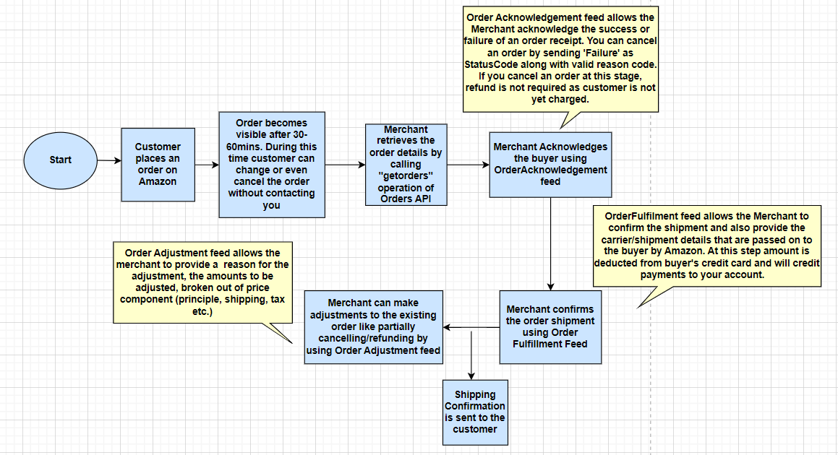

**7.3** **Reports management** — The Reports API section of SP APIs lets you request various reports that are. To know more about report API, click [here](https://developer-docs.amazon.com/sp-api/docs/reports-api-v2021-06-30-reference).

**7.4** **Dynamic Pricing** — Dynamic pricing helps you to offer products on Amazon with high competition, as the price automatically changes according to the lowest offer from competitors. In order to make your pricing decisions you will be using the operations available in Product API.

**9. Useful Links for integration**

* Selling Partner API Documentation: <https://developer-docs.amazon.com/sp-api/>
* Developer Guide & Pre-Requisites : <https://developer-docs.amazon.com/sp-api/docs/what-is-the-selling-partner-api>

**8.** **Support provided by API Integration Services (APIIS) Team:**

The API Integration Services team can support you during the setup of your automation:

* We help you in identifying the best solution that covers your needs with the help of Amazon resources
* We can explain in detail and guide you through the best practices when using our APIs and automating with Amazon.
* We also help you to understand the cause of errors and warning you get and provide you the possible solutions that you can implement to fix them

Please note that the support we provide doesn‘t include any coding or code tracing. However, we will be able to support you on making API calls using postman tool. In Case you use a plug-in or refer to an integrator, you have to contact your solution provider for any issues with their platform.

If you are interested to build your own application by taking the support of APIIS team, please feel free to reach out to your Account Manager and an associate from APIIS team will get back to you.