README – Steps followed in doing this Assignment

1. Create 3 Ubuntu Virtual Machines with the IP Addresses 192.168.56.104, 192.168.56.105 and 192.168.56.106 respectively.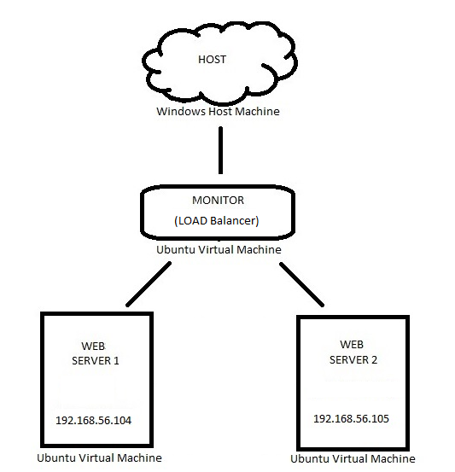
2. Install apache2 mysql, php and phpmyadmin on all the 3 systems.
3. Download and copy Wordpress to the www folder in the two servers.

* Make Wordpress Front Page a static page and create a login form on the homepage for the users to login.

1. Enable mod_proxy and mod_proxy_balancer modules in the apache2 using a2enmod command.
2. Now with the help of loadbalancer module inside apache2, configure the Server IP -192.168.56.106 as the monitor with servers 192.168.56.104 and 192.168.56.105 as the balance members, so that the requests are now send to the 2 balance members alternatively.

* This is done by editing the apache2.conf files in the apache2 directory and the proxy_balancer.conf files inside the mods-enabled.conf by adding proxybalancer and proxypass fields.

1. Install JMeter in the Host machine and create a Test Plan for testing the Monitor and the balance members.

* Set the server name/IP in HTTP Requests Defaults.
* Add Logic Controller- Recording Controller to record the steps for login.
* Remove the unwanted css, js steps.
* Label the script and modify it as necessary.
* Add assertions to verify that initial, login and logout screen are indeed tested.
* Add listeners like Aggregate Report, Summary Report to generate the Reports.

1. Now for each Server Configurations ( with and without Load Balancer )
   1. Modify the values - thread properties (Number of threads, Ramp Up time, Loop Count)
   2. In the servers 192.168.56.104 and 192.168.56.105 modify the StartServers, MinSpareServers ,MaxSpareServers , MaxRequestworker, MaxConnectionPerChild values (mpm*.conf files inside the mods-enabled folder in apache2 directory)
   3. And note the Throughput, Average Response Time and Error % (Number of requests for which timeout has occurred)