Assignment 2

**Random Forests**

Sharin KG

14111033

**Question 1.**

As discussed in class build a random forest classifier using bagging and random splitting using m random features to decide the split at each node. Find the number of trees at which the error levels off by using a binary search between 2 trees and 400-500 trees. Plot 5-fold cross-validated error rates against the number of trees in the forest and report the number at which error levels off.

**Solution**

The number of trees at which the error levels off was found to be **93** by using Binary search between **2** and **500** trees. And the threshold for carrying out binary search was fixed to be **0.0015** based on the error rate at mid and last point.

Code Snippet 1. Function for Binary Search and Validation Error

#Function – Binary Search

binSearch **<-** **function(**h_error,low,high**){**

mid **<-** floor**((**low**+**high**)/**2**)**

m_error **<-** getXError**(**mid**)**

int **=** abs**(**h_error **-** m_error**)**

**if((**abs**(**low**-**mid**)<=**1**)||(**abs**(**mid**-**high**)<=**1**)){**

return**(**high**)**

**}**

**if(**int**<**0.0015**){**

high **=**mid

return **(**binSearch**(**h_error,low,high**))**

**}**

**else{**

low **=** mid

return **(**binSearch**(**h_error,low,high**))**

**}**

**}**

#Function - Validation Error

getXError **<-** **function(**noTree**){**

set.seed**(**2**)**

error**<-**numeric**(**0**)**

**for(**i **in** 1**:**5**)**

**{**

x_test_s **=** folds**[[**i**]]**

x_train_s **=**setdiff**(**c**(**1**:**20000**)**, x_test_s**)**

x_test **=** Data**[**x_test_s,**]**

x_train **=** Data**[**x_train_s,**]**

actual **=** Data**$**lettr**[**x_test_s**]**

x_fit **<-** randomForest**(**lettr **~** . ,data**=**x_train, ntree**=**noTree,replace **=** **TRUE)**

predictions**=**predict**(**x_fit,newdata **=** x_test,type**=**"class"**)**

error2**=**mean**(**actual**!=**predictions**)**

error**=**rbind**(**error,error2**)**

**}**

return**(**mean**(**error**))**

**}**

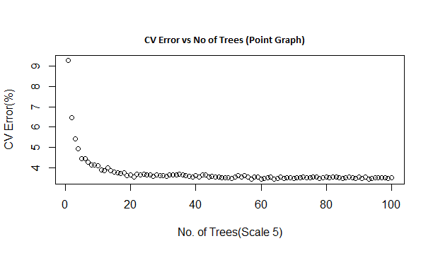

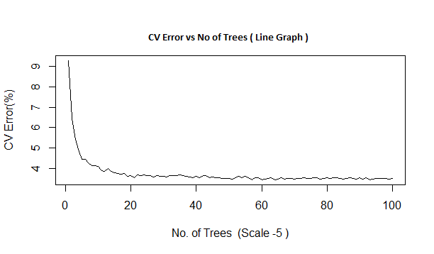

**Question 2.**

Compute and report the out-of-bag error for the forest with the least error in part a).

**Solution**

The OOB for Number of Trees – 93 was found to be

Code Snippet 2. Finding OOB Rate

set.seed**(**415**)**

rf**=**randomForest**(**lettr**~**.,data**=**Data,ntree **=** 93,replace **=** **TRUE)**

print**(**rf**)**

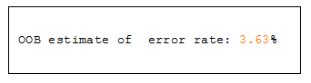

**Question 3.**

Experiment with different values of m (say 1, 2, 4, 8) and report 5 fold cross-validated error rates in the form of a table fixing the number of trees at 1.25 times the number obtained in part a) (where the error levels off).

**Solution**

Fixing the Number of Trees to be – 93*1.25 = 116, Cross Validated errors were generated.

As the number of attributes was 17, the least error rate was expected be around 4 (~ root (17)) and this was found to be true.

|  |  |
| --- | --- |
| **m Value** | **5 Fold Cross Validated Error Value (%)** |
| 1 | 5.60 |
| 2 | 3.87 |
| 4 | 3.72 |
| 8 | 4.16 |

Table 1. m vs. CV error rate

m**=**1

total_error**<-**array**(**0,dim**=**4**)**

**for(**k **in** 1**:**4**){**

set.seed**(**415**)**

cerror**<-**numeric**(**0**)**

print**(**"Count"**)**

print**(**m**)**

**for(**i **in** 1**:**5**)** **{**

cx_test_s **=** folds**[[**i**]]**

cx_train_s **=**setdiff**(**c**(**1**:**20000**)**, cx_test_s**)**

cx_test **=** Data**[**cx_test_s,**]**

cx_train **=** Data**[**cx_train_s,**]**

cactual **=** Data**$**lettr**[**cx_test_s**]**

cx_fit **<-** randomForest**(**lettr **~** . ,data**=**cx_train, ntree**=**116,replace **=** **TRUE**,mtry **=** m**)**

prediction**=**predict**(**cx_fit,newdata **=** cx_test,type**=**"class"**)**

cerror**=**rbind**(**cerror,mean**(**cactual**!=**prediction**))**

**}**

print**(**cerror**)**

total_error**[**k**]=**mean**(**cerror**)**

m**=**m**\***2

**}**

print**(**total_error**\***100**)**

Code Snippet 3. Generating CV Error rates for m=1,2,3,4

**Question 4.**

Study the effect of the size of the randomly sampled data set from L while constructing a tree. Start by sampling 10% of the points from L for constructing a tree and go up to 80% in increments of 10% and the number of trees, say T, in the forest at which the error levels off in each case. Find the 5 fold cross-validated error for a forest with T trees and plot it against the size of the sampled data set expressed as a percentage of L. Comment on the results and say whether bagging is justified as a randomization method to select samples?

**Solution**

For sampling size ranging from 10% to 80% of the training set, the CV error rate vs. Size of sampled data plots were made, after finding the error off number of trees for each time.

* ***CV Error vs. No of Trees Plot***

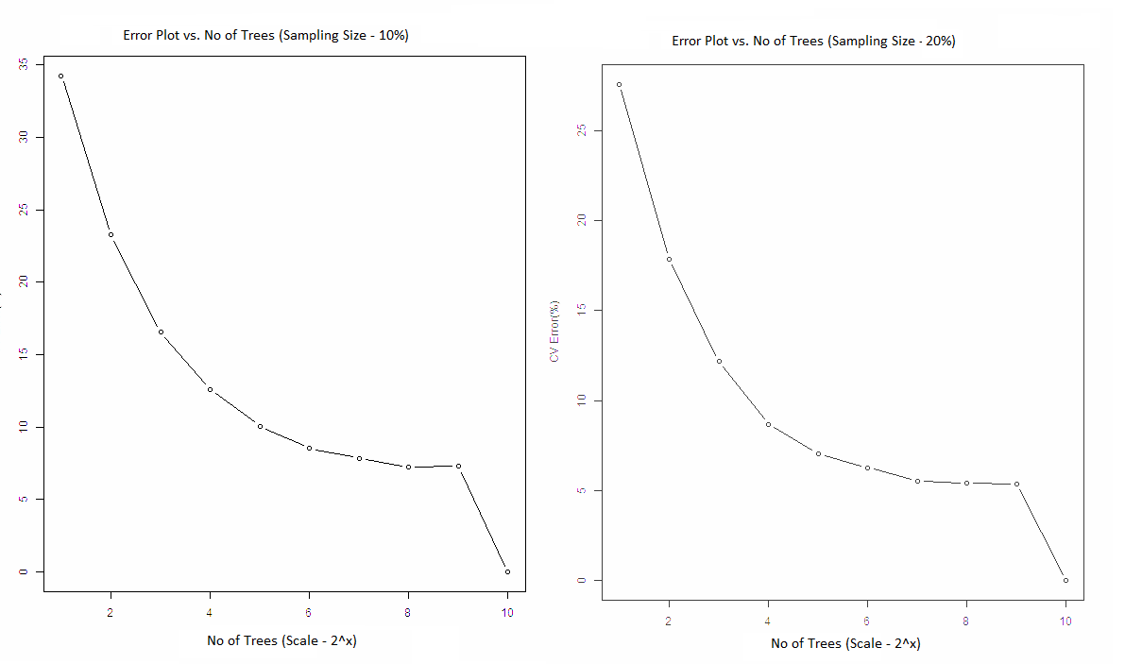

Figure 2: For Sampling Rates 10 and 20%

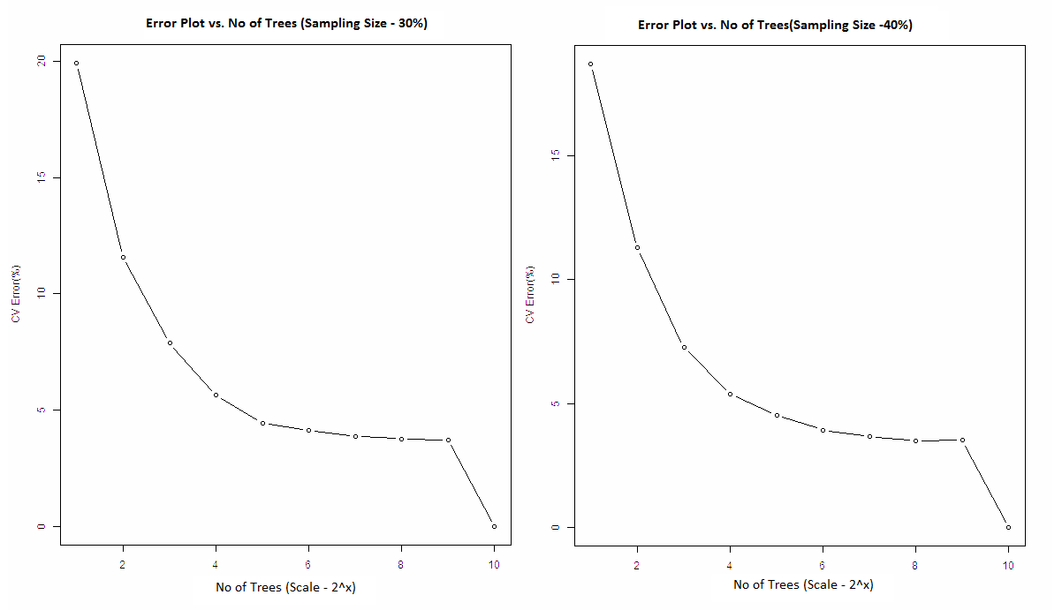

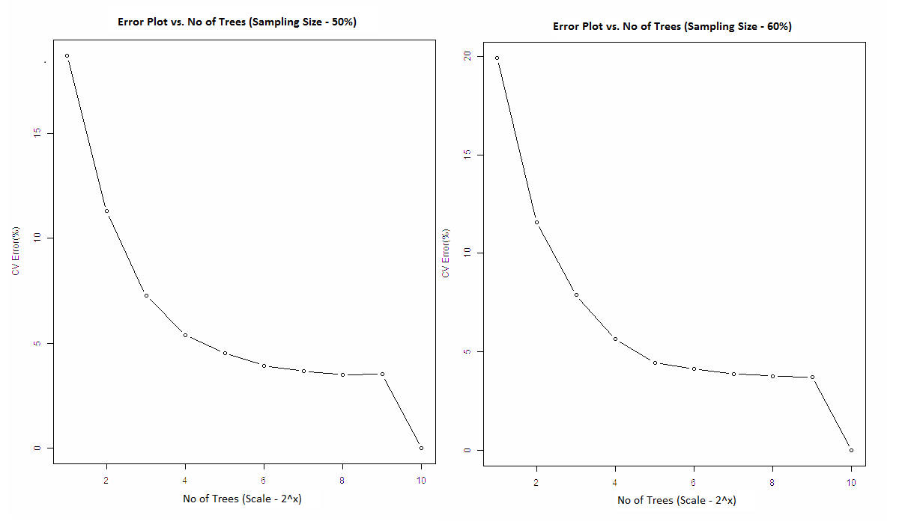

Figure 2: For Sampling Rates 30 -60%

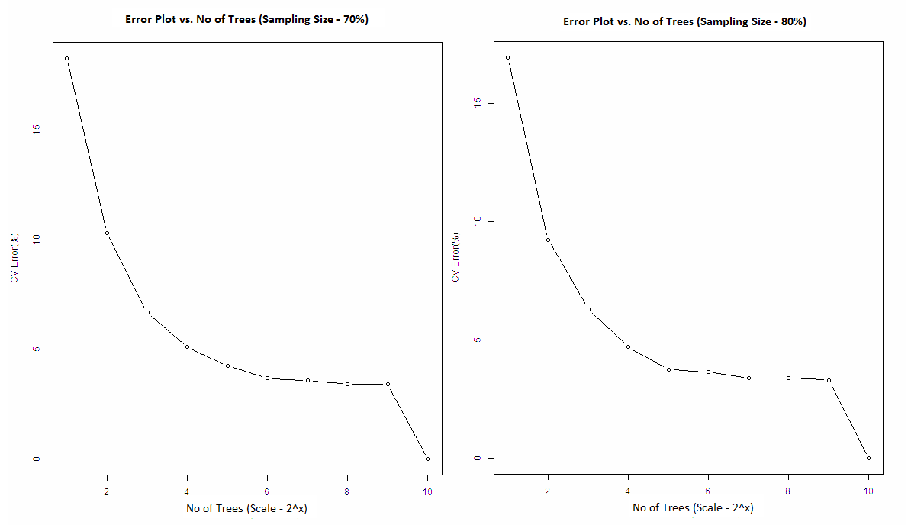

Figure 4: For Sampling Rates 70 and 80%

From the above and below graphs, we can clearly see the trend that is – As the size of the sampled data from the Learning Set increases, the error rate clearly decreases up to a certain point after which it becomes stable (around 60%), and since bagging also takes into account ~63% of randomized data, it is justified.

* *5 fold CV vs. Size of the Sampled Data from L*

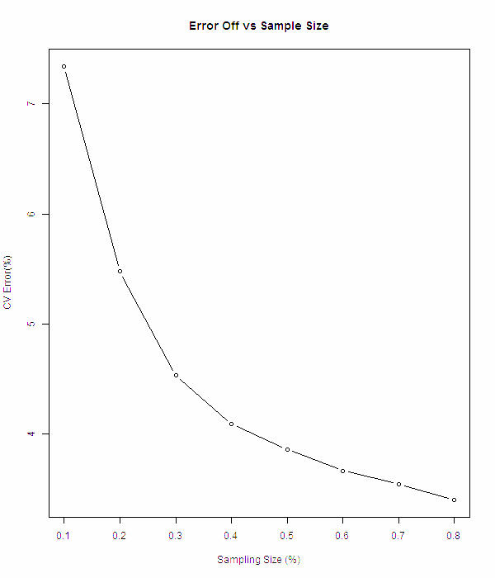

Code Snippet for Part d of the Question

#Function - Validation Error

getXError **<-** **function(**noTree,size**){**

set.seed**(**415**)**

error**<-**numeric**(**0**)**

**for(**i **in** 1**:**5**){**

x_test_s **=** folds**[[**i**]]**

x_train_s **=**setdiff**(**c**(**1**:**20000**)**, x_test_s**)**

x_test **=** Data**[**x_test_s,**]**

x_train **=** Data**[**x_train_s,**]**

actual **=** Data**$**lettr**[**x_test_s**]**

x_fit **<-** randomForest**(**lettr **~** . ,data**=**x_train, ntree**=**noTree,sampsize **=** nrow**(**x_train**)\***size,replace **=** **FALSE)**

predictions**=**predict**(**x_fit,newdata **=** x_test,type**=**"class"**)**

error**=**rbind**(**error,mean**(**actual**!=**predictions**))**

**}**

return**(**mean**(**error**))**

**}**

#Function - Binary Search

binSearch **<-** **function(**h_error,low,high,ssize**){**

mid **<-** floor**((**low**+**high**)/**2**)**

m_error **<-** getXError**(**mid,ssize**)**

int **=** abs**(**h_error **-** m_error**)**

**if((**abs**(**low**-**mid**)<=**1**)||(**abs**(**mid**-**high**)<=**1**)){**

return**(**high**)**

**}**

**if(**int**<**0.0015**){**

high **=**mid

return **(**binSearch**(**h_error,low,high,ssize**))**

**}**

**else{**

low **=** mid

return **(**binSearch**(**h_error,low,high,ssize**))**

**}**

**}**

arr_opt_pt**<-**array**(**0,dim**=**8**)**

arr_x**<-**array**(**0,dim**=**8**)**

**for(**k **in** 1**:**8**){**

s_size **=** sample_size**[**k**]**

tresh **=** getXError**(**500,s_size**)**

arr_opt_pt**[**k**]=**binSearch**(**tresh,2,500,s_size**)**

arr_x**[**k**]<-** getXError**(**arr_opt_pt**[**k**]**,s_size**)**

error_plot**=**array**(**0,dim**=**10**)**

**for(**i **in** 1**:**9**){**

**if(**i**<**9**){**

error_plot**[**i**]=**getXError**(**2**^**i,s_size**)**

**}**

**else{**

error_plot**[**i**]=**getXError**(**500,s_size**)**

**}**

**}**

fileName **=** paste**(**"Plot_", k, ".jpg"**)**

png**(**filename **=** fileName, width **=** 600, height **=** 700**)**

plot**(**error_plot**\***100,type **=** "b",xlab **=** "No. of Trees (Scale - 2^x)",ylab **=** "CV Error(%)", main **=** "Error Plot vs No. of Trees"**)**

dev.off**()**

**}**

png**(**filename **=** "Part4.jpg", width **=** 600, height **=** 700**)**

plot**(**x**=**sample_size, y**=**arr_x**\***100,type **=** "b",xlab **=** "Sampling Size (%)",ylab **=** "CV Error(%)", main**=**"Error Off vs Sample Size"**)**

dev.off**()**