SMART AC JUNCTION
IoT-Enabled AC Control and Electrical Monitoring System
R&D Working Concept and Development Approach
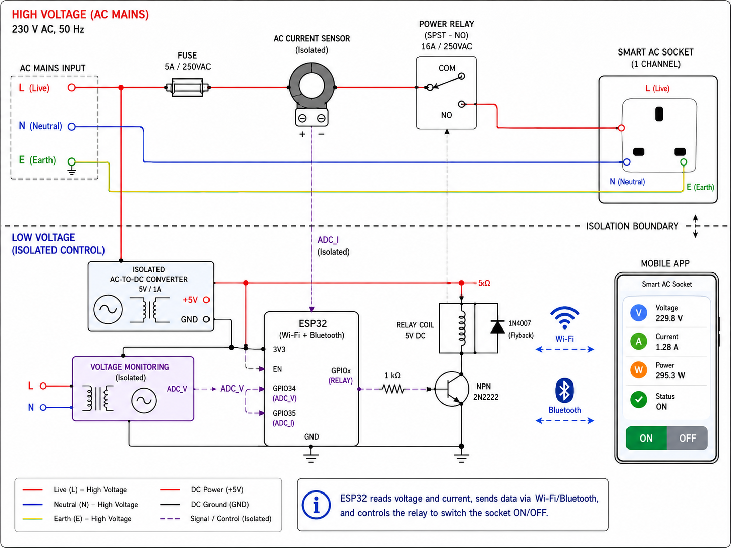
Figure 1. Reference schematic for a single smart AC socket channel
Document Type | Technical R&D Concept
Initial Prototype | 1 AC socket channel
Planned Expansion | 4 independently controlled AC sockets
Important: 230 V AC design and testing must use suitable isolation, fusing, rated components, enclosure, creepage and clearance practices.

1. Purpose
The purpose of this system is to develop an IoT-enabled smart AC socket controller that can remotely switch an AC load, monitor electrical parameters, and report operating data to a mobile application. The ESP32 acts as the main controller and performs relay control, voltage and current acquisition, power/energy calculation, Wi-Fi communication, and Bluetooth communication.

2. System Objectives
- Control a 230 V AC socket through a relay.
- Measure incoming AC voltage.
- Measure the current consumed by the connected load.
- Calculate power and accumulated energy consumption.
- Provide relay ON/OFF status to the user.
- Send live electrical data to a mobile application.
- Receive ON/OFF commands from the mobile application.
- Support Wi-Fi for remote access and Bluetooth for local control or provisioning.
- Provide a scalable architecture for expansion from one channel to four channels.

3. System Architecture
The system is divided into four main technical blocks:
- AC power path
- Low-voltage power supply
- Sensing and control electronics
- Wireless/mobile communication
230 V AC Input
|
+--> Fuse --> Current Sensor --> Relay --> AC Socket --> Load
|
+--> Voltage Sensor ---------------------> ESP32 ADC
|
+--> Isolated AC/DC --> 5 V ------------> ESP32
|
+--> Relay Driver
+--> Wi-Fi / BLE
+--> Mobile App / Cloud

4. Working Principle
When 230 V AC is applied, the input power is used in two paths. The high-voltage path supplies the controlled socket, while an isolated AC-to-DC converter powers the low-voltage electronics. The ESP32 continuously measures electrical parameters, processes user commands, controls the relay, and publishes device status.
Power ON
|
ESP32 boots and initializes GPIO, ADC, Wi-Fi and BLE
|
Read voltage + current
|
Calculate RMS / power / energy
|
Check protection limits
|
Send status to mobile application
|
Receive ON/OFF command and control relay

5. Power and AC Load Path
The Live conductor is the controlled conductor. Neutral and Earth remain directly connected to the corresponding socket terminals in the basic single-pole switching design.
Conductor | Connection | Function
Live (L) | AC input -> Fuse -> Current Sensor -> Relay COM -> Relay NO -> Socket Live | Switched AC path
Neutral (N) | AC input -> Socket Neutral | Direct return path
Earth (E) | AC input -> Socket Earth | Protective earth connection

6. Relay Control Operation
The ESP32 GPIO should not directly energize the relay coil. A transistor or MOSFET driver stage is used. A flyback diode is placed across a DC relay coil to suppress the inductive voltage spike generated when the coil is switched OFF.
Mobile App ON
v
ESP32 receives command
v
GPIO HIGH
v
Relay driver ON
v
Relay coil energized
v
COM-NO closed
v
Socket receives AC Live

Mobile App OFF
v
ESP32 receives command
v
GPIO LOW
v
Relay driver OFF
v
Relay released
v
COM-NO open
v
Socket Live disconnected

7. Voltage Monitoring
An isolated voltage-sensing stage monitors the mains voltage between Live and Neutral and provides a safe, conditioned low-voltage waveform to an ESP32 ADC input. The firmware samples this waveform and calculates RMS voltage.
V_RMS = sqrt( (1/N) * sum(v[n]^2) )
Typical application value: 229 V to 235 V AC

8. Current Monitoring
The load current is measured using an isolated current sensor such as a current transformer (CT) or another suitably isolated AC current sensing device. The sensor output is conditioned and sampled by the ESP32 ADC.
I_RMS = sqrt( (1/N) * sum(i[n]^2) )
The measured current changes with the connected appliance and falls close to zero when no load is operating.

9. Power and Energy Calculation
The ESP32 uses the measured voltage and current to calculate electrical consumption. For a simple estimate, apparent power is calculated as:
S = V_RMS x I_RMS
For accurate real-power measurement, especially with motors, chargers and switching power supplies, the voltage and current waveforms should be sampled together:
P = (1/N) * sum( v[n] x i[n] )
Accumulated energy is obtained by integrating power over time:
Energy (kWh) = integral of Power over time / 1000

10. Wi-Fi and Bluetooth Communication

10.1 Wi-Fi
Wi-Fi provides remote communication between the ESP32 and the application backend or MQTT broker.
ESP32
| Wi-Fi
Router
| Internet
Cloud / MQTT Broker
|
Mobile Application

10.2 Bluetooth
Bluetooth Low Energy can be used for local control and for first-time provisioning of Wi-Fi credentials. The mobile application connects to the ESP32 over BLE, transfers network settings or control commands, and receives local device information.

11. Example Device Data
Example telemetry payload sent by the ESP32:
{
"device_id": "SMART_SOCKET_01",
"voltage": 230.2,
"current": 1.28,
"power": 265.0,
"energy_kwh": 1.45,
"relay": "ON"
}
Example control command:
{
"device_id": "SMART_SOCKET_01",
"command": "ON"
}

12. Mobile Application Functions
- Device discovery and pairing
- Wi-Fi provisioning through BLE
- Socket ON/OFF control
- Live voltage display
- Live current display
- Power display
- Energy history
- Online/offline and relay status
- Fault/alert indication

13. Protection Logic
Because the ESP32 continuously monitors electrical conditions, the firmware can perform supervisory protection. Hardware protection remains mandatory and must not be replaced by software protection.
Condition | Firmware Action | User Feedback
Overcurrent | Turn relay OFF | Overcurrent fault alert
Overvoltage | Turn relay OFF or inhibit restart | Overvoltage alert
Undervoltage | Turn relay OFF or inhibit restart | Undervoltage alert
Overtemperature (future) | Turn relay OFF | Thermal fault alert
Communication loss | Apply configured fail-safe behavior | Offline indication

14. Recommended R&D Development Approach
The first prototype should be developed as a single-channel smart socket. Once electrical measurement, switching and communication are stable, the same architecture can be expanded to four outputs.
- Verify ESP32 power-up and GPIO control with a low-voltage LED load.
- Add the relay-driver stage and verify relay switching without connecting a mains load.
- Integrate the isolated AC-to-DC supply and verify stable 5 V / 3.3 V rails.
- Integrate the current sensor and calibrate the ADC current reading.
- Integrate the isolated voltage sensor and calibrate the RMS voltage reading.
- Implement power and energy calculations.
- Add Wi-Fi communication and MQTT/API messaging.
- Add BLE provisioning and local control.
- Implement protection logic and watchdog behavior.
- Validate the complete single-channel prototype with suitably controlled test loads.
- Create the custom PCB and then expand the design to four channels.

15. Expansion to 4-Port AC Junction
For the final four-port product, one ESP32 can control four relay-driver channels. If all sockets share the same incoming mains supply, one common voltage channel is generally sufficient, while individual current sensing per socket enables independent load monitoring.
ESP32
|
+--> GPIO 1 --> Relay Driver 1 --> Relay 1 --> Socket 1
+--> GPIO 2 --> Relay Driver 2 --> Relay 2 --> Socket 2
+--> GPIO 3 --> Relay Driver 3 --> Relay 3 --> Socket 3
+--> GPIO 4 --> Relay Driver 4 --> Relay 4 --> Socket 4
|
+--> 1 x AC Voltage Measurement
+--> 4 x Current Measurement Channels
+--> Wi-Fi + Bluetooth --> Mobile App / Cloud

16. Functional Summary
Function | Implementation
Main controller | ESP32
Load switching | Power relay + transistor/MOSFET driver
Voltage measurement | Isolated voltage sensing + ADC
Current measurement | CT / isolated current sensor + ADC
Power measurement | Firmware calculation from synchronized voltage/current samples
Energy measurement | Power integration over time
Remote communication | Wi-Fi
Local communication/provisioning | Bluetooth Low Energy
User interface | Mobile application
Initial prototype | 1 socket channel
Final target | 4 independently controlled socket channels

17. Conclusion
The proposed Smart AC Junction combines AC load control, electrical monitoring and wireless connectivity in a single ESP32-based system. The ESP32 controls the relay, measures voltage and current, calculates consumption, and exchanges commands and telemetry with the mobile application. Developing and validating one complete socket channel first provides a controlled path toward the final four-port IoT junction design.
End of Document

