LOGISTICS DATA ANALYST INTERN
Week 4 Report: Predictive Modeling and
Optimization in Logistics Systems
Forecasting delivery time with Python and translating predictions into operational decisions

Prepared by: Hari Sai Yugesh
Programme: Yuva Intern, Logistics Data Analyst Intern (24 Aug 2026 to 21 Sep 2026)
Task: Week 4, Predictive Modeling and Optimization in Logistics Systems
Case study: RegionalCart simulated logistics operation

Selected model: Linear Regression • Test MAE 0.460 days • R² 0.491

1. Introduction and Executive Summary
Weeks 1 to 3 moved from strategic planning, through data cleaning, to exploratory analysis. Week 4 completes the predictive and prescriptive stage of the same logistics case study. The prediction problem is to estimate actual delivery time before dispatch, then use that estimate to flag risky orders and guide operational actions.
The dataset remains hypothetical and reproducible: 8,000 orders from January to June 2026, with delivery time affected by distance, shipping mode, zone and workload. The purpose is to demonstrate a sound modelling workflow; the numerical conclusions should be re-estimated on real company data before operational use.
- Linear Regression was selected because it achieved the lowest future-holdout MAE (0.460 days, about 11.0 hours) and the highest holdout R² (0.491) among the tested models.
- A time-based 80/20 split produced 6,400 training orders and 1,600 future test orders. Five-fold TimeSeriesSplit cross-validation gave Linear Regression a mean MAE of 0.483 days.
- The strongest predictive inputs were promised service level, distance and shipping mode, followed by zone and workload. Weight and order hour added little predictive value in this simulated dataset.
- In a model-based peak-capacity scenario, reducing effective workload on 67 peak-period test orders from above 1.5× normal to 1.2× normal reduced their predicted late rate from 13.4% to 6.0%.
- Same Day remained risky: 41.4% of Same Day test orders were predicted late. A conservative screening rule identified 24 of 70 as short-distance orders with predicted ETA within one day.

2. Problem Definition and Dataset

2.1 Logistics prediction problem
Business question: before an order is dispatched, how many days is it likely to take to reach the customer? The target variable is actual_days. A useful model can support ETA communication, late-risk prioritisation, capacity planning and service-level decisions.
This is a supervised regression problem because the target is continuous. The model deliberately excludes fields that would only be known after fulfilment (for example actual_days itself, is_late, OTIF, fill_rate and quantity delivered), preventing target leakage.

2.2 Dataset and model features
Variable | Type | Role in model
distance_km | Numeric | Distance to customer; expected to increase transit time.
weight_kg | Numeric | Shipment weight; retained to test whether heavier loads matter.
promised_days | Numeric | Customer service promise known before dispatch.
load_ratio | Numeric | Daily order load relative to a normal day; proxy for capacity pressure.
hour / weekday / month | Calendar | Timing variables derived from order timestamp.
zone | Category | North, South, East, West or Central delivery region.
ship_mode | Category | Standard, Second, First or Same Day service level.
actual_days | Target | Observed delivery time in days to be predicted.

df = pd.read_csv("logistics_orders_week3.csv", parse_dates=["order_ts"])
df = df.sort_values("order_ts").reset_index(drop=True)
features = ["distance_km", "weight_kg", "promised_days", "load_ratio",
"hour", "weekday", "month", "zone", "ship_mode"]
X = df[features]
y = df["actual_days"]

3. Modeling Methodology

3.1 Data preparation
Numeric features are median-imputed and standardized. Categorical features are filled with the most frequent category and one-hot encoded. The preprocessing and estimator are kept inside one scikit-learn Pipeline so that the same transformations are learned only from training data and automatically applied to validation or future data.
preprocessor = ColumnTransformer([
("num", Pipeline([
("imputer", SimpleImputer(strategy="median")),
("scaler", StandardScaler())]), numeric_features),
("cat", Pipeline([
("imputer", SimpleImputer(strategy="most_frequent")),
("onehot", OneHotEncoder(handle_unknown="ignore", sparse_output=False))]),
categorical_features)
])

3.2 Train/test strategy
The rows are sorted by order time and split chronologically: the first 80% (6,400 orders) form the training set and the latest 20% (1,600 orders) form the holdout test set. This is more realistic than a random split because a deployed logistics model predicts future orders from past data, not randomly intermingled observations.
split_idx = int(len(df) * 0.80)
X_train, X_test = X.iloc[:split_idx], X.iloc[split_idx:]
y_train, y_test = y.iloc[:split_idx], y.iloc[split_idx:]

3.3 Candidate models and rationale
Model | Reason for inclusion | Logistics relevance
Mean baseline | Simple benchmark | Shows whether ML adds value beyond predicting the average delivery time.
Linear Regression | Interpretable regression | Strong baseline when effects are approximately additive; easy to explain to operations managers.
Random Forest | Ensemble trees | Captures nonlinear interactions without requiring a linear relationship.
Gradient Boosting | Boosted trees | Often strong on structured tabular data; can model complex distance, workload and service effects.

4. Evaluation and Validation

4.1 Evaluation metrics
Metric | Meaning | Why used
MAE | Mean absolute error in days | Primary metric. Directly answers how far the ETA is wrong on average; easy to interpret operationally.
RMSE | Square root of mean squared error | Penalises large misses more heavily, useful because major ETA errors can cause service failures.
R² | Explained variance relative to mean baseline | Shows how much variation in delivery time is explained. Higher is better; 1.0 is perfect.

4.2 Holdout model comparison
Model | MAE (days) | RMSE (days) | R²
Baseline Mean | 0.653 | 0.817 | -0.002
Linear Regression | 0.460 | 0.582 | 0.491
Random Forest | 0.472 | 0.595 | 0.469
Gradient Boosting | 0.463 | 0.585 | 0.487
Tuned Gradient Boosting | 0.461 | 0.583 | 0.491

Linear Regression achieved the lowest holdout MAE of 0.460 days and RMSE of 0.582 days, with R² = 0.491. The mean baseline had MAE 0.653 days, so the selected model reduced average absolute error by 29.6% relative to the baseline.
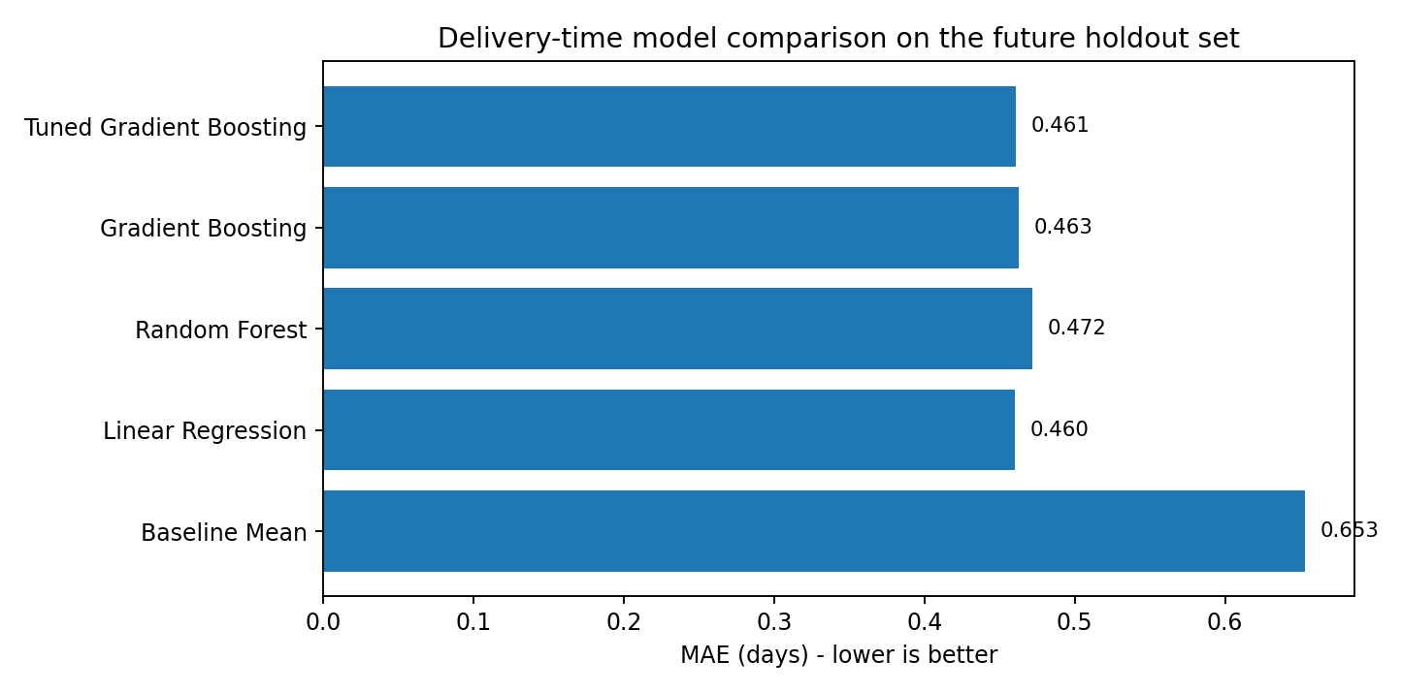
Figure 1: Future-holdout MAE comparison across baseline and predictive models

4.3 Cross-validation and hyperparameter tuning
Five-fold TimeSeriesSplit was applied only within the training period. Each fold trains on earlier orders and validates on a later block, preserving time order and reducing optimistic leakage. The table shows stable results across folds.
Model | CV MAE | CV R²
Linear Regression | 0.483 ± 0.009 | 0.481 ± 0.020
Random Forest | 0.501 ± 0.012 | 0.444 ± 0.017
Gradient Boosting | 0.488 ± 0.013 | 0.472 ± 0.016

Gradient Boosting was additionally tuned over n_estimators, learning_rate and max_depth. The best combination was n_estimators=180, learning_rate=0.05, max_depth=2. Its holdout MAE was 0.461 days, still slightly worse than Linear Regression, so the simpler model was retained.
tscv = TimeSeriesSplit(n_splits=5)
grid = GridSearchCV(
gb_pipe,
{"model__n_estimators": [100, 180],
"model__learning_rate": [0.03, 0.05, 0.1],
"model__max_depth": [2, 3]},
cv=tscv, scoring="neg_mean_absolute_error", n_jobs=-1)
grid.fit(X_train, y_train)

5. Selected Model Diagnostics

5.1 Actual vs predicted delivery time
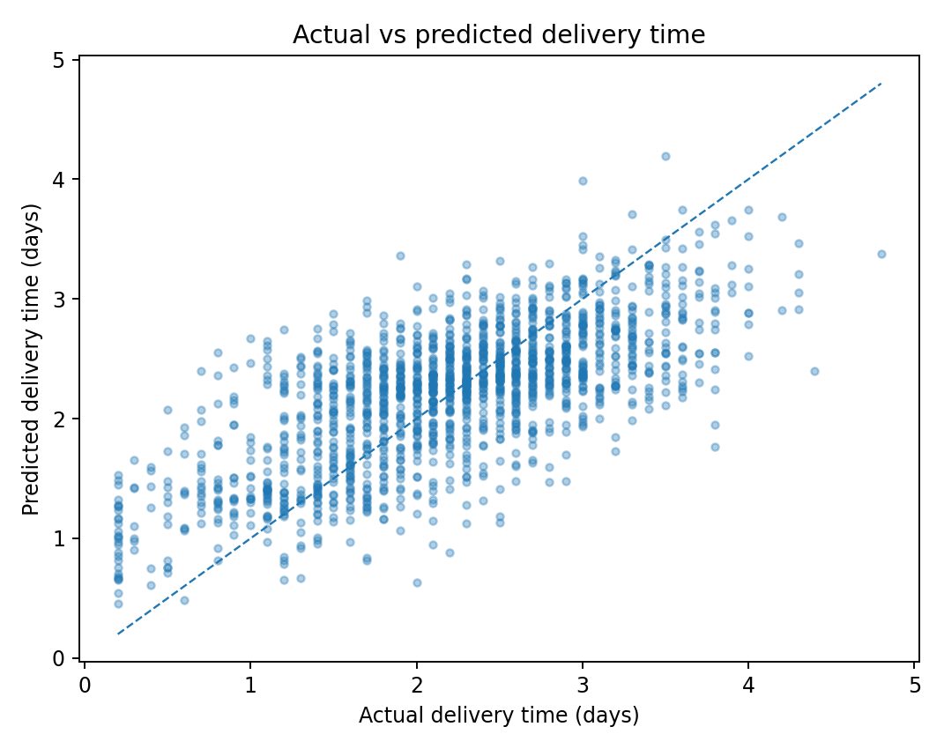
Figure 2: Actual delivery time versus Linear Regression predictions
Predictions follow the overall direction of actual delivery time but remain compressed around the center because random noise and omitted real-world factors cannot be predicted. The model is useful for planning but should not be treated as an exact promised arrival timestamp.

5.2 Residual errors
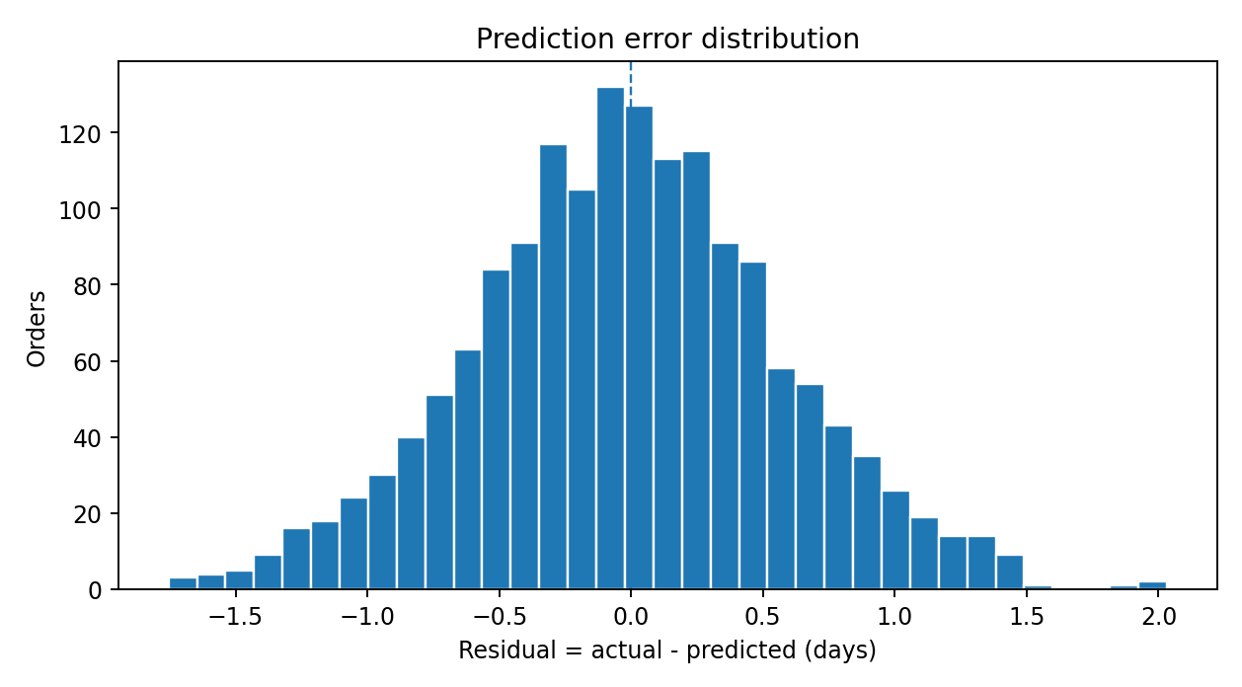
Figure 3: Distribution of residual errors (actual minus predicted)
Residuals are centered near zero, indicating no large systematic over- or under-prediction in aggregate. The remaining spread represents order-level uncertainty. RMSE is higher than MAE because larger errors receive more weight.

5.3 Feature importance
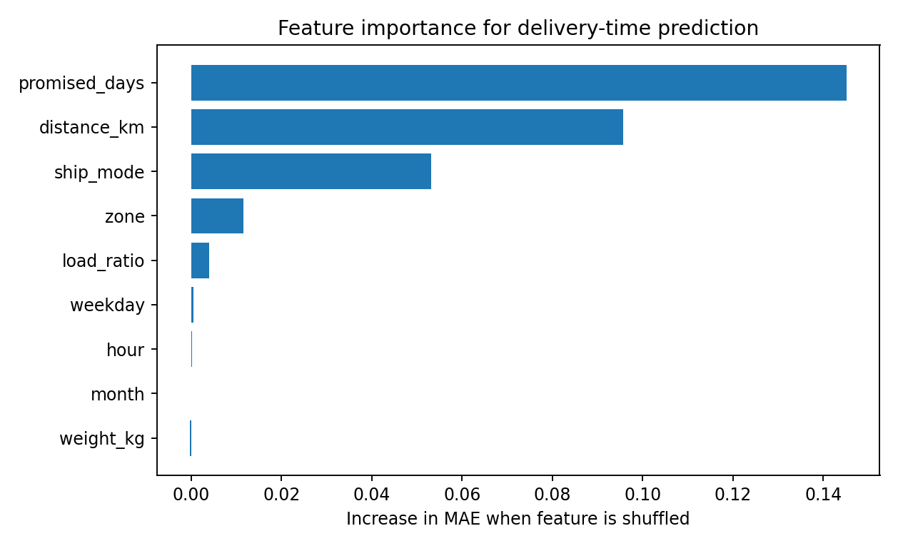
Figure 4: Permutation importance measured as increase in MAE when each feature is shuffled
Promised days, distance and shipping mode are the most influential features. Zone has a smaller but visible contribution, while load ratio matters mainly on peak days rather than uniformly. Weight, hour, weekday and month have near-zero incremental importance in this six-month simulation. This aligns with Week 3, which found distance, service design, West-zone performance and peak load to be the main operational issues.

5.4 From ETA prediction to a late-risk flag
An order is flagged as risky when predicted_days > promised_days. On the holdout set this rule achieved 81.3% accuracy, 57.0% precision and 29.2% recall. Recall is only 29.2%, so this threshold misses many late orders. For operations, the risk margin should therefore be used as a ranking score rather than as a hard yes/no gate.
predicted_days = model.predict(X_future)
risk_margin_days = predicted_days - X_future["promised_days"]
# Highest positive margin = first candidate for dispatcher attention
priority_queue = orders.assign(risk_margin_days=risk_margin_days) .sort_values("risk_margin_days", ascending=False)

6. Optimization Strategies Based on Predictions
Prediction describes what is likely to happen; optimization converts that forecast into an action. The scenarios below are model-based decision-support tests, not causal proof. A real deployment should pilot each intervention and compare actual KPI changes against a control or historical baseline.

6.1 Capacity allocation during peak demand
Week 3 showed that very busy days have poorer service. To test a capacity intervention, all holdout orders with load_ratio > 1.5 were changed to an effective load ratio of 1.2, representing temporary vehicles, drivers, cross-dock support or pre-sorting that reduces congestion. There were 67 such orders in the holdout period.
Scenario | Predicted late rate
Peak orders – current inputs | 13.4%
Peak orders – capacity scenario | 6.0%
All test orders – current inputs | 10.3%
All test orders – capacity scenario | 10.0%

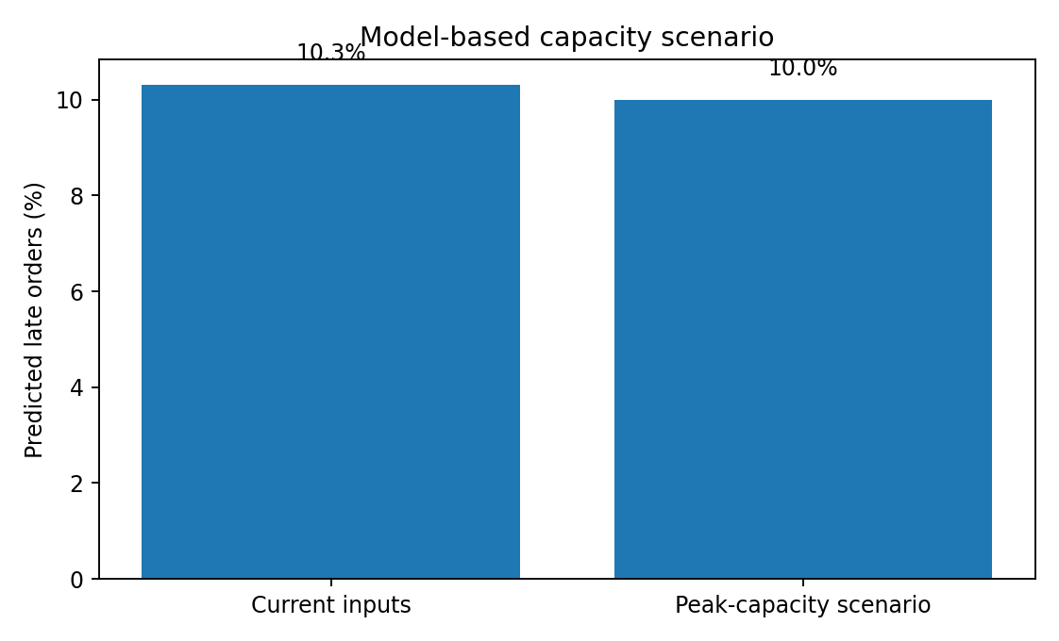
Figure 5: Predicted late rate under the peak-capacity scenario
The model predicts the strongest benefit specifically for peak orders. This supports a targeted strategy: add temporary capacity only when forecast workload crosses a defined threshold instead of carrying excess resources every day.

6.2 Same Day service screening
The test set contains 70 Same Day orders, with a model-predicted late rate of 41.4%. A conservative policy allows Same Day only when distance is at most 20 km and predicted ETA is at most 1 day. The rule retains 24 orders. The remaining orders should be repriced, moved to First Class, assigned dedicated capacity, or given a revised promise.
This is a screening rule rather than a universal threshold. In a real network, the distance limit should be tuned by zone, traffic conditions, rider capacity and customer value.

6.3 Priority-based resource allocation
When expedite capacity is scarce, the correct question is not simply “which orders are late?” but “which orders have the largest predicted lateness margin?” Sorting by predicted_days − promised_days creates a priority queue for dispatchers. Dedicated vehicles, faster sorting, or route resequencing can then be allocated to the highest-risk orders first.
Order time | Zone | Mode | Km | Pred. days | Risk margin
06-02 15:57 | West | Standard Class | 105.7 | 4.20 | 1.20
06-28 09:19 | West | First Class | 96.2 | 3.10 | 1.10
06-26 12:11 | West | Same Day | 75.6 | 2.09 | 1.09
06-07 08:39 | West | First Class | 99.7 | 3.06 | 1.06
05-28 22:12 | West | Standard Class | 84.7 | 3.99 | 0.99

6.4 Route planning and cost minimization
The current dataset is order-level and does not include latitude/longitude or a road-network matrix, so a full Vehicle Routing Problem (VRP) cannot be solved from it without inventing missing route data. The recommended next optimization layer is therefore:
- Add customer coordinates, depot coordinates, vehicle capacity, route time windows and road travel times.
- Cluster nearby deliveries into route candidates by zone and geography.
- Use Google OR-Tools VRP to minimize total distance or cost subject to vehicle capacity and promised-time constraints.
- Add the predicted delivery-time risk as a penalty or priority weight so high-risk orders receive earlier or dedicated service.
- Compare optimized versus current routes on total kilometres, cost per delivery, vehicle utilisation and OTIF.

6.5 Inventory and staffing optimization
The same predictive framework can be extended to shipment volume forecasting. Daily or zone-level order forecasts can drive temporary staffing, vehicle roster size and pre-positioned stock. A practical rule is to trigger extra resources when forecast volume or load ratio exceeds a percentile threshold and to set reorder points using forecast demand during lead time plus safety stock.

7. End-to-End Python Implementation
The separate Python file supplied with this report reproduces the complete workflow: data loading, preprocessing, model comparison, chronological validation, tuning, diagnostics, risk ranking and optimization scenarios. The core training sequence is shown below.
models = {
"Linear Regression": LinearRegression(),
"Random Forest": RandomForestRegressor(n_estimators=250, max_depth=12,
min_samples_leaf=3, random_state=42),
"Gradient Boosting": GradientBoostingRegressor(n_estimators=180,
learning_rate=0.05,
max_depth=3, random_state=42)
}
for name, estimator in models.items():
pipe = Pipeline([("prep", preprocessor), ("model", estimator)])
pipe.fit(X_train, y_train)
pred = pipe.predict(X_test)
print(name, mean_absolute_error(y_test, pred), r2_score(y_test, pred))
The script also writes week4_model_results.json and week4_test_predictions.csv, making the analysis auditable and allowing results to be consumed by a dashboard later.

8. Final Recommendations
Recommendation | Operational action
Deploy the ETA model first as decision support, not automation. | Show predicted days and risk margin to dispatchers. Track accuracy weekly and compare against actual delivery time.
Use targeted peak-capacity triggers. | When expected load exceeds roughly 1.5× normal, add temporary drivers/vehicles or pre-sort orders. The scenario suggests concentrated benefit on peak orders.
Screen Same Day orders before accepting the promise. | Use distance plus predicted ETA; long-distance or risky Same Day requests should be repriced, reassigned or given a realistic promise.
Prioritise by risk margin. | Allocate scarce expedite capacity to orders with the largest predicted ETA minus promised time, especially West-zone and long-distance orders.
Build the next optimization dataset. | Capture GPS coordinates, vehicle capacities, stop time windows, road times and route IDs so OR-Tools can optimize actual vehicle routes rather than only order-level decisions.
Monitor model drift and KPI impact. | Track MAE/RMSE/R² plus OTIF, late rate, cost per delivery and vehicle utilisation. Retrain when service mix, routes or demand patterns change.

9. Limitations and Controls
- The data is simulated, so model performance reflects the designed relationships. Real-world performance may be lower and must be measured on real company data.
- The dataset covers only six months, limiting seasonal learning. A production model should include at least one full year where possible.
- Traffic, weather, driver identity, vehicle type, route sequence, customer availability and real GPS travel time are absent. These are important ETA features and should be added.
- The optimization scenarios are counterfactual predictions from the model, not randomized causal experiments. Operational pilots are needed before claiming realised improvements.
- The binary late-risk threshold has low recall. Use continuous risk ranking, tune thresholds according to the cost of missing a late order, or fit a dedicated calibrated classification model in a future iteration.

10. Conclusion
Week 4 converts the descriptive findings from Week 3 into a predictive workflow. Four model configurations plus a mean baseline were evaluated using a future holdout and time-series cross-validation. Linear Regression was retained because it was both the most accurate on the holdout set (MAE 0.460 days; R² 0.491) and the easiest to explain. The model confirms that service promise, distance, shipping mode and zone are central to delivery-time prediction, while workload becomes important during peak conditions.
The model is then used prescriptively: to rank risky orders, test peak-capacity relief, screen Same Day service and define the data needed for route optimization. The main management lesson is that predictive accuracy alone is not the final objective. Value comes from connecting the forecast to a repeatable dispatch rule, testing the intervention, and measuring OTIF and cost outcomes after implementation.

References and Tools
- scikit-learn documentation: Pipeline, ColumnTransformer, LinearRegression, RandomForestRegressor, GradientBoostingRegressor, GridSearchCV, TimeSeriesSplit and permutation_importance.
- pandas and NumPy for data preparation and calculation; matplotlib for model diagnostic charts.
- Google OR-Tools documentation for the recommended future Vehicle Routing Problem implementation.
- Week 1 strategic plan, Week 2 cleaning pipeline and Week 3 EDA report from the same RegionalCart simulated case study.
- Full code supplied separately: week4_predictive_modeling.py.

