LOGISTICS DATA ANALYST INTERN
Week 3 Report: Advanced Data Analysis and Visualization in Logistics
Exploring delivery performance, cost drivers and bottlenecks with Python, matplotlib and seaborn
Prepared by: Hari Sai Yugesh
Programme: Yuva Intern, Logistics Data Analyst Intern (24 Aug 2026 to 21 Sep 2026)
Task: Week 3, Advanced Data Analysis and Visualization in Logistics

1. Introduction and Summary
Weeks 1 and 2 defined the logistics scenario and prepared clean data. This report moves to the analysis stage: exploring a logistics dataset, visualising it, and turning the patterns into insights and recommendations that an operations manager could act on.
Important note on the data. The dataset is hypothetical. I generated 8,000 orders for January to June 2026 with a built-in structure (for example, a festival-season surge and longer distances in the West zone), using the same columns as the cleaned data from Week 2. Every number and chart in this report was produced by running the Python code on that simulated data. The findings therefore show how the analysis method works; on real company data the same code should be rerun to get real conclusions.

Key results
- Of all orders, 21.6% were delivered late and 75% were On-Time-In-Full (OTIF). Average delivery cost was INR 211.1.
- Distance is the main cost driver (correlation 0.8, about INR 4.19 per extra km). Shipping mode shifts the whole cost level.
- The West zone is the biggest delivery bottleneck: 42.1% of its orders are late against 11.5% in Central.
- The festival surge in March pushed monthly OTIF down to 66.3%, from roughly 77% in other months.
- Same Day delivery is the least reliable service (42.5% late) and the most expensive.

2. Dataset Definition and Simulation

2.1 Structure and key variables
The dataset holds one row per customer order. The variables cover delivery times, shipment volumes and transportation costs, as required, plus the context needed to explain them.
Variable | Type | Meaning
order_ts | Datetime | When the order was placed (Jan to Jun 2026)
zone | Category | North, South, East, West or Central delivery region
ship_mode | Category | Standard Class, Second Class, First Class or Same Day
distance_km | Numeric | Delivery distance in kilometres
weight_kg | Numeric | Shipment weight (shipment volume measure)
qty_ordered / qty_delivered | Integer | Units ordered and units actually delivered
promised_days | Integer | Delivery time promised to the customer
actual_days | Numeric | Delivery time actually taken (delivery time measure)
delivery_cost | Numeric | Total delivery cost in INR (transportation cost measure)
load_ratio | Numeric | Orders on that day divided by the median day (workload measure)
is_late, fill_rate, otif, cost_per_km | Derived | KPI fields built from the columns above

2.2 How the data was simulated
The structure below was built in on purpose so that the dataset behaves like a real operation. The analysis later has to rediscover these patterns from the numbers alone, which is a useful test of the EDA method.
- Order volume is higher at month-end, lower on weekends, and about twice as high during a festival week in mid-March. Orders cluster around morning and early-evening hours.
- Distances differ by zone: Central is the closest and West the farthest.
- Delivery cost depends on distance, weight and a shipping-mode premium, plus a surcharge on very busy days, with random variation.
- Delivery time depends on distance, shipping mode, zone and daily workload, with random variation.
- Some orders arrive short of the ordered quantity, more often on very busy days.

2.3 Loading and checking the data
import pandas as pd, numpy as np
import matplotlib.pyplot as plt
import seaborn as sns

df = pd.read_csv("logistics_orders_week3.csv", parse_dates=["order_ts"])

# Derived KPI fields (defined in Weeks 1 and 2)
df["is_late"] = (df["actual_days"] > df["promised_days"]).astype(int)
df["fill_rate"] = df["qty_delivered"] / df["qty_ordered"]
df["otif"] = ((df["is_late"] == 0) & (df["qty_delivered"] >= df["qty_ordered"])).astype(int)
df["cost_per_km"] = df["delivery_cost"] / df["distance_km"]

print(df.shape)
print(df.dtypes)
print(df.isna().sum().sum()) # confirm the data is clean before analysis

3. Methodology
The analysis follows the usual EDA sequence, from simple to detailed:
- Summary statistics to understand the typical value and spread of each variable.
- Distributions to see shape, skew and unusual values.
- Relationships using correlation and scatter plots to find what drives cost and delay.
- Comparisons by group by zone, shipping mode, hour and month to locate where performance differs.
- Interpretation turning patterns into operational findings and recommendations.
Tools: Python 3, pandas and NumPy for calculation; matplotlib and seaborn for charts. Chart colours are kept consistent: orange for the main series, grey for context, red for the item that needs attention.

4. Exploratory Data Analysis

4.1 Central tendency and spread
num = ["distance_km", "weight_kg", "delivery_cost", "actual_days", "cost_per_km"]
summary = df[num].agg(["mean", "median", "std", "min", "max", "skew"]).T.round(2)
print(summary)

# Headline KPIs
print("Late rate :", round(df["is_late"].mean() * 100, 1), "%")
print("OTIF :", round(df["otif"].mean() * 100, 1), "%")
print("Avg cost :", round(df["delivery_cost"].mean(), 1), "INR")

Variable | Mean | Median | Std dev | Min | Max | Skew
distance_km | 25.37 | 21.9 | 15.02 | 1.7 | 116.1 | 1.31
weight_kg | 12.58 | 11.3 | 6.95 | 0.9 | 50 | 1.12
delivery_cost | 211.1 | 199.32 | 78.15 | 30.19 | 598.21 | 0.84
actual_days | 2.22 | 2.2 | 0.84 | 0.2 | 5.5 | -0.06
cost_per_km | 10.11 | 8.58 | 5.45 | 3.21 | 123.06 | 4.4

Reading the table. For distance, weight and cost the mean sits above the median and the skew is positive. This means most deliveries are short, light and cheap, while a smaller number of long or heavy ones pull the average up. Reporting only the mean would overstate the typical delivery, so the median is the better description of a normal order. Transit time (actual_days) is almost symmetric (skew -0.06), with mean and median both about 2.2 days. Cost per km is strongly skewed (4.4): a few short deliveries cost a lot for each km travelled, which points to a fixed cost per delivery that short trips cannot spread out.

4.2 Correlations
Correlation measures how strongly two variables move together, from -1 to +1. The most useful pairs are summarised here and shown in full in Figure 5.
Pair | Correlation | Meaning
Distance and delivery cost | 0.8 | Strong: longer deliveries cost more
Weight and delivery cost | 0.28 | Weak to moderate: heavier loads add some cost
Distance and transit days | 0.37 | Moderate: distance slows delivery, but is not the whole story
Transit days and late | 0.55 | Strong, as expected, since lateness is defined from delivery time
Daily load and transit days | 0.13 | Weak overall: busy days slow deliveries, but only on the busiest days
Daily load and fill rate | -0.07 | Weak negative: busy days bring more short deliveries
Distance and weight | 0.01 | None: the two are independent

A caution: a weak overall correlation does not mean no effect. Daily load has a small overall correlation with lateness (0.11) because the effect appears only on the busiest days, which Section 5.8 examines directly. Correlation also does not prove cause.
cols = ["distance_km", "weight_kg", "delivery_cost", "actual_days",
"load_ratio", "is_late", "fill_rate"]
corr = df[cols].corr()

sns.heatmap(corr, annot=True, fmt=".2f", cmap="RdBu_r", center=0, vmin=-1, vmax=1)
plt.title("Correlation between key variables")
plt.show()

# Strength of the distance-cost relationship
slope, intercept = np.polyfit(df["distance_km"], df["delivery_cost"], 1)
r2 = df["distance_km"].corr(df["delivery_cost"]) ** 2

5. Visualizations and Interpretation
Each chart below is introduced with the reason for choosing that chart type, followed by the code, the figure, and what it shows.

5.1 Daily order volume (line chart)
Why this chart. A line chart is the standard choice for change over time. A 7-day moving average smooths daily noise so the trend and the surge are clear, and the median line gives a baseline for a normal day.
daily = df.groupby(df["order_ts"].dt.normalize()).size()

fig, ax = plt.subplots(figsize=(8, 3.6))
ax.plot(daily.index, daily.values, color="grey", lw=0.8, alpha=0.7) # raw daily counts
ax.plot(daily.index, daily.rolling(7, center=True).mean(), lw=2.2) # 7-day trend
ax.axhline(daily.median(), ls="--") # normal-day baseline
ax.set_title("Daily order volume"); ax.set_ylabel("Orders per day")

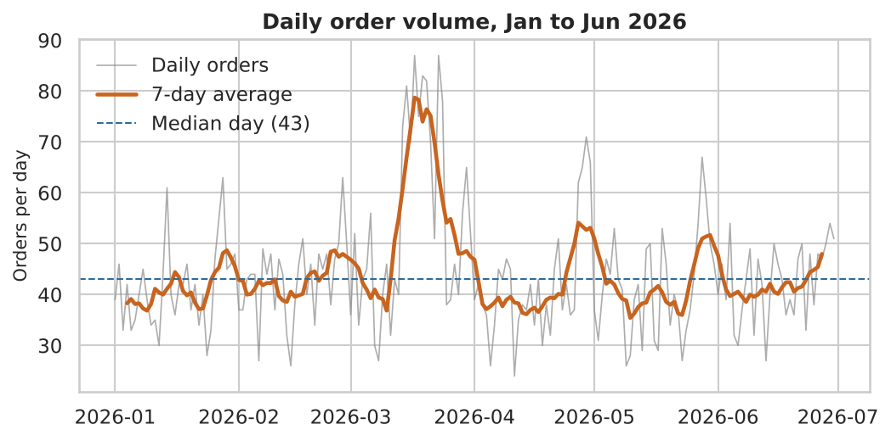
Figure 1: Daily order volume with 7-day average and median day
What it shows. Volume is steady at a median of 43 orders a day, with small month-end bumps. There is a sharp surge in mid-March, peaking at 87 orders on 2026-03-17, about double a normal day. Planning capacity for the median day would leave the operation short for the whole surge.

5.2 Distribution of cost and distance (histograms)
Why this chart. A histogram with a density curve shows the full shape of a numeric variable, which a single average cannot. Marking mean and median on the chart shows the skew directly.
fig, axes = plt.subplots(1, 2, figsize=(8, 3.4))
sns.histplot(df["delivery_cost"], bins=40, kde=True, ax=axes[0])
axes[0].axvline(df["delivery_cost"].mean(), ls="--") # mean
axes[0].axvline(df["delivery_cost"].median(), ls=":") # median
sns.histplot(df["distance_km"], bins=40, kde=True, ax=axes[1])

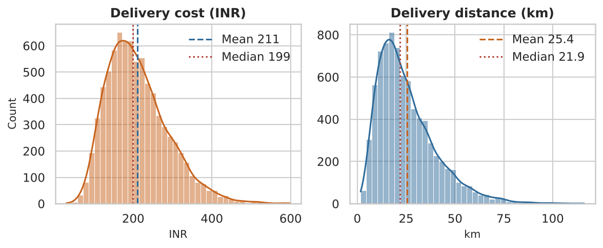
Figure 2: Distribution of delivery cost and delivery distance
What it shows. Both variables have a long right tail. Most deliveries are within about 30 km and cost INR 100 to 300, but a minority travel far and cost much more. The mean (INR 211.1) is above the median (INR 199.32), so budgeting on the average cost would slightly overstate a typical order while hiding the expensive tail.

5.3 Cost by shipping mode (box plot)
Why this chart. A box plot compares the spread of a number across categories, showing median, quartiles and extreme values in one view. It suits comparing four shipping modes.
order = ["Standard Class", "Second Class", "First Class", "Same Day"]
sns.boxplot(data=df, x="ship_mode", y="delivery_cost", order=order)

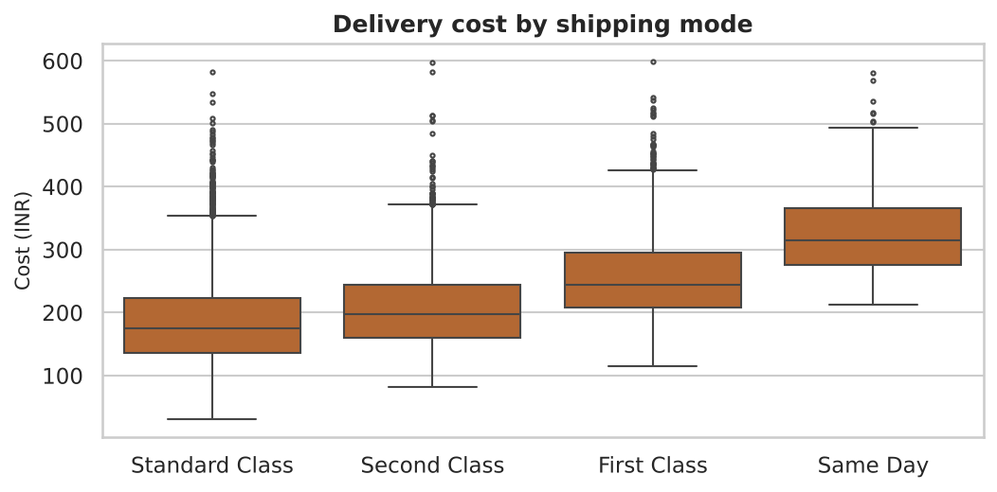
Figure 3: Delivery cost by shipping mode
What it shows. Cost rises steadily with service level. Average cost is INR 186.5 for Standard, 208.2 for Second Class, 256.4 for First Class and 324.1 for Same Day, which is about 74% above Standard. Spread also grows with service level, so costs are less predictable for premium modes.

5.4 Distance versus cost (scatter plot with fitted line)
Why this chart. A scatter plot is the right tool for the relationship between two numeric variables. Colouring points by shipping mode adds a third variable, and the fitted line quantifies the trend. A sample of 2,500 points avoids over-plotting.
samp = df.sample(2500, random_state=1) # sample to avoid over-plotting
sns.scatterplot(data=samp, x="distance_km", y="delivery_cost",
hue="ship_mode", hue_order=order, s=14, alpha=0.55)
xs = np.linspace(df["distance_km"].min(), df["distance_km"].max(), 50)
plt.plot(xs, slope * xs + intercept, color="black") # least-squares line

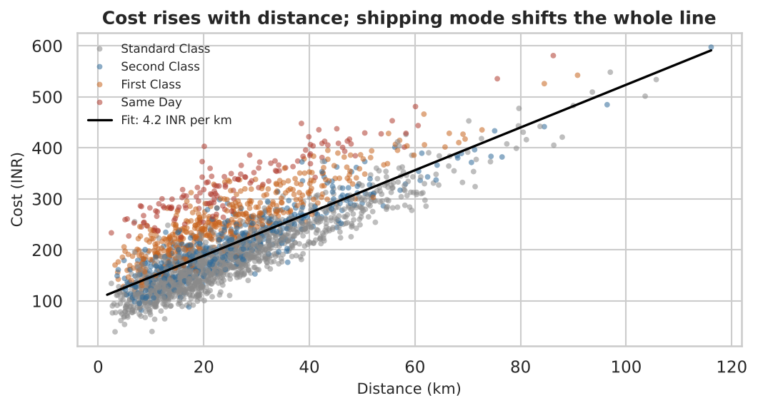
Figure 4: Delivery cost against distance, coloured by shipping mode
What it shows. Cost increases in a nearly straight line with distance, at about INR 4.19 per km, and distance alone explains about 65% of the variation in cost (R squared 0.65). The colours show that premium modes sit higher on the chart at every distance: the mode adds a fixed premium on top of the distance cost. The intercept of about INR 105 also shows a large cost that does not depend on distance, which is why short deliveries are expensive per km.

5.5 Correlation heat map
Why this chart. A heat map shows many pairwise relationships at once, with colour showing strength and direction. It is a quick way to find which variables deserve a closer look.
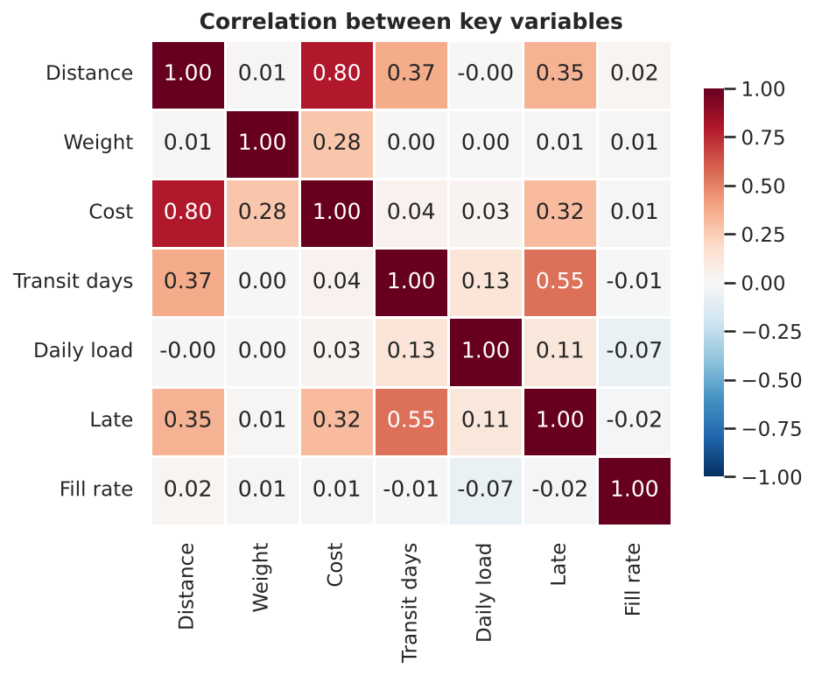
Figure 5: Correlation heat map of key variables
What it shows. The strongest cost link is distance (0.8). Lateness is most connected to transit time (0.55), then to distance (0.35). Weight has almost no link with delay. Daily load has a small positive link with transit time (0.13) and a small negative link with fill rate (-0.07), a first sign that workload hurts service, examined further below.

5.6 Late rate by zone and by hour (bar chart and line chart)
Why this chart. A bar chart compares a rate across a small number of categories, and sorting the bars makes the ranking obvious. A line chart suits an ordered variable like hour of day. A dashed line for the overall rate shows who is above or below average.
fig, axes = plt.subplots(1, 2, figsize=(8, 3.5))
late_zone = (df.groupby("zone")["is_late"].mean() * 100).sort_values(ascending=False)
axes[0].bar(late_zone.index, late_zone.values)
axes[0].axhline(df["is_late"].mean() * 100, ls="--") # overall late rate

late_hour = df.groupby("hour")["is_late"].mean() * 100
axes[1].plot(late_hour.index, late_hour.values, marker="o")

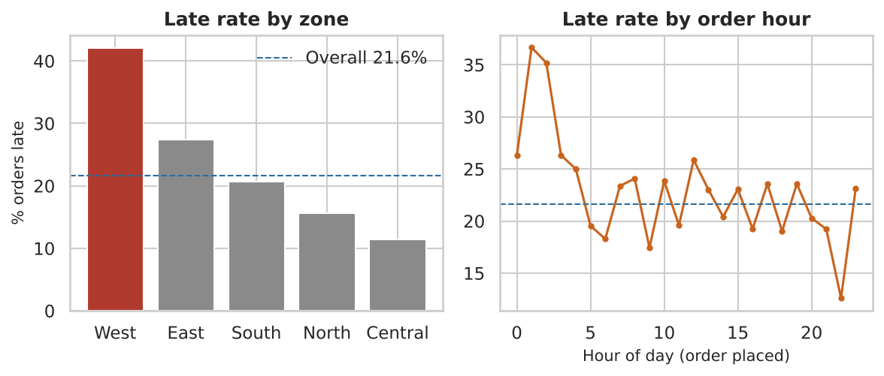
Figure 6: Late-delivery rate by zone and by hour the order was placed
What it shows. The zone differences are large. West has a late rate of 42.1%, followed by East at 27.4, while Central is at 11.5%. West is 3.7 times as likely to be late as Central. This tracks distance, since average distance is 38.7 km in West and 14.8 km in Central, though the heat map below shows the gap is larger than distance alone explains. By hour, the picture is flat: orders placed in the busiest hours (9 to 11 and 18 to 19, 40% of orders) are late 20.7% of the time against 22.3% for other hours. The spikes at night come from very few orders and should not be read as a real pattern. Hour of order is therefore not a bottleneck; zone is.

5.7 Late rate by zone and shipping mode (heat map)
Why this chart. A heat map of a two-way table shows how two categories combine. Problems that hide in the averages, such as a bad combination of zone and service, appear as a single dark cell.
heat = df.pivot_table(index="zone", columns="ship_mode",
values="is_late", aggfunc="mean") * 100
sns.heatmap(heat[order], annot=True, fmt=".0f", cmap="OrRd",
cbar_kws={"label": "% late"})

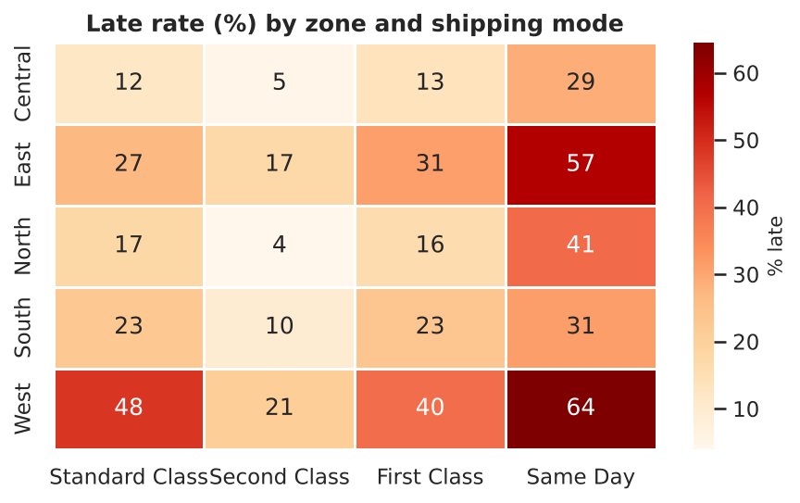
Figure 7: Late rate (%) by zone and shipping mode
What it shows. The worst cell is West with Same Day, where 64.4% of orders are late. Same Day is weak in every zone, and especially in West and East. Standard Class is late 48.5% of the time in West against 12.1% in Central. Second Class is the most reliable mode in every zone. Both Standard and Second Class promise 3 days, but Standard is late 23.5% of the time against 10.1% for Second Class. The Standard promise is too tight for how long Standard orders actually take.

5.8 Monthly orders and OTIF (combined bar and line chart)
Why this chart. Placing volume (bars) and service level (line) on one chart makes the link between workload and performance visible. A dual-axis chart should be read carefully, so each axis is labelled and the line is drawn in a different colour from the bars.
monthly = df.groupby("month_name", sort=False).agg(orders=("is_late", "size"),
otif=("otif", "mean"))
fig, ax = plt.subplots(figsize=(8, 3.4))
ax.bar(monthly.index, monthly["orders"]) # volume as bars
ax2 = ax.twinx()
ax2.plot(monthly.index, monthly["otif"] * 100, marker="o") # service level as line

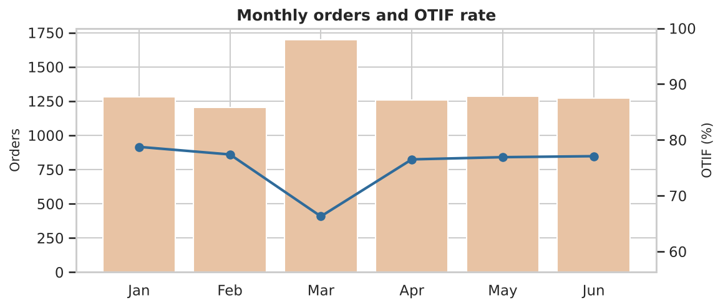
Figure 8: Monthly order volume and OTIF rate
What it shows. March had 1,697 orders against about 1,250 to 1,300 in other months, and OTIF dropped to 66.3% from roughly 77%. The surge clearly cost service quality. A direct comparison on the busiest days (those with more than 1.5 times the median volume, which hold 14% of all orders) confirms it: 34.4% of those orders were late against 19.6% on normal days, and only 90.8% were delivered in full against 96.3%.
df["peak_day"] = df["load_ratio"] > 1.5 # day with more than 1.5x the median volume
print(df.groupby("peak_day")[["is_late", "otif"]].mean().round(3))
print(df.groupby("peak_day")["fill_rate"].apply(lambda s: (s >= 1).mean()).round(3))

6. Analytical Insights
Area | Finding | Evidence
Operational efficiency | Overall on-time performance is weak: about 1 order in 5 is late and only 75% are OTIF. Performance falls during surge periods. | Late rate 21.6%; March OTIF 66.3%; busy-day late rate 34.4% (Figures 1, 8)
Cost drivers | Distance is the dominant driver, then shipping mode, then weight. A large part of the cost does not vary with distance. | r = 0.8 (distance); INR 4.19 per km; Same Day costs about 74% more than Standard (Figures 3, 4)
Bottleneck 1: zone | West (and to a lesser extent East) is the main delivery bottleneck. | West late rate 42.1% against 11.5% in Central (Figures 6, 7)
Bottleneck 2: service design | Same Day is unreliable, and the Standard promise is tighter than Standard handling allows. | Same Day 42.5% late; Standard 23.5% against Second Class 10.1% (Figure 7)
Bottleneck 3: surge capacity | Capacity is planned for a normal day, so festival peaks cause late and short deliveries. | Peak days: 34.4% late and 90.8% full, against 19.6% and 96.3% on normal days
Not a driver | The hour at which an order is placed does not explain lateness, and neither does weight. | Late rate 20.7% in busy hours against 22.3% otherwise; weight and lateness r = 0.01

7. Recommendations
- Fix the West zone first. West holds 1,141 of the 8,000 orders. If its late rate were brought down to the level of the other four zones (18.2%), roughly 270 fewer orders would be late and the overall late rate would fall from 21.6% to about 18.2%. Options are a micro-hub or cross-dock closer to West customers, dedicated vehicles, and route consolidation, to be tested with the route optimisation approach from Week 1.
- Re-set delivery promises. Either promise 4 days for Standard Class or speed up its handling, since it is late 23.5% of the time on a 3-day promise while Second Class is late only 10.1%.
- Restrict or reprice Same Day. Offer it only in short-distance zones such as Central, where it is least late, and review its price. It costs about 74% more than Standard and is late 42.5% of the time.
- Plan for peak periods. Use the order history to forecast surges such as the March festival week, and add temporary vehicles and drivers and pre-position stock before the peak. This addresses both lateness and the short deliveries on busy days.
- Reduce the fixed cost per delivery. Because a large part of cost does not depend on distance, consolidating nearby orders into one run, or setting a minimum order value for very short deliveries, would lower the cost per km.
- Monitor weekly. Track OTIF, late rate by zone and mode, and cost per delivery in a simple dashboard built from the same code, so that changes can be measured against this baseline.

8. How the Visualizations Help Interpret Logistics Performance
Chart type | Metric it explains | Decision it supports
Line chart (daily volume) | Demand and workload over time | Staffing and vehicle capacity, surge planning
Histogram (cost, distance) | Typical value, spread and tail of costs | Realistic budgets, spotting expensive deliveries
Box plot (cost by mode) | Cost level and variability by service | Pricing and service-mix decisions
Scatter plot with fit | Cost per km and the fixed cost component | Cost control, consolidation, minimum order rules
Correlation heat map | Which variables move together | Choosing what to investigate or model next
Bar and line (late rate) | On-time performance by zone and hour | Where to send improvement effort
Two-way heat map | Late rate for zone and service combinations | Targeted fixes such as dropping Same Day in weak zones
Bar and line (monthly OTIF) | Service level against volume | Showing the cost of surges to management

The same numbers could be given in a table, but the charts make patterns visible straight away: the March surge, the long tail of costs, and the single dark West and Same Day cell would take much longer to find in rows of figures. Charts also make the case to non-technical decision-makers, which is the purpose of analysis in an operation.

9. Limitations
- The data is simulated, so the patterns found are the ones built into it. The value of this exercise is the method; real data should be analysed with the same code.
- Correlation does not prove cause. The recommendations are hypotheses to test, for example with a pilot in one zone, not guaranteed results.
- The analysis covers six months, so it cannot show yearly seasonality.
- Variables such as traffic, weather, driver and vehicle type, and customer availability were not included and would affect real results.

10. Conclusion
This analysis shows how exploration and visualisation turn a table of orders into operational decisions. Summary statistics showed that a typical delivery is shorter and cheaper than the average suggests. The scatter plot and correlations identified distance as the main cost driver. Group comparisons located the main bottlenecks in the West zone, in Same Day service and in surge periods, while ruling out order hour and weight. Each finding links to a concrete action, from re-setting delivery promises to planning for peak demand. The next step is to apply the same code to a real dataset and to build predictive models on the features found to matter.

References and Tools
- pandas documentation: groupby, pivot_table, describe and correlation methods.
- matplotlib and seaborn documentation: histplot, boxplot, scatterplot and heatmap.
- Tukey, J. W. (1977). Exploratory Data Analysis. Addison-Wesley.
- Kaggle: DataCo Smart Supply Chain and Olist datasets, as references for the logistics variables.
- Full code: analysis.py in the GitHub repository for this internship.

