# web-scrapping-for-company-fillings

web-scrapping-for-IPO-Prospectus It is a scrapping tool which extracts the data from EDGAR | Company Filings and calculate some attributes by string matching.

It mainly focuses on company's Board of Committee, Initial Employee count and consolidated financial data.

Techonologies : Selenium and Python web scrapping techniques

Actual data :

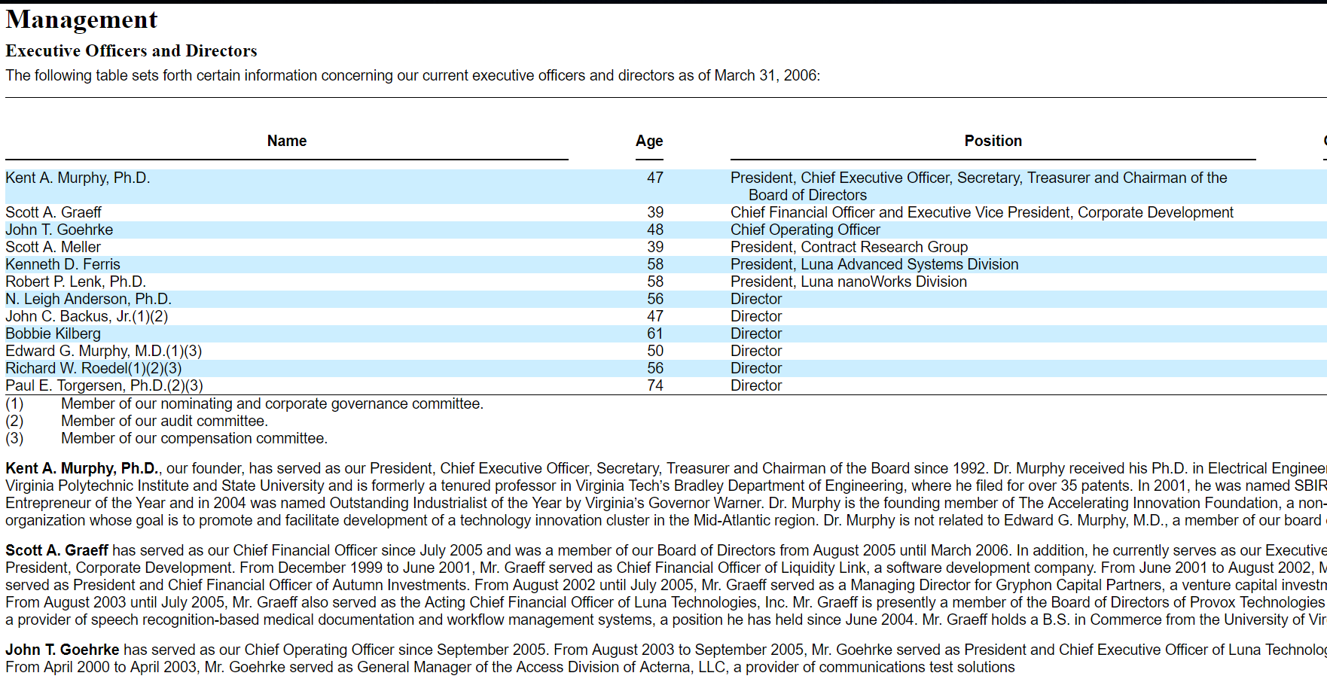

Formatted data :

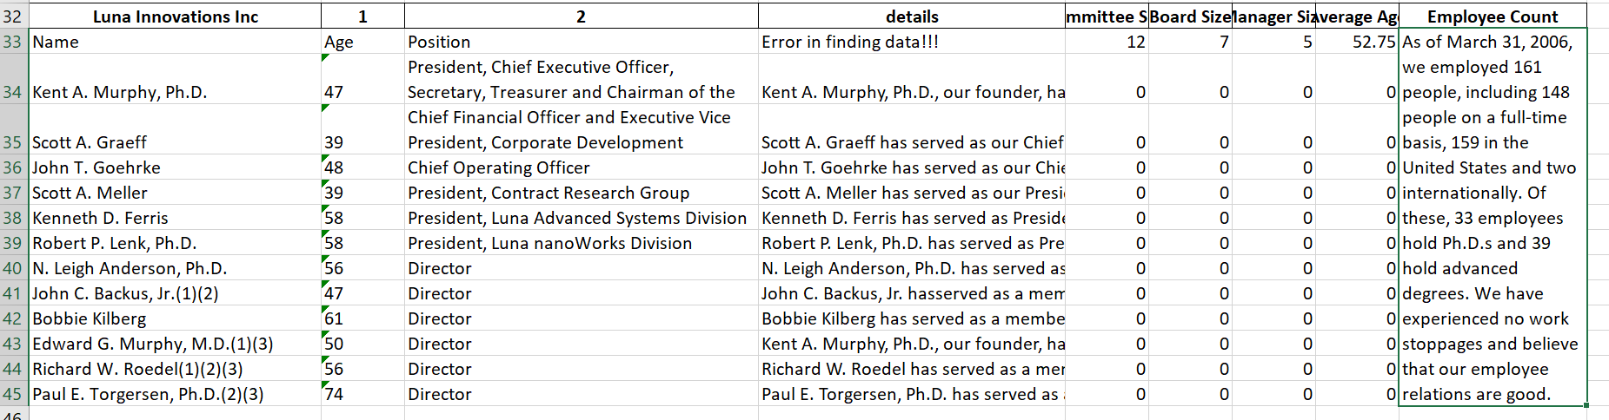

Actual Finance data :

