SWASTIK COLLEGE

Tribhuvan University

Faculties of Computer Science



Bachelors of Science in Computer Science and Information

Technology

(BSc. CSIT)

Course: **Design and Analysis of Algorithms (CSC-314)**

Semester: V

A Lab Report On: Backtracking

**Submitted to:**

Department of BSc. CSIT

Swastik College

**Submitted by:**

Name: Yugesh Poudel

Roll No: 29349/078

**LAB 1**

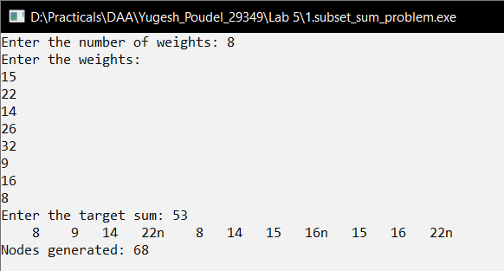

**LAB 2**

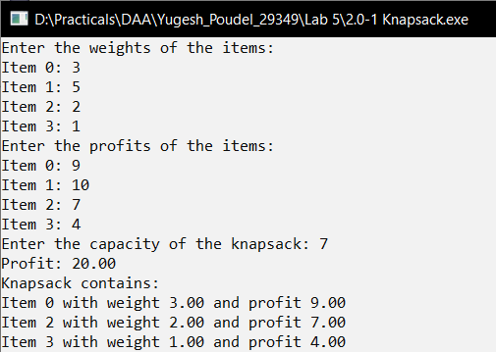

**LAB 3**

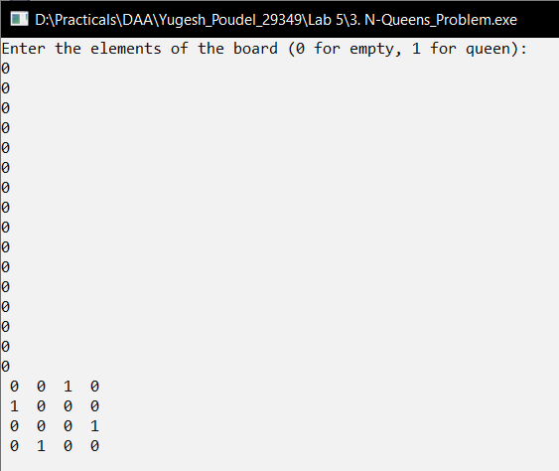

SWASTIK COLLEGE

Tribhuvan University

Faculties of Computer Science



Bachelors of Science in Computer Science and Information

Technology

(BSc. CSIT)

Course: **Design and Analysis of Algorithms (CSC-314)**

Semester: V

A Lab Report On: Proofs of NP Completeness

**Submitted to:**

Department of BSc. CSIT

Swastik College

**Submitted by:**

Name: Yugesh Poudel

Roll No: 29349/078

**LAB 1**

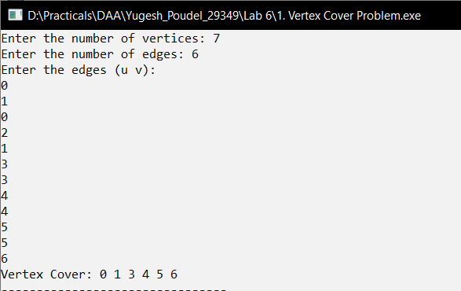

**COMPARISON GRAPH (BY YUGESH POUDEL)  
