

PROJECT SPECIFICATION FORM (PSF)

AI-Enhanced Part-Time Job Search Application for Students
and Job Seekers in Nepal

Yugina Gurung
NP069780
BSc (Hons) Information Technology
Supervisor: Rajeev Poudel
2nd Marker: Omkar Basnet
2026

Table of Contents
1. PROJECT OVERVIEW & OBJECTIVES 1
1.1 Project Title 1
1.2 Problem Statement 1
1.2.1 Absence of a Dedicated Part-Time Job Platform 1
1.2.2 Rising Employment Fraud 1
1.2.3 Inadequate AI Integration in Nepal's Recruitment Technology 2
1.3 Objectives 2
1.4 Purpose, Scope & Limitations 3
1.4.1 Purpose 3
1.4.2 Within Scope 4
1.4.3 Outside Scope 4
1.4.4 Limitations 5
2. SYSTEM REQUIREMENTS 6
2.1 Functional Requirements 6
2.1.1 Job Seeker Role 6
2.1.2 Employer Role 8
2.1.3 Administrator Role 9
2.2 Non-Functional Requirements 11
3. TECHNICAL SPECIFICATIONS 13
3.1 Technology Stack 13
3.1.1 Front-End: React with Bootstrap 13
3.1.2 Back-End: Python with Django 13
3.1.3 Database: MySQL 8.0 14
3.1.4 AI Recommendation Engine 14
3.2 System Architecture 15
4. FEASIBILITY STUDY 20
4.1 Technical Feasibility 20
4.2 Operational Feasibility 21
4.3 Economic Feasibility 21
5. PLANNING & MANAGEMENT 23
5.1 Project Timeline / Milestones 23
5.2 Risk Assessment 27
6. VALIDATION & ACCEPTANCE 30
6.1 Testing Plan 30
6.2 Expected Outcomes / Deliverables 31
7. REFERENCES 33

1. PROJECT OVERVIEW & OBJECTIVES

1.1 Project Title
AI-Enhanced Part-Time Job Search Application for Students and Job Seekers in Nepal

1.2 Problem Statement
Nepal's youth employment landscape is characterised by three deeply interconnected structural problems that collectively prevent students and job seekers from accessing suitable flexible employment through digital channels.

1.2.1 Absence of a Dedicated Part-Time Job Platform
At present, there is no reliable, user-friendly and dedicated digital platform in Nepal which specifically supports part-time, flexible or entry-level employment. While a few platforms like MeroJob and JobsNepal have been created for professional and experienced individuals, the absence of schedule-based filtering and a lack of part-time job postings excludes students and fresh graduates. Most of the platforms, like Mero Job and Jobs Nepal, are designed for professional and experienced individuals, and the complex application process and absence of schedule-based filtering and part-time job postings render the platforms inaccessible for students and fresh graduates (Ghimire et al., 2024). Most Nepal's job seekers among students, therefore, must resort to informal, unstructured platforms like Facebook groups and personal networks, which are inefficient, geographically limited and inescapably unsafe (Khanal, 2022).
1.2.2 Rising Employment Fraud
The issue of employment fraud is a growing problem of the digital job market in Nepal. The fraudsters are deliberately exploiting the fact employers don't verify jobs, setting up job posts on social media platforms and non-verified platforms, demanding registration fees, obtain personal ID documents, and running fake interviews to collect personal information (Ray, 2024). According to the Nepal Police Cyber Bureau (2021), the number of cybercrimes in relation to online employment fraud has been continuously rising from year to year and students and fresh graduates are the most frequently targeted groups. The damage to the economy and mental health from this scam has led to a lack of trust in online employment sites, dampening uptake even when there are real alternatives available.

1.2.3 Inadequate AI Integration in Nepal's Recruitment Technology
The recruitment technology in Nepal is still very basic; there is no platform in Nepal that can match or match personalized through the help of AI with the help of keywords. AI-powered recommender systems are shown to substantially alleviate information overload and enhance job search results for users across the globe (Felfernig et al., 2023). Nepal's job seekers (especially those who are new to the part-time job market) are deprived of such efficiency and they have to invest disproportionate time in manual, unguided search of jobs through broken and unconfirmed channels.

1.3 Objectives
The following six SMART objectives define the scope and expected outcomes of this project:
- To undertake primary research using a structured questionnaire survey (at least 30 respondents) and literature search to document the problems of Nepali students and entry-level job seekers in accessing flexible and verified part-time job.
- To critically analyze the strengths, weaknesses and feature gaps of the current digital recruitment solutions (MeroJob, LinkedIn and Workana) and develop a valid design argument for the proposed solution.
- To develop a detailed system design of an AI-powered part-time job search app on a web application, providing all 3 user roles UI/UX prototype in Figma and an Entity-Relationship Diagram (ERD), Data Flow Diagrams (DFD).
- To build a full-fledged web-based application featuring an AI-powered hybrid job recommendation system, a schedule-based filter, an employer verification process, and a fraud reporting system all built on top of React and Bootstrap (frontend), Python and Django (backend), and MySQL (database).
- To design and demonstrate platform security and trust mechanisms such as document-based employer verification, administrator approval workflows and a user facing fraud-reporting mechanism.
- To assess the system implemented against the documented user requirements using structured testing such as Unit testing, Integration Testing, User acceptance testing (UAT) with the target users..

1.4 Purpose, Scope & Limitations

1.4.1 Purpose
This project aims to tackle the urgent need for an intelligent, secure, and accessible web platform in Nepal that matches verified part-time work opportunities with students and entry-level job seekers, in a smart and safe way. By providing verified flexible employment opportunities to Nepal's youth in a democratic manner, this system contributes to SDG Goal 8 (Decent Work and Economic Growth).

1.4.2 Within Scope
- Design and development of a web-based application that can be accessed using standard web browser, desktop and mobile computers.
- User Registration and Profile Management for three user roles: Job Seekers, Employers and Administrators.
- Collaborative filtering with content-based recommendation system with AI based and personalized recommendation based on skills, availability, location and work schedule. Filter by jobs based on their schedule, shift type (morning, evening, weekend) and location.
- Employer verification system - employers submit business registration documents, verified and approved by the Administrator prior to listing being available.
- Fraud Reporting Mechanism - users report suspicious listings which will then be reviewed by administrators and acted upon.
- Job Application Management: job seekers apply and follow up on the applications they've made, as well as being notified of their application status.
- Manage users, employer verifications, job postings and fraud cases in the Administrator Dashboard.
- Bilingual interface (English and Nepali language). Platform developed and tested locally (localhost).
- Platform built and tested in a local development environment (localhost).
- Real-time video/audio interview capabilities.

1.4.3 Outside Scope
- Career counseling, legal advice or job guarantees by professionals.
- Native mobile applications (iOS/Android) - the platform will be mobile-responsive by means of the web browser only.
- Support for third-party payment processors, such as premium listings or subscriptions.
- Automated background checks of jobseekers or employers.
- Multilingualism other than English and Nepali in the early development stage.

1.4.4 Limitations
- Although collaborative filtering is included, it will be limited to content-based filtering in the initial phase of the system, because of the cold-start issue mentioned by Ekstrand et al., 2011, collaborative filtering will be added as the number of users increases.
- The sample size used in the survey (67) is adequate for exploratory research but not statistically representative of the total students' population of Nepal.
- In this phase, the verification of documents is done manually and depends on the employees who process those documents; automated document verification technology is not used.
- In this developmental phase, the system will not be able to accept nepali currency and handle currency transactions/payment processing..

2. SYSTEM REQUIREMENTS

2.1 Functional Requirements
Functional requirements describe the behaviors and interaction that the system supports for each user role. Requirements are formulated based on the main survey conducted with 67 respondents (Yugina Gurung, 2026) and the results of the literature review..

2.1.1 Job Seeker Role
Table 1
Functional Requirements - Job Seeker Role
ID | Requirement | Priority | Source
FR-JS-01 | User registration with email, password, name, educational background, and skills profile | Critical | Survey Q17 - 94% adoption intent
FR-JS-02 | AI-powered personalised job recommendation feed based on skills, availability, location, and schedule | Critical | Survey Q18 - 97% AI receptiveness
FR-JS-03 | Schedule-based job filtering by working hours, shift type, and days available | Critical | Survey Q19 - 68.7% top feature request
FR-JS-04 | Location-based job filtering by district or area within Nepal | High | Survey Q19 - 64.2% request
FR-JS-05 | One-click job application with profile-based autofill; no formal CV required | Critical | Survey Q11 - 76.1% cited complex process as barrier
FR-JS-06 | Application status tracking with real-time notifications | High | Survey Q22 open-ended
FR-JS-07 | Fraud reporting - flag suspicious listings with reason selection and description | Critical | Survey Q12 - 77.6% fraud exposure
FR-JS-08 | View employer verification status and trust badge on all listings | Critical | Survey Q16 - 80.6% demand for verification
FR-JS-09 | Save favourite job listings for later review | Medium | Literature - Shrivastav et al. (2025)
FR-JS-10 | Profile management - update skills, availability schedule, and resume upload | High | Survey Q22 open-ended

2.1.2 Employer Role
Table 2
Functional Requirements - Employer Role
ID | Requirement | Priority | Source
FR-EM-01 | Employer registration with business name, contact details, and business registration document upload | Critical | Dahal & Joshi (2024) - verification necessity
FR-EM-02 | Document-based verification submission to Administrator for approval before listing activation | Critical | Survey Q16 - 80.6% feel safer with verification
FR-EM-03 | Create, edit, and delete verified part-time job listings with title, description, salary, schedule, and location | Critical | Core functional requirement
FR-EM-04 | View and manage received job applications with applicant profile access | High | Core functional requirement
FR-EM-05 | Receive notification when job application is received or when fraud report is filed against a listing | High | System integrity requirement
FR-EM-06 | Employer dashboard to track listing status (pending/approved/rejected), applications, and platform messages | High | Core functional requirement

2.1.3 Administrator Role
Table 3
Functional Requirements - Administrator Role
ID | Requirement | Priority | Source
FR-AD-01 | Review and approve or reject employer registration and document submissions | Critical | Jain & Vohra (2015) -verification mechanism
FR-AD-02 | Review, approve, or reject job listing submissions before public visibility | Critical | Core security requirement
FR-AD-03 | View and action all fraud reports submitted by job seekers; update report status | Critical | Pavithra & Keerthana (2024)
FR-AD-04 | User management - view, suspend, or remove job seeker and employer accounts | High | Platform governance requirement
FR-AD-05 | Platform analytics dashboard - listing volumes, application rates, fraud report counts | Medium | Operational management requirement

Figure 1 below illustrates the use case diagram showing interactions between all three user roles and the system's core functional modules.
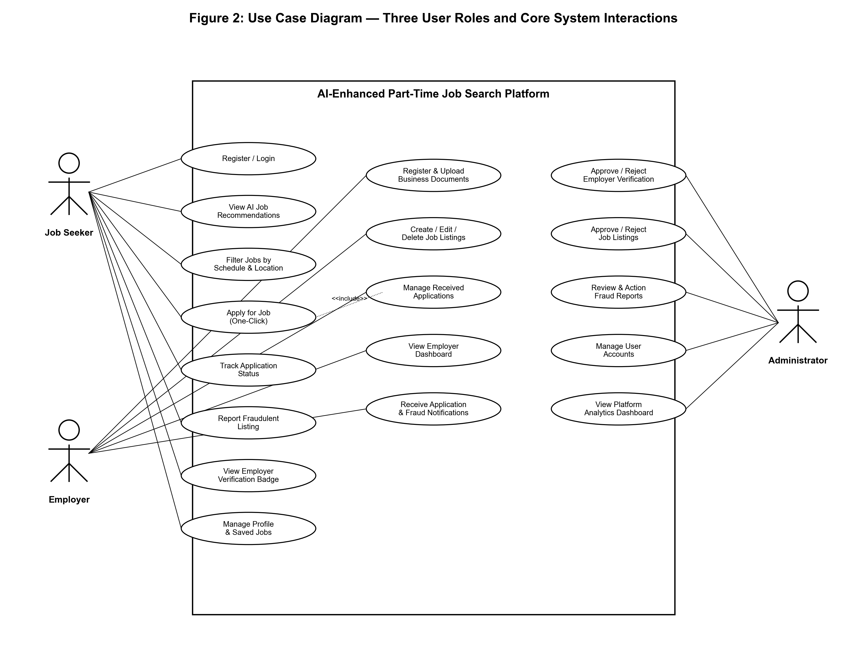
Figure 1
Use Case Diagram - Three User Roles (Job Seeker, Employer, Administrator) and Core System Interactions

2.2 Non-Functional Requirements
Non-functional requirements (NFRs) define the quality attributes the system must exhibit to be effective, trustworthy, and sustainable.
Table 4
Non-Functional Requirements
Category | Requirement | Acceptance Criterion
Performance | System page load time must not exceed 3 seconds under normal network conditions | Measured via Chrome DevTools Lighthouse score ≥ 85
Security | All user data stored with AES-256 encryption; Django's built-in CSRF, XSS, and SQL injection protections enabled | No critical vulnerabilities in OWASP Top 10 test
Usability | Interface navigable by a first-time user within 5 minutes without training; bilingual English/Nepali support | UAT task completion rate ≥ 85%
Reliability | System uptime of 99% during development testing phase on localhost | Zero critical system crashes during UAT
Scalability | Database and API architecture designed to support up to 10,000 concurrent users without structural re-engineering | Django ORM with MySQL connection pooling
Accessibility | Mobile-responsive layout functions correctly on screens from 360px width upward | Tested on Chrome mobile emulation and physical devices
Maintainability | All code documented with inline comments; Django admin interface for content management without code access | Code review by supervisor; admin interface functional
Data Privacy | User personal data collected only as required; no third-party data sharing without consent | Privacy policy displayed; GDPR-aligned data handling

3. TECHNICAL SPECIFICATIONS

3.1 Technology Stack
The technology stack was chosen systematically by comparing the different technology alternatives in the Technical Research part of the Investigation Report (Yugina Gurung, 2026). All selections made have been adequately argued from the functional requirements, the development environment and literature sources.

3.1.1 Front-End: React with Bootstrap
To support three different user interfaces (Job Seeker, Employer, Administrator), the front-end framework is chosen to be React 18+ because of the component-based architecture that allows for a modular, reusable UI development. React's virtual DOM guarantees performance for dynamic content like real-time recommendation feeds and notification updates. Using Bootstrap 5, the web designer creates a responsive CSS grid system that will enable business to offer a mobile-first interface for Nepal's key user base, who use primarily mobile devices (Nepal Telecommunications Authority, 2023).

3.1.2 Back-End: Python with Django
The back end is chosen to be Python 3.11+ with Django 4.2+ because Django's batteries-including philosophy includes all of the following: user authentication out of the box, an ORM to interact with MySQL and its features, a full admin interface for managing the platform, CSRF/XSS/SQL injection protections built into Django. Django REST Framework (DRF) is used to build RESTful API's that are used by the front-end (React). The AI recommendation engine implementation is made possible by Python's Scikit-learn library.

3.1.3 Database: MySQL 8.0
The relational database management system is chosen as MySQL 8.0. The data model for the system extends into user profiles, employer profiles, job postings, applications, fraud reports, and even recommendations – all of which is naturally relational, and requires full ACID compliance, referential integrity, and UTF-8 (Nepali) Unicode support. MySQL's native Django ORM integration eliminates the need for custom database connection code.

3.1.4 AI Recommendation Engine
The recommendation engine follows a hybrid strategy: It first uses content based filtering (content matching user profile attributes - skills, availability, location - to job listing attributes using TF-IDF vectorization and cosine similarity method from scikit-learn) and later collaborative filtering, once some user interaction data is available. This is a step-by-step process directly addressing the cold-start problem pointed out by Ekstrand et al. (2011) at new platforms.
Table 5
Technology Stack Summary
Layer | Technology | Version | Justification
Front-End Framework | React | 18+ | Component-based; virtual DOM; largest ecosystem
CSS Framework | Bootstrap | 5 | Mobile-responsive grid; pre-built UI components
Back-End Framework | Django (Python) | 4.2+ | Batteries-included; ORM; built-in security; admin panel
API Layer | Django REST Framework | 3.15+ | RESTful API for React-Django communication
Database | MySQL | 8.0 | Relational; ACID; full Unicode; Django ORM native support
AI/ML Library | Scikit-learn & Pandas | Latest stable | TF-IDF vectorisation; cosine similarity; recommendation logic
UI/UX Design | Figma | Latest | Industry-standard; component libraries; prototype sharing
Version Control | Git / GitHub | Latest | Code backup; version history; academic submission record
Project Management | Jira (Kanban) | Latest | Task tracking aligned with Agile Scrum methodology
IDE | Visual Studio Code | Latest | Multi-language; integrated terminal; Git panel; extensions
Browser/Testing | Google Chrome + DevTools | 120+ | Highest Nepal market share; responsive design testing

3.2 System Architecture
The proposed system features a three-layer architecture: (1) Presentation Layer with a front-end built using React and Bootstrap, displayed in the user's browser; (2) Application Layer, developed in Django to process the business logic, send API responses, and handle AI recommendation logic; and (3) Data Layer, implementing a MySQL database to store all persistent data. Only RESTful JSON APIs, implemented with Django REST Framework are used for communication between front-end and back-end.
The Administrator operates through the Django built-in admin panel (server-side rendered) rather than through the React front-end, providing a clear separation between platform management and end-user interactions. The AI recommendation engine runs as a Python module within the Django application layer, accessing user and job listing data through the Django ORM.
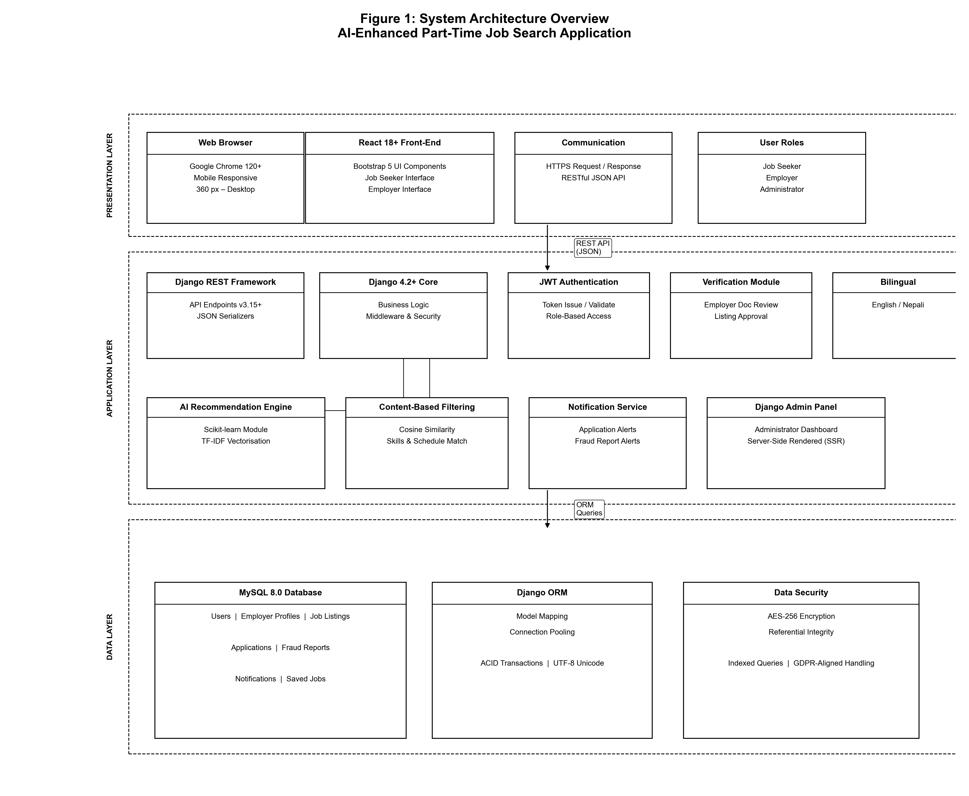
Figure 2
System Architecture Overview of AI-Enhanced Part-Time Job Search Application
Note. Three-tier architecture: React front-end → Django REST API → MySQL database, with AI recommendation engine embedded in the application layer.

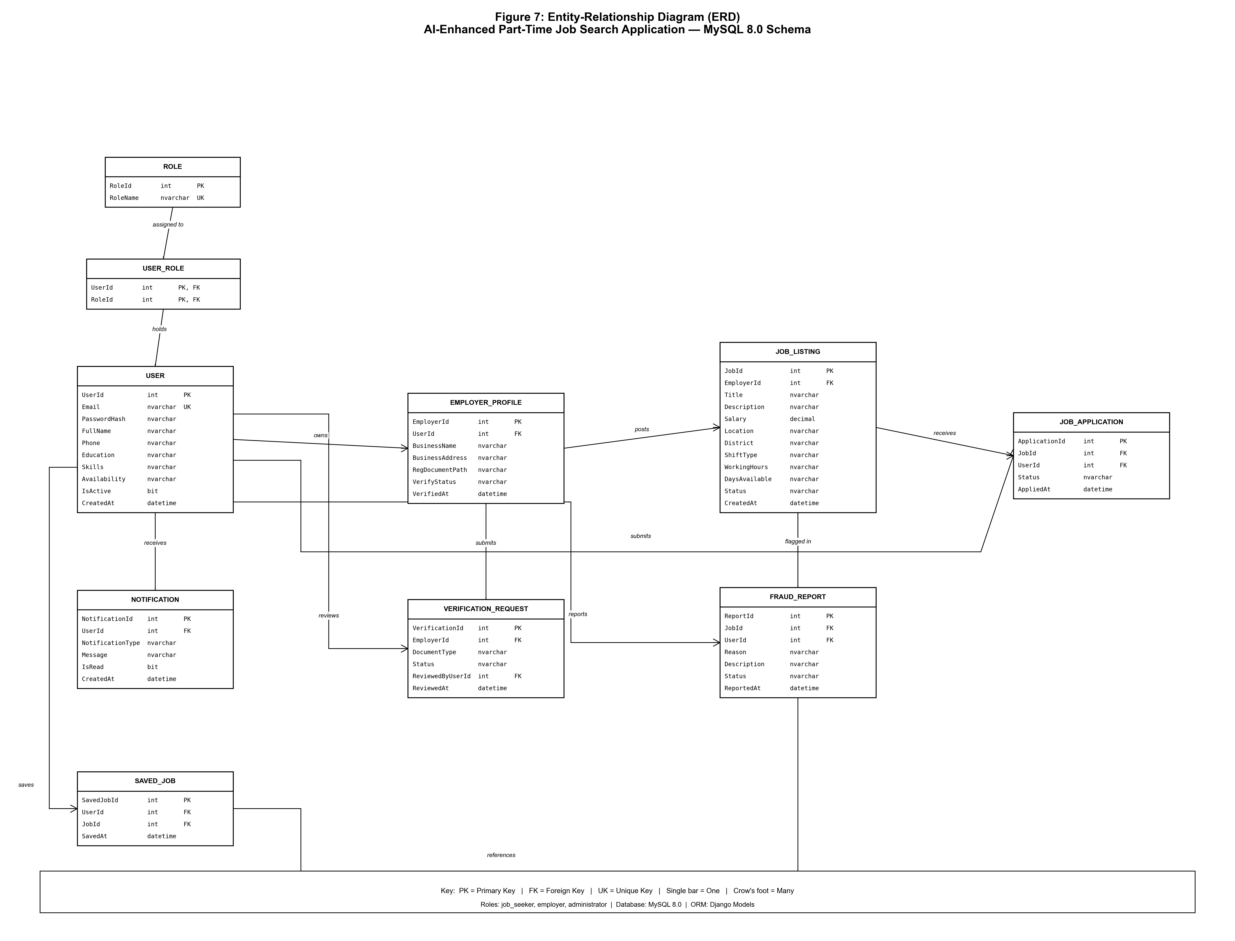
Figure 3
ERD of AI-Enhanced Part-Time Job Search Application

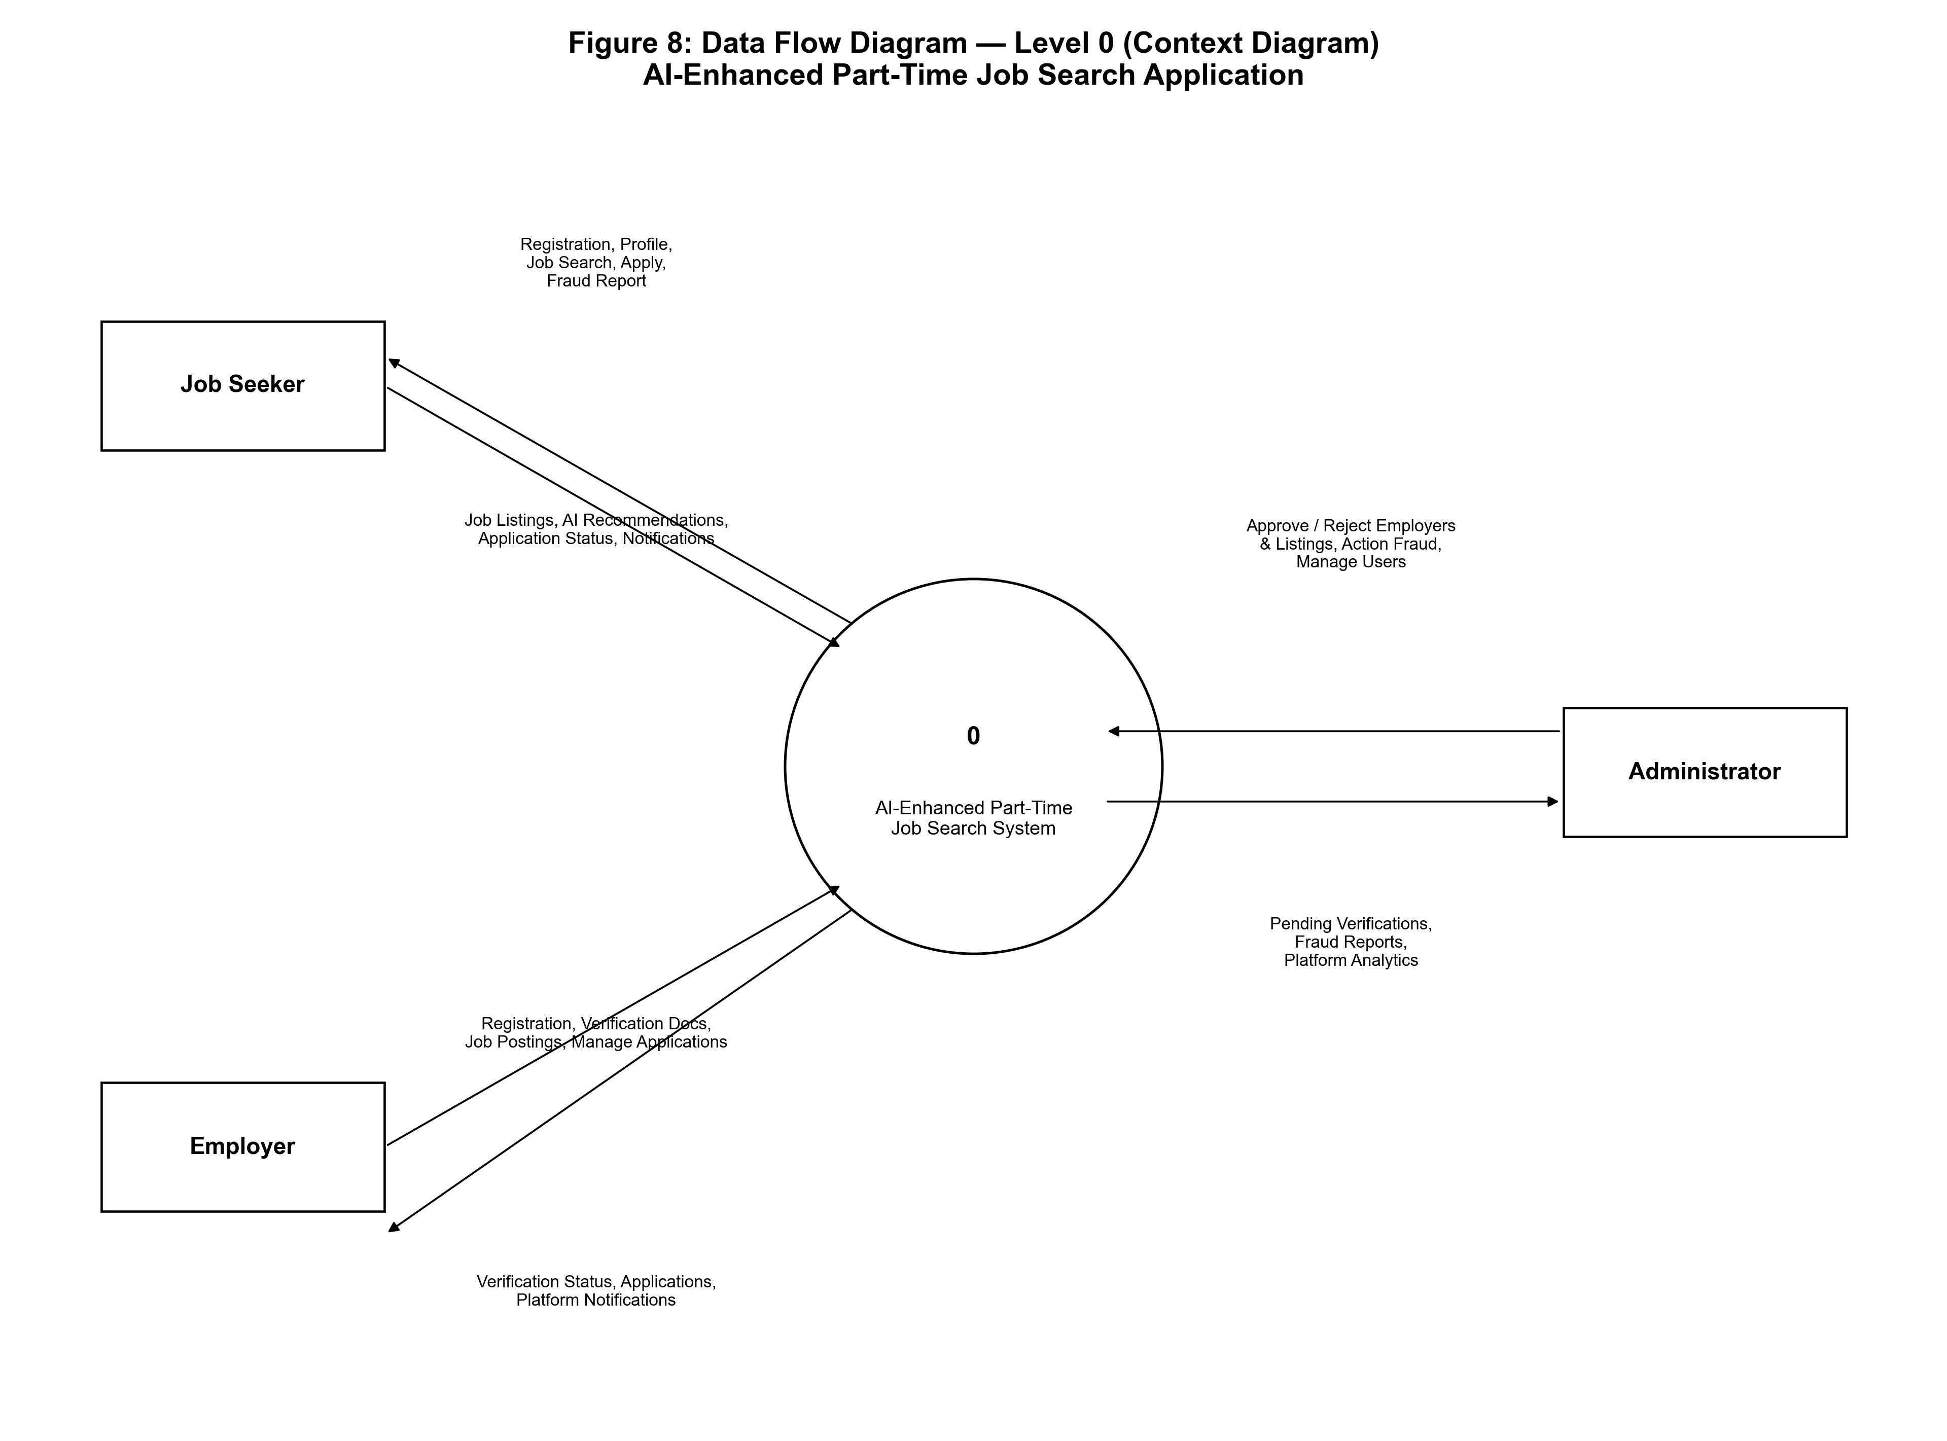
Figure 4
DFD of AI-Enhanced Part-Time Job Search Application

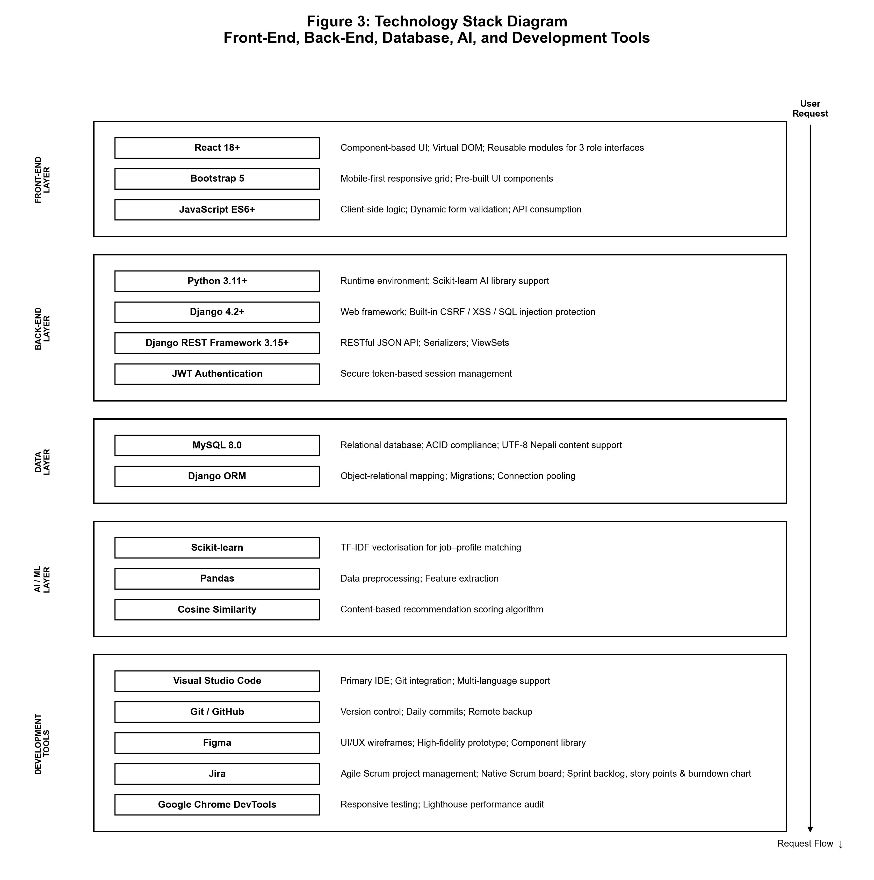
Figure 5
Technology Stack Diagram - Front-End, Back-End, Database, and AI Components

4. FEASIBILITY STUDY

4.1 Technical Feasibility
The project is technically feasible based on the following assessment:
Table 6
Hardware Requirements
Component | Minimum | Recommended
Processor | Intel Core i5 (8th Gen) / AMD Ryzen 5 | Intel Core i7 (10th Gen+) / AMD Ryzen 7
RAM | 8 GB DDR4 | 16 GB DDR4
Storage | 50 GB SSD | 100 GB SSD
Display | 13-inch, 1366×768 | 15-inch, 1920×1080 (Full HD)
Internet | 10 Mbps broadband | 25 Mbps+ broadband

Table 7
Software Requirements
Software | Version | Purpose
Node.js | 20.x LTS | React development server and npm package management
Python | 3.11+ | Django back-end runtime and Scikit-learning AI library
MySQL Server | 8.0+ | Local development database
Git | 2.40+ | Version control and GitHub integration
Visual Studio Code | Latest | Primary IDE for all development
Google Chrome | 120+ | Primary browser for testing and debugging
Figma | Latest (browser) | UI/UX design and prototype creation

All required technologies are open source or free to use, and the student developer has previously studied and implemented competency in the following technologies: React, Python/Django, MySQL. There are no software licensing restrictions.

4.2 Operational Feasibility
The system is feasible for the intended users in its functioning. The main survey confirmed that 84.6% of the respondents were comfortable in using digital platforms and 94% were ready to use digital part-time job platform dedicatedly (Yugina Gurung, 2026). The bilingual English/Nepali interface, simplified registration process and responsive mobile design all contribute to the solution of key usability challenges discovered in Nepal's digital adoption study (Poudel & Sapkota, 2022). The administrator verification process is simple and can be completed by one platform moderator via Django admin panel.

4.3 Economic Feasibility
The project is free of software licensing fees: all the technologies selected are open source, freely available. Students use their own computers for development. No cloud costs are incurred during the development and testing period, since the system is running on localhost. The project is resource-light, with the only cost being the time the student puts into the project. Costs would be estimated for future production deployment: AWS EC2 instance (approximately USD 10-20/month), AWS RDS MySQL instance (approximately USD 15-25/month), and domain registration (approximately USD 10-15/year) - which would provide the platform with a low operational cost for a not-for-profit or early-stage commercial model.

5. PLANNING & MANAGEMENT

5.1 Project Timeline / Milestones
The project is designed in the Agile Scrum method, consists of six sprints throughout the development phase and is preceded by the Investigation Report phase. The Agile Scrum framework was chosen over Waterfall because of its flexibility in responding to changing requirements, delivery sprinted in a structured manner and its correlation with academic milestones.

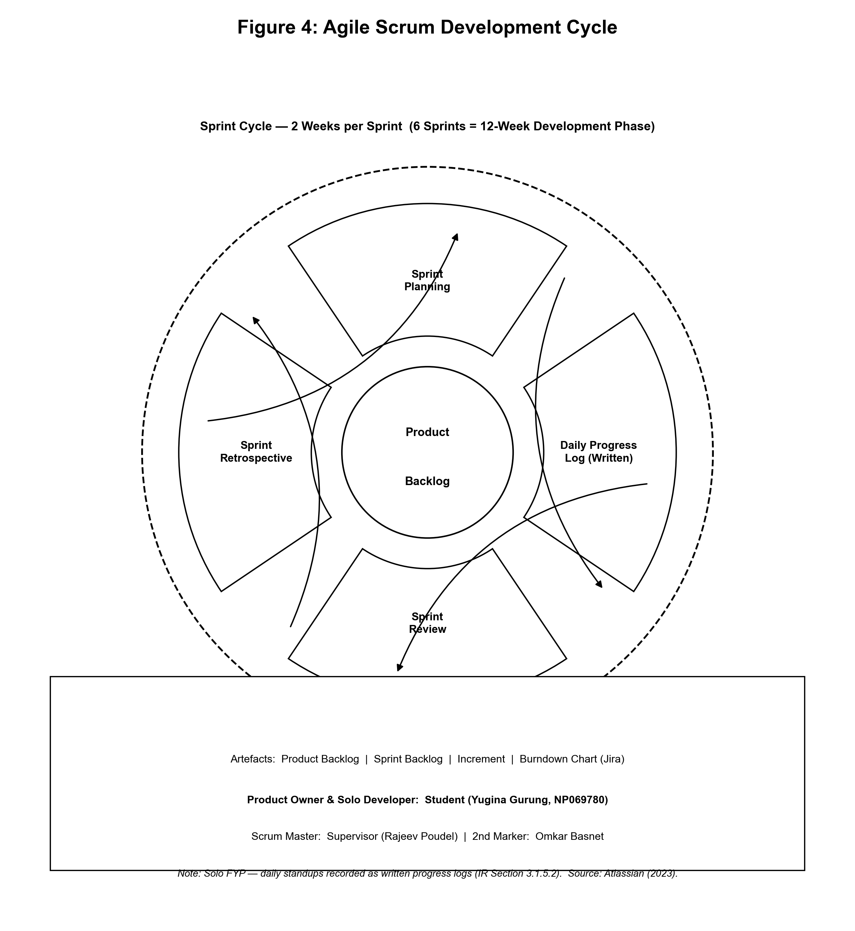

Figure 6
Agile Scrum Development Cycle
Note. Adapted from Atlassian (2023). The cycle shows Sprint Planning → Daily Standup → Sprint Review → Sprint Retrospective repeated for each development sprint.
Table 8
Project Milestones and Timeline
Milestone | Description | Target Date | Status
M1 - PPF Approved | Project Proposal Form submitted and approved; project title and scope confirmed | 01 Mar 2026 | Done
M2 - IR Complete | Complete Investigation Report submitted including literature review, survey analysis, and system design | 11 May 2026 | Done
M3 - Design Complete | System architecture, ERD, and Figma UI prototype finalised and supervisor-reviewed | Week 1-2 of Dev Phase | Planned
M4 - Sprint 1 Complete | Core Django models, MySQL schema, user authentication (JWT), and basic React layout | Week 3-4 | Planned
M5 - Sprint 2 Complete | Job listing CRUD, employer verification workflow, administrator dashboard functional | Week 5-6 | Planned
M6 - Sprint 3 Complete | AI recommendation engine integrated; schedule-based filtering implemented | Week 7-8 | Planned
M7 - Sprint 4 Complete | Fraud reporting mechanism, notification system, and bilingual interface complete | Week 9-10 | Planned
M8 - Testing Complete | Unit, integration, and UAT testing complete; bugs fixed; performance optimised | Week 11-12 | Planned
M9 - FYP Submitted | Complete Final Year Project submitted on Moodle | 12 May 2026 | Planned

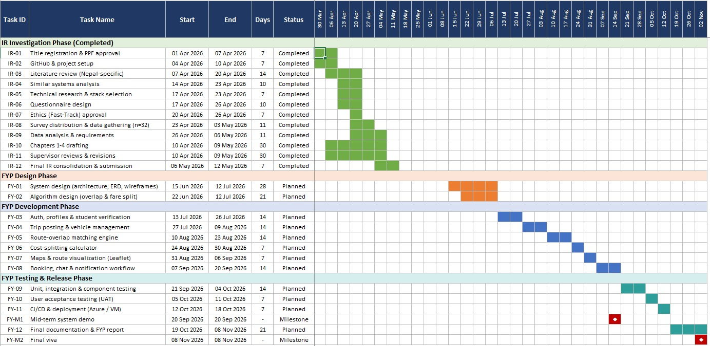
Figure 7
Gantt Chart

5.2 Risk Assessment
The following risk assessment identifies potential threats to project delivery and documents mitigation strategies for each.
Table 9
Risk Assessment Matrix
Risk | Category | Probability | Impact | Mitigation Strategy
Cold-start problem limits AI recommendation accuracy in early platform phase | Technical | High | Medium | Implement content-based filtering first; add collaborative filtering incrementally as data grows (Ekstrand et al., 2011)
Scope creep - adding features beyond planned scope during development | Management | Medium | High | Strict Agile Scrum backlog management; features not in Sprint Backlog deferred to future sprints
Data loss during development | Technical | Low | High | Daily Git commits to GitHub remote repository; weekly local backups
Insufficient survey respondents for validation | Research | Low | Medium | Targeted recruitment through university networks; minimum 30 respondents achieved (67 actual)
Learning curve for new technical tools (Scikit-learn AI) | Technical | Medium | Medium | Early prototyping of AI module in Sprint 1; leverage extensive Python documentation and community resources
Employer adoption slow - insufficient verified listings at launch | Operational | Medium | High | Manual seeking of initial employer listings; direct outreach to Kathmandu Valley businesses
Security vulnerabilities in authentication system | Security | Low | High | Use Django's battle-tested authentication framework; implement JWT tokens; conduct OWASP Top 10 review

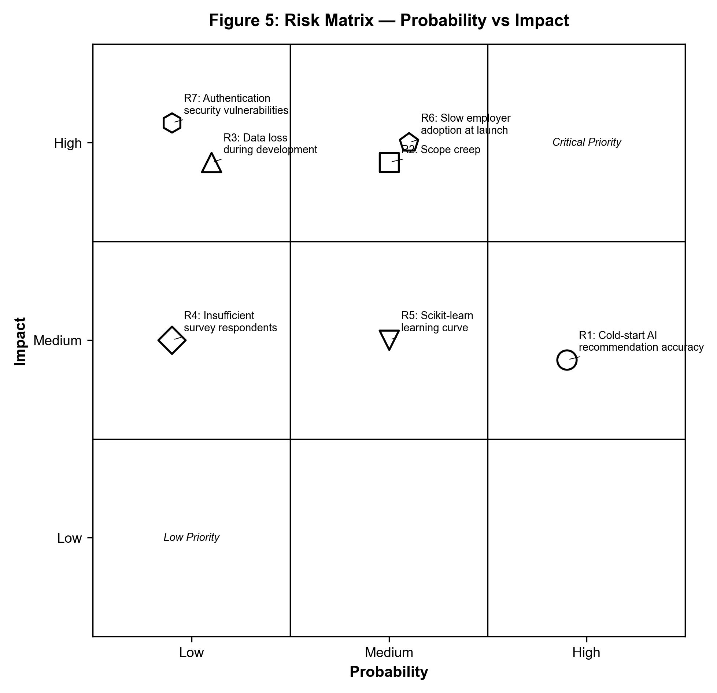
Figure 8
Risk Matrix - Probability vs Impact
Note. Risks plotted by probability (x-axis) and impact (y-axis). High-probability, high-impact risks receive primary mitigation focus.

6. VALIDATION & ACCEPTANCE

6.1 Testing Plan
The testing strategy follows a layered approach, progressing from unit-level component validation through to full user acceptance testing with members of the target demographic.
Table 10
Testing Plan Overview
Testing Type | Description | Tools | Acceptance Criterion
Unit Testing | Individual functions and Django model methods tested in isolation to verify correct behaviour | Django TestCase, pytest | All unit tests pass with 0 failures; 80%+ code coverage
Integration Testing | API endpoints tested end-to-end from React front-end request to MySQL database response and back | Postman, Django test client | All API endpoints return correct status codes and JSON payloads
System Testing | Complete user flows tested end-to-end for all three user roles (Job Seeker, Employer, Administrator) | Chrome DevTools, manual testing | All documented user stories completable without errors
Security Testing | Authentication, authorisation, CSRF protection, and SQL injection prevention verified | OWASP ZAP, manual checks | No critical OWASP Top 10 vulnerabilities identified
Performance Testing | Page load times and API response times measured under simulated load | Chrome Lighthouse | Lighthouse performance score ≥ 85; API response < 500ms
User Acceptance Testing (UAT) | 5-10 target users (students and fresh graduates) complete defined task scenarios and provide structured feedback | Structured task sheets, SUS questionnaire | Task completion rate ≥ 85%; System Usability Scale score ≥ 70
Responsive Design Testing | Interface tested across mobile screen sizes (360px, 375px, 414px) and desktop breakpoints | Chrome DevTools device emulation | All layouts render correctly across all tested breakpoints

6.2 Expected Outcomes / Deliverables
Upon successful completion of the project, the following deliverables will be produced and submitted:
- Investigation Report (IR) - A detailed academic report on the background of the problem, domain research, similar systems analysis, technical research, primary survey data collection and analysis, system development methodology justification, and research conclusions. Status: Complete.
- Project Specification Form (SPF) - This document contains the complete system specification including functional and non-functional requirements, technical architecture, feasibility analysis, project plan, risk assessment and testing plan.
- System Design Documentation - Entity-Relationship Diagram (ERD), Data Flow Diagrams (Level 0 and Level 1), complete Figma UI/UX prototype of all screens for all three user roles and API endpoint specification document.
- Made a fully functional Web App on localhost with React + Bootstrap front-end for all three user roles; Django + DRF back-end that has a fully functional RESTful API; a fully migrated schema in the MySQL database; an AI recommendation engine using Scikit-learn content-based filtering; employer verification system; system for fraud reporting; English/Nepali bilingual interface.
- Testing Report - Test report detailing the outcome of unit testing, integration testing, system testing, security testing, performance testing and UAT detailing test cases, the outcome of tests, bugs identified and documentation of bug fixes.
- Log Sheet - An ongoing record of all project activities, supervisor meetings and development progress kept throughout the project life cycle.

7. REFERENCES
Atlassian. (2023). What is agile project management? Retrieved from
https://www.atlassian.com/agile/project-management
Dahal, R. K., & Joshi, S. P. (2024). The application of e-recruitment by job seekers and the impact of perceived values in Nepal. Journal of Management and Development Economics, 1(1), 108–125. https://doi.org/10.33168/JMCDE.2024.0108
Ekstrand, M. D., Riedl, J. T., & Konstan, J. A. (2011). Collaborative filtering recommender systems. Foundations and Trends in Human–Computer Interaction, 4(2), 81–173. https://doi.org/10.1561/1100000009
Felfernig, A., Wundara, M., Tran, T. N. T., Le, V.-M., Lubos, S., & Polat-Erdeniz, S. (2023). Recommender systems: An overview of approaches and applications. AI & Society, 38, 611–625. https://doi.org/10.1007/s00146-021-01316-w
Ghimire, B., Upadhyay, J., Joshi, S. P., Subedi, S., & Karki, P. (2024). Analyzing the cognitive approach of Nepali youth job seekers towards online recruitment. The Harvest, 3(1), 1–20. https://doi.org/10.3126/harvest.v3i1.64173
International Labour Organization. (2023). Global employment trends for youth 2023: Investing in transforming futures for young people. ILO. https://www.ilo.org/publications/global-employment-trends-youth-2023
Khanal, B. (2022). A study of part-time worker students at the postgraduate level. Bouddhik Abhiyan Journal, 7, 1–10. https://doi.org/10.3126/bdkan.v7i1.47528
Kuhn, P., & Mansour, H. (2014). Is internet job search still ineffective? The Economic Journal, 124(581), 1213–1233. https://doi.org/10.1111/ecoj.12119
MeroJob. (2024). Jobs in Nepal. https://www.merojob.com
MySQL. (2019). MySQL 8.0 reference manual: What is MySQL? Oracle. https://dev.mysql.com/doc/refman/8.0/en/what-is-mysql.html
Nepal Police Cyber Bureau. (2021). Cybercrime awareness and prevention. https://cyberbureau.nepalpolice.gov.np
Nepal Telecommunications Authority. (2023). Management information system report. NTA. https://nta.gov.np/wp-content/uploads/2023/MIS_Report_2023.pdf
Neupane, S. (2024, August 27). Rising unemployment sparks surge in online job scams. Khabarhub. https://english.khabarhub.com/2024/27/389461/
Pavithra, B., & Keerthana, J. S. (2024). A study on awareness of online employment scam. EPRA International Journal of Multidisciplinary Research, 10(4), 72-75. https://doi.org/10.36713/epra16363
Poudel, R., & Sapkota, A. (2022). Factors influencing the adoption of digital platforms in Nepal. Journal of Business and Management, 9(1), 14-27.
Ray, A. (2024, December 14). Fraudsters are exploiting Nepali job seekers. The Kathmandu Post. https://kathmandupost.com/national/2024/12/14/fraudsters-are-exploiting-nepali-job-seekers
Shrivastav, P., Shrivastav, N., & Ranja, P. (2025). A study of role of online platforms in modern recruitment process. Journal of Informatics Education and Research, 5(1). https://doi.org/10.52783/jier.v5i1.2119
Venkatesh, V., Morris, M. G., Davis, G. B., & Davis, F. D. (2003). User acceptance of information technology: Toward a unified view. MIS Quarterly, 27(3), 425–478. https://doi.org/10.2307/30036540
World Bank. (2022). Nepal economic update: Employment and labour market. World Bank Group. https://www.worldbank.org/en/country/nepal/publication/nepal-economic-update
Yugina Gurung. (2026). AI-enhanced part-time job search application for students and entry-level job seekers in Nepal [Investigation Report]. Asia Pacific University of Technology and Innovation.

