- Perform basic Image Handling and processing operations on the image.

- Read an image in python and convert the given Image into Grayscale
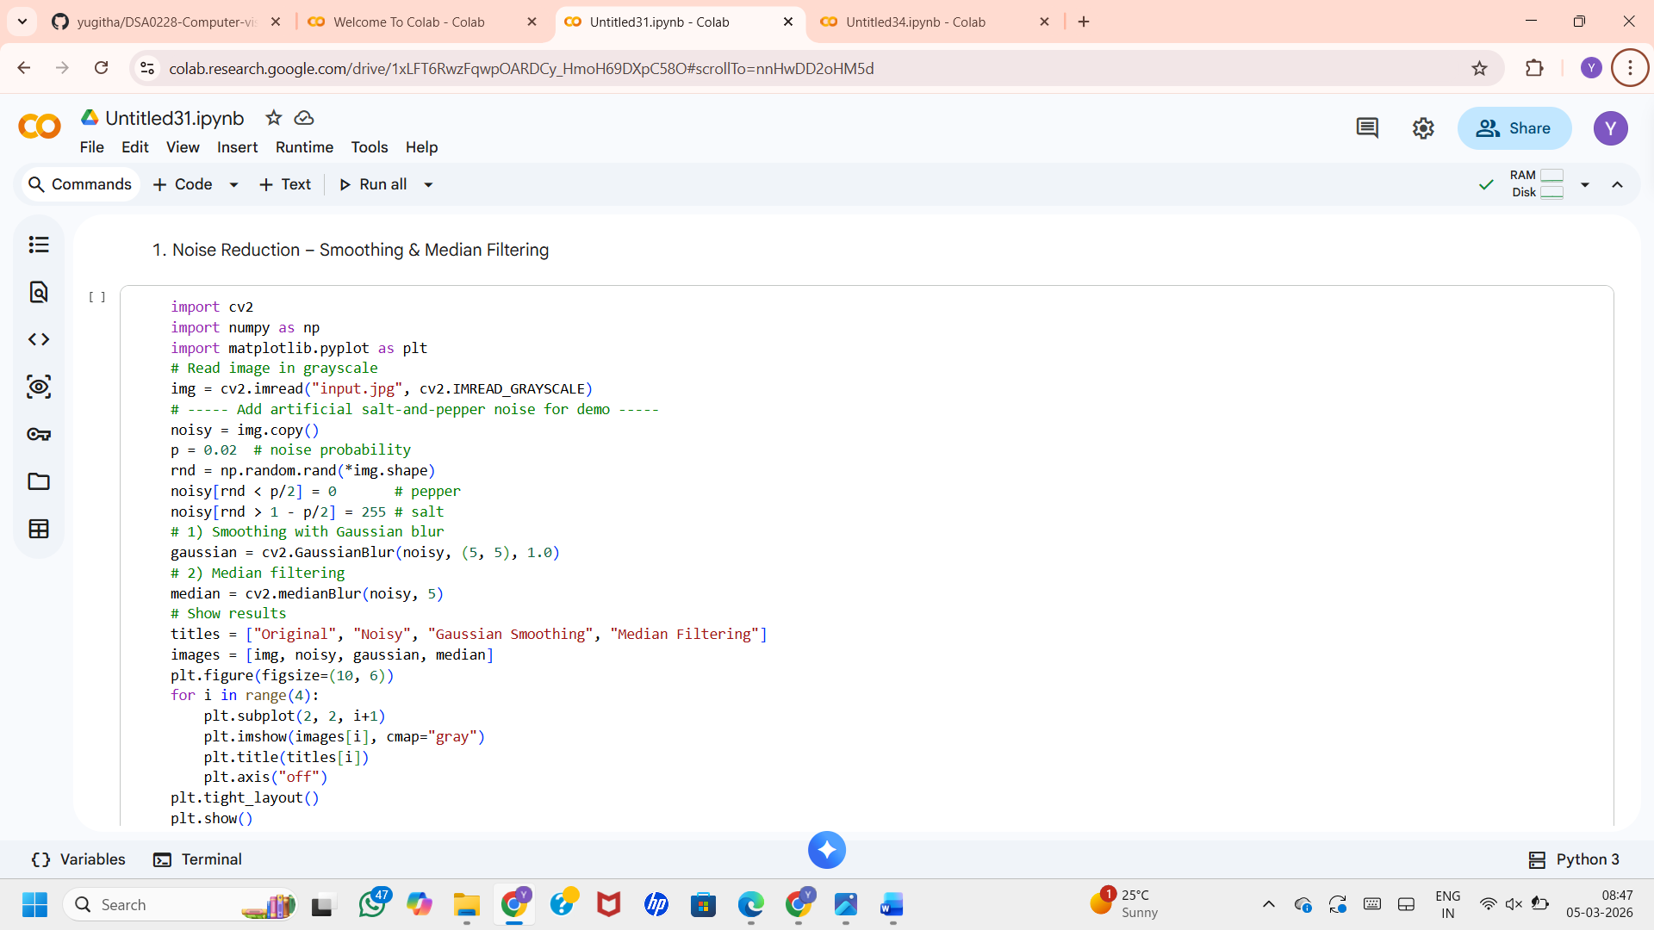

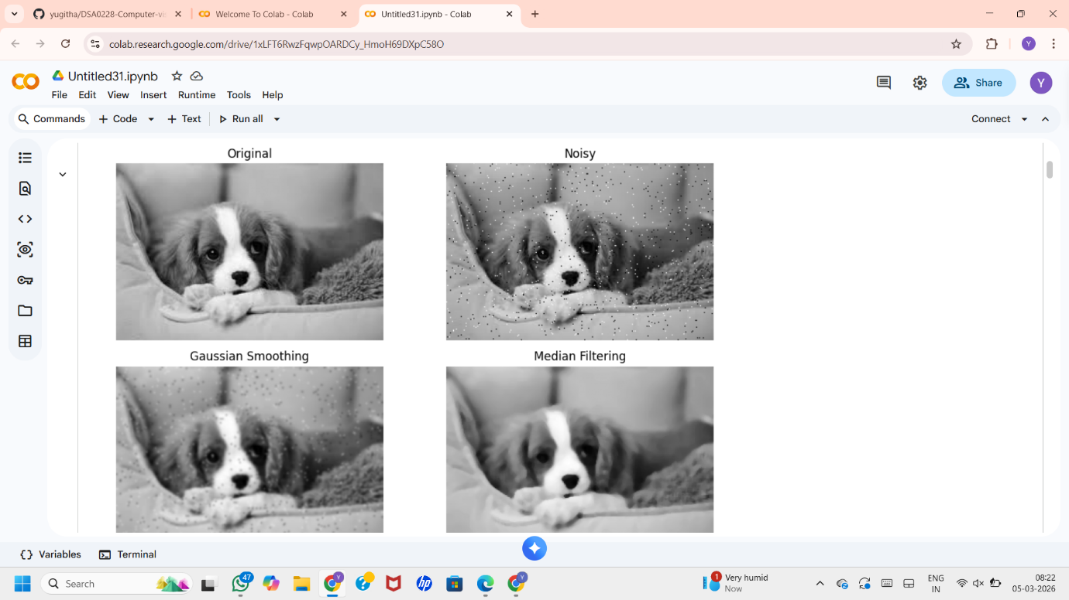
Output

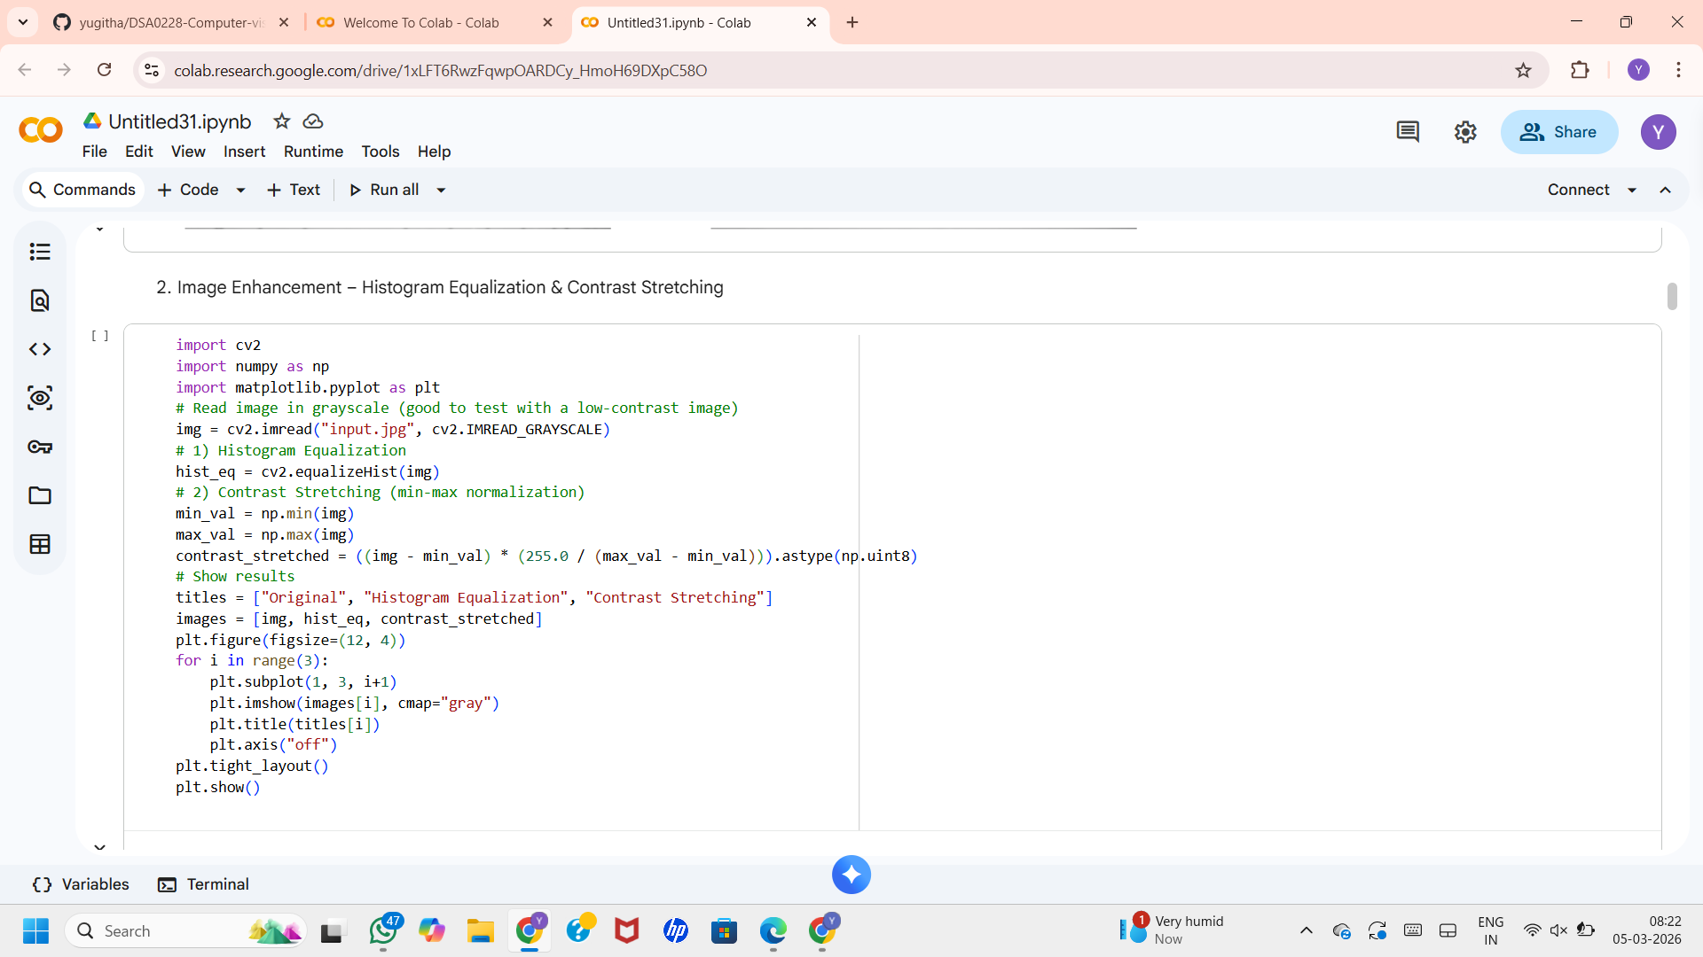
b. Read an image in python and Convert an Image to Blur using Gaussian Blur
Output
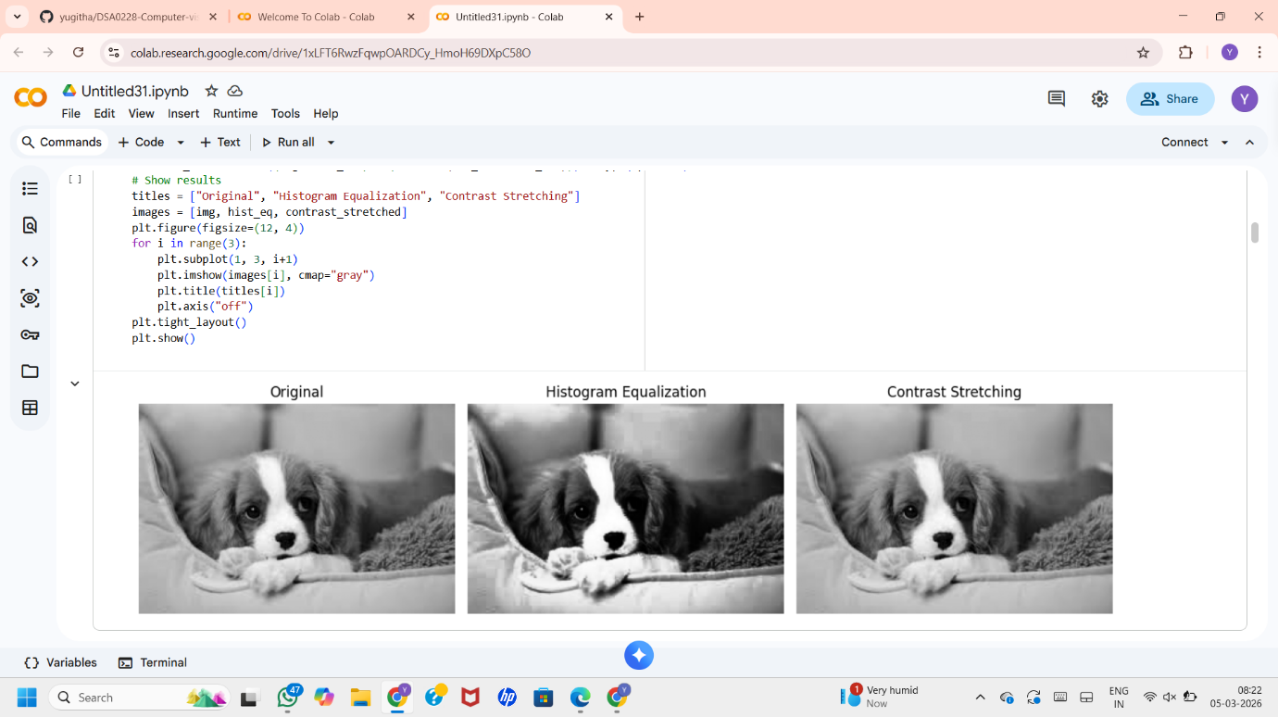

c. Read an image in python and Convert the given Image to show outline using Canny
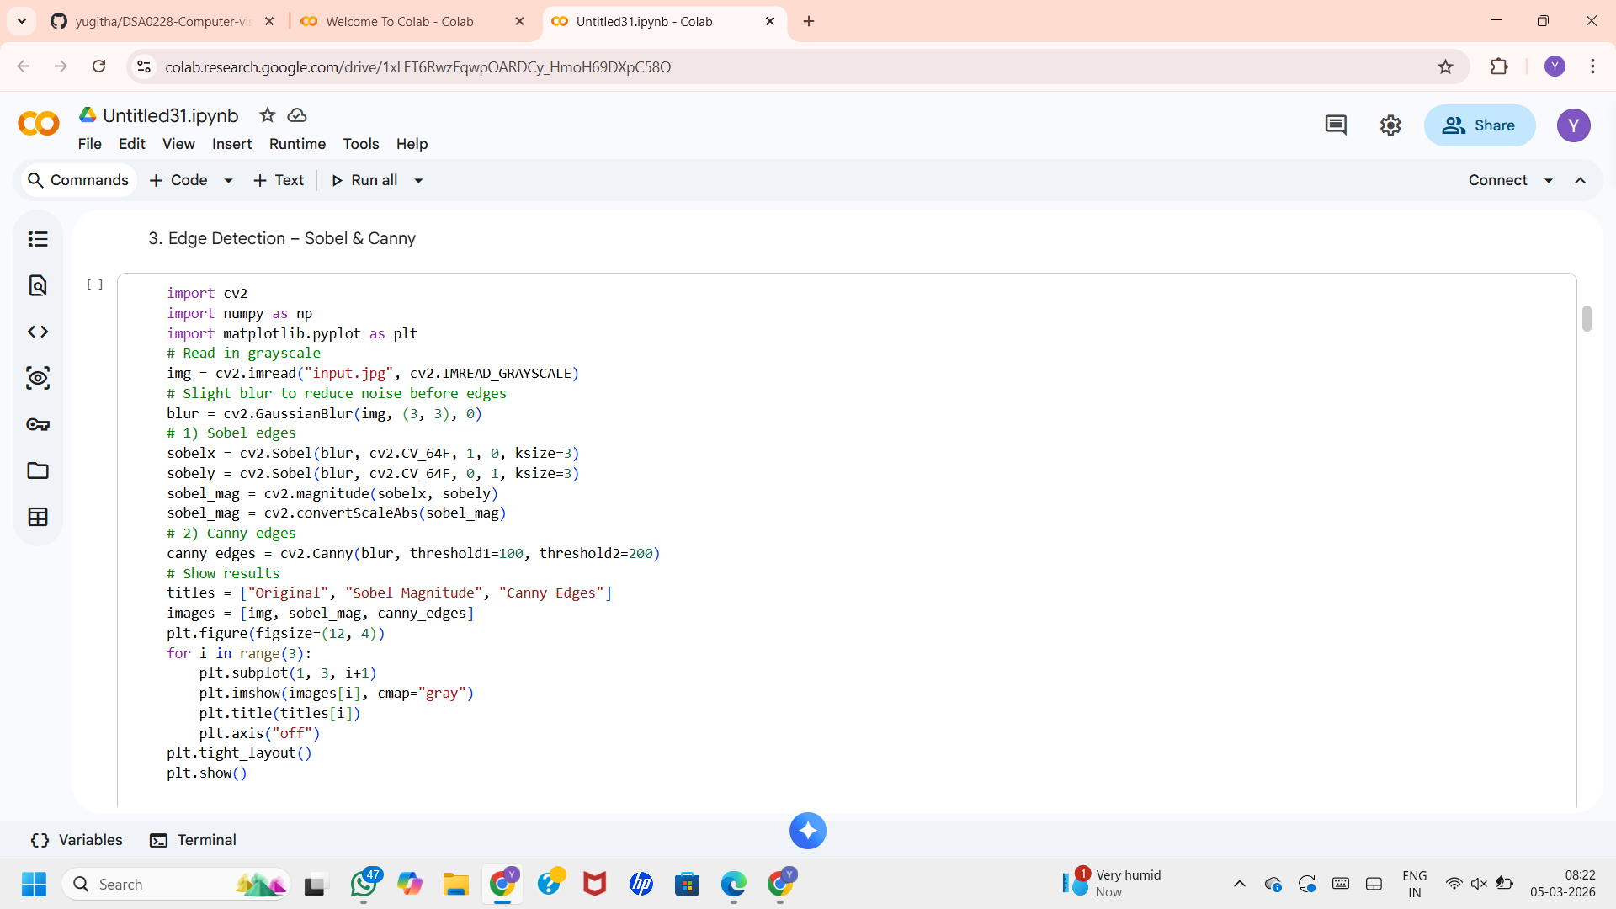
function.

Output
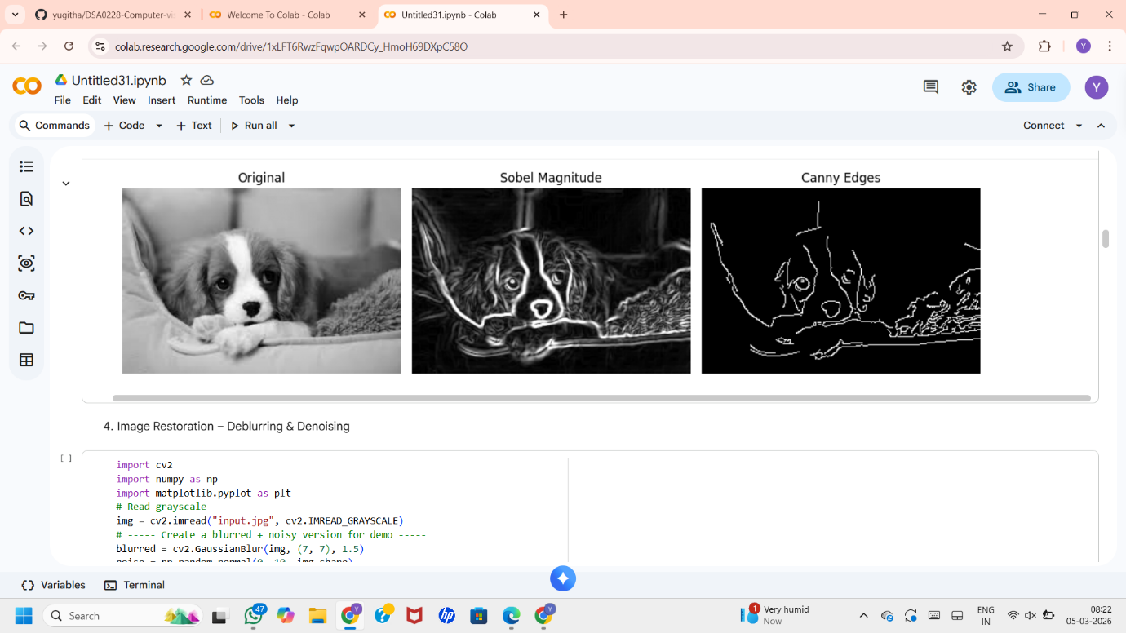

d. Read an image in python and Dilate an Image using Dilate function.
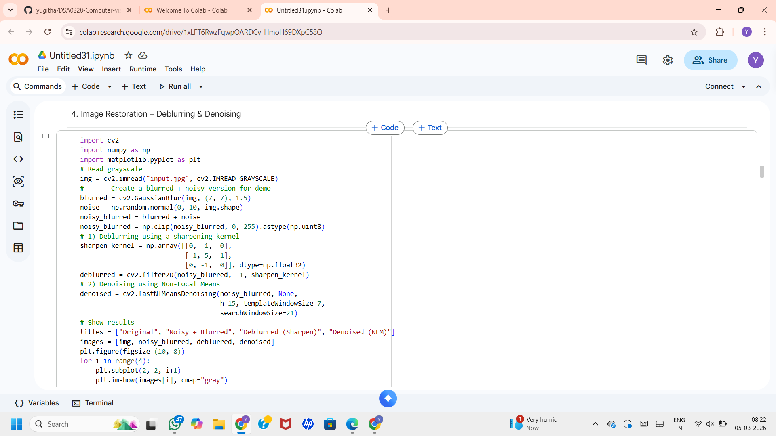
Output

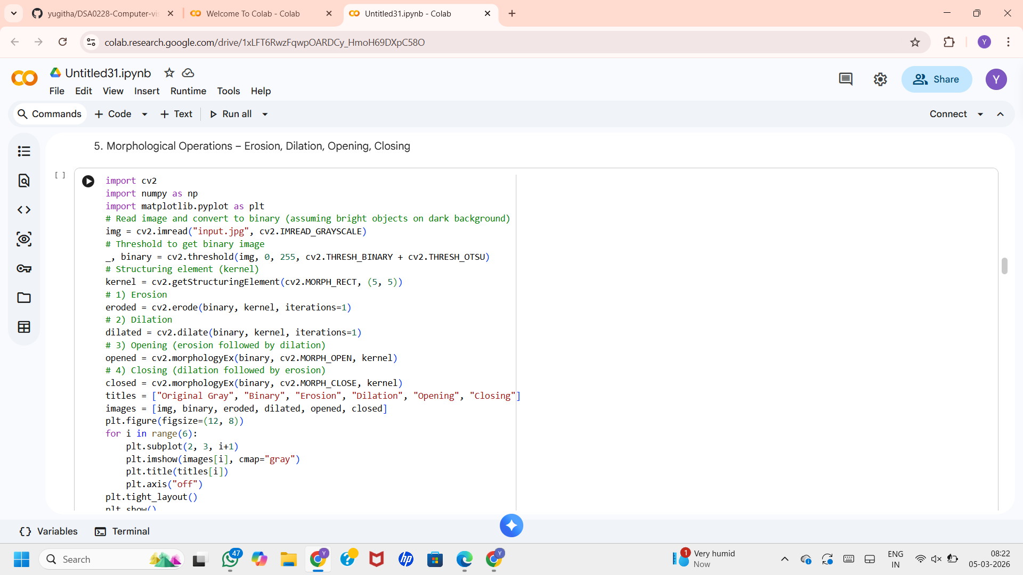
e. Read an image in python and Erode an Image using erode function.
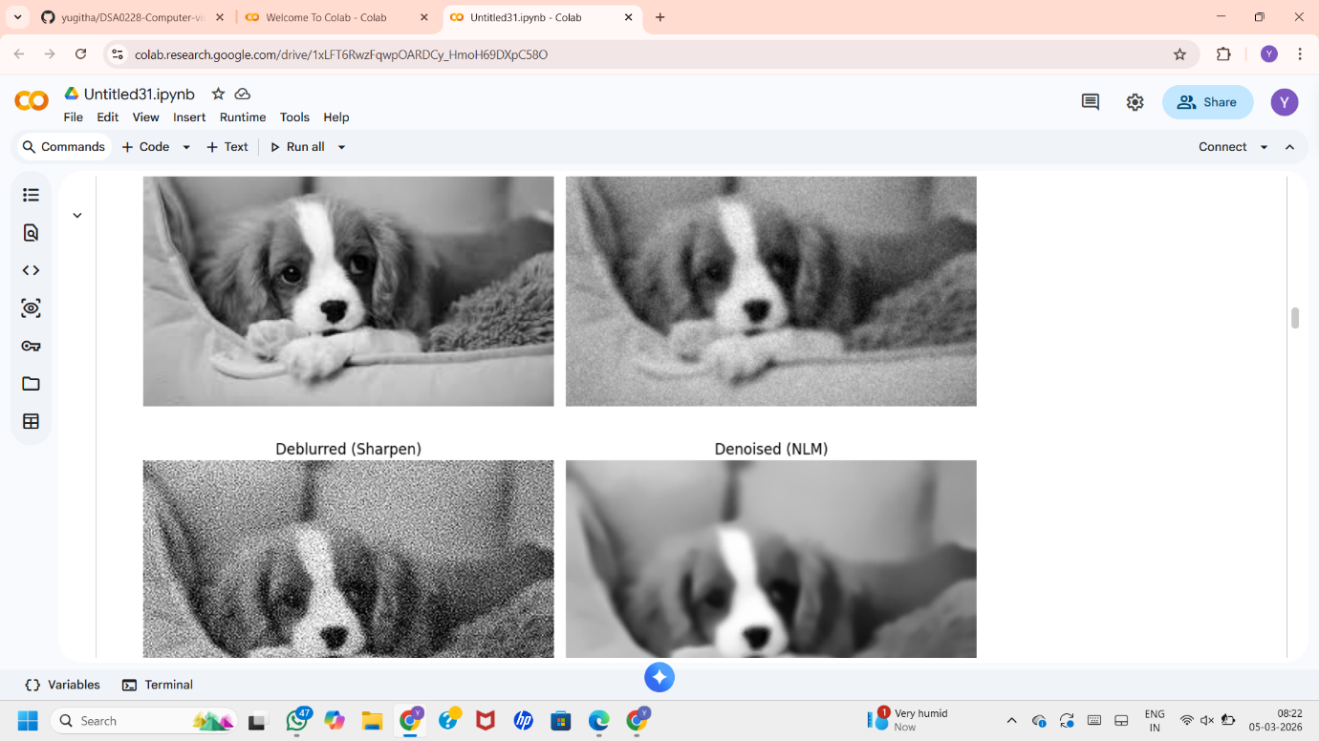

Output
