SIMATS ENGINEERING
ASSESSMENT TOOL III— Interactive Dashboard Project
Course: Data Handling and  Visualization | Code: DSA0603 | CO: CO5
Duration: 180 min | Total Marks: 100 | Reg No : 192424102  Name: YUGITHA B

COURSE OUTCOME COVERED
CO5: Analyze and evaluate visualization choices to communicate patterns, comparisons, relationships, and potential misleading effects through appropriate visualization methods, applied through the design of interactive dashboards. (BL4)
Activity Tool : Interactive Dashboard Project

Weightage: 20% Code of Conduct:
I YUGITHA B (192424102) (Name / Reg No) certify that this submission is my original work and that I have adhered to the guidelines specified for this assessment. I understand that any violation of academic integrity rules will result in disciplinary action.
Signature of the student: ________________________

Q1. Building a Sales Performance Dashboard
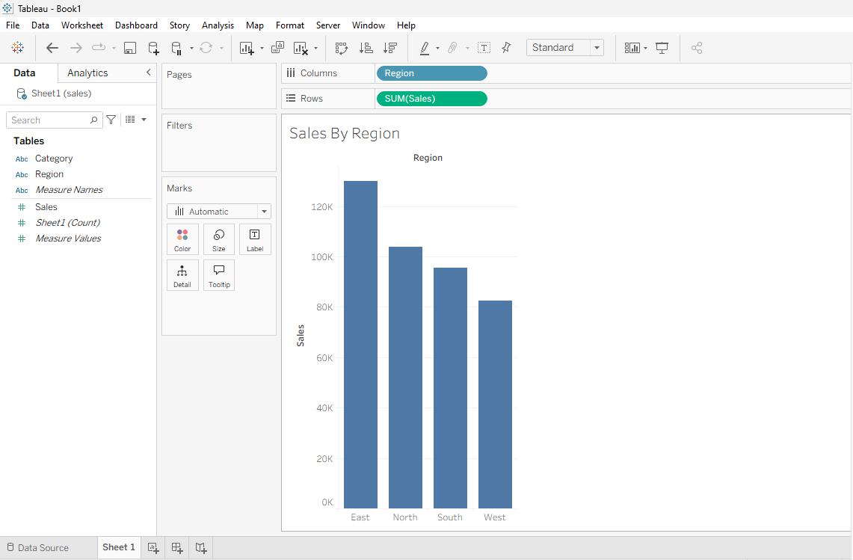

Q2. KPI Dashboard with Parameters

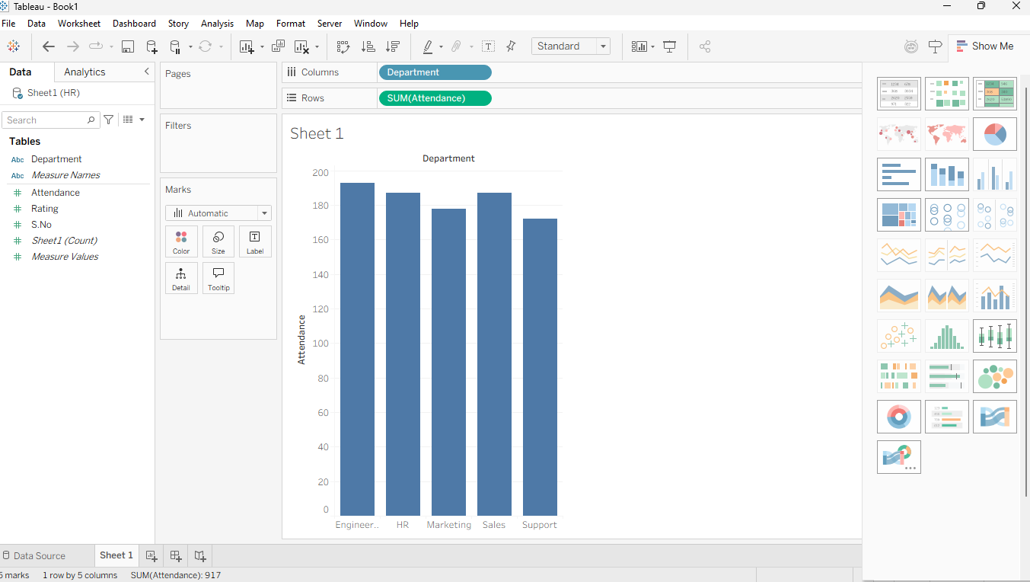
Q3. Drill-Down Dashboard with Dashboard Actions
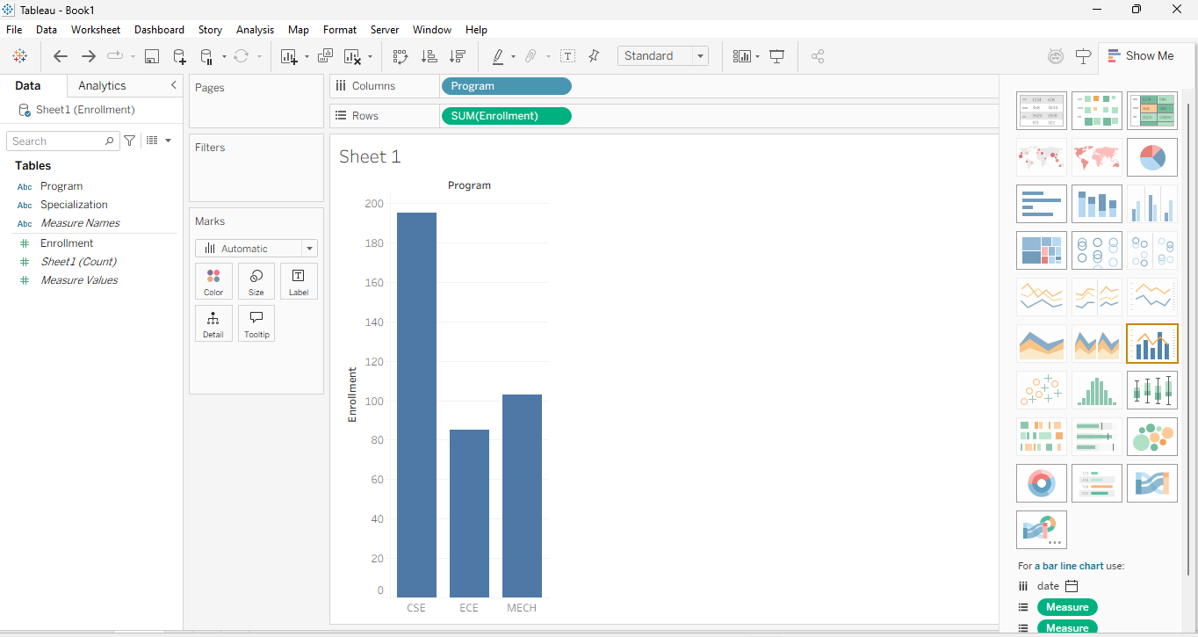

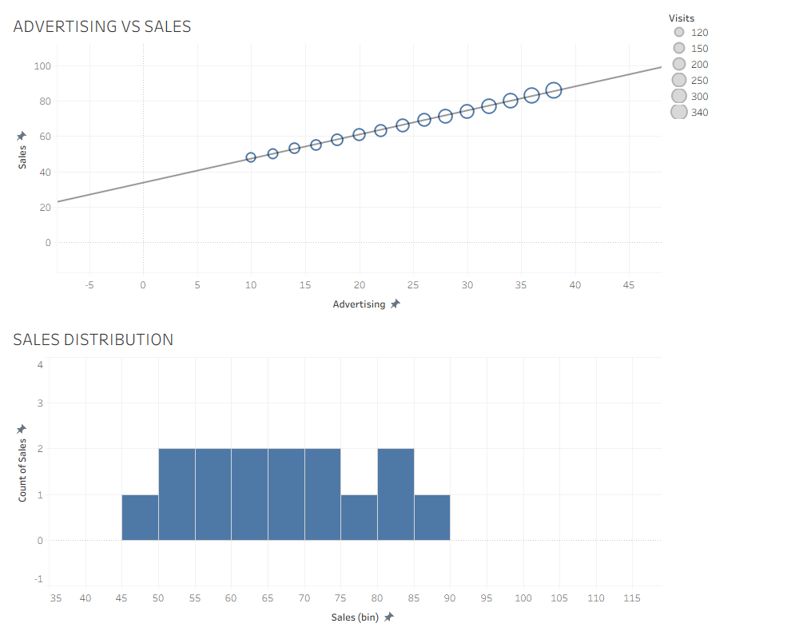
Q4. Multivariate Analysis Dashboard
Q5. Misleading Dashboard and Redesign

