Set 1: Monthly Sales Data
- Create a line chart to visualize the monthly sales. Label the axes and title the chart appropriately.
# Monthly Sales Data
month <- c("January", "February", "March", "April", "May")
sales <- c(15000, 18000, 22000, 20000, 23000)
# Line Chart
plot(sales,
type = "o",
xaxt = "n",
xlab = "Month",
ylab = "Sales ($)",
main = "Monthly Sales Trend")
axis(1, at = 1:5, labels = month)
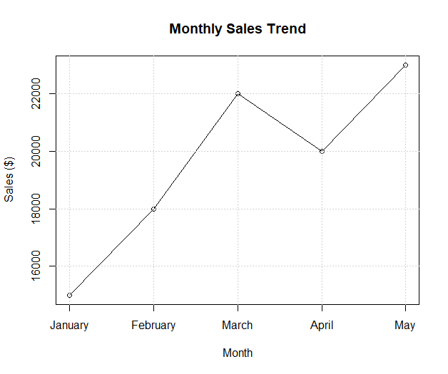
grid()

- Generate a bar chart to display the top-selling products for the year. Label the chart elements.
# Product Sales Data
products <- c("Product A", "Product B", "Product C", "Product D", "Product E")
product_sales <- c(350, 420, 280, 500, 390)

# Bar Chart
barplot(product_sales,
names.arg = products,
xlab = "Products",
ylab = "Units Sold",
main = "Top Selling Products",
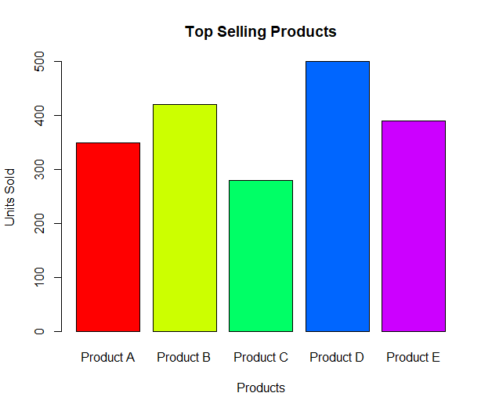
col = rainbow(5))

- Develop a scatter plot to explore the relationship between advertising budget and monthly sales. Explain the insights drawn from the scatter plot.
# Data
advertising <- c(2000, 2500, 3000, 2800, 3500)
sales <- c(15000, 18000, 22000, 20000, 23000)
# Scatter Plot
plot(advertising,
sales,
pch = 19,
col = "blue",
xlab = "Advertising Budget ($)",
ylab = "Monthly Sales ($)",
main = "Advertising Budget vs Monthly Sales")
# Regression Line
abline(lm(sales ~ advertising), col = "red", lwd = 2)
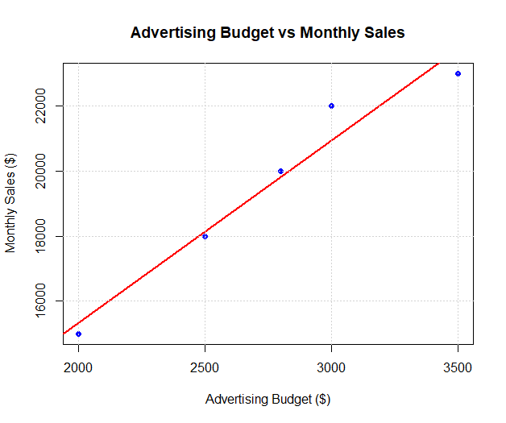
grid()

Set 2: Customer Feedback Analysis
- Create a histogram to represent the distribution of customer ages. Label the axes and title the chart.
# Customer Data
age <- c(25, 30, 35, 28, 40)
# Histogram
hist(age,
main = "Distribution of Customer Ages",
xlab = "Age",
ylab = "Frequency",
col = "lightblue",
border = "black")
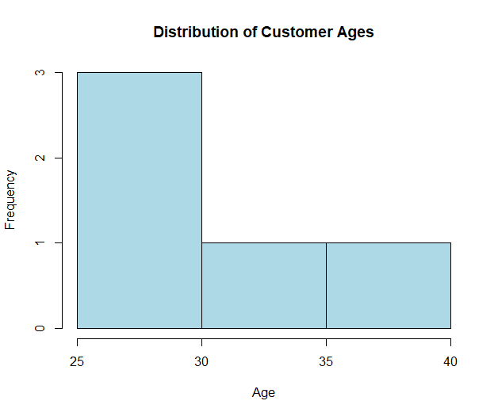

2. Generate a pie chart to display the overall distribution of customer satisfaction scores. Include labels.
# Satisfaction Scores
satisfaction <- c(4, 5, 3, 4, 5)
# Count each score
score_count <- table(satisfaction)
# Pie Chart
pie(score_count,
labels = paste(names(score_count),
"(", score_count, ")", sep = ""),
main = "Distribution of Customer Satisfaction Scores",
col = rainbow(length(score_count)))
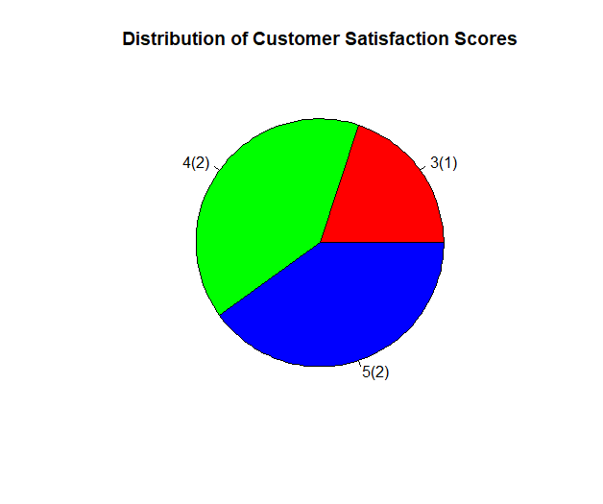

3.Build a stacked bar chart to visualize the distribution of customer satisfaction scores by age group.
# Customer Data
age <- c(25, 30, 35, 28, 40)
satisfaction <- c(4, 5, 3, 4, 5)
# Create Age Groups
age_group <- cut(age,
breaks = c(20, 30, 40, 50),
labels = c("21-30", "31-40", "41-50"),
include.lowest = TRUE)

# Frequency Table
data_table <- table(age_group, satisfaction)
# Stacked Bar Chart
barplot(data_table,
beside = FALSE,
col = c("skyblue", "orange", "green"),
legend = rownames(data_table),
main = "Customer Satisfaction by Age Group",
xlab = "Satisfaction Score",
ylab = "Number of Customers")

- Develop a word cloud from open-ended customer feedback to identify prevalent customer sentiments.
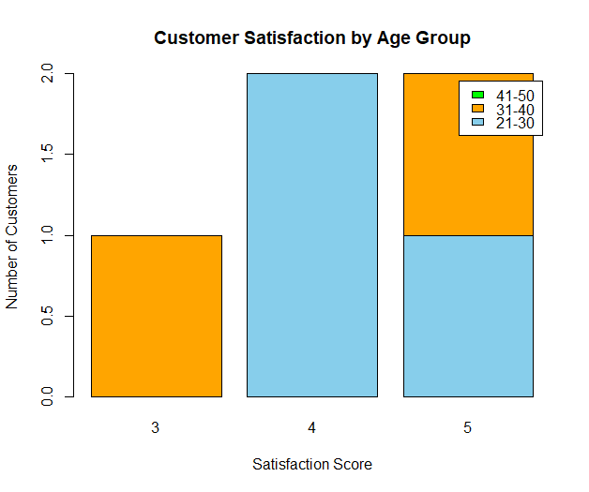

Set 3: Employee Performance Evaluation

- Create a line chart to visualize the performance trend of employees over time. Include a legend and labels.
# Employee Data
employee <- c(1, 2, 3, 4, 5)
performance <- c(85, 92, 78, 90, 76)

# Line Chart
plot(employee,
performance,
type = "o",
pch = 16,
col = "blue",
xlab = "Employee ID",
ylab = "Performance Score",
main = "Employee Performance Trend")
legend("topright",
legend = "Performance Score",
col = "blue",
lty = 1,
pch = 16)
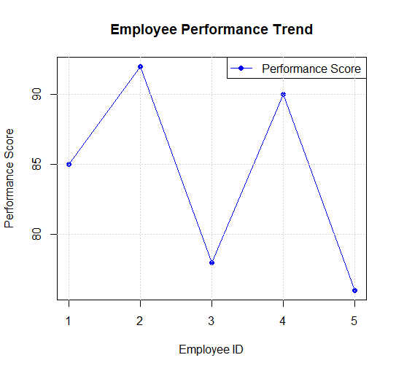
grid()

- Generate a bar chart showing the distribution of employees across different departments. Label the chart elements.
# Department Data
department <- c("Sales", "HR", "Marketing", "Sales", "HR")
# Count Employees
dept_count <- table(department)
# Bar Chart
barplot(dept_count,
col = rainbow(length(dept_count)),
main = "Distribution of Employees Across Departments",
xlab = "Department",
ylab = "Number of Employees")

- Build a scatter plot to analyze the correlation between years of service and performance scores. Explain any insights.
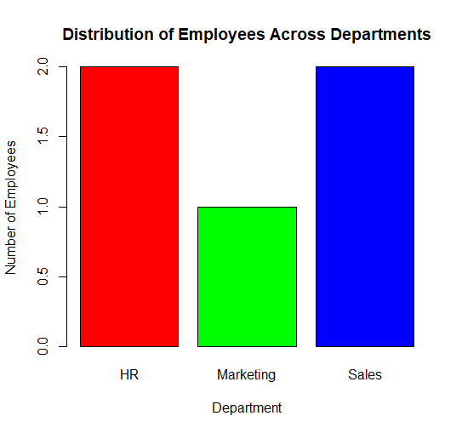
# Data
years_service <- c(5, 3, 7, 4, 2)
performance <- c(85, 92, 78, 90, 76)
# Scatter Plot
plot(years_service,
performance,
pch = 19,
col = "blue",
xlab = "Years of Service",
ylab = "Performance Score",
main = "Years of Service vs Performance Score")
# Regression Line
abline(lm(performance ~ years_service),
col = "red",
lwd = 2)
grid()
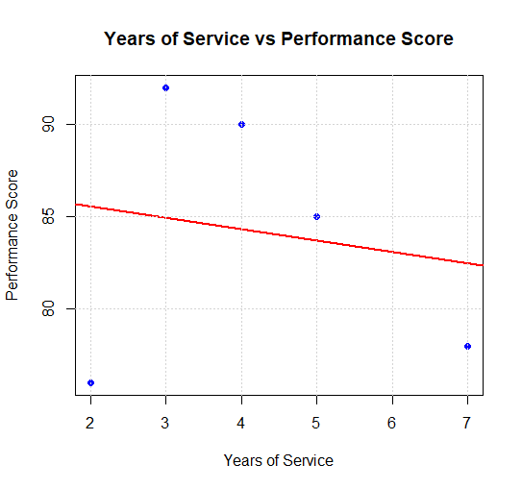

Set 4: Product Inventory Management
- Create a bar chart to visualize the quantity of each product in the inventory. Label the axes and title the chart.
# Product Data
product <- c("Product A", "Product B", "Product C", "Product D", "Product E")
quantity <- c(250, 175, 300, 200, 220)
# Bar Chart
barplot(quantity,
names.arg = product,
col = rainbow(5),
xlab = "Product Name",
ylab = "Quantity Available",
main = "Product Inventory Quantity")

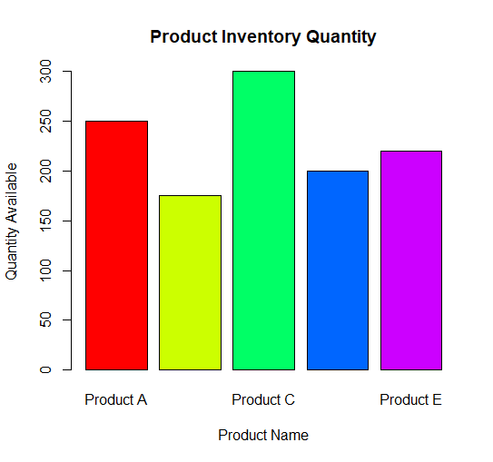

- Generate a stacked bar chart to show the quantity of each product within different product categories.
# Product Categories
category <- c("Electronics", "Electronics", "Furniture", "Furniture", "Accessories")
# Data Table
inventory <- data.frame(category, quantity)
# Create Table
inventory_table <- xtabs(quantity ~ category + product)
# Stacked Bar Chart
barplot(inventory_table,
beside = FALSE,
col = c("red", "blue"),
legend = rownames(inventory_table),
xlab = "Products",
ylab = "Quantity Available",
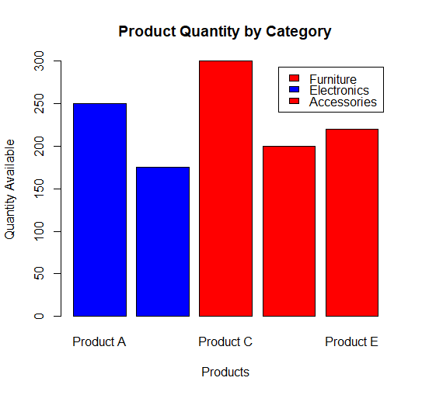
main = "Product Quantity by Category")

- Build a scatter plot to explore the relationship between product price and quantity available.Explain the findings.
# Data
price <- c(500, 750, 300, 650, 450)
quantity <- c(250, 175, 300, 200, 220)
# Scatter Plot
plot(price,
quantity,
pch = 19,
col = "blue",
xlab = "Product Price ($)",
ylab = "Quantity Available",
main = "Product Price vs Quantity Available")
# Regression Line
abline(lm(quantity ~ price),
col = "red",
lwd = 2)

grid()
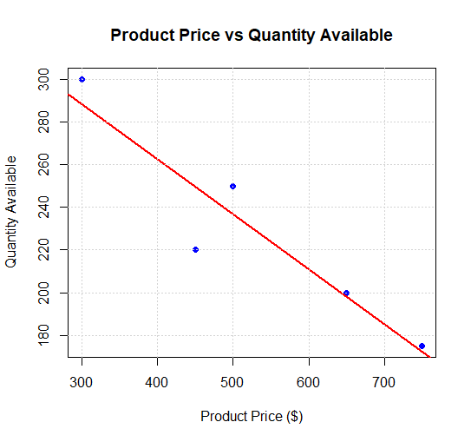

Set 5: Website Analytics
- Create a line chart to visualize the trend in daily page views over time. Label the axes and title the chart.
# Website Traffic Data
date <- as.Date(c("2023-01-01",
"2023-01-02",
"2023-01-03",
"2023-01-04",
"2023-01-05"))
page_views <- c(1500, 1600, 1400, 1650, 1800)
# Line Chart
plot(date,
page_views,
type = "o",
pch = 16,
col = "blue",
xlab = "Date",
ylab = "Page Views",
main = "Daily Website Page Views")

grid()
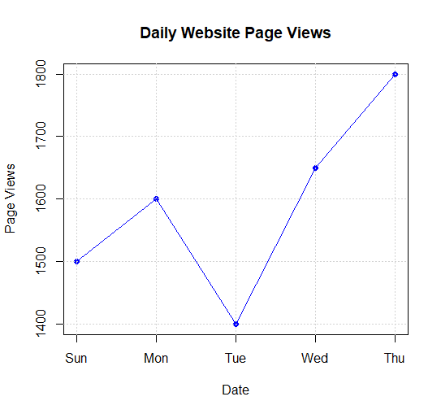

- Generate a bar chart showing the top N days with the highest click-through rates. Label the chart elements.
# Data
date <- c("2023-01-01",
"2023-01-02",
"2023-01-03",
"2023-01-04",
"2023-01-05")
ctr <- c(2.3, 2.7, 2.0, 2.4, 2.6)
# Bar Chart
barplot(ctr,
names.arg = date,
col = rainbow(5),
xlab = "Date",
ylab = "Click-through Rate (%)",
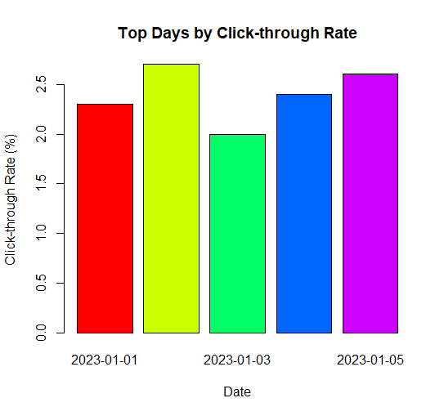
main = "Top Days by Click-through Rate")

- Develop a stacked area chart to display the distribution of user interactions (likes, shares,comments) on a website.
# User Interaction Data
likes <- c(120, 140, 110, 150, 170)
shares <- c(60, 70, 55, 75, 80)
comments <- c(30, 35, 25, 40, 45)
# Matrix
interaction <- rbind(likes, shares, comments)
# Stacked Area Chart
x <- 1:5
plot(x,
cumsum(interaction)[1:5],
type = "n",
xlab = "Day",
ylab = "Number of Interactions",
main = "Distribution of User Interactions")
polygon(c(x, rev(x)),
c(rep(0,5), rev(likes)),
col = "skyblue",
border = NA)
polygon(c(x, rev(x)),
c(likes, rev(likes + shares)),
col = "orange",
border = NA)
polygon(c(x, rev(x)),
c(likes + shares, rev(likes + shares + comments)),
col = "green",
border = NA)
legend("topleft",
legend = c("Likes", "Shares", "Comments"),
fill = c("skyblue", "orange", "green"))

Set 6 : Product Sales Analysis
- Create a grouped bar chart to visualize the sales of each product for the first quarter. Label the chart elements.
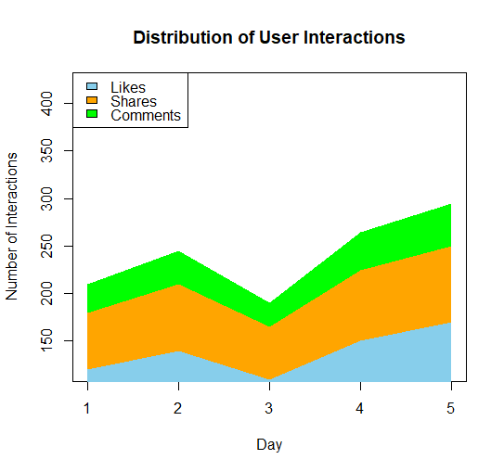
# Monthly Product Sales Data
products <- c("Product A", "Product B", "Product C")
sales <- matrix(c(2000, 1500, 1200,
2200, 1800, 1400,
2400, 1600, 1100),
nrow = 3,
byrow = FALSE)
colnames(sales) <- products
rownames(sales) <- c("January", "February", "March")
# Grouped Bar Chart
barplot(sales,
beside = TRUE,
col = c("red", "blue", "green"),
main = "Quarter 1 Product Sales",
xlab = "Products",
ylab = "Sales",
legend = rownames(sales))

- Generate a stacked area chart to represent the overall sales trend for all products over the three months.
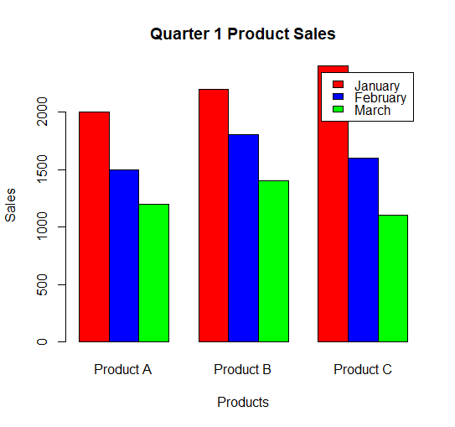
# Sales Data
months <- c(1, 2, 3)
productA <- c(2000, 2200, 2400)
productB <- c(1500, 1800, 1600)
productC <- c(1200, 1400, 1100)
# Cumulative Values
total1 <- productA
total2 <- productA + productB
total3 <- productA + productB + productC
# Plot
plot(months, total3,
type = "n",
xlab = "Month",
ylab = "Sales",
main = "Overall Sales Trend")

polygon(c(months, rev(months)),
c(rep(0,3), rev(total1)),
col = "red",
border = NA)
polygon(c(months, rev(months)),
c(total1, rev(total2)),
col = "blue",
border = NA)
polygon(c(months, rev(months)),
c(total2, rev(total3)),
col = "green",
border = NA)
axis(1,
at = months,
labels = c("January", "February", "March"))
legend("topleft",
legend = c("Product A", "Product B", "Product C"),
fill = c("red", "blue", "green"))
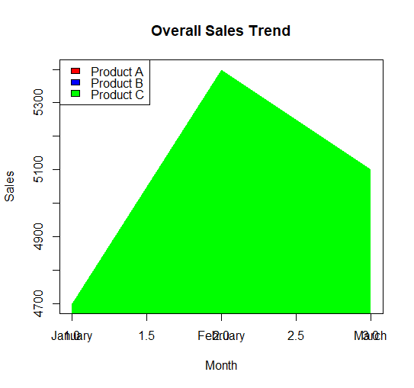

- Build a table to show the monthly sales data for each product. Label the table elements.
# Create Data Frame
sales_table <- data.frame(
Product = c("Product A", "Product B", "Product C"),
January = c(2000, 1500, 1200),
February = c(2200, 1800, 1400),
March = c(2400, 1600, 1100)
)
# Display Table
print(sales_table)

Product January February March
1 Product A 2000 2200 2400
2 Product B 1500 1800 1600
3 Product C 1200 1400 1100

Set 7 Customer Demographics Analysis
- Create a bar chart to visualize the distribution of customer ages. Label the axes and title the chart.
# Customer Data
age <- c(28, 35, 42)
# Customer IDs
customer <- c("Customer 1", "Customer 2", "Customer 3")
# Bar Chart
barplot(age,
names.arg = customer,
col = c("skyblue", "orange", "green"),
xlab = "Customers",
ylab = "Age (Years)",
main = "Distribution of Customer Ages")

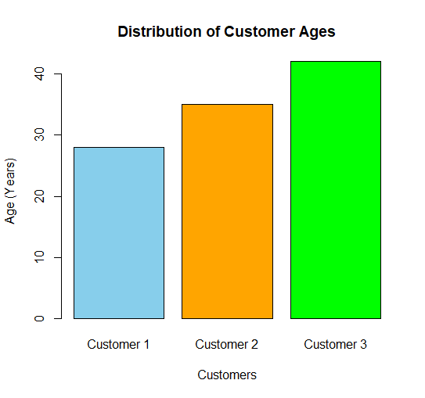

- Generate a pie chart to represent the distribution of customers by gender.
# Gender Data
gender <- c("Female", "Male", "Female")
# Count Gender
gender_count <- table(gender)
# Pie Chart
pie(gender_count,
labels = paste(names(gender_count),
"(", gender_count, ")", sep = ""),
col = c("pink", "lightblue"),
main = "Customer Distribution by Gender")
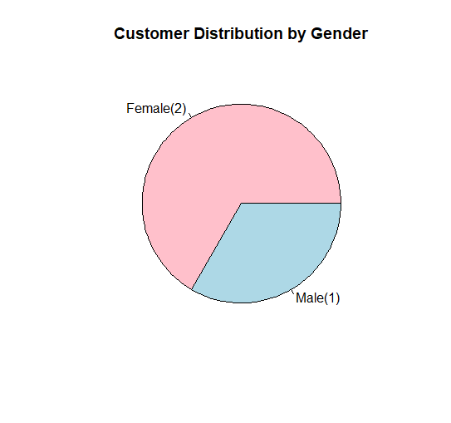

3. Build a table to show the demographic information for each customer. Label the table
elements.
# Customer Demographic Table
customer_data <- data.frame(
Customer_ID = c(1, 2, 3),
Age = c(28, 35, 42),
Gender = c("Female", "Male", "Female"),
Income = c(50000, 60000, 75000)
)
# Display Table
print(customer_data)
Customer_ID Age Gender Income
1 1 28 Female 50000
2 2 35 Male 60000
3 3 42 Female 75000

Set8 Employee Performance Analysis
1. Create a line chart to visualize the performance trend of employees over time. Label
the axes and title the chart.
# Employee Data
employee <- c(1, 2, 3)
performance <- c(85, 92, 78)
# Line Chart
plot(employee,
performance,
type = "o",
pch = 16,
col = "blue",
xlab = "Employee ID",
ylab = "Performance Score",
main = "Employee Performance Trend")
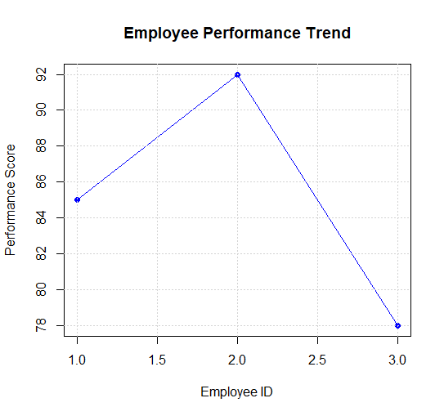
grid()

- Generate a bar chart showing the distribution of employees across different departments.Label the chart elements.
# Department Data
department <- c("Sales", "HR", "Marketing")
# Count Employees
dept_count <- table(department)
# Bar Chart
barplot(dept_count,
names.arg = names(dept_count),
col = c("red", "green", "blue"),
xlab = "Department",
ylab = "Number of Employees",
main = "Distribution of Employees Across Departments")

- Build a table to display the performance data for each employee. Label the table elements.
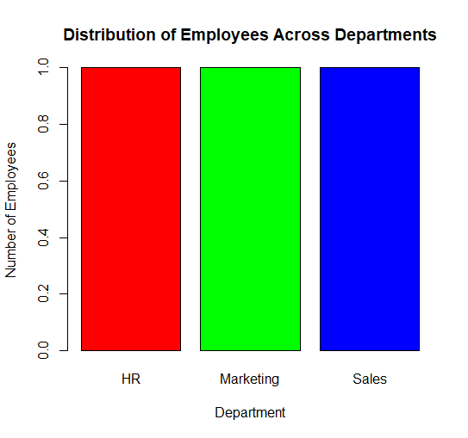
# Employee Performance Table
employee_data <- data.frame(
Employee_ID = c(1, 2, 3),
Department = c("Sales", "HR", "Marketing"),
Years_of_Service = c(5, 3, 7),
Performance_Score = c(85, 92, 78)
)
# Display Table
print(employee_data)
Employee_ID Department Years_of_Service Performance_Score
1 1 Sales 5 85
2 2 HR 3 92
3 3 Marketing 7 78

Set 9 Product Inventory Management
- Create a bar chart to visualize the quantity of each product in the inventory. Label the axes and title the chart.
# Product Data
product <- c("Product A", "Product B", "Product C")
quantity <- c(250, 175, 300)
# Bar Chart
barplot(quantity,
names.arg = product,
col = c("skyblue", "orange", "green"),
xlab = "Product Name",
ylab = "Quantity Available",
main = "Product Inventory Quantity")
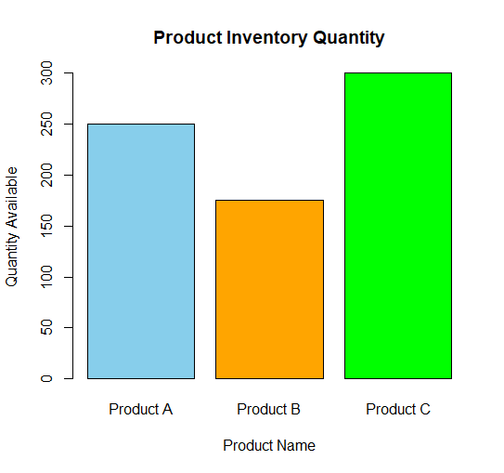

- Generate a stacked bar chart to show the quantity of each product within different product categories.

# Product Data
product <- c("Product A", "Product B", "Product C")
category <- c("Category 1", "Category 1", "Category 2")
quantity <- c(250, 175, 300)

# Create Table
inventory_table <- xtabs(quantity ~ category + product)

# Stacked Bar Chart
barplot(inventory_table,
beside = FALSE,
col = c("red", "blue"),
legend = rownames(inventory_table),
xlab = "Products",
ylab = "Quantity Available",
main = "Quantity by Product Category")
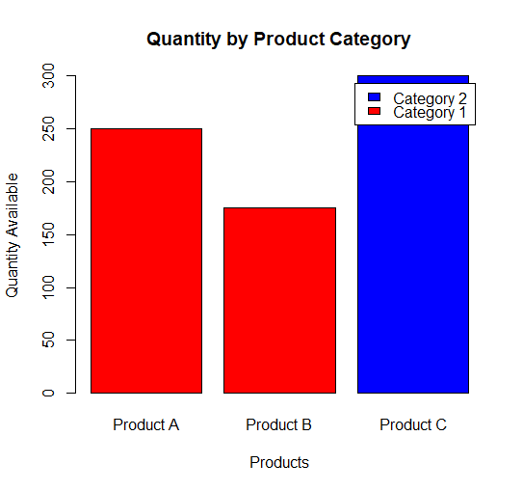

- Build a table to show the inventory data for each product. Label the table elements.

# Inventory Table
inventory_data <- data.frame(
Product_ID = c(1, 2, 3),
Product_Name = c("Product A", "Product B", "Product C"),
Quantity_Available = c(250, 175, 300),
Price = c(20, 15, 18)
)

# Display Table
print(inventory_data)
Product_ID Product_Name Quantity_Available Price
1 1 Product A 250 20
2 2 Product B 175 15
3 3 Product C 300 18

Set 10: Survey Responses Analysis

1. Create a grouped bar chart to visualize the distribution of answers for Label the chart elements.

# Survey Data
responses <- c("A", "B", "C")
# Count Responses
response_count <- table(responses)
# Grouped Bar Chart
barplot(response_count,
beside = TRUE,
col = c("red", "blue", "green"),
names.arg = names(response_count),
xlab = "Question 1 Responses",
ylab = "Number of Responses",
main = "Distribution of Answers for Question 1")
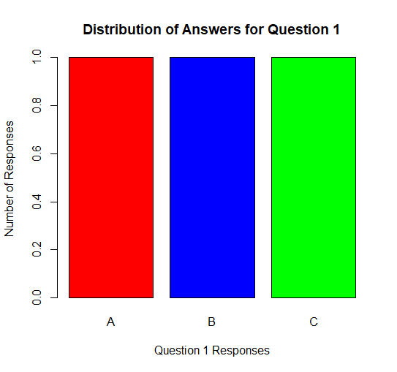

- Generate a stacked bar chart to represent the overall distribution of responses for all three questions.

# Survey Data
survey_data <- data.frame(
Q1 = c("A", "B", "C"),
Q2 = c("B", "A", "A"),
Q3 = c("C", "D", "B")
)
# Response Levels
levels <- c("A", "B", "C", "D")
# Frequency Table
response_matrix <- rbind(
table(factor(survey_data$Q1, levels = levels)),
table(factor(survey_data$Q2, levels = levels)),
table(factor(survey_data$Q3, levels = levels))
)
rownames(response_matrix) <- c("Question 1", "Question 2", "Question 3")
# Stacked Bar Chart
barplot(t(response_matrix),
beside = FALSE,
col = c("red", "blue", "green", "orange"),
xlab = "Survey Questions",
ylab = "Number of Responses",
main = "Overall Distribution of Survey Responses",
legend.text = c("A", "B", "C", "D"))
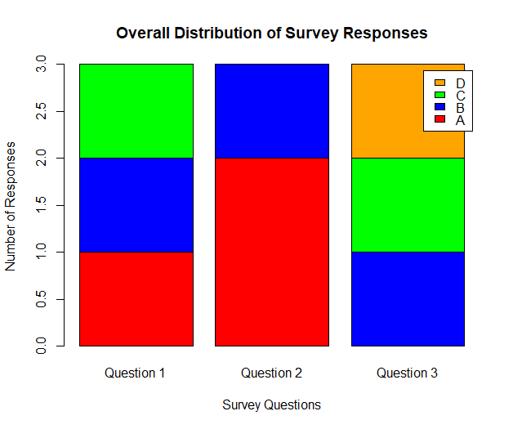

- Build a table to show the survey response data for each survey. Label the table elements.
# Survey Response Table
survey_table <- data.frame(
Survey_ID = c(1, 2, 3),
Question_1 = c("A", "B", "C"),
Question_2 = c("B", "A", "A"),
Question_3 = c("C", "D", "B")
)
# Display Table
print(survey_table)
Survey_ID Question_1 Question_2 Question_3
1 1 A B C
2 2 B A D
3 3 C A B

