Set 18: Time Series Analysis
# Monthly Sales Data
sales <- c(15000, 18000, 22000, 20000, 23000)
# Create time series
sales_ts <- ts(sales, start = c(2026, 1), frequency = 12)
# Plot time series
plot(sales_ts,
type = "o",
main = "Monthly Sales Trend",
xlab = "Month",
ylab = "Sales ($)")
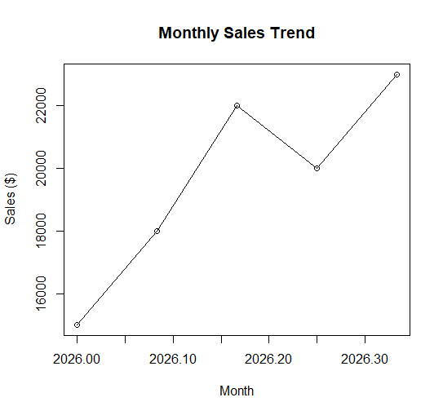

import matplotlib.pyplot as plt

advertising = [5000, 6000, 7000, 6500, 8000]
sales = [15000, 18000, 22000, 20000, 23000]

plt.scatter(advertising, sales)

plt.xlabel("Advertising Budget ($)")
plt.ylabel("Monthly Sales ($)")
plt.title("Advertising Budget vs Monthly Sales")

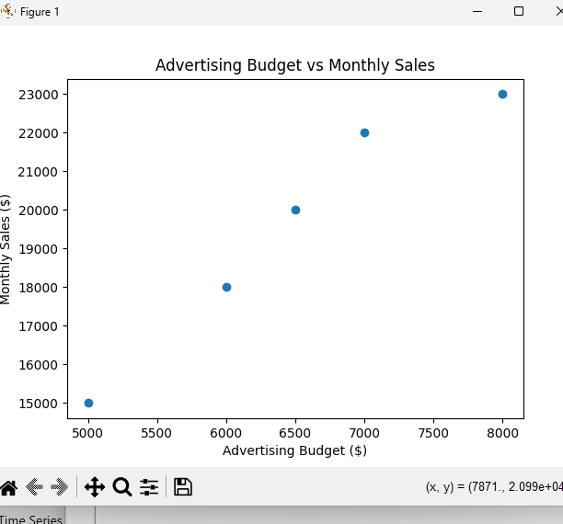
plt.show()

# Monthly Sales Data
sales <- c(15000, 18000, 22000, 20000, 23000)

# Create time series
sales_ts <- ts(sales, start = c(2026, 1), frequency = 12)

# Autocorrelation plot
acf(sales_ts,
main = "Autocorrelation of Monthly Sales")
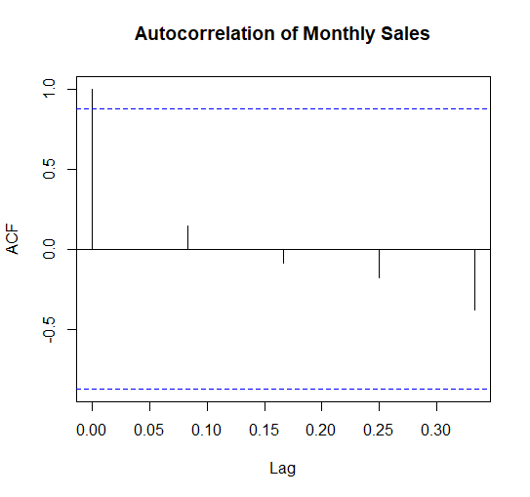

Set 19: Employee Performance Analysis
import matplotlib.pyplot as plt
from collections import Counter
departments = ["Sales", "HR", "Marketing", "Sales", "HR"]
count = Counter(departments)
plt.bar(count.keys(), count.values())
plt.xlabel("Department")
plt.ylabel("Number of Employees")
plt.title("Employee Distribution by Department")
plt.show()
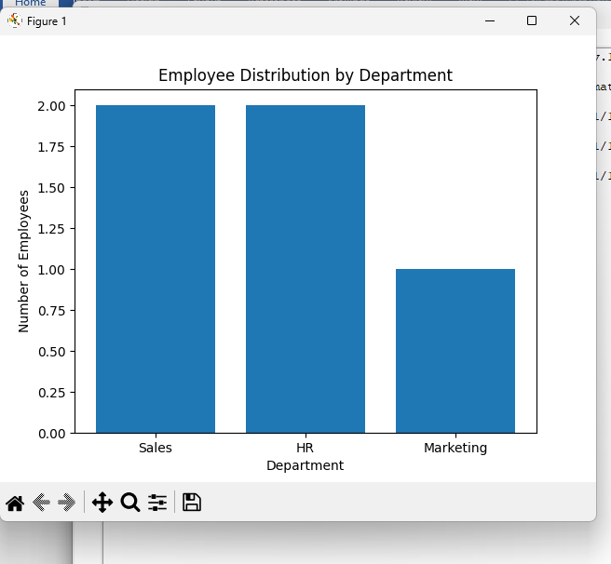

# Employee data
employee_id <- c(1, 2, 3, 4, 5)
performance <- c(85, 92, 78, 90, 76)

# Line chart
plot(employee_id, performance,
type = "o",
main = "Employee Performance Trend",
xlab = "Employee ID",
ylab = "Performance Score")

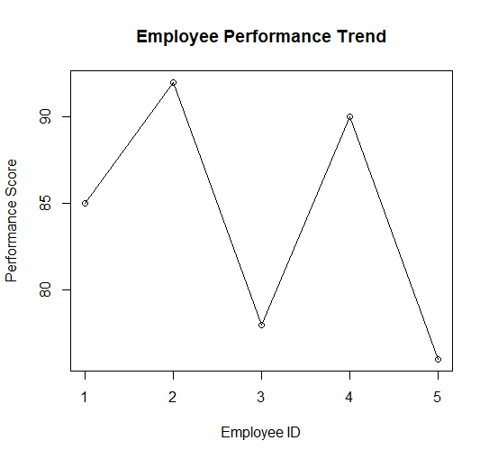

import pandas as pd

data = {
"Employee ID": [1, 2, 3, 4, 5],
"Department": ["Sales", "HR", "Marketing", "Sales", "HR"],
"Years of Service": [5, 3, 7, 4, 2],
"Performance Score": [85, 92, 78, 90, 76]
}

df = pd.DataFrame(data)

print("Employee Performance Data")
print(df)

Employee Performance Data
Employee ID Department Years of Service Performance Score
0 1 Sales 5 85
1 2 HR 3 92
2 3 Marketing 7 78
3 4 Sales 4 90
4 5 HR 2 76

Set 20: Product Inventory Management
# Product Inventory Data
product <- c("Product A", "Product B", "Product C", "Product D", "Product E")
quantity <- c(250, 175, 300, 200, 220)

# Bar chart
barplot(quantity,
names.arg = product,
main = "Quantity Available by Product",
xlab = "Product",
ylab = "Quantity Available")
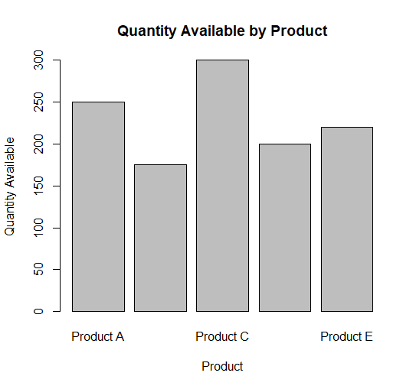

import matplotlib.pyplot as plt
products = ["Product A", "Product B", "Product C", "Product D", "Product E"]
category1 = [100, 75, 150, 100, 120]
category2 = [150, 100, 150, 100, 100]
plt.bar(products, category1, label="Category 1")
plt.bar(products, category2, bottom=category1, label="Category 2")
plt.xlabel("Product")
plt.ylabel("Quantity Available")
plt.title("Inventory by Product Category")
plt.legend()
plt.show()
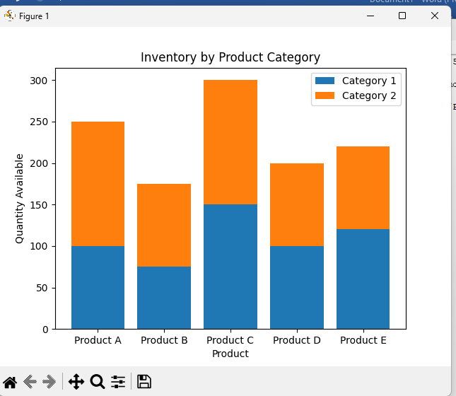

import matplotlib.pyplot as plt
product = ["Product A", "Product B", "Product C", "Product D", "Product E"]
price = [50, 70, 40, 60, 55]
quantity = [250, 175, 300, 200, 220]
plt.scatter(price, quantity)
plt.xlabel("Product Price ($)")
plt.ylabel("Quantity Available")
plt.title("Product Price vs Quantity Available")
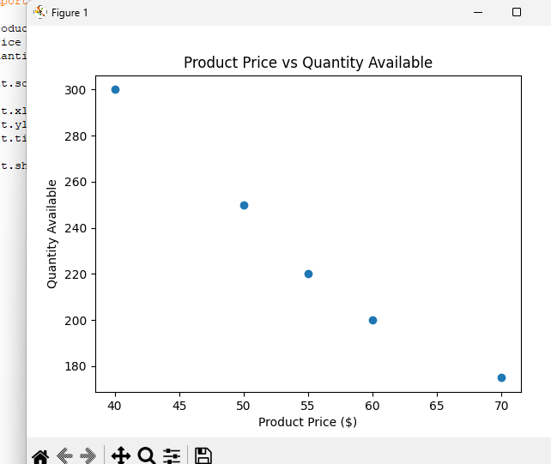
plt.show()

Set 21: Website Traffic Analysis
import matplotlib.pyplot as plt
dates = ["2023-01-01", "2023-01-02", "2023-01-03",
"2023-01-04", "2023-01-05"]

likes = [500, 550, 480, 600, 650]
shares = [150, 180, 140, 200, 220]
comments = [80, 90, 70, 100, 110]
plt.stackplot(dates, likes, shares, comments,
labels=["Likes", "Shares", "Comments"])
plt.xlabel("Date")
plt.ylabel("Number of Interactions")
plt.title("User Interactions Over Time")
plt.legend(loc="upper left")
plt.show()
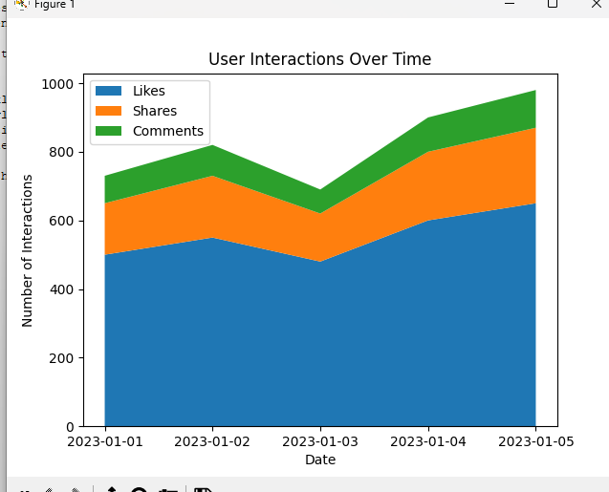

# Website Traffic Data
date <- c("2023-01-01", "2023-01-02", "2023-01-03",
"2023-01-04", "2023-01-05")

ctr <- c(2.3, 2.7, 2.0, 2.4, 2.6)

# Create data frame
data <- data.frame(Date = date, CTR = ctr)

# Sort by CTR
data <- data[order(-data$CTR), ]

# Select Top 3 days
top3 <- data[1:3, ]

# Bar chart
barplot(top3$CTR,
names.arg = top3$Date,
main = "Top 3 Days by Click-through Rate",
xlab = "Date",
ylab = "Click-through Rate (%)")
