Part A: Data Types in R
NAME : YUGITHA B REG NO : 192424102

Define data types in R. Explain the different basic data types with suitable examples.

Data Type | Description | Example
Integer | Whole numbers | 25L
Numeric | Decimal numbers | 25.5
Character | Text or strings | "Hello"
Logical | TRUE or FALSE values | TRUE
Complex | Complex numbers | 3 + 4i

Create variables of different data types and identify their types using class().

a <- 25L
b <- 25.5
c <- "R Programming"
d <- TRUE
e <- 3 + 4i
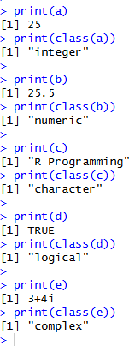
print(a) print(class(a)) print(b) print(class(b)) print(c) print(class(c)) print(d) print(class(d)) print(e) print(class(e))

OUTPUT

- Differentiate between integer and numeric data types in R.

Integer | Numeric
Stores whole numbers | Usually stores decimal numbers
Written with L | Usually written without L
Example: 25L | Example: 25.5
class(25L) gives "integer" | class(25.5) gives "numeric"

- Explain typeof(), class(), and is.numeric(). typeof()
x <- 25.5
typeof(x)
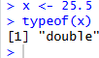

class()
x <- 25.5
class(x)
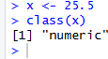

is.numeric()
x <- 25.5
is.numeric(x)
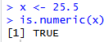

Convert numeric to character and character to numeric.

# Numeric to character x <- 25.5
y <- as.character(x) print(y) print(class(y))
# Character to numeric
a <- "100"
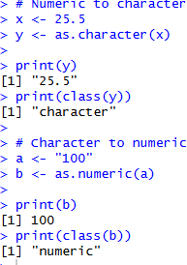
b <- as.numeric(a) print(b) print(class(b))

Identify the data type of each variable.

Variable | Value | Data Type | Justification
a | 25L | Integer | L specifies an integer
b | 25.5 | Numeric | Decimal value
c | "R Programming" | Character | Text is enclosed in quotes
d | FALSE | Logical | TRUE/FALSE value
e | 3 + 4i | Complex | Contains imaginary part i

Explain type coercion in R.
Type coercion is the automatic conversion of one data type into another data type. x <- c(10, "20", TRUE)

print(x)
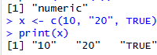

Part B: Vectors in R

Define a vector in R. Explain how to create different vectors using c().
A vector is a collection of elements of the same basic data type. The c() function is used to combine values and create a vector. Numeric vector:
x <- c(10, 20, 30, 40)

Character vector:
names <- c("Ravi", "Anu", "Kumar")

Logical vector:
result <- c(TRUE, FALSE, TRUE)

Create a numeric vector containing ten elements and perform arithmetic operations.
x <- c(10, 20, 30, 40, 50, 60, 70, 80, 90, 100)
# Addition print(x + 5) # Subtraction print(x - 5)
# Multiplication print(x * 2)
# Division

print(x / 2) 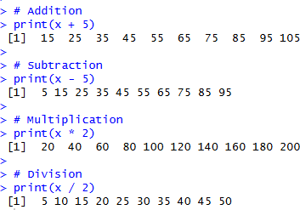

Explain vector indexing in R.
Vector indexing is used to access specific elements of a vector. Consider:
R
x <- c(10, 20, 30, 40, 50)

Access individual element:
R x[2]
Output:
20

Select multiple elements:
R
x[c(1, 3, 5)]
Output:
10 30 50

Exclude elements using negative indices:
R
x[-2]
Output:
10 30 40 50
R uses 1-based indexing, so the first element is at position 1.

Create a vector of student marks and perform the operations.
marks <- c(80, 65, 90, 75, 88, 70, 95)
# Sum print(sum(marks)) # Average print(mean(marks)) # Maximum print(max(marks)) # Minimum print(min(marks))
# Marks greater than 75 print(marks[marks > 75])
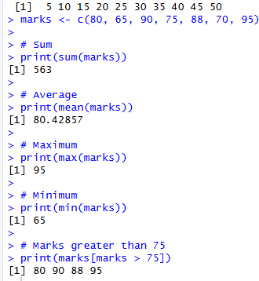

Explain vector recycling in R.
Vector recycling means R repeats the shorter vector when performing an operation with a longer vector.
Example: R

x <- c(10, 20, 30, 40) y <- c(2, 4)
x + y
R repeats y as:
2, 4, 2, 4
So:
10+2 = 12
20+4 = 24
30+2 = 32
40+4 = 44

Output:
[1] 12 24 32 44
- Create a character vector of five student names. names <- c("Arun", "Bala", "Divya", "Kavi", "Meena") # Sort alphabetically
print(sort(names)) # Find length
print(length(names))
# Access third element print(names[3])

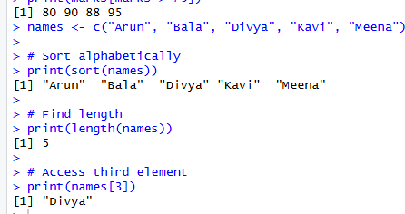

Determine the output of each operation.
  - x + y
x <- c(10, 20, 30, 40, 50)
y <- c(2, 4, 6, 8, 10)
x + y
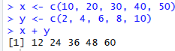

x * 2
x <- c(10, 20, 30, 40, 50)
y <- c(2, 4, 6, 8, 10)
x * 2
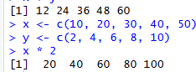

x[c(1, 3, 5)]
x <- c(10, 20, 30, 40, 50)
y <- c(2, 4, 6, 8, 10)
x[c(1, 3, 5)]
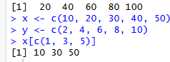
- College attendance program attendance <- c(90, 82, 88, 75, 95, 86) # Students with attendance above 85% print(attendance[attendance > 85])
# Average attendance print(mean(attendance))
# Number of students meeting requirement print(sum(attendance > 85))

