PROJECT REPORT
ON
Analysis of VNSGU Student Academic Performance using Python
AS
A PARTIAL REQUIREMENT FOR THE DEGREE
OF
BACHELOR OF COMPUTER APPLICATION(BCA)

FOR SUBJECT
602 DATA ANALYSIS WITH PYTHON

Submitted by:
Yug Sanjaybhai Patel (6308)
Darshan Mukeshbhai Parmar (6291)

Guided by:
Asst. Prof. Twinkle S. Panchal
Sutex Bank College of Computer Applications and Science, Amroli

Acknowledgement
We would like to express our sincere gratitude to Asst. Prof. Twinkle S. Panchal, Sutex Bank College of Computer Applications and Science, Amroli, for her valuable guidance, continuous encouragement, and constant support throughout the development of this project titled “Analysis of VNSGU Student Academic Performance using Python”, submitted as a part of the subject Data Analysis with Python (602).

Her expert knowledge, constructive suggestions, and thoughtful feedback helped us understand the concepts of data analysis, exploratory data analysis, visualization techniques, and machine learning implementation more effectively. Her motivation and guidance played an important role in successfully completing this project and improving our understanding of practical data analytics using Python tools and libraries.

We are also thankful to Sutex Bank College of Computer Applications and Science, Amroli, for providing us with the necessary academic environment, infrastructure, and learning resources required to carry out this project work successfully. The support from the college helped us gain practical exposure to real-world data analysis techniques and strengthened our knowledge in the field of data science and analytics.

This project provided us with an opportunity to apply theoretical concepts such as data preprocessing, statistical analysis, data visualization, and machine learning clustering techniques on real academic datasets. Through this work, we were able to develop a deeper understanding of how data-driven approaches can help in identifying patterns, trends, and insights in educational data.

Finally, we would like to extend our sincere thanks to everyone who directly or indirectly supported and encouraged us during the completion of this project. Their support and motivation contributed significantly to the successful completion of this work.

Yug Sanjaybhai Patel
Darshan Mukeshbhai Parmar

INDEX
Sr. No. | Chapter Title | Page No
1. | Project Definition
2. | Dataset Details
3. | Python tools and libraries used
4. | Understanding data
5. | Understanding Spread of Data
6. | Automating EDA using Python
7. | Handling missing data and outliers
8. | Univariate Analysis
9. | Bivariate Analysis
10. | Multivariate Analysis
11. | Data Visualization
12. | Machine Learning Implementation
13. | Conclusion
14. | Reference

Chapter 1: Project Definition :
Analysis of VNSGU Student Academic Performance using Python

Understanding student academic performance is essential for evaluating educational quality, identifying learning gaps, and improving institutional decision-making. In this project, we analyse the VNSGU student result dataset using Python to extract meaningful academic insights through Exploratory Data Analysis (EDA).
This project focuses on analysing structured examination result data to understand performance distribution, subject-wise trends, grading patterns, and overall academic outcomes.
The primary objective of this analysis is to transform raw examination result data into actionable insights using statistical techniques and data visualization tools.

Project Objectives :
We aim to answer the following analytical questions:
- What is the overall performance distribution of students?
- What is the average marks obtained in each subject?
- Which subject has the highest failure rate?
- How are total marks distributed among students?
- What percentage of students passed and failed?
- Identify top-performing students based on total marks.
- Are there any outliers in subject-wise marks?
- What is the correlation between subjects and total marks?

Chapter 2: Dataset Details :

Dataset Name: VNSGU Master Student Result Dataset

Dataset Source:
https://ums.vnsgu.net/Result/StudentResultDisplay.aspx?HtmlURL=7596,0000

Dataset Type: Structured Excel Dataset (.xlsx)

Dataset Domain: Educational Data Analytics / Academic Performance Analysis

Dataset Description
The dataset contains academic performance records of students enrolled under VNSGU. It includes structured information related to student identification, subject-wise marks, total marks, and result status.
The dataset typically contains the following types of attributes:
- Seat Number (Unique Student Identifier)
- Student Name
- Collage Name
- Subject-wise Marks
- Total Marks
- SGPA
- Percentage
- Result Status (Pass/Fail)

Chapter 3: Python tools and libraries used :
Python 3.10 :
Python is a programming language widely used by Data Scientists. Python has in-built mathematical libraries and functions, making it easier to calculate mathematical problems and to perform data analysis.
Pandas :
Pandas is a fundamental, open-source Python library for data manipulation and analysis, providing fast, flexible, and expressive data structures like DataFrames (2D tables) and Series (1D arrays) to handle tabular data efficiently, making it ideal for cleaning, transforming, exploring, and analyzing large datasets in data science, machine learning, and analytics. It simplifies tasks like reading/writing files (CSV, Excel), handling missing data, filtering, grouping, merging, and performing statistical analysis, integrating seamlessly with other tools like NumPy and Matplotlib.
NumPy :
NumPy (Numerical Python) is a foundational Python library for data science, primarily used for its efficient multi-dimensional array object (the ndarray) and high-performance mathematical functions. It is a core component of the Python data science ecosystem, serving as the backbone for other major libraries like Pandas, Matplotlib, and scikit-learn.
Matplotlib :
Matplotlib is a foundational, powerful Python library for creating a wide range of static, animated, and interactive visualizations in data science. It provides extensive customization options and serves as the backbone for many other visualization libraries like Seaborn.
Seaborn :
Seaborn is a powerful Python library for statistical data visualization, built on Matplotlib, that creates attractive, informative plots with minimal code, seamlessly integrating with pandas DataFrames to reveal trends, relationships, and patterns in data, making it essential for Exploratory Data Analysis (EDA). It offers high-level functions for complex plots (like distributions, regressions, heatmaps, violin plots) with beautiful default styles, color palettes, and themes, simplifying the process of understanding data structures and distributions.
Scikit-learn :
Scikit-learn (sklearn) is the most popular, open-source Python library for classical machine learning, providing simple and efficient tools for predictive data analysis. It is built on top of the scientific Python stack (NumPy, SciPy, Matplotlib) and is an essential tool for data scientists.
Chapter 4: Understanding data :
4.1: Importing necessary Python libraries :
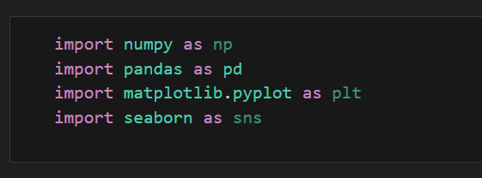

4.2: Creating the data frame :
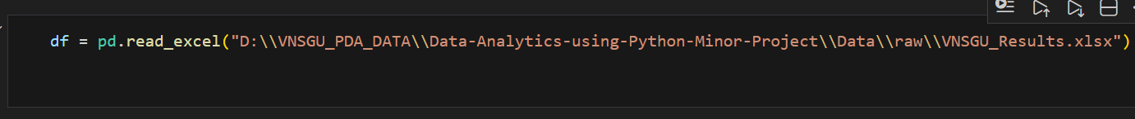

4.3 display all column names :
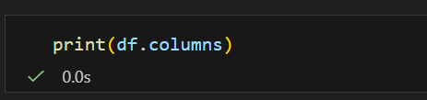
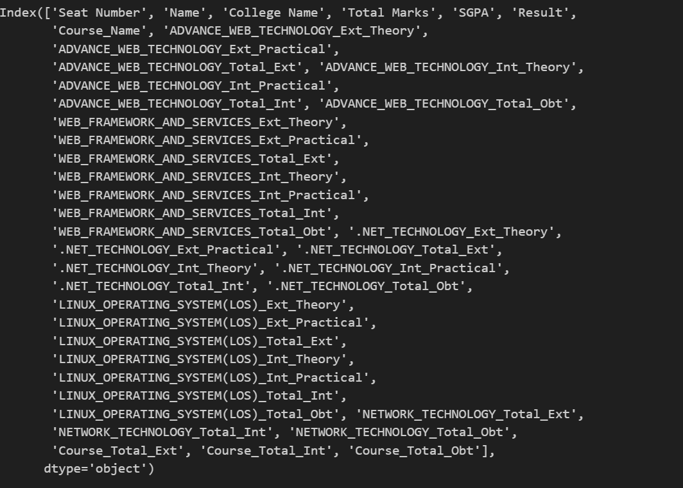

4.5 display top few lines of data :
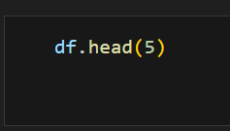
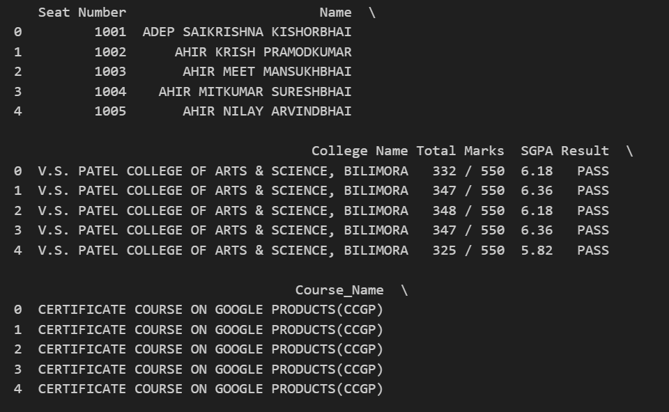
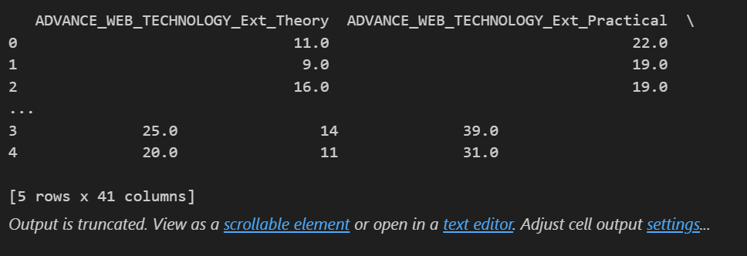

4.6 display shape of data :
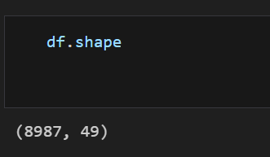

4.7 Getting summary of the dataframe using df.info() :
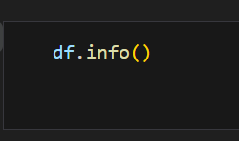
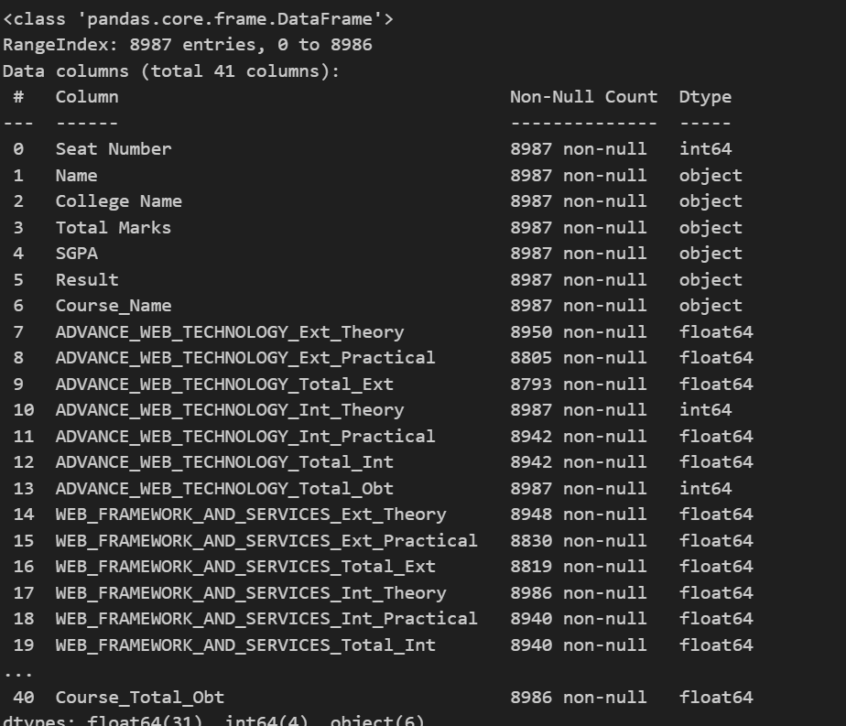

Chapter 5: Understanding spread of data :
With our dataset we have used histogram with “kde=True” to understand the distribution and spread of data in column “rate” (user ratings).

5.1 Distribution of Total Marks (Histogram)
To understand how students performed overall, we visualize the distribution of total marks using a histogram with kernel density estimation (KDE).
A histogram shows:
- How marks are distributed
- Which score range has maximum students
- Whether distribution is normal, skewed, or uneven
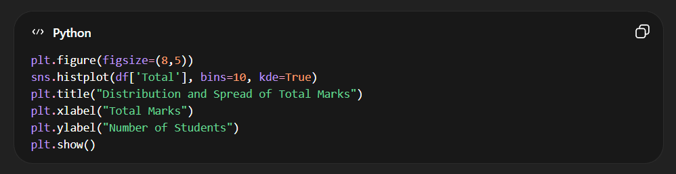

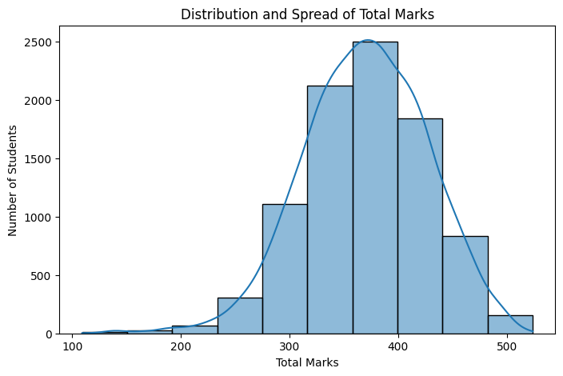

5.2 Spread of Subject-wise Marks (Boxplot Analysis)
To understand variability and detect outliers in individual subjects, we use boxplots.
A boxplot helps in:
- Identifying median marks
- Observing spread (IQR)
- Detecting outliers
- Comparing subject difficulty levels
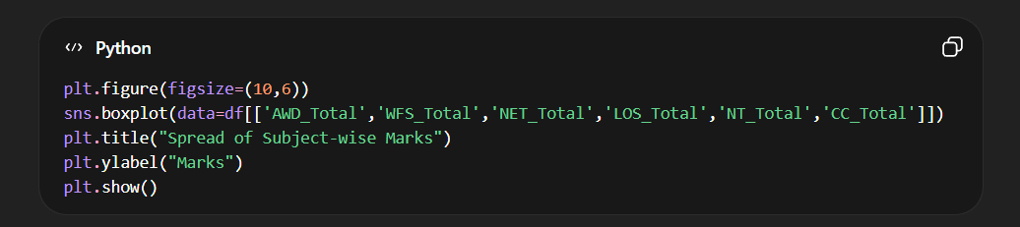

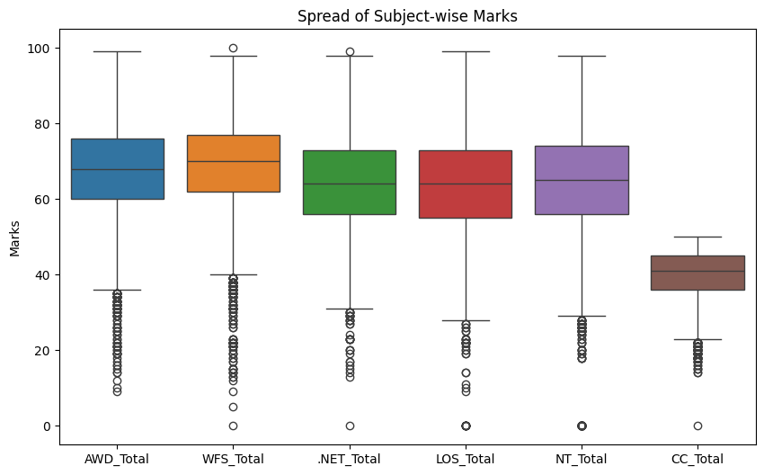

Chapter 6: Automating EDA using python :

Automating Exploratory Data Analysis (EDA) in Python is achieved using specialized libraries that generate comprehensive, interactive reports with just a few lines of code.

In Python's pandas library, df.info() and df.describe() are fundamental methods for performing initial exploratory data analysis (EDA).

df.info(): Provides a concise structural summary of the DataFrame. It provides following information about dataset:
- Data Types (Dtypes),
- Non-Null Counts,
- Column Names,
- Memory Usage,
- Total Entries/Rows

df.describe(): Offers a statistical summary of the numerical data.
- Count: The number of non-null observations in each column.
- Mean: The average value.
- Std: The standard deviation (spread of data).
- Min: The minimum value.
- 25%, 50%, 75%: The first quartile, median (50th percentile), and third quartile.
- Max: The maximum value.

These functions help data analysts quickly understand the dataset's composition and spot potential issues like missing values or outliers without manually sifting through rows.

6.1: Getting summary of the dataframe using df.info()
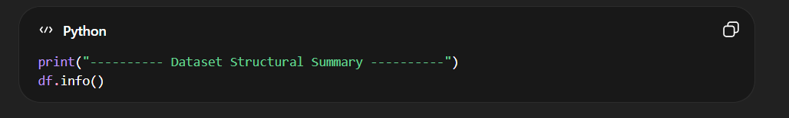
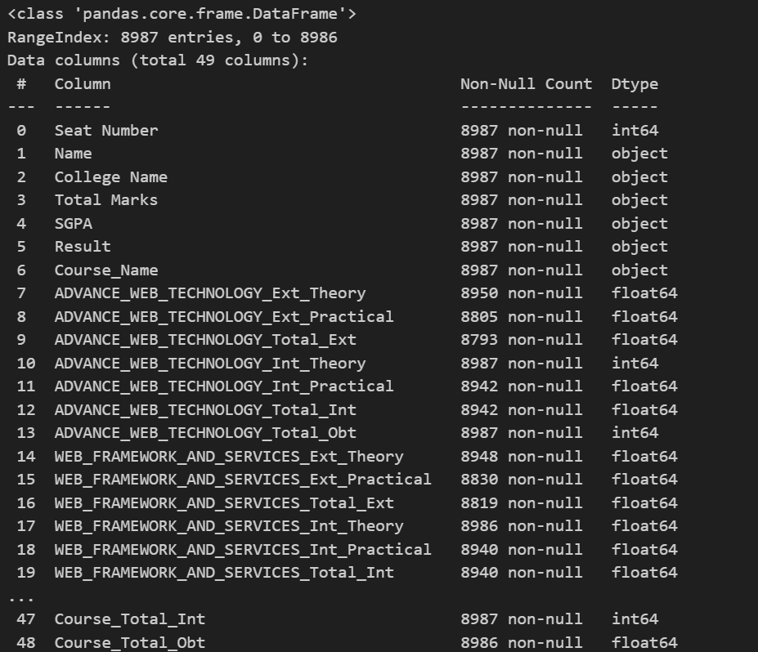

6.2: Getting description of the dataframe using df.describe()
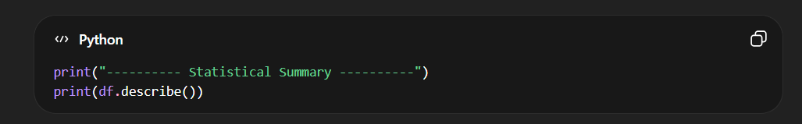
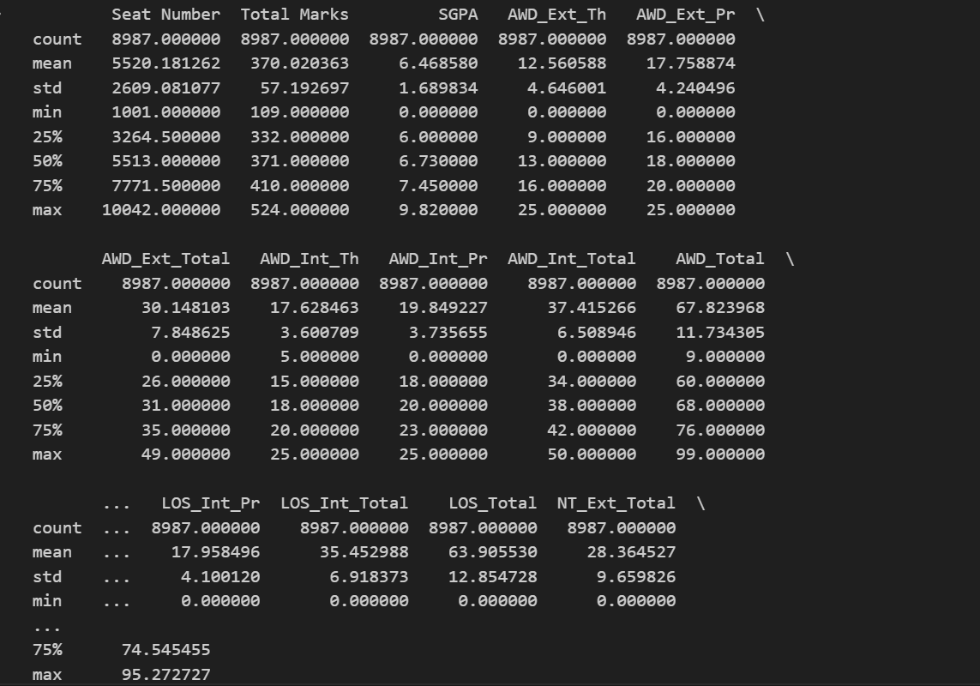

Chapter 7: Handling missing data and outliers (Data cleaning and preparation) :
Before performing deeper analysis, it is essential to clean and prepare the dataset. Raw academic data may contain:
- Missing values
- Incorrect data types
- Duplicate records
- Extreme values (outliers)
Data cleaning ensures accurate and reliable analysis results.

7.1 Handling Missing Values :
Missing values can distort statistical calculations and visualizations. Therefore, we first identify and handle them properly.
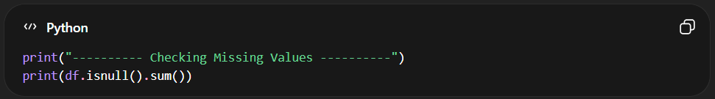

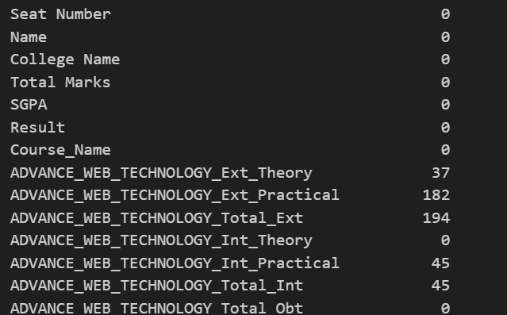
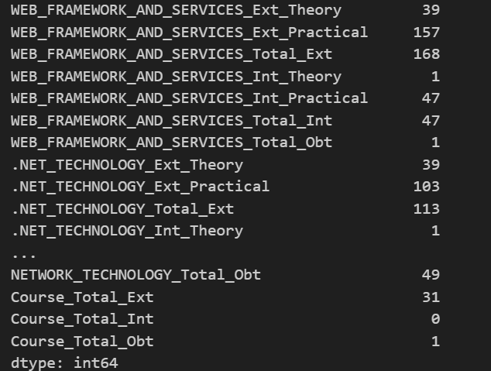

7.2: Fill Missing Values :

7.2.1Handling Missing Marks :
During data inspection, certain subject columns contained missing values. Upon verification with examination records, these missing values represented students who scored zero marks in specific components (e.g., absent).
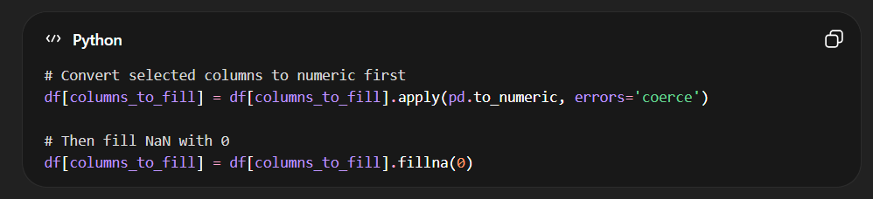

7.2.2 Handling SGPA Column :
The SGPA column contained the value "--" for students who failed the examination. Since this does not represent zero SGPA but rather an undefined grade point, these values were converted to NaN instead of zero to maintain statistical integrity.
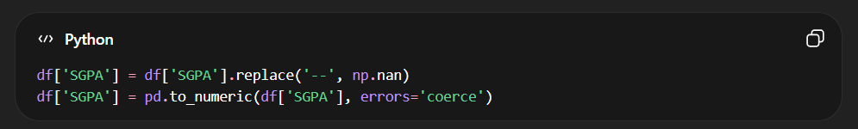
7.2.3 Cleaning Total Marks Column :
The “Total Marks” column contained values in the format “Obtained Marks / Maximum Marks” (e.g., 345/550). Since only the obtained marks were required for analysis, the denominator part was removed.
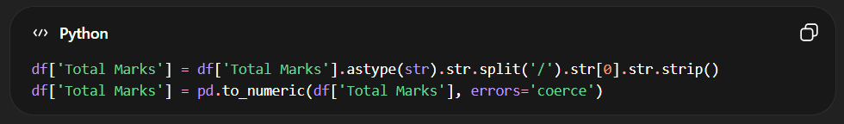

7.2.4 Converting Marks Columns to Numeric :
The subject mark columns contained some non-numeric values and blank entries. Since these represented either absent students or zero marks, they were converted into numeric format and missing values were replaced with 0.
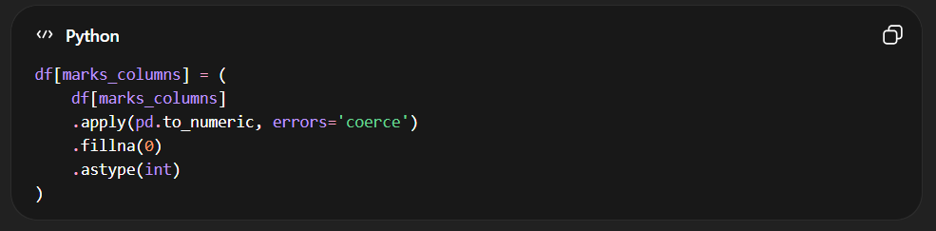

Chapter 8 Univariate Analysis :
Univariate Analysis involves analyzing a single variable at a time to understand its distribution, central tendency, and frequency patterns.
In this chapter, we analyze:
- SGPA Distribution
- Pass vs Fail Ratio
- Subject-wise Failure Count
- Percentage Distributation
8.1 SGPA Distribution :
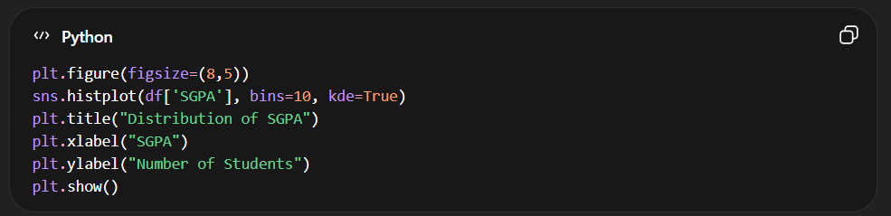
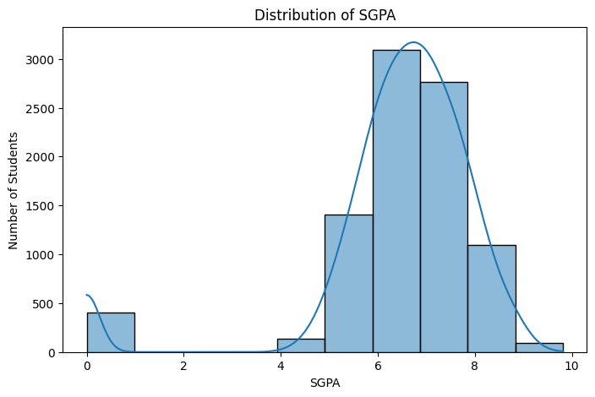
Interpretation:
- Majority clustered around 6–8 average performance.
- High peak near 8–9 strong academic performance.
- Values near 0 indicate failed students (if included).

8.2 Pass vs Fail Distribution :
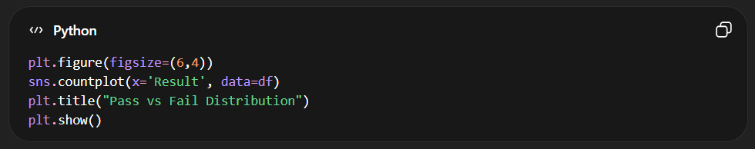
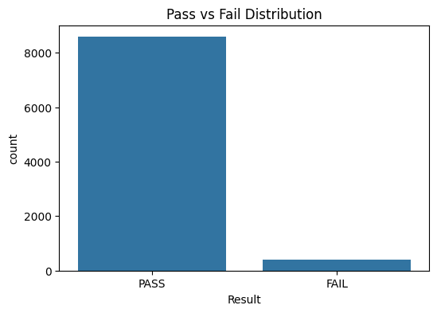
Interpretation:
- Higher PASS count → strong semester performance.
- Low FAIL/ATKT count → difficult subjects.
8.4 Failure Count Per Subject :
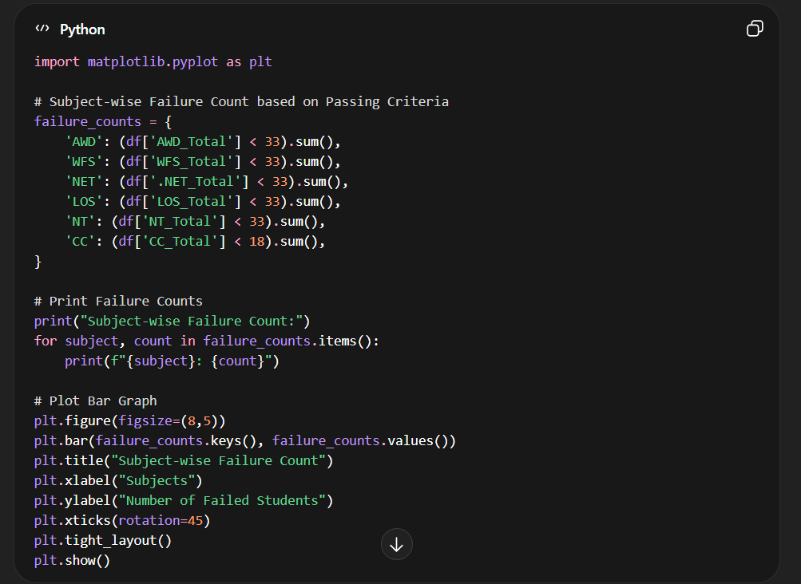
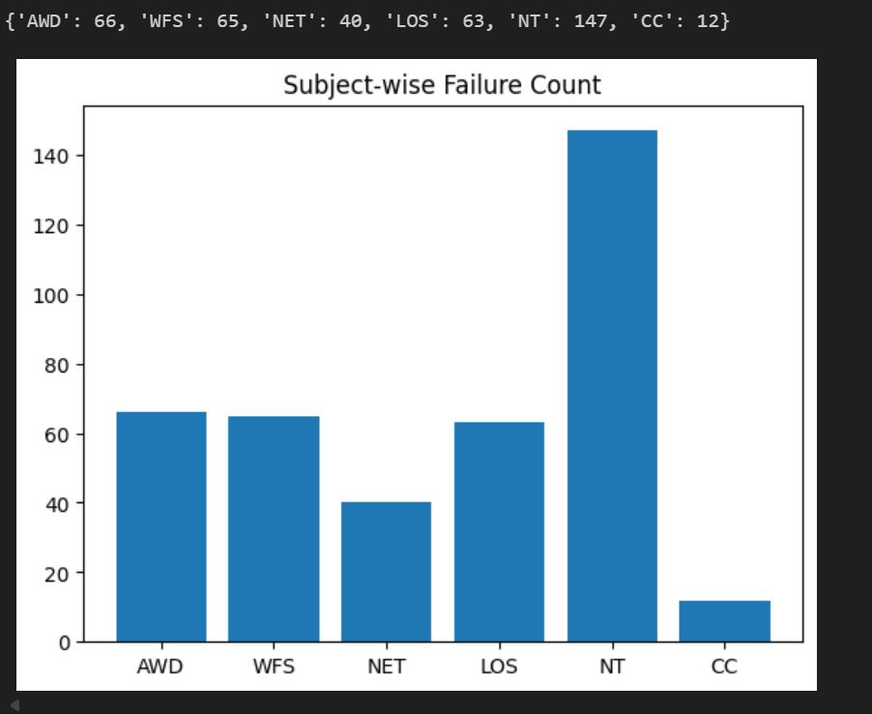
Interpretation:
- Network Technology (NT) has the highest failures (147), indicating it is the most difficult subject.
- AWD, WFS, and LOS show moderate failure counts, suggesting average difficulty.
- Cloud Computing (CC) has the lowest failures (12), showing strongest student performance.
8.6 Percentage Distribution :
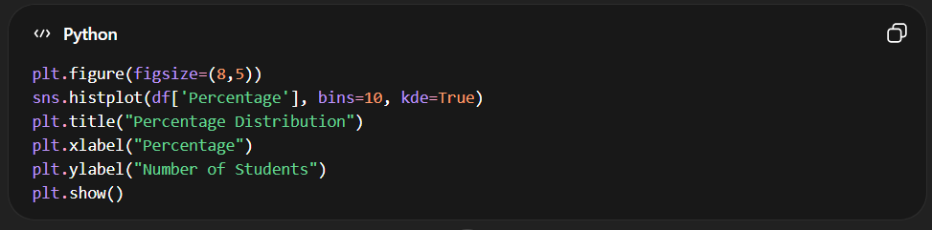

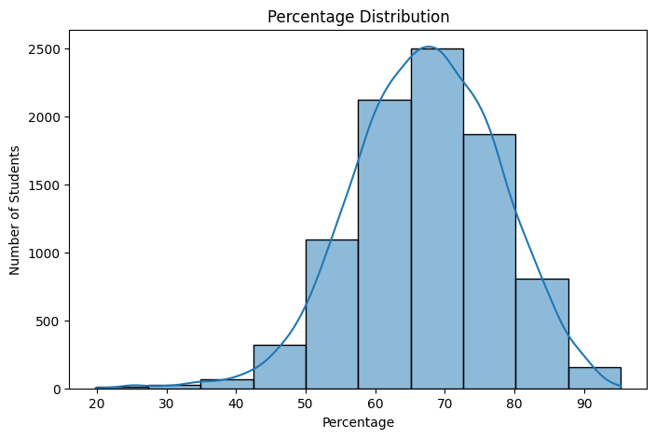
Interpretation :
- Most students scored between 55% and 75%, indicating average to good overall performance.
- The distribution appears approximately bell-shaped (normal), showing balanced academic results.
- Very few students scored below 40% or above 90%, indicating limited extreme performance cases.

Chapter 9: Bivariate Analysis
Bivariate Analysis involves examining the relationship between two variables to understand patterns, dependencies, and performance trends within the dataset. In this chapter, we analyze relationships between academic metrics such as total marks, percentage, result status, subject performance, and institutional comparison.

9.1 Distribution of Total Marks by Result :
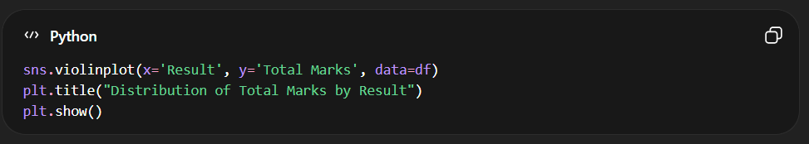
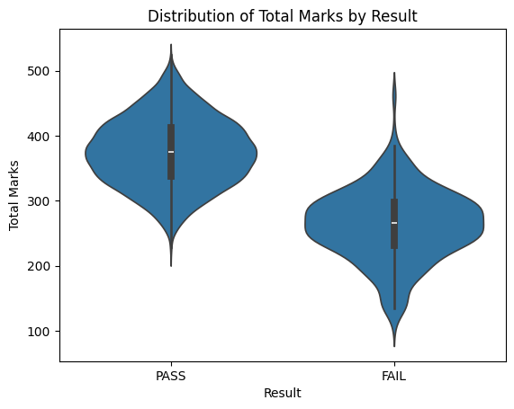
Interpretation:
The violin plot shows a clear distinction between PASS and NOT PASS students. Students who passed are concentrated in the higher total marks range, while non-passing students are clustered in the lower score region. The separation confirms that total marks strongly influence final result status.

9.2 Top 5 Colleges by Average Percentage :
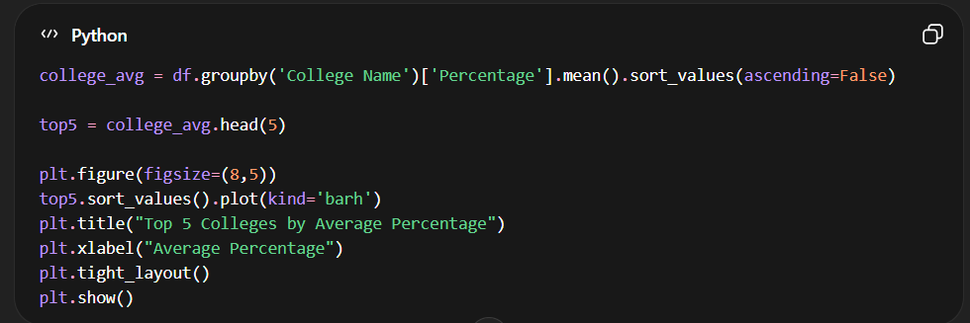
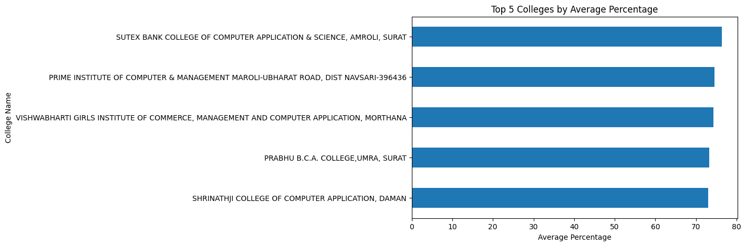
Interpretation:
The comparison reveals measurable differences in academic performance across institutions. The top-performing colleges demonstrate consistently higher average percentages, indicating stronger academic outcomes. This analysis highlights institutional variation under the same university framework.

9.3 Subject-wise Correlation Analysis :
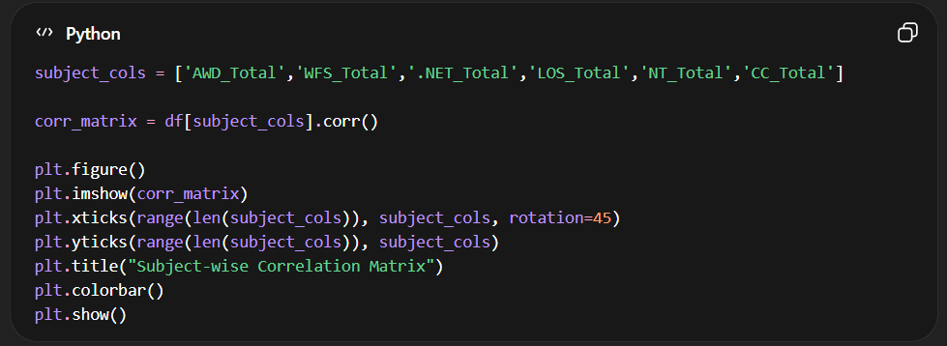
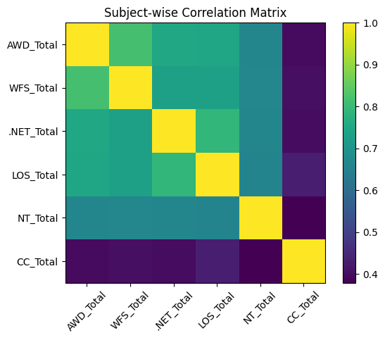

Interpretation:
The correlation heatmap indicates strong positive relationships among several theory-based subjects. High correlation values suggest that students who perform well in one subject tend to perform well in related subjects. Lower correlation values indicate relatively independent performance patterns.

9.4 Percentage Distribution by Result :
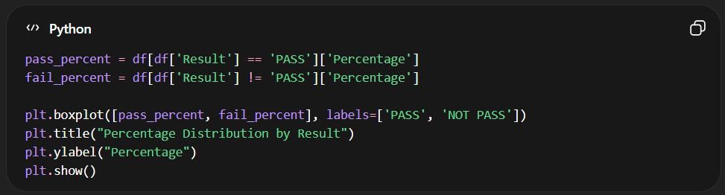
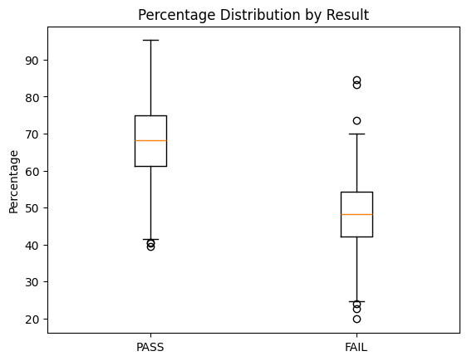
Interpretation:
The median percentage of PASS students is significantly higher than that of NOT PASS students. The boxplot clearly shows that percentage is a strong determinant of final academic outcome. The variability among failing students is greater, indicating inconsistent performance patterns.

9.5 Subject-wise Passing Percentage :
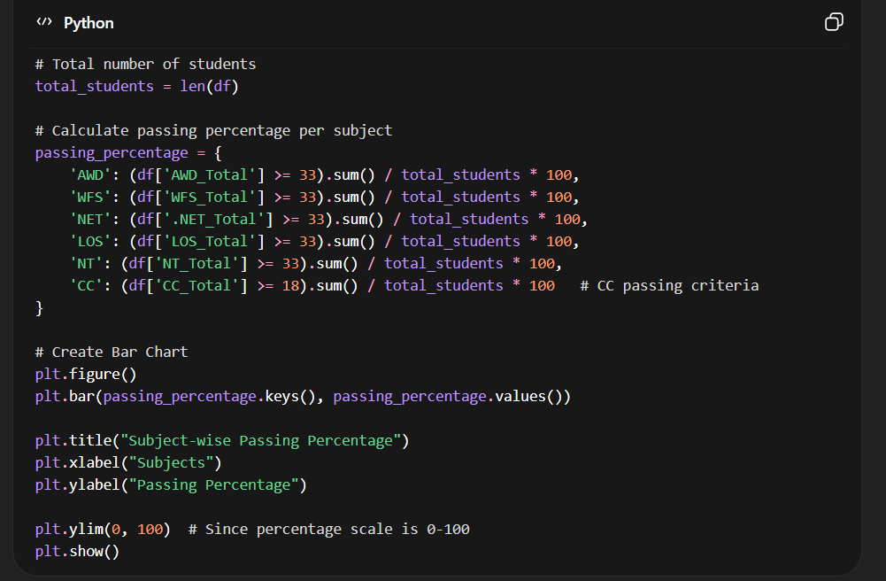
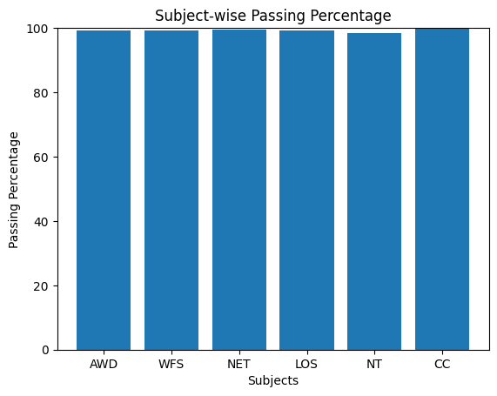
Interpretation:
Most subjects demonstrate high passing percentages, indicating strong overall academic performance. However, comparatively lower passing rates in certain subjects highlight potential areas of academic difficulty. This analysis provides valuable insight for curriculum review and academic improvement strategies.

Chapter 10: Multivariate Analysis
Multivariate analysis examines the relationship among three or more variables simultaneously to identify complex patterns within the dataset. In the context of student result analysis, multiple academic indicators such as subject marks, SGPA, percentage, and result status are analyzed together to understand how different factors collectively influence student performance. This approach provides deeper insights compared to univariate or bivariate analysis by considering multiple dimensions of academic data at the same time.
10.1 Subject-wise Internal vs External Average Marks :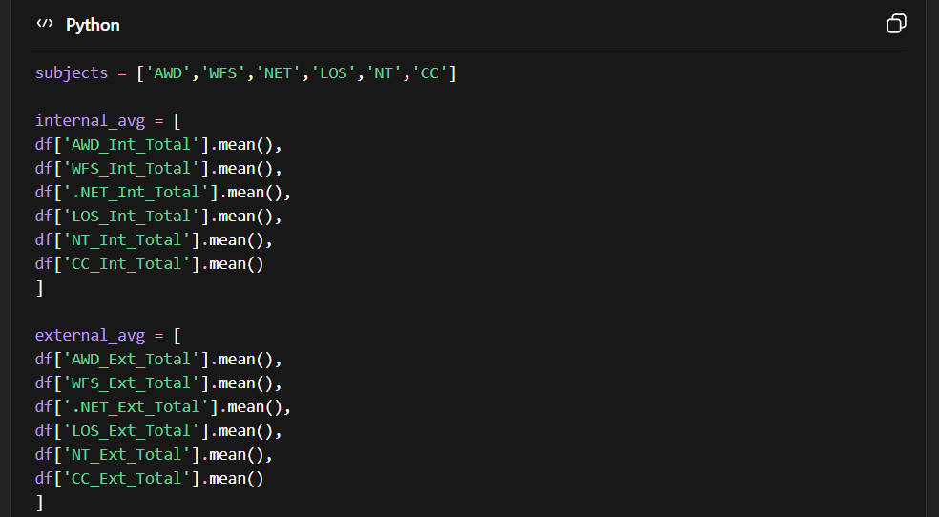
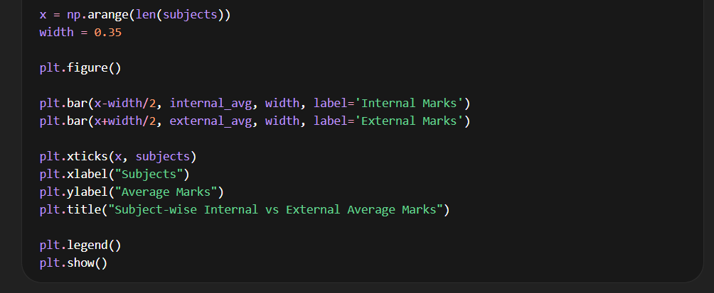
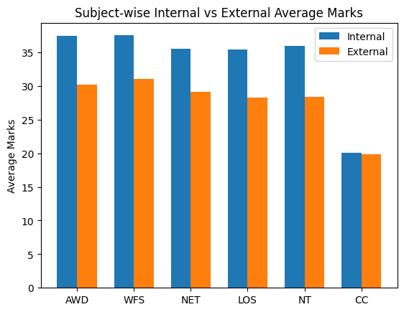
Interpretation :
This visualization compares the average internal and external marks for each subject. The results help identify whether internal assessments are more lenient compared to university examinations. Significant differences between the two can indicate variations in evaluation patterns.

10.2 Correlation Heatmap of Subjects and SGPA :
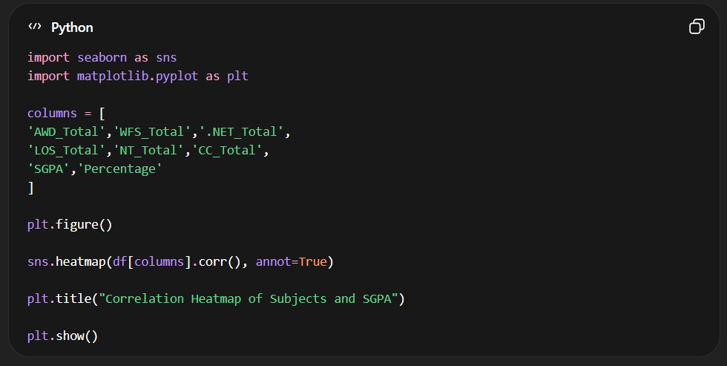
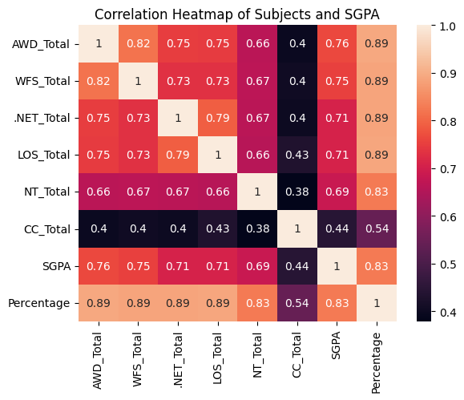
Interpretation :
The heatmap illustrates the strength of relationships between subject marks, SGPA, and percentage. Higher positive correlations suggest that strong performance in those subjects contributes significantly to overall academic achievement.

10.3 Radar Chart of Subject Performance by Result :
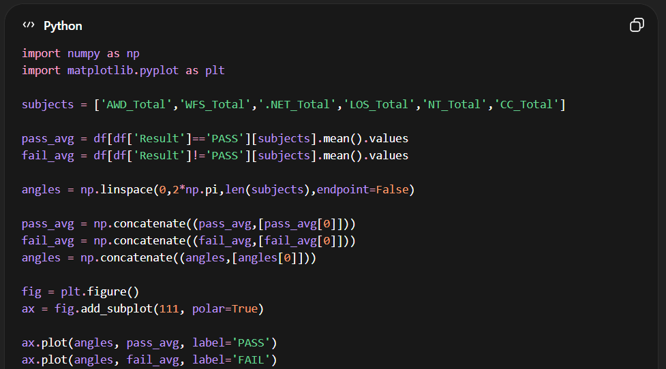
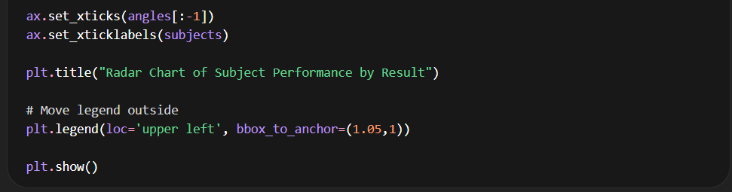
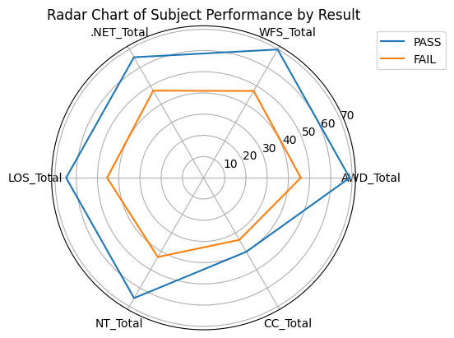
Interpretation :
The radar chart visualizes differences in subject-wise performance between passing and failing students. Subjects where failing students score significantly lower indicate areas that may contribute most to academic failure.

10.4 Pair Plot (Scatter Matrix) of Core Subjects :
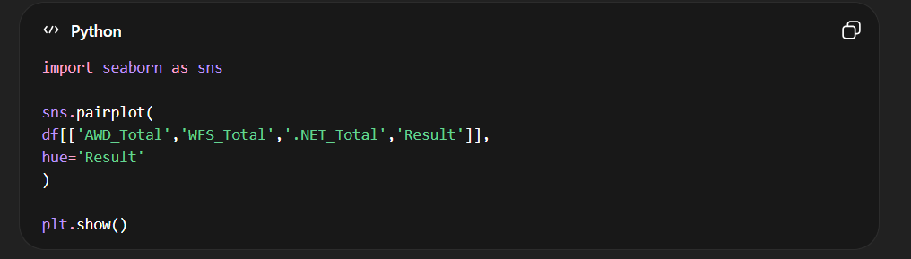

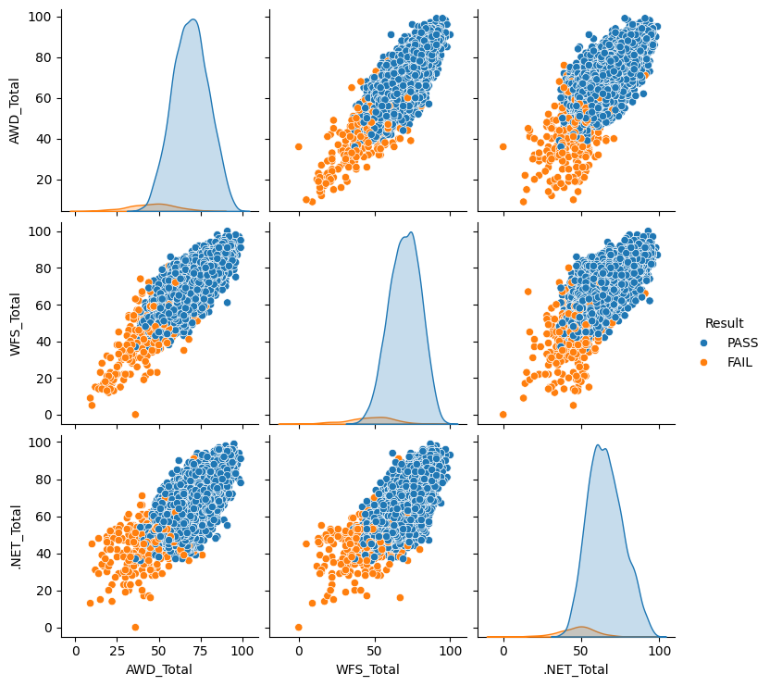
Interpretation
The pair plot provides a comprehensive view of relationships between core subjects. The color differentiation highlights clusters of passing and failing students, helping identify subject performance patterns associated with academic success.
Chapter 11: Data Visualization Using Sweetviz
Data visualization plays a crucial role in understanding patterns, trends, and relationships within a dataset. Instead of manually creating multiple charts, the Sweetviz library was used to generate an automated exploratory data analysis (EDA) report. Sweetviz provides an interactive visualization dashboard that summarizes dataset characteristics including distributions, correlations, missing values, and variable relationships.
The generated report provides a comprehensive overview of student performance data in an easy-to-understand visual format.

11.1 Sweetviz Library Overview :
Sweetviz is a Python library designed for automated exploratory data analysis. It generates an interactive HTML report containing statistical summaries and visualizations for all variables in a dataset.
Key features include:
- Variable distribution visualization
- Target variable analysis
- Correlation analysis
- Missing value detection
- Feature comparison
- Automatic chart generation
This tool significantly reduces the effort required to manually create multiple charts for dataset exploration.
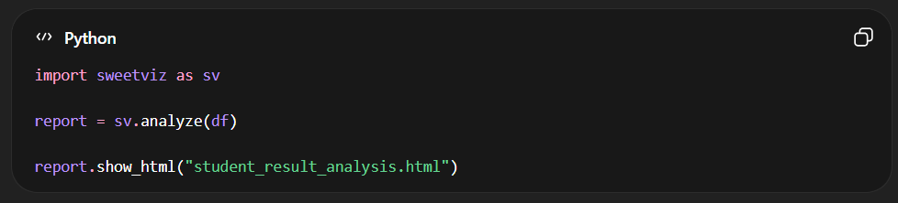
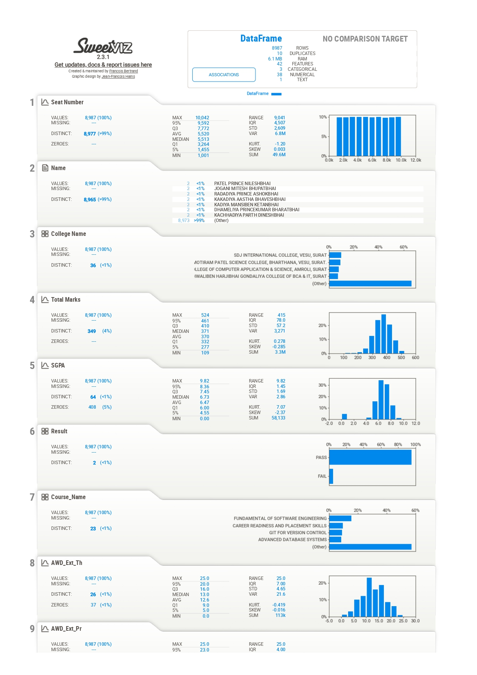
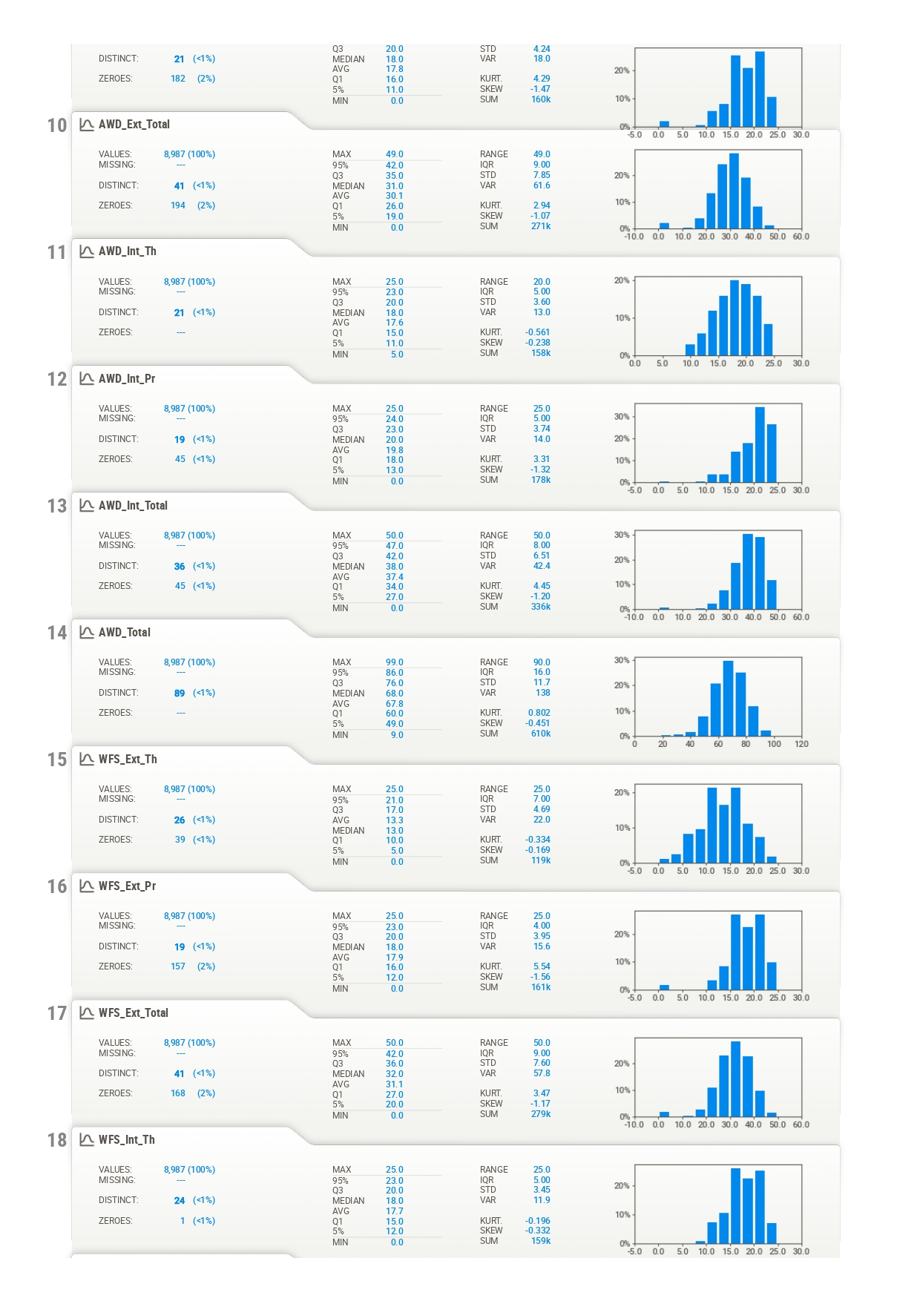
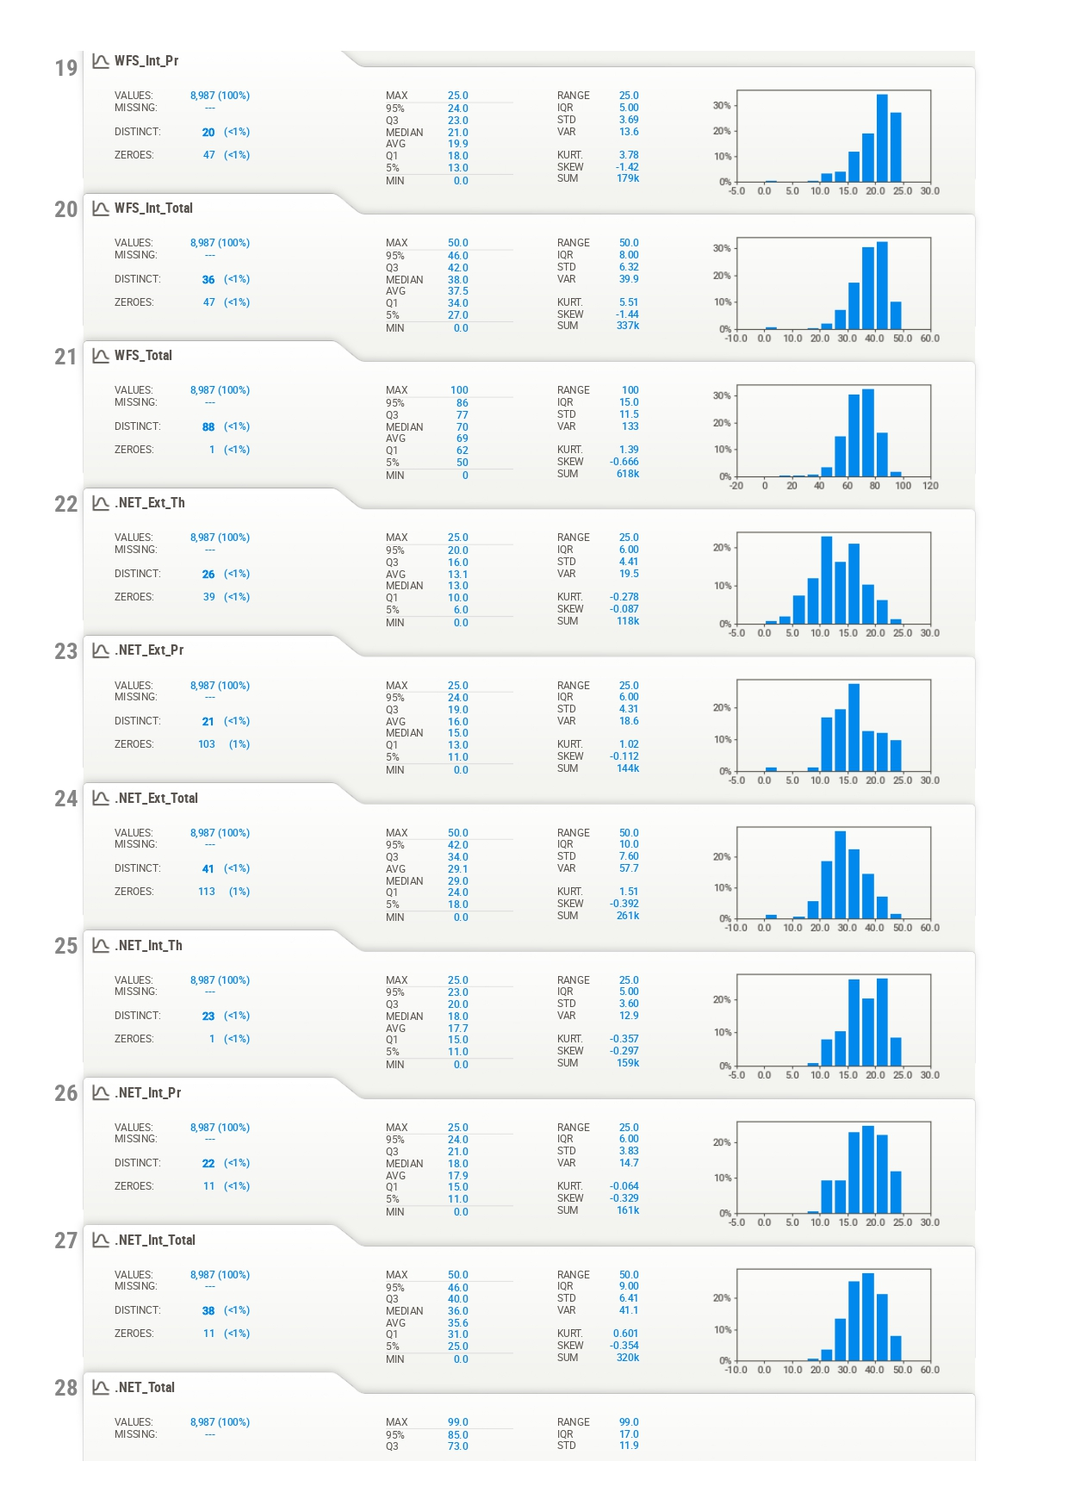
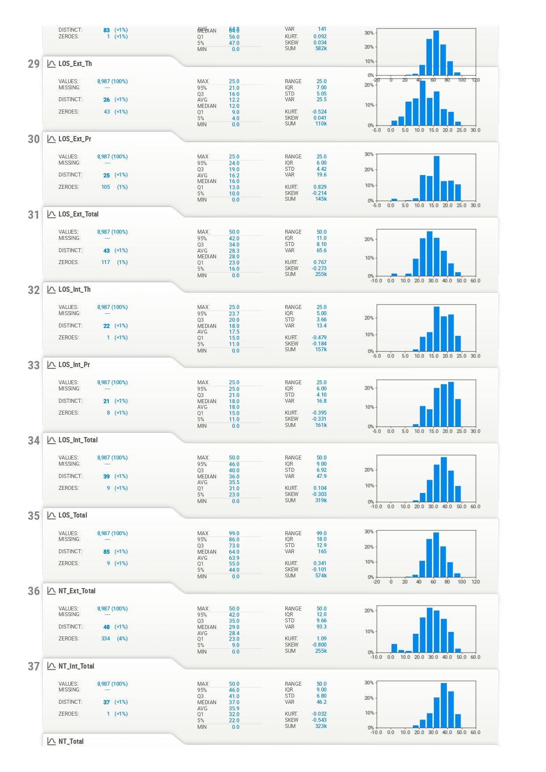
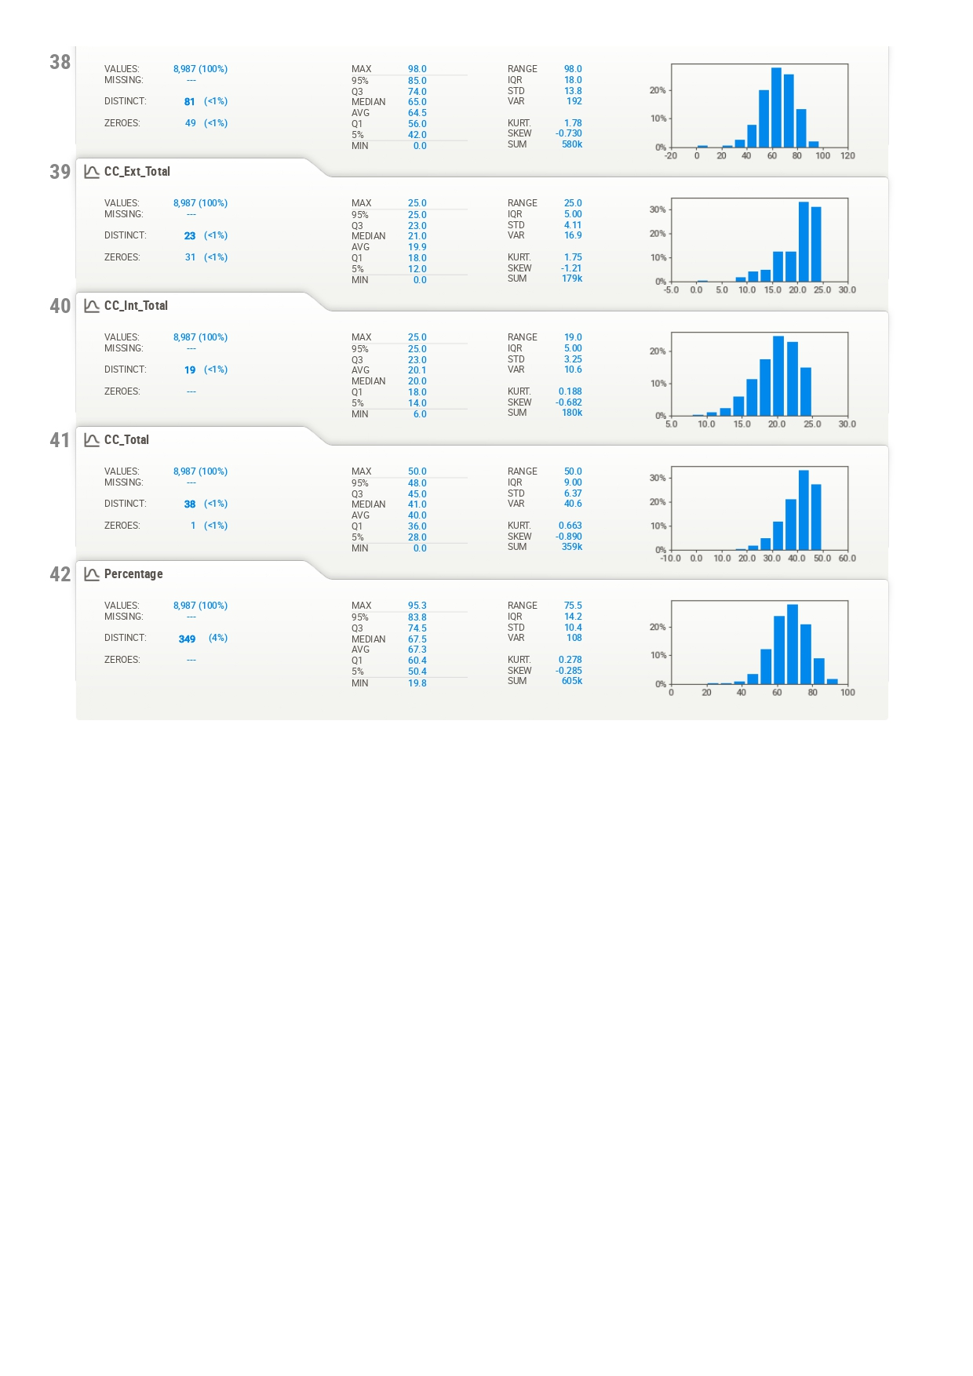

Chapter 12 Machine Learning Implementation :
In this chapter, the Python implementation used for student performance clustering is presented.
The code performs the following steps:
- Import required libraries
- Load cleaned dataset
- Check missing values
- Standardize features
- Apply K-Means Clustering
- Determine optimal clusters using Elbow Method
- Assign clusters to students
- Label clusters based on performance
- Visualize clusters using PCA
- Evaluate clustering using Silhouette Score
- Save trained model and results

12.1 Import Required Libraries :
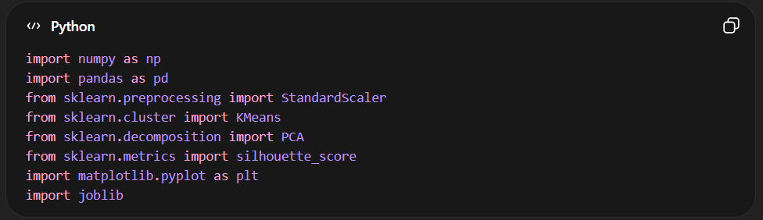

12.2 Load Dataset :
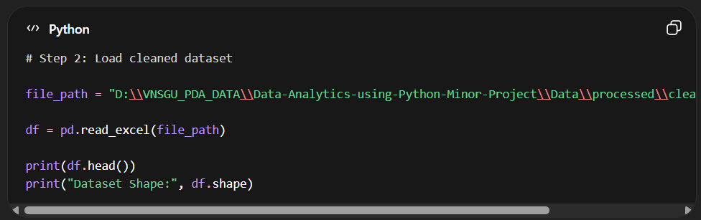

12.3 Select Features for Clustering :
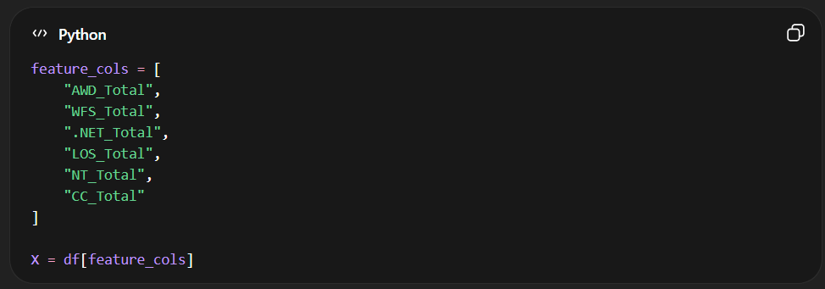

12.4 Check Missing Values :
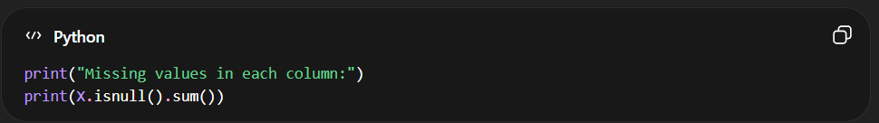

12.5 Standardize the Data :
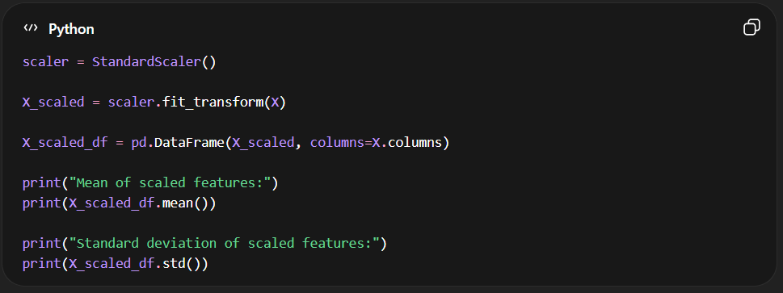
12.6 Determine Optimal Clusters using Elbow Method :
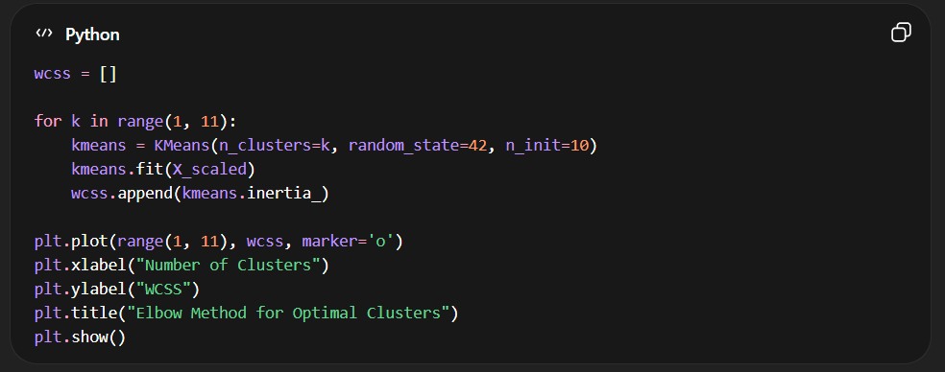

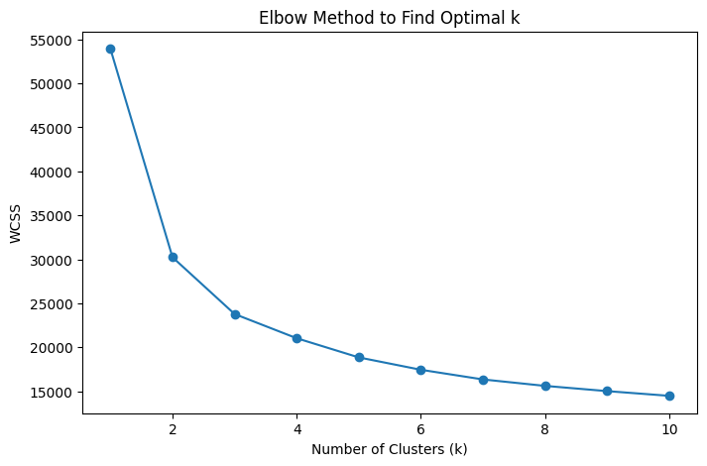

12.7 Apply K-Means Clustering :
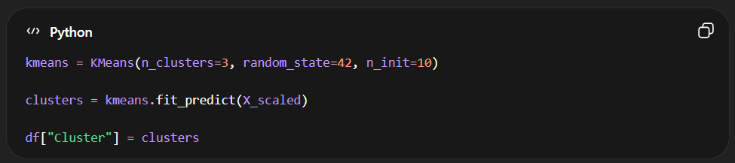

12.8 Count Students in Each Cluster :
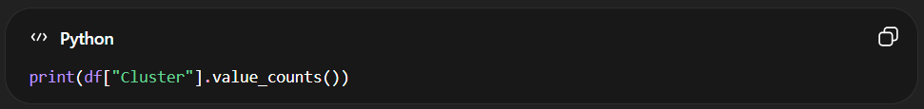

12.9 Cluster-wise Performance Summary :
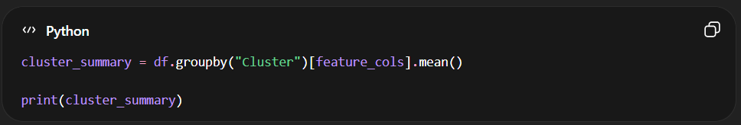

12.10 Assign Performance Labels :
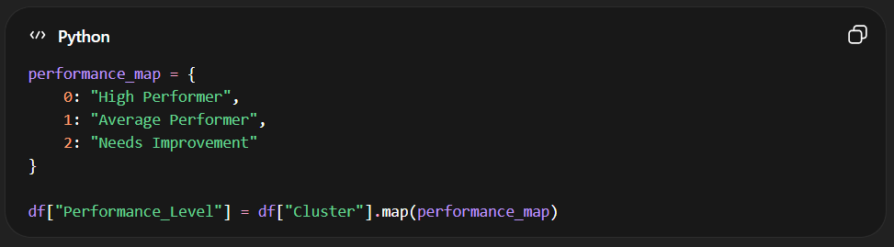

12.11 PCA Visualization :
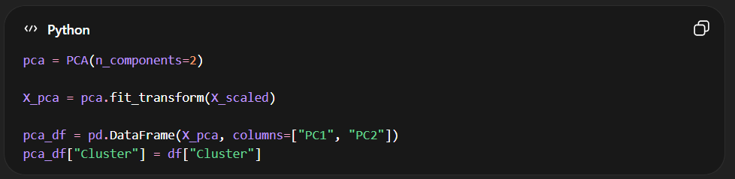

12.12 Plot Cluster Visualization :
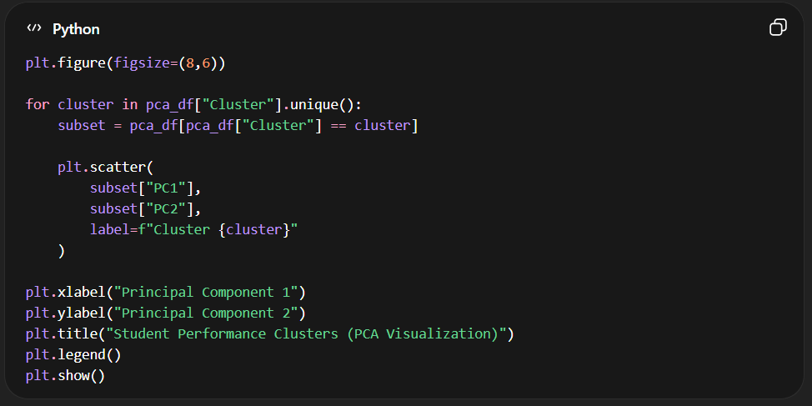
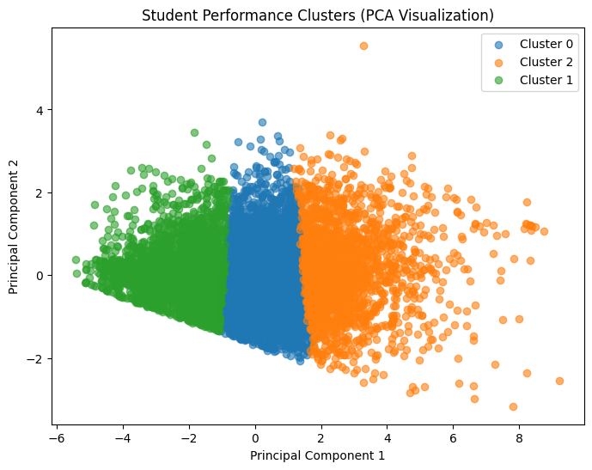

12.13 Performance Distribution Chart:
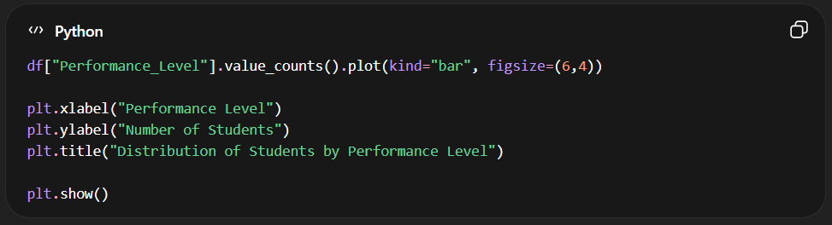
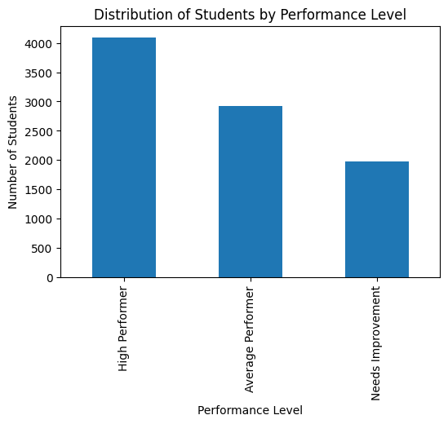

12.14 Evaluate Model using Silhouette Score :
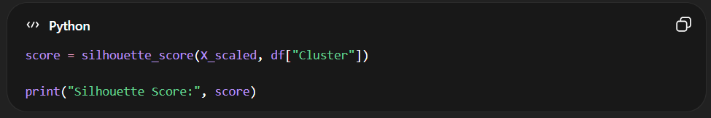

12.15 Save Model and Results :
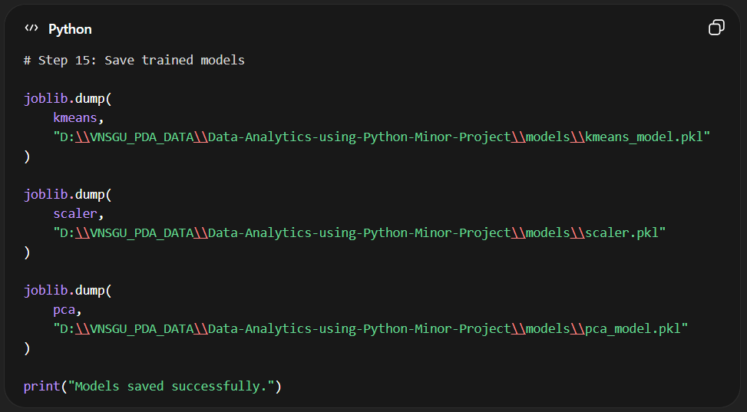

12.16 Student Performance Prediction Script :
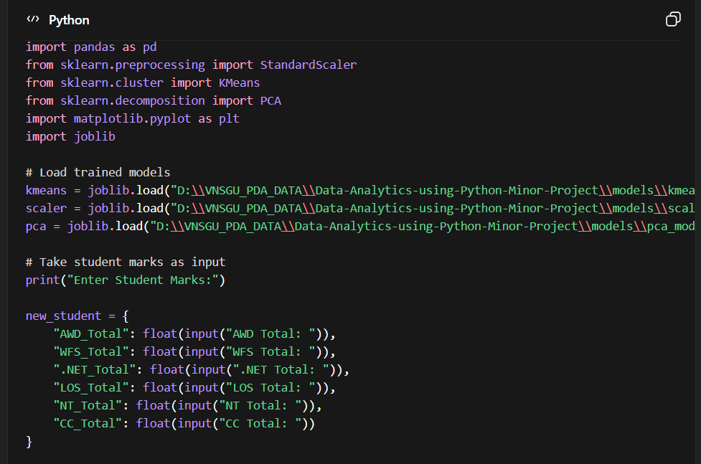
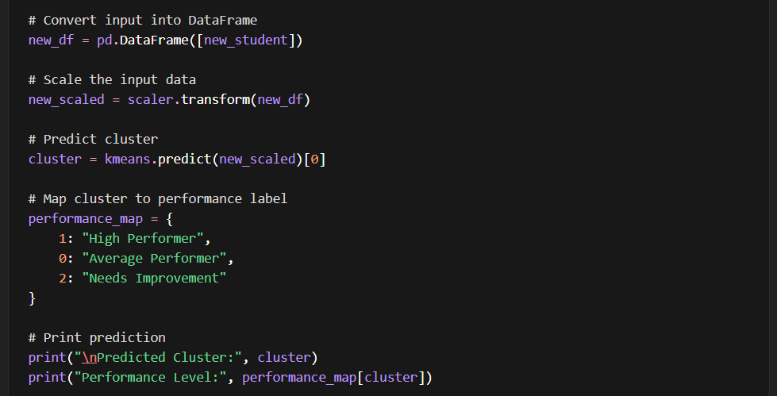

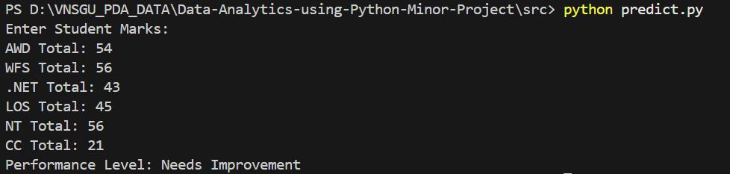

Chapter 13 Conclusion :
By applying different data analysis techniques and based on the statistical and visual results, we have reached the following conclusions:
- The majority of students fall within the average academic performance range, indicating balanced overall academic results.
- Most students scored between 55% and 75%, which represents moderate to good academic performance.
- The pass rate is significantly higher than the fail rate, showing satisfactory academic outcomes in the dataset.
- Network Technology (NT) has the highest number of failures, indicating that it is comparatively the most difficult subject for students.
- Cloud Computing (CC) has the lowest number of failures, suggesting stronger student performance in this subject.
- A strong positive correlation exists between subject marks, SGPA, and percentage, indicating that good performance in individual subjects contributes significantly to overall academic success.
- Students who passed generally obtained higher total marks and percentages, while failing students are concentrated in the lower score ranges.
- The K-Means clustering model successfully categorized students into three performance groups: High Performer, Average Performer, and Needs Improvement, helping to identify academic performance patterns among students

Chapter 14: References :
• Python Official Documentation
https://docs.python.org/3/

• Pandas Official Documentation
https://pandas.pydata.org/docs/

• NumPy Official Documentation
https://numpy.org/doc/

• Seaborn Documentation
https://seaborn.pydata.org/

• Matplotlib Documentation
https://matplotlib.org/stable/index.html

• Scikit-learn Documentation
https://scikit-learn.org/stable/

• VNSGU Student Result Portal (Dataset Source)
https://ums.vnsgu.net/Result/StudentResultDisplay.aspx?HtmlURL=7596,0000

• UCI Machine Learning Repository
https://archive.ics.uci.edu/

• GeeksforGeeks – Machine Learning Tutorials
https://www.geeksforgeeks.org/machine-learning/

