Marwadi University
Faculty of Computer Applications

BCA 4E Python CSE Exam

Enrollment No. : 92400527297
Name : yug patel
Class : bca 4e
Date : 3-apr-2026

Answer – 1
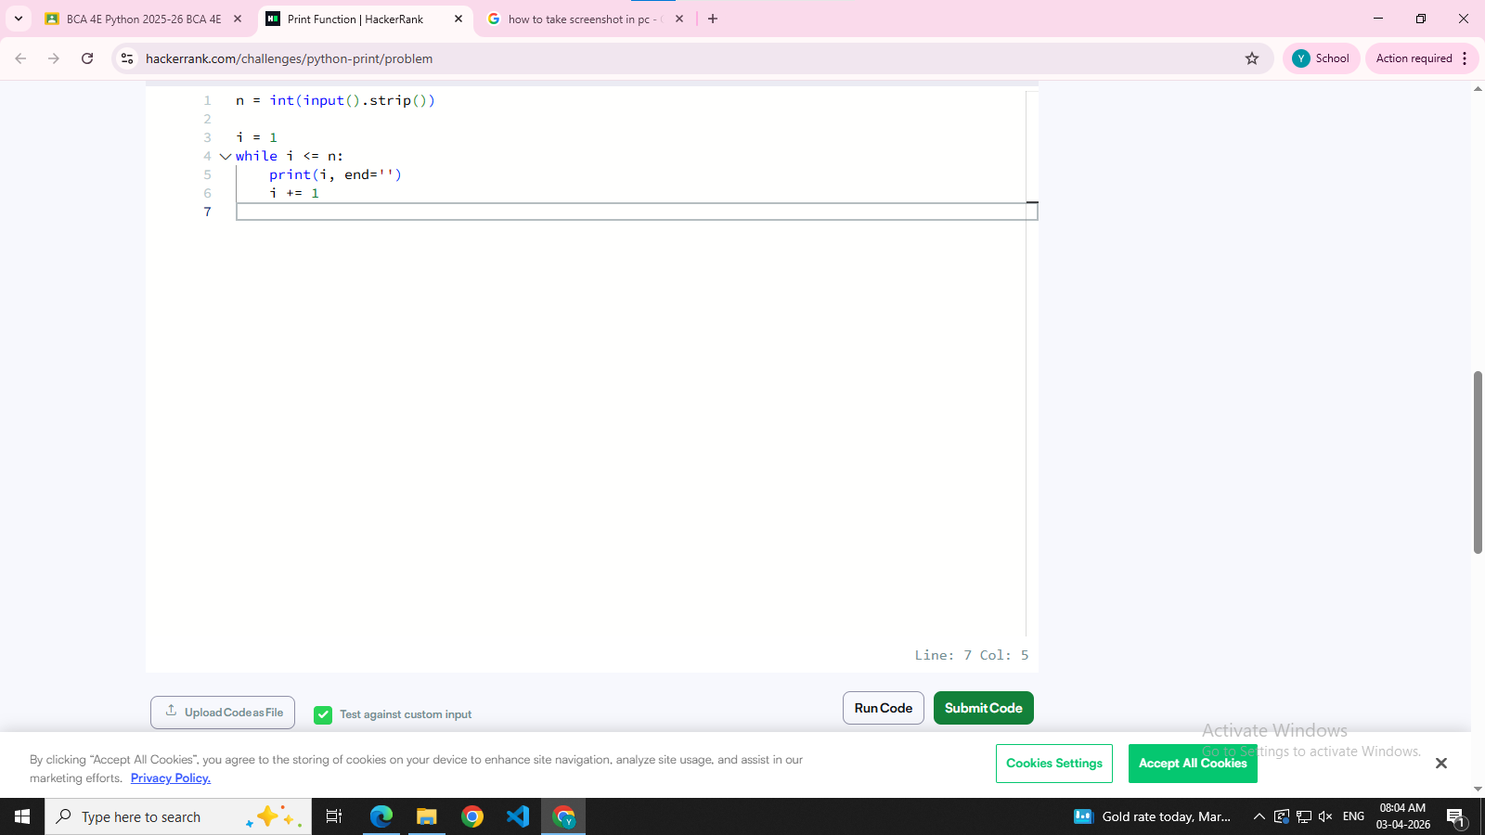
Answer – 2
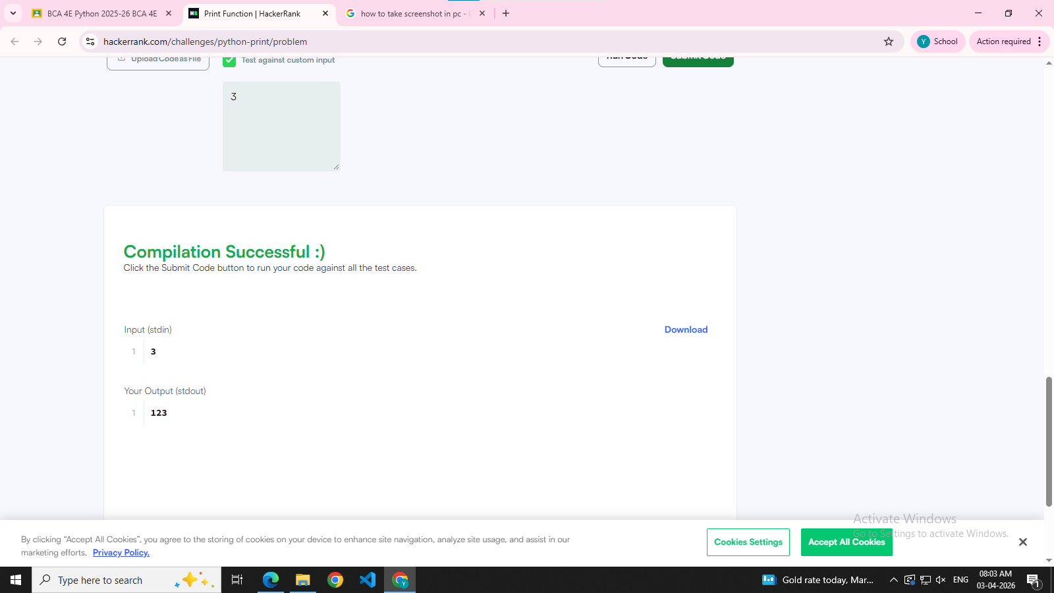
Answer – 3

Answer – 4

Answer - 5

