CsEUE203-OOP(JAVA)

PROBLEM:- 1(1) | - Vending machine (VendingMachine.java, main in this file)  - Define an enum Coin with constants ONE, TWO, FIVE, TEN.  - In main, set a snack price of 15 and a running total of 0; create a Scanner.  - Loop: read a coin name, use a switch expression to convert the Coin to its value (ONE→1, TWO→2, FIVE→5, TEN→10), add it to the total, and print the total so far.  - Stop the loop once the total reaches 15 or more.  - Print the change to return (total − 15).  Expected output: TEN then FIVE prints “Paid. Change: 0”; TEN then TEN prints  “Paid. Change: 5”.
CODE :- | import java.util.*;  enum Coin{ ONE, TWO, FIVE, TEN  }  public class VendingMachine {  public static void main(String args[]){ int total = 15;  int sum = 0;  Scanner sc = new Scanner(System.in);  while(sum < total){  System.out.println("ONE | TWO | FIVE | TEN "); String c = sc.nextLine();  Coin myC = Coin.valueOf(c); switch (myC) {  case ONE: sum += 1; break;  case TWO: sum += 2; break;  case FIVE: sum += 5; break;  case TEN: sum += 10; break;

default: break;
}
}

int last = sum - total; System.out.print(last);

sc.close();
}
}
OUTPUT :- | 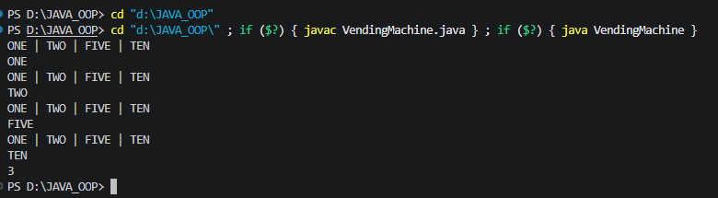
Problame_1.2 | Toll booth (TollBooth.java, main in this file)  - Define a record Vehicle(String number, String type).  - In main, keep a running toll total and three counters (bike, car, truck).  - Loop until the user types “done” for the number: build a Vehicle, use a switch expression on its type for the toll (bike→20, car→50, truck→150), add to the total, and increment that type’s counter.  - After the loop, print the total toll and the type with the highest count. Expected output: two cars + one bike → “Total toll: 120”, “Most frequent: car”.
CODE:- | import java.util.*; public class TollBooth {  public static int Vehicle(int number, String type) { int n = 0;  if (type.equals("B")) { n = number * 20;  } else if (type.equals("C")) { n = number * 50;  } else if (type.equals("T")) { n = number * 150;  }  return n;  }  public static void main(String args[]) { Scanner sc = new Scanner(System.in); int sum = 0;  while (true) {  System.out.print("Bike : B | Car : C | Truck : T | Exit : Q ");

String veh = sc.nextLine(); if (veh.equals("Q")) break;
System.out.print("Enter number of vehicles: "); int num = sc.nextInt();
sc.nextLine();

sum += Vehicle(num, veh);
}

System.out.println("Total Toll Collected: " + sum); sc.close();
}
}
OUTPUT:- | 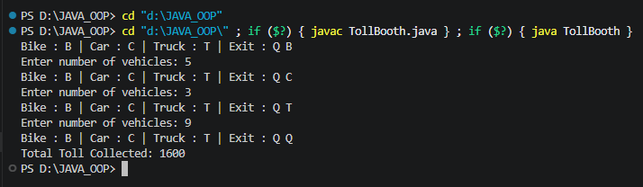
Problame_1.3 | (For Advanced Learners – home) Rock-Paper-Scissors-Lizard-Spock (RPSLS.java)  - Define an enum Move with ROCK, PAPER, SCISSORS, LIZARD, SPOCK.  - Write winner(Move a, Move b) returning 1 if a beats b, -1 if b beats a, 0 for a tie — use a switch expression listing what each move beats (Scissors cut Paper, Paper covers Rock, Rock crushes Lizard, Lizard poisons Spock, Spock smashes Scissors,  and the five mirror cases).  - In main, play 5 rounds: pick a random computer Move, read the player’s Move, call winner(), print the round result and keep score.  - After 5 rounds, print the overall winner.  Expected output: each round prints both moves and the round winner; ends with a “You win 3–2” summary.
CODE:- | import java.util.*; class RPSLS  {  enum Move{ROCK,PAPER,SCISSORS,LIZARD,SPOCK}  static int winner(Move a, Move b)  {  if(a==b) return 0; switch (a)  {  case ROCK:  if(b==Move.SCISSORS || b==Move.LIZARD) return 1;  else return -1;

case PAPER: if(b==Move.ROCK||b==Move.SPOCK) return 1;
else return -1;
case SCISSORS: if(b==Move.PAPER||b==Move.LIZARD) return 1;
else return -1;
case LIZARD: if(b==Move.PAPER||b==Move.SPOCK) return 1;
else return -1;
case SPOCK: if(b==Move.ROCK||b==Move.SCISSORS) return 1;
else return -1;
}
return 0;
}

public static void main(String arg[])
{
Scanner sc=new Scanner(System.in); Random r=new Random();
Move moves[]=Move.values(); int playerScore=0,compScore=0; for(int i=1;i<=5;i++)
{
System.out.println("Enter your move:");
Move player=Move.valueOf(sc.next().toUpperCase()); Move computer=moves[r.nextInt(moves.length)]; System.out.println("Your move:"+player); System.out.println("Computer move:"+computer); int result=winner(player,computer);
if(result==1)
{
System.out.println("You won!"); playerScore++;
}
else if(result==-1)
{
System.out.println("Computer won!"); compScore++;
}
else
System.out.println("It's a tie!");
}
System.out.println("\nFinal Score:");

System.out.println("Your Score:"+playerScore); System.out.println("Computer's Score:"+compScore); if(playerScore>compScore)
System.out.println("You are the final winner!"); else if(playerScore<compScore) System.out.println("Computer is the final winner!"); else
System.out.println("It's a Tie!");
}
}
OUTPUT | 