AN ANALYSIS OF PORTUGUESE BANK MARKETING DATA

The George Washington University (DATS 6103: An Introduction to Data Mining)

TEAM 11: Anjali Mudgal, Guoshan Yu, Medhasweta Sen

December 20, 2022

# INTRODUCTION

Bank marketing is the practice of attracting and acquiring new customers through traditional media and digital media strategies. The use of these media strategies helps determine what kind of customer is attracted to a certain institutions. This also includes different banking institutions purposefully using different strategies to attract the type of customer they want to do business with.

Marketing has evolved from a communication role to a revenue generating role. The consumer has evolved from being a passive recipient of marketing messages to an active participant in the marketing process. Technology has evolved from being a means of communication to a means of data collection and analysis. Data analytics has evolved from being a means of understanding the consumer to a means of understanding the consumer and the institution.

Bank marketing strategy is increasingly focused on digital channels, including social media, video, search and connected TV. As bank and credit union marketers strive to promote brand awareness, they need a new way to assess channel ROI and more accurate data to enable personalized offers. Add to that the growing importance of purpose-driven marketing.

The relentless pace of digitization is disrupting not only the established order in banking, but bank marketing strategies. Marketers at both traditional institutions and digital disruptors are feeling the pressure.

Just as bank marketers begin to master one channel, consumers move to another. Many now toggle between devices on a seemingly infinite number of platforms, making it harder than ever for marketers to pin down the right consumers at the right time in the right place.

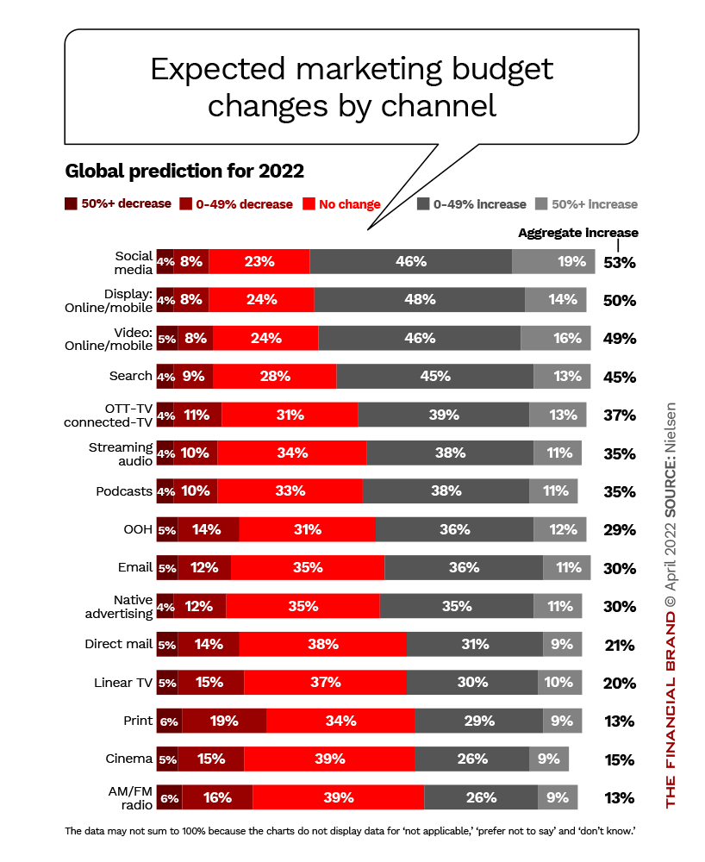

## The Data Set

The data set used in this analysis is from a Portuguese bank. The data set contains 41,188 observations and 21 variables. The variables include the following:

* + age (numeric)
  + job : type of job (categorical: ‘admin.’,‘blue-collar’,‘entrepreneur’,‘housemaid’,‘management’,‘retired’,‘self-employed’,‘services’,‘student’,‘technician’,‘unemployed’,‘unknown’)
  + marital : marital status (categorical: ‘divorced’,‘married’,‘single’,‘unknown’; note: ‘divorced’ means divorced or widowed)
  + education (categorical: ‘basic.4y’,‘basic.6y’,‘basic.9y’,‘high.school’,‘illiterate’,‘professional.course’,‘university.degree’,‘unknown’)
  + default: has credit in default? (categorical: ‘no’,‘yes’,‘unknown’)
  + housing: has housing loan? (categorical: ‘no’,‘yes’,‘unknown’)
  + loan: has personal loan? (categorical: ‘no’,‘yes’,‘unknown’)
  + contact: contact communication type (categorical: ‘cellular’,‘telephone’)
  + month: last contact month of year (categorical: ‘jan’, ‘feb’, ‘mar’, …, ‘nov’, ‘dec’)
  + day_of_week: last contact day of the week (categorical: ‘mon’,‘tue’,‘wed’,‘thu’,‘fri’)
  + duration: last contact duration, in seconds (numeric). Important note: this attribute highly affects the output target (e.g., if duration=0 then y=‘no’). Yet, the duration is not known before a call is performed. Also, after the end of the call y is obviously known. Thus, this input should only be included for benchmark purposes and should be discarded if the intention is to have a realistic predictive model.
  + campaign: number of contacts performed during this campaign and for this client (numeric, includes last contact)
  + pdays: number of days that passed by after the client was last contacted from a previous campaign (numeric; 999 means client was not previously contacted)
  + previous: number of contacts performed before this campaign and for this client (numeric)
  + poutcome: outcome of the previous marketing campaign (categorical: ‘failure’,‘nonexistent’,‘success’)
  + emp.var.rate: employment variation rate - quarterly indicator (numeric)
  + cons.price.idx: consumer price index - monthly indicator (numeric)
  + cons.conf.idx: consumer confidence index - monthly indicator (numeric)
  + euribor3m: euribor 3 month rate - daily indicator (numeric)
  + nr.employed: number of employees - quarterly indicator (numeric)
  + balance - average yearly balance, in euros (numeric)
  + y - has the client subscribed a term deposit? (binary: ‘yes’,‘no’)

## The SMART Questions

 The SMART questions are as follows:

1.Relationship between subscribing the term deposit and how much the customer is contacted (last contact, Campaign, Pdays, Previous Number of contacts)

1. Find out the financially stable population? Will that affect the outcome?

3.Effect of dimensionality reduction on accuracy of the model.

1. How are the likelihood of subscriptions affected by social and economic factors?

Throughout the paper we would try to answer the questions

Importing the required libraries

## Importing the dataset

## Basic Information about the data

Shape of dataset is : (45211, 23)  
<class 'pandas.core.frame.DataFrame'>  
RangeIndex: 45211 entries, 0 to 45210  
Data columns (total 23 columns):  
 # Column Non-Null Count Dtype   
--- ------ -------------- -----   
 0 age 45211 non-null int64   
 1 job 45211 non-null object   
 2 marital 45211 non-null object   
 3 education 45211 non-null object   
 4 default 45211 non-null object   
 5 balance 45211 non-null int64   
 6 housing 45211 non-null object   
 7 loan 45211 non-null object   
 8 contact 45211 non-null object   
 9 day 45211 non-null int64   
 10 month 45211 non-null object   
 11 duration 45211 non-null int64   
 12 campaign 45211 non-null int64   
 13 pdays 45211 non-null int64   
 14 previous 45211 non-null int64   
 15 poutcome 45211 non-null object   
 16 y 45211 non-null int64   
 17 month_int 45211 non-null int64   
 18 cons.conf.idx 45211 non-null float64  
 19 emp.var.rate 45211 non-null float64  
 20 euribor3m 45211 non-null float64  
 21 nr.employed 45211 non-null float64  
 22 cons.price.idx 45211 non-null float64  
dtypes: float64(5), int64(9), object(9)  
memory usage: 7.9+ MB  
Columns in dataset   
 None

# Exploratory Data Analysis (EDA)

## Distribution of y(target) variable

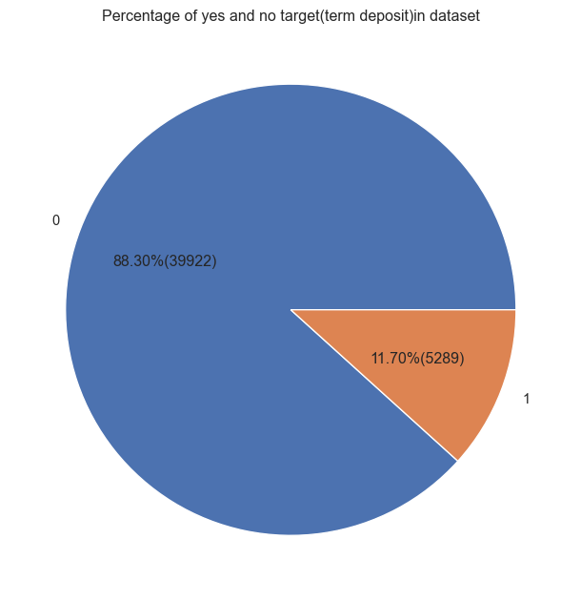

We have 45,211 datapoints, if our model predicts only 0 as output, we would still get 88% accuracy, so our dataset is unbalanced which may gives misleading results. Along with the accuracy, we will also consider precision and recall for evaluation.

## Missing values and Outliers

### Education

Here, even though we do not have any missing values but we have ‘unknown’ and ‘other’ as categories, so we will first get rid of them. The variables with ‘unknown’ rows are Education and Contact showned below.

Text(0.5, 1.0, 'Type of education Distribution')

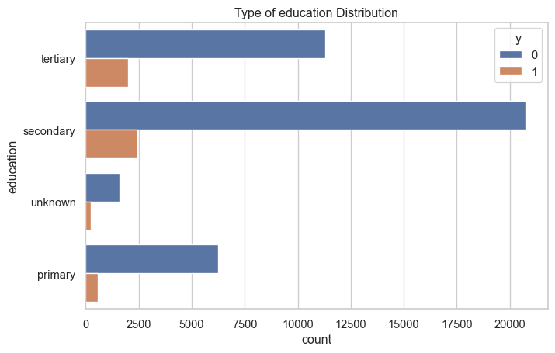

### Contact

Text(0.5, 1.0, 'Type of Contact Distribution')

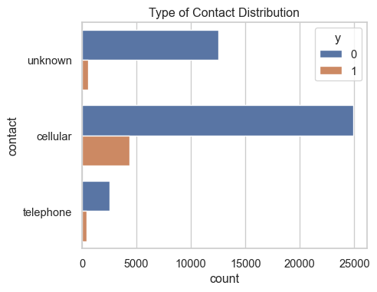

* since the type of communication(cellular and telephone) is not really a good indicator of subcription, we drop this variable.

### Poutcome

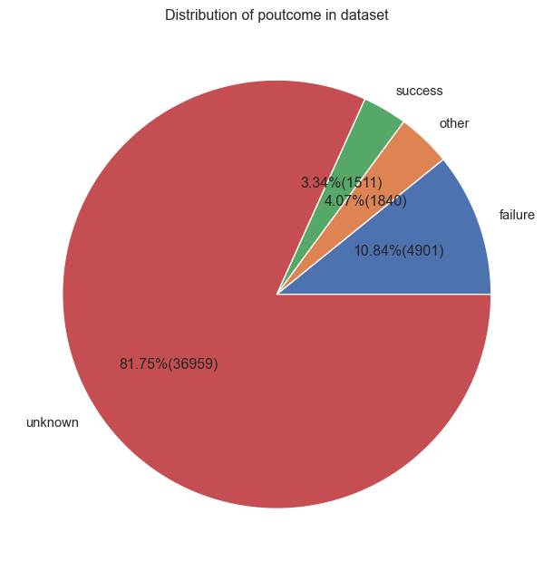

poutcome  
failure 4901  
other 1840  
success 1511  
unknown 36959  
dtype: int64

There are *36959 unknown* values(82%) and 1840 values with other(4.07% ) category, we will directly drop these columns.

## Outliers

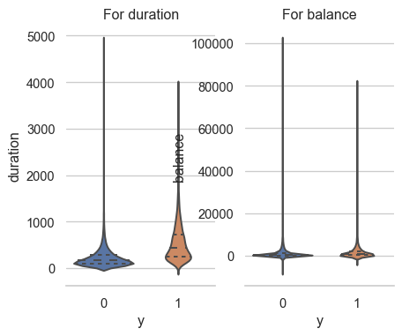

* There are outliers in duration and balance so we need to get rid of them.

# Data Cleaning

* Contact is not useful so we drop it.
* In poutcome, we have a lot of ‘unknown’ and ‘other’ values so we drop it.
* Day is not giving any relevant infomation so we drop it.
* Removing the unknowns from ‘job’ and ‘education’ columns.
* Remove the outliers from balance and duration.

## Dropping the irrelavant columns and missing values

for job  
unknown : 288  
dropping rows with value as unknown in job  
for education  
unknown : 1730  
dropping rows with value as unknown in education

## Outlier removal

We have outliers in balance and duration, so to get rid of them we would try to remove the enteries few standard deviation away, since from the histograms most of the enteries are around mean only, we are removing the enteries more than 3SD away.

### *Balance - Outliers*

removing entries before balance -7772.283533  
dtype: float64 and after balance 10480.338218  
dtype: float64

### *Duration - Outliers*

Dropping rows where the duration of calls is less than 5sec since that is irrelevant. And also since converting the call duration in minutes rather than seconds makes more sense we would convert it into minutes.

plotting violen plot for duration and balance after cleaning data

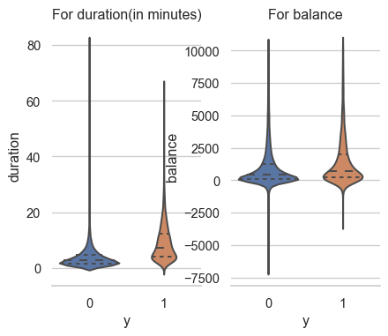

# Data Visualization

Let’ visualize important relationships between variables now.

## SMART Question 1 :

Relationship between subscribing the term deposit and how much the customer is contacted (last contact, Campaign, Pdays, Previous Number of contacts)

Answer : Based on last contact info only number of contacts performed during this campaign is contributing a lot towards subscription rates.

Suggestion: People who are contacted less than 5 times should be targeted more. Also, they could contact in less frequency in order to attract more target customers. The plot below shows the relationship between the number of calls and duration vs subscription

### Number of calls versus Duration and affect on subscription

Here if we notice, people are more likely to subscribe if the number of calls are less than 5.

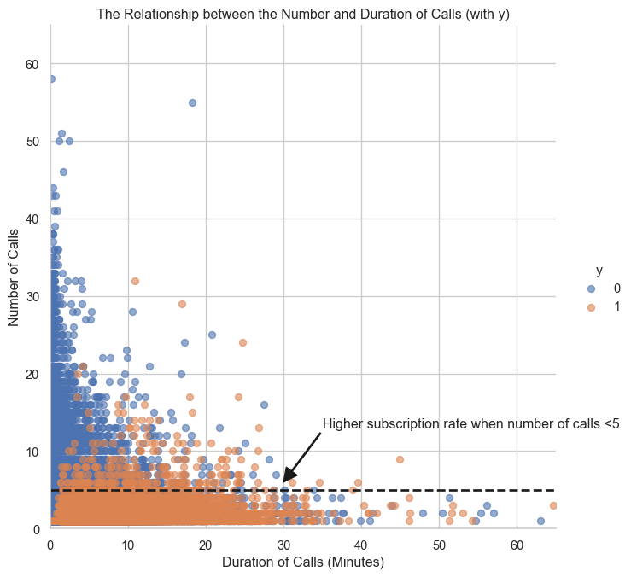

Checking between pdays and previous as well

Here as we can see from the t- test, t

* + pdays: number of days that passed by after the client was last contacted from a previous campaign (numeric; 999 means client was not previously contacted)
  + previous: number of contacts performed before this campaign and for this client (numeric)

We can notice from the plot that there is no relationship between subscription with pdays or previous. The datapoints are distrubuted randomly along the axies.

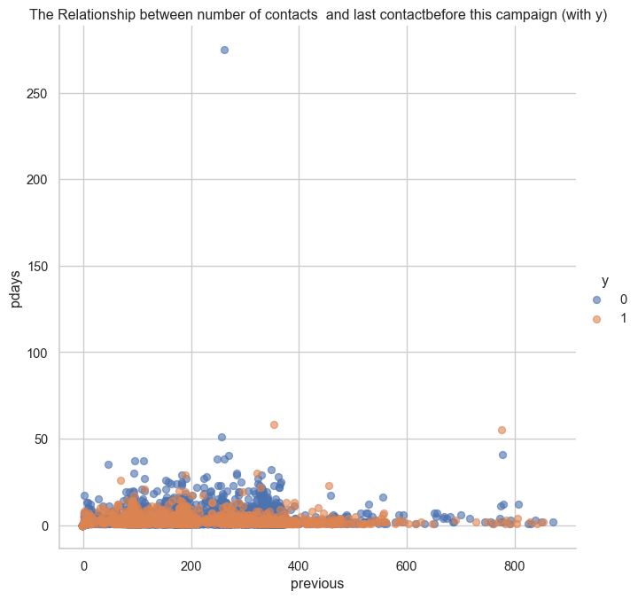

## Month wise subscription

Text(0.5, 0, 'Month')

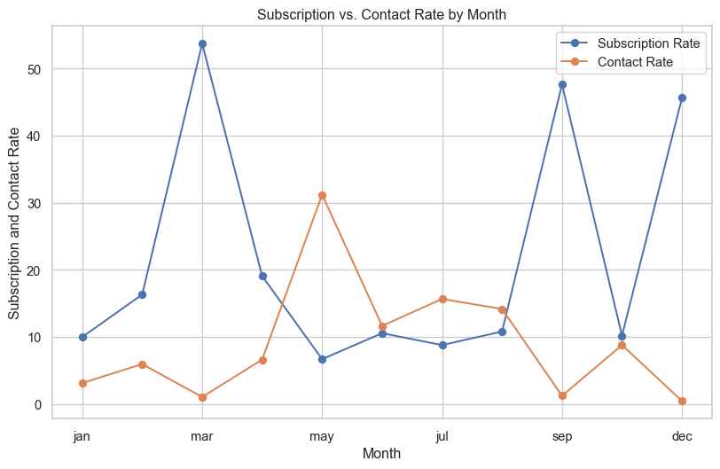

Maximum percentage of people have subscribed in the month of March but bank is contacting people more in the month of May.

**Suggestion**:So it’s better to contact customer’s based on the subcription rate plot.

### SMART Question 7: How are the likelihood of subscriptions affected by social and economic factors?

month cons.conf.idx emp.var.rate euribor3m nr.employed  
0 jan 1310 1310 1310 1310  
1 feb 2492 2492 2492 2492  
2 mar 439 439 439 439  
3 apr 2772 2772 2772 2772  
4 may 13050 13050 13050 13050  
5 jun 4874 4874 4874 4874  
6 jul 6550 6550 6550 6550  
7 aug 5924 5924 5924 5924  
8 sep 514 514 514 514  
9 oct 661 661 661 661  
10 nov 3679 3679 3679 3679  
11 dec 195 195 195 195

**Answer** : Based on the above table we can see that there is no distinguishable difference in the month of march or may from rest of all the month, so social and economic factor **do not have major influence** on the outcome.

### SMART Question 2

Find out the **financially stable** population? Will that affect the outcome?

We will try to find the financially stable population based on age, jobs, loan and balance.

### Loan

Text(0.5, 1.0, 'Type of loan Distribution')

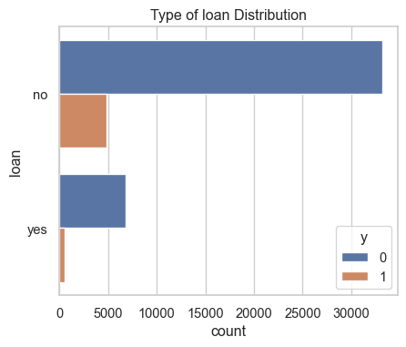

Text(0.5, 1.0, 'Type of housing Distribution')

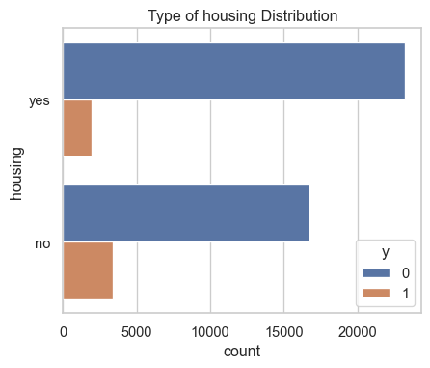

People with housing loans are less likely to subscribe to term deposit but the difference here is not huge.

Text(0.5, 1.0, 'Type of default Distribution')

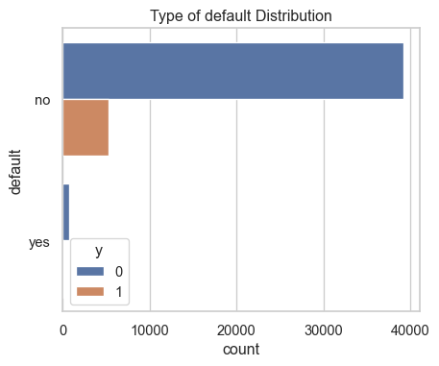

So people who have not paid back there loans and have credits, have not subcribed to the term deposit.

* people who have loans are subscribing to term deposit less.

### Age

Elder people might be more financially stable since they are subscriped to the term deposit more.

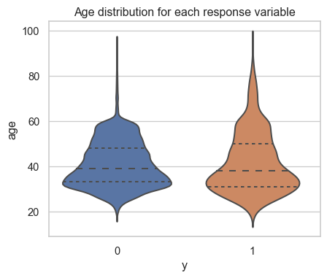

* People who are old are more likely to subscribe to term deposit.

### Job

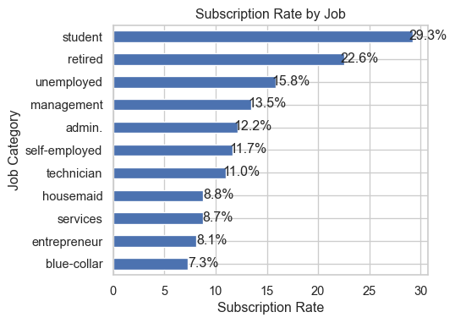

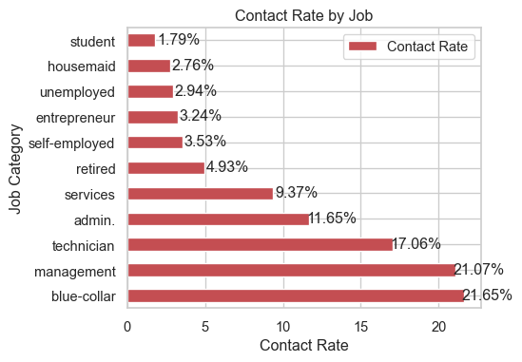

People in blue collar and management jobs are contacted more, which should not be the case. Since they have less subscription rates. Unlike popular assumption, students, retired and unemployment seem to have a high subscription rates. Even though they are contacted very less.

**suggestion**: The high subscripted rate group(students, retired and unemployment) should be contacted more.

### Balance

Checking the subscriptions in each balance groups

balGroup % Contacted % Subscription  
0 low balance 60.339143 10.503513  
1 moderate balance 17.399906 14.036275  
2 high balance 13.709374 16.715341  
3 Negative 8.551578 5.700909  
 balanceGroup Contact Rate Subscription Rate  
0 Negative 8.551578 5.700909  
1 low balance 60.339143 10.503513  
2 moderate balance 17.399906 14.036275  
3 high balance 13.709374 16.715341

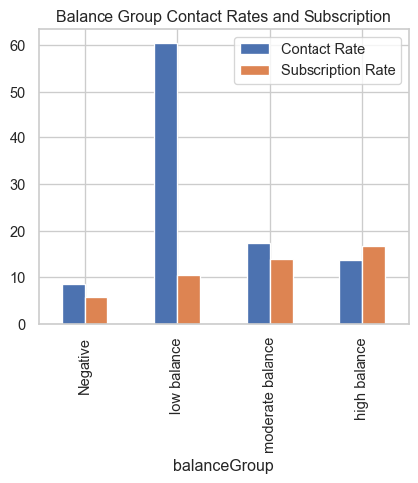

**suggestion**:People with moderate to high balance, are contacted less but they have high subscription rates so bank should target them more.

It might be possible that balance group and jobs are telling the same information since some jobs might have high salary and thus balance groups might be depicting jobs only, so we will try to look at them together.

Balance Group versus Job

Text(0.5, 1.0, 'Contact for each balance group in job category')

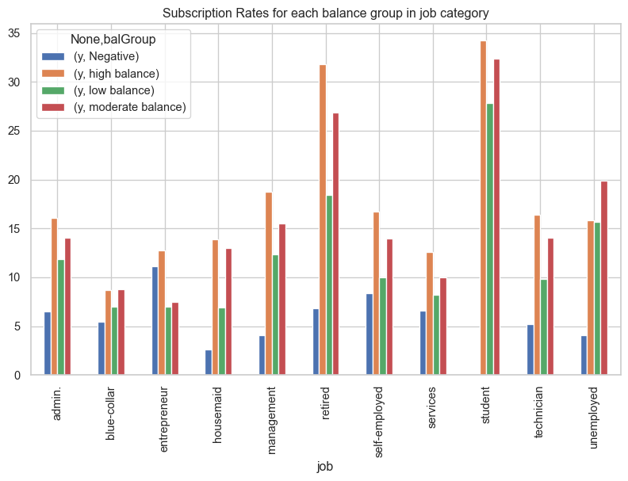

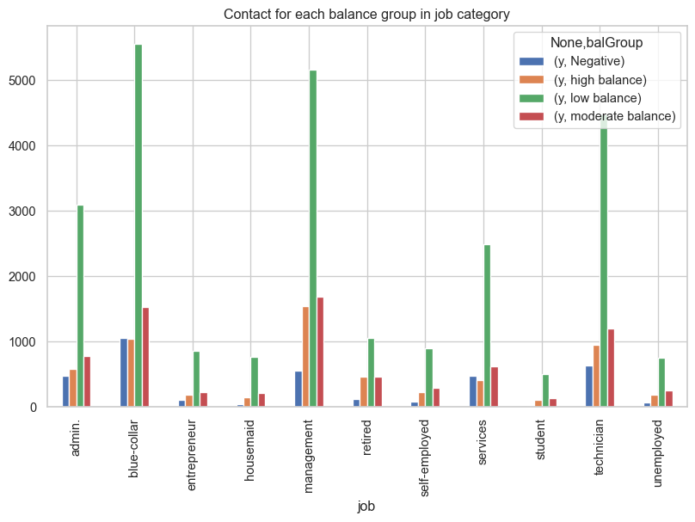

Student and Retired are more likely to subscribe and usually have moderate to high balance.

We found from the second bar chart that only the low balance groups are targeted in each category even though moderate to high balance category are more likely to subscribe.

# Data Encoding

## One Hot Encoding

We would encode ‘housing’,‘loan’,‘default’,‘job’,‘education’ and ‘marital’ as they are all categorical variables.

## Sin - Cos encoding

Transforming month into sin and cos so that there cyclic nature (jan-dec are as close as jan-feb) is retained which is usually lost in label encoding. Unlike one hot encoding, the dimension will reduce from 12(month_jan, month_feb … month_dec) to 2(sin_month , cos_month)

<AxesSubplot: xlabel='sin_month', ylabel='cos_month'>

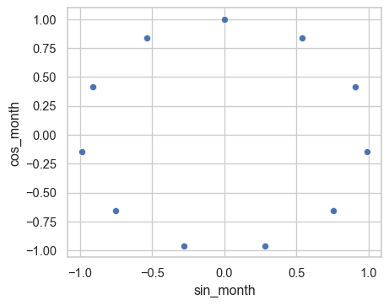

## Dropping unnecessary columns irrelevant for modelling

Here we dropped the ‘month’ column as they are encoded. Also, we dropped irrelvant variables ‘pdays’ and enconomic factors(‘cons.conf.idx’, ‘emp.var.rate’, ‘euribor3m’, ‘nr.employed’,‘cons.price.idx’) for modelling.

# Data Modeling

## Splitting our Dataset

We are splitting our dataset in 1:4 ratio for training and testing set.

## Balancing Our Dataset

We tried to balance our dataset using following methods:

* Upsampling using SMOTE
* Sin and cos transformation from month_int.

# Scaling numeric variables

Scaling age, balance, duration so that our algorithms perform better and all variables are treated equally. Since all three variables are in different scales, so we transform them into same standard.

# Logistic Regression

Performing Logistic Regression on both balanced and unbalanced dataset. RFE is used in selecting the most important features ## Unbalanced Dataset

Columns selected by RE ['duration', 'housing_no', 'housing_yes', 'loan_no', 'loan_yes', 'job_admin.', 'job_blue-collar', 'job_entrepreneur', 'job_housemaid', 'job_retired', 'job_self-employed', 'job_student', 'education_primary', 'education_tertiary', 'cos_month', 'age', 'balance', 'sin_month']

As we can see from RFE, the most relevant features are :

* Duration
* Housing
* Loan
* Job
* Education
* cos_month

From other features selection techniques and EDA, we can see that ‘age’ and ‘balance’ also contrubuted to the subscrption, so we added up these variables as well.

Applying model with selected features

Accuracy for training set 0.8918982571832312  
Accuracy for testing set 0.884950541686293  
Confusion matrix   
[[7335 150]  
 [ 827 180]]  
 precision recall f1-score support  
  
 0 0.90 0.98 0.94 7485  
 1 0.55 0.18 0.27 1007  
  
 accuracy 0.88 8492  
 macro avg 0.72 0.58 0.60 8492  
weighted avg 0.86 0.88 0.86 8492

Here, the accuracy is 89% but the precision(0.59) and recall rate value(0.20) is low. And we also check on the balanced dataset since the low recall rate might be caused because of the less number of y = 1 value.

# Balanced Dataset

Columns selected by RE ['housing_yes', 'loan_yes', 'job_blue-collar', 'job_entrepreneur', 'job_housemaid', 'job_management', 'job_self-employed', 'job_services', 'job_technician', 'job_unemployed', 'education_primary', 'education_secondary', 'marital_divorced', 'marital_married', 'marital_single']

Accuracy for training set 0.8830944224565138  
Accuracy for testing set 0.8224211022138483  
Confusion matrix   
[[6328 1157]  
 [ 351 656]]  
 precision recall f1-score support  
  
 0 0.95 0.85 0.89 7485  
 1 0.36 0.65 0.47 1007  
  
 accuracy 0.82 8492  
 macro avg 0.65 0.75 0.68 8492  
weighted avg 0.88 0.82 0.84 8492

Here, important features are * Housing * Loan * Job * Education * Marital Status

We also added the important features from unbalaced dataset * Duration * Age * Month * Balance

Here even though the precision and recall have improved, and accuracy has dropped down, but the important relationships are lost since the training data now is artificially generated datapoints. We will try to find the optimal cut-off value for original dataset and compare it with the model for balanced data.

### Deciding cut off value for logistic regression - Unbalance

But to have good values for cut-off we would try to find a cutoff where the precision and recall values are decent

Based on plot we would choose 0.25 as cut off   
Accuracy for testing set 0.8784738577484692  
Confusion matrix   
[[7016 469]  
 [ 563 444]]  
 precision recall f1-score support  
  
 0 0.93 0.94 0.93 7485  
 1 0.49 0.44 0.46 1007  
  
 accuracy 0.88 8492  
 macro avg 0.71 0.69 0.70 8492  
weighted avg 0.87 0.88 0.88 8492

|  |
| --- |
| Optimal Cutoff at 0.25 |

Here as after applying feature selection, finding optimized cut-off, we are able to achieve higher accuracy with optimal precision and recall. Resulting from the comparison, we would continue our modellings with unbalance dataset.

### Smart Question 5: The optimal cut off value for classification of our imbalance dataset.

**Answer**: The optimal cut off value for our imbalance dataset is 0.25 as the precision- recall chart indicated.

### SMART Question 2: Since the dataset is imbalanced, will down sampling/up sampling or other techniques improve upon the accuracy of models.

**Answer**: As observed from above there is a slight improvement in accuracy, precision and recall after we apply SMOTE, but that improvement can also be acheived by adjusting the cut off value as well. So, we should always try adjusting cut-off first, before upsampling.

For ROC - AUC curve refer (Figure 1).  
For precision recall curve refer(Figure 2).

# Decision Tree

## Feature Selection

Feature 0 variable age score 0.12  
Feature 1 variable balance score 0.16  
Feature 2 variable duration score 0.33  
Feature 3 variable campaign score 0.04  
Feature 4 variable previous score 0.05  
Feature 5 variable housing_no score 0.01  
Feature 6 variable housing_yes score 0.04  
Feature 12 variable job_blue-collar score 0.01  
Feature 15 variable job_management score 0.01  
Feature 20 variable job_technician score 0.01  
Feature 28 variable sin_month score 0.08  
Feature 29 variable cos_month score 0.03  
Important features from decision treee are :   
['age', 'balance', 'duration', 'campaign', 'previous', 'housing_no', 'housing_yes', 'job_blue-collar', 'job_management', 'job_technician', 'sin_month', 'cos_month']

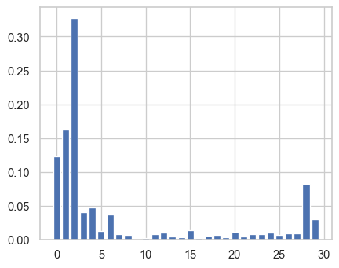

Features selected from this algorithm are

* Age
* Balance
* Duration
* Campaign
* Previous
* Housing
* Job
* Education
* Marital
* Month - Sin,cos

We have all the important features from EDA here

## Hyperparameter tuning

For tuning the hyperparameter’s we will use GridSearch CV.

Fitting 5 folds for each of 168 candidates, totalling 840 fits

Best parameters from Grid Search CV :   
{'criterion': 'entropy', 'max_depth': 6, 'max_features': None, 'splitter': 'best'}

Training model based on the parameters we got from Grid SearchCV.

0.8916627414036741  
[[7176 309]  
 [ 611 396]]  
 precision recall f1-score support  
  
 0 0.92 0.96 0.94 7485  
 1 0.56 0.39 0.46 1007  
  
 accuracy 0.89 8492  
 macro avg 0.74 0.68 0.70 8492  
weighted avg 0.88 0.89 0.88 8492

From the decision tree we have better precision, recall, accuracy and thus better f1 score. Hence, decision tree is performing better than logistic regression.

AUC Curve : Figure 1  
Precision Recall Curve : Figure 2

# Random Forest

## Feature Selection

Important features from random forest :  
['age', 'balance', 'duration', 'campaign', 'previous', 'housing_no', 'housing_yes', 'job_admin.', 'job_management', 'job_technician', 'education_secondary', 'education_tertiary', 'marital_married', 'marital_single', 'sin_month', 'cos_month']

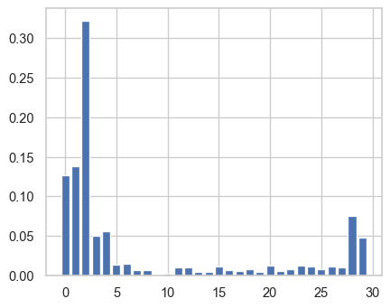

## Hyperparameter Tuning

Fitting 3 folds for each of 32 candidates, totalling 96 fits

{'bootstrap': True, 'max_depth': 110, 'max_features': 3, 'n_estimators': 1000}

Training accuracy 1.0  
Testing set accuracy 0.8951954780970325  
[[7243 242]  
 [ 648 359]]  
 precision recall f1-score support  
  
 0 0.92 0.97 0.94 7485  
 1 0.60 0.36 0.45 1007  
  
 accuracy 0.90 8492  
 macro avg 0.76 0.66 0.69 8492  
weighted avg 0.88 0.90 0.88 8492

We are getting best performance from Random Forest but we are not sure why we are getting such idealistic results so we would also apply cross validation to test our results

{'Training Accuracy scores': array([1., 1., 1., 1., 1.]),  
 'Mean Training Accuracy': 100.0,  
 'Training Precision scores': array([1., 1., 1., 1., 1.]),  
 'Mean Training Precision': 1.0,  
 'Training Recall scores': array([1., 1., 1., 1., 1.]),  
 'Mean Training Recall': 1.0,  
 'Training F1 scores': array([1., 1., 1., 1., 1.]),  
 'Mean Training F1 Score': 1.0,  
 'Validation Accuracy scores': array([0.90241389, 0.8971151 , 0.89785105, 0.89665832, 0.90328279]),  
 'Mean Validation Accuracy': 89.94642314134781,  
 'Validation Precision scores': array([0.62526767, 0.58672377, 0.59436009, 0.57677165, 0.64009112]),  
 'Mean Validation Precision': 0.6046428582347663,  
 'Validation Recall scores': array([0.37435897, 0.35128205, 0.35083227, 0.37564103, 0.36025641]),  
 'Mean Validation Recall': 0.3624741455727371,  
 'Validation F1 scores': array([0.46832398, 0.43945469, 0.44122383, 0.45496894, 0.46103363]),  
 'Mean Validation F1 Score': 0.4530010159118049}

After applying cross validation, we are getting some what real estimates.

AUC Curve : Figure 1  
Precision Recall Curve : Figure 2

# Linear SVC

Finding a linear hyperplane that tries to separate two classes.

0.8857748469147433  
[[7381 104]  
 [ 866 141]]  
 precision recall f1-score support  
  
 0 0.89 0.99 0.94 7485  
 1 0.58 0.14 0.23 1007  
  
 accuracy 0.89 8492  
 macro avg 0.74 0.56 0.58 8492  
weighted avg 0.86 0.89 0.85 8492

# SVC

Finding a complex hyperplane that tries to separate the classes.

0.8865991521431936  
[[7423 62]  
 [ 901 106]]  
 precision recall f1-score support  
  
 0 0.89 0.99 0.94 7485  
 1 0.63 0.11 0.18 1007  
  
 accuracy 0.89 8492  
 macro avg 0.76 0.55 0.56 8492  
weighted avg 0.86 0.89 0.85 8492

# Naive Bayes

Naive Bayes a naive assumption that all the features are independent of each other and thus by reducing the complexity of computing conditional probabilities it evaluates the probability of 0 and 1.

Fitting 10 folds for each of 100 candidates, totalling 1000 fits

GaussianNB(var_smoothing=0.0533669923120631)  
Model score is 0.886481394253415

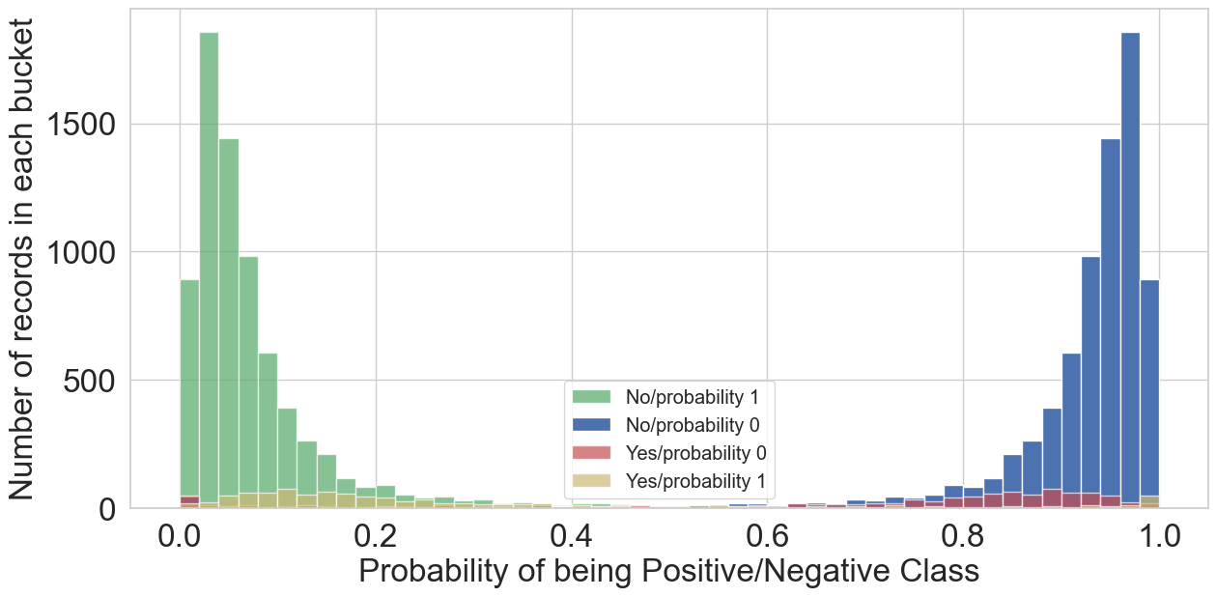

test set evaluation:   
0.886481394253415  
[[7293 192]  
 [ 772 235]]  
 precision recall f1-score support  
  
 0 0.90 0.97 0.94 7485  
 1 0.55 0.23 0.33 1007  
  
 accuracy 0.89 8492  
 macro avg 0.73 0.60 0.63 8492  
weighted avg 0.86 0.89 0.87 8492

## For balanced

For balanced dataset, as we can see there is a slight improvement in performance. The f1 score has improved and also, the yellow bars are now slightly shifted towards right side.

Model score is 0.4401789919924635

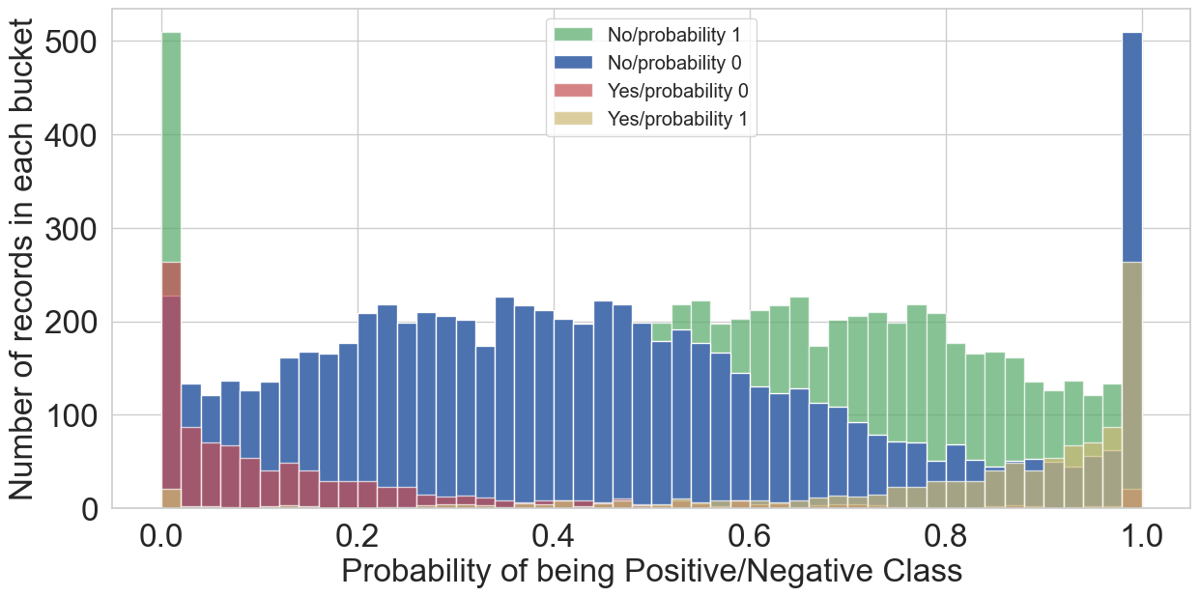

test set evaluation:   
0.4401789919924635  
[[2818 4667]  
 [ 87 920]]  
 precision recall f1-score support  
  
 0 0.97 0.38 0.54 7485  
 1 0.16 0.91 0.28 1007  
  
 accuracy 0.44 8492  
 macro avg 0.57 0.65 0.41 8492  
weighted avg 0.87 0.44 0.51 8492

As we can see from the graph for the red and yellow bars for yes(1 term deposit) are coming on the opposite sides which is not expected.

AUC Curve : Figure 1  
Precision Recall Curve : Figure 2

# KNN

Using the k - nearest neighbours we try to predict the testing dataset. Now to find the optimal k value we will look into precision and accuracy curve for different k values.

Maximum accuracy:- 0.8888365520489873 at K = 36

|  |
| --- |
| Accuracy curve for different k values |

Maximum Precision:- 0.2302337568649409 at K = 4

|  |
| --- |
| Precision curve for different k values |

Based on the above plot, optimal k value is 3, with maximum f1 score of 0.33.

Train set accuracy 0.9294924634950542  
Test set accuracy 0.8798869524258125  
[[7173 312]  
 [ 708 299]]  
 precision recall f1-score support  
  
 0 0.91 0.96 0.93 7485  
 1 0.49 0.30 0.37 1007  
  
 accuracy 0.88 8492  
 macro avg 0.70 0.63 0.65 8492  
weighted avg 0.86 0.88 0.87 8492

AUC Curve : Figure 1  
Precision Recall Curve : Figure 2

# ROC -AUC Curve

|  |
| --- |
| Figure 1: AUC ROC Curve for all Models |

# Precision Recall Curve

In imbalance problem since we have a high number of Negatives, this makes the False Posiitve Rate as low, resulting in the shift of ROC AUC Curve towards left, which is slightly misleading.

So in imbalance problem we usually make sure to look at precision recall curve as well.

|  |
| --- |
| Figure 2: Precision Recall Curve for all Models |

As per the ROC Curve and Precision Recall curve, KNN is performing best. But after combining these results with precision recall curve, we suggest using Random Forest for our problem.

# Summary

Table 1: Summary of Models

| Model | Accuracy | Precision | Recall | AUC |
| --- | --- | --- | --- | --- |
| Logistic(Cutoff=0.25) | 0.88 | 0.51 | 0.58 | 0.872 |
| Logistic (Balanced-Train) | 0.85 | 0.49 | 0.54 |  |
| Decision Tree | 0.91 | 0.66 | 0.47 | 0.923 |
| Random Forest | 0.88 | 0.66 | 0.46 | 0.913 |
| SVC | 0.89 | 0.75 | 0.15 |  |
| Linear SVC | 0.89 | 0.62 | 0.16 |  |
| Gaussian Bayes | 0.88 | 0.50 | 0.25 | 0.841 |
| KNN | 0.92 | 0.78 | 0.54 | 0.965 |
| Naive Bayes | 0.85 | 0.56 | 0.02 |  |
| Naive Bayes (Balanced-Train) | 0.69 | 0.19 | 0.35 |  |

See Table 1.

# Conclusion

Our model would be beneficial in the following ways :

* For target marketing for bank campaigns, or in other events. For example based on the customer’s job, age and loan history the model would can easily predict whether the customer is going to subscribe to the term deposit or not. So out of the million people, we can easily shortlist people based on our model and spend the time on them so as to improve efficiency.
* Improving buissness effficiency of banks. Since using the eda or model we can easily check the subscription insights, it would be very helpful for banks to improve their stratergies. For example, based on the monthly subscription rates, if banks are deciding the campaign promotion time, it can improve there efficiency.
* Since, we have month as a input factor in our model, and all other values are static, we can even find the best month to contact customer based on the predicted probability of the customer. As there can be a relation between the job type and the month they are subscribing or their fluctuating balance and age. This can be very useful in finding the best time to contact.
* Based on the model, since the number of contact is playing a major role, if we have the optimal time to contact them, we can restrict our calls to less than 5 and find a better turnover.
* We didn’t see any relation with the social and economic factors here, but if we had the data for multiple years, there was a possibility of finding a relation. Our model can accomodate these factors as well, and if trained by accomodating these factors as well, this can be helpful for banks in finding the proper time for there campaign.

Hence, analyzing this kind of marketing dataset has given us valuable insight into how we can tweak our model to give buisness insights as well as customer insights to improve subscription of term deposits.

# Reference

* https://www.kaggle.com/janiobachmann/bank-marketing-dataset
* (PDF) Data Analysis of a Portuguese marketing campaign using bank … (no date). Available at: https://www.researchgate.net/publication/339988208_Data_Analysis_of_a_Portuguese_Marketing_Campaign_using_Bank_Marketing_data_Set (Accessed: December 20, 2022).
* Bank marketing data set. (n.d.). 1010data.com. Retrieved December 20, 2022, from https://docs.1010data.com/Tutorials/MachineLearningExamples/BankMarketingDataSet_2.html
* Manda, H., Srinivasan, S., & Rangarao, D. (2021). IBM Cloud Pak for Data: An enterprise platform to operationalize data, analytics, and AI. Packt Publishing.
* Solving Bank Marketing Calssification Problem - Databricks. (n.d.). Databricks.com. Retrieved December 20, 2022, from https://databricks-prod-cloudfront.cloud.databricks.com/public/4027ec902e239c93eaaa8714f173bcfc/8143187682226564/2297613386094950/3186001515933643/latest.html
* Solving Bank Marketing Calssification Problem - Databricks. (n.d.). Databricks.com. Retrieved December 20, 2022, from https://databricks-prod-cloudfront.cloud.databricks.com/public/4027ec902e239c93eaaa8714f173bcfc/8143187682226564/2297613386094950/3186001515933643/latest.html
* Bank Marketing Data Set. (n.d.). UCI Machine Learning Repository. Retrieved December 20, 2022, from https://archive.ics.uci.edu/ml/datasets/Bank+Marketing
* https://tradingeconomics.com/