Software Requirement Specification (SRS) for

Online Shopping System (OSS)

Table of Contents

1. Introduction

2. System Requirement Analysis

3. System Analysis

4. Design

5. Implementation

6. Testing

7. Results & Challenges

8. Conclusion

9. References

# 1.Introduction

## Purpose:

This document is meant to delineate the features of OSS, so as to serve as a guide to the developers on one hand and a software validation document for the prospective client on the other.

The Online Shopping System (OSS) for electronics item shop web application is intended to provide complete solutions for vendors as well as customers through a single get way using the internet.It will enable vendors to setup online shops, customer to browse through the shop and purchase them online without having to visit the shop physically. The administration module will enable a system administrator to approve and reject requests for new shops and maintain various lists of shop category.

## Scope:

This system allows the customer’s to maintain their cart for add

or remove the product over the internet.

## Definitions:

OSS- Online shopping System (for electronics item shop)

SRS- Software Requirement Specification GUI- Graphical User Interface

Stackholder- The person who will participate in system

Ex. Customer, Administrator, Visitor etc.

* 1. **Overview:**

This system provides an easy solution for customers to buy the product without going to the shop and also to shop owner to sale the product.

This proposed system can be used by any naïve users and it does not require any educational level,experience or technical expertise in computer field but it will be of good use if user has the good knowledge of how to operate a computer.

## Overall Description:

The Online Shopping system (OSS) application enables vendors to set up online shops, customers to browse through the shops, and a system administrator to approve and reject requests for new shops and maintain lists of shop categories. Also the developer is designing an online shopping site to manage the items in the shop and also help customers to purchase them online without visiting the shop physically.The online shopping system will use the internet as the sole method for selling goods to its consumers.

## Product Perspective:

This product aimed toward a person who don’t want to visit

the shop as he might don’t get time for that or might not interested in visiting there and dealing with lot of formalities.

## Product Functions:

OSS should support this use case:

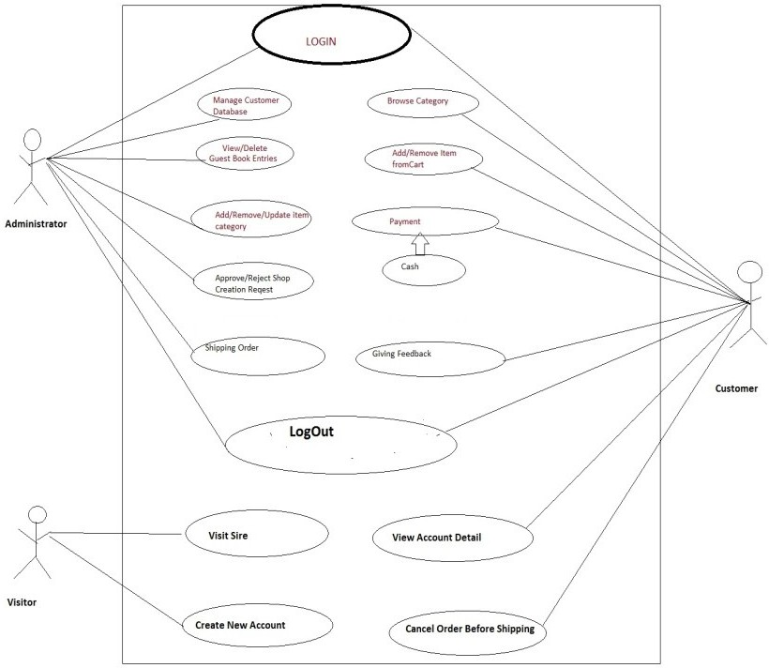

## User Characeristics:

User should be familiar with the terms like login,register,order system etc.

## Principle Actors:

2 Principle Actors are Customer and Administrator.

## General Constraints:

A full internet connection is required for OSS.

* 1. **Assumptions and Dependencies**: Working of OSS need Internet Connection.

# Specific Requirements:

## Functional Requirements:

This section provides requirement overview of the system.

Various functional modules that can be implemented by the system will be -

## Description:

* + 1. **Registration**

If customer wants to buy the product then he/she must be

registered, unregistered user can’t go to the shopping cart.

## Login

Customer logins to the system by entering valid user id and password for the shopping.

## Changes to Cart

Changes to cart means the customer after login or registration can make order or cancel order of the product from the shopping cart.

## Payment

In this system we are dealing the mode of payment by Cash.We will

extend this to credit card,debit card etc in the future.

## Logout

After ordering or surfing for

the product customer has to logout.

## Report Generation

After ordering for the product,the system will sent one copy of the bill to the customer’s Email-address and another one for the system data base.

## Non-Functional Requirements:

Following Non-Functional Requirements will be there in the insurance to the internet:

1. Secure access to consumer’s confidential data.
2. 24X7 availability**.**
3. Better component design to get better performance at peak time.
4. Flexible service based architecture will be highly desirable for future extension.Non-Functional Requirements define system properties and constraints.

Various other Non-Functional Requirements are:

* + **Security**
  + **Reliability**
  + **Maintainability**
  + **Portability**
  + **Extensibility**
  + **Reusability**
  + **Compatibility**
  + **Resource Utilization**
  1. **Performance Requirements:**

In order to maintain an acceptable speed at maximum number of uploads allowed from a particular customer as any number of users can access to the system at any time.

Also the connections to the servers will be based on the attributes of the user like his location and server will be working 24X7 times.

## Technical Issues:

This system will work on client-server architecture. It will require an internet server and which will be able to run PHP application. The system should support some commonly used browser such as IE, mozzila firefox,chrome etc.

# Interface Requirement:

Various interfaces for the product could be- 1). Login Page

1. Registration Form
2. There will be a screen displaying information about product that the shop having.
3. If the customers select the buy button then another screen of shopping cart will be opened.
4. After ordering for the product,the system will sent one copyof the bill to the customer’s Email- address

## Software Interface:

1. Operating System:Windows7 Ultimate which supports networking.
2. JAVA development toolkit.

## Hardware Interface:

Hardware requirements for insurance on internet will be same for both parties which are as follows:

Processor:Dual Core RAM:2 GB

Hard Disk:320 GB NIC:For each party

## Communication Interfaces:

The two parties should be connected by LAN or WAN for the communication purpose.

Communication c

hannel

SENDER

RECEIVER

SENDER

# System Design Specification:

* 1. **Architecture Design:**
     1. Data Flow Diagram(DFD):

It is a way of representing system requirements in graphical form;this led to modular design.A DFD describes a data flow(logical) rather than how they are processed.So they do not depend upon software,hardware,data structure or file organization.It is also known as ‘bubble sort’.

A DFD is a structured analysis and a design tool that can be used for flowcharting in place of ,or in association with ,information-oriented and process- oriented system flowcharts.

A DFD is considered as an abstract of the logic of information-oriented or process-oriented system flowchart.The four basic symbols used to construct data flow diagrams are-

A rectangle represents a data source or destination.

A directed line represents flow of

data.

An Oval represents a process that

transforms into

streams.

An Open ended rectangle represents

storage.

The points at which data is transformed are called as nodes.The principle processes that take place at nodes are:

1.Combining data streams 2.Splitting data streams 3.Modifiying data streams

Request

Request

Server



Databas e

|  |  |
| --- | --- |
| General |  |
| Customer |
|  |
| Admin |

# CONTEXT ANALYSIS DIAGRAM(CAD)

ADMINISTRATOR

ONLINE SHOPPING SYSTEM

CUSTOMER

**1 LEVEL *DED* .FOR** ADMIN

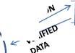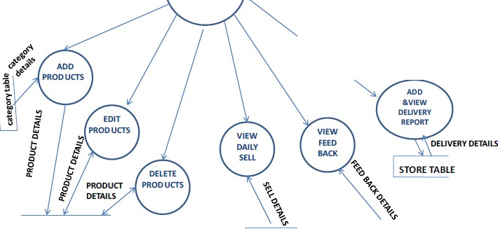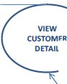

o p.II' cfo0'

,Jt"'f '

f O\'

LOGIN TABLE

ADMIN

ID &PASSWORD

, .REJECTED IF N OT

M ACHED

LOGIN

,.

CUSTOMER

- --' '-"'ETAILS

USER TABLE

P RODUCT TABLE

SELL TAB LE IFEEDBACK

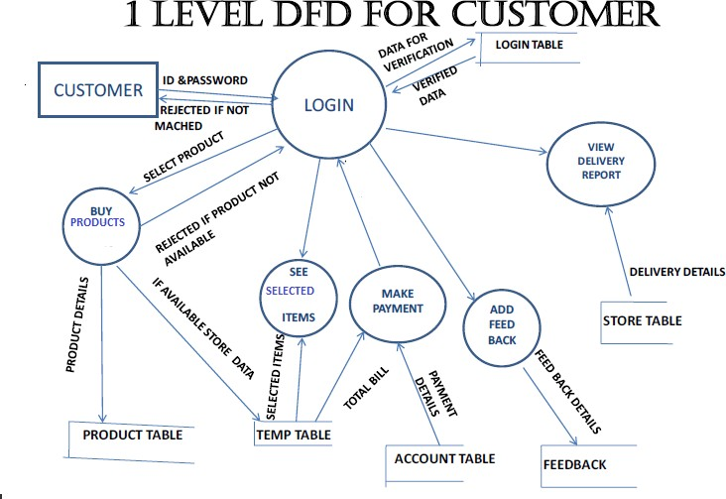

**E-R DIAGRAM**

PROD\_NAME

MAKE PAYMENT

USER\_NAME

CUSTOMER DETAILS

USER\_ID

**BUY PRODUCT**

DOB

E\_mail add

DELIVERY

FEEDBACK

PHONE\_NO

GENDER

ADDRESS

QUANTITY

PRODUCT

PRO\_ID

PRICE

**Use case diagram**

**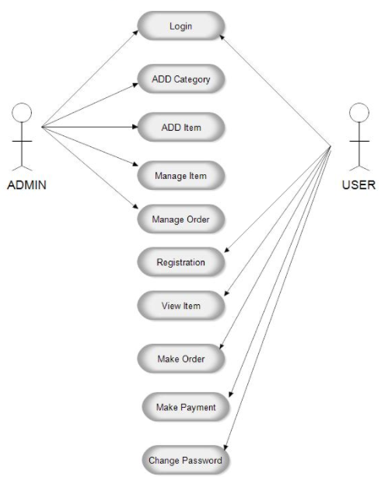**

**Class diagram**

**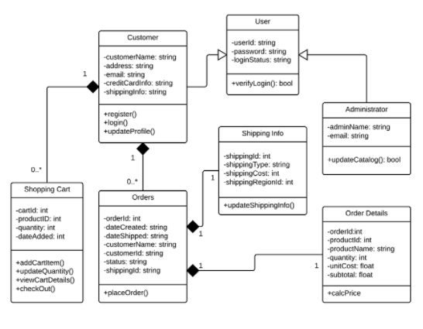**

**Deployment diagram**

**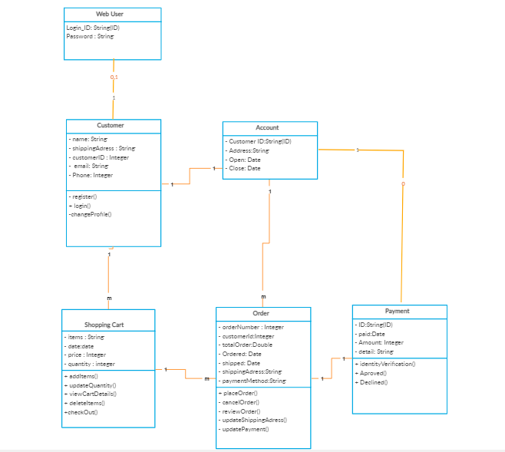**

## 

### **Component Diagram**

## 

## UML package diagram

## C:\Users\yugal.saini\Downloads\MicrosoftTeams-image (9).png

## Software Testing

**Software Testing** is a method to check whether the actual software product matches expected requirements and to ensure that software product is[Defect](https://www.guru99.com/defect-management-process.html)free. It involves execution of software/system components using manual or automated tools to evaluate one or more properties of interest. The purpose of software testing is to identify errors, gaps or missing requirements in contrast to actual requirements.

Some prefer saying Software testing definition as a [White Box](https://www.guru99.com/white-box-testing.html) and [Black Box Testing](https://www.guru99.com/black-box-testing.html). In simple terms, Software Testing means the Verification of Application Under Test (AUT). This Software Testing course introduces testing software to the audience and justifies the importance of software testing.

Linux Tutorial for Beginners Introduction to Linux Operating System

## Why Software Testing is Important?

**Software Testing is Important** because if there are any bugs or errors in the software, it can be identified early and can be solved before delivery of the software product. Properly tested software product ensures reliability, security and high performance which further results in time saving, cost effectiveness and customer satisfaction.

**What is the need of Testing?**

Testing is important because software bugs could be expensive or even dangerous. Software bugs can potentially cause monetary and human loss, and history is full of such examples.

* In April 2015, Bloomberg terminal in London crashed due to software glitch affected more than 300,000 traders on financial markets. It forced the government to postpone a 3bn pound debt sale.
* Nissan cars recalled over 1 million cars from the market due to software failure in the airbag sensory detectors. There has been reported two accident due to this software failure.
* Starbucks was forced to close about 60 percent of stores in the U.S and Canada due to software failure in its POS system. At one point, the store served coffee for free as they were unable to process the transaction.
* Some of Amazon's third-party retailers saw their product price is reduced to 1p due to a software glitch. They were left with heavy losses.
* Vulnerability in Windows 10. This bug enables users to escape from security sandboxes through a flaw in the win32k system.
* In 2015 fighter plane F-35 fell victim to a software bug, making it unable to detect targets correctly.
* China Airlines Airbus A300 crashed due to a software bug on April 26, 1994, killing 264 innocents live
* In 1985, Canada's Therac-25 radiation therapy machine malfunctioned due to software bug and delivered lethal radiation doses to patients, leaving 3 people dead and critically injuring 3 others.
* In April of 1999, a software bug caused the failure of a $1.2 billion military satellite launch, the costliest accident in history
* In May of 1996, a software bug caused the bank accounts of 823 customers of a major U.S. bank to be credited with 920 million US dollars.

## Four Traditional Types of Ecommerce Business Models

If you’re starting an ecommerce business, odds are you’ll fall into at least one of these four general categories.

Each has its benefits and challenges, and many companies operate in several of these categories simultaneously.

Knowing what bucket your big idea fits in will help you think creatively about what your opportunities and threats might be.

### 1. B2C – Business to consumer.

[B2C businesses](https://www.bigcommerce.com/ecommerce-answers/what-is-b2c-ecommerce-the-online-shopping-boom-explained/) sell to their end-user. The B2C model is the most common business model, so there are many unique approaches under this umbrella.

Anything you buy in an online store as a consumer — think wardrobe, household supplies, entertainment — is done as part of a B2C transaction.

The decision-making process for a B2C purchase is much shorter than a business-to- business (B2B) purchase, especially for items that have a lower value.

Think about it: it’s much easier for you to decide on a new pair of tennis shoes than for your company to vet and [purchase a new email service provider](https://www.adamenfroy.com/best-email-marketing-services) or food caterer.

Because of this shorter sales cycle, B2C businesses typically spend less marketing dollars to make a sale, but also have a lower average order value and less recurring orders than their B2B counterparts.

And B2C doesn’t only include products, but services as well.

B2C innovators have leveraged technology like mobile apps, native advertising and remarketing to market directly to their customers and make their lives easier in the process.

For example, using an app like [Lawn Guru](https://lawnguru.co/) allows consumers to easily connect with [local lawn mowing services](https://lawnguru.co/services/lawn-mowing/), garden and patio specialists, or snow removal experts.

Additionally, home service businesses can use Housecall Pro’s [plumbing software app](https://www.housecallpro.com/industries/plumbing-software/) to track employee routes, text customers, and process credit card payments on the go, benefitting both the consumer and business alike.

### 2. B2B – Business to business.

In a B2B business model, a business sells its product or service to another business. Sometimes the buyer is the end user, but often the buyer resells to the consumer.

B2B transactions generally have a longer sales cycle, but higher order value and more recurring purchases.

[Recent B2B innovators](https://www.bigcommerce.com/blog/b2b-ecommerce-trends/) have made a place for themselves by replacing catalogs and order sheets with ecommerce storefronts and improved targeting in niche markets.

In 2020, close to half of [B2B buyers are millennials](https://www.trustradius.com/vendor-blog/millennial-b2b-buyers-what-you-need-to-know-about-the-new-wave-of-decision-makers) — nearly double the amount from 2012. As younger generations enter the age of making business transactions, B2B selling in the online space is becoming more important.

### 3. C2B – Consumer to business.

C2B businesses allow individuals to sell goods and services to companies.

In this ecommerce model, a site might allow customers to post the work they want to be completed and have businesses bid for the opportunity. Affiliate marketing services would also be considered C2B.

Elance (now [Upwork](https://www.upwork.com/" \t "_blank)) was an early innovator in this model by helping businesses hire freelancers.

The C2B ecommerce model’s competitive edge is in pricing for goods and services.

This approach gives consumers the power to name their price or have businesses directly compete to meet their needs.

Recent innovators have creatively used this model to connect companies to social media influencers to market their products.

### 4. C2C – Consumer to consumer.

A C2C business — also called an online marketplace — connects consumers to exchange goods and services and typically make their money by charging transaction or listing fees.

Online businesses like Craigslist and eBay pioneered this model in the early days of the internet.

C2C businesses benefit from self-propelled growth by motivated buyers and sellers, but face a key challenge in quality control and technology maintenance.

Conclusions

The ‘Online Shopping’ is designed to provide a web based application that would make searching, viewing and selection of a product easier. The search engine provides an easy and convenient way to search for products where a user can Search for a product interactively and the search engine would refine the products available based on the user’s input. The user can then view the complete specification of each product. They can also view the product reviews and also write their own reviews. Use of Ajax components would make the application interactive and prevents annoying post backs. Its drag and drop feature would make it easy to use.

Limitations

This application does not have a built in check out process. An external checkout package has to be integrated in to this application. Also users cannot save the shopping carts so that they can access later i.e. they cannot create wish lists which they can access later. This application does not have features by which user can set price ranges for products and receive alerts once the price reaches the particular range.

Scope for Future Work

The following things can be done in future. • The current system can be extended to allow the users to create accounts and save products in to wish list. • The users could subscribe for price alerts which would enable them to receive messages when price for products fall below a particular level. • The current system is confined only to the shopping cart process. It can be extended to have an easy to use check out process. • Users can have multiple shipping and billing information saved. During checkout they can use the drag and drop feature to select shipping and billing information.

. References

• All about Microsoft controls in C# <http://www.msdn.microsoft.com/>

• Wikipedia for various diagrams & testing methods <http://www.wikipedia.org/>

• Cool text for Images and Buttons <http://cooltext.com/>

• K-State Research Exchange for samples in report writing <http://krex.k-state.edu/dspace/handle/2097/959>

• Smart Draw for drawing all the Diagrams used in this report. <http://www.smartdraw.com/>

• Sample Ecommerce Application <http://www.NewEgg.com>

• Ajax Toolkit controls

http://asp.net/aja