

Water Based Varnish Series

Model
YH - 303 (Water Based Coating Varnish for Post Press Coating)

Description
It is used for coating on the surface of printed paper products.

Characteristic
* High gloss (glossy degree is up to 70-80°) and rub resistance, easy operation, good intermiscibility with printing ink.
* Excellent adhesion with printing ink. The coating layer has good transparence, even and flat.
* Good rub resistance, smooth feels.

Application
It is suitable for printed paper products such as poster, book cover, food and medicine packaging.

Working Conditions
* It is suitable for roller coating.
* Coating layer thickness and coating speed can be adjusted under actual working situation and needs.

Storage
Do not expose under the sunshine directly and keep in the cool place. Storage period: 6 months.

Package
PE Drum. Weight: 125kg.

Safety Operation Requirements
* Please do not touch with skin, eyes, and body mucous membranes directly. If operator contacts carelessly, wash it with soap water immediately.
* Please keep the working place safe.

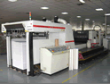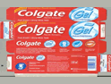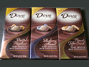
Note: The above information is provided within our knowledge range. The actual working situation is out of our control. Please choose the suitable products according to your actual working conditions and needs.

