

Water Based Varnish Series

Model
YH - 306 (Water Based Matte Varnish)

Description
It is used for coating on the surface of printed paper products.

Characteristic
* Soft gloss and smooth feels. High rub and scratch resistance. Good adhesion resistance.
* Non-toxic and non-pollution, it does not harm to operators' health.
Application
It is suitable for printed paper products such as poster, book cover, food and medicine packaging.

Working Conditions
* It is suitable for roller coating. 0～5％ water can be added to dilute under actual working conditions needs.
* Coating consumption volume: 7～10g（dry weight）/m2.
* Hot air drying or I.R dryer.

Storage
Do not expose under the sunshine directly and keep in the cool place. Temperature required: 10～30℃. Storage period: 6 months.

Package
Plastic Drum. Weight: 18kg or125kg.

Safety Operation Requirements
* Please put on rubber protection gloves during working and do not touch with skin, eyes, and body mucous membranes directly. If operator contacts carelessly, wash it with soap water immediately, otherwise your skin may be injured.
* Please keep the air flow smoothly in working place.

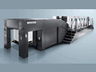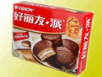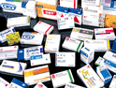
Note: The above information is provided within our knowledge range. The actual working situation is out of our control. Please choose the suitable products according to your actual working conditions and needs.

