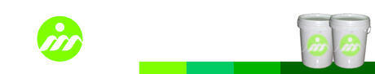

Water Based Adhesive Series

Model
YH - 501 (Water Based Adhesive for OPP, PET or PVC film)

Description
It is used for laminating OPP, PET or PVC film with printed paper surface

Characteristic
* Quick drying after laminating with printed paper. Especially for high speed laminating. Good adhesion and excellent brightness.
* Excellent adhesion with printing ink, the finished laminating surface is even and flat. No bubbles appear.
* Completely dissolve offset printing spray powder, improve printing surface flatness and brightness.
* Good color retention and adhesion strength with metallic ink.
* Test under hard conditions, the laminated products can also has the excellent functions.

Application
* It is suitable for laminating printed paper with processed OPP, PET, and PVC film. The laminated paper can be stamped, creased and die cut.
* It is suitable for handbags, book cover, color box.

Working Conditions
* It is suitable for roller coating.
* Drying temperature required: 50℃~90℃, laminating speed: 10~40m/min. Due to drying time, adhesive volume and printing base material, the adhesive must be dried until it has enough adhesive force.

Storage
Do not expose under the sunshine directly and keep in the cool place. Temperature required is below 30℃. Storage period: 6 months.

Package
Plastic Drum. Weight: 18kg or 125kg.

Safety Operation Requirements
Please do not touch with skin, eyes, and body mucous membranes directly.
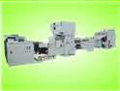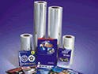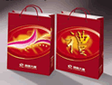
Note: The above information is provided within our knowledge range. The actual working situation is out of our control. Please choose the suitable products according to your actual working conditions and needs.

