

UV Varnish for Silk Screen Printing Series

Model
YH - 788 (UV Varnish for Silk Screen Printing)

Description
It is used for coating on the surface of printed paper, PVC, matte and gloss film.

Characteristic
* High gloss and excellent flatness.
* High rub resistance, excellent adhesion and quick drying.

Application
* It is suitable for coating on the surface of high class printed paper products, especially for PP matte film.

Working Conditions
* After silk screen coating (150~400 lines), please dried by UV curing system within 30 seconds, Otherwise the coating result and product appearance may be influenced.
* The products should be completely dried after coating; otherwise the adhesion may be affected.

Storage
Do not expose under the sunshine directly and keep in the cool place. Storage period: 6 months.

Package
Iron tin or drum. Weight: 3.5kg/tin or 20kg/drum.

Safety Operation Requirements
* During working, do not expose under the sunshine directly and isolate from water.
* Please do not touch with skin, eyes, and body mucous membranes directly; otherwise it may cause skin sensibility.
* Please wash hands with cleaning agent after some working period.

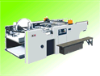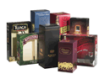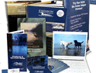
Note: The above information is provided within our knowledge range. The actual working situation is out of our control. Please choose the suitable products according to your actual working conditions and needs.

