Contents

Check out / Check in naming convention: 1

Deploy group naming convention: 1

Labeling 1

How to migrate to another Repository: 2

How to Package to UAT 5

# Check out / Check in naming convention:

Use the following format:

SIR##### - <description>

# Deploy group naming convention:

For Projects team: PROJ_<PUSHDATE>_<USERID>_<SIR#>

For Maintenance team: MAINT_<PUSHDATE>_<USERID>_<SIR#>

# Labeling

Informatica requires a non-numeric character as the first character. We will create labels that are ‘MONYYYY’ format. The month and year will be related to the push month. For Example - FEB2015, APR2015, etc.

For hotfixes, we will use actual dates (MONYYYYDD format). FEB201501, FEB201528

When moving objects to testing because folders are out of sync, use the label BASELINE. If the labels do not exist, please create them.

Remigrations: Create a new label and add V<#> to the object you are changing . For example, if the object that you are changing has FEB2015 label, create and use a new label FEB2015V1

# How to Migrate to Another Repository:

1. Click on the deployment group you want to migrate.

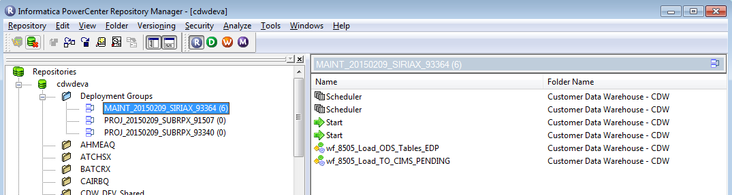

1. Drag and drop into the destination you wish to migrate. If done successfully, a migration wizard will pop up. The following screenshots provided are in order of the wizard

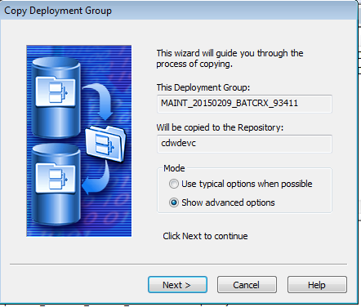 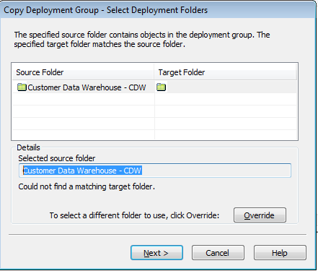 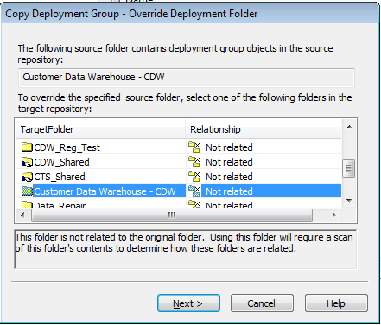

* 1. Select ‘Show advanced options’
  2. Click override to choose the folder if not given in the target section
  3. Select the appropriate folder that matched the name from the previous screen (in this case Customer Data Warehouse – CDW)

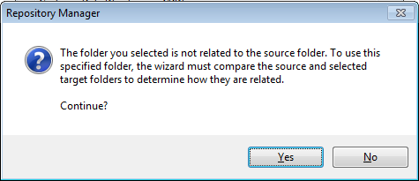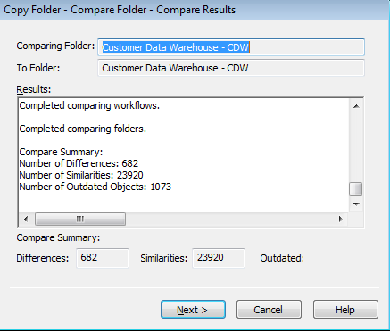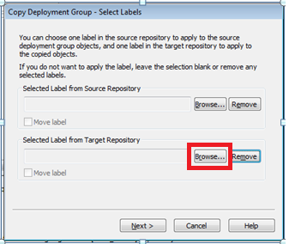

* 1. You may see this message or a similar. When you click yes, a scan will commence. **This will take some time (1 minute for CDW_Shared, 5 minutes for CDW_Maintenance, 20 minutes for Customer Data Warehouse - CDW). If the repository manager is not responsive, minimize and work on something else. If you get a message prompt, choose ‘Wait for program to respond’.**
  2. Click Next until you reach the label screen.
  3. If you want to use a label **(from Dev to Test, using a label is required for UAT migration),** choose “Browse…” from the Target Repository

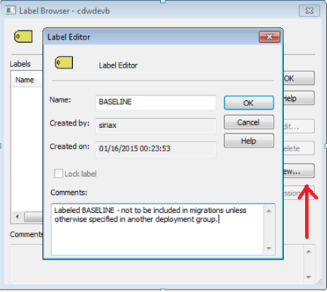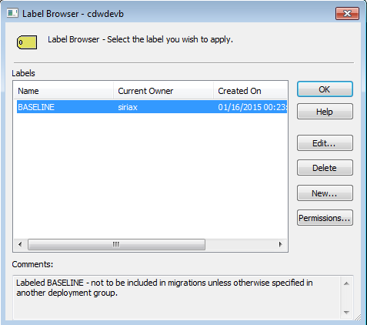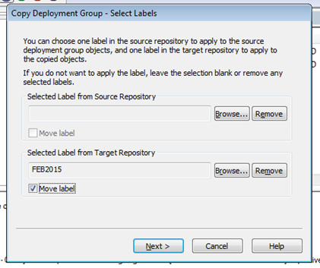

* 1. If desired label exists, skip this step. Otherwise click on New (as seen with the red arrow in background)… and create a new label.
  2. Choose label from list by highlighting and clicking ok
  3. Verify label is on the screen and click ‘Move label’ checkbox. Click Next

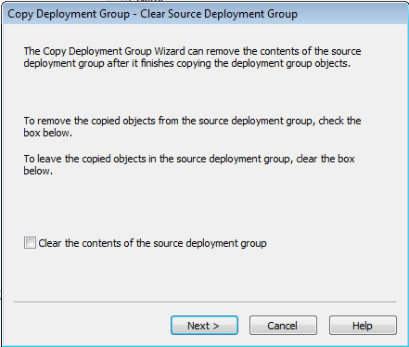 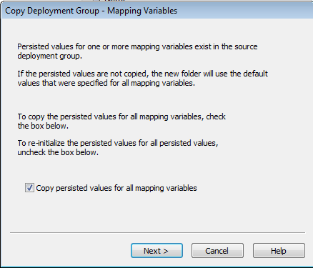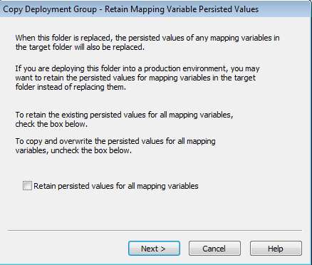

* 1. Uncheck checkbox ‘Clear the contents of the source deployment group’ if checked
  2. Check checkbox ‘Copy persisted values for all mapping variables’ if not checked
  3. Uncheck checkbox ‘Retain persisted values for all mapping variables’ if checked

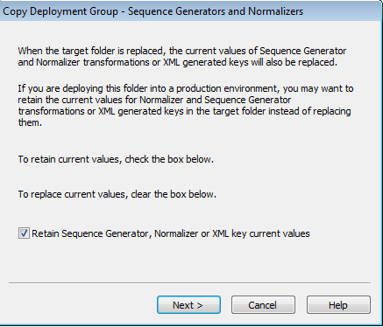 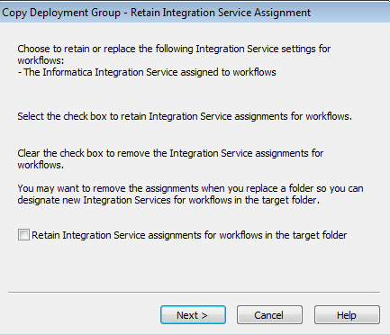 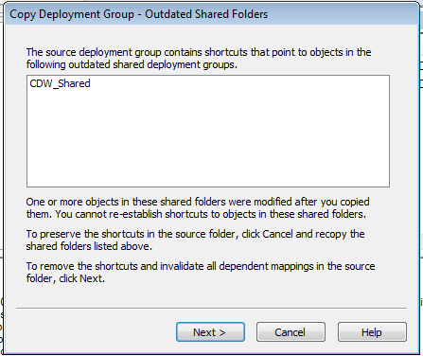

* 1. Check checkbox for the sequence generator values if not checked
  2. Uncheck checkbox for integration service retention if checked
  3. If you see this screen, you did not select advance options and you need to cancel out of the process.

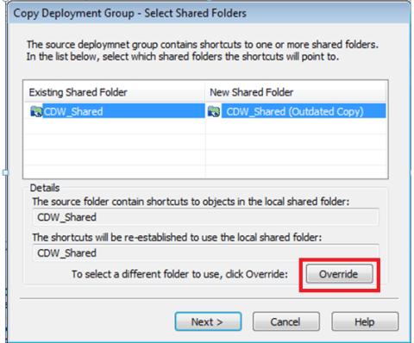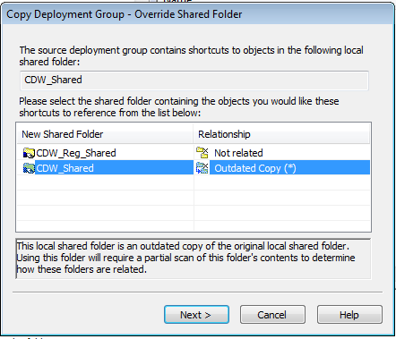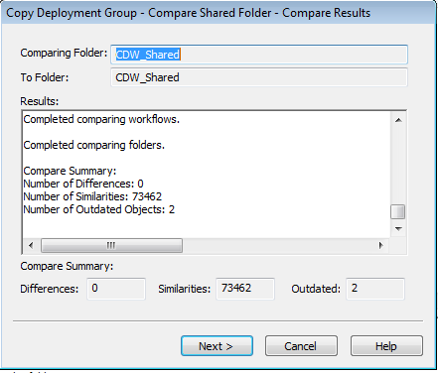

* 1. You might see this screen instead. **Click on override regardless what is shown on the screen**. **Do not click on Next or you will need to start over**. If override is greyed out, there is an issue.
  2. Select the appropriate name and click next, a scan will commence (1-2 minutes).
  3. Click next once the scan is complete.

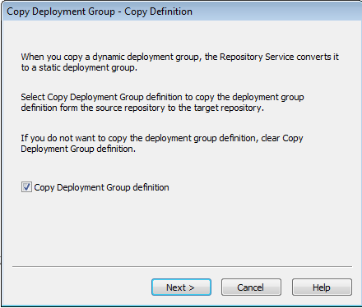 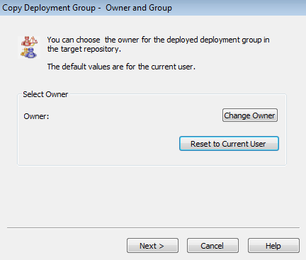

* 1. Check checkbox for copy deployment group definition if not checked.
  2. Don’t need to change the name

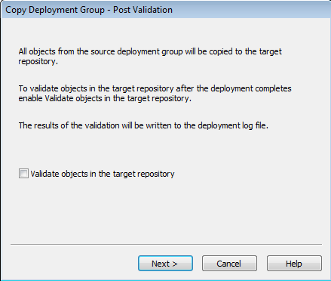 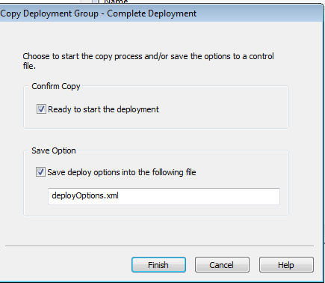

* 1. Uncheck checkbox – no need to validate since we’re going to validate. This will also scan the entire repository.
  2. Click Finish to start the migration

# How to Package to UAT

Create a query that is shared and has parameter name ‘Reusable Status’ with Operator ‘Is One Of’ set to ‘Non-reusable, Reusable’. Then create another parameter called ‘Label’ with the Operator type ‘Contains’ and value set to the label you used to migrate to the testing environment. In the example below, and object labelled with FEB2015 will be picked up.

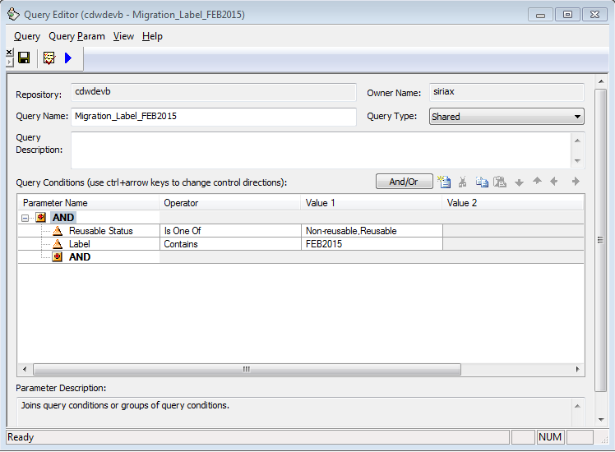

After creating the query, be sure to set the permissions

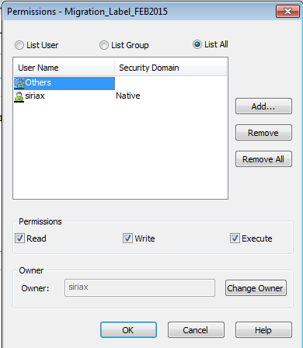

Read and execute privileges for others are required.

Create a new deployment group. The name format should be as follows

**~PCS<number>_<Team – PROJ or MAINT>_<Description if not a regular push>**

Examples:

~PCS98394_PROJ

~PCS98394_MAINT

~PCS98800_PROJ_HOTFIX

**Set group type to Dynamic and click on Queries…**

**Choose the query that you want this group to pull the objects from.**

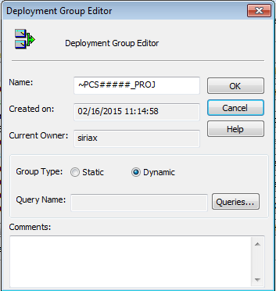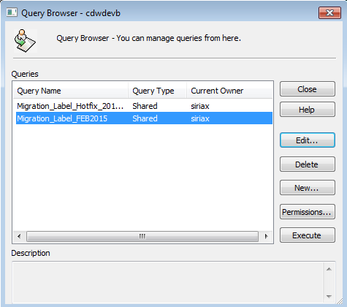

After you select a query and close, it should appear on the screen.

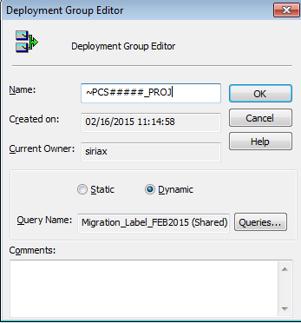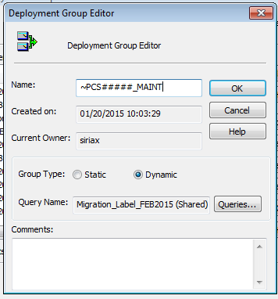

You should be able to see the deployment group. Give the group execute permissions for everyone.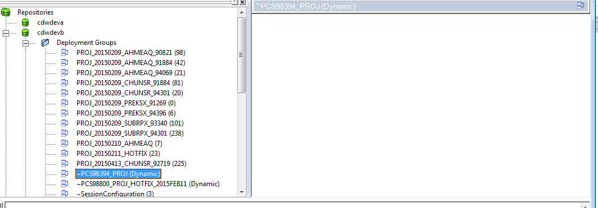

The ‘~’ was added to the front for sorting purposes.

Rollback:

Hight the group name->tools->deployment->history->select your group->view history