LAB3-LOOP

Group: 61

Name & ID: 陳宥涵(Joy) 102401053 趙慈暄(Bonnie) 104503002

Program execution flow

1. The final result of ninenine in memory.

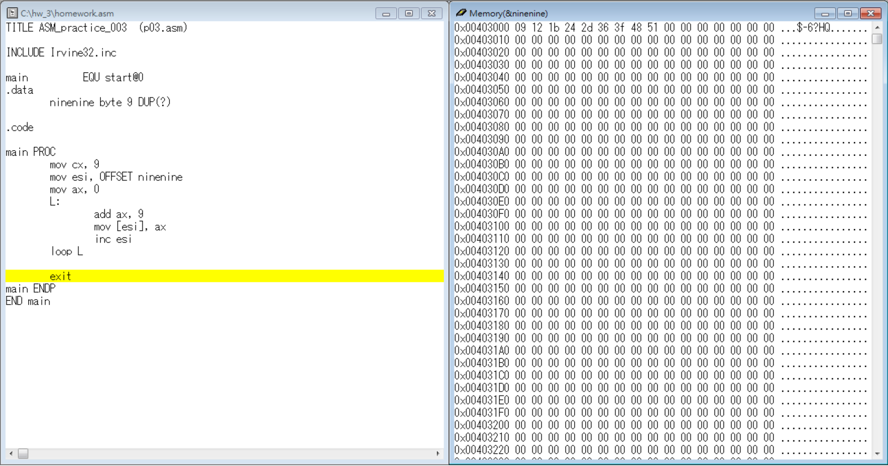

Reviews:

Today is the first time for us to program loops. Frankly, I thought of creating two loops in the beginning since I didn’t think of a way to do it in a loop. However, with a small reminder from TA, I found that since the value in ax will be preserved, so I it will automatically add up to nine times. I just have to save move the pointer to save each result in a run. TA also explained the difference between esi, ax and [esi], ax clearly again, thanks to TA, I finally get the function of the mysterious brackets.