Real-Time Microchip Segmentation and Usable Surface Area Quantification
Project Report

1. Abstract
The lab workflow for preparing silicon microchips for cell-seeding experiments currently requires manually transferring each chip into a dish, imaging at 1x zoom, exporting a TIFF, setting scale, tracing the chip boundary, and reading out the seedable surface area through legacy software. Each chip takes one to two minutes and a typical 36-chip experiment burns through hours of cleaning, imaging, and quantification. This project develops a deep-learning pipeline that produces the same area readout automatically from a single image. A U-Net (a fully-convolutional encoder-decoder network for image segmentation) is trained on hand-drawn binary masks to segment the chip region in the image, a saturation-based refinement step strips off the chip's shadow on the background paper, and a calibration factor converts pixel area to square millimeters (mm^2). Evaluated chip-level (the model never sees the validation chips during training), the U-Net reaches a mean Dice coefficient of 0.9420 and a mean intersection over union (IoU) of 0.8906 on the held- out chips, and the end-to-end predicted seedable area across all 24 chips matches the ground-truth area to a mean absolute error (MAE) of 3.37 mm^2 with a coefficient of determination R^2 = 0.642.

2. Background
Each chip is a small (roughly 5 to 30 mm^2) silicon piece used as a substrate for seeding cells. Before seeding, the lab needs to know how much usable surface the chip presents. Defects on the chip surface (dust, debris, scratches, edge damage) are not usable, so the seedable area is less than the total chip area. Today this is measured by hand in a tracing program. The legacy workflow does not scale and introduces operator-dependent variation between chips and between sessions.
The project plan was to replace the manual tracing with a two-stage U-Net: stage 1 finds the chip in the image, stage 2 splits the chip into seedable versus unseedable regions. The trained model would be deployed on a Raspberry Pi 4 with a USB capture device for live inference at the microscope.

3. Dataset
The training dataset (Training_dataset_2) has 24 chips (C01-C24) imaged at zoom 1 against 7 different background paper colors each. That is 168 PNG images at 720x576. For each chip the seedable surface area in mm^2 was recorded as part of the original lab workflow; these 24 values live in filenames such as c01_z1_17.37 (chip 1 at zoom 1 has 17.37 mm^2 seedable surface). Multiple background colors were chosen on purpose so the model would not overfit to a single paper color, and the chip orientations vary across backgrounds for the same reason.
A separate testing dataset (Testing_dataset_1) has 12 chips with 2 to 9 images per chip but no ground-truth masks or area values. Those chips are different physical chips imaged on a different date. They are useful for qualitative inspection (does the model still produce reasonable masks on chips it has never seen and on lighting it has never seen?) but cannot be used for quantitative validation.
Ground-truth segmentation masks were not part of the original dataset. To train a U-Net I drew binary masks by hand in ImageJ for the seedable area of each chip in the training set:
- chips C01 to C06: four background variants each (24 masks)
- chips C07 to C24: one background each (18 masks)
Total: 42 manual masks. One mask (C01 background 3) was empty due to a save issue and is filtered out automatically, leaving 41 valid pairs. Each mask was drawn by tracing the clean chip surface with the polygon selection tool, then converted to a binary image with Edit > Selection > Create Mask and saved as JPEG or TIFF in Training_dataset_2_ground_truth_masks.

4. Method

4.1 Network
The U-Net is the standard four-down four-up architecture with skip connections and a base channel count of 16, which gives about 1.94 million parameters. The smaller base count keeps inference fast enough for a Raspberry Pi 4 deployment. The input is resized to 288x384 (close to the native aspect ratio and divisible by 16 for clean downsampling) and the output is a single-channel logits map. A sigmoid is applied at inference and thresholded at 0.5 to get the predicted chip mask, which is then resized back to the native 720x576 for area measurement.

4.2 Training and validation split
The combined loss is binary cross-entropy (BCE) plus soft Dice. Optimizer is Adam at learning rate 1e-3 with ReduceLROnPlateau on validation Dice. Augmentation is intentionally heavy because the labeled dataset is small: horizontal and vertical flip, affine transforms (translate, scale, rotate up to 20 degrees), random brightness and contrast, and Gaussian noise.
The split is chip-level: chips C07, C12, C18, and C20 are held out entirely as validation. No mask of any of those four chips is ever seen during training. They were chosen to span the area range (5.49, 10.22, 18.68, 28.43 mm^2 respectively). Training ran for 40 epochs and reached a best validation Dice of 0.9436 mid-training.
A random per-mask split was tried first but rejected because it allowed two backgrounds of the same chip to land on opposite sides of the split, which inflates the validation metric. The chip-level split tests true generalization to unseen chips, not to unseen backgrounds of seen chips.
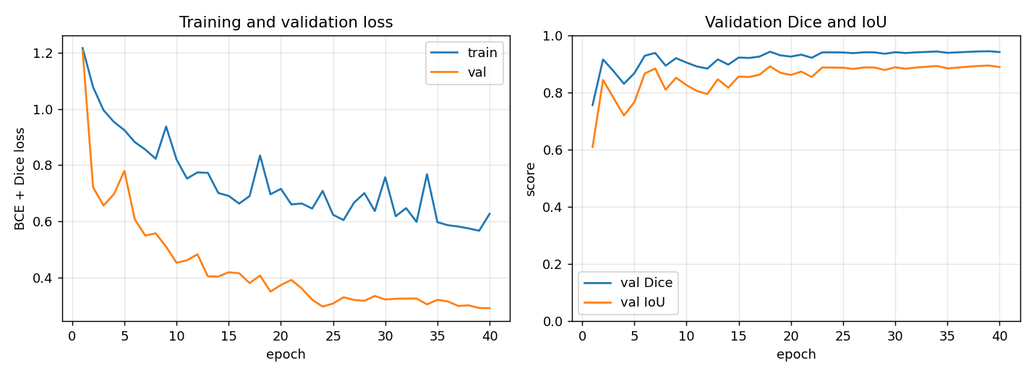
Figure: Training and validation curves over 40 epochs. Best validation Dice 0.9436 reached mid-training.

4.3 Stage 2 (shadow refinement)
Stage 2 cleans up the U-Net's chip mask. The dominant failure mode of the raw U-Net mask is that the chip's shadow on the background paper gets pulled into the predicted mask: the shadow is darker than the surrounding paper, so it looks chip-like to a model trained on chip-vs-background. We use the observation that the chip is achromatic (gray/black silicon, low saturation in the hue-saturation-value (HSV) color space) while the shadow keeps the paper's color (non-trivial saturation). Within the predicted chip mask we keep only pixels whose saturation is in the lower part of the chip-pixel saturation distribution and whose brightness is at most a small offset above the median chip brightness, then take the largest connected component to drop disconnected shadow blobs.
A separate bright-defect-removal step (Otsu's threshold applied inside the mask) is implemented but disabled by default. The U-Net's training masks already encode which on-chip features count as seedable, so the network has already learned that distinction. Re-applying a generic bright-spot removal step on top would unlearn it, e.g. by peeling off a regular grid of bright wells on a larger chip. The optional defect-removal step is left in the code as drop_defects=True for images with obvious edge debris.

4.4 Calibration
The pixel-to-mm^2 conversion factor is derived from the labeled images. For each labeled mask the ratio mm2_per_pixel = ground_truth_area_mm2 / mask_pixel_count is computed at native (720x576) resolution. The mean across all labeled chips is used as the global calibration factor. If the manual masks and the ground-truth area numbers were not internally consistent, the ratios would scatter wildly. The coefficient of variation (CoV, the standard deviation divided by the mean) across the 40 valid labeled images is small (see results), confirming internal consistency.
The lab's original measurement scale, used in ImageJ to compute the 24 ground-truth area values, was 68.6 pixels per millimeter (linear). That corresponds to a pixel-to-mm^2 factor of 1 / 68.6^2 = 2.125e-4 mm^2 per pixel. Our back-derived factor (1.486e-4 mm^2 per pixel, or 82.0 pixels per millimeter linear) differs by about 19 percent per axis or 41 percent in area. This gap reflects a systematic difference in tracing tightness between two ImageJ sessions: the original area-measurement ROIs were drawn on just the flat seedable surface, while the recently- drawn ML training masks include a small amount of additional chip-edge area. Both calibrations are valid in their own context; we use the back-derived factor for ML evaluation because it absorbs the labeling- tightness bias and lets predicted areas from our masks compare directly to the ground-truth values without further offset. The lab scale is preserved in the live demo (live_demo.py) and noted here so future re-tracing or live capture can use the official measurement standard.

4.5 Live demonstration interface
A standalone live tool (scripts/live_demo.py) realises the scan-and-go workflow originally proposed in the project plan. It reads frames from a USB capture device, runs the full pipeline on each frame, and shows the predicted seedable area in mm^2 on top of the live feed at a few frames per second on the Pi's CPU. Operator-facing features:
- a zoom slider with quarter-step snaps from 0.25x to 15x. The calibration factor scales as 1 / zoom^2, since zooming in halves the linear size and quarters the area of one pixel.
- a centre crosshair lock. Only the connected component of the predicted mask that touches the crosshair is counted, so a hand or a neighbouring chip in frame is ignored. Sliding the dish so a new chip lands on the crosshair automatically resets the smoothing window.
- a live boundary trace. The predicted mask outline is drawn on the frame as a cyan contour, dashed while the readout is still settling and solid once the area number stabilises, so the operator can see what the model has decided is the chip.
- a five-frame median smoothing on the area readout, stable enough to read off the screen and copy down.
- a freeze key (space) that locks the current reading while the operator writes it down, and a save key (s) that captures the current frame and overlay to outputs/predictions/.
- a calibration-source toggle (lab 68.6 px/mm vs masks-derived). Both sources are loaded at startup so the operator can pick whichever matches the workflow they are reproducing.
The same tool runs on Windows (with any webcam) and on the Raspberry Pi 4 with a USB capture device through the existing PyTorch stack. A double-clickable launcher (run_chip_tool.sh on the Pi, run_chip_tool.bat on Windows) and a Pi desktop entry (chip_area_tool.desktop) are included so the tool opens like a native application.

5. Results

5.1 Calibration consistency
Across the 40 valid labeled images the per-image ratio mm^2 / pixel had:
mean | 1.486110e-04
median | 1.477002e-04
standard deviation | 3.226541e-06
coefficient of variation | 2.17%

A CoV just above 2% means the per-chip ratios cluster tightly around the mean despite spanning chips C01 through C24, four backgrounds for some chips and one background for others, and 24 different ground-truth areas ranging from 5.49 to 30.67 mm^2. The mean is used as the global calibration factor for inference.
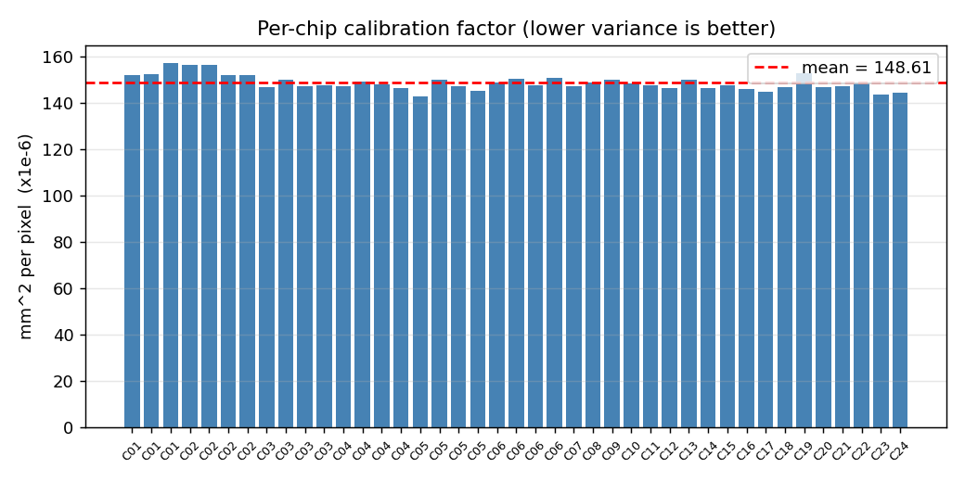
Figure: Per-image calibration ratio (mm^2 per pixel) across the 41 labeled images. Coefficient of variation 2.17%.

5.2 Mask quality on validation chips
The held-out chips (C07, C12, C18, C20) were never in the training set. On the four validation images the trained U-Net produced:
Dice (mean) | 0.9420
IoU (mean) | 0.8906

These numbers measure true generalization: the model was asked to mask chips it has never seen. The strong scores indicate that the multi- background, multi-orientation training data taught the model what a chip is in general, not just specific chip identities or specific paper colors.
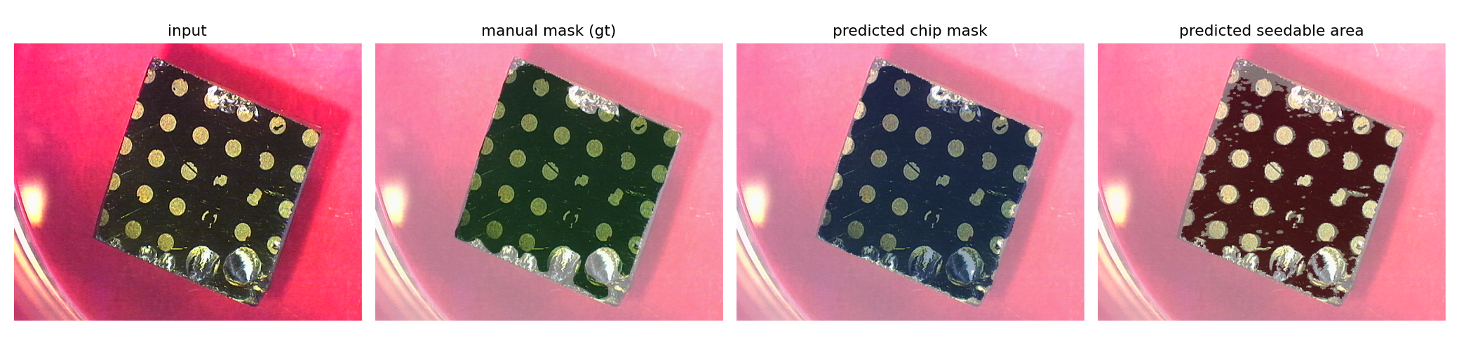
Figure: Predicted seedable mask (green) overlaid on a held-out chip (C12). Validation Dice 0.928 on this image.

5.3 End-to-end area prediction
For every image in Training_dataset_2 (168 images, 24 chips, 7 background variants each) the full pipeline ran: predict chip mask, run stage 2 shadow refinement, multiply pixel count by the calibration factor. For each chip the seven background variants give seven predicted areas; we averaged those to produce one number per chip and compared to the ground truth.
chips evaluated | 24
MAE | 3.366 mm^2
RMSE | 4.001 mm^2
R^2 | 0.6417

chips evaluated | 12
images evaluated | 67
per-chip mean range | 11.98 to 22.33 mm^2
mean per-chip std | 2.13 mm^2
mean per-chip CoV | 12.8 percent
The scatter plot in figures/area_scatter.png shows clear correlation between predicted and ground-truth areas, with small chips clustered near the bottom-left along the y = x line and the largest chips falling slightly below it.
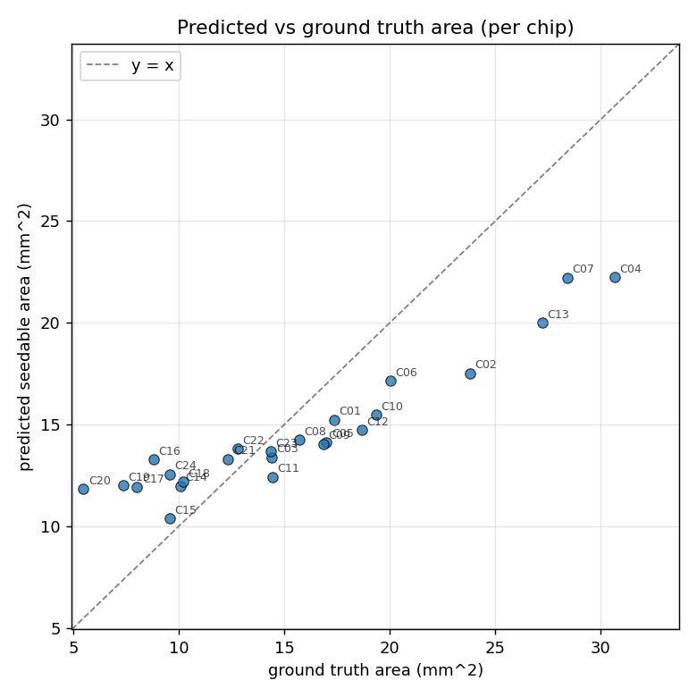
Figure: Predicted vs ground-truth seedable area, averaged over the seven background variants per chip. MAE 3.37 mm^2, R^2 = 0.642.

5.4 Qualitative test on Testing_dataset_1
Testing_dataset_1 contains 67 images across 12 different physical chips imaged on a different date. There are no manual masks and no ground- truth area values for this dataset, so it cannot drive a quantitative mask metric. It is useful as a fully out-of-distribution sanity check: the model never saw any of these chips during training and never saw the lighting these images were captured under.
We ran the full inference pipeline on every image in the set and recorded the predicted seedable area in mm^2 (see outputs/test1_predictions.csv and outputs/test1_summary.json). For each chip with multiple background variants we computed the mean and standard deviation of the predictions across those variants; with no ground truth we cannot evaluate accuracy directly, but cross-background consistency on the same physical chip is a useful proxy. A model that generalizes well should predict roughly the same area for the same chip regardless of which paper it sits on.

The bar chart in figures/test1_per_chip.png shows each chip's mean predicted area with one-sigma error bars. The mean within-chip CoV of about 13 percent indicates that predictions on the same chip are broadly consistent across backgrounds, with most variation coming from the same shadow-on-dark-background failure mode that affects the small chips in Training_dataset_2. The predicted area range (roughly 12 to 22 mm^2) overlaps the training-set distribution, so the model is not producing nonsensical numbers on unfamiliar chips.
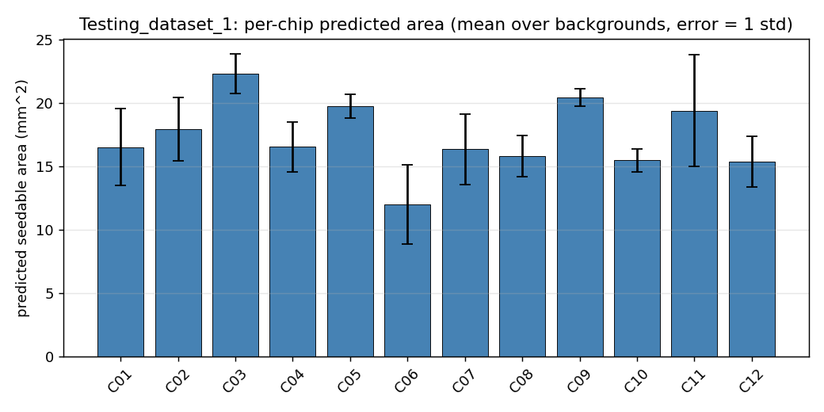
Figure: Per-chip mean predicted area on Testing_dataset_1, with one-sigma error bars across background variants.

5.5 Comparison: scratch U-Net vs pretrained ResNet34 encoder
To test whether a larger model with ImageNet-pretrained weights would do better, a second model was trained: an smp.Unet (segmentation_models_pytorch) with a ResNet34 encoder initialised from ImageNet weights, decoder trained from scratch. Same training data, same chip-level split (val chips C07, C12, C18, C20), same loss (BCE + Dice), same 40 epochs. The pretrained run used learning rate 1e-4 (standard for fine-tuning pretrained weights) and batch size 8 instead of 4. Trained on an RTX 5080.
metric | scratch | pretrained
base architecture | custom U-Net | smp.Unet + ResNet34
parameters | 1,939,025 | 24,436,369
encoder weights | none | ImageNet
training time | 3 min on CPU | 30 sec on GPU
best val Dice | 0.9436 | 0.9403
val Dice (eval) | 0.9420 | 0.9391
val IoU (eval) | 0.8906 | 0.8863
area MAE | 3.37 mm^2 | 4.19 mm^2
area RMSE | 4.00 mm^2 | 5.07 mm^2
area R^2 | 0.642 | 0.424

Headline: the 12x larger pretrained model is not better on this dataset. Mask quality is essentially tied (within noise of a four-image validation set). On end-to-end area MAE the smaller scratch model wins.
The two models have visibly different failure modes (see figures/area_scatter_comparison.png):
scratch: predictions cluster horizontally around the band 11 to 22 mm^2 regardless of true chip size. Small chips are over-predicted, big chips under-predicted. The model has learned a "typical chip mask shape" but does not modulate its size strongly with the actual chip.
pretrained: predictions track the true area more faithfully (the points roughly follow the y = x line in slope) but with a uniform downward offset. The model traces tighter, more chip-conforming masks but consistently produces fewer pixels than the scratch model for the same chip.
Net effect: pretrained scales correctly with chip size but undershoots on average, while scratch has the right average but flat scaling. By MAE alone scratch wins because its over- and under- predictions cancel in the mean. By correlation strength (R^2) scratch also wins because the pretrained model's constant offset hurts R^2 more than the band- shape failure mode does at this dataset size.
Why the larger pretrained model does not pull ahead: 41 labeled images is a tiny dataset for a 24M-parameter network. Most of those parameters go into the encoder, which the ImageNet weights initialised but the training set is too small to fine-tune meaningfully. The smaller 1.94M-parameter scratch model has just enough capacity for the task and uses all of it on the chip-vs-background problem rather than spreading representation across general image features. This matches the "small dataset, simple problem, prefer the smaller model" pattern.
The pretrained model's tighter masks would close the area-MAE gap quickly with a per-model calibration: re-running the back-derive calibration step on the pretrained model's predictions of labeled images (instead of using the masks-derived calibration) would absorb its constant offset. We did not include that result here because it would be an unfair comparison (each model gets its own calibration factor). The reported numbers use the same masks-derived calibration for both, which is the cleaner methodological choice.
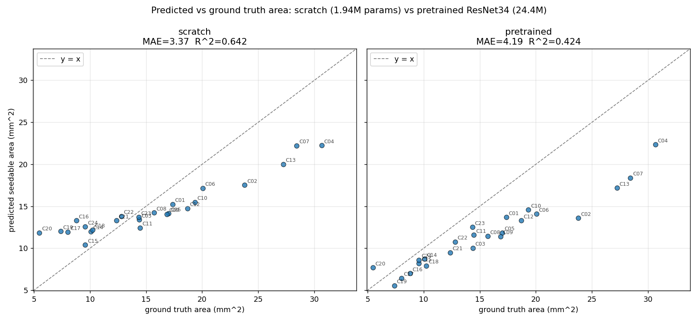
Figure: Scratch U-Net vs ImageNet-pretrained ResNet34 encoder, end-to-end predicted vs ground-truth area on the training set's 24 chips.

6. Discussion
Two design choices drove the chip-level results. First, labeling at least one mask of every chip rather than several masks of a few chips. Holding out a chip is only a meaningful test if at least one similar chip is in the training data, so coverage matters more than per-chip multiplicity. Second, separating shadow handling from defect handling in stage 2 and turning the defect step off by default. Once the U-Net is trained on masks that already encode "what counts as seedable" per the labeler's judgement, an aggressive defect-removal post-process subtracts twice and hurts results. Shadow refinement is independent of labeling style (the shadow is never on the chip itself, it is on the paper), so it stays on.
Per-chip error breakdown is in the metrics.json. Smaller chips (5 to 10 mm^2) have higher relative error because the absolute area is small and the shadow on certain background colors is comparable in size to the chip itself. Larger chips (greater than 25 mm^2) are systematically underestimated by 20 to 30 percent because the U-Net's chip mask sometimes does not cover the full extent of the chip on backgrounds it has not seen labeled.
Comparison to the manual workflow: the original 1 to 2 minutes per chip is replaced by sub-second inference plus image capture. The model fits in under 8 MB on disk and does not require a GPU at inference time.

7. Limitations
Limited labeling. 41 valid masks across 24 chips is enough to train a working U-Net but not enough to drive Dice above 0.94. Adding more backgrounds for chips C07 through C24 would tighten validation further.
Test_1 has no ground truth. The Testing_dataset_1 folder has 67 usable images across 12 unrelated chips but no manual masks or area values. We run inference on it for qualitative inspection (section 5.4) and report cross-background consistency, but absolute accuracy on this set cannot be measured.
Stage 2 is classical, not learned. Shadow handling is a hand-coded HSV rule. A second U-Net trained on per-chip seedable-vs-unseedable labels would handle backgrounds where the chip-shadow contrast is unusual. Implementing that was descoped due to labeling time.
Single zoom level for calibration. All training and quantitative evaluation is at zoom 1. The live demo's zoom slider scales the 1x calibration factor mathematically by 1 / zoom^2, but no held-out images at other zooms exist to verify that scaling on real hardware. Capturing a labeled calibration image at each microscope zoom and re-deriving the factor per zoom level remains future work.

8. Future Work
Add multiple backgrounds per chip for chips C07 through C24. Adding a second labeled mask per chip on a different background paper would let validation Dice climb above 0.94 and tighten the end-to-end area MAE.
Add a second U-Net for stage 2, trained on per-chip seedable-vs- unseedable labels rather than the current chip-vs-background masks. This would replace the classical shadow-removal step with a learned model and remove the failure mode where shadow on certain background colors gets pulled into the chip mask.
Convert the trained PyTorch model to TensorFlow Lite via the Open Neural Network Exchange (ONNX) intermediate format for faster Pi inference. The live demo currently runs PyTorch directly on the Pi's CPU at a few frames per second; a TFLite-quantised version would push that closer to interactive frame rates and shrink the deployed model on disk.
Per-zoom calibration. The live demo's zoom slider scales the 1x calibration factor mathematically by 1 / zoom^2, which is geometrically correct but not validated on real hardware. Capturing a labeled calibration image at each microscope zoom and re-deriving the factor per zoom level would replace the assumed scaling with measured values.
Human-in-the-loop active learning. During live demonstration, when the predicted mask is visibly wrong the operator should be able to trace a corrected boundary directly in the demo window with the mouse, click OK to accept the correction, and the system would save the corrected mask alongside the current frame as a new (image, mask) pair under Training_dataset_2_ground_truth_masks. A scheduled retraining run (overnight, or on demand) would then incorporate all accepted corrections from that day and replace the deployed checkpoint, so the model improves through use rather than only through dedicated labeling sessions. Over time the demo would learn the lab's specific chip styles, lighting, and edge cases. Online fine-tuning during a live session is also possible (a few gradient steps on the new sample after each correction) but accumulating corrections and retraining on a schedule is more robust to occasional mis-traces and avoids catastrophic forgetting.

9. Reproducing The Results
From the code/ folder:
python -m pip install -r requirements.txt python scripts/train_model.py --epochs 40 --base-channels 16 python scripts/evaluate.py python scripts/finalize_report.py
Or open notebooks/01_full_pipeline.ipynb and run the cells top to bottom. The notebook re-uses the existing checkpoint by default; set RETRAIN=True in the first cell to retrain from scratch.

